**3. Result**

**Sign in Page**

**Register Page**



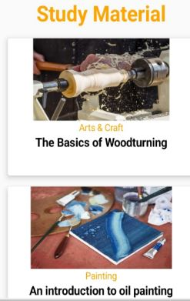**Main Page**



**Book Page**

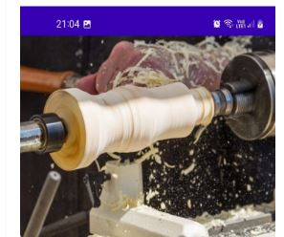

**The Basics of Woodturning**

What is wood Turning

Woodturning is a form of woodworking involving a lathe. With other kinds of woodworking, the wood is stationary and the tools moves to creates cuts.

In woodturning the lathe turns the wood on its axis at high revolutions per minute while relatively stationary special cutting tools on a tool rest do the work.

A wood lathe allows wood turners to create all kinds of objects, from bowls to stair railings to chess pieces to musical instruments.