Future Sales Prediction

**Name:CT.Swetha**

**Reg.no:912421104049**

**Phase2 project submission**

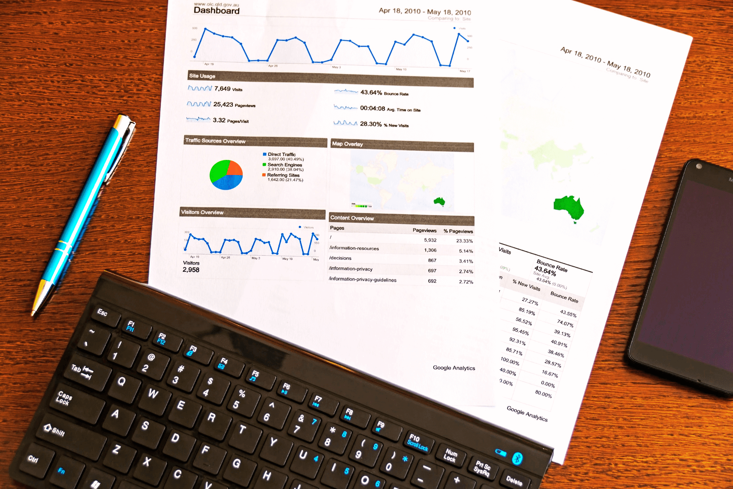

INTRODUCTION:

One of the most common methods used to predict sales is regression analysis. This method involves using historical sales data to train a model that can predict future sales. The model can take into account factors such as past sales, marketing campaigns, and economic indicators to make its predictions.

DATA SOURCE

One of the most common methods used to predict sales is regression analysis. This method involves using historical sales data to train a model that can predict future sales. The model can take into account factors such as past sales, marketing campaigns, and economic indicators to make its predictions.

Datalink:

https://www.kaggle.com/datasets/chakradharmattapalli/future-sales-prediction

Data preprocessing

Data preprocessing is an important step in the data mining process. It refers to the cleaning, transforming, and integrating of data in order to make it ready for analysis. The goal of data preprocessing is to improve the quality of the data to make it more suitable for the specific data mining task.

Feature Engineering

Feature Engineering is the process of creating new features or transforming existing features to improve the performance of a machine-learning model. It involves selecting relevant information from raw data and transforming it into a format that can be easily understood by a mode

Model Training

Model training is the phase in the data science development lifecycle where

Practitioners try to fit the best combination of weights and bias to a machine learning algorithm to minimize a loss function over the prediction range.

# **Predicting Sales**

## Forecasting the monthly sales with LSTM

This series of articles was designed to explain how to use Python in a simplistic way to fuel your company’s growth by applying the predictive approach to all your actions. It will be a combination of programming, data analysis, and machine learning.

I will cover all the topics in the following nine articles:

1- [Know Your Metrics](https://towardsdatascience.com/data-driven-growth-with-python-part-1-know-your-metrics-812781e66a5b)

2- [Customer Segmentation](https://towardsdatascience.com/data-driven-growth-with-python-part-2-customer-segmentation-5c019d150444)

3- [Customer Lifetime Value Prediction](https://towardsdatascience.com/data-driven-growth-with-python-part-3-customer-lifetime-value-prediction-6017802f2e0f)

4- [Churn Prediction](https://towardsdatascience.com/churn-prediction-3a4a36c2129a)

[5- Predicting Next Purchase Day](https://towardsdatascience.com/predicting-next-purchase-day-15fae5548027)

6- **Predicting Sales**

[7- Market Response Models](https://towardsdatascience.com/market-response-models-baf9f9913298)

[8- Uplift Modeling](https://towardsdatascience.com/uplift-modeling-e38f96b1ef60)

[9- A/B Testing Design and Execution](https://towardsdatascience.com/a-b-testing-design-execution-6cf9e27c6559)

Articles will have their own code snippets to make you easily apply them. If you are super new to programming, you can have a good introduction for [Python](https://www.kaggle.com/learn/python) and [Pandas](https://www.kaggle.com/learn/pandas) (a famous library that we will use on everything) here. But still without a coding introduction, you can learn the concepts, how to use your data and start generating value out of it.

Example program:

Import pandas as pd # to extract data from dataset(.csv file)

Import csv #used to read and write to csv files

Import numpy as np #used to convert input into numpy arrays to be fed to the model

Import matplotlib.pyplot as plt #to plot/visualize sales data and sales forecasting

Import tensorflow as tf # acts as the framework upon which this model is built

From tensorflow import keras #defines layers and functions in the model

#here the csv file has been copied into three lists to allow better availability

List_row,date,traffic = get_data(‘/home/abh/Documents/Python/Untitled Folder/Sales_dataset’)

Output:

Original data set for sales data for 5 years:

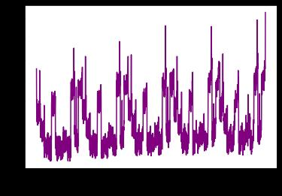

History = model.fit(

X = [inp_day,inp_mon,inp_year,inp_week,inp_hol,inp7,inp_prev,inp_sess],

Y = out,

Batch_size=16,

Steps_per_epoch=50,

Epochs = 15,

Verbose=1,

Shuffle =False

)

#all the inputs were fed into the model and the training was completed

Output:

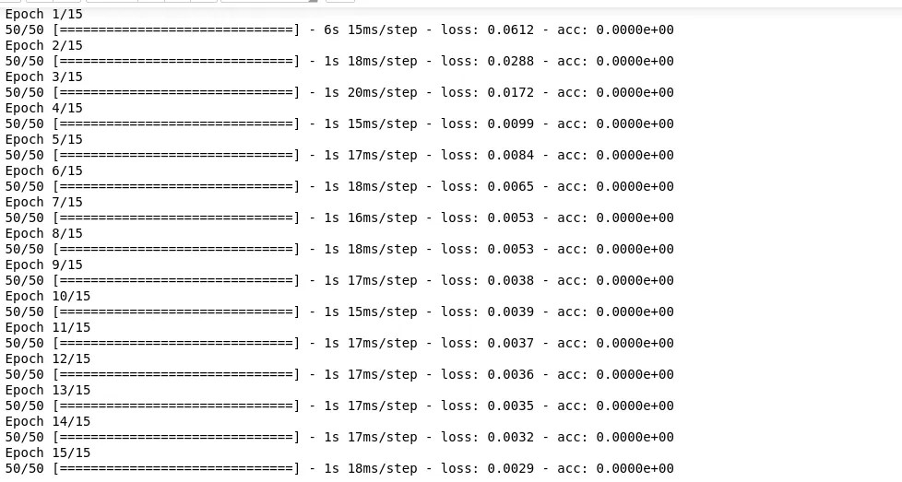

Conclusion: The phase2 submission was about future sales prediction with innovative technology.