**LEAP Details:**

**1) VM details used in LEAP**

|  |  |  |  |  |  |  |
| --- | --- | --- | --- | --- | --- | --- |
| **IP Address** | **Hostname** | **OS type** | **Usage** | **VNC Password** | **Username** | **Password** |
| 10.120.100.31 | QPaaSICNV5070 | Linux | Leap Offshore Setup | password | QPaaS | G0d!g!t@1 |
| 192.168.40.63 | QPaaSICNV5069 | Linux (IP address is changed) | Leap Offshore Setup | password | QPaaS | G0d!g!t@1 |
| 10.120.101.126 | QPaaSICNV1655 | Windows | For Research Purpose |  |  |  |
| 10.120.101.131 | QPaaSICNV1616 | Windows | For Research Purpose |  |  |  |
| 10.120.100.230 | QPaaSICNV5095 | Linux | Not in use | G0d!g!t@1 |  |  |
| 10.120.100.229 | QPaaSICNV5096 | Linux | Not in use | G0d!g!t@1 |  |  |

**2) Tools setup in VMs:**

|  |  |  |  |  |
| --- | --- | --- | --- | --- |
| 10.120.100.31  [QPaaSICNV5070] | **Tools** | **URL** | **Username** | **Password** |
|  | Jenkins Docker container | http://10.120.100.31:8080/ | admin | leapadmin |

|  |  |  |  |  |
| --- | --- | --- | --- | --- |
| 192.168.40.63 [QPaaSICNV5069] | Tools | **URL** | **Username** | **Password** |
|  | Sonarqube Docker Container | http:// 192.168.40.63:9000/ | admin | admin |
|  | Octane Docker container | http://192.168.40.63:8008/ | sa@nga | Leap@admin |
|  | TeamCity | http://192.168.40.63:8111/ | admin | leapadmin |

**3) Steps followed to setup LEAP tools in AWS Offshore setup** 

**4) Configurations in Slack and Jenkins to communicate with each other**



**5) Fix made to resolve Git issue in Ubuntu setup**

To Configure Git in System for Jenkins to execute Git jobs:

<https://www.guru99.com/jenkins-github-integration.html>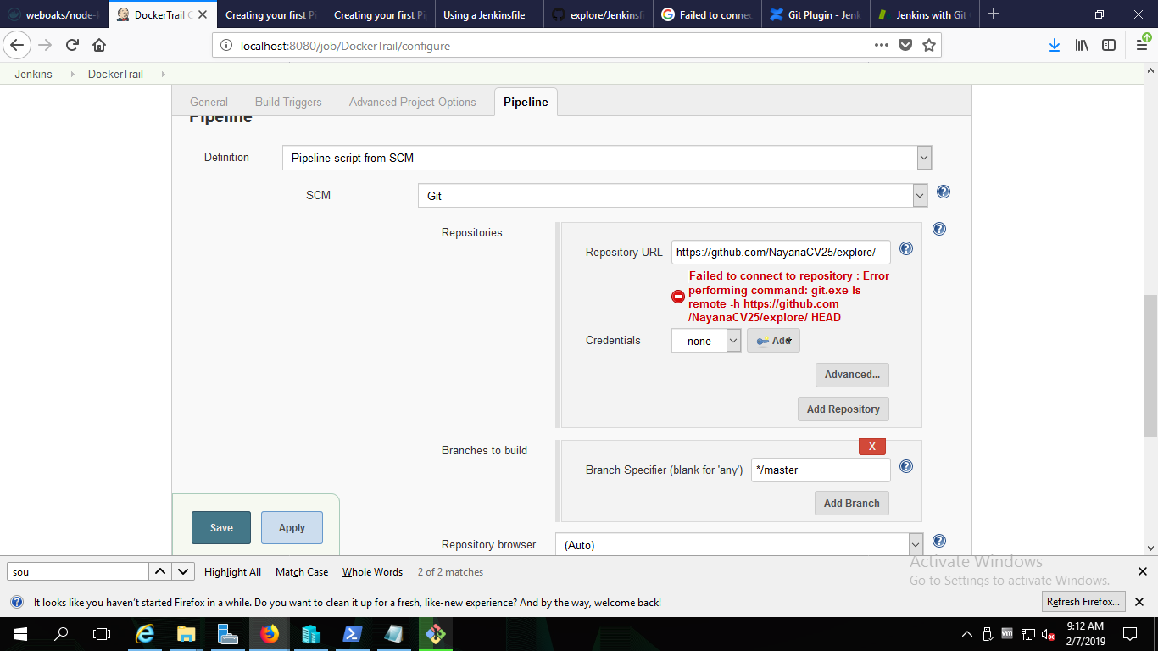

Again one more error to execute sh so fixed by adding ./git/usr/bin in to environment variables PATH

<https://stackoverflow.com/questions/45140614/jenkins-pipeline-sh-fail-with-cannot-run-program-nohup-on-windows>

**6) Jenkins setup steps in Ubuntu**



**7) Team City installation details**



**8) Octane Installation details**

Octane is installed using Docker which internally using docker compose installs Elastic search 5.6.6, Mssql 2017 latest.

For docker installation followed <https://marketplace.microfocus.com/appdelivery/content/alm-octane-docker-container-technology-preview> latest zip.

Octane is available in http:// 192.168.40.63:8008/ Login details – **username** : sa@nga **password** : Leap@admin also created a sample defect in the site.

In 192.168.40.63 VM in home directory Octane folder is there where the below 2 files along with cleaup.sh file is present.

To create docker-

* cd Octane
* Octane > docker-compose up –d
* To stop docker Octane > docker-compose down



**9) Login Details for applications**



**10) Offshore AWS urls :**

**GitHub:** <https://github.com/swethacts/> [Login details available in the attached Login-Details file]

**Jenkins:** [**http://ec2-3-17-187-0.us-east-2.compute.amazonaws.com:8080/**](http://ec2-3-17-187-0.us-east-2.compute.amazonaws.com:8080/)

Username – admin Password – admin

**Sonarqube:** [**http://ec2-3-17-187-0.us-east-2.compute.amazonaws.com:9000/**](http://ec2-3-17-187-0.us-east-2.compute.amazonaws.com:9000/)

Username – admin Password – admin

**Sample Java application:** [**http://ec2-3-17-187-0.us-east-2.compute.amazonaws.com:3000/**](http://ec2-3-17-187-0.us-east-2.compute.amazonaws.com:3000/)

**How to start sample application background:**

Download project from https://github.com/swethacts/angularjs-springmvc-sample-boot

To home directory, extract folder. Create 2 files startui.sh and startbackend.sh with the commands specified in the attached file. Cd to the sample application directory and execute the command as mentioned in the attached file to start the application run in the background.



**11) To install Maven in Jenkins Docker**

Docker exec –it %CONTAINER_ID% /bin/bash

bash#> apk upgrade

bash#> apk update

bash#> apk add maven

bash#> mvn –version

To Check Java version

bash#> java –version

**Request Access:**

SLACK channels and slash command creation https://ctsengops.slack.com