Step 1: Install postgre sql from the following link

<https://www.enterprisedb.com/postgresql-tutorial-resources-training?uuid=db55e32d-e9f0-4d7c-9aef-b17d01210704&campaignId=7012J000001NhszQAC>.

After installing, please remember the password and port of the postgre sql and update in the following file.

Open database.yaml file

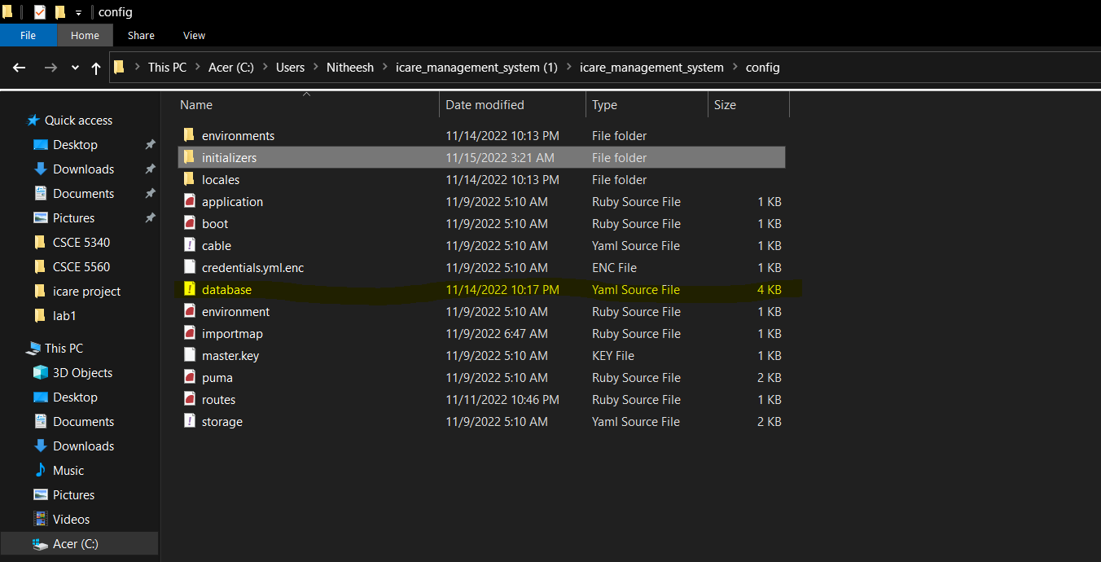

Update password and port

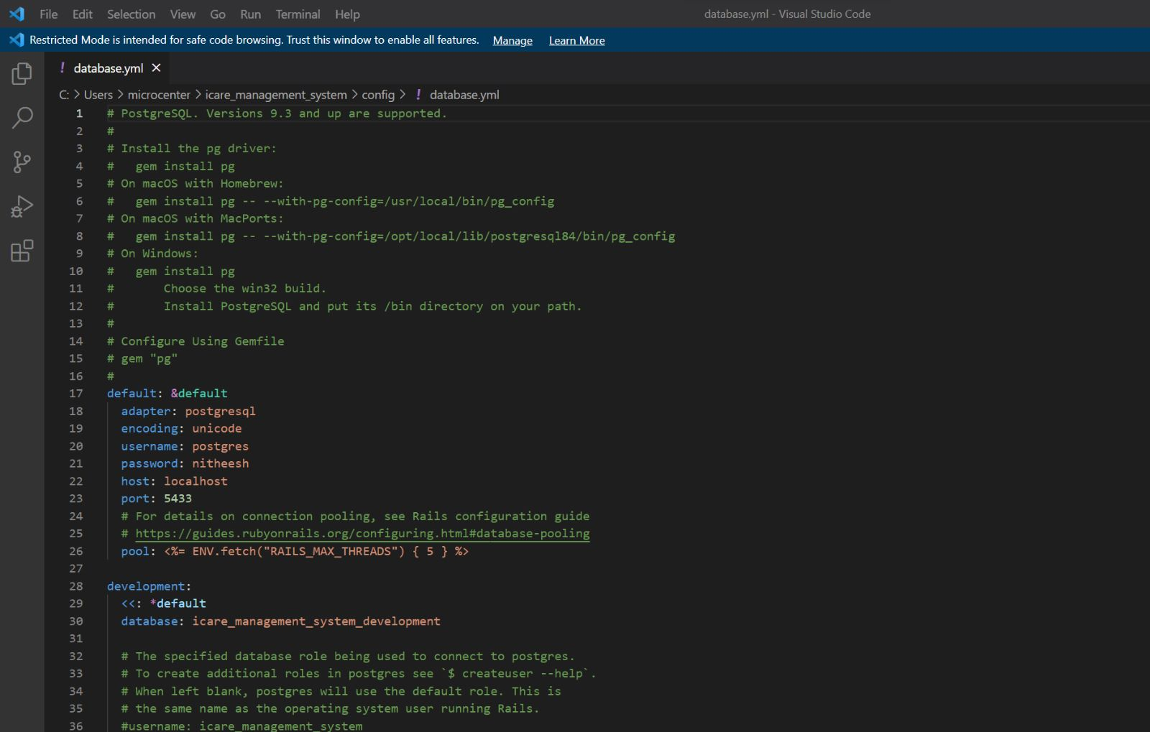

Step2: Install ruby on rails from the following link

<https://rubyinstaller.org/downloads/>

install the highlighted version 3.0.4-1

We will get the below screen after installing click enter, I will install all the components

After the above screen, you will get the following screen and you need to enter once again

Step3: Install the highlighted part after opening the below link

<https://wkhtmltopdf.org/downloads.html>

After installing open the installation path and copy the path of the highlighted part in the below image

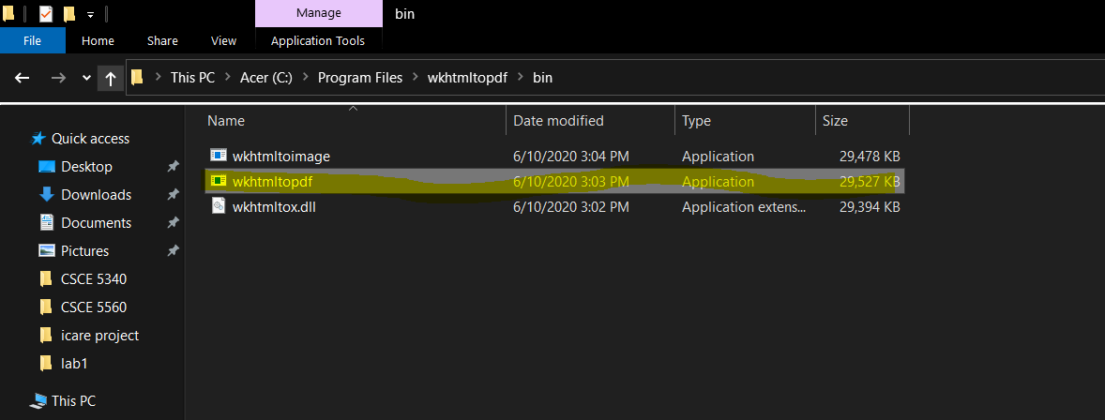

And edit it in following highlighted file

Just make sure to check the back slashes after coping we need to change them when we copy

Step4: Download and extract the project and copy the project in c drive ->users -> your profile

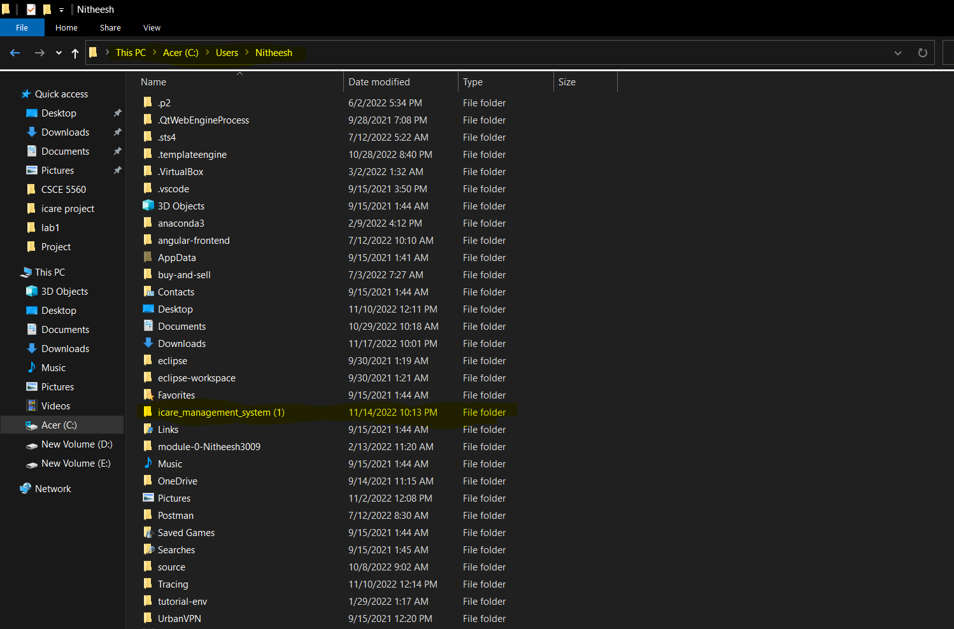

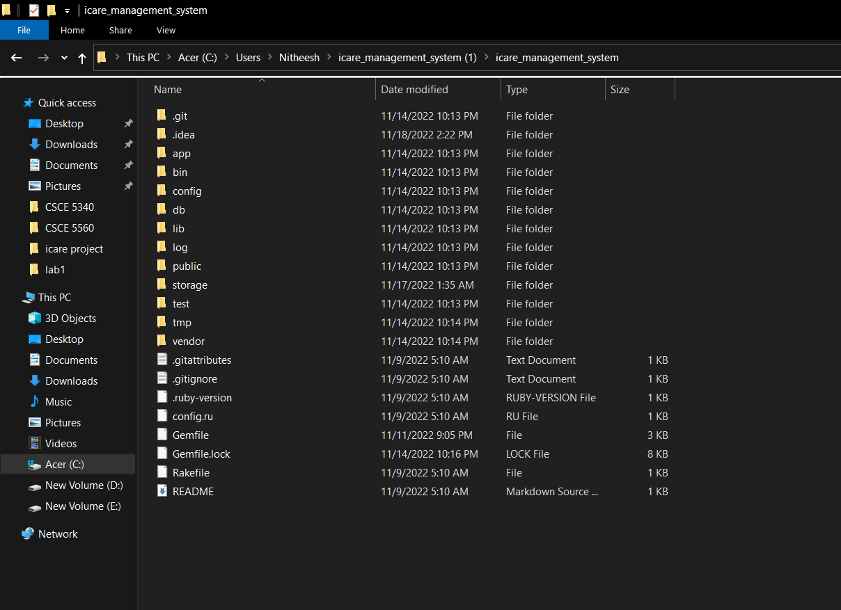

Step5: Open cmd in the project folder and run bundle install, this will install all the required dependencies for the project.

After bundle install we need to run “rails db:create”

Then after run “rails db:migrate”

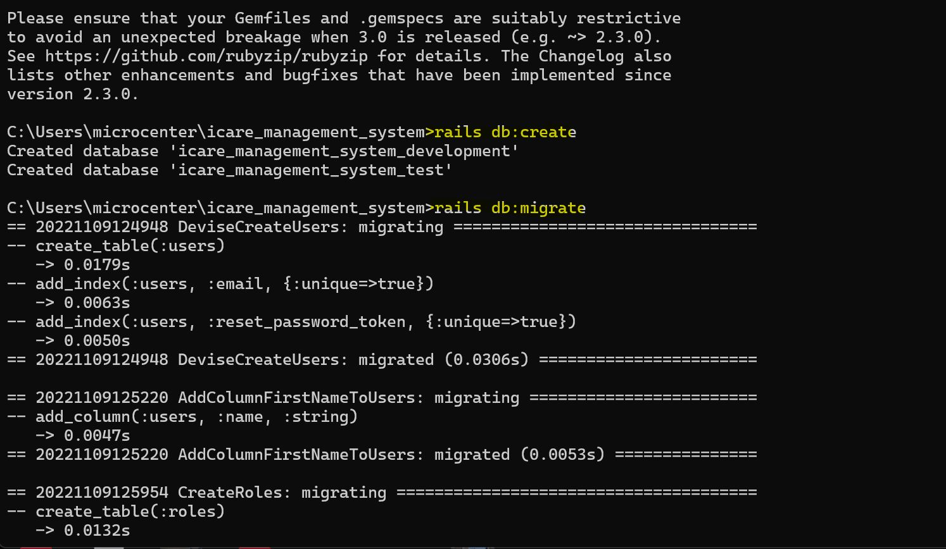

Run “rails db:seed”



Then run “rake tmp:cache:clear”

Then after run “rake add_drug”

Then run “rails s”

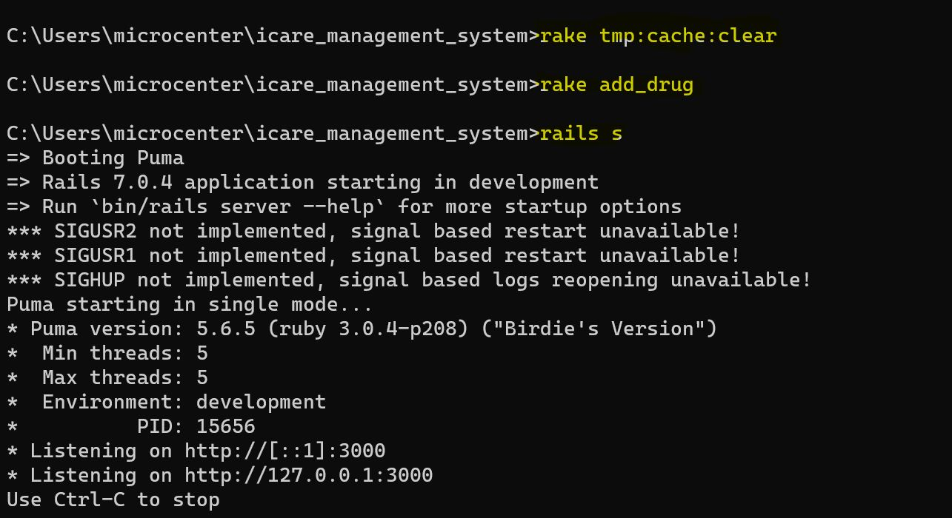

Then we can open browser and open localhost:3000

First we need to login to admin, we can’t create users without having roles so that we need to create roles first in admin and we can create users in admin

Mail: [admin@admin.com](mailto:admin@admin.com)

Password: password

Once you login, go to roles and create nurse and doctor role

You can see the below screen after creating

Once we click on the users we can see new user button clicking upon that we will get the following form to create the user after creating the user remember the username and password

Use that username and password to login to into user profile by going to localhost:3000

We can see the below screen after logging in, we can check the dashboards and also create patients

After clicking the new patient we will get the form and after creating we can see the below image

