**SAMPLE DOCUMENT FROM OUR SERVER**

**QUESTION TWO**

1. INVOICE (INV_NUM, PROD_NUM, SALE_DATE, PROD_LABEL, VEND_CODE, VEND_NAME, QUANT_SOLD, PROD_PRICE)

**The primary key for the table will be a combination of INV_NUM and PROD_NUM (composite key)**

**Below are the functional dependencies:-**

{INV_NUM, PRODUCT_NUM} {SALE_DATE, PROD_LABEL, VEND_CODE, VEND_NAME, QUANT_SOLD, PROD_PRICE}

{INV_NUM} {SALE_DATE}

{PROD_NUM} {PROD_LABEL, VEND_CODE, VEND_NAME, PROD_PRICE}

{VEND_CODE} {VEND_NAME}

**Below are the partial dependencies**:

{INV_NUM} {SALE_DATE}

{PROD_NUM} {PROD_LABEL, VEND_CODE, VEND_NAME, PROD_PRICE}

**Below are the transitive dependencies**

{VEND_CODE} {VEND_NAME}



PRODUCT (PROD_NUM, PROD_LABEL, PROD_PRICE)



The tables above are second normal form tables (2NF)

1. INVOICE (INV_NUM, PROD_NUM, QUANT_SOLD, PROD_PRICE)

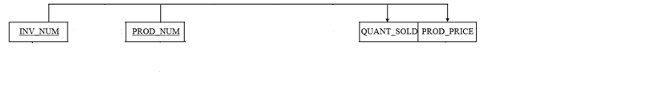

The table above is a first normal form table (1NF)