Use below URL to access application: http://localhost:8080

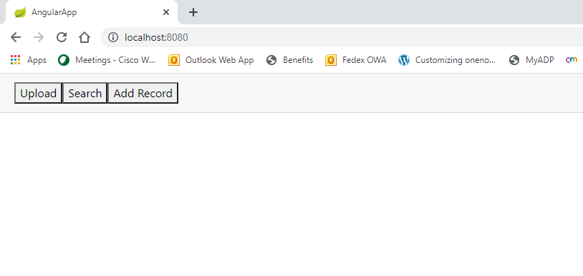

Upload Tab

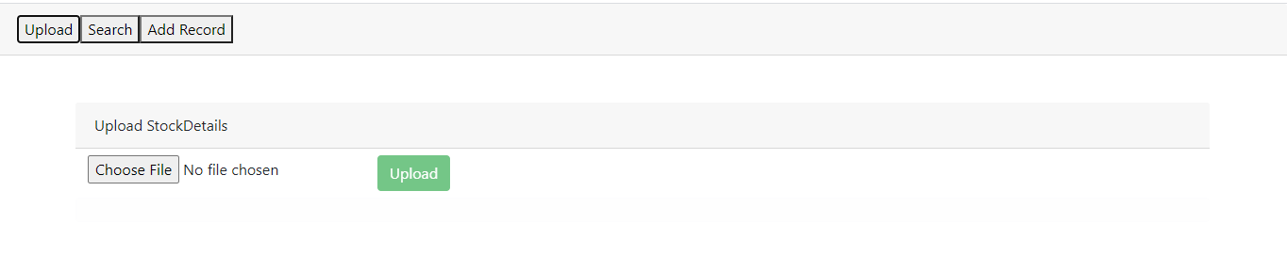

Select file to upload and click on upload button.

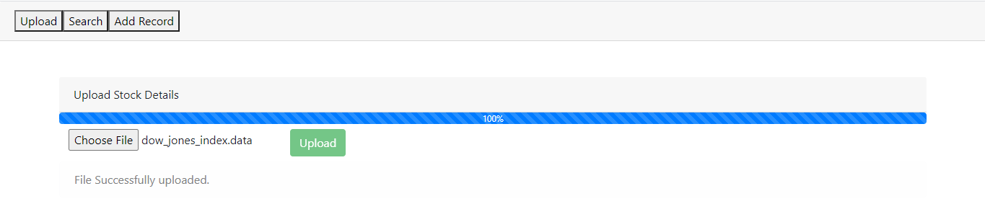

Once file uploaded, success message is printed. If any error, error message is printed.

Search Tab:

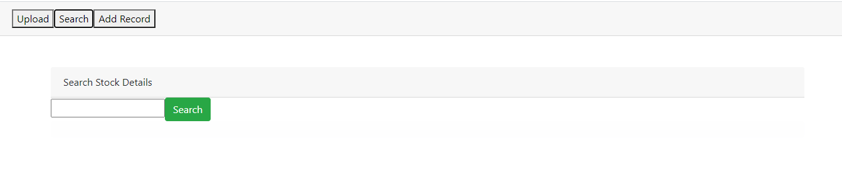 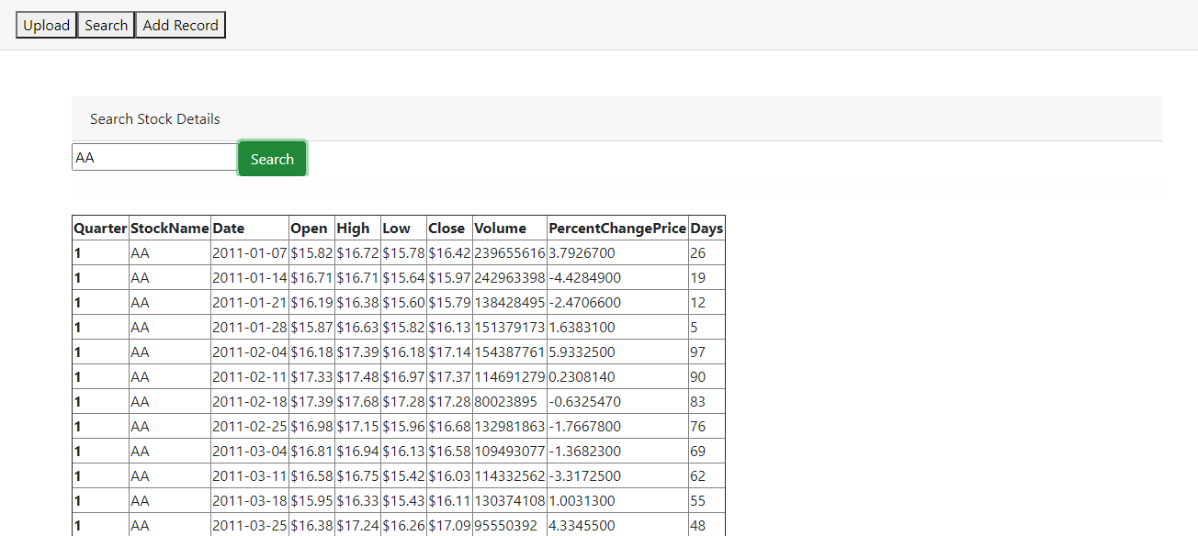

Add RecordTab

