import heapq

def manhattan_distance(state, goal):
distance = 0
for val in range(1, 9):
idx1 = state.index(val)
idx2 = goal.index(val)
x1, y1 = idx1 % 3, idx1 // 3
x2, y2 = idx2 % 3, idx2 // 3
distance += abs(x1 - x2) + abs(y1 - y2)
return distance

def get_neighbors(state):
neighbors = []
idx = state.index(0)
x, y = idx % 3, idx // 3
directions = [(-1, 0), (1, 0), (0, -1), (0, 1)] # left, right, up, down

for dx, dy in directions:
nx, ny = x + dx, y + dy
if 0 <= nx < 3 and 0 <= ny < 3:
new_idx = ny * 3 + nx
new_state = state[:] # copy state
new_state[idx], new_state[new_idx] = new_state[new_idx], new_state[idx]
neighbors.append(new_state)
return neighbors

def reconstruct_path(came_from, current):
path = [current]
while tuple(current) in came_from:
current = came_from[tuple(current)]
path.insert(0, current)
return path

A* Search
def a_star(start, goal):
open_set = []
heapq.heappush(open_set, (manhattan_distance(start, goal), 0, start))
came_from = {}
g_score = {tuple(start): 0}

while open_set:
_, cost, current = heapq.heappop(open_set)

if current == goal:
return reconstruct_path(came_from, current)

for neighbor in get_neighbors(current):
tentative_g = g_score[tuple(current)] + 1
if tuple(neighbor) not in g_score or tentative_g < g_score[tuple(neighbor)]:
g_score[tuple(neighbor)] = tentative_g
f = tentative_g + manhattan_distance(neighbor, goal)
heapq.heappush(open_set, (f, tentative_g, neighbor))
came_from[tuple(neighbor)] = current

return None

IDA* Search
def ida_star(start, goal):
def dfs(path, g, threshold):
node = path[-1]
f = g + manhattan_distance(node, goal)
if f > threshold:
return f
if node == goal:
return path
min_threshold = float('inf')
for neighbor in get_neighbors(node):
if neighbor not in path: # avoid cycles
path.append(neighbor)
result = dfs(path, g + 1, threshold)
if isinstance(result, list): # found solution
return result
if result < min_threshold:
min_threshold = result
path.pop()
return min_threshold

threshold = manhattan_distance(start, goal)
path = [start]

while True:
result = dfs(path, 0, threshold)
if isinstance(result, list):
return result
if result == float('inf'):
return None
threshold = result

def get_input():
print("Enter the initial state (9 numbers, use 0 for blank):")
start = list(map(int, input().split()))
print("Enter the goal state (9 numbers):")
goal = list(map(int, input().split()))
return start, goal

def print_solution(solution):
if solution is None:
print("No solution found.")
else:
print("Steps to reach goal:")
for state in solution:
for i in range(0, 9, 3):
print(state[i:i+3])
print("-----")
print("Total steps:", len(solution) - 1)

if __name__ == "__main__":
start, goal = get_input()

print("\n--- A* Search ---")
a_star_result = a_star(start, goal)
print_solution(a_star_result)

print("\n--- Memory-Bounded A* (IDA*) ---")
ida_star_result = ida_star(start, goal)
print_solution(ida_star_result)

Exercise2 Output:
Start: 1 2 3 4 5 6 0 7 8
Goal: 1 2 3 4 5 6 7 8 0
--- A* Search ---
Steps to reach goal:
[1, 2, 3]
[4, 0, 5]
[6, 7, 8]
-----
[1, 2, 3]
[4, 5, 0]
[6, 7, 8]
-----
Total steps: 1
--- Memory-Bounded A* (IDA*) ---
Steps to reach goal:
[1, 2, 3]
[4, 0, 5]
[6, 7, 8]
-----
[1, 2, 3]
[4, 5, 0]
[6, 7, 8]
-----
Total steps: 1

Exercise2 Output

DFS in Binary Search Tree:

Enter the element to search using DFS: 20
Element found in BST using DFS.

BFS in Binary Search Tree:

Enter the element to search using BFS: 7
Element found in BST using BFS.

Exercise3 Output:
Linear Regression:
MSE: 442.24
R² : 0.9278
Polynomial Regression (degree = 2):
MSE: 49.74
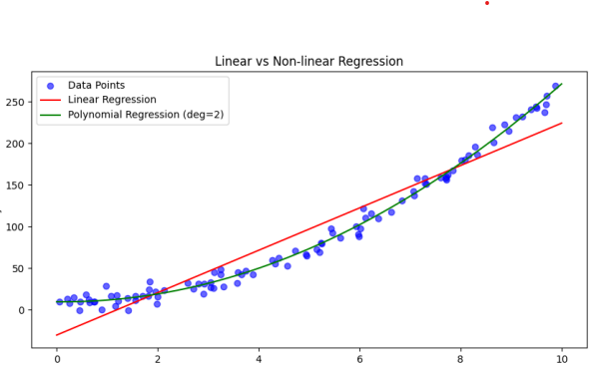
R² : 0.9919

