**Power BI and Tableau**

**Assignment 1**

**Power BI is a suite of business analytics tools to analyse data and share insights.**

1. **Install Power BI Desktop and share the final screenshot of the report view page which appears when power desktop starts.**

Power BI has three views :

* Report View
* Data View
* Relationship view

**Report View is the default view**

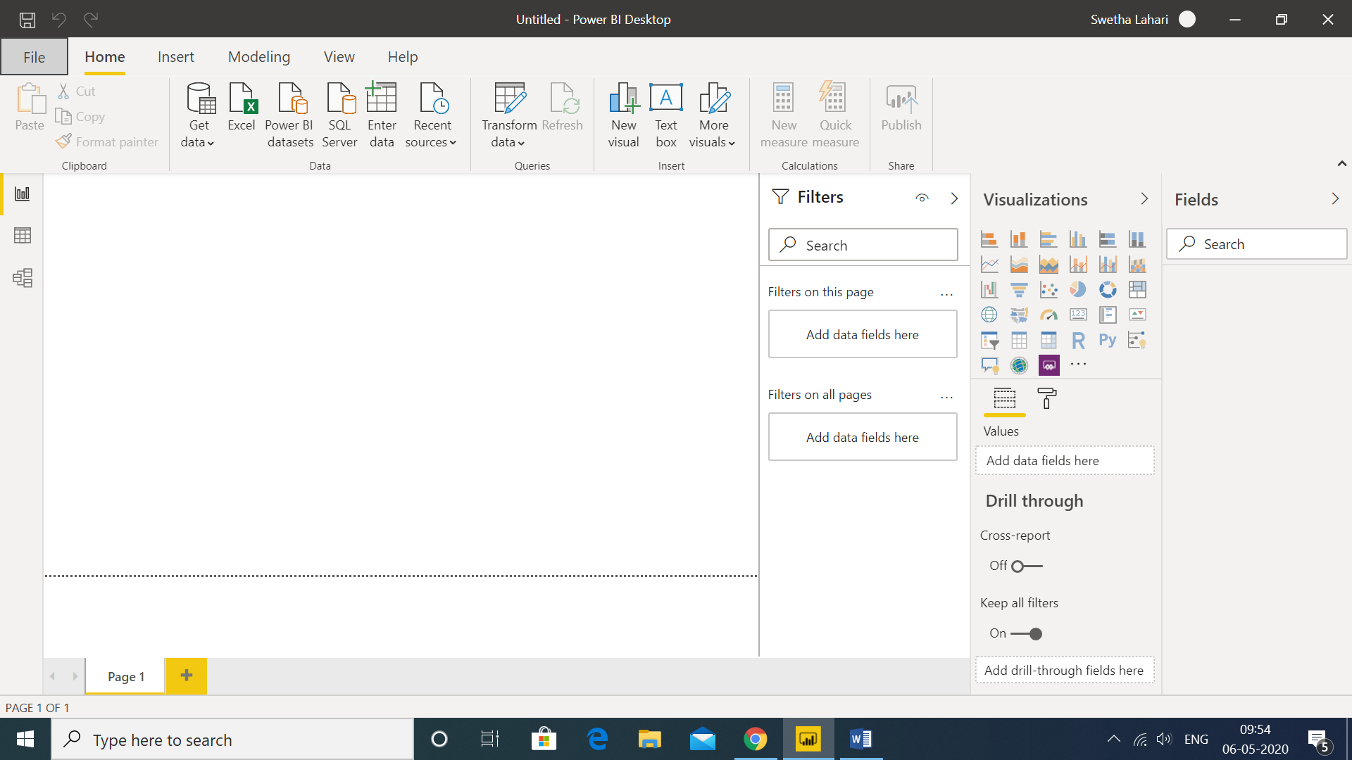

In this view, one can use the visualizations available to explain the insights.

The white screen in the centre is called canvas, and visual elements can be dragged to generate the report

1. **Prepare a document and with the following screenshot**

**− Report View**

In this view, you create reports and visuals, where most of your creation time is spent.



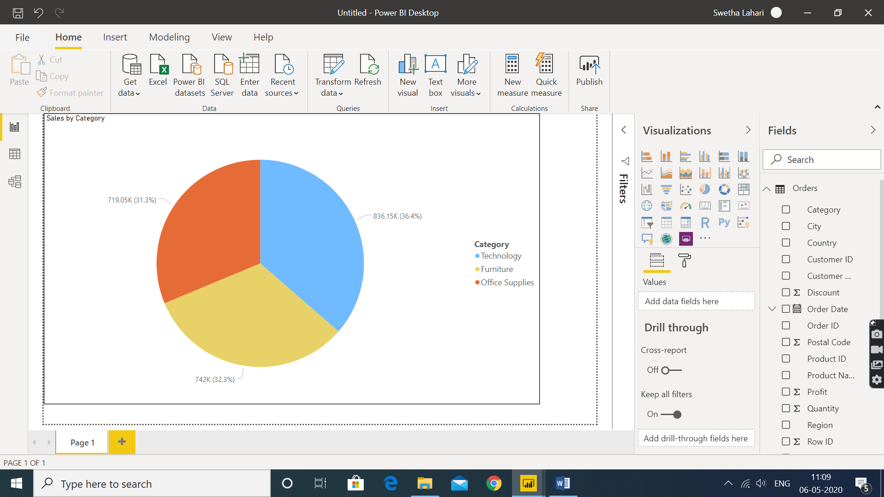

**− Data View**

Displays the table data in rows and columns for further analysis and transformations.

In this view, you see the tables, measures, and other data used in the data model associated with your report, and transform the data for best use in the report's model.

**Example**: an Excel file with orders details is loaded. Get Data -> Excel -> Choose the file to import, preview the selected table and select “Transform”.

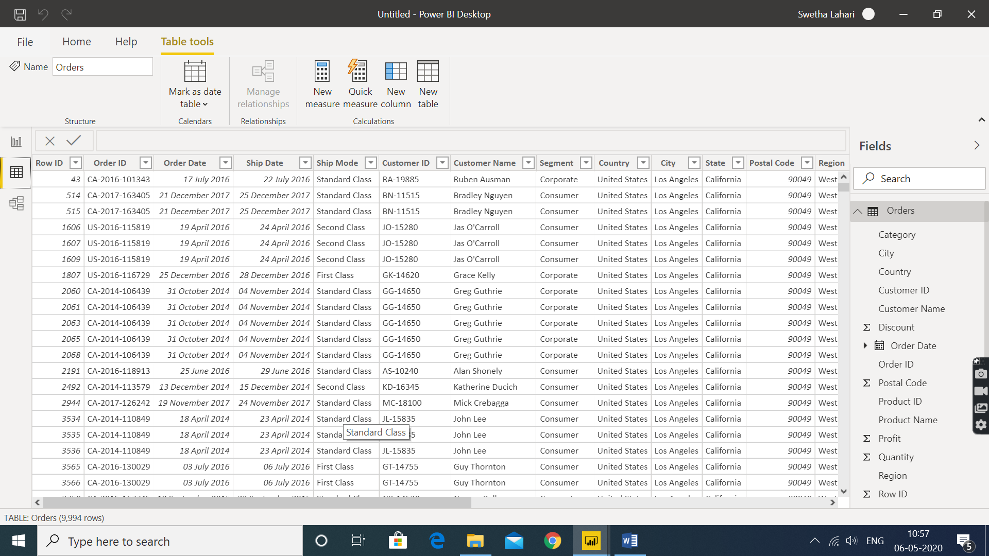

**− Model View**

Also known as Relationship View, it shows the tables loaded into the editor and the relationship among them

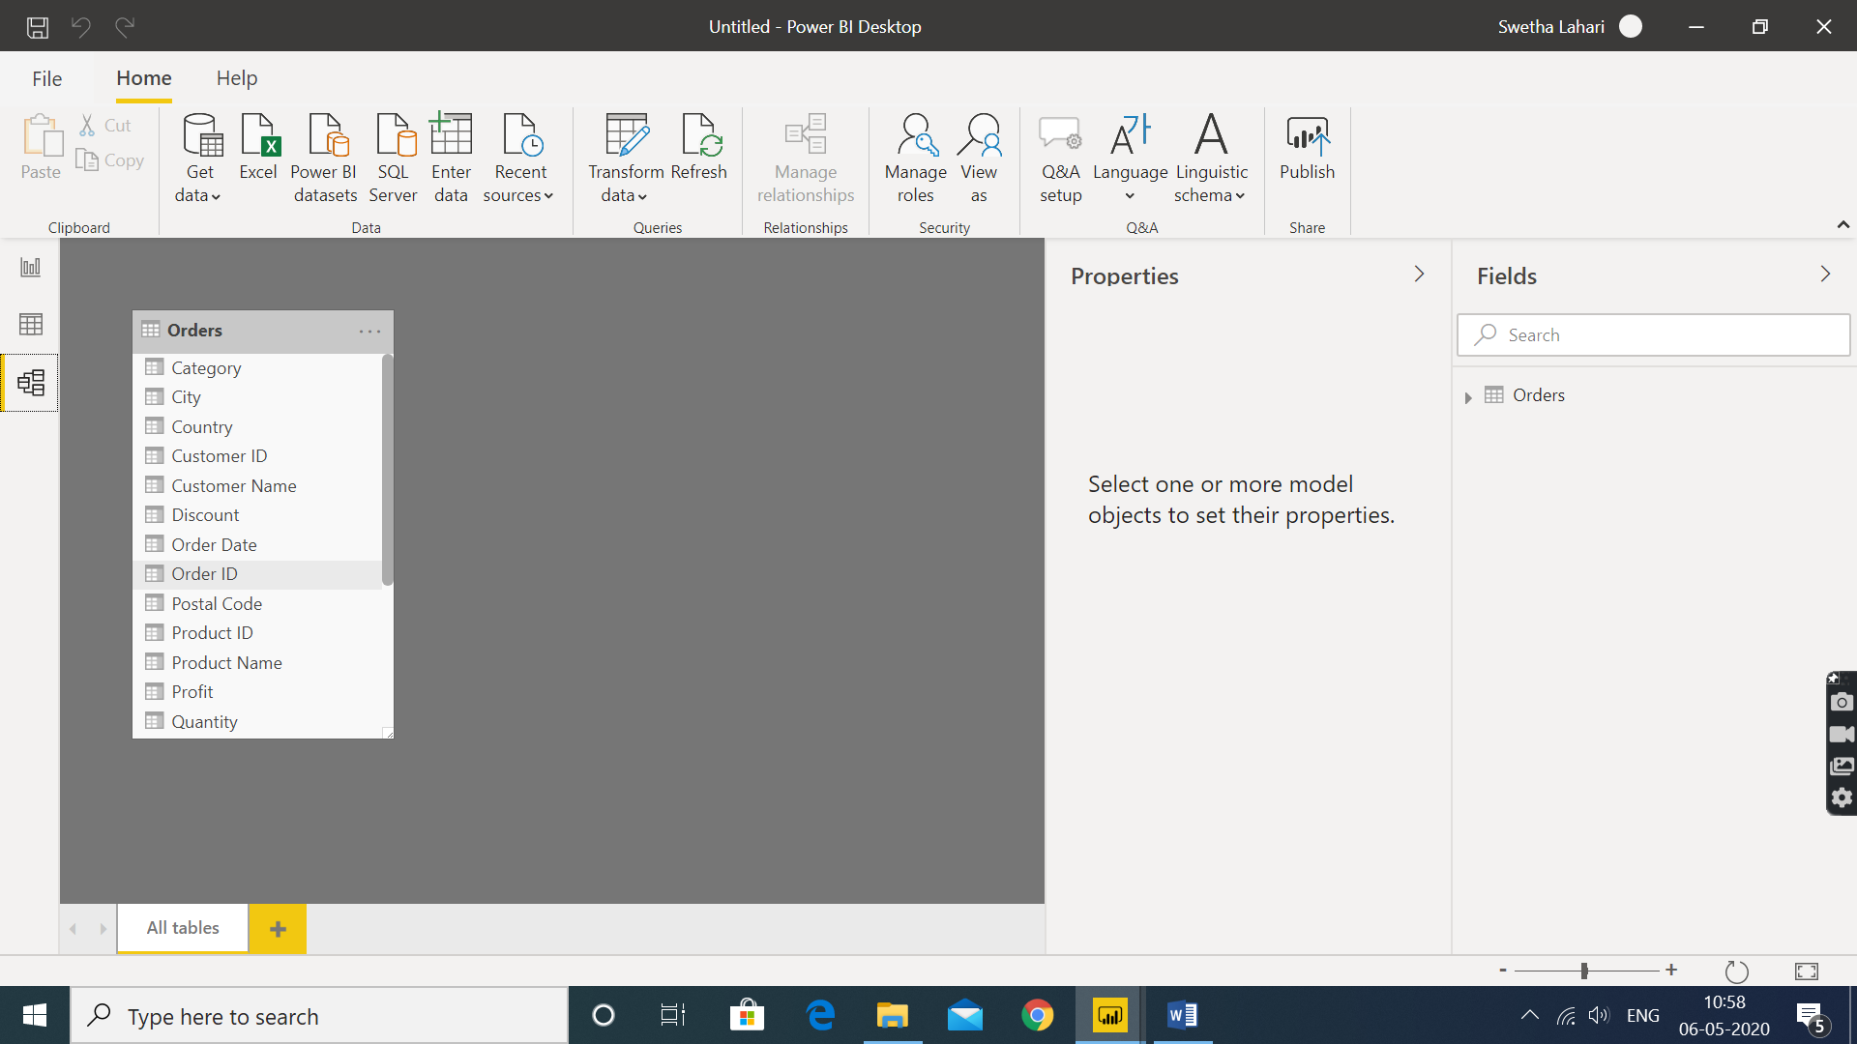

**− Power Query Editor**

* To transform data into required format, Power Query Editor is used.
* With Power Query Editor, you make changes to your data, such as changing a data type, removing columns, or combining data from multiple sources, generate / Extract more columns, merge columns, append tables , delete columns etc.,
* Also, every step / action performed in the query editor is recorded and can be used to understand set of operations applied or to revert back few operations etc.,

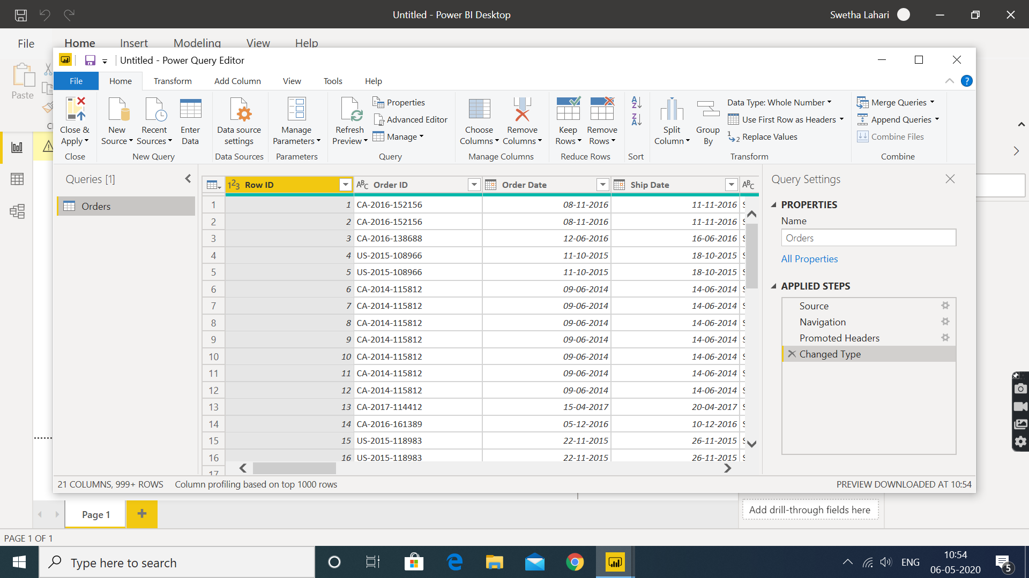

**− Advance Editor**

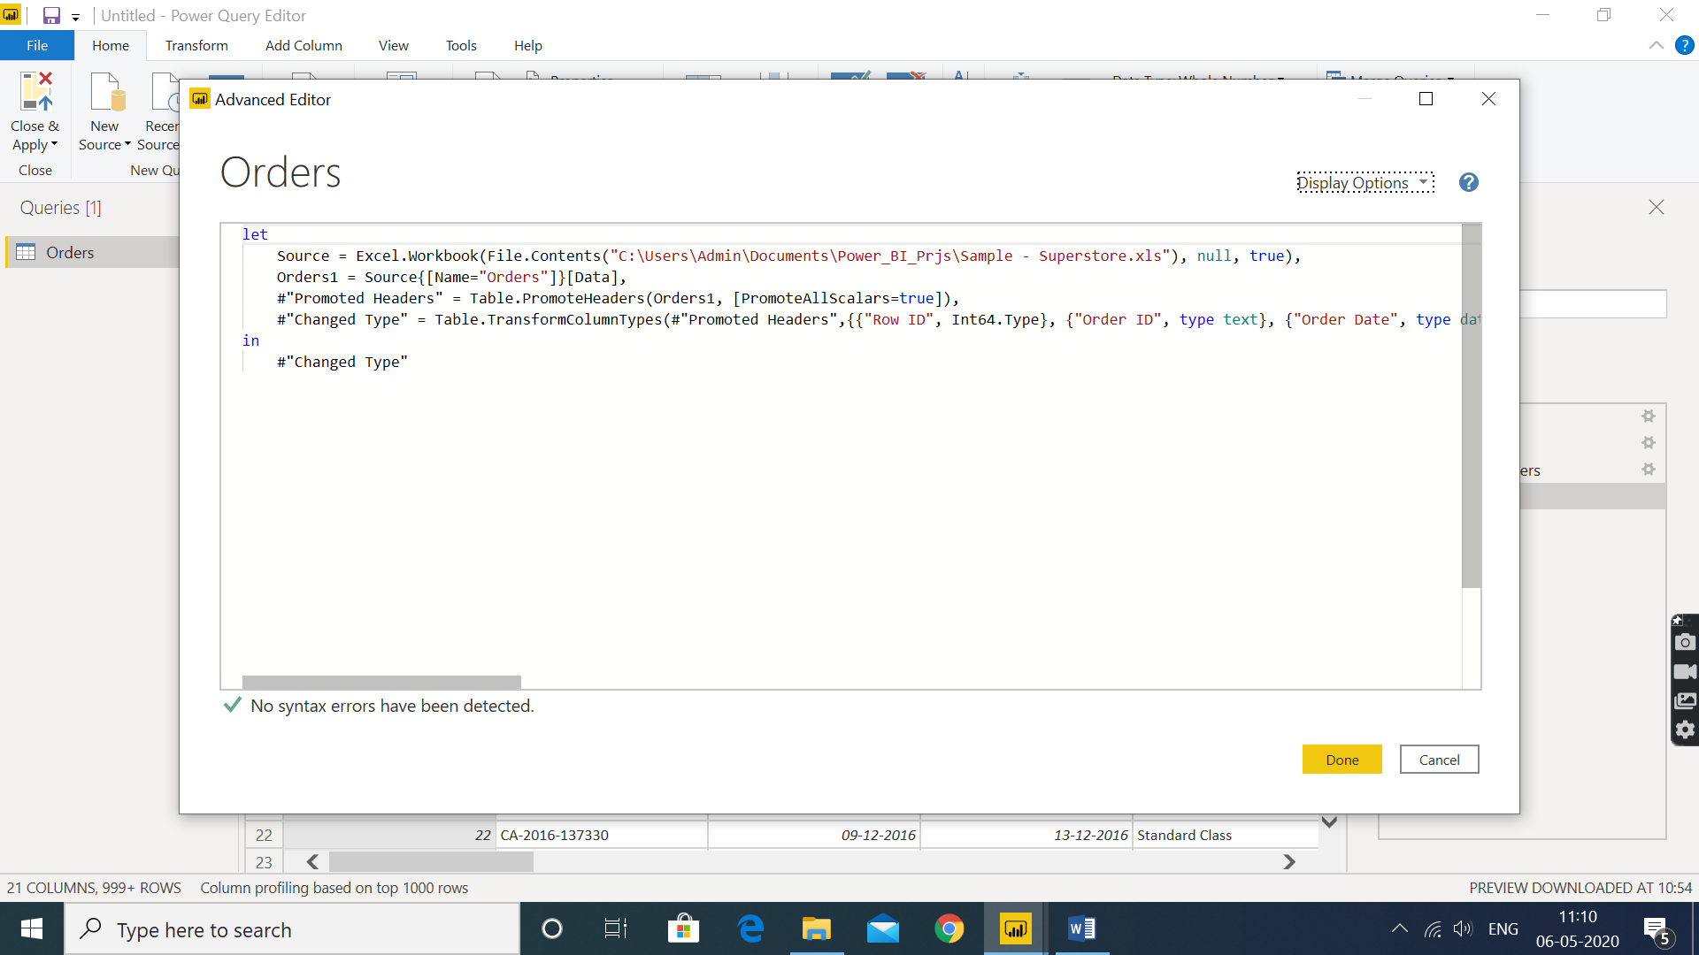

1. **Prepare a document with details of the following along with their price**

**− Power BI Desktop**

* Power BI Desktop is a free application you install on your local computer that lets you connect to, transform, and visualize your data.
* With Power BI Desktop, you can connect to multiple different sources of data, and combine them (often called modeling) into a data model.
* This data model lets you build visuals, and collections of visuals you can share as reports, with other people inside your organization.
* Most users who work on business intelligence projects use Power BI Desktop to create reports, and then use the Power BI service to share their reports with others.

**− Power BI Pro**

* Self- Service and cloud support.
* Collaboration , publishing , sharing and ad-hoc analysis
* Fully managed by Microsoft
* With Power BI Pro, users are licensed individually and participate fully in the use of Power BI – both the creation of content and the consumption.
* All Pro users can connect to hundreds of data sources on-premises and in the cloud, create interactive reports and 360-degree dashboards, share that content with other Pro users, and consume content shared by others.
* If an organization consists of 200 total users – 50 are engaging in self-service BI, while the remaining 150 are limited to viewing BI content – Power BI Pro is the most economical deployment option for all users within the organization

**Price : $9.99 Monthly Price per user**

**− Power BI Premium**

* Enterprise BI, big data analytics , cloud and on- premises reporting
* Advanced administration and deployment controls
* Dedicated cloud compute and storage resources
* Allows any user to consume Power BI content
* With Power BI Premium, you are licensing capacity for your content rather than licensing all users of that content.
* Content (datasets, dashboards, and reports) is stored in Premium and can then be viewed by as many users as you want, without additional per-user costs.
* These users can only view content, not create it.
* Viewing includes looking at dashboards and reports on the web, in our mobile apps, or embedded in your organization’s portals or apps.
* The creators of content in Premium still need their own Pro licenses.
* Power BI Premium increases capacity limits and provides consistent performance, extending deployments with larger storage sizes, higher refresh rates, isolation and other performance capabilities in the future
* Also included with Power BI Premium is Power BI Report Server, as well as the ability to embed Power BI in your apps
* Say, if the organization consists of 700 total users – 100 are engaging in self-service BI, while the remaining 600 occasionally view BI content – the most economical deployment option would be to license Power BI Pro for the 100 users engaging in self-service BI and to license Power BI Premium for the 600 seeking occasional access to view BI content.

**Price : $ 4995 Monthly price per dedicated cloud compute and storage resource with annual subscription**

**Table of common and difference of features:**

|  |  |  |
| --- | --- | --- |
|  | **Pro** | **Premium** |
| **Content consumption** | | |
| Paginated reports provide fixed-layout documents optimized for printing and archiving | No | Yes |
| Analyze data in Microsoft Excel | Yes | Yes |
| Embed content in other interfaces like Teams, SharePoint, and other SaaS applications | Yes | Yes |
| View and interact with Power BI content | Yes | Yes |
| View and interact with Power BI content through the Power BI mobile app for iOS, Android, and Windows | Yes | Yes |
| Ask questions about data to get immediate answers and personalize definitions so Power BI understands your business language including acronyms. | Yes | Yes |
| Subscribe to reports for notifications about changes | Yes | Yes |
| [View Power BI content in other interfaces](javascript:void(0);) | Yes | Yes |
| **Data prep, modeling, and visualization creation** | | |
| AI-powered data modeling using AutoML, Cognitive Services, and Azure Machine Learning | No | Yes |
| Creation of data visualizations, reports, and dashboards | Yes | Yes |
| Standard and big data prep and ETL | Yes | Yes |
| Access to a library of Power BI visuals and the custom visual SDK | Yes | Yes |
| Access to data connectors for cloud and on-premises data sources | Yes | Yes |
| Out-of-the-box visualizations, themes, and personalization options | Yes | Yes |
| Deployment, administration, compliance, and security | Yes | Yes |
| Cloud service | Yes | Yes |
| Select a chosen home region datacenter for your data processing environment | Yes | Yes |
| Monitor content creation, consumption, and publishing with user metrics | Yes | Yes |
| Data security and encryption | Yes | Yes |
| Meets industry, global, regional, and government certifications | Yes | Yes |
| Available in Microsoft national clouds | Yes | Yes |
| **Deployment and administration** | | |
| Monitor performance of dedicated compute and memory resources | Yes | Yes |
| Maximum size of individual dataset | 1 GB | 10 GB |
| Maximum storage | 10 G per user | 100 TB |
| Maximum number of automatic refreshes per day | 8 | 48 |
| [Store Power BI data to Azure Data Lake Storage Gen2](javascript:void(0);) | No | Yes |
| Deploy Power BI content to multiple regions | Yes | Yes |
| Incremental data refresh | Yes | Yes |
| Publish reports to be shared | Yes | No |
| Widespread distribution of content without requiring a Power BI Pro license for content consumers | Yes | Yes |
| [Publish and consume paginated reports in Power BI](javascript:void(0);) | Yes | Yes |
| Allocate compute resources | Yes | Yes |
| On-premises reporting through Power BI Report Server | No | Yes |
| Compute processing environment | Shared | Dedicated |
| **Licensing differences** | | |
| Licensed by dedicated cloud compute and storage resources | No | Yes |
| Licensed per user | Yes | No |