**FLIGHT DELAY PREDICTION FOR AVAIATION INDUSTRY USING MACHINE LEARNING**

DONE BY :

**A.KIRUTHIKA**

**R.NITHYA**

**E.MANJU**

**S.KEERTHANA**

**INTRODUCTION**

* 1. **Overview**

Over the last twenty years, air travel has been increasingly preferred among travelers, mainly because of its speed and in some cases comfort. This has led to phenomenal growth in air traffic and on the ground. An increase in air traffic growth has also resulted in massive levels of aircraft delays on the ground and in the air. These delays are responsible for large economic and environmental losses. The main objective of the model is to predict flight delays accurately in order to optimize flight operations and minimize delays.

* 1. **Purpose**

Using a machine learning model, we can predict flight arrival delays. The input to our algorithm is rows of feature vector like departure date, departure delay, distance between the two airports, scheduled arrival time etc. We then use decision tree classifier to predict if the flight arrival will be delayed or not. A flight is considered to be delayed when difference between scheduled and actual arrival times is greater than 15 minutes. Furthermore, we compare decision tree classifier with logistic regression and a simple neural network for various figures of merit.

**Purpose definition and design thinking :**

Emapathy map :

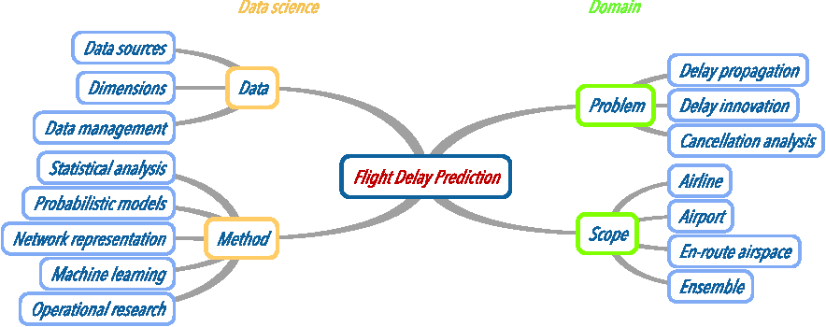

**Ideation and range stroming map :**

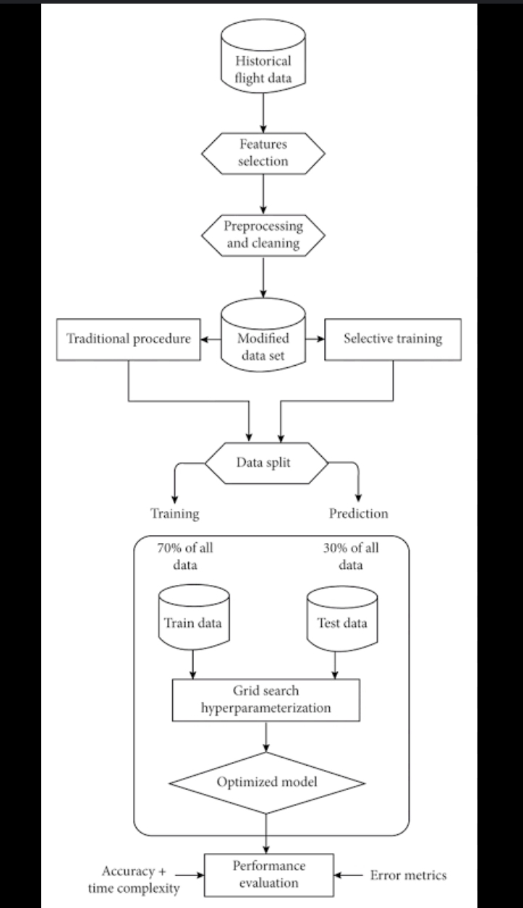

The actual and scheduled departure time is same the flight will be on time. Now giving values as the flight will be get delayed the output will be,

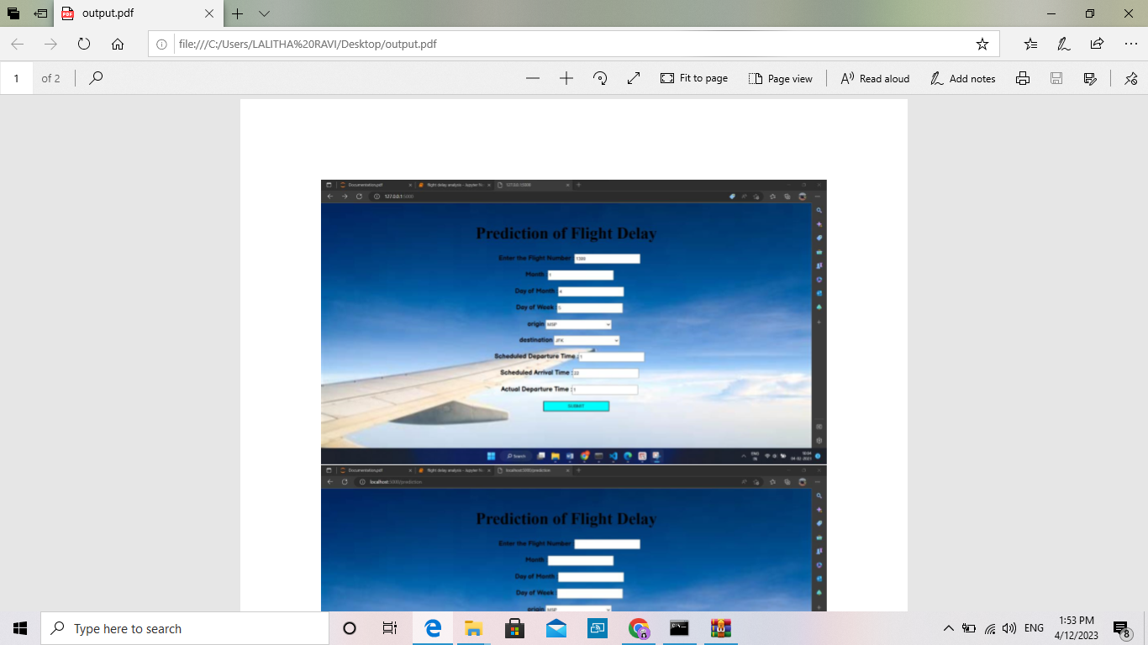



**ADVANTAGES AND DISADVANTAGES**

**Advantage:** Using the flight delay system we can predict whether the flight will departure late when compared to the scheduled departure time.

**Disadvantage:** To use this system we need both scheduled departure time and actual departure time to calculate the delay.

**APPLICATIONS**

This can be applied for customers who wait for confirmation if the flight will arrive or will get delayed through customer service for a long time. Customers will get to know their answer pretty quick also.

**CONCLUSION**

Following this project, it is likely that the choice of approaches that can be utilised to produce notable results will be heavily influenced by the dataset's balance. Many machine learning models, such as Decision Tree Classifier, have been used to predict airplane arrival and delays. We were able to acquire a quick answer about the flight status thanks to IBM Cloud and the Flask application.

**FUTURE SCOPE**

Many machine learning models can be used to forecast airline arrival delays, including Logistic Regression, Random Forest Regression, Linear Regression, and its variation Boosted Linear Regression. Even these algorithms will be able to forecast delays with excellent accuracy when given the proper combination of input parameters. We can forecast arrival delay even without including departure delay as an attribute if weather and air traffic control information are made available. We can also estimate whether a flight will be delayed or cancelled depending on weather elements such as snow, rain, or storms.

**APPENDIX**

**Source code:**

**Jupyter notebook**