Data Types:
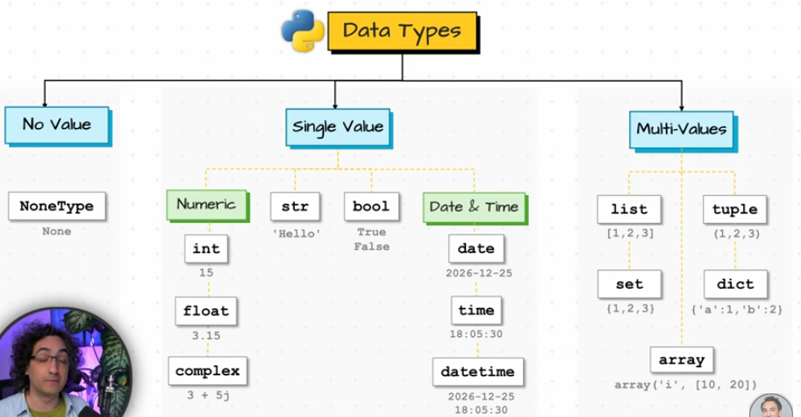
Int
Float
String
Boolean-True,False
None-means no value,nothing or unknown.Used to show the absence of any data.(Blank “” is a string value with no characters inside,it is not same as none)
Functions and Methods:
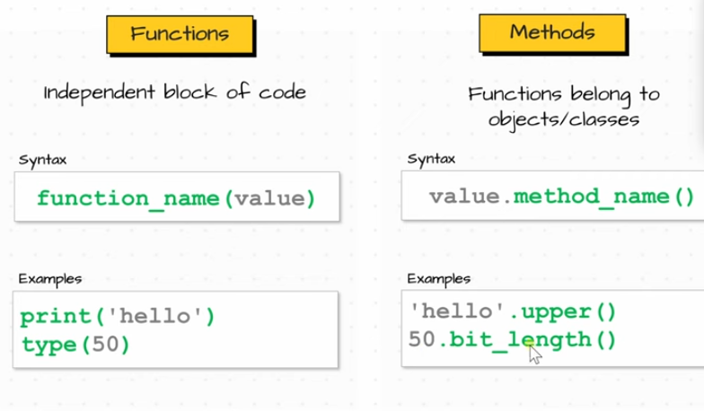
Variable:
-they make updates super easy.One change updates everything.
NOTE:Python executes the code line by line.

Operator Precedence and Associativity:
Precedence | Operator | Associativity
Highest | () | Left → Right
 | ** | Right → Left
 | * / // % | Left → Right
 | + - | Left → Right
 | < <= > >= == != | Left → Right
 | not | Right → Left
 | and | Left → Right
Lowest | or | Left → Right

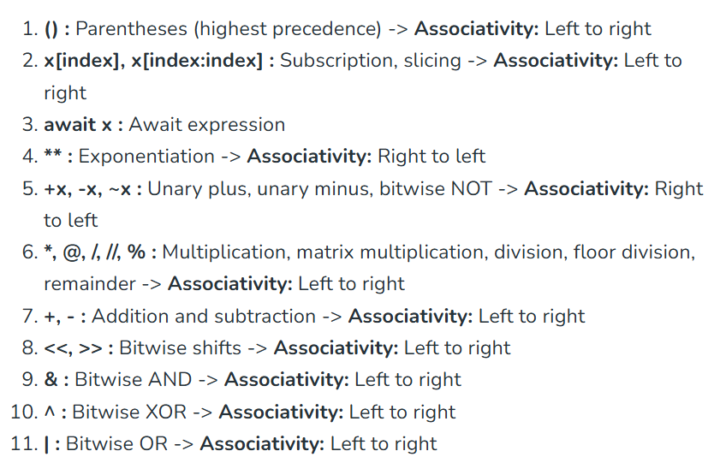
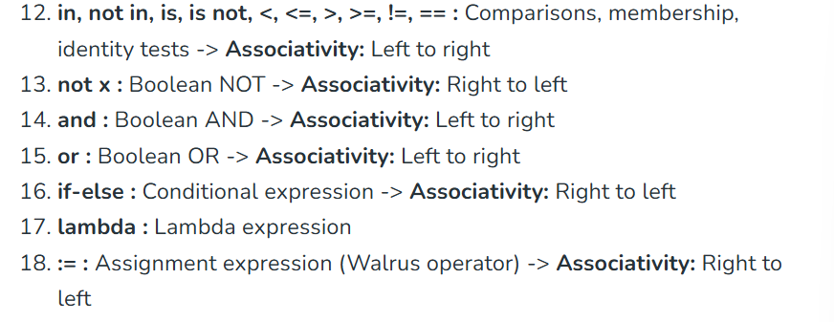
String Functions:
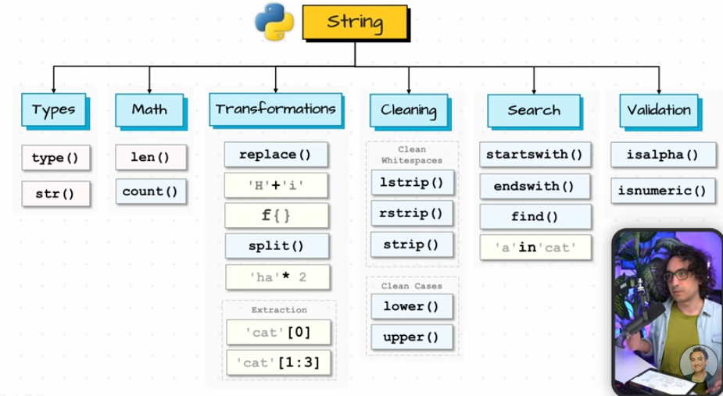
type(value)-returns the data type of a value,so you know what kind of object it is.
Str(value)-converts any value into string value.
len(value)-returns the number of characters in a string.
count(substring)-returns how often a word appears in the string.
Eg:
A=”””
Python is easy to learn.
Python is powerful.
Many people love python.
“””
Print(A.count(“Python”))
op:
2
Note: python is case sensitive
replace(old,new)-swaps part of the text with something new
eg:
price=”1234,56”
print(price.replace(“,”,”.”))
op:
1234.56
‘string’+’string’-joins two string into one.
f string-used for formatting.Used to put expressions directly inside the string.
Eg1:
name=”Swetha”
age=21
is_student=False
print(“My name is “ + name + “.I am “ + age + “years old and my student status is “ + is_student + “.”)
print(f”My name is {name}.I am {age} years old and my student status is {is_student}.”)
Eg2:
Print(f”2+3={2+3}”)
op:
2+3=5
Eg3:
print(f”{This is me}) #error
Print(f”{{This is me}}) #{This is me}
split(separator)-breaks a string into smaller parts.
‘string’*number-repeats the string multiple times.
Indexing & Slicing-[start:end]
[start:end:step]
lstrip(),rstrip(),strip()-removes spaces
Another use case:
Eg:
text=”###ABC###”
Print(text.strip(“#”))
op:
ABC
lower(),upper()-
eg:
a=”swetha”
print(a.upper())
startswith(substring)-checks if the string begin with a specific word.Returns true or false.
endswith(substring)-checks if the string end with a specific word.Returns true or false.
‘substring’ in ‘string’-checks if a word exists in the string.Returns true or false.
find(substring)-returns the starting position of a word in the string. Output will be the index of the substring+1.
isalpha()-checks if the string has only letters.
isnumeric()-checks if the string has only numbers.

Data Structure:
-is a way of organizing and storing data so it van be used efficiently.
Types:
- List
- Tuple
- Set
- Dictionary
List:
-A list an ordered collection of items.
-mutables
-allows duplicates
-indexed
Create:
letters=[‘a’,’b’,’c’]
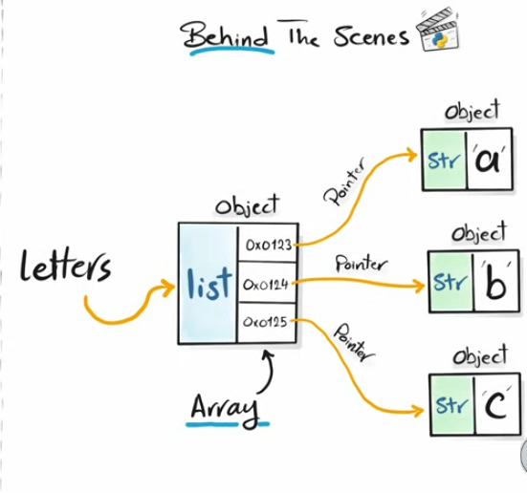
Mixed=[1,’a’,True,None]
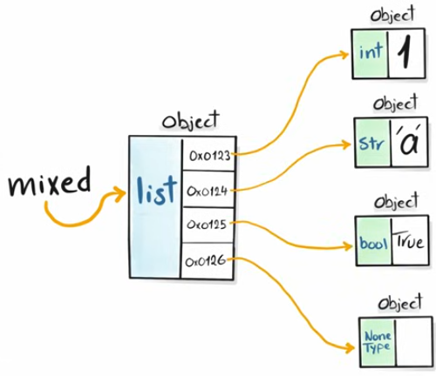
list():
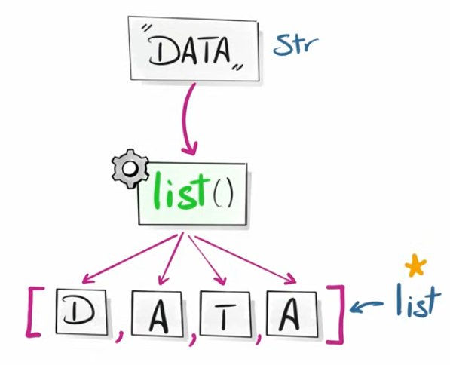
str=’DATA’
print(list(str))
eg:
numbers=list(range(5))
print(numbers)
op:
[0,1,2,3,4]
Nested List:
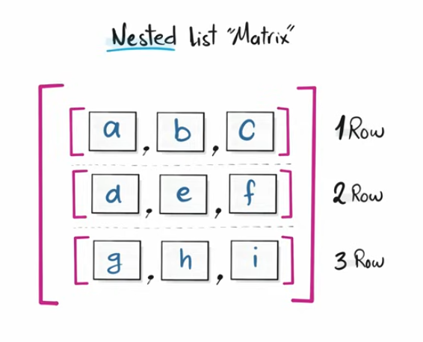
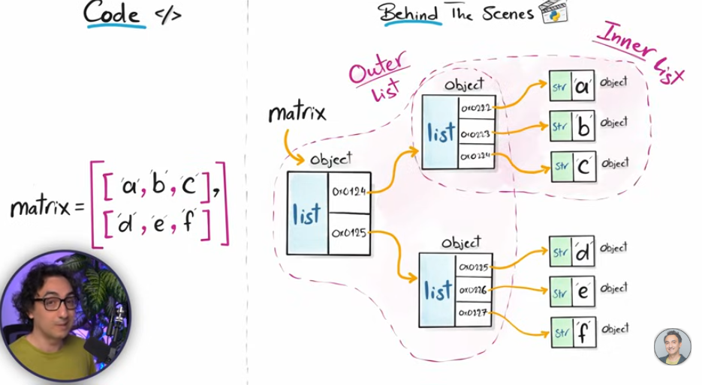
Eg:
matrix=[[‘a’,’b’,’c’],[‘d’,’e’,’f’]]
Print(matrix)
op:
[[‘a’,’b’,’c’],[‘d’,’e’,’f’]]
Access & Read List:
Eg:
Lst=[‘a’,’b’,’c’,’d’]
print(lst[0]) # a
print(lst[-1]) # d
print(lst[-2]) # c
print(lst[:2]) # [‘a’,’b’]
print(lst[2:]) # [‘c’,’d’]
print(lst[:]) # [‘a’,’b’,‘c’,’d’]
Access & Read Nested List:
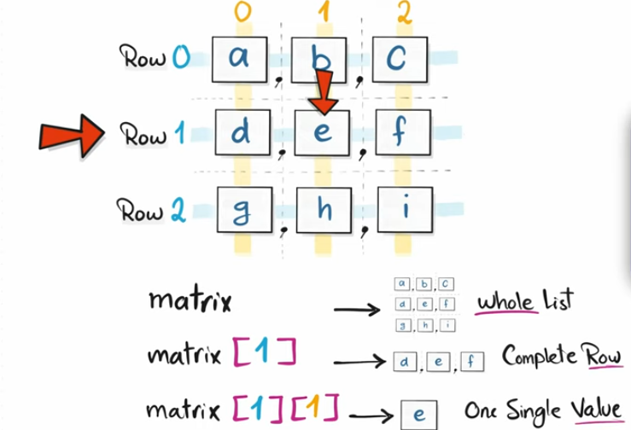
print(matrix[:2]) #[[‘a’,’b’,’c’],[‘d’,’e’,’f’]]
print(matrix[2][:2]) # [‘g’,’h’]
Unpacking List:
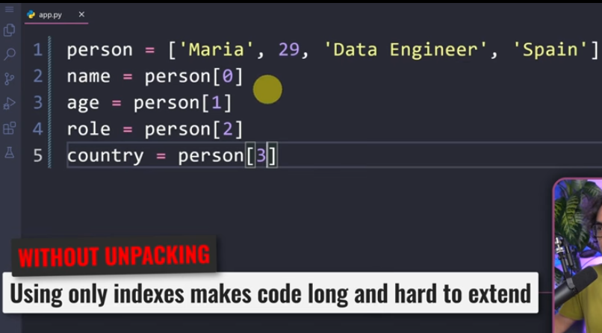
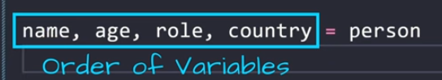
Asterisk:
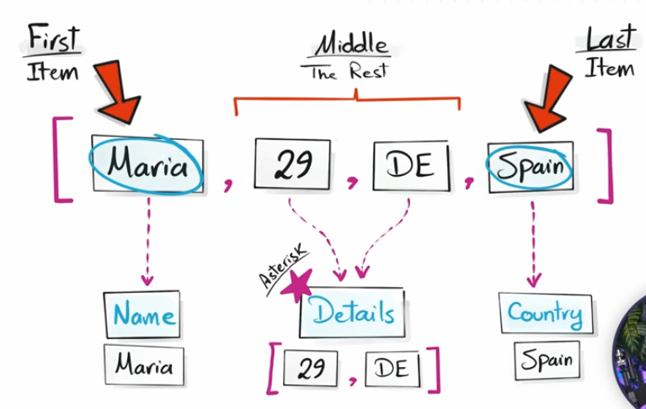
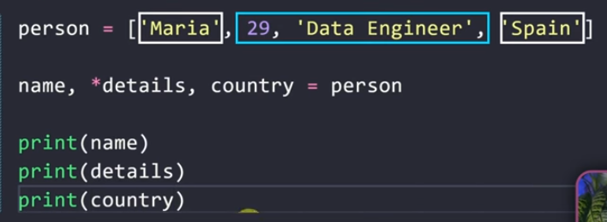
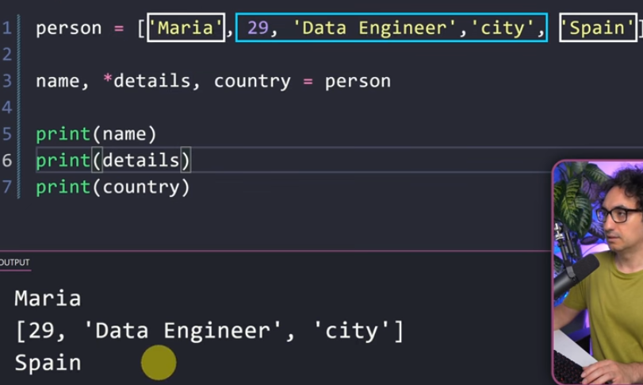
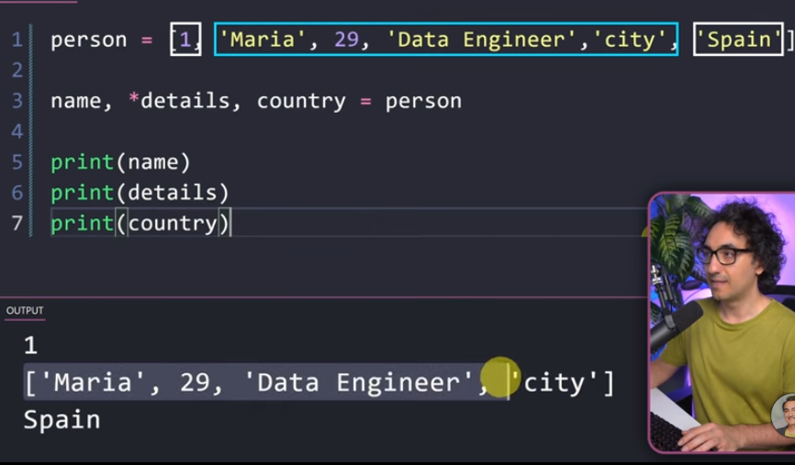
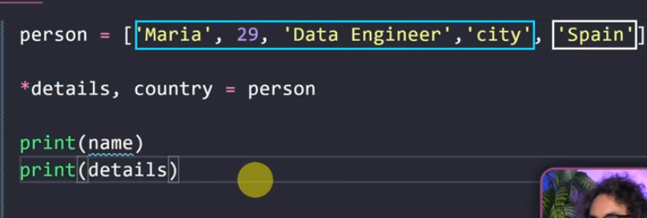
Note:Only one asterisk is allowed in unpacking
Underscore:
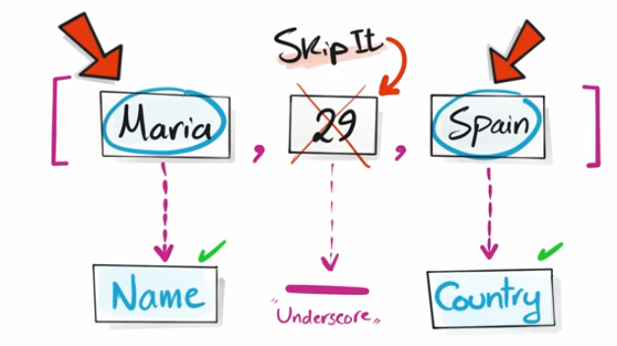
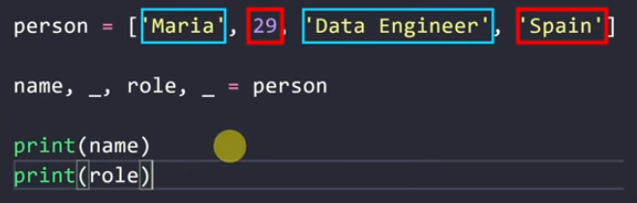
Explore & Analyze Lists:
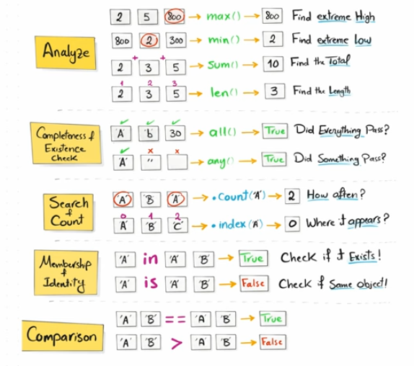
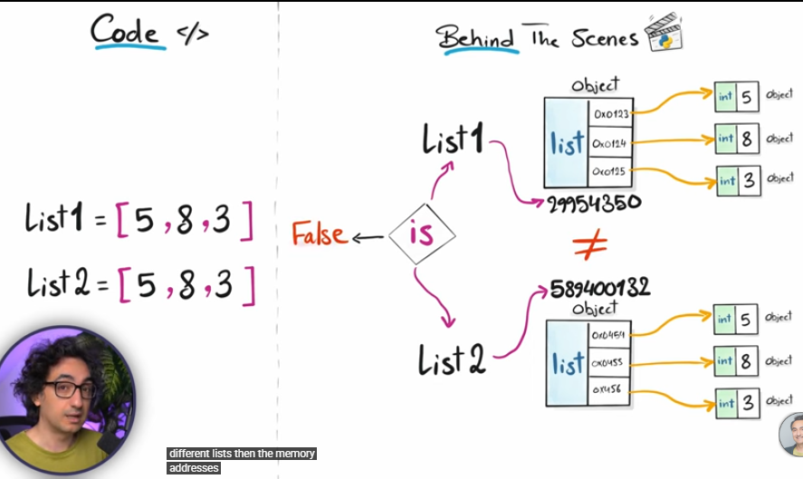
append():
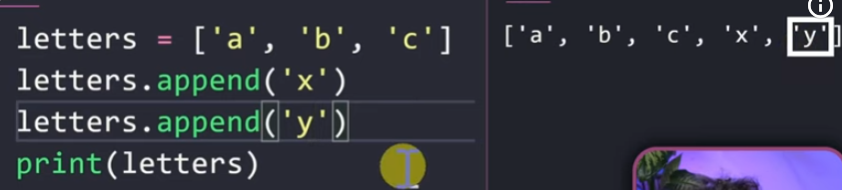
insert():
-insert at specific position.
.insert(index,value)
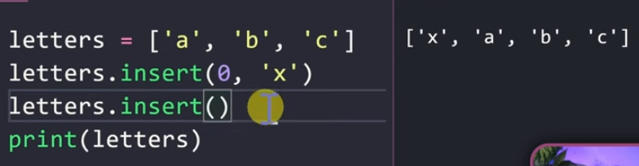
Adding in Nested List Matrix:
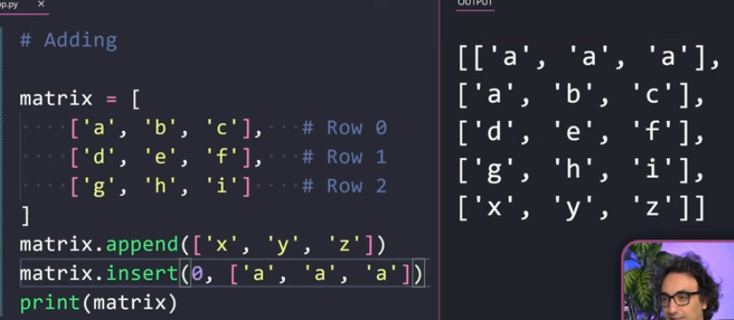
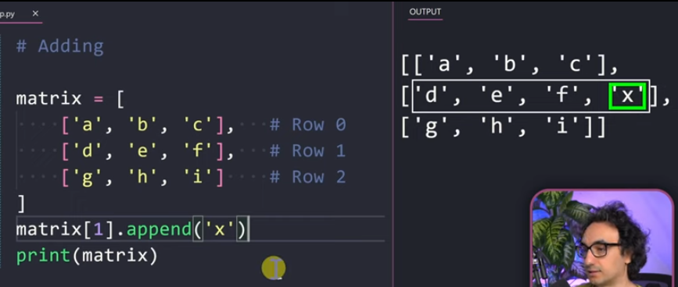
Remove Items:
.clear() Removes everything
.remove() deletes by values.But it only deletes the first match.
.pop() deletes by position.
-It removes and return the deleted item.
-By default it removes the last item.
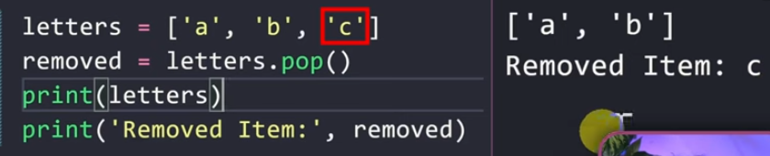
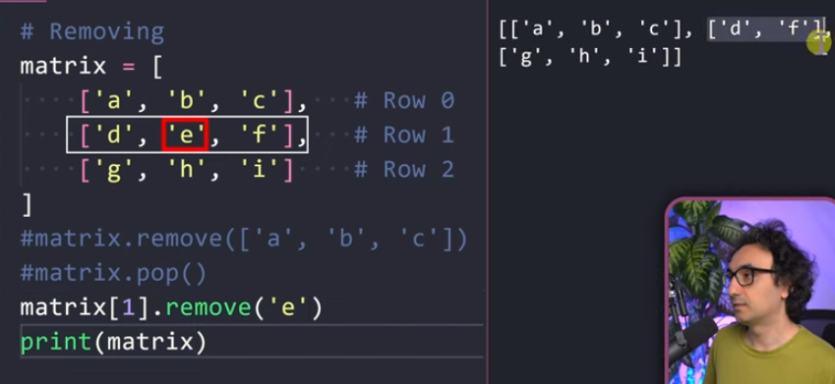
Update:
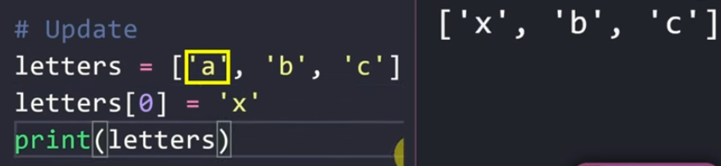
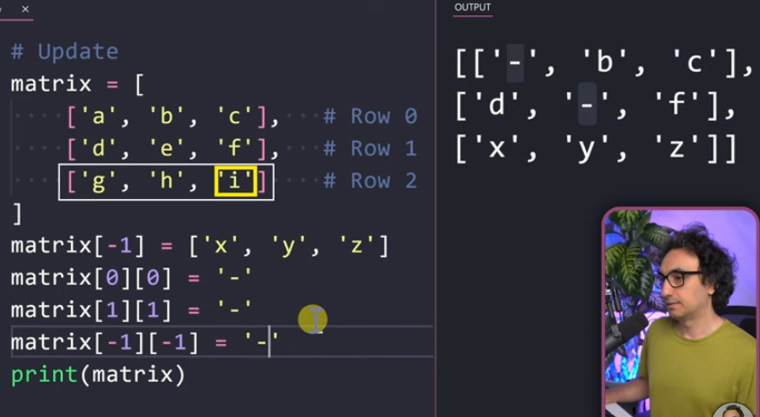
Sort:
.sort() Ascending order
.sort(reverse=True) Descending order
In nested list:
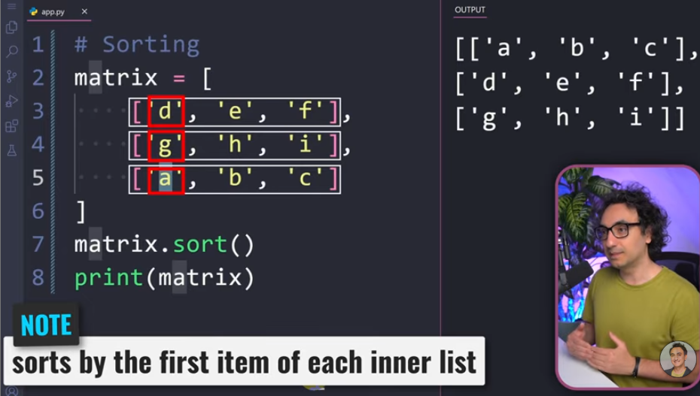
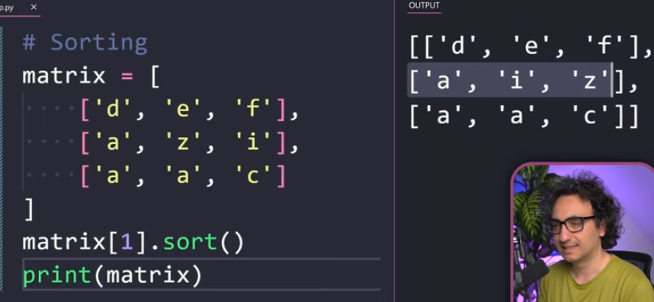
Sorted:
-sort the data without changing the original list.
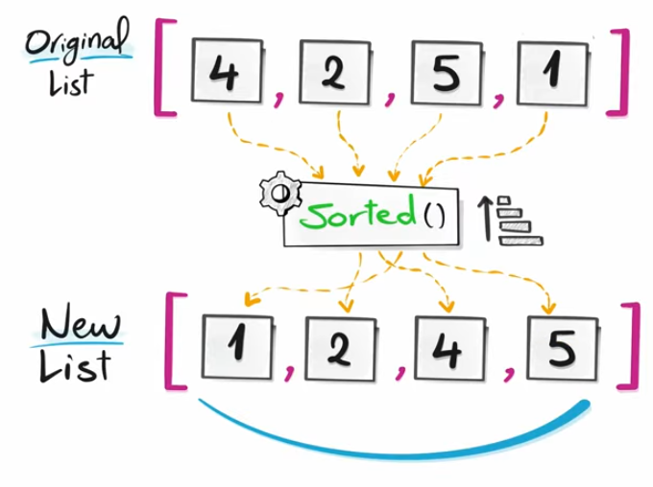
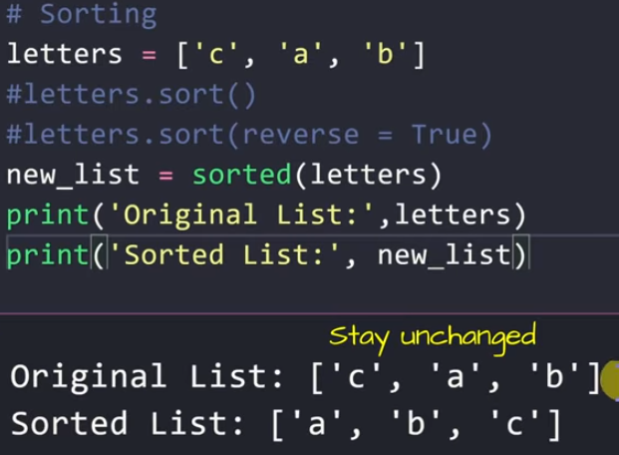
Reverse:
.reverse()
Reversed:
-Doesn’t change the original list.
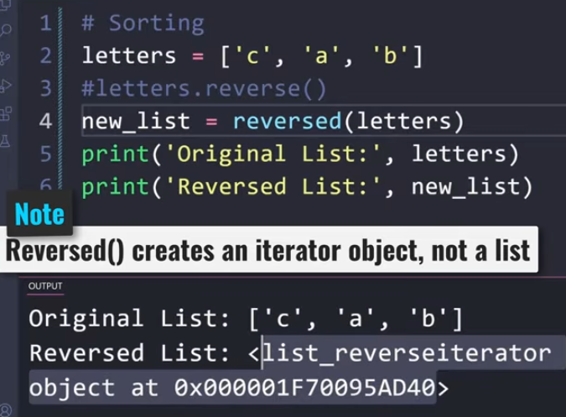
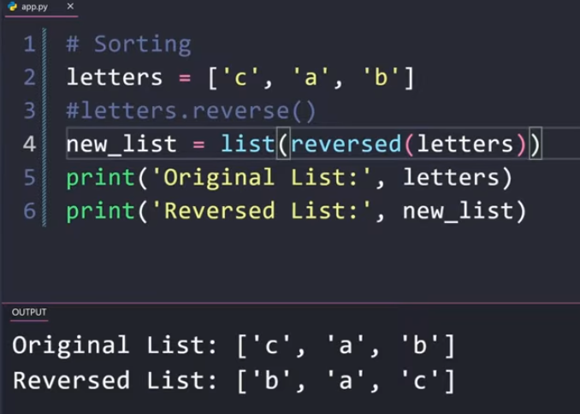
Copying List:
Assignment:
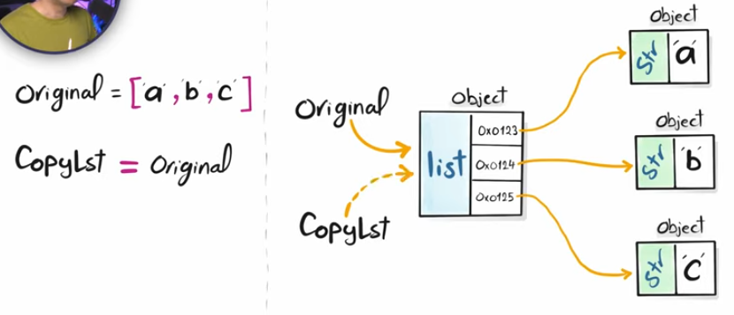
If original list updated,then copy list also gets updated.
Shallow Copy:
-When we don’t want the copy list to be affected by the original list.
-Creates a separate list in memory.
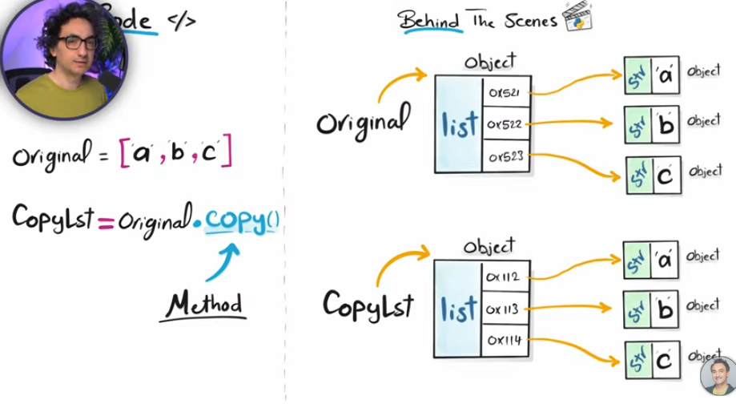
Deep Copy:
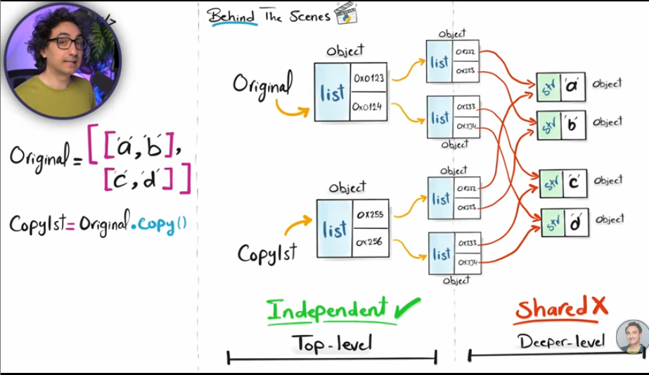In the nested list.
So here we have problem with using shallow copy in the nested list.
So we use deepcopy() from copy module.
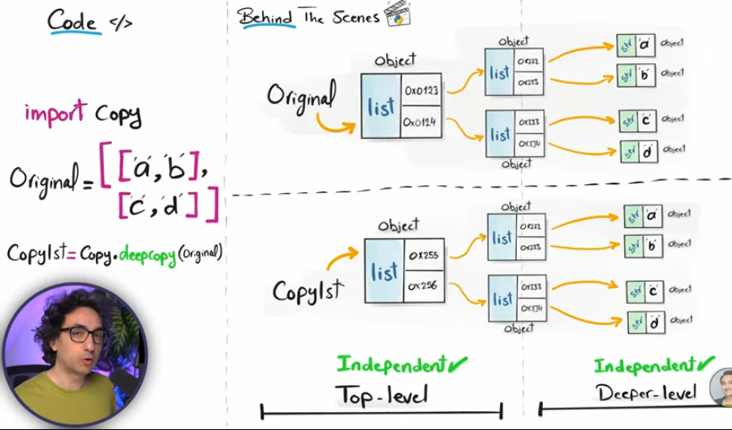
Combining Lists:
-using + operator.
-we can multiply a list
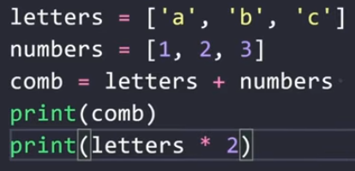
extend():
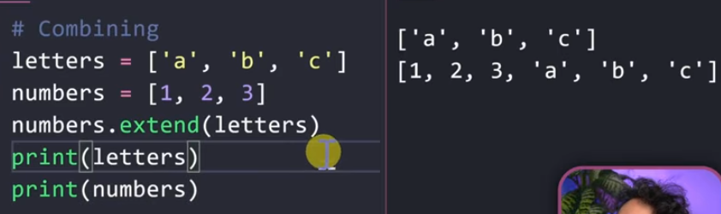
zip():
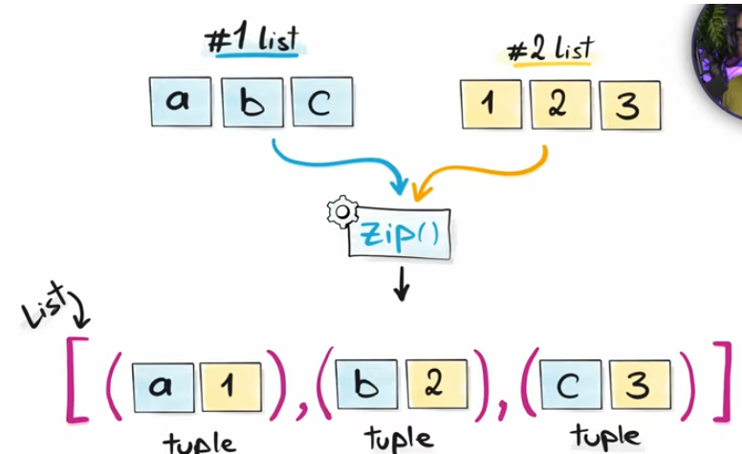

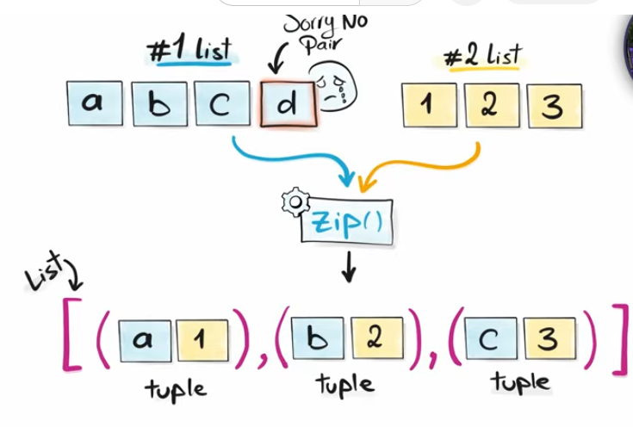
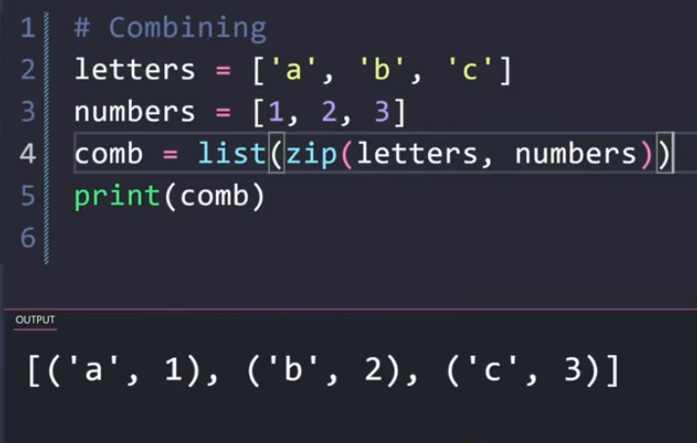
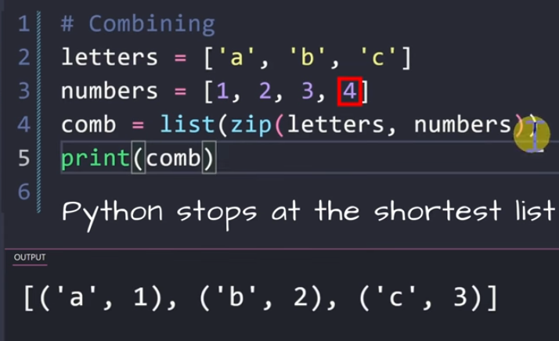
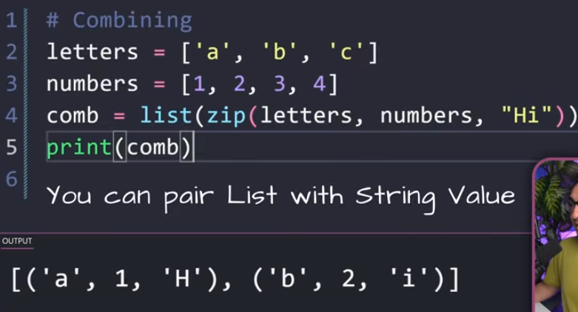
Iterators & Iterables:
(i)For Loop:
Letters=[‘a’,’b’,’c’]
for l in letters:
Print(l)
op:
a
b
c
Enumerate:
-It will take the iterable and return both the value and its position.
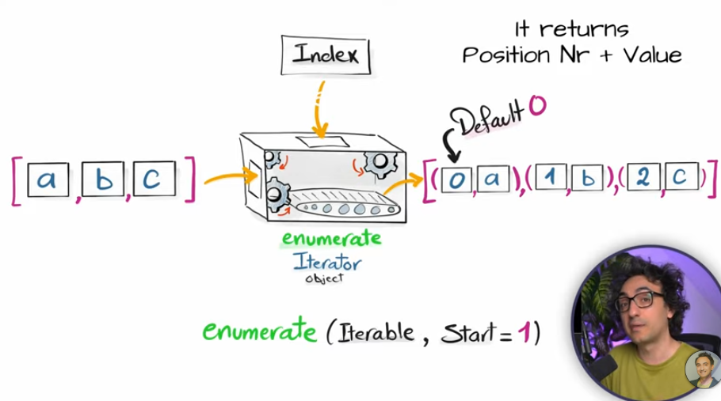
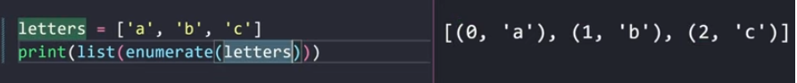
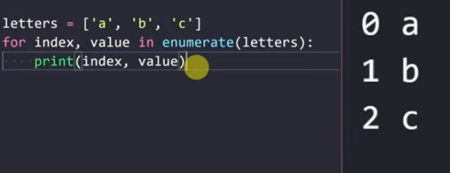
Reversed:
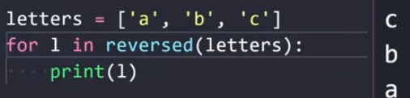
Zip:
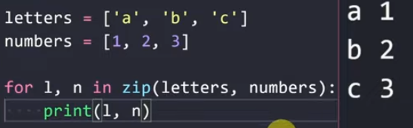
(ii)map():
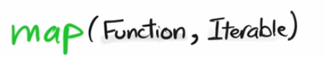
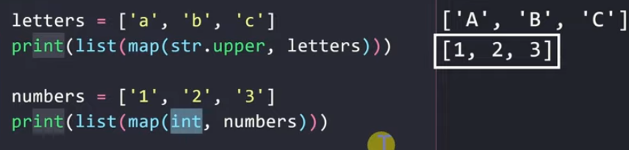
(iii)Filter:
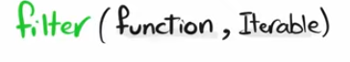
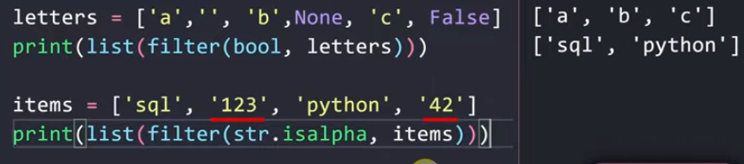
Lambda Functions:
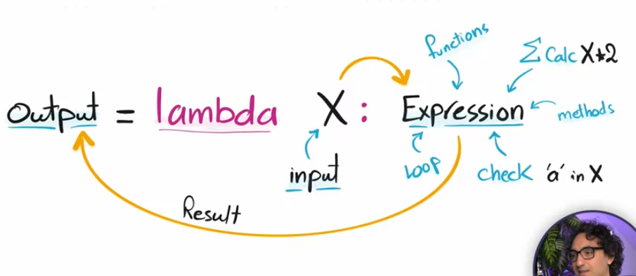
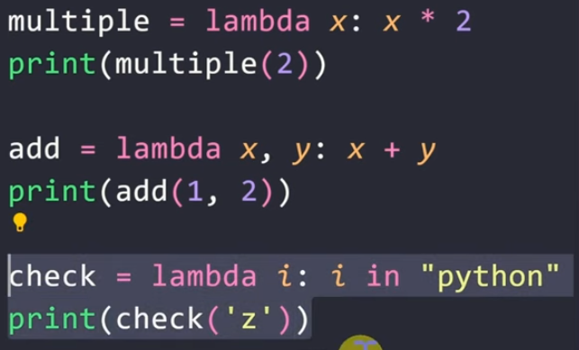
List Comprehension:
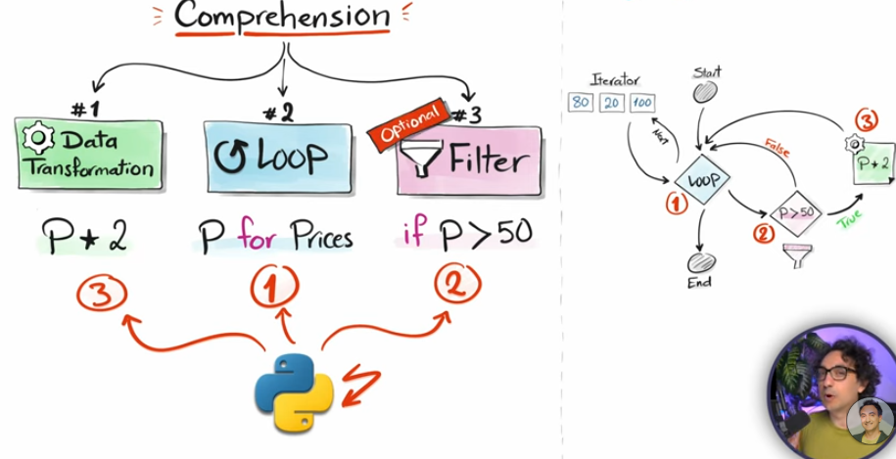
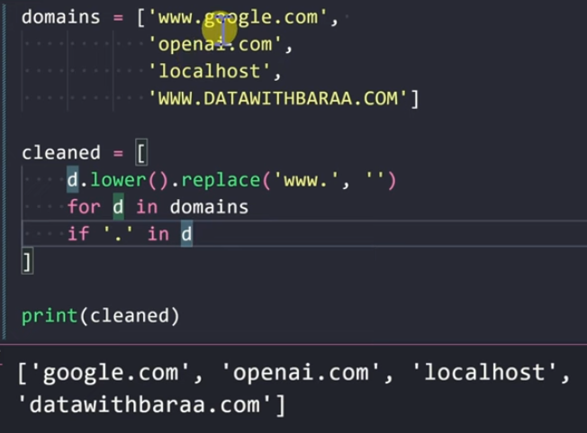
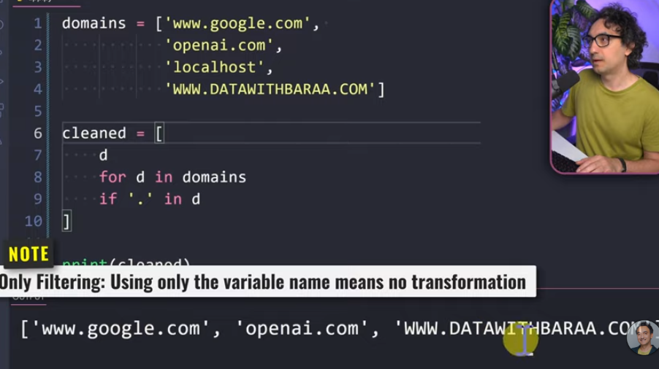
Tuple:
-same as list but it is immutable.
-Tuple is ordered
-Allow duplicates
Set:
-unordered collection of unique values
-they don’t allow duplicates.Python doesn’t throw error if we have duplicates in the set but it simply removes it while printing.
-set is not indexed
-set is mutable
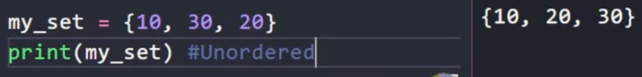
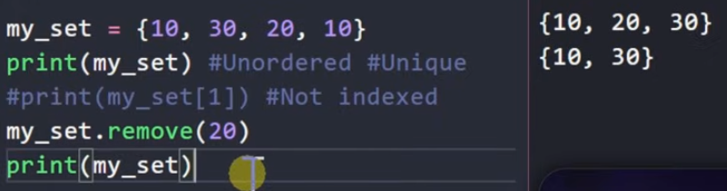
Set Methods:
add():
-inserts the item somewhere in the set,but only if it is new.
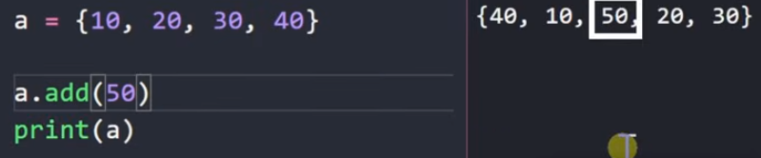
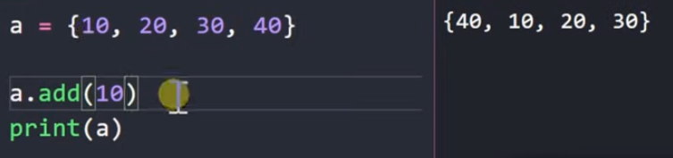
update():
-merges another group of values into the set.
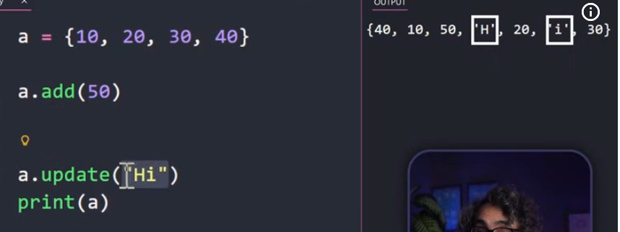
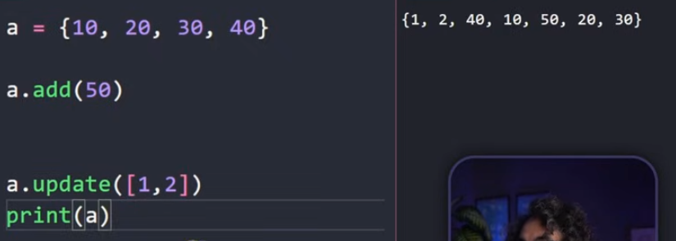

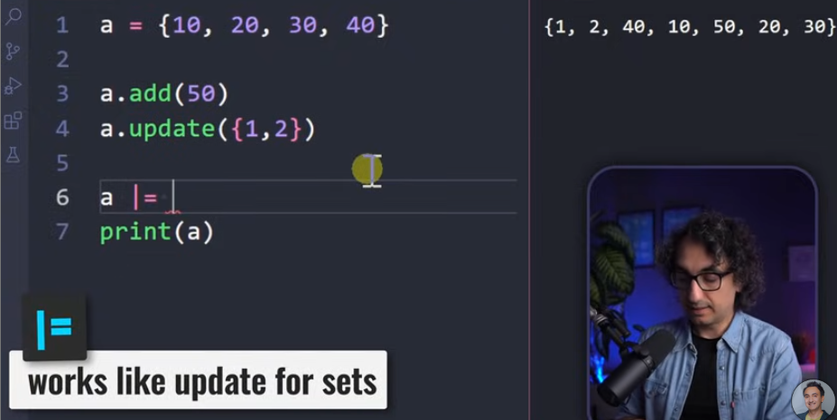
.remove():
.remove()
-throws an error if the value we are trying to remove is not present in the set.
.discard():
-removes the item if it exists and does nothing if it does not.
.pop():
-it removes and returns a random item from a set.
Eg:
a.pop()
.union() or |:
-combines all unique items from both sets.
-these operators return a new set and leave the original untouched.
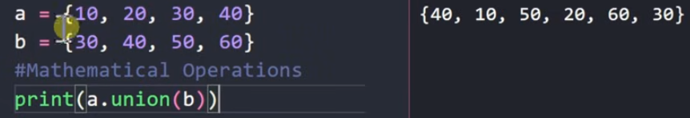
.intersections() or &:
-return only shared items.
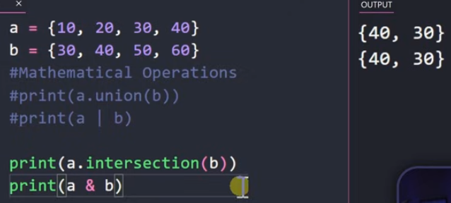
.difference() or -:
-returns items in A but not in B.
.symmetric_difference() or ^:
-only non shared items.
.issubset():
-returns true if all items in this set exist in the other.
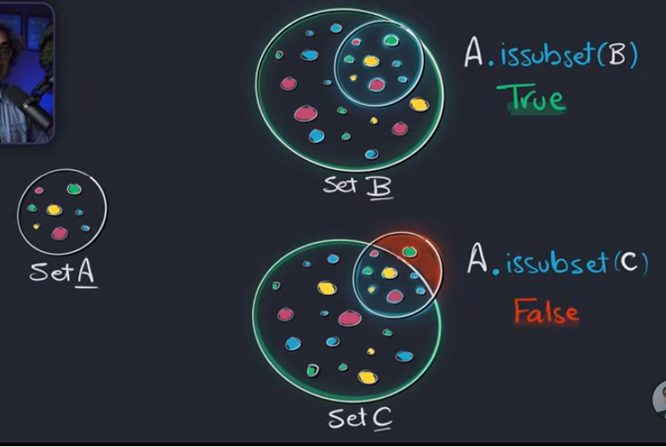
.issuperset():
-returns true when it includes all items of the other set.
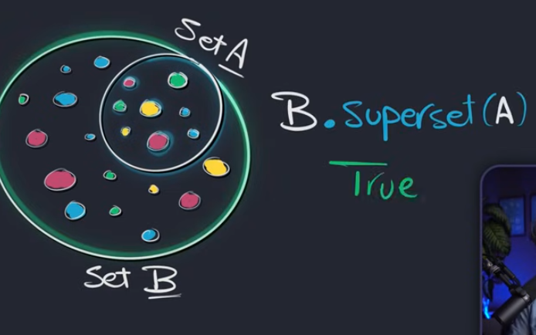
.isdisjoint():
-returns true if both sets share no items.
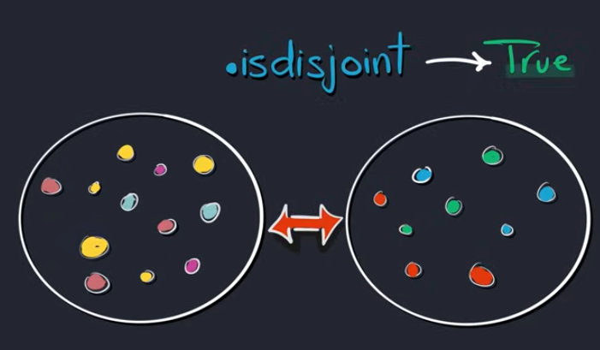
Dictionary:
-key value pairs
-they are ordered
-doesn’t allow duplicates for keys.Keys must be unique.Allows duplicates in values.
-it is not indexed.Access individual values using keys.
-they are mutable
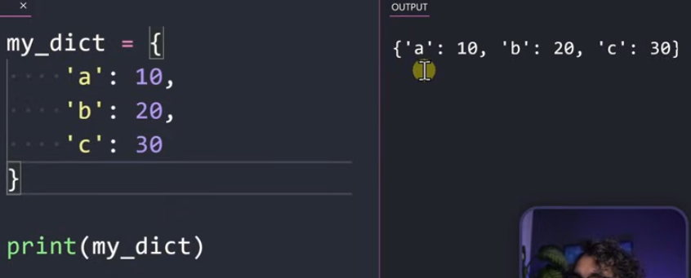
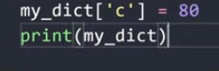
Dictionary Methods:
.get():
-returns the value,if not returns none.
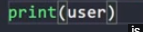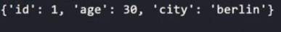
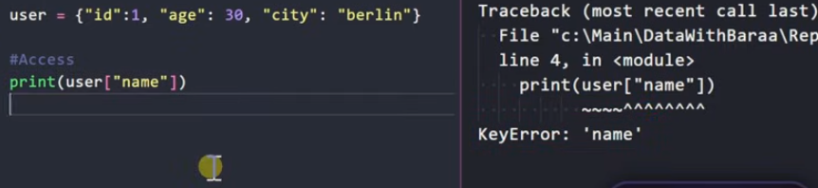
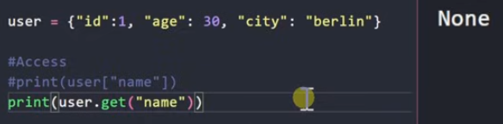
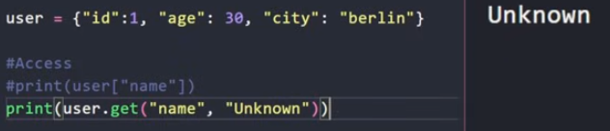
in operator:
-tests if the key is inside the dictionary.
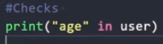
keys():
-returns all the keys in your dictionary
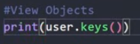
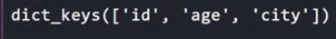
values():
-returns all the values in your dictionary.
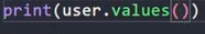
items():
-returns all pairs(key,value) of your dictionary.
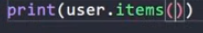
Looping:
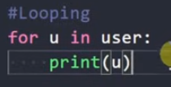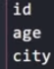
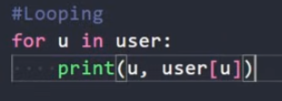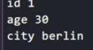
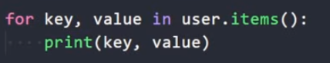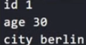
Add,Remove & Update:
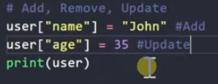
-update() adds new keys and updates existing ones using another dictionary.
-pop() removes a key from the dictionary and returns its value.
-popitem() returns and deletes the most recent key value pair from the dictionary.
-fromkeys() builds a new dictionary where all keys get the same default value.
Dictionary Comprehension:
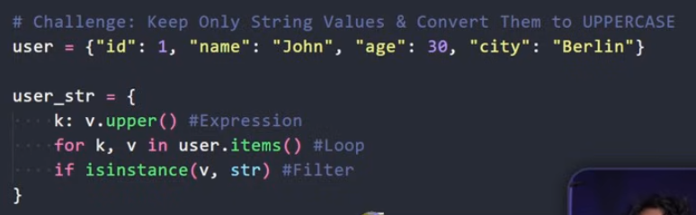
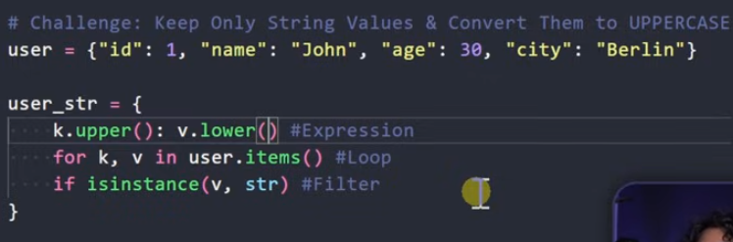
List vs Tuple vs Set vs Dictionary:
