PORTFOLIO
showcase my best work, demonstrating my skills, problem-solving abilities, and business acumen. It includes data analytics projects for portfolio that highlight my analytical process, technical proficiency in tools like Python, R, SQL, and Tableau, and real-world problems I've solved with data. The portfolio must feature visualizations, clean code, and document methodology that make complex data accessible.
It must serve as a living proof of my capabilities, offering tangible evidence of my value as a data professional that goes beyond what a resume can convey.
By showcasing my data analytics training and projects, I make my skills more impactful and relatable to potential employers.
They need analysts who can convert data into decisions, showcase my fundamental skills, proving my ability to solve problems, and create measurable value.
highlights my unique analytical approach, making me memorable in a competitive job market, my portfolio projects should also open doors to promotions, freelance work, and a stronger professional reputation, transforming me from a candidate to a proven data professional.
CAREER FOUNDRY
JOB ROLES: ANALYTICS
DATA ANALYTICS
READY FRAME WORK
1.Bussiness Metrics and Representative data
2.Focus on Executive Questions
3.showcase your ability to use Analytical Frameworks
4.as well as Data Best Practices
5.90%of my write up is about my insights and my impact.
DON’T MIX ROLES
DATA ENGINEER BUILDS PIPELINES, DATA ANALYST EXTRACT INSIGHTS, DATA SCIENTIST BUILD MODELS. YOUR PROJECT TITLES SHOULD SOUND LIKE ANALYST WORK.
EX: Spotify retention analysis
Ecommerce sales trends
Marketing ROI and Budget analysis

Make sure you reference real business metrics, industry names, company names in the titles of your project. So that it is very clear you are focused on Data Analyst roles.

Your project should focus on 3 main things
1.Insights
2.Recommendations
3.Visualizations
That help a story telling.
GITHUB
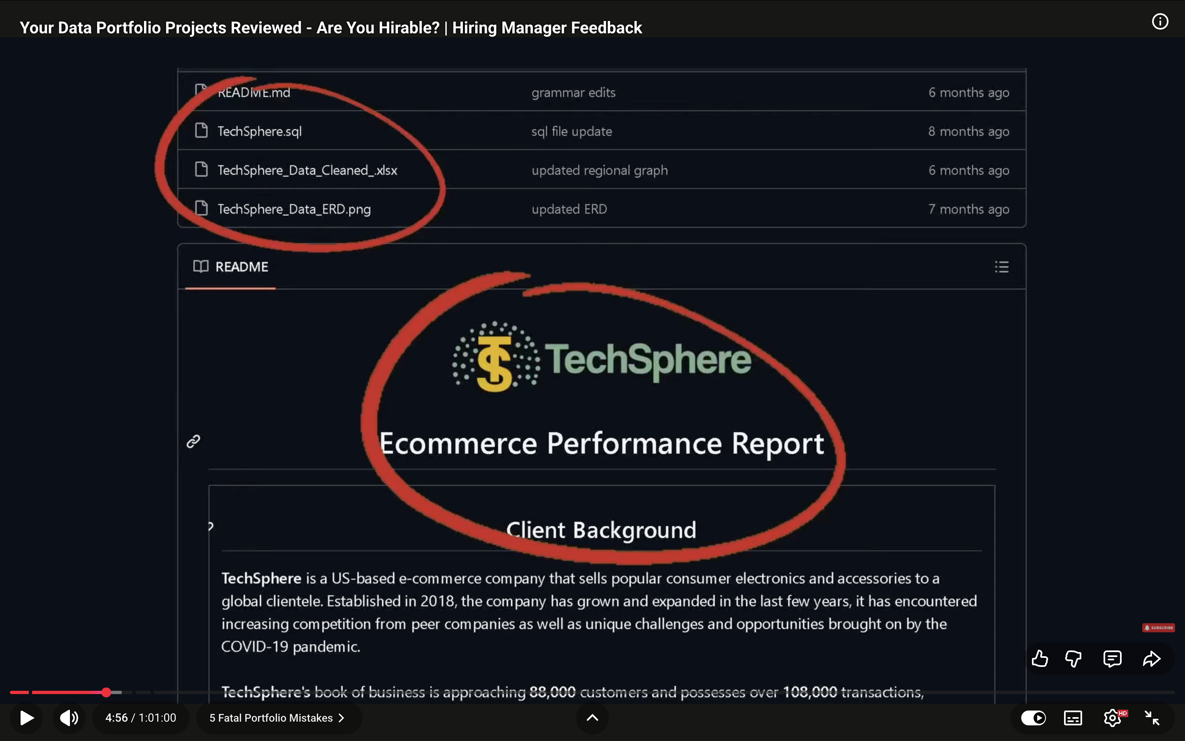
Make sure your projects are framed around the relevant company context.
Ex: Retailer sales analysis, Ticketing Platform sales,
Easily applicable to a wide variety of different industries.
My portfolio should sound like work that a company would actually have me do.

Business Relevance: RATE 5/5
Does it look at metrics, data, Insights that are relevant to company.
Analytical Rigor: 5/5
How much analytical rigor, analytical thinking and technical rigor is behind the project.
Professional Polish:5/5
Does it look clean, sleek, is something I would actually hand to a stakeholder.
Frame your work as if I am working at a sample company.
Example: In this Project we analyze remote work impact on employee wellbeing for company name.
2 pages long of Insights, Findings, Visualizations and recommendations.
Key Metrics and Analysis:
There needs to be context about Why were you looking at these metrics?
What do these metrics mean?
And Who do they actually matter for ?
What stakeholders are interested?
What kinds of business questions were you actually answering?
Business Outcome:
Actionable insights to recommend improvements for employee well-being, including mental health support programs, flexible work policies, and targeted interventions.
Outcome must be on that page.

Presentation: Should be focusing on visualizations and findings,
Screenshot the presentation best visualizations and keep it in the read me.
don’t leave that for someone else to re discover.
For dashboards/visualization:
We never use gradients at work, no to pie charts, we don’t use maps at work and we usually use something that changes over time, we can’t see the trend or like business metrics that move with the map.
Consider Showing something like some graphs that show how these things have changed over time and carry all of that to my other projects as well.
Pick 3 to 4 projects that I want to revamp and keep on the last page on this main page to show to a hiring manager.
ANALYST:
business metrics and values in INSIGHTS, ANALYSIS, FINDINGS, business metrics and values in RECOMMENDATIONS, VISUALIZATIONS.

Look at the Stakeholders, business metrics and deliverables that roles are looking for, and make sure our projects are aligned to that domain.
Keep it simple.
your first project should be most business relevant, most impressive, most analytically rigorous project.
Keep 2 most company relevant projects.
Cohort Analysis
One thing that makes a portfolio stand out was story telling- diverse visualizations used to tell a narrative about what you found in the data.
Data Story telling in the actual visualizations.
Focus on the main insight you discover, the dimension you would slice by, WHAT ARE THOSE INSIGHTS. Tie this all together.
What does this mean, why would someone care right so that would be maybe something more like cost of living is highly related to quality of life, Organizations focus on increasing quality of life.
It should not be just stating these three main aspects right it should be stating one thing that you see in the visualization as a bullet and then we have a dashboard here.

Ecommerce/company name SAS Churn prediction model:
Make sure to be clear with myself about what kinds of roles I am applying to, If I am applying to analyst roles don’t focus on predictive modeling or model results.
Company relevance.
Technical documentation page : pdf for reference that to include in the readme.
Insights:
Use Headers, Formatting and bolding, visualizations to show what that story is/
to highlight key points of the insights.
Back up your story telling with evidence/visualization to help them understand where that is coming from.
There should be graphs here and it should say what that headline is. There would be a graph it might say early stage customers tend to be fragile and then at the bottom there would be a caption that actually includes some metrics and numbers so when you say shorter account ages.
Account ages that were shorter by how much and more likely to churn, what was the churn rate of this group compared to the mid stage customers for example.
Recommendation:
Make it clear that my recommendations come from my insights above, by referencing the numbers from my findings.
Example: focus on retention within the first month, write parenthesis based on seeing early adopters turn with X percent more than adopters that have activity in their first month.
Keep it organized.
SALES PERFORMANCE.
Github:

Read ME Structure:
1. Background and

