DATA WAREHOUSING AND DATA MINING
ANNEXURE A – CASE STUDY ASSESSMENT

Name: SWETHAMBIGAI.S
Register No.: 192565064
Class/Section: CSA1606
Date: 13.08.2026

CASE STUDY 1: Shepherd Boy and the Wolf
Treat “Wolf is present” as the positive condition.
Actual Situation | Prediction/Warning | Result
Wolf is present and villagers respond | Positive | True Positive (TP)
Wolf is absent but boy cries “Wolf!” | Positive | False Positive (FP)
Wolf is present but villagers do not respond | Negative | False Negative (FN)
Wolf is absent and no warning is given | Negative | True Negative (TN)
True Positive (TP): A real wolf is present and the warning is correctly acted upon.
False Positive (FP): No wolf is present, but the boy gives a wolf warning.
False Negative (FN): A real wolf is present, but the villagers ignore the warning.
True Negative (TN): No wolf is present and no false warning is given.
Conclusion: The story demonstrates the consequences of false positives and false negatives. Repeated false-positive warnings reduce trust and can eventually cause a real warning to be treated as negative.

CASE STUDY 2: Cat Image Classification
Given: 100 images; 30 contain a cat and 70 do not. The model correctly predicts a cat in 25 of the 30 cat images and correctly predicts no cat in 50 of the 70 non-cat images.
Actual / Predicted | Cat | No Cat
Cat | TP = 25 | FN = 5
No Cat | FP = 20 | TN = 50
TP = 25
FN = 30 − 25 = 5
TN = 50
FP = 70 − 50 = 20
Precision = TP / (TP + FP) = 25 / (25 + 20) = 0.5556 = 55.56%
Recall = TP / (TP + FN) = 25 / (25 + 5) = 0.8333 = 83.33%
F1 Score = 2 × Precision × Recall / (Precision + Recall) ≈ 0.6667 = 66.67%
Measure | Result
TP | 25
FP | 20
FN | 5
TN | 50
Precision | 55.56%
Recall | 83.33%
F1 Score | 66.67%

CASE STUDY 3: Email Spam Classification Using Naïve Bayes
Features: Offer (Yes/No), Free (Yes/No), Email Length (Short/Long).
No. | Offer | Free | Length | Class
1 | Yes | Yes | Short | Spam
2 | Yes | No | Long | Not Spam
3 | No | Yes | Short | Spam
4 | No | No | Long | Not Spam
5 | Yes | Yes | Long | Spam
6 | No | No | Short | Not Spam

1. Prior Probabilities
There are 3 Spam and 3 Not Spam emails out of 6.
P(Spam) = 3/6 = 0.5
P(Not Spam) = 3/6 = 0.5

2. Conditional Probabilities

Feature | Condition | Spam | Not Spam
Offer | Yes | 2/3 | 1/3
Offer | No | 1/3 | 2/3
Free | Yes | 3/3 = 1 | 0/3 = 0
Free | No | 0/3 = 0 | 3/3 = 1
Length | Short | 2/3 | 1/3
Length | Long | 1/3 | 2/3

3. Naïve Bayes Classification
Test email: Offer = Yes, Free = No, Length = Short
For Spam:
P(Spam | Features) ∝ 0.5 × (2/3) × 0 × (2/3) = 0
For Not Spam:
P(Not Spam | Features) ∝ 0.5 × (1/3) × 1 × (1/3) = 1/18 ≈ 0.0556
Therefore, the email is classified as NOT SPAM.
Note: The zero probability occurs because the training data contains no Spam email with Free = No. Laplace smoothing can be used to avoid this zero-frequency problem.

4. Comparison Using WEKA
The dataset can be loaded into WEKA Explorer and classified using the NaiveBayes classifier. The WEKA result should be compared with the manual result above.

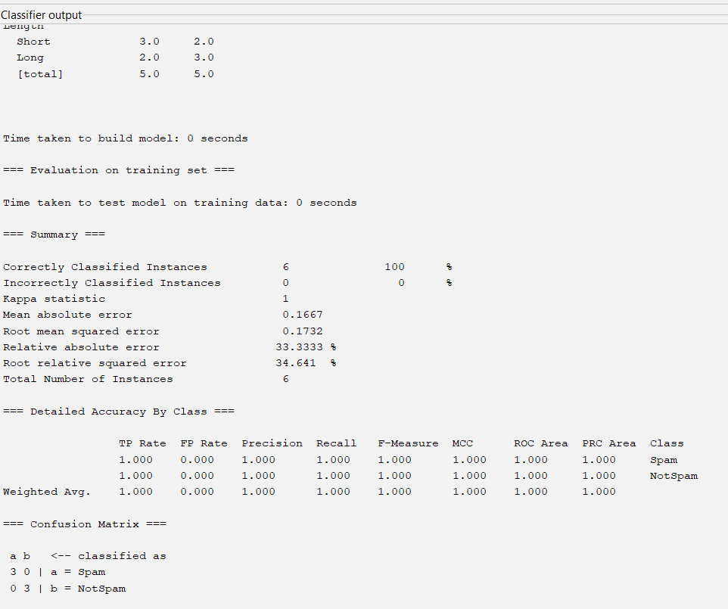

5. Independence Assumption in Naïve Bayes
Naïve Bayes assumes that the features are conditionally independent given the class. For example, when classifying an email as Spam, it assumes that the presence of “Offer” is independent of the presence of “Free” once the class is known.
The assumption simplifies calculations and makes Naïve Bayes computationally efficient. In real-world email data, the features may not be completely independent. For example, promotional emails containing “Offer” may also be more likely to contain “Free”. Even so, Naïve Bayes can perform well in many classification tasks.

OVERALL CONCLUSION
These case studies demonstrate confusion matrix concepts, classification performance measures, and the Naïve Bayes classification algorithm. The cat classification example gives Precision = 55.56%, Recall = 83.33%, and F1 Score = 66.67%. For the given email features, the manual Naïve Bayes calculation classifies the email as Not Spam. This result can be verified using the NaiveBayes classifier in WEKA.

