SIMATS ENGINEERING
Department of Computer Science and Engineering
DSA01 – Object-Oriented Programming with C++

ASSIGNMENT 4 – CO4
Designing Reusable Class Hierarchies
CO4: Analyse and implement C++ applications using inheritance, virtual base classes, abstract classes, pointers and polymorphism to design reusable and extensible programs, including constructors in derived classes, member classes, pointers to objects, the this pointer and pointers to derived classes.

Student Details | Information | Student Details | Information
Student Name | SWETHAMBIGAI.S | Register Number | 192565064
Department / Programme | B.Tech CSE Cyber Security | Academic Year | 2nd Year
Faculty Name | Amritha | Nature of Assignment | Individual
Duration | 1 Week | Total Marks | 50
Date of Submission | 18.11.2026 | Date of Evaluation
GitHub Repository |  | Course Code | DSA01

MARK SHEET (Rubric-based Evaluation)
Task | Task Title | Max Marks | Marks Awarded | Remarks
1 | Class Design Review | 6
2 | From Requirement to Hierarchy | 8
3 | Constructors in Derived Classes and Member Classes | 9
4 | Pointers to Derived Classes: Forensics | 7
5 | Pointers to Objects and the this Pointer | 7
6 | Vehicle Rental Fleet Design Challenge | 13
 | TOTAL | 50 |  | Percentage:

OVERALL REMARKS
Criteria | Faculty Remarks
Design and implementation
Analysis and evaluation
Execution evidence and GitHub
Viva / verification

SWETHAMBIGAI.S
Student Signature | Faculty Signature | Program Director
SWETHAMBIGAI.S

Declaration and Scope of this Report
This report addresses all six tasks in the supplied Assignment 4 – CO4 brief. The official PDF determines the questions, marks, required code and evidence. The Assignment 1 document is used only as a presentation reference; its metro-fare content is not reused.
All runnable programs included in the submission folder were compiled with g++ 14.2.0 using C++17 and the flags -Wall -Wextra -pedantic. The intentionally defective Task 4 program was separately built with AddressSanitizer; it is expected to demonstrate a non-virtual-destructor deletion defect and a leaked derived allocation. The repaired program uses virtual dispatch, a virtual destructor and unique_ptr ownership.
Terminal figures are rendered from captured stdout/stderr logs of commands executed in this preparation environment. They are genuine captures of those program runs, but are not screenshots from the student’s personal computer. The GitHub link remains a placeholder because publishing to the student’s account requires account authorization and progressive commits must be made by the student.

Contents
- Task 1 – Class Design Review
- Task 2 – From Requirement to Hierarchy
- Task 3 – Constructors in Derived Classes and Member Classes
- Task 4 – Pointers to Derived Classes: Forensics
- Task 5 – Pointers to Objects and the this Pointer
- Task 6 – Vehicle Rental Fleet Design Challenge
- Appendix A – Source Files and Build Instructions
- References

TASK 1 – CLASS DESIGN REVIEW (6 Marks)

1.1 Diagnose the Design (2 marks)
The three payroll classes contain overlapping concepts but do not share a common abstraction. The design creates duplicated state and makes uniform processing difficult.
Deficiency | Why it is a problem | Repair
Repeated fields | Professor and LabAssistant repeat name, id and basic; future changes must be repeated. | Move common identity and basic pay into Staff.
Public data | Any caller can write invalid or inconsistent values without validation. | Use protected/private data and controlled constructors/accessors.
Inconsistent names | name/id versus nm/code describe the same concepts. | Use consistent name and id identifiers in the base class.
Unused da field | The field is stored but ignored by both pay() implementations. | Remove it or explicitly include a documented DA policy.
Magic number 0.42 | The DA percentage is embedded in code and difficult to audit/change. | Use a named constant such as DA_RATE = 0.42.
No common interface | A mixed collection cannot call pay() through one common type. | Introduce virtual pay() and process Staff pointers.
Extension cost | Adding a category requires new duplicated fields and external conditionals. | Add a derived class that overrides pay().

1.2 Repair the Design (3 marks)
Staff is an abstract base class containing the common name, employee ID and basic salary. Professor, LabAssistant and GuestFaculty inherit publicly and implement their own pay() rule. GuestFaculty stores hours and hourly rate because its payment is not based on a monthly basic salary. The DA rule is represented by a named constant rather than the literal 0.42.
constexpr double DA_RATE = 0.42;
class Staff {
protected: std::string name_; int id_; double basic_;
public:
Staff(std::string n, int id, double b);
virtual ~Staff() = default;
virtual double pay() const = 0;
virtual const char* role() const = 0;
};
class Professor : public Staff { double research_;
public: double pay() const override { return basic_ * (1 + DA_RATE) + research_; }
};
class LabAssistant : public Staff {
public: double pay() const override { return basic_ * (1 + DA_RATE); }
};
class GuestFaculty : public Staff { double hours_, rate_;
public: double pay() const override { return hours_ * rate_; }
};
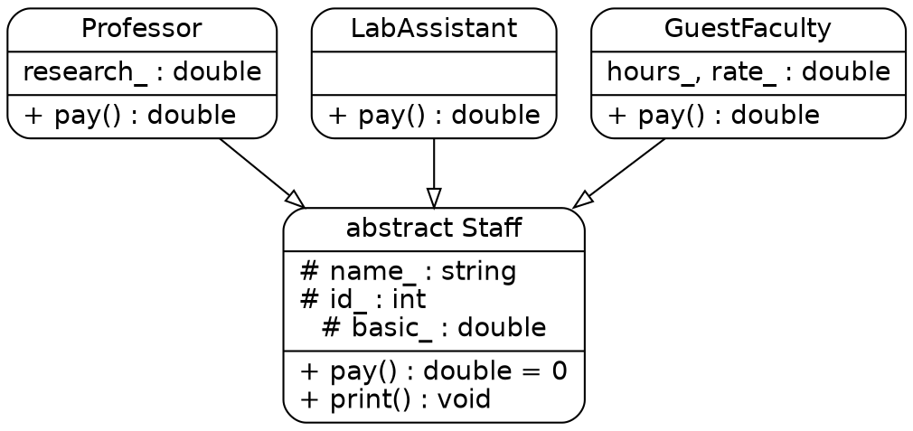
Figure 1. UML-style payroll hierarchy; Staff defines the shared abstraction.
The runnable implementation is Task01/payroll.cpp. It stores heterogeneous staff objects as std::unique_ptr<Staff> and invokes print()/pay() through the base pointer. The virtual destructor ensures safe destruction through the base type.

Figure 2. Captured execution output for the three payroll categories.

1.3 Design Defence (1 mark; under 100 words)
The hierarchy centralises common identity data and exposes one pay() contract. Each staff category owns only the data and calculation specific to it. A new category can be added by deriving from Staff and overriding pay() and role(); the existing payroll loop remains unchanged. This reduces duplicated code and supports runtime polymorphism. The virtual destructor also makes deletion through Staff pointers safe.

Alternative: One Staff Class with a Type and switch
struct StaffRecord {
enum class Type { Professor, LabAssistant, GuestFaculty };
Type type; std::string name; int id; double basic, research, hours, rate;
double pay() const {
switch (type) {
case Type::Professor: return basic * 1.42 + research;
case Type::LabAssistant: return basic * 1.42;
case Type::GuestFaculty: return hours * rate;
} return 0;
}
};

Measure | Derived hierarchy | Single class + switch
Time per pay() | O(1); virtual dispatch has constant overhead. | O(1); switch has a bounded number of branches.
Space per object | Only shared fields plus category-specific fields. | All category fields exist in every object, including unused fields.
Add a new type | Add one derived class; payroll loop is unchanged. | Edit enum, switch, structure fields and likely validation/tests.
Type safety | Compiler enforces implementation of pure virtual methods. | Invalid or unhandled type values are possible.

For a fixed set of categories both pay() approaches are O(1). The hierarchy is preferable when categories are expected to grow independently. The switch design can be acceptable for a small, closed set of types.

TASK 2 – FROM REQUIREMENT TO HIERARCHY (8 Marks)

2.1 Identify the Relationships (2 marks)
Person is the common identity entity. Student and Staff are both kinds of Person, so each is-a relationship is public virtual inheritance. TeachingAssistant is both a Student and a Staff member, so it uses multiple inheritance. ResearchScholar is a specialised Student with fellowship information, giving multilevel inheritance. The overall model is hybrid because it combines hierarchical, multiple and multilevel inheritance.
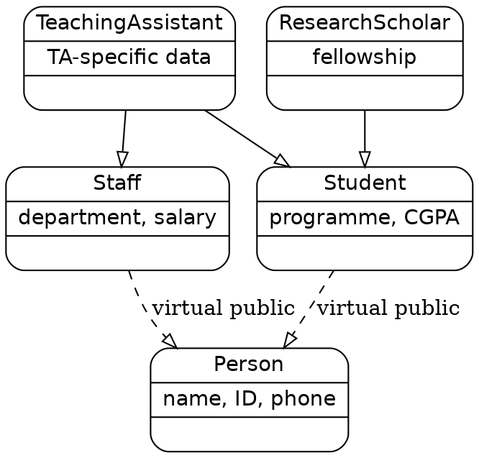
Figure 3. University people hierarchy with one shared virtual Person base.

Relationship | Kind | Inheritance type / reason
Student → Person | is-a | Public virtual; a student is a person and shares one Person subobject in the diamond.
Staff → Person | is-a | Public virtual; a staff member is a person.
TeachingAssistant → Student and Staff | is-a | Multiple inheritance; a teaching assistant has both roles.
ResearchScholar → Student | is-a | Single inheritance; scholar specialises student (multilevel chain from Person).
Person has Address | has-a | Composition; Address is a member object owned by Person.
Student has Course | has-a | Composition; Course is a member object owned by Student.

2.2 Resolve the Diamond (2 marks)
Without virtual inheritance, TeachingAssistant contains one Person subobject through Student and a second Person subobject through Staff. A member such as name becomes ambiguous because the compiler cannot determine which Person::name is intended. With public virtual inheritance, Student and Staff share one virtual Person base subobject in the most-derived TeachingAssistant. The most-derived constructor is responsible for initialising that shared virtual base.
struct Student : virtual Person { /* ... */ };
struct Staff : virtual Person { /* ... */ };
struct TeachingAssistant : Student, Staff { /* one Person subobject */ };

2.3 Design the Classes (3 marks)
class Person {
protected: std::string name_; int id_; std::string phone_; Address address_;
public: Person(std::string, int, std::string, Address);
};
class Student : public virtual Person {
protected: std::string programme_; double cgpa_; Course course_;
public: Student(...);
};
class Staff : public virtual Person {
protected: std::string department_; double salary_;
public: Staff(...);
};
class TeachingAssistant : public Student, public Staff {
public: TeachingAssistant(...); // directly initialises virtual Person
};
class ResearchScholar : public Student {
private: double fellowship_;
};
Public inheritance preserves the public “is-a” interface. Protected or private inheritance would hide or alter the public Person interface and is not appropriate for these domain relationships. Member classes such as Address and Course are composed by value, giving clear ownership and automatic destruction.

2.4 Access Table (1 mark)
Person member | public inheritance in Student | protected inheritance | private inheritance
public | public | protected | private
protected | protected | protected | private
private | not directly accessible | not directly accessible | not directly accessible

Predict the Output – Virtual Diamond
Prediction written before execution:
Person Student Staff TA
The virtual base Person is constructed once before the non-virtual direct bases Student and Staff. The TeachingAssistant constructor body runs last. The captured execution matches the prediction.
Figure 4. Virtual diamond output.

Remove virtual and verify
Prediction: Person Student Person Staff TA. Each intermediate base constructs its own Person subobject. The output confirms two Person constructor calls. Accessing ta.id is ambiguous because two inherited Person::id candidates exist; the compiler diagnostic is included in the evidence folder.
Figure 5. Non-virtual diamond output.
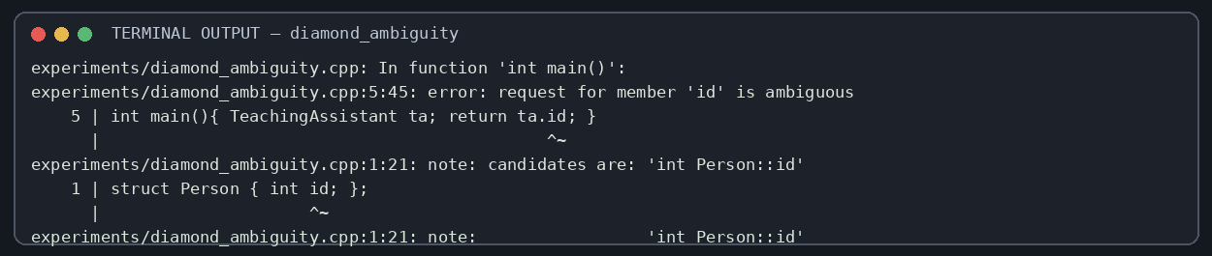
Figure 6. Compiler diagnostic for ambiguous Person::id in the non-virtual diamond.

Alternative: Composition
TeachingAssistant could contain Student student; Staff staff; rather than inherit from both. The contained Student and Staff each contain their own Person subobject, so two identity records may be stored. The name must be accessed explicitly as ta.student.name or ta.staff.name; this removes ambiguity at the call site but can duplicate identity data. Composition is appropriate if a teaching assistant merely coordinates two role records rather than being substitutable for Student and Staff. sizeof(TeachingAssistant) should be measured on the target ABI; virtual inheritance adds implementation metadata, while composition stores both complete member objects. Both name lookups are O(1).

TASK 3 – CONSTRUCTORS IN DERIVED CLASSES AND MEMBER CLASSES (9 Marks)

3.1 Pass Values to Base Constructors (3 marks)
A derived constructor passes values to its base through a member-initializer list. For Student and Staff, the virtual Person initializer is used when those classes are most-derived objects. When TeachingAssistant is the most-derived object, TeachingAssistant itself must initialise Person; the Person initializers written in Student and Staff are ignored for that object.
TeachingAssistant(...): Person(name, age, city, pin),
Student(name, age, regNo, city, pin, course),
Staff(name, age, city, pin, department) { }

3.2 Member Classes (2 marks)
Address is a value member of Person and Course is a value member of Student. Their constructors are called automatically by the owning constructor. They are not base classes: the relationship is has-a. Because they are stored by value, their lifetimes are bounded by their owners.

3.3 Trace Construction and Destruction (3 marks)
The trace program creates a Student, a Staff and a TeachingAssistant in separate scopes. Each constructor/destructor prints a label. The output demonstrates that the virtual Person base is constructed once in the most-derived object, then direct bases are constructed in declaration order, then members, then the derived constructor body. Destruction reverses that sequence.
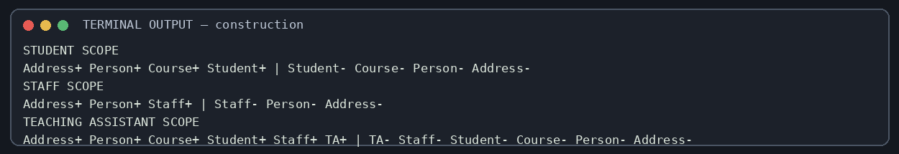
Figure 7. Constructor and destructor trace from the three scoped objects.
Object | Construction order | Destruction order
Student | Person → Course/Address member sequence → Student body (Address is constructed as Person member before Person body; Course after base) | Student → Course → Person body/destructor → Address
Staff | Person (including Address) → Staff body | Staff → Person → Address
TeachingAssistant | virtual Person → Student base (Course) → Staff base → TeachingAssistant body | TeachingAssistant → Staff → Student → Course → Person → Address

More precisely, within each class, virtual bases are constructed first, then direct non-virtual bases in their declaration order, then data members in their declaration order, then the constructor body. Destruction runs in reverse order. The member declaration order, not the textual order of the initializer list, controls member construction.

3.4 Experiment: Remove virtual (1 mark)
Removing virtual causes two Person subobjects in TeachingAssistant. Person constructor/destructor output appears twice. The sizeof experiment measures the virtual diamond, non-virtual diamond and composition alternatives on this g++ 14.2.0 ABI; the exact byte count is platform-dependent. The original supplied Engine/Vehicle/Car program was also compiled and run. Its output is Vehicle Engine Car | ~Car ~Engine ~Vehicle: base first, then member, then derived body; destruction reverses the order.
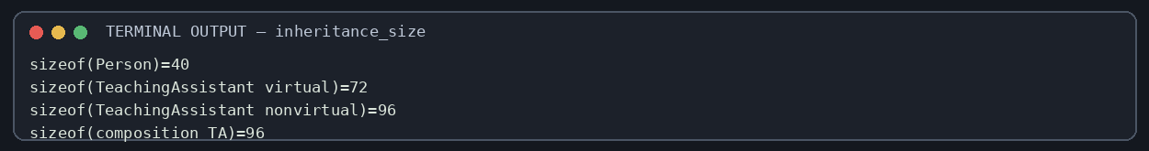
Figure 8. sizeof comparison for virtual inheritance, non-virtual inheritance and composition.
Figure 9. Exact output from the supplied Engine/Vehicle/Car construction-order program.

Complete the Code – TODO 1
The constructor initialises the Person base, the registration number and the Address member in the initializer list. The compiled output matches the expected line exactly.
Student(const std::string& n, int a, long long r, const std::string& city, int pin)
: Person(n, a), regNo(r), home(city, pin) {}
Figure 8. Completed Student constructor output: 192311001 Kavya (19) Salem-636001.
The intentionally reordered initializer-list experiment produces -Wreorder warnings. Initialisation still follows declaration order (base classes first, then members in their declaration order), so writing home before regNo in the list does not change the actual construction order. The warning is evidence that the list is misleading and should be corrected.
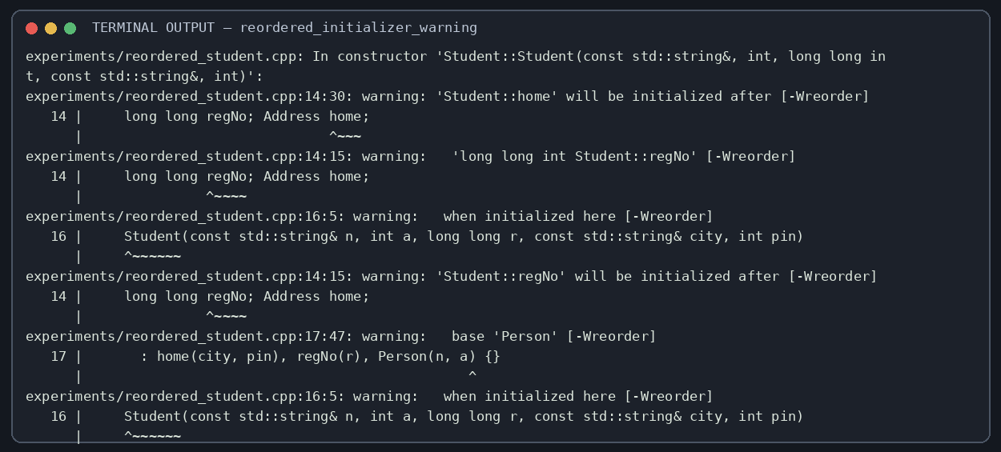
Figure 10. g++ -Wreorder diagnostic from the deliberately reordered initializer list.

Alternative: Address Pointer Instead of Member Object
class Student {
Address* home;
public:
Student(...) : home(new Address(city, pin)) {}
~Student() { delete home; }
Student(const Student& other) : home(new Address(*other.home)) {}
};
A pointer member adds pointer storage (typically sizeof(Address*) bytes) and dynamic allocation/deallocation overhead. Construction performs an allocation, usually O(1) for this small object but with allocator overhead; destruction must release it. A correct copy constructor must deep-copy the pointed-to Address, and copy assignment must handle self-assignment and release old storage safely. Otherwise two Students may share ownership or double-delete. A value member is simpler, exception-safe and needs no manual copy control. Prefer std::unique_ptr<Address> if dynamic lifetime is genuinely required.

TASK 4 – POINTERS TO DERIVED CLASSES: FORENSICS (7 Marks)

4.1 Locate the Defects (2 marks)
- rate() is non-virtual in Account, so Account* dispatches to Account::rate() at compile time. SeniorAccount::rate() only hides the base function.
- Account has a non-virtual destructor. Deleting a SeniorAccount through Account* is undefined behaviour; the SeniorAccount destructor is not reliably called, so its history allocation leaks.
- Account copy = SeniorAccount() slices the derived object. Only the Account base subobject is copied; SeniorAccount-specific state and dynamic type are lost.

4.2 Construct Evidence (2 marks)
The deliberately faulty source is compiled with -fsanitize=address. The captured report identifies a new-delete-type-mismatch when the derived allocation is deleted through the base pointer and an 800-byte direct leak allocated by SeniorAccount. Sanitizer behaviour and diagnostics are toolchain-dependent, but this run demonstrates the resource-management failure.
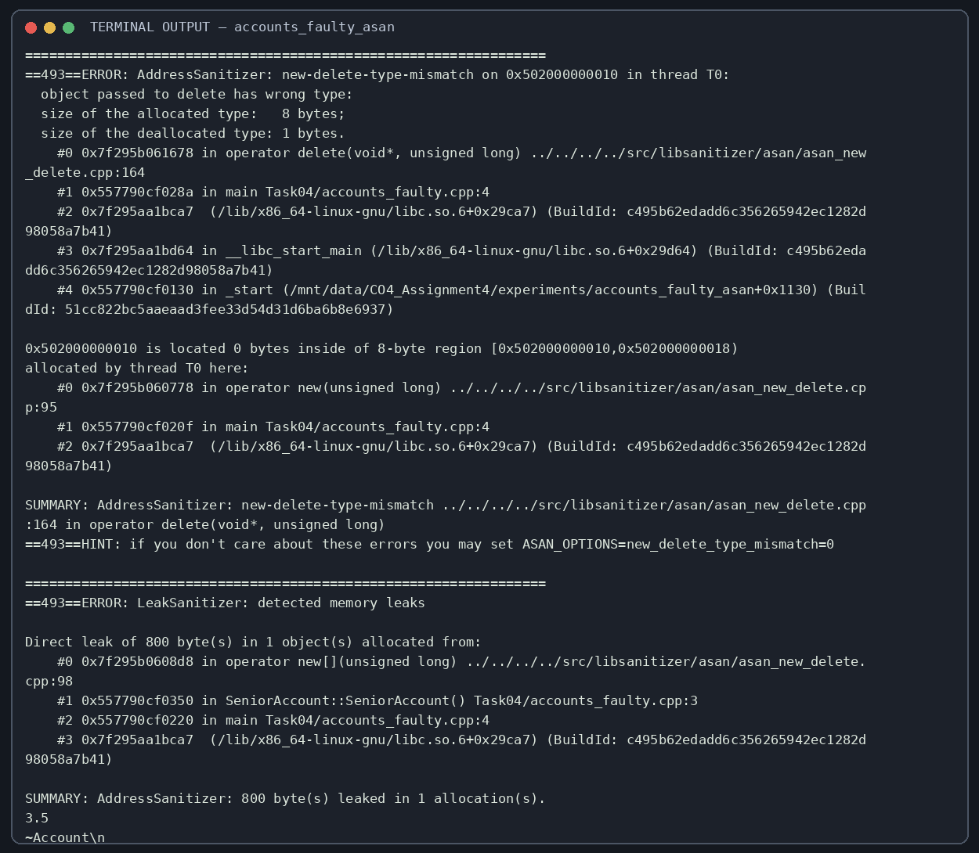
Figure 11. AddressSanitizer new-delete-type-mismatch and leak report from the intentionally faulty example.
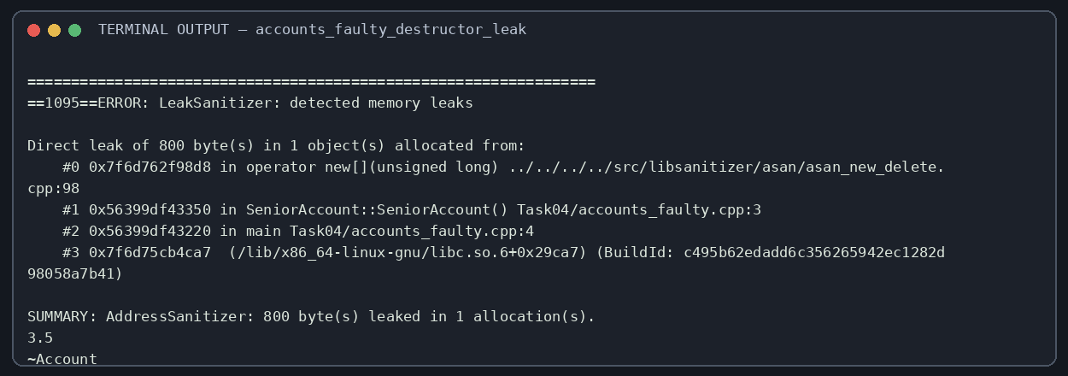
Figure 12. With the mismatch stop suppressed, only the base destructor runs and LeakSanitizer still reports the derived history allocation.

4.3 Repair the Program (2 marks)
class Account {
public:
virtual double rate() const { return 3.5; }
virtual ~Account() = default;
};
class SeniorAccount final : public Account {
std::unique_ptr<double[]> history;
public:
SeniorAccount() : history(std::make_unique<double[]>(100)) {}
double rate() const override { return 4.0; }
};
std::vector<std::unique_ptr<Account>> accounts;
accounts.push_back(std::make_unique<Account>());
accounts.push_back(std::make_unique<SeniorAccount>());
The fixed program prints 3.5 for a regular account and 4 for a senior account. The vector owns each object through unique_ptr, virtual dispatch selects the correct override, and the virtual destructor permits correct destruction. No manual delete is required.
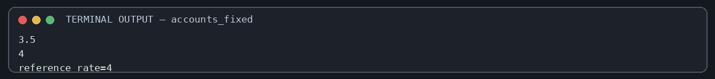
Figure 13. Repaired account program output.

Predict the Output – Static Binding, Virtual Dispatch and Slicing
Prediction: 3.5 4 3.5
p->rate() is non-virtual and is bound to Account::rate at compile time. p->vrate() is virtual and dispatches to SeniorAccount::vrate at run time. copy is a standalone Account object created from the base portion of s; slicing removes the SeniorAccount dynamic type, so copy.vrate() returns 3.5. The actual run matches the prediction.
Figure 14. Captured output for static binding, virtual dispatch and object slicing.

4.4 Prevent Recurrence (1 mark)
- If a class is intended to be used polymorphically, give it a public virtual destructor.
- Mark derived overrides with override so the compiler checks the signature.
- Use owning smart pointers (unique_ptr/shared_ptr as appropriate) instead of unmanaged owning raw pointers.
- Store polymorphic objects by pointer/reference, not by value, to avoid slicing.

Alternative: std::vector<std::unique_ptr<Account>>
The unique_ptr collection processes n accounts in O(n) time and uses O(n) pointer storage plus the object allocations. Runtime rate() remains O(1) per account. It prevents leaks caused by forgotten delete and ensures the derived destructor runs when Account has a virtual destructor. It does not automatically fix non-virtual rate() (dispatch remains static), nor does it prevent slicing if a separate Account value is still copied from a SeniorAccount. Correct virtual declarations and pointer/reference-based polymorphic access are still required.

TASK 5 – POINTERS TO OBJECTS AND THE this POINTER (7 Marks)

5.1 Four Ways to Reach an Object (3 marks)
Form | Example | Safety and typical use
Direct object | Cart c; c.add(...); | Simple automatic object; lifetime is scope-bound.
Pointer to existing object | Cart* p = &c; p->total(); | Non-owning; may be null or dangle if object lifetime ends.
Reference | Cart& r = c; r.total(); | Alias that must refer to an object; cannot be reseated.
Dynamic object | auto p = std::make_unique<Cart>(); p->total(); | Dynamic lifetime with explicit ownership; unique_ptr releases automatically.

5.2 this Pointer and Array of Pointers (2 marks)
Inside a non-static member function, this is a pointer to the object on which the function was called. *this is the actual object. Returning Cart& from add() and setDiscount() returns the current object by reference and enables chaining without copying. In setDiscount(double discount), this->discount identifies the data member while discount alone identifies the parameter.
Cart& add(const std::string& item, double price) {
if (n < 10) { items[n] = item; prices[n] = price; ++n; }
return *this;
}
Cart& setDiscount(double discount) {
this->discount = discount;
return *this;
}
For an array of Cart pointers, iterate over the pointer array and compare each pointed-to total. The implemented program uses Cart* carts[] = { &c1, &c2, &c3 }; and selects the index with the greatest total. Pointer arithmetic (carts + i) is equivalent to indexing (carts[i]) for valid array positions.

5.3 Complete the Code and Compare (2 marks)
The completed program produces the required expected result of 324.00 after adding Rice (60), Dal (120), and Oil (180), then applying a 10% discount. Additional tests demonstrate direct object access, pointer access, reference access, a dynamically owned object and highest-total selection.
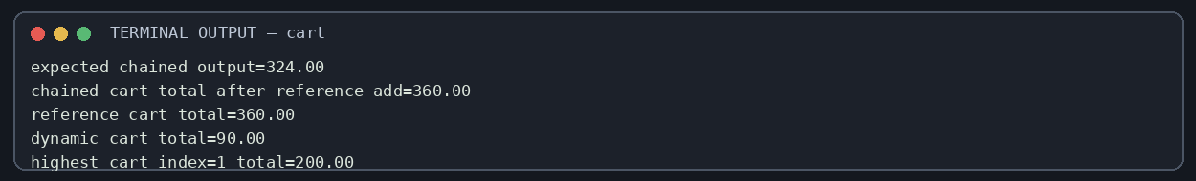
Figure 15. Completed Cart methods, method chaining, object access and highest-cart selection.
If add() returned Cart by value, each call would return a copy. Chaining could still compile, but subsequent calls would operate on temporary copies rather than the original cart. It would also copy the internal arrays and strings. Returning Cart& preserves object identity and avoids the copy.

Alternative: std::vector<Cart> Instead of Array of Pointers
Finding the highest total remains O(n) time in either representation. A vector<Cart> stores the Cart objects directly, avoids one heap allocation per cart and has contiguous object storage; however, vector growth may relocate objects and invalidate pointers/references/iterators to its elements. An array of pointers stores O(n) pointer slots and can keep separately allocated objects at stable addresses, but adds indirection and ownership complexity. If using vector<Cart>, reserve capacity before taking long-lived pointers or use stable ownership such as vector<unique_ptr<Cart>>.

TASK 6 – DESIGN CHALLENGE: VEHICLE RENTAL FLEET (13 Marks)

Stage 1 – Interpret the Problem (2 marks)
The system must represent bicycles, two-wheelers, cars and electric cars, and permit new categories such as electric buses. Every vehicle has a registration number and daily rate. Motor vehicles additionally carry a fuel/charge level and service due date; cars have seating capacity; electric cars have battery capacity and an energy rate. The behaviour that varies is rental-charge calculation and category-specific description.
Testable requirement | Acceptance condition
Common identity | Every vehicle exposes a registration number and daily rate.
Polymorphic charge | Calling charge(days) through Vehicle* selects the concrete vehicle rule.
Rental state | A vehicle can be rented once; a second rent attempt is rejected until return.
Late return | Return charge includes a defined late fee; negative late days are treated as zero.
Fleet operations | Fleet can list, rent and return heterogeneous vehicles through base pointers.
Extensibility | A new ElectricBus class can be added without modifying existing concrete vehicle classes or the fleet loop.

Stage 2 – Propose the Hierarchy (2 marks)
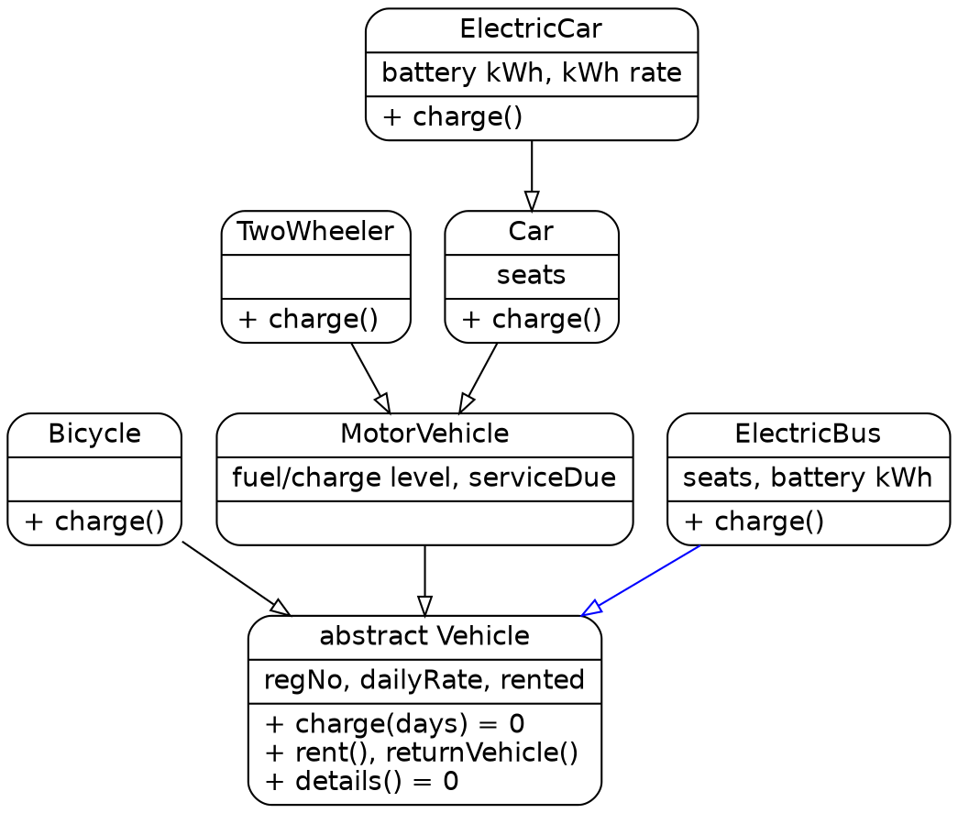
Figure 16. Vehicle hierarchy; ElectricBus is added as a new Vehicle subtype.
Vehicle is abstract because charge(int days) and details() are pure virtual. MotorVehicle extends Vehicle with fuel/charge level and service due date. TwoWheeler and Car derive from MotorVehicle; ElectricCar extends Car with battery capacity and kWh rate. Bicycle derives directly from Vehicle. ElectricBus is a new direct Vehicle subtype, demonstrating extension without editing the existing classes.

Stage 3 – Critical Design Decisions (2 marks)
- Common registration, daily rate and rental state belong in Vehicle.
- charge(), details() and the destructor are virtual. charge() and details() are pure virtual to prevent instantiating an incomplete base Vehicle.
- The fleet is stored as std::vector<std::unique_ptr<Vehicle>>, conceptually an array of base-class pointers with automatic ownership.
- MotorVehicle owns service/level data; Car owns seat capacity; ElectricCar owns battery-specific pricing data.
- A late day is charged at 50% of the daily rate in this implementation. This is an explicit demonstration policy because the handout does not specify a late-fee formula.

Stage 4 – Design the Classes and Pseudocode (4 marks)
ABSTRACT CLASS Vehicle
PRIVATE registration, dailyRate, rented
PUBLIC pure virtual charge(days), details()
PUBLIC rent(): if rented then reject; otherwise set rented=true
PUBLIC returnVehicle(lateDays): if not rented reject; set rented=false
return charge(1) + max(0, lateDays) * dailyRate * 0.5
END CLASS
ALGORITHM RENT-AND-RETURN(fleet)
FOR EACH vehicle IN fleet
DISPLAY vehicle.details()
IF vehicle.rent() THEN
DISPLAY vehicle.charge(2)
DISPLAY vehicle.returnVehicle(1)
END IF
END FOR
END ALGORITHM
The pseudocode follows a clear sequence: inspect each polymorphic object, request a rental, compute the two-day quote through its override, and return it with a one-day late penalty. Production code should separate quote calculation from payment, validate dates and mileage/energy, and persist rental transactions.

Stage 5 – Implement and Demonstrate (3 marks)
The executable implements Bicycle, TwoWheeler, Car, ElectricCar and ElectricBus. Each vehicle is stored in the same vector of unique_ptr<Vehicle>. The fleet loop is unchanged when ElectricBus is added. All five categories are rented and returned; the output shows the category-specific charge and late-return amount.
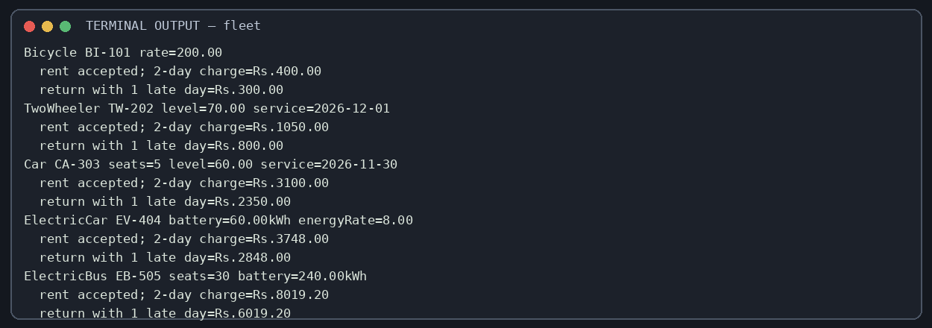
Figure 17. Fleet execution: five vehicle types rented and returned through Vehicle pointers.

Alternative: One Vehicle Class with Type Code and switch
enum class VehicleType { Bicycle, TwoWheeler, Car, ElectricCar, ElectricBus };
struct VehicleRecord { VehicleType type; double dailyRate, fuel, battery, kwhRate; int seats;
double charge(int days) const {
switch(type) { /* one branch for every category */ }
}
};
Measure | Abstract base + virtual functions | One class + switch
Time per charge() | O(1) virtual dispatch plus constant calculation. | O(1) bounded switch plus constant calculation.
Space per object | Base fields + only derived fields required by that type. | All possible fields stored for every type; unused fields waste space.
Add a new type | Add a derived class; fleet loop and existing classes remain unchanged. | Modify enum, data record, switch, validation and likely tests.
Extensibility | Open for extension; existing code depends on abstraction. | Central switch becomes a modification hotspot.

Both approaches are O(1) per charge call and O(n) to list or process n vehicles. A virtual call has a small dispatch cost; a switch has branch cost. The hierarchy better isolates category behaviour and is selected because the brief explicitly requires extensibility.

APPENDIX A – SOURCE FILES AND BUILD INSTRUCTIONS
The ZIP contains one folder per task, all C++ source files, captured output logs, terminal-style evidence images, sanitizer diagnostics and this README. Compile with:
g++ -std=c++17 -Wall -Wextra -pedantic path/to/source.cpp -o program
./program
The following source files are the authoritative task implementations included in the ZIP. The remaining helper and intentionally faulty experiment files are included alongside them for verification.

Task 1 – Payroll hierarchy
#include <iostream>
#include <memory>
#include <string>
#include <vector>
#include <iomanip>
class Staff {
protected:
std::string name_;
int id_;
double basic_;
public:
Staff(std::string name, int id, double basic)
: name_(std::move(name)), id_(id), basic_(basic) {}
virtual ~Staff() = default;
virtual double pay() const = 0;
virtual const char* role() const = 0;
void print() const {
std::cout << role() << " | " << name_ << " | ID " << id_
<< " | Rs." << std::fixed << std::setprecision(2) << pay() << '\n';
}
};
class Professor final : public Staff {
double research_;
public:
Professor(std::string n, int id, double b, double research)
: Staff(std::move(n), id, b), research_(research) {}
double pay() const override { return basic_ * 1.42 + research_; }
const char* role() const override { return "Professor"; }
};
class LabAssistant final : public Staff {
public:
LabAssistant(std::string n, int id, double b) : Staff(std::move(n), id, b) {}
double pay() const override { return basic_ * 1.42; }
const char* role() const override { return "Lab Assistant"; }
};
class GuestFaculty final : public Staff {
double hours_, rate_;
public:
GuestFaculty(std::string n, int id, double hours, double rate)
: Staff(std::move(n), id, 0.0), hours_(hours), rate_(rate) {}
double pay() const override { return hours_ * rate_; }
const char* role() const override { return "Guest Faculty"; }
};
int main() {
std::vector<std::unique_ptr<Staff>> payroll;
payroll.push_back(std::make_unique<Professor>("Anitha", 101, 50000, 8000));
payroll.push_back(std::make_unique<LabAssistant>("Bala", 102, 30000));
payroll.push_back(std::make_unique<GuestFaculty>("Charan", 103, 40, 900));
for (const auto& s : payroll) s->print();
}

Task 2 – Virtual diamond
#include <iostream>
#include <string>
struct Person { std::string name; Person() { std::cout << "Person "; } };
struct Student : virtual Person { Student() { std::cout << "Student "; } };
struct Staff : virtual Person { Staff() { std::cout << "Staff "; } };
struct TeachingAssistant : Student, Staff { TeachingAssistant() { std::cout << "TA "; } };
int main() { TeachingAssistant ta; std::cout << '\n'; }

Task 3 – Construction trace
#include <iostream>
#include <string>
struct Address {
std::string city; int pin;
Address(const std::string& c, int p) : city(c), pin(p) { std::cout << "Address+ "; }
~Address() { std::cout << "Address- "; }
std::string str() const { return city + "-" + std::to_string(pin); }
};
struct Course {
std::string code;
explicit Course(std::string c) : code(std::move(c)) { std::cout << "Course+ "; }
~Course() { std::cout << "Course- "; }
};
struct Person {
std::string name; int age; Address home;
Person(std::string n, int a, std::string city, int pin)
: name(std::move(n)), age(a), home(city, pin) { std::cout << "Person+ "; }
virtual ~Person() { std::cout << "Person- "; }
};
struct Student : virtual Person {
long long regNo; Course course;
Student(std::string n, int a, long long r, std::string city, int pin, std::string c)
: Person(std::move(n), a, std::move(city), pin), regNo(r), course(std::move(c)) { st
d::cout << "Student+ "; }
~Student() override { std::cout << "Student- "; }
};
struct Staff : virtual Person {
std::string department;
Staff(std::string n, int a, std::string city, int pin, std::string d)
: Person(std::move(n), a, std::move(city), pin), department(std::move(d)) { std::cou
t << "Staff+ "; }
~Staff() override { std::cout << "Staff- "; }
};
struct TeachingAssistant : Student, Staff {
TeachingAssistant(std::string n, int a, long long r, std::string city, int pin, std::s
tring c, std::string d)
: Person(n, a, city, pin), Student(n, a, r, city, pin, c), Staff(n, a, city, pin, d)
{ std::cout << "TA+ "; }
~TeachingAssistant() override { std::cout << "TA- "; }
};
int main() {
std::cout << "STUDENT SCOPE\n";
{ Student s("Kavya", 19, 192311001, "Salem", 636001, "CSE"); std::cout << "| "; }
std::cout << "\nSTAFF SCOPE\n";
{ Staff t("Ravi", 42, "Chennai", 600001, "Physics"); std::cout << "| "; }
std::cout << "\nTEACHING ASSISTANT SCOPE\n";
{ TeachingAssistant ta("Meena", 22, 192311002, "Madurai", 625001, "CSE", "CSE"); std::
cout << "| "; }
std::cout << '\n';
}

Task 3 – Completed TODO program
#include <iostream>
#include <string>
class Person {
protected: std::string name; int age;
public: Person(const std::string& n, int a) : name(n), age(a) {}
};
class Address {
std::string city; int pin;
public:
Address(const std::string& c, int p) : city(c), pin(p) {}
std::string str() const { return city + "-" + std::to_string(pin); }
};
class Student : public Person {
long long regNo; Address home;
public:
Student(const std::string& n, int a, long long r, const std::string& city, int pin)
: Person(n, a), regNo(r), home(city, pin) {}
void print() const { std::cout << regNo << ' ' << name << " (" << age << ") " << home.
str() << '\n'; }
};
int main() { Student s("Kavya", 19, 192311001, "Salem", 636001); s.print(); }

Task 4 – Repaired polymorphic accounts
#include <iostream>
#include <memory>
#include <vector>
class Account {
public:
virtual double rate() const { return 3.5; }
virtual ~Account() = default;
};
class SeniorAccount final : public Account {
std::unique_ptr<double[]> history;
public:
SeniorAccount() : history(std::make_unique<double[]>(100)) {}
double rate() const override { return 4.0; }
};
int main() {
std::vector<std::unique_ptr<Account>> accounts;
accounts.push_back(std::make_unique<Account>());
accounts.push_back(std::make_unique<SeniorAccount>());
for (const auto& a : accounts) std::cout << a->rate() << '\n';
Account& reference = *accounts[1];
std::cout << "reference rate=" << reference.rate() << '\n';
}

Task 5 – Cart and this pointer
#include <iomanip>
#include <iostream>
#include <memory>
#include <string>
class Cart {
std::string items[10]; double prices[10]{}; int n = 0; double discount = 0;
public:
Cart& add(const std::string& item, double price) {
if (n < 10 && price >= 0) { items[n] = item; prices[n] = price; ++n; }
return *this;
}
Cart& setDiscount(double discount) { this->discount = (discount >= 0 && discount <= 10
0) ? discount : 0; return *this; }
double total() const { double t=0; for (int i=0;i<n;++i) t += prices[i]; return t*(100
-discount)/100; }
const std::string& item(int i) const { return items[i]; }
int size() const { return n; }
};
int main() {
Cart direct; direct.add("Rice",60).add("Dal",120).setDiscount(10);
Cart* pointer = &direct; pointer->add("Oil",180);
std::cout << std::fixed << std::setprecision(2) << "expected chained output=" << point
er->total() << '\n';
Cart& reference = direct; reference.add("Soap",40);
auto dynamic = std::make_unique<Cart>(); dynamic->add("Tea",90);
std::cout << std::fixed << std::setprecision(2) << "chained cart total after reference
add=" << pointer->total() << '\n';
std::cout << "reference cart total=" << reference.total() << '\n';
std::cout << "dynamic cart total=" << dynamic->total() << '\n';
Cart c1; c1.add("A",50).add("B",80);
Cart c2; c2.add("C",200);
Cart c3; c3.add("D",100).add("E",50);
Cart* carts[] = {&c1,&c2,&c3};
int best=0; for (int i=1;i<3;++i) if (carts[i]->total()>carts[best]->total()) best=i;
std::cout << "highest cart index=" << best << " total=" << carts[best]->total() << '\n
';
}

Task 6 – Vehicle rental fleet
#include <algorithm>
#include <iostream>
#include <memory>
#include <string>
#include <vector>
#include <iomanip>
class Vehicle {
std::string reg_; double dailyRate_; bool rented_ = false;
public:
Vehicle(std::string r,double rate):reg_(std::move(r)),dailyRate_(rate){}
virtual ~Vehicle()=default;
virtual double charge(int days) const=0;
virtual const char* type() const=0;
virtual void details() const=0;
bool rent(){ if(rented_) return false; rented_=true; return true; }
double returnVehicle(int daysLate) { if(!rented_) return -1; rented_=false; return cha
rge(1)+std::max(0,daysLate)*dailyRate_*0.5; }
const std::string& registration()const{return reg_;}
double dailyRate()const{return dailyRate_;}
};
class Bicycle:public Vehicle { public: using Vehicle::Vehicle; double charge(int d)const o
verride{return dailyRate()*d;} const char* type()const override{return "Bicycle";} voi
d details()const override{std::cout<<type()<<" "<<registration()<<" rate="<<dailyRate(
)<<'\n';} };
class MotorVehicle:public Vehicle { std::string serviceDue_; double level_; public: MotorV
ehicle(std::string r,double rate,double level,std::string due):Vehicle(std::move(r),ra
te),serviceDue_(std::move(due)),level_(level){} void motorDetails()const{std::cout<<"l
evel="<<level_<<" service="<<serviceDue_;} };
class TwoWheeler:public MotorVehicle { public: using MotorVehicle::MotorVehicle; double ch
arge(int d)const override{return dailyRate()*d+50;} const char* type()const override{r
eturn "TwoWheeler";} void details()const override{std::cout<<type()<<" "<<registration
()<<" ";motorDetails();std::cout<<'\n';} };
class Car:public MotorVehicle { int seats_; public: Car(std::string r,double rate,double l
evel,std::string due,int seats):MotorVehicle(std::move(r),rate,level,std::move(due)),s
eats_(seats){} double charge(int d)const override{return dailyRate()*d+100;} const cha
r* type()const override{return "Car";} void details()const override{std::cout<<type()<
<" "<<registration()<<" seats="<<seats_<<' ';motorDetails();std::cout<<'\n';} };
class ElectricCar:public Car { double batteryKwh_; double kwhRate_; public: ElectricCar(st
d::string r,double rate,double level,std::string due,int seats,double battery,double k
wh):Car(std::move(r),rate,level,std::move(due),seats),batteryKwh_(battery),kwhRate_(kw
h){} double charge(int d)const override{return Car::charge(d)+batteryKwh_*kwhRate_*0.1
;} const char* type()const override{return "ElectricCar";} void details()const overrid
e{std::cout<<type()<<" "<<registration()<<" battery="<<batteryKwh_<<"kWh energyRate="<
<kwhRate_<<'\n';} };
class ElectricBus:public Vehicle { int seats_; double battery_; public: ElectricBus(std::s
tring r,double rate,int seats,double battery):Vehicle(std::move(r),rate),seats_(seats)
,battery_(battery){} double charge(int d)const override{return dailyRate()*d+battery_*
0.08;} const char* type()const override{return "ElectricBus";} void details()const ove
rride{std::cout<<type()<<" "<<registration()<<" seats="<<seats_<<" battery="<<battery_
<<"kWh\n";} };
int main(){
std::vector<std::unique_ptr<Vehicle>> fleet;
fleet.push_back(std::make_unique<Bicycle>("BI-101",200));
fleet.push_back(std::make_unique<TwoWheeler>("TW-202",500,70,"2026-12-01"));
fleet.push_back(std::make_unique<Car>("CA-303",1500,60,"2026-11-30",5));
fleet.push_back(std::make_unique<ElectricCar>("EV-404",1800,80,"2026-12-15",5,60,8));
fleet.push_back(std::make_unique<ElectricBus>("EB-505",4000,30,240));
std::cout<<std::fixed<<std::setprecision(2);
for(auto& v:fleet){v->details(); if(v->rent()) std::cout<<" rent accepted; 2-day charge=
Rs."<<v->charge(2)<<'\n'; std::cout<<" return with 1 late day=Rs."<<v->returnVehicle(
1)<<'\n';}
}

Appendix B – Evidence and Experiment Notes
The evidence folder contains plain-text logs and PNG terminal captures. The sanitizer experiment is deliberately faulty and is included to demonstrate the defect before repair. The final repaired account implementation uses unique_ptr and virtual destruction. Compiler version: g++ 14.2.0; language mode: C++17.

References
- Official course handout: Assignment 4 – CO4, Designing Reusable Class Hierarchies, DSA01 Object-Oriented Programming with C++, 14 pages, supplied by the student.
- ISO/IEC 14882:2017, Programming Languages — C++. Used for inheritance, virtual functions, object lifetime, construction/destruction order and smart-pointer language/library behaviour.
- GNU Compiler Collection (GCC), g++ 14.2.0. Compiler warnings and AddressSanitizer/LeakSanitizer observations were captured in the preparation environment.
Submission checklist: create the required DSA01-192565064-Assignment4 GitHub repository; upload each task folder and README; commit tasks progressively; replace the cover-page GitHub placeholder with the working repository URL; personally review and explain the programs during viva.

