SIMATS ENGINEERING
Department of Computer Science and Engineering
DSA01 – Object-Oriented Programming with C++
ASSIGNMENT 2 – CO2
Design C++ Programs by Applying Functions and Object-Oriented Concepts
CO2: Design C++ programs by applying functions and object-oriented concepts, including call by reference, return by reference, inline functions, default arguments, function overloading, classes, arrays within classes, static members, arrays of objects and friend functions.
Student Name | SWETHAMBIGAI.S | Register Number | 192565064
Department / Section | B.Tech CSE Cyber Security | Academic Year / Semester | 2nd year
Faculty Name | Amritha | Nature of Assignment | Individual
Duration | 1 Week | Total Marks | 50
Date of Submission | 12.11.2026 | Date of Evaluation
GitHub Repository | [PASTE YOUR GITHUB LINK] | Course Code | DSA01

MARK SHEET (Rubric-based Evaluation)
Task | Task Title | Max | Marks Awarded | Remarks
1 | Object-Oriented Analysis | 4
2 | Tokens, Keywords, Identifiers and Constants | 3
3 | Data Types and Compatibility | 4
4 | Implicit Conversions | 4
5 | Operators and Precedence | 4
6 | Control Structures | 4
7 | Procedural vs Object-Oriented | 4
8 | Input and Output | 4
9 | Implementation and Testing | 4
10 | Expectation vs Execution | 4
11 | Final Recommendation | 4
12A | Re-evaluate: Impact Analysis | 2
12B | Re-evaluate: Evaluation of Original Design | 2
12C | Re-evaluate: Adaptation or Redesign | 2
12D | Re-evaluate: Evidence-Based Defence | 2
 | TOTAL | 50 |  | Percentage:

OVERALL REMARKS

SWETHAMBIGAI.S
Student Signature | Faculty Signature | Program Director

Declaration and scope of this report
This report documents the design, implementation, predictions and validation for Questions 1–7 of the supplied CO2 assignment. All runnable task programs were compiled in the stated environment using C++17 with -Wall -Wextra -pedantic. The dangling-reference example is compiled only to capture the diagnostic; it is deliberately not executed because using the returned reference would invoke undefined behaviour.
The terminal-style figures in this report were generated from the captured standard output and compiler diagnostics of the programs run in this environment. They are not screenshots from the student’s personal computer. The assignment requires the student to execute the work individually and commit it progressively; the included source and evidence are a prepared starting submission that must be personally reviewed and explained in the viva.

Contents
Q1 – Call by Value, by Reference and by Pointer
Q2 – Return by Reference and Its Dangers
Q3 – Default Arguments and Function Overloading
Q4 – Specifying a Class with an Array Inside It
Q5 – Static Members and Arrays of Objects
Q6 – Friend Functions and Inline Functions
Q7 – Diagnose, Redesign and Validate
Appendix A – Source files and build instructions
References

Q1 – Call by Value, by Reference and by Pointer (6 marks)
The fee-concession problem is a direct example of parameter-passing semantics. A value parameter receives an independent copy. A reference parameter becomes an alias for the caller’s object. A pointer parameter receives an address; dereferencing that pointer writes to the caller’s object, provided the pointer is valid.
Method | Parameter storage / meaning | Caller fee changed? | Typical use
By value: long long fee | Independent local copy | No | Small scalar input when mutation is not required
By reference: long long& fee | Alias to caller object | Yes | In-place update when mutation is part of the function contract
By pointer: long long* fee | Local pointer value containing caller address | Yes, after *fee | Optional target / nullable argument or C-style interfaces
By const reference: const Student& | Alias, read-only through this parameter | No | Large object input without copying

For a starting fee of ₹450.00 represented as 45,000 paise, the sample applies three independent examples: merit 10%, sports 15%, and single-parent 25%. Integer arithmetic is used. The calculation is fee − (fee × percentage / 100); the resulting stored fees are 45,000 paise for the value call, 38,250 paise for the 15% reference call and 33,750 paise for the 25% pointer call. The value function prints its local result (40,500 paise) but does not update the original variable.

Prediction for the supplied program
1 12 13
1 100
16 13 6
After change(a,b,&c), a remains 1 because it is passed by value; b becomes 12 and c becomes 13. bigger(a,c) returns a reference to c because c is greater than a. Assigning 100 through that reference changes c. show(1) uses y=5 and z=10; show(1,2) uses z=10; show(1,2,3) supplies all arguments. The three sums are 16, 13 and 6. The observed output matches the prediction exactly.
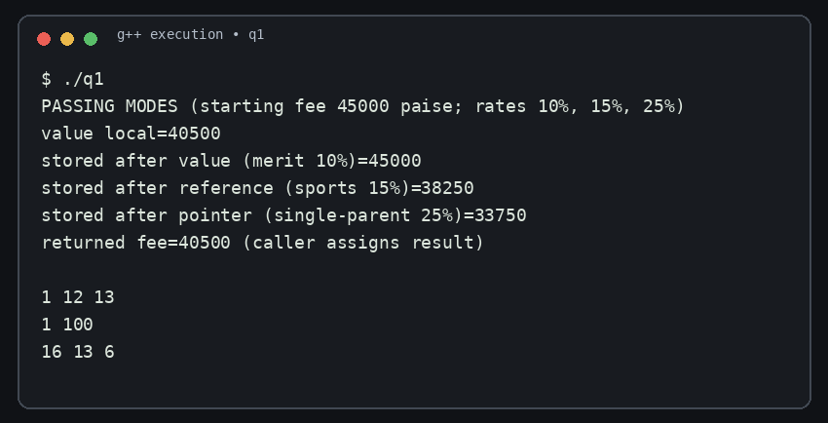
Figure 1. Actual execution of the Q1 parameter-passing and prediction program.

Completed-code result
The supplied TODO is completed by fee -= fee * percent / 100;. The reference parameter aliases hostelFee, so the caller’s value changes from 45,000 to 40,500. applyByValue modifies only its local copy and the stored fee remains 45,000.
Call | Expected stored fee | Observed stored fee | Reason
applyByValue(45000,10) | 45000 | 45000 | Only local copy changes
applyConcession(45000,10) | 40500 | 40500 | Reference aliases caller variable
byPointer(&fee,25) | 33750 | 33750 | Dereference writes to caller object

Design decision and alternative
For a chain of concessions, returning a new fee is safer when the calculation is conceptually a transformation and the caller should decide when to store the result: fee = applyConcession(fee, percentage). It also makes the update visible at the call site. A reference-based mutator is suitable when the API clearly promises to update an existing student record. A production design should calculate each concession in a documented order and avoid silently applying percentages to an already discounted amount unless that is the policy.

Parameter form | Time | Extra parameter storage per call | Large Student object
T by value | O(1) for scalar fee calculation | O(sizeof(T)) copied | Copies entire object; expensive
T& | O(1) | O(1) reference/alias | No object copy
const T& | O(1) | O(1) reference/alias | No object copy; read-only
Return T | O(1) for scalar calculation | Returned value; may use elision | Copies/moves result as required

All three scalar fee versions are O(1) time. Passing a large Student object by value has O(size of Student) copy cost, while reference and const reference avoid that copy. A const reference is preferred for large read-only inputs.

Q2 – Return by Reference and Its Dangers (4 marks)
highest() scans the marks array and returns a reference to the element with the greatest value. Because the result is an lvalue, the caller can write highest(marks,n) += 2 or assign directly to it. The array element itself is changed, not a temporary copy.
int& highest(int marks[], int n) {
int best = 0;
for (int i = 1; i < n; ++i)
if (marks[i] > marks[best]) best = i;
return marks[best];
}
A const reference permits reading but blocks modification through that reference. Returning by value returns a separate copy, so changing the copy does not change the array. An index return (int) is often the clearest and safest choice for a container that can reallocate; a pointer (int*) also refers to the element but has the same invalidation issue as a reference.
Interface | Caller usage | Safety / trade-off
int& | highest(a,n) += 2; | Convenient direct update; must ensure referenced element remains alive
const int& | cout << highestReadOnly(a,n); | Read-only alias; still lifetime-sensitive
int | int top = highestCopy(a,n); | Independent value; safest from container invalidation
int index | a[highestIndex(a,n)] += 2; | Index can be re-applied after reallocation if element ordering/identity is preserved
int* | *highestPointer(a,n) += 2; | Nullable and explicit indirection; invalidated with storage movement

Dangling reference diagnostic
Returning a reference to a local automatic variable is invalid because the local object’s lifetime ends when the function returns. The reference then dangles. Using it is undefined behaviour; the program must not dereference it. GCC 14.2.0 with -Wall -Wextra -pedantic emits -Wreturn-local-addr for the deliberate example. The diagnostic is captured below; the program is not run.
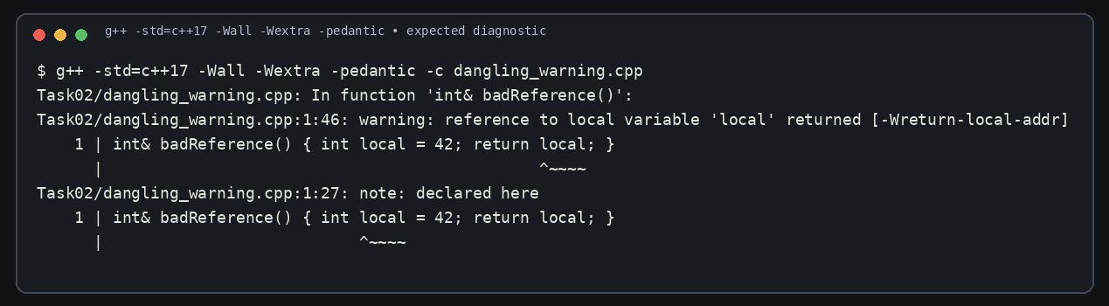
Figure 2. Actual compiler warning for returning a reference to a local variable.
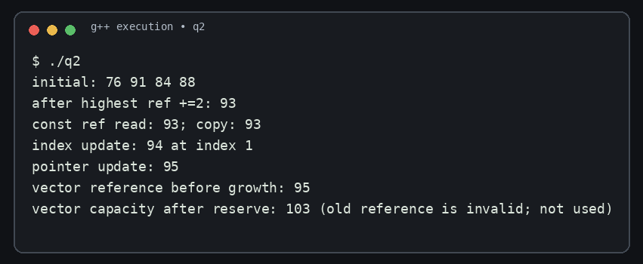
Figure 3. Safe array-reference, index, pointer and vector-invalidation demonstration.
When std::vector grows beyond its capacity, it may allocate a new memory block and move its elements. References, pointers and iterators to the old elements are then invalidated. The demonstration forces a capacity increase using reserve(capacity()+100) and intentionally does not use the old reference afterward. A vector index is not a stable identity if insertions or erasures change element positions, but it can be used to access the current element after reallocation when the logical index remains valid.
Finding the maximum takes O(n) time and O(1) auxiliary space for reference, const-reference, copy, index and pointer return variants. The return type does not change the scan complexity. For a growing vector, returning a value or an index plus a fresh lookup is generally safer than retaining a reference across a growth operation.

Q3 – Default Arguments and Function Overloading (6 marks)
The original declarations overlap: charge(double), charge(double,bool) and charge(double,bool=false,bool=false) all accept charge(2). Each candidate can accept the argument through the same int-to-double conversion, so there is no uniquely best overload. Calls with two arguments can also overlap. The compiler reports an ambiguous call.
The redesigned interface overloads by the physical representation of the input: int means grams, double means kilograms, and Parcel represents a structured parcel. Each overload has its own trailing defaults for express and insurance. The Parcel overload uses fields in the object. The six designed calls are shown below.
Call | Predicted overload | Reason | Observed selection
charge(2) | int grams | Exact match | int grams
charge(2.0f) | double kg | float→double promotion | double kg
charge(750) | int grams | Exact match | int grams
charge(1.5) | double kg | Exact match | double kg
charge(Parcel{2.5,true,false}) | Parcel const reference | Exact user-defined type match | Parcel
charge(2,true,true) | int grams | Exact first argument; bools exact | int grams

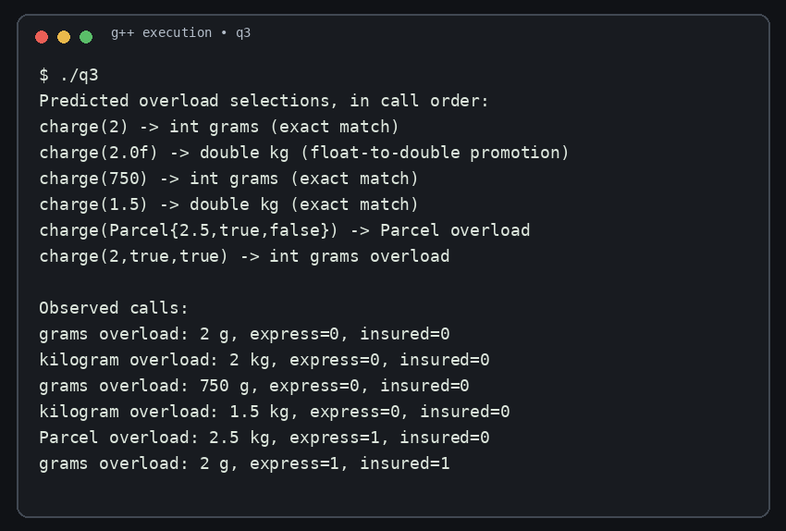
Figure 4. Actual overload selection for six test calls.
Overload resolution prefers an exact match over a promotion, and a promotion over a standard conversion. float-to-double is a floating-point promotion, while int-to-double is a conversion. Default arguments do not create a separate overload; they supply omitted trailing arguments after a function has been selected. They must be specified from right to left because an argument list cannot omit an earlier parameter while supplying a later one.

Alternative: Parcel structure or template
struct Parcel { double kg; bool express=false; bool insured=false; };
void charge(const Parcel& p);
// call: charge(Parcel{2.0, true, false});
A single Parcel structure avoids an expanding overload list when options grow, but every caller must construct or pass a Parcel. A function template could accept different numeric types, but requires constraints or explicit conversions to prevent unintended interpretations of units. Overload selection is performed at compile time and adds no run-time dispatch cost. Each overload call passes small scalar parameters; passing Parcel by const reference avoids copying its fields as the structure grows. All implementations perform O(1) work for a fixed set of charge rules.

Q4 – Specifying a Class with an Array Inside It (6 marks)
SavingsAccount stores an account number, balance in paise, a fixed array of ten signed transaction amounts and a count. Positive values represent deposits and negative values represent withdrawals. The array and count are private so that callers cannot alter the statement history or create an inconsistent count. Public deposit(), withdraw() and miniStatement() provide controlled operations. The constructor and small accessors are defined inside the class; miniStatement() is defined outside using SavingsAccount::miniStatement().
The submitted implementation uses shifting when the array is full: each new transaction moves the nine retained entries one position to the left and stores the newest transaction at the end. The 11th transaction therefore discards the oldest entry. The run inserts twelve deposits and one withdrawal, so the statement displays the latest ten entries: deposits 400 through 1,200 paise and a withdrawal of 500 paise. Opening balance is 100,000 paise; deposits total 7,800 paise and withdrawal is 500 paise, giving 107,300 paise.
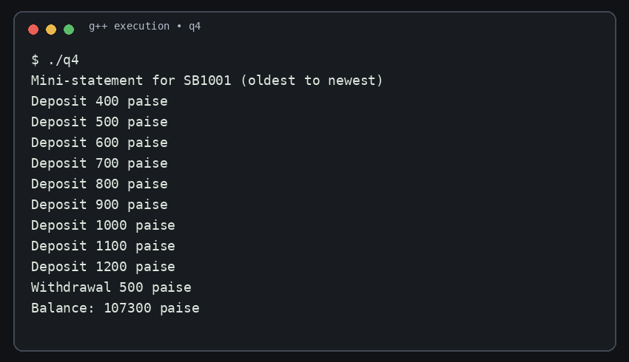
Figure 5. Actual mini-statement output after thirteen transactions.

Design | Insertion when full | Time per new item | Storage
Fixed array with shifting | Shift k−1 entries then append | O(k); k=10 or 50 | O(k)
std::deque | pop_front(), push_back() | O(1) amortized at ends | O(k)
Circular array | Overwrite at next index and advance | O(1) | O(k)

For a last-50 requirement, increasing the fixed array bound from 10 to 50 is a small code change, but the shifting cost rises with the retained history. A circular buffer is the preferred design because its append operation stays O(1) and storage remains bounded. A deque also provides constant-time insertion/removal at its ends but uses a more complex segmented allocation. The fixed array is simple and has predictable storage; it remains acceptable for a very small history where simplicity is more important than insertion cost.

Q5 – Static Members and Arrays of Objects (7 marks)
The ticket capacity and issued-seat counter belong to the bus service as a whole, not to an individual ticket. Therefore issued and CAPACITY are static. Each ticket stores its own seat number and passenger name as non-static data. The static data member requires one out-of-class definition (int BusTicket::issued = 0;) in this C++17 program. A static member function has no this pointer because it is not invoked on one particular object; it cannot directly access an individual ticket’s non-static seat or name.
The supplied Token prediction is 101 103 104 4. Token::next begins at 100. Three array elements invoke the constructor, producing IDs 101, 102 and 103; the extra object produces 104. issued() returns next−100, which is 4. Four constructor calls occur.
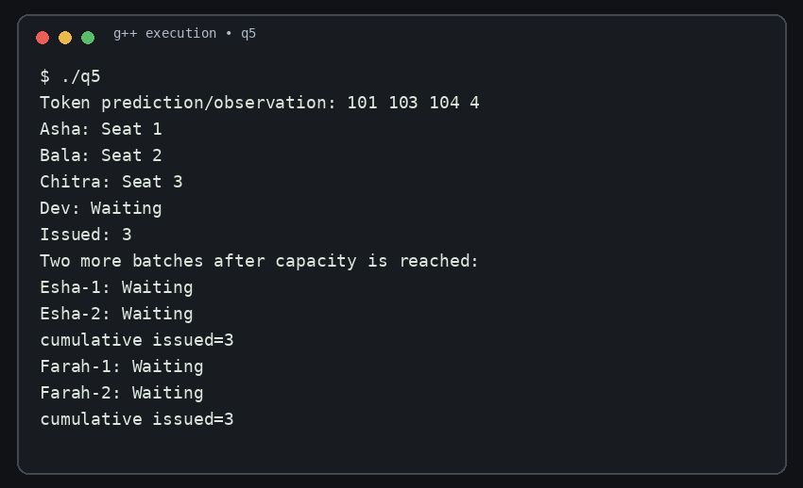
Figure 6. Actual Token prediction and BusTicket capacity test.
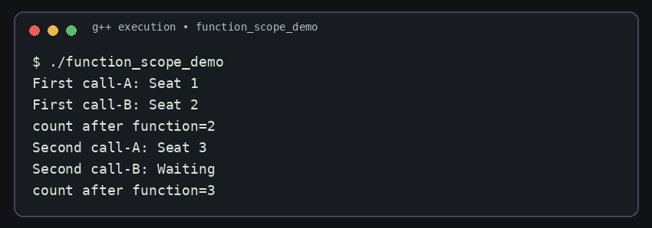
Figure 7. Static ticket count persists across two function calls and local-object destruction.
The completed BusTicket constructor increments issued and assigns the next seat only while issued is less than CAPACITY. The fourth ticket retains seat=0 and prints Waiting. The static count() function returns issued. The array of four objects is initialized with four temporary BusTicket values; the observable result is three seats and one waiting passenger. Creating tickets inside a function does not reset a static counter when local ticket objects are destroyed. A second function call continues from the same class-level count; the separate demonstration below creates two local tickets in each of two calls, producing seats 1 and 2 in the first call, seat 3 and Waiting in the second, with a cumulative count of 3.
Counter design | Time per ticket | Space | Encapsulation / multiple buses
Static class member | O(1) | One shared counter | Encapsulated, but one class-wide bus count; poor for simultaneous independent buses
Global variable | O(1) | One global counter | Weak encapsulation; global namespace and coupling
TicketOffice object | O(1) | One counter per office | Best separation for multiple buses; pass office reference to each ticket

A TicketOffice object is the strongest scalable alternative if two buses operate concurrently: each office owns its own capacity and issued count. The static member best matches the single-bus problem stated in the handout.

Q6 – Friend Functions and Inline Functions (8 marks)
Time keeps hours and minutes private. minutesBetween(a,b) and earlier(a,b) operate symmetrically on two Time objects, so a non-member friend function is reasonable: neither time is inherently the “owner” of the operation. A friend is not a member and is called as minutesBetween(a,b), but it may access the private members of both arguments. A member alternative would be departure.minutesTo(arrival), where the left operand is the implicit object.
The completed functions convert each time to minutes after midnight. The absolute difference is |(h1×60+m1)−(h2×60+m2)|. earlier() compares hour first and minute second. The required output is 205 false. Additional checks give zero difference and false for identical times, and a two-minute difference with the 11:59 time earlier than 12:01.
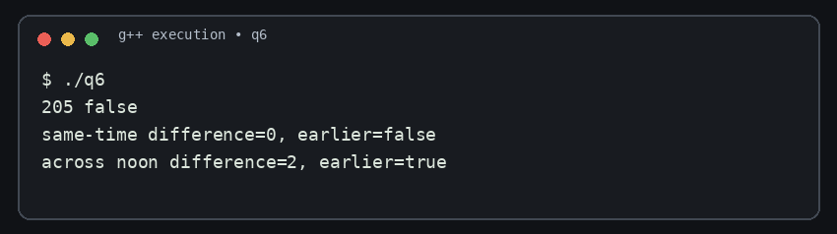
Figure 8. Actual correctness tests for same-time and cross-noon inputs.
Making h and m public would remove the need for friendship but weaken encapsulation: any caller could create invalid times such as 27:95 or change the fields without validation. Private data plus friend operations keeps the representation protected. A getter-based non-friend function is also valid, though it exposes read accessors.

Inline investigation: ten million calls
The benchmark compares an inline friend function with a noinline function using the same calculation and a volatile accumulator to retain the calls. It was compiled with -O0 and -O2. Five runs were collected for each build. The median inline and noinline times were approximately 19.47 ms and 20.35 ms at -O0, and 3.30 ms and 12.81 ms at -O2. These are machine- and run-dependent observations, not guaranteed language properties. At -O0 the call overhead difference is small and noise can reverse the order; at -O2 the compiler’s inlining and optimization substantially reduce the measured inline path. The inline keyword is an ODR/linkage rule and an optimization suggestion, not a command that forces substitution.

Build | Median inline time | Median noinline time | Interpretation
-O0 | 19.47 ms | 20.35 ms | Similar; noise and call overhead dominate
-O2 | 3.30 ms | 12.81 ms | Inlining plus optimization materially reduced this microbenchmark

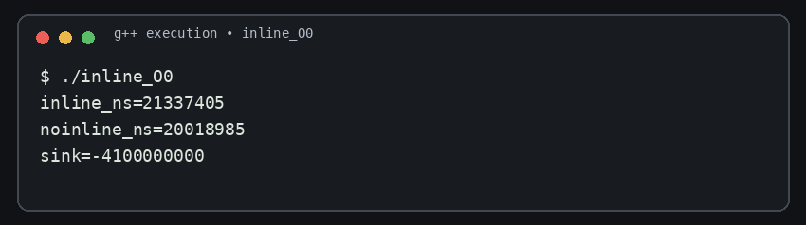
Figure 9. One captured -O0 timing run (five-run medians are reported in the table).
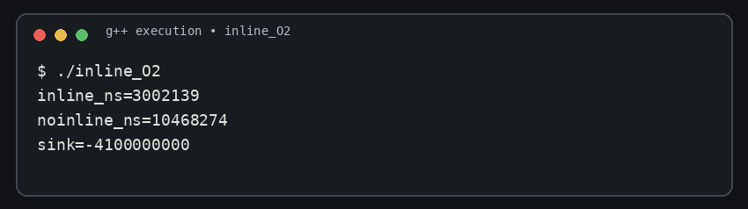
Figure 10. One captured -O2 timing run (five-run medians are reported in the table).
The deployment decision is to keep the private representation and small comparison helpers, while treating inline as an implementation choice. The friend design is concise for symmetric operations. If the class later needs validation or a richer invariant, member functions or public const getters may offer a clearer interface. Complexity remains O(1) per comparison; optimization changes constants, not asymptotic complexity.

Q7 – Diagnose, Redesign and Validate (13 marks)

A. Diagnose the limitation
The Q4 shifting history is bounded to ten transactions, but when full every new record moves nine existing entries. This is O(k) work per append for capacity k. The limitation is not the maximum operation count; it is repeated movement of records that are retained unchanged. In the Q7 controlled comparison, 200,000 insertions were performed with capacity 1,000. Both implementations retained the same 1,000 values and produced the same checksum 199,499,500.

B. Measurable design objective
Keep the same fixed-capacity “last k transactions” behaviour and the same retained data while reducing full-buffer append work from O(k) to O(1). The test objective is to reduce median elapsed time for 200,000 appends at capacity 1,000 without changing retained count or checksum.

C. Revised design
The redesign stores records in a fixed-size circular array with a next-write index and a count. Each append writes one slot, advances next=(next+1)%capacity, and increases count until full. When full, the next write overwrites the oldest record. No retained records are shifted. A statement printer begins at the oldest slot (next when full) and walks in chronological order.
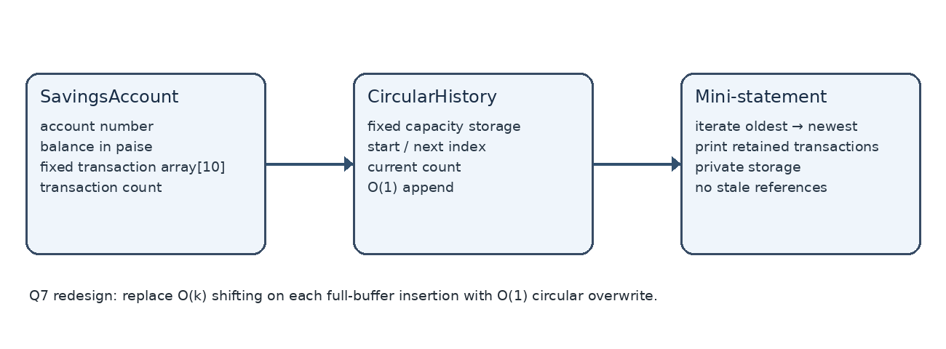
Figure 11. Q7 redesign architecture: account owns bounded circular history.
Component | Responsibility
SavingsAccount | Own account number, balance and transaction-history object
CircularHistory | Own fixed storage, next index and count
add(record) | Overwrite one slot and advance index in O(1)
iterateOldestFirst() | Traverse retained entries in O(k) for display

The redesign uses O(k) storage, the same asymptotic space as the shifting array. It adds index bookkeeping and makes chronological traversal less direct. The trade-off is worth it when records are appended frequently or capacity is larger.

D. Prediction before implementation
For capacity k=1,000 and N=200,000 appends, shifting may move roughly (N−k)×(k−1) ≈ 199 million retained elements. Circular insertion should perform one slot write and a small index update per operation. Both versions should retain 1,000 entries with identical checksum. The circular version is predicted to be substantially faster.

E. Implementation and validation
Metric | Shifting baseline | Circular redesign
Operations | 200,000 | 200,000
Capacity | 1,000 | 1,000
Retained count | 1,000 | 1,000
Checksum | 199,499,500 | 199,499,500
Five-run median | 20,929 µs | 1,531 µs
Observed speed-up | — | about 13.7×

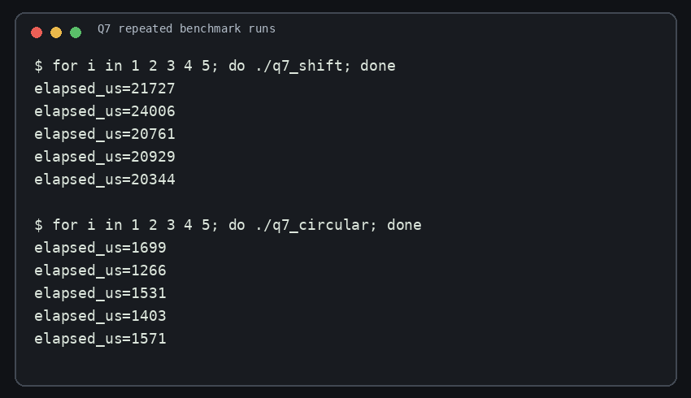
Figure 12. Five repeated timings from the actual Q7 executables.

The measured median improvement is about 13.7 times (20,929 / 1,531). The checksum and retained count match, which verifies that both programs produced the same retained data for the tested sequence. The timings were collected with g++ 14.2.0 using the default unoptimized build command; the result is specific to this environment and should be rechecked on the student’s own computer.

F. Final defence
The measurable objective was achieved for the chosen workload: identical retained data with a lower median append time. The circular design still costs O(k) to print the complete mini-statement, requires careful wraparound logic and has fixed capacity. For a tiny k or infrequent inserts, the shifting version is easier to understand and may be preferable. The redesign is justified for frequent inserts and larger histories, not as a universal replacement.

Appendix A – Source files and build instructions
The ZIP contains separate task folders and complete C++ source files. The report includes the key source files below as editable text. The source files in the ZIP are the authoritative copies for compilation.

Q1 – parameter passing
#include <iostream>
#include <iomanip>
using namespace std;
void byValue(long long fee, int p) { fee -= fee * p / 100; cout << "value local=" << fee << '\n'; }
void byReference(long long& fee, int p) { fee -= fee * p / 100; }
void byPointer(long long* fee, int p) { if (fee) *fee -= *fee * p / 100; }
void change(int a, int& b, int* c) { a += 10; b += 10; *c += 10; }
int& bigger(int& p, int& q) { return p > q ? p : q; }
void show(int x, int y=5, int z=10) { cout << x+y+z << ' '; }
long long returnedFee(long long fee, int p) { return fee - fee*p/100; }
int main() {
cout << "PASSING MODES (starting fee 45000 paise; rates 10%, 15%, 25%)\n";
long long v=45000, r=45000, p=45000;
byValue(v,10); cout << "stored after value (merit 10%)=" << v << '\n';
byReference(r,15); cout << "stored after reference (sports 15%)=" << r << '\n';
byPointer(&p,25); cout << "stored after pointer (single-parent 25%)=" << p << '\n';
cout << "returned fee=" << returnedFee(45000,10) << " (caller assigns result)\n\n";
int a=1,b=2,c=3; change(a,b,&c); cout << a << ' ' << b << ' ' << c << '\n';
bigger(a,c)=100; cout << a << ' ' << c << '\n';
show(1); show(1,2); show(1,2,3); cout << '\n';
}

Q2 – references and invalidation
#include <iostream>
#include <vector>
using namespace std;
int& highest(int marks[], int n) { int best=0; for(int i=1;i<n;++i) if(marks[i]>marks[best]) best=i; return marks[best]; }
const int& highestReadOnly(const int marks[], int n) { int best=0; for(int i=1;i<n;++i) if(marks[i]>marks[best]) best=i; return marks[best]; }
int highestCopy(const int marks[], int n) { int best=0; for(int i=1;i<n;++i) if(marks[i]>marks[best]) best=i; return marks[best]; }
int highestIndex(const int marks[], int n) { int best=0; for(int i=1;i<n;++i) if(marks[i]>marks[best]) best=i; return best; }
int* highestPointer(int marks[], int n) { int best=0; for(int i=1;i<n;++i) if(marks[i]>marks[best]) best=i; return &marks[best]; }
// Deliberately unsafe demonstration only. Never call or dereference this function.
int& danglingReference() { int local=42; return local; }
int main(){
int marks[]={76,91,84,88}; const int n=4;
cout << "initial: "; for(int x:marks) cout<<x<<' '; cout<<'\n';
highest(marks,n)+=2; cout << "after highest ref +=2: "<<marks[1]<<'\n';
cout << "const ref read: "<<highestReadOnly(marks,n)<<"; copy: "<<highestCopy(marks,n)<<'\n';
int idx=highestIndex(marks,n); marks[idx]+=1; cout<<"index update: "<<marks[idx]<<" at index "<<idx<<'\n';
int* ptr=highestPointer(marks,n); *ptr+=1; cout<<"pointer update: "<<*ptr<<'\n';
vector<int> dynamicMarks={70,95,82}; int& beforeGrowth=dynamicMarks[1];
cout<<"vector reference before growth: "<<beforeGrowth<<'\n';
dynamicMarks.reserve(dynamicMarks.capacity()+100); // forces reallocation on normal implementations
cout<<"vector capacity after reserve: "<<dynamicMarks.capacity()<<" (old reference is invalid; not used)\n";
}

Q3 – overload design
#include <iostream>
#include <string>
using namespace std;
struct Parcel { double kilograms; bool express=false; bool insured=false; };
void charge(int grams, bool express=false, bool insured=false) { cout<<"grams overload: "<<grams<<" g, express="<<express<<", insured="<<insured<<'\n'; }
void charge(double kilograms, bool express=false, bool insured=false) { cout<<"kilogram overload: "<<kilograms<<" kg, express="<<express<<", insured="<<insured<<'\n'; }
void charge(const Parcel& p) { cout<<"Parcel overload: "<<p.kilograms<<" kg, express="<<p.express<<", insured="<<p.insured<<'\n'; }
int main(){
cout<<"Predicted overload selections, in call order:\n";
cout<<"charge(2) -> int grams (exact match)\n";
cout<<"charge(2.0f) -> double kg (float-to-double promotion)\n";
cout<<"charge(750) -> int grams (exact match)\n";
cout<<"charge(1.5) -> double kg (exact match)\n";
cout<<"charge(Parcel{2.5,true,false}) -> Parcel overload\n";
cout<<"charge(2,true,true) -> int grams overload\n\nObserved calls:\n";
charge(2); charge(2.0f); charge(750); charge(1.5); charge(Parcel{2.5,true,false}); charge(2,true,true);
}

Q4 – savings account
#include <iostream>
#include <array>
#include <string>
#include <utility>
using namespace std;
class SavingsAccount {
string accountNumber; long long balancePaise=0; array<long long,10> transactions{}; size_t count=0;
void record(long long signedAmount) { if(count<transactions.size()) transactions[count++]=signedAmount; else { for(size_t i=1;i<transactions.size();++i) transactions[i-1]=transactions[i]; transactions.back()=signedAmount; } }
public:
explicit SavingsAccount(string number, long long openingPaise=0):accountNumber(std::move(number)),balancePaise(openingPaise){}
void deposit(long long paise) { if(paise<=0) { cout<<"Deposit rejected\n"; return; } balancePaise+=paise; record(paise); }
bool withdraw(long long paise) { if(paise<=0 || paise>balancePaise) { cout<<"Withdrawal rejected\n"; return false; } balancePaise-=paise; record(-paise); return true; }
void miniStatement() const;
long long balance() const { return balancePaise; }
};
void SavingsAccount::miniStatement() const {
cout<<"Mini-statement for "<<accountNumber<<" (oldest to newest)\n";
for(size_t i=0;i<count;++i){ long long x=transactions[i]; cout<<(x>=0?"Deposit ":"Withdrawal ")<< (x>=0?x:-x)<<" paise\n"; }
cout<<"Balance: "<<balancePaise<<" paise\n";
}
int main(){ SavingsAccount a("SB1001",100000); for(int i=1;i<=12;++i) a.deposit(i*100); a.withdraw(500); a.miniStatement(); }

Q5 – static tickets
#include <iostream>
#include <string>
using namespace std;
class Token { static int next; int id; public: Token():id(++next){} int get()const{return id;} static int issued(){return next-100;} };
int Token::next=100;
class BusTicket { static int issued; static constexpr int CAPACITY=3; int seat; string name; public:
explicit BusTicket(const string& n):seat(0),name(n){ if(issued<CAPACITY) seat=++issued; }
static int count(){return issued;} void print()const{cout<<name<<": "<<(seat?"Seat "+to_string(seat):string("Waiting"))<<'\n';}
}; int BusTicket::issued=0;
void createBatch(const string& prefix){ BusTicket batch[2]={BusTicket(prefix+"-1"),BusTicket(prefix+"-2")}; for(const auto& t:batch)t.print(); cout<<"cumulative issued="<<BusTicket::count()<<'\n'; }
int main(){ Token counter[3]; Token extra; cout<<"Token prediction/observation: "<<counter[0].get()<<' '<<counter[2].get()<<' '<<extra.get()<<' '<<Token::issued()<<'\n';
BusTicket trip[4]={BusTicket("Asha"),BusTicket("Bala"),BusTicket("Chitra"),BusTicket("Dev")}; for(const auto& t:trip)t.print(); cout<<"Issued: "<<BusTicket::count()<<'\n';
cout<<"Two more batches after capacity is reached:\n"; createBatch("Esha"); createBatch("Farah"); }

Q5 – function-scope persistence test
#include <iostream>
#include <string>
#include <utility>
using namespace std;
class BusTicket { static int issued; static constexpr int CAPACITY=3; int seat=0; string name; public: explicit BusTicket(string n):name(std::move(n)){if(issued<CAPACITY)seat=++issued;} void print()const{cout<<name<<": "<<(seat?"Seat "+to_string(seat):string("Waiting"))<<'\n';} static int count(){return issued;} };
int BusTicket::issued=0;
void createTwo(const string& label){BusTicket a(label+"-A"),b(label+"-B");a.print();b.print();cout<<"count after function="<<BusTicket::count()<<'\n';}
int main(){createTwo("First call");createTwo("Second call");}

Q6 – friend functions
#include <iostream>
#include <chrono>
using namespace std;
class Time { int h,m; public: Time(int hh,int mm):h(hh),m(mm){} friend int minutesBetween(const Time&,const Time&); friend bool earlier(const Time&,const Time&); };
inline int minutesBetween(const Time& a,const Time& b){ int x=a.h*60+a.m,y=b.h*60+b.m; return x>y?x-y:y-x; }
inline bool earlier(const Time& a,const Time& b){ return a.h<b.h || (a.h==b.h && a.m<b.m); }
int main(){ Time departure(9,45),arrival(13,10),same(12,0),beforeNoon(11,59),afterNoon(12,1);
cout<<minutesBetween(departure,arrival)<<' '<<boolalpha<<earlier(arrival,departure)<<'\n';
cout<<"same-time difference="<<minutesBetween(same,same)<<", earlier="<<earlier(same,same)<<'\n';
cout<<"across noon difference="<<minutesBetween(beforeNoon,afterNoon)<<", earlier="<<earlier(beforeNoon,afterNoon)<<'\n'; }

Q6 – inline benchmark
#include <chrono>
#include <iostream>
using namespace std;
class Clock { int h,m; public: Clock(int a,int b):h(a),m(b){} friend inline int fastMinutes(const Clock&,const Clock&); friend int regularMinutes(const Clock&,const Clock&); };
inline int fastMinutes(const Clock&a,const Clock&b){return (a.h*60+a.m)-(b.h*60+b.m);}
#if defined(__GNUC__)
__attribute__((noinline))
#endif
int regularMinutes(const Clock&a,const Clock&b){return (a.h*60+a.m)-(b.h*60+b.m);}
int main(){Clock a(9,45),b(13,10); volatile long long sink=0; constexpr int N=10000000;
auto t1=chrono::steady_clock::now(); for(int i=0;i<N;++i)sink+=fastMinutes(a,b); auto t2=chrono::steady_clock::now();
for(int i=0;i<N;++i) { sink+=regularMinutes(a,b); }
auto t3=chrono::steady_clock::now();
cout<<"inline_ns="<<chrono::duration_cast<chrono::nanoseconds>(t2-t1).count()<<"\nnoinline_ns="<<chrono::duration_cast<chrono::nanoseconds>(t3-t2).count()<<"\nsink="<<sink<<'\n'; }

Q7 – shifting baseline
#include <iostream>
#include <vector>
#include <chrono>
using namespace std;
class ShiftHistory { vector<int> a; size_t cap; public: explicit ShiftHistory(size_t c):cap(c){} void add(int x){ if(a.size()==cap) a.erase(a.begin()); a.push_back(x);} size_t size()const{return a.size();} long long checksum()const{long long s=0;for(int x:a)s+=x;return s;} };
int main(){constexpr int N=200000, K=1000; ShiftHistory h(K); auto s=chrono::steady_clock::now(); for(int i=0;i<N;++i)h.add(i); auto e=chrono::steady_clock::now(); cout<<"strategy=shift\noperations="<<N<<" capacity="<<K<<" retained="<<h.size()<<" checksum="<<h.checksum()<<"\nelapsed_us="<<chrono::duration_cast<chrono::microseconds>(e-s).count()<<'\n';}

Q7 – circular redesign
#include <iostream>
#include <vector>
#include <chrono>
using namespace std;
class CircularHistory { vector<int> a; size_t next=0,count=0; public: explicit CircularHistory(size_t c):a(c){} void add(int x){a[next]=x;next=(next+1)%a.size();if(count<a.size())++count;} size_t size()const{return count;} long long checksum()const{long long s=0;for(size_t i=0;i<count;++i)s+=a[i];return s;} };
int main(){constexpr int N=200000, K=1000; CircularHistory h(K); auto s=chrono::steady_clock::now(); for(int i=0;i<N;++i)h.add(i); auto e=chrono::steady_clock::now(); cout<<"strategy=circular\noperations="<<N<<" capacity="<<K<<" retained="<<h.size()<<" checksum="<<h.checksum()<<"\nelapsed_us="<<chrono::duration_cast<chrono::microseconds>(e-s).count()<<'\n';}

References
[1] Official course handout, “ASSIGNMENT 2 – CO2”, 15 pages, supplied by the student. Questions, task order, expected outputs and evidence requirements are taken from this document.
[2] ISO/IEC 14882:2017, Programming Languages — C++. Used as the language-standard reference for C++17 terminology and behaviour.
[3] GNU Compiler Collection (GCC), g++ 14.2.0 compiler environment used for the recorded builds and execution evidence. Compiler diagnostics and benchmark timings in this report are local observations.
Submission checklist: enter student name and register number; create the required DSA01-[RegisterNumber]-Assignment2 repository; add the actual repository URL to the cover page; review and personally explain the code; commit each task separately as required by the handout.

