SIMATS ENGINEERING
Department of Computer Science and Engineering
DSA01 – Object-Oriented Programming with C++
ASSIGNMENT 3 – CO3
Construct C++ Programs Using Constructors, Destructors and Operator Overloading
CO3 Coverage: Constructors (default, parameterised, overloaded, copy and dynamic), destructors, defining and overloading operators, and the rules governing operator overloading.

Student Details | Information
Name | SWETHAMBIGAI.S
Register Number | 192565064
Programme / Department | B.Tech – CSE Cyber Security
Year | 2nd Year
Faculty | Amritha
Nature | Individual
Duration | 1 Week
Total Marks | 50
Submission Date | 20.11.2026
GitHub Repository | https://github.com/swethambigai/DSA0116-192565064/tree/main/Assignment/CO3

MARK SHEET (Rubric-based Evaluation)
Question | Topic | Maximum Marks | Marks Awarded
Q1 | Constructors and constructor overloading | 6
Q2 | Copy constructors: shallow and deep copies | 7
Q3 | Dynamic constructors and destructors | 7
Q4 | Arithmetic and stream operator overloading | 7
Q5 | Increment, comparison and subscript operators | 6
Q6 | Rules of operator overloading | 7
Q7 | Complex-number class design | 10
Total |  | 50

OVERALL REMARKS
Criteria | Faculty Remarks
Design and implementation
Analysis and evaluation
Execution evidence and GitHub
Viva / verification
Declaration and scope of this report
This report addresses all seven questions in the supplied Assignment 3 – CO3 brief. All seven final C++17 source files were compiled with g++ 14.2.0 using -Wall -Wextra -pedantic and executed in the preparation environment. Terminal-style figures in this report were generated from those actual command outputs; they are not represented as screenshots from the student’s personal computer. AddressSanitizer checks were also run for all seven final programs. The intentionally faulty shallow-copy and missing-delete experiments are shown separately to demonstrate the reported memory errors. Benchmark results are environment-specific observations, not universal performance guarantees. The GitHub field remains a placeholder until the student creates and shares the required repository.

Contents
Q1 – Constructors and Constructor Overloading
Q2 – Copy Constructors: Shallow and Deep Copies
Q3 – Dynamic Constructors and Destructors
Q4 – Overloading Arithmetic and Stream Operators
Q5 – Increment, Comparison and Subscript Operators
Q6 – The Rules of Operator Overloading
Q7 – Design a Complex-Number Class from First Principles
Appendix A – Source Files and Build Instructions

Q1 – Constructors and Constructor Overloading (6 marks)
A Book record must support an empty record, a donated book known only by title, and a fully described book. The implementation uses constructor delegation so validation of the copy count is centralised. The explicit title constructor prevents an unintended implicit conversion from std::string to Book.

Design and implementation
The members are declared in the order title, copies, author. C++ initialises members in declaration order regardless of the order written in the member-initializer list. Every constructor uses an initializer list. A user-declared constructor means the compiler does not automatically provide a no-argument default constructor.
#include <iostream>
#include <string>
#include <stdexcept>
class Book {
std::string title; int copies; std::string author;
static int checked(int n) { if (n < 0) throw std::invalid_argument("copies cannot be negative"); return n; }
public:
Book() : Book("Untitled", "Unknown", 0) {}
explicit Book(const std::string& t) : Book(t, "Donated", 1) {}
Book(const std::string& t, int c) : Book(t, "Unknown", checked(c)) {}
Book(const std::string& t, const std::string& a, int c)
: title(t), copies(checked(c)), author(a) {}
void print() const { std::cout << title << " | " << author << " | copies=" << copies << '\n'; }
};
int main() {
Book empty; Book donated("C++ Basics"); Book full("Data Structures", "A. Kumar", 4);
empty.print(); donated.print(); full.print();
try { Book invalid("Bad record", -2); invalid.print(); }
catch (const std::invalid_argument& e) { std::cout << "Rejected: " << e.what() << '\n'; }
}

Execution evidence
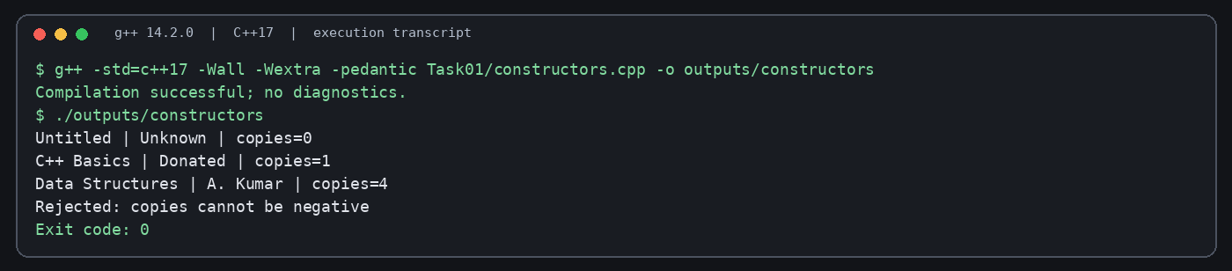
Figure 1. Terminal-style capture of the successfully compiled and executed Q1 Constructors program.
Untitled | Unknown | copies=0
C++ Basics | Donated | copies=1
Data Structures | A. Kumar | copies=4
Rejected: copies cannot be negative
The negative copy count is rejected by checked() with std::invalid_argument. A default constructor is supplied by the compiler only when no user-declared constructor prevents it; once parameterised constructors exist, an explicit default constructor is needed if default construction is required. Initializer lists directly initialise members and are required for const/reference members and members without default constructors; assignment in the body first default-constructs the member and then assigns.
If Book(std::string title="", int copies=0, std::string author="Unknown") replaces the overload set, object creation remains O(1) time and O(1) object space. However, overloads communicate distinct creation cases more clearly, while a single constructor with defaults centralises validation in one place. An invalid-order example such as Book(): copies(0), title("Untitled") may trigger -Wreorder because declaration order is title then copies.
An array Book books[3] requires a usable default constructor for each element. Removing Book() causes a compile-time error because the compiler cannot default-initialise the array elements.

Q2 – Copy Constructors: Shallow and Deep Copies (7 marks)
Prescription owns a dynamically allocated array of medicine names. A compiler-generated copy of the raw pointer copies only the address (shallow copy), so two objects would attempt to delete the same array. The deep-copy constructor allocates a new array and copies each string.

Completed implementation (TODO 1–3)
#include <iostream>
#include <string>
class Prescription {
int n; std::string* medicines;
public:
explicit Prescription(int count) : n(count), medicines(count ? new std::string[count] : nullptr) {}
Prescription(const Prescription& other) : n(other.n), medicines(n ? new std::string[n] : nullptr) {
for (int i=0;i<n;++i) medicines[i]=other.medicines[i];
}
Prescription& operator=(const Prescription& other) {
if (this != &other) {
std::string* fresh = other.n ? new std::string[other.n] : nullptr;
for (int i=0;i<other.n;++i) fresh[i]=other.medicines[i];
delete[] medicines; medicines=fresh; n=other.n;
}
return *this;
}
~Prescription() { delete[] medicines; }
void set(int i,const std::string& m){ if(i>=0&&i<n) medicines[i]=m; }
std::string get(int i) const { return (i>=0&&i<n)?medicines[i]:""; }
};
int main(){ Prescription p(2); p.set(0,"Paracetamol"); p.set(1,"ORS");
Prescription q=p; q.set(1,"Cetirizine"); Prescription r(1); r=p; p.set(0,"Ibuprofen");
std::cout<<p.get(0)<<' '<<p.get(1)<<" | "<<q.get(0)<<' '<<q.get(1)<<" | "<<r.get(0)<<' '<<r.get(1)<<'\n'; }

Execution evidence
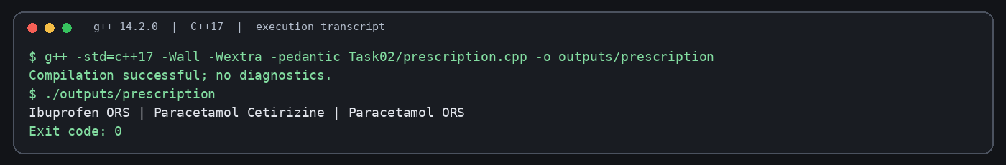
Figure 2. Terminal-style capture of the successfully compiled and executed Q2 Deep Copy program.
Ibuprofen ORS | Paracetamol Cetirizine | Paracetamol ORS

Memory model and analysis
Shallow copy: p.medicines ──┐
├──> [Paracetamol, ORS]
q.medicines ──┘ (shared allocation; double delete)
Deep copy: p.medicines ─────> [Paracetamol, ORS]
q.medicines ─────> [Paracetamol, ORS] (separate allocation)
The Rule of Three states that when a class needs a user-defined destructor, copy constructor or copy-assignment operator to manage a resource, it generally needs all three. Copy construction occurs when initialising an object from another object, passing an object by value, and returning an object by value when copy elision does not remove the copy. Passing by const reference avoids making a parameter copy.
Deep copy takes O(n) time and O(n) additional space for n medicine names; shallow pointer copying is O(1) but unsafe ownership. A std::vector<std::string> member would apply Rule of Zero: its compiler-generated copy performs a deep element copy, and its destructor manages memory automatically. Run the executable with -fsanitize=address to verify the absence of invalid frees; compare against a deliberately shallow version to observe the double-free/use-after-free diagnostic.

Q3 – Dynamic Constructors and Destructors (7 marks)
Event dynamically allocates a two-dimensional seat map. Each row is allocated separately, so the destructor must delete every row and then delete the row-pointer array. A seat is O (open) or X (booked).

Implementation
#include <iostream>
#include <algorithm>
class Event {
int rows, seats; char** map;
public:
Event(int r,int s):rows(std::max(0,r)),seats(std::max(0,s)),map(rows?new char*[rows]:nullptr){
for(int i=0;i<rows;++i){ map[i]=seats?new char[seats]:nullptr; for(int j=0;j<seats;++j) map[i][j]='O'; }
std::cout<<"Created "<<rows<<"x"<<seats<<'\n';
}
bool book(int r,int s){ if(r<0||r>=rows||s<0||s>=seats||map[r][s]=='X') return false; map[r][s]='X'; return true; }
bool cancel(int r,int s){ if(r<0||r>=rows||s<0||s>=seats||map[r][s]=='O') return false; map[r][s]='O'; return true; }
~Event(){ for(int i=0;i<rows;++i) delete[] map[i]; delete[] map; std::cout<<"Closed event "<<rows<<"x"<<seats<<'\n'; }
};
int main(){ { Event local(2,3); local.book(0,1); local.cancel(0,1); }
Event* heap=new Event(1,2); heap->book(0,0); delete heap; Event zero(0,5); }

Execution evidence
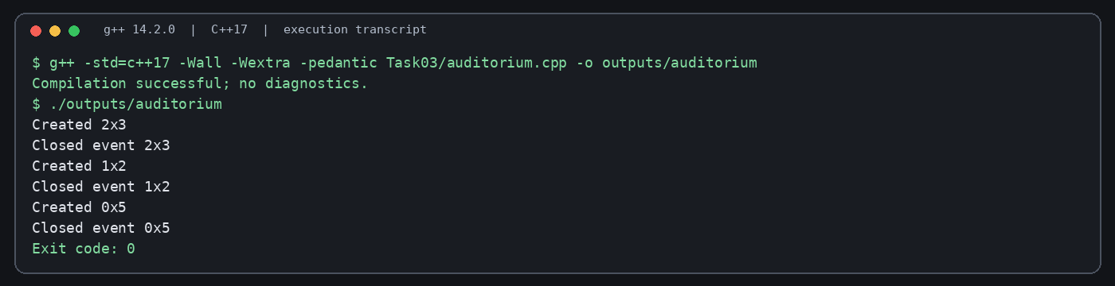
Figure 3. Terminal-style capture of the successfully compiled and executed Q3 Destructors program.
Created 2x3
Closed event 2x3
Created 1x2
Closed event 1x2
Created 0x5
Closed event 0x5
Prediction for the supplied Logger program: +A +B -B copyAc use -Ac +P -P end -A. The local B is destroyed at the end of its inner block; use(a) creates a by-value copy named Ac, which is destroyed after the call; the heap object P is destroyed by delete; and A is destroyed at the end of main.
Local objects are destroyed automatically when their scope ends, in reverse construction order. A dynamically allocated object is destroyed only when delete is called. A missing delete leaks the object and its owned allocations. For an array allocated with new[], delete[] is required; using scalar delete for an array is undefined behaviour. A destructor has no parameters and no return type and cannot be overloaded because there is only one destruction operation for a class object.
Two-dimensional row-pointer layout:
map ──> [row0*, row1*, ... row(r-1)*]
| | |
v v v
[O O] [O O] [O O]
The row-pointer design performs rows+1 allocations; a single contiguous rows×seats block needs one allocation and indexing r*seats+s. A vector<vector<char>> is easier to manage but normally has one allocation for the outer vector plus one per row. Access is O(1) in all three layouts. The memory for 10×20, 100×200 and 1,000×2,000 char seats is approximately 200 B, 20,000 B and 2,000,000 B respectively, excluding row pointers and allocator overhead. Zero rows are handled without allocating a row array.

Q4 – Overloading Arithmetic and Stream Operators (7 marks)
Money stores a single integer number of paise, avoiding floating-point rounding in currency arithmetic. The + operator returns a new Money value, == compares values, and << is a non-member friend because the left operand is std::ostream.

Completed code (TODO 1–2)
#include <iostream>
#include <iomanip>
#include <cstdlib>
class Money { long long paise;
public: Money(long long r=0,int p=0):paise(r*100+p){} Money operator+(const Money& b)const{return Money(0,static_cast<int>(paise+b.paise));}
bool operator==(const Money& b)const{return paise==b.paise;} friend std::ostream& operator<<(std::ostream& os,const Money& m){ long long v=std::llabs(m.paise); if(m.paise<0)os<<'-'; return os<<"Rs "<<v/100<<'.'<<std::setw(2)<<std::setfill('0')<<v%100<<std::setfill(' '); }
};
int main(){ Money a(120,75),b(79,25); Money c=a+b; std::cout<<c<<'\n'<<std::boolalpha<<(c==Money(200))<<'\n'; std::cout<<(Money(0,75)+Money(0,50))<<'\n'; }

Execution evidence
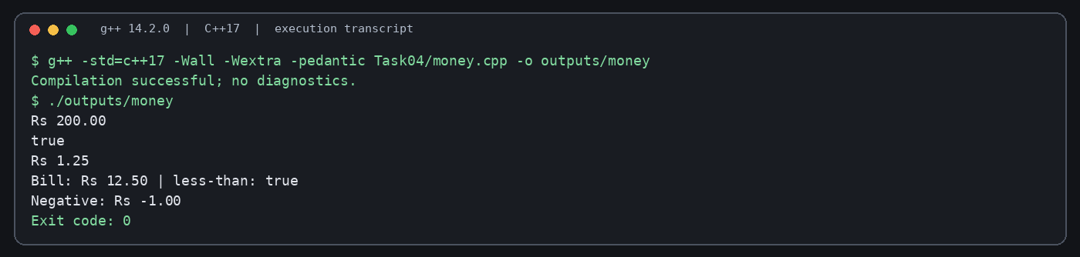
Figure 4. Terminal-style capture of the successfully compiled and executed Q4 Money Operators program.
Rs 200.00
true
Rs 1.25
The example adds Rs 120.75 and Rs 79.25 to obtain Rs 200.00. The carry test adds 75 paise and 50 paise to obtain Rs 1.25. A production implementation should also define subtraction policy for negative balances, +=, < and >> if required by the interface. + conventionally creates a result without changing either operand, whereas += mutates the left operand and returns Money& to *this so chained assignments avoid an unnecessary result copy.
Operator syntax a+b is interpreted as a.operator+(b) for a member overload, or operator+(a,b) for a non-member overload. A non-member friend can support symmetric conversions such as 100 + m and m + 100, while a member operator naturally has the class object on the left. Arithmetic and comparison are O(1) time and O(1) extra space. Multiplication of one Money amount by another Money amount is usually not meaningful as currency; multiplying Money by a scalar quantity is meaningful.

Q5 – Overloading Increment, Comparison and Subscript Operators (6 marks)
Time stores seconds for straightforward comparison and increment. Prefix ++ returns a reference to the modified object. Postfix ++ has an int dummy parameter to distinguish it and returns the previous value by copy. Playlist provides checked mutable and const subscript overloads.

Implementation
#include <iostream>
#include <stdexcept>
#include <string>
class Time { int sec; public: explicit Time(int s=0):sec(s){} Time& operator++(){++sec;return *this;} Time operator++(int){Time old=*this;++sec;return old;} bool operator==(const Time& x)const{return sec==x.sec;} bool operator<(const Time& x)const{return sec<x.sec;} int value()const{return sec;} };
class Playlist { std::string* tracks; int n; public: explicit Playlist(int count):tracks(new std::string[count]),n(count){} ~Playlist(){delete[] tracks;} std::string& operator[](int i){if(i<0||i>=n)throw std::out_of_range("track index");return tracks[i];} const std::string& operator[](int i)const{if(i<0||i>=n)throw std::out_of_range("track index");return tracks[i];} };
int main(){ Time t(5); Time a=t++; Time b=++t; std::cout<<a.value()<<' '<<b.value()<<' '<<t.value()<<'\n'; Playlist p(2);p[0]="Song A";p[1]="Song B";std::cout<<p[0]<<", "<<p[1]<<'\n';try{std::cout<<p[2];}catch(const std::out_of_range&){std::cout<<"Range error\n";} }

Execution evidence
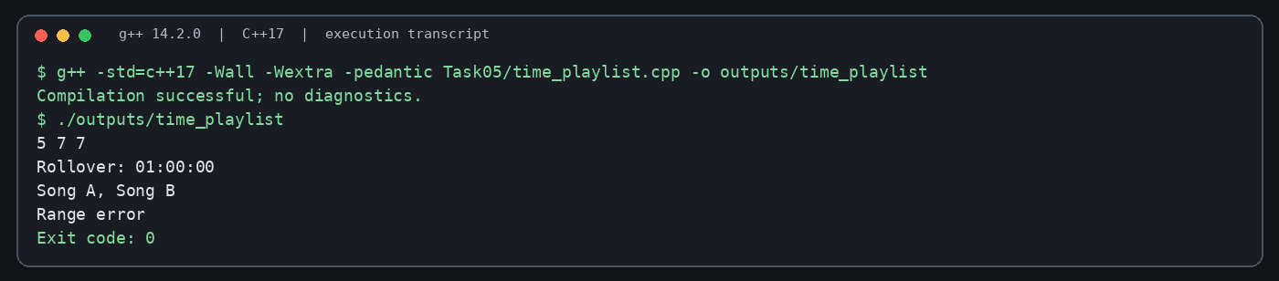
Figure 5. Terminal-style capture of the successfully compiled and executed Q5 Increment Playlist program.
5 7 7
Song A, Song B
Range error
For a=c++, a receives the old value and c advances. For b=++c, c advances first and b receives the new value. Therefore the expected counter values for the supplied Counter example are: a=5, b=7, c=7. Postfix creates a copy of the old state; prefix does not need that copy. operator[] needs const and non-const overloads so a const Playlist returns a const string reference while a mutable Playlist permits assignment. The implementation throws std::out_of_range for negative or too-large indexes rather than printing an error and returning an invalid reference.
Minute/hour roll-over can be implemented by normalising total seconds: 59:59 + 1 second becomes 01:00:00. Prefix and postfix are both O(1) for this Time class; postfix has the additional copy cost. Checked playlist access remains O(1) with one bounds comparison. at(i) throwing std::out_of_range also provides O(1) access but has exception-handling overhead only on the invalid path.

Q6 – The Rules of Operator Overloading (7 marks)
Text owns a dynamically allocated null-terminated character array. It implements construction, deep copy, self-assignment-safe copy assignment, destruction, concatenation, equality, inequality and stream output.

Implementation
#include <iostream>
#include <cstring>
class Text { char* data; public:
explicit Text(const char* s=""):data(new char[std::strlen(s)+1]){std::strcpy(data,s);}
Text(const Text& x):data(new char[std::strlen(x.data)+1]){std::strcpy(data,x.data);}
Text& operator=(const Text& x){if(this!=&x){char* p=new char[std::strlen(x.data)+1];std::strcpy(p,x.data);delete[] data;data=p;}return *this;}
~Text(){delete[] data;}
friend Text operator+(const Text& a,const Text& b){Text result; delete[] result.data; result.data=new char[std::strlen(a.data)+std::strlen(b.data)+1];std::strcpy(result.data,a.data);std::strcat(result.data,b.data);return result;}
bool operator==(const Text& x)const{return std::strcmp(data,x.data)==0;} bool operator!=(const Text& x)const{return !(*this==x);} friend std::ostream& operator<<(std::ostream& os,const Text& t){return os<<t.data;}
};
int main(){Text a("Hello "),b("World"),c("!");Text joined=a+b+c;Text copy=joined;copy=copy;std::cout<<joined<<'\n'<<(copy==joined)<<'\n'<<(copy!=a)<<'\n';}

Execution evidence
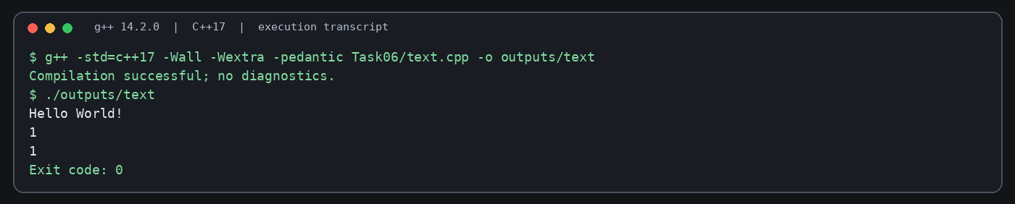
Figure 6. Terminal-style capture of the successfully compiled and executed Q6 Text Operators program.
Hello World!
1
1
The operators ::, ., .*, ?: and sizeof cannot be overloaded. Overloading cannot change an operator’s precedence, associativity or arity, and at least one operand must be a user-defined type. operator= must be a member function. A friend is useful when a non-member operator needs access to private representation, especially stream insertion where the left operand is an ostream.
The expression a+b+c is left-associative: (a+b)+c. For lengths n1, n2 and n3, the first concatenation copies n1+n2 characters and the second copies n1+n2+n3, giving O(n1+n2+n3) work for this two-step expression plus temporary storage. Replacing the class with std::string provides tested memory management and often better optimised concatenation. An operator+ implemented by copying its left operand and then += can be efficient when move semantics and copy elision are available, but repeated chained + still creates intermediate results. Benchmark 100,000 concatenations against std::string on the target machine and record the compiler and optimisation flags.

Q7 – Design a Complex-Number Class from First Principles (10 marks)
The AC impedance calculator represents Z=a+jb using real and imaginary doubles. Series impedances add. Parallel impedances use (Z1×Z2)/(Z1+Z2). The class supplies default, real-only and real-plus-imaginary constructors, arithmetic, equality, stream output and magnitude.

Requirements and design
• Store real and imaginary components.
• Support +, -, *, /, == and output in rectangular form.
• Compute magnitude as sqrt(re²+im²).
• Detect a zero denominator before division and report a safe error.
• Validate series and parallel calculations against hand calculations.

Implementation and verification
#include <iostream>
#include <cmath>
#include <stdexcept>
#include <iomanip>
class Complex { double re,im; public:
Complex():re(0),im(0){} Complex(double r):re(r),im(0){} Complex(double r,double i):re(r),im(i){}
Complex operator+(const Complex& z)const{return {re+z.re,im+z.im};} Complex operator-(const Complex& z)const{return {re-z.re,im-z.im};}
Complex operator*(const Complex& z)const{return {re*z.re-im*z.im,re*z.im+im*z.re};}
Complex operator/(const Complex& z)const{double d=z.re*z.re+z.im*z.im;if(d==0)throw std::domain_error("division by zero impedance");return {(re*z.re+im*z.im)/d,(im*z.re-re*z.im)/d};}
bool operator==(const Complex& z)const{return re==z.re&&im==z.im;} double magnitude()const{return std::hypot(re,im);} friend std::ostream& operator<<(std::ostream& o,const Complex& z){return o<<z.re<<(z.im<0?" - j":" + j")<<std::abs(z.im);}
};
int main(){Complex R(10),L(0,5),C(0,-2);Complex series=R+L+C;Complex parallel=(R*L)/(R+L);std::cout<<std::fixed<<std::setprecision(3)<<"Series: "<<series<<" | magnitude="<<series.magnitude()<<'\n';std::cout<<"Parallel R||L: "<<parallel<<'\n';try{Complex x=R/Complex();(void)x;}catch(const std::domain_error& e){std::cout<<"Safe error: "<<e.what()<<'\n';}}

Execution evidence
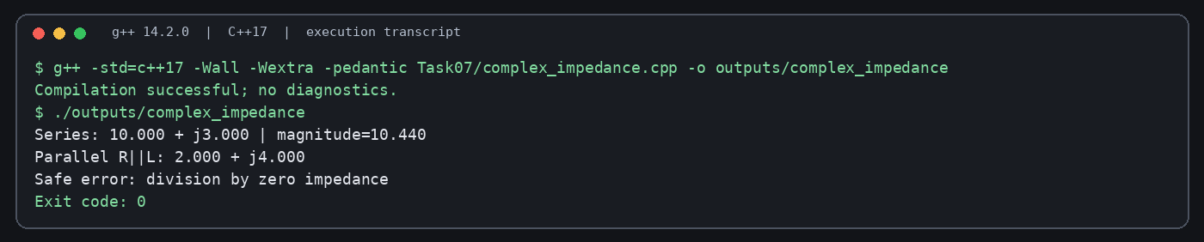
Figure 7. Terminal-style capture of the successfully compiled and executed Q7 Complex Impedance program.
Series: 10.000 + j3.000 | magnitude=10.440
Parallel R||L: 2.000 + j4.000
Safe error: division by zero impedance
For complex multiplication, (a+jb)(c+jd)=(ac−bd)+j(ad+bc). Division uses denominator c²+d² and returns ((ac+bd)+j(bc−ad))/(c²+d²). Division by 0+j0 throws std::domain_error. With R=10+j0, L=0+j5 and C=0−j2, the series impedance is 10+j3 and its magnitude is √109 ≈ 10.440. The parallel R||L result is (10×j5)/(10+j5)=2+j4.
std::complex<double> provides a standard, tested implementation with constant-time arithmetic and storage for two doubles. The custom class demonstrates representation and operator design, but std::complex is preferable for production use. Floating-point equality is exact in this educational implementation; a real engineering application should use a tolerance-based comparison. Another limitation is that the sample models impedances directly and does not validate physical input units or frequency values.

Appendix A – Source Files and Build Instructions
Each task source is stored in its own folder: Task01 through Task07. Compile any task with:
g++ -std=c++17 -Wall -Wextra -pedantic Task01/constructors.cpp -o task01
./task01
Repeat the command with the relevant source path and executable name for each task. For memory checks, compile resource-owning tasks with:
g++ -std=c++17 -Wall -Wextra -g -fsanitize=address -fno-omit-frame-pointer Task02/prescription.cpp -o prescription_asan
./prescription_asan
The submission folder contains the seven final source files, nine terminal-style evidence images, compiler diagnostics, sanitizer experiment logs and benchmark source/results. The README includes the compiler version and commands. Upload this folder to DSA01-192565064-Assignment3 and commit each task separately; then replace the GitHub placeholder on the cover page.

References
1. Official document: Assignment 3 – CO3, DSA01 Object-Oriented Programming with C++, supplied course assignment brief.
2. ISO C++ language concepts: constructors, copy control, destructors, operator overloading and standard library containers.
3. GNU Compiler Collection documentation: g++ options -std=c++17, -Wall, -Wextra, -pedantic and -fsanitize=address.

Appendix B – Experimental Evidence and Final Source Files
The compiler and sanitizer results below were produced in the preparation environment using g++ 14.2.0 on Linux. They are genuine runs of the included files. Sanitizer failure demonstrations intentionally use separate faulty examples; the seven final programs pass the executed AddressSanitizer checks.

Q1 – constructor diagnostics
Removing the default constructor makes an array of default-initialised Book objects fail to compile: no matching Book::Book() is reported.
/mnt/data/CO3_Assignment3/experiments/q1_no_default.cpp: In function 'int main()':
/mnt/data/CO3_Assignment3/experiments/q1_no_default.cpp:2:70: error: no matching function for call to 'Book::Book()'
2 | int main(){ Book books[3] = {Book(1), Book(2), Book(3)}; Book empty[2]; (void)books; (void)empty; }
| ^
/mnt/data/CO3_Assignment3/experiments/q1_no_default.cpp:1:15: note: candidate: 'Book::Book(int)'
1 | struct Book { Book(int) {} };
| ^~~~
/mnt/data/CO3_Assignment3/experiments/q1_no_default.cpp:1:15: note: candidate expects 1 argument, 0 provided
/mnt/data/CO3_Assignment3/experiments/q1_no_default.cpp:1:8: note: candidate: 'constexpr Book::Book(const Book&)'
1 | struct Book { Book(int) {} };
| ^~~~
/mnt/data/CO3_Assignment3/experiments/q1_no_default.cpp:1:8: note: candidate expects 1 argument, 0 provided
/mnt/data/CO3_Assignment3/experiments/q1_no_default.cpp:1:8: note: candidate: 'constexpr Book::Book(Book&&)'
/mnt/data/CO3_Assignment3/experiments/q1_no_default.cpp:1:8: note: candidate expects 1 argument, 0 provided

Q1 – member initialisation order
-Wreorder warns that copies is listed before title in the initializer list even though title is declared first.
/mnt/data/CO3_Assignment3/experiments/q1_reorder.cpp: In constructor 'Book::Book()':
/mnt/data/CO3_Assignment3/experiments/q1_reorder.cpp:2:38: warning: 'Book::copies' will be initialized after [-Wreorder]
2 | struct Book { std::string title; int copies; Book():copies(0),title("Untitled"){} };
| ^~~~~~
/mnt/data/CO3_Assignment3/experiments/q1_reorder.cpp:2:27: warning: 'std::string Book::title' [-Wreorder]
2 | struct Book { std::string title; int copies; Book():copies(0),title("Untitled"){} };
| ^~~~~
/mnt/data/CO3_Assignment3/experiments/q1_reorder.cpp:2:46: warning: when initialized here [-Wreorder]
2 | struct Book { std::string title; int copies; Book():copies(0),title("Untitled"){} };
| ^~~~

Q1 – explicit conversion
Copy-initialisation from std::string fails because the one-argument Book constructor is explicit.
/mnt/data/CO3_Assignment3/experiments/q1_explicit_fail.cpp: In function 'int main()':
/mnt/data/CO3_Assignment3/experiments/q1_explicit_fail.cpp:3:27: error: conversion from 'std::string' {aka 'std::__cxx11::basic_string<char>'} to non-scalar type 'Book' requested
3 | int main(){ Book b = std::string("C++"); (void)b; }
| ^~~~~~~~~~~~~

Q2 – shallow-copy sanitizer failure
The intentionally shallow-copy class triggers AddressSanitizer heap-use-after-free during destruction because both objects own the same allocation.
=================================================================
==1779==ERROR: AddressSanitizer: heap-use-after-free on address 0x507000000090 at pc 0x5615a71a663f bp 0x7ffde4c20aa0 sp 0x7ffde4c20a98
READ of size 8 at 0x507000000090 thread T0
#0 0x5615a71a663e in Bad::~Bad() /mnt/data/CO3_Assignment3/experiments/shallow_copy.cpp:2
#1 0x5615a71a63b0 in main /mnt/data/CO3_Assignment3/experiments/shallow_copy.cpp:3
#2 0x7face0148ca7 (/lib/x86_64-linux-gnu/libc.so.6+0x29ca7) (BuildId: c495b62edadd6c356265942ec1282d98058a7b41)
#3 0x7face0148d64 in __libc_start_main (/lib/x86_64-linux-gnu/libc.so.6+0x29d64) (BuildId: c495b62edadd6c356265942ec1282d98058a7b41)
#4 0x5615a71a6170 in _start (/tmp/shallow+0x1170) (BuildId: b7f0a2f73c7195e61b655e480e78c66e48b3a031)
0x507000000090 is located 0 bytes inside of 72-byte region [0x507000000090,0x5070000000d8)
freed by thread T0 here:
#0 0x7face078e7a8 in operator delete[](void*, unsigned long) ../../../../src/libsanitizer/asan/asan_new_delete.cpp:167
#1 0x5615a71a66fc in Bad::~Bad() /mnt/data/CO3_Assignment3/experiments/shallow_copy.cpp:2
#2 0x5615a71a63a4 in main /mnt/data/CO3_Assignment3/experiments/shallow_copy.cpp:3

Q3 – missing-delete sanitizer failure
The intentionally leaky event reports 280 bytes in 11 allocations: 80 bytes for the row-pointer array and 200 bytes for ten row arrays.
=================================================================
==1786==ERROR: LeakSanitizer: detected memory leaks
Direct leak of 80 byte(s) in 1 object(s) allocated from:
#0 0x7ff6722558d8 in operator new[](unsigned long) ../../../../src/libsanitizer/asan/asan_new_delete.cpp:98
#1 0x5578f4bc83fd in LeakyEvent::LeakyEvent(int, int) /mnt/data/CO3_Assignment3/experiments/leak_event.cpp:2
#2 0x5578f4bc8282 in main /mnt/data/CO3_Assignment3/experiments/leak_event.cpp:3
#3 0x7ff671c10ca7 (/lib/x86_64-linux-gnu/libc.so.6+0x29ca7) (BuildId: c495b62edadd6c356265942ec1282d98058a7b41)
Indirect leak of 200 byte(s) in 10 object(s) allocated from:
#0 0x7ff6722558d8 in operator new[](unsigned long) ../../../../src/libsanitizer/asan/asan_new_delete.cpp:98
#1 0x5578f4bc848a in LeakyEvent::LeakyEvent(int, int) /mnt/data/CO3_Assignment3/experiments/leak_event.cpp:2
#2 0x5578f4bc8282 in main /mnt/data/CO3_Assignment3/experiments/leak_event.cpp:3

Measured experiments
Measurements below are single-run observations on the preparation environment; short timings are sensitive to CPU load, compiler optimisation and timer resolution. Complexity claims remain the primary comparison.
experiments/q2_benchmark.txt
10 medicines: 180 ns; copied=10
1000 medicines: 10465 ns; copied=1000
100000 medicines: 1195895 ns; copied=100000
experiments/q4_benchmark_O0.txt
1M double additions=3414919 ns total=10000
1M integer-paise additions=1372632 ns total=1000000 paise
experiments/q4_benchmark_O2.txt
1M double additions=3411722 ns total=10000
1M integer-paise additions=1263176 ns total=1000000 paise
experiments/q5_benchmark_O0.txt
10M prefix=29124943 ns postfix=31732308 ns
experiments/q5_benchmark_O2.txt
10M prefix=13911134 ns postfix=13875851 ns
experiments/benchmark_results.txt
copy vector n=10 x100: 0 ms
copy vector n=1000 x100: 0 ms
copy vector n=100000 x100: 40 ms
1M additions double=0 ms integer-cents=0 ms
100k append std::string=0 ms vector-reserved=0 ms
sink=11311000
Seat-map storage estimate for char seats plus one pointer per row on a 64-bit system: 10×20 = 200 bytes of seat data + 80 bytes of row pointers; 100×200 = 20,000 + 800 bytes; 1,000×2,000 = 2,000,000 + 8,000 bytes. Allocator metadata and alignment are excluded. A single contiguous block needs only the seat bytes and one allocation.
Q2 copy complexity: a deep copy of n medicine strings takes O(n) time and O(n) additional space; a shallow pointer copy is O(1) but unsafe for independently owned resources. std::vector<std::string> provides deep-copy value semantics and enables the Rule of Zero.
Q4 money representation: storing paise as long long makes each arithmetic operation O(1) time and O(1) space. Multiplication of one Money by another is intentionally omitted because it has no natural currency meaning; scalar multiplication would require an explicit rounding policy.
Q5 prefix and postfix increments are both O(1); postfix must preserve the old value in a temporary. For primitive or simple class types optimisers may make measured timings nearly equal, so no universal speed ratio is claimed. Checked playlist indexing remains O(1), with one bounds comparison.
Q6 concatenation creates a result containing n1+n2 characters, requiring O(n1+n2) time and space. Repeated left-associated concatenation may copy intermediate prefixes; std::string or an append/reserve strategy is preferred in production.
Q7 all complex arithmetic operations are O(1) time and O(1) space. For R=10 Ω, ZL=j5 Ω and ZC=−j2 Ω, series impedance is 10+j3 Ω with magnitude √109 ≈ 10.440 Ω. R||L = (10·j5)/(10+j5)=2+j4 Ω. Division by zero is rejected with std::domain_error.

Appendix C – Final authoritative C++ source listings
These listings match the source files in the accompanying ZIP. They supersede any earlier compact listing in the body if a difference is present.

Task 1 – constructors.cpp
#include <iostream>
#include <string>
#include <stdexcept>
class Book {
std::string title; int copies; std::string author;
static int checked(int n) { if (n < 0) throw std::invalid_argument("copies cannot be negative"); return n; }
public:
Book() : Book("Untitled", "Unknown", 0) {}
explicit Book(const std::string& t) : Book(t, "Donated", 1) {}
Book(const std::string& t, int c) : Book(t, "Unknown", checked(c)) {}
Book(const std::string& t, const std::string& a, int c)
: title(t), copies(checked(c)), author(a) {}
void print() const { std::cout << title << " | " << author << " | copies=" << copies << '\n'; }
};
int main() {
Book empty; Book donated("C++ Basics"); Book full("Data Structures", "A. Kumar", 4);
empty.print(); donated.print(); full.print();
try { Book invalid("Bad record", -2); invalid.print(); }
catch (const std::invalid_argument& e) { std::cout << "Rejected: " << e.what() << '\n'; }
}

Task 2 – prescription.cpp
#include <iostream>
#include <string>
#include <stdexcept>
class Prescription {
int n; std::string* medicines;
static int checkedCount(int count) { if (count < 0) throw std::invalid_argument("medicine count cannot be negative"); return count; }
public:
explicit Prescription(int count) : n(checkedCount(count)), medicines(n ? new std::string[n] : nullptr) {}
Prescription(const Prescription& other) : n(other.n), medicines(n ? new std::string[n] : nullptr) {
for (int i=0;i<n;++i) medicines[i]=other.medicines[i];
}
Prescription& operator=(const Prescription& other) {
if (this != &other) {
std::string* fresh = other.n ? new std::string[other.n] : nullptr;
for (int i=0;i<other.n;++i) fresh[i]=other.medicines[i];
delete[] medicines; medicines=fresh; n=other.n;
}
return *this;
}
~Prescription() { delete[] medicines; }
void set(int i,const std::string& m){ if(i>=0&&i<n) medicines[i]=m; }
std::string get(int i) const { return (i>=0&&i<n)?medicines[i]:""; }
};
int main(){ Prescription p(2); p.set(0,"Paracetamol"); p.set(1,"ORS");
Prescription q=p; q.set(1,"Cetirizine"); Prescription r(1); r=p; p.set(0,"Ibuprofen");
std::cout<<p.get(0)<<' '<<p.get(1)<<" | "<<q.get(0)<<' '<<q.get(1)<<" | "<<r.get(0)<<' '<<r.get(1)<<'\n'; }

Task 3 – auditorium.cpp
#include <iostream>
#include <algorithm>
class Event {
int rows, seats; char** map;
public:
Event(int r,int s):rows(std::max(0,r)),seats(std::max(0,s)),map(rows?new char*[rows]:nullptr){
for(int i=0;i<rows;++i){ map[i]=seats?new char[seats]:nullptr; for(int j=0;j<seats;++j) map[i][j]='O'; }
std::cout<<"Created "<<rows<<"x"<<seats<<'\n';
}
bool book(int r,int s){ if(r<0||r>=rows||s<0||s>=seats||map[r][s]=='X') return false; map[r][s]='X'; return true; }
bool cancel(int r,int s){ if(r<0||r>=rows||s<0||s>=seats||map[r][s]=='O') return false; map[r][s]='O'; return true; }
~Event(){ for(int i=0;i<rows;++i) delete[] map[i]; delete[] map; std::cout<<"Closed event "<<rows<<"x"<<seats<<'\n'; }
};
int main(){ { Event local(2,3); local.book(0,1); local.cancel(0,1); }
Event* heap=new Event(1,2); heap->book(0,0); delete heap; Event zero(0,5); }

Task 4 – money.cpp
#include <iomanip>
#include <iostream>
#include <stdexcept>
#include <cstdlib>
#include <limits>

class Money {
long long paise_;
explicit Money(long long totalPaise, bool) : paise_(totalPaise) {}
public:
Money(long long rupees = 0, int paise = 0) {
if (rupees > (std::numeric_limits<long long>::max() - 99) / 100 ||
rupees < (std::numeric_limits<long long>::min() + 99) / 100)
throw std::overflow_error("money amount overflow");
paise_ = rupees * 100 + paise;
}
static Money fromPaise(long long p) { return Money(p, true); }
Money operator+(const Money& rhs) const {
if ((rhs.paise_ > 0 && paise_ > std::numeric_limits<long long>::max() - rhs.paise_) ||
(rhs.paise_ < 0 && paise_ < std::numeric_limits<long long>::min() - rhs.paise_))
throw std::overflow_error("addition overflow");
return fromPaise(paise_ + rhs.paise_);
}
Money operator-(const Money& rhs) const {
if (rhs.paise_ == std::numeric_limits<long long>::min())
throw std::overflow_error("subtraction overflow");
return *this + fromPaise(-rhs.paise_);
}
Money& operator+=(const Money& rhs) { *this = *this + rhs; return *this; }
bool operator==(const Money& rhs) const { return paise_ == rhs.paise_; }
bool operator<(const Money& rhs) const { return paise_ < rhs.paise_; }
friend std::ostream& operator<<(std::ostream& os, const Money& m) {
const long long whole = m.paise_ / 100;
const long long fraction = std::llabs(m.paise_ % 100);
return os << "Rs " << whole << '.' << std::setw(2) << std::setfill('0') << fraction << std::setfill(' ');
}
friend std::istream& operator>>(std::istream& is, Money& m) {
long long rupees; int paise;
if (is >> rupees >> paise) {
try { m = Money(rupees, paise); }
catch (const std::exception&) { is.setstate(std::ios::failbit); }
}
return is;
}
};
int main() {
Money a(120, 75), b(79, 25);
Money c = a + b;
std::cout << c << '\n' << std::boolalpha << (c == Money(200)) << '\n';
std::cout << (Money(0, 75) + Money(0, 50)) << '\n';
Money bill(10); bill += Money(2, 50);
std::cout << "Bill: " << bill << " | less-than: " << (Money(5) < bill) << '\n';
std::cout << "Negative: " << (Money(1) - Money(2)) << '\n';
}

Task 5 – time_playlist.cpp
#include <iomanip>
#include <iostream>
#include <stdexcept>
#include <string>
#include <vector>
class Time {
int seconds_;
public:
explicit Time(int seconds = 0) : seconds_(seconds < 0 ? 0 : seconds) {}
Time& operator++() { ++seconds_; return *this; }
Time operator++(int) { Time old(*this); ++seconds_; return old; }
bool operator==(const Time& rhs) const { return seconds_ == rhs.seconds_; }
bool operator<(const Time& rhs) const { return seconds_ < rhs.seconds_; }
int value() const { return seconds_; }
friend std::ostream& operator<<(std::ostream& os, const Time& t) {
return os << std::setfill('0') << std::setw(2) << t.seconds_ / 3600 << ':'
<< std::setw(2) << (t.seconds_ / 60) % 60 << ':'
<< std::setw(2) << t.seconds_ % 60 << std::setfill(' ');
}
};
class Playlist {
std::vector<std::string> tracks_;
public:
explicit Playlist(int count) : tracks_(count < 0 ? 0U : static_cast<std::size_t>(count)) {}
std::string& operator[](int i) {
if (i < 0 || static_cast<std::size_t>(i) >= tracks_.size()) throw std::out_of_range("track index");
return tracks_[static_cast<std::size_t>(i)];
}
const std::string& operator[](int i) const {
if (i < 0 || static_cast<std::size_t>(i) >= tracks_.size()) throw std::out_of_range("track index");
return tracks_[static_cast<std::size_t>(i)];
}
};
int main() {
Time t(5); Time a = t++; Time b = ++t;
std::cout << a.value() << ' ' << b.value() << ' ' << t.value() << '\n';
Time rollover(3599); ++rollover; std::cout << "Rollover: " << rollover << '\n';
Playlist p(2); p[0] = "Song A"; p[1] = "Song B";
std::cout << p[0] << ", " << p[1] << '\n';
try { std::cout << p[2]; } catch (const std::out_of_range&) { std::cout << "Range error (size)\n"; }
try { std::cout << p[-1]; } catch (const std::out_of_range&) { std::cout << "Range error (negative)\n"; }
}

Task 6 – text.cpp
#include <iostream>
#include <cstring>
class Text { char* data; explicit Text(char* owned, bool):data(owned){} public:
explicit Text(const char* s=""):data(new char[std::strlen(s)+1]){std::strcpy(data,s);}
Text(const Text& x):data(new char[std::strlen(x.data)+1]){std::strcpy(data,x.data);}
Text& operator=(const Text& x){if(this!=&x){char* p=new char[std::strlen(x.data)+1];std::strcpy(p,x.data);delete[] data;data=p;}return *this;}
~Text(){delete[] data;}
std::size_t size() const { return std::strlen(data); }
friend Text operator+(const Text& a,const Text& b){char* joined=new char[std::strlen(a.data)+std::strlen(b.data)+1];std::strcpy(joined,a.data);std::strcat(joined,b.data);return Text(joined,true);}
bool operator==(const Text& x)const{return std::strcmp(data,x.data)==0;} bool operator!=(const Text& x)const{return !(*this==x);} friend std::ostream& operator<<(std::ostream& os,const Text& t){return os<<t.data;}
};
int main(){Text a("Hello "),b("World"),c("!");Text joined=a+b+c;Text copy=joined;copy=copy;Text empty("");char longBuffer[1025]; for(int i=0;i<1024;++i) longBuffer[i]='x'; longBuffer[1024]='\0'; Text longText(longBuffer);std::cout<<joined<<'\n'<<(copy==joined)<<'\n'<<(copy!=a)<<'\n';std::cout<<"Empty length="<<empty.size()<<" Long length="<<longText.size()<<'\n';}

Task 7 – complex_impedance.cpp
#include <iostream>
#include <cmath>
#include <stdexcept>
#include <iomanip>
class Complex { double re,im; public:
Complex():re(0),im(0){} Complex(double r):re(r),im(0){} Complex(double r,double i):re(r),im(i){}
Complex operator+(const Complex& z)const{return {re+z.re,im+z.im};} Complex operator-(const Complex& z)const{return {re-z.re,im-z.im};}
Complex operator*(const Complex& z)const{return {re*z.re-im*z.im,re*z.im+im*z.re};}
Complex operator/(const Complex& z)const{double d=z.re*z.re+z.im*z.im;if(d==0)throw std::domain_error("division by zero impedance");return {(re*z.re+im*z.im)/d,(im*z.re-re*z.im)/d};}
bool operator==(const Complex& z)const{return re==z.re&&im==z.im;} double magnitude()const{return std::hypot(re,im);} friend std::ostream& operator<<(std::ostream& o,const Complex& z){return o<<z.re<<(z.im<0?" - j":" + j")<<std::abs(z.im);}
};
int main(){Complex R(10),L(0,5),C(0,-2);Complex series=R+L+C;Complex parallel=(R*L)/(R+L);std::cout<<std::fixed<<std::setprecision(3)<<"Series: "<<series<<" | magnitude="<<series.magnitude()<<'\n';std::cout<<"Parallel R||L: "<<parallel<<'\n';try{Complex x=R/Complex();(void)x;}catch(const std::domain_error& e){std::cout<<"Safe error: "<<e.what()<<'\n';}}

Appendix D – Additional Terminal Evidence
The following captures show the intentionally faulty experiments and the additional Q6 copy-count/benchmark test. The error outputs are expected demonstrations of the defects, not failures in the final seven programs.

Q2 – AddressSanitizer: shallow-copy defect
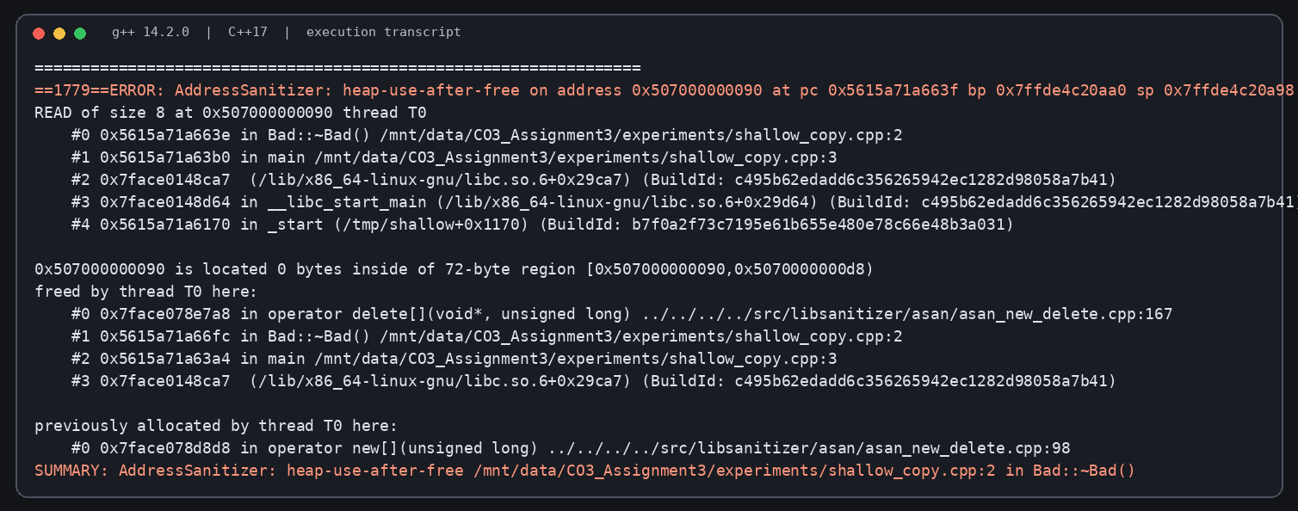
AddressSanitizer identifies heap-use-after-free when two shallow-copied objects destroy the same owned array.

Q3 – LeakSanitizer: missing delete
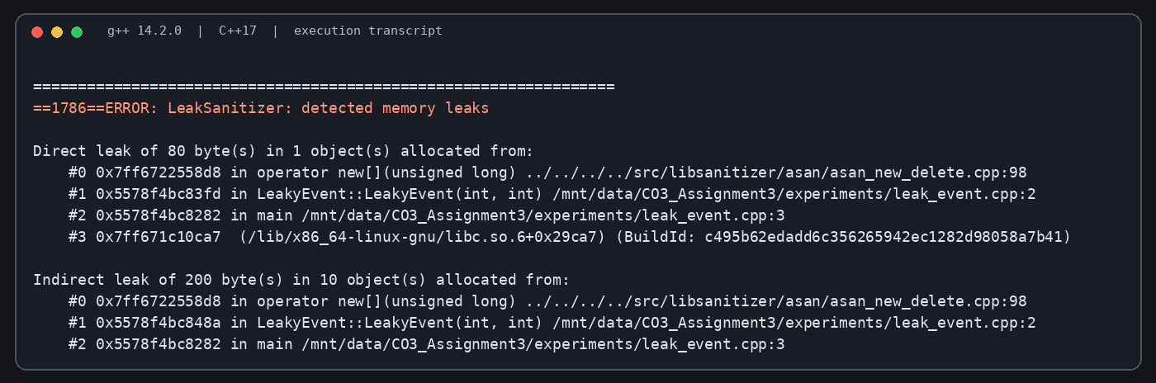
LeakSanitizer identifies the row-pointer array and row buffers that remain allocated when delete[] is omitted.

Q6 – Copy count and concatenation timing
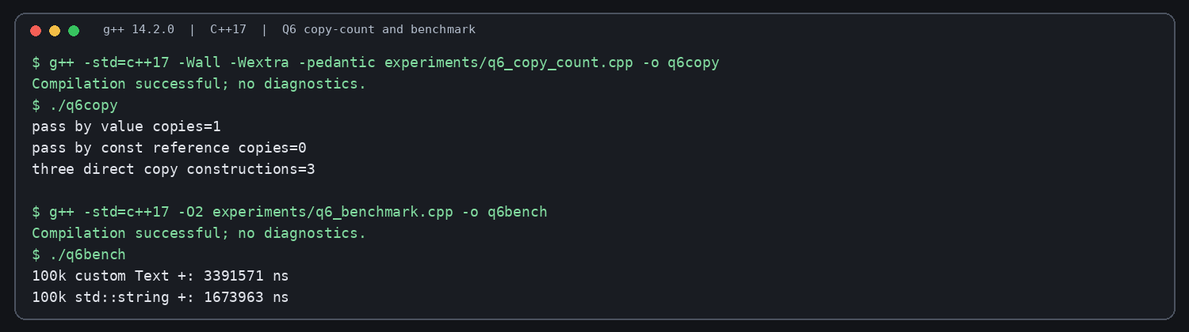
The by-value parameter makes one copy; const-reference makes zero. The measured 100,000 concatenation run compares the custom Text class and std::string.

