SIMATS ENGINEERING
Department of Information Technology
SIMATS ENGINEERING
Department of Information Technology
DSA01 – Object-Oriented Programming with C++

ASSIGNMENT 5 – CO5
RELIABLE SOFTWARE WITH RUNTIME POLYMORPHISM AND EXCEPTIONS
CO5: Build robust C++ applications by applying virtual functions, runtime polymorphism and exception handling mechanisms to develop reliable and error-resilient software solutions.

Student Name | SWETHAMBIGAI.S | Register Number | 192565064
Department / Section | B.Tech CSE Cyber Security | Academic Year / Semester | 2nd year
Faculty Name | Amritha | Nature of Assignment | Individual
Duration | 1 Week | Total Marks | 50
Date of Submission | 23.11.2026 | Date of Evaluation
GitHub Repository | DSA01-192565064-Assignment5 | Compiler | g++ 13.3.0, -std=c++17 -Wall -Wextra

MARK SHEET (Rubric-based Evaluation)
Task | Task Title | Max | Marks Awarded | Remarks
1 | Object-Oriented Analysis | 4
2 | Tokens, Keywords, Identifiers and Constants | 3
3 | Data Types and Compatibility | 4
4 | Implicit Conversions | 4

5 | Operators and Precedence | 4
6 | Control Structures | 4
7 | Procedural vs Object-Oriented | 4
8 | Input and Output | 4
9 | Implementation and Testing | 4
10 | Expectation vs Execution | 4
11 | Final Recommendation | 4
12A | Re-evaluate: Impact Analysis | 2
12B | Re-evaluate: Evaluation of Original Design | 2
12C | Re-evaluate: Adaptation or Redesign | 2
12D | Re-evaluate: Evidence-Based Defence | 2
 | TOTAL | 50 |  | Percentage:

Declaration and scope of this report
This report follows the supplied Assignment 5 – CO5 brief and uses the supplied Assignment 1 DOCX as the formatting reference. The case study, task sequence and expected outputs are taken from the Assignment 5 question PDF.
The C++ programs and benchmark harnesses were compiled and executed in a Linux environment using g++ 14.2.0. Terminal-style figures in this report are captures of those local program runs. They are not screenshots from the student’s personal computer. The benchmark values are one measured run and are machine-, load- and compiler-dependent.
The supplied brief requires a GitHub repository, progressive commits and a working repository link. A repository link cannot be generated on the student’s behalf in this document; the actual link must be inserted on the cover page and submitted to faculty.

Case study and engineering objective
The hospital raises out-patient bills (consultation and tests), in-patient bills (room charges per day, procedures and medicines), day-care surgery bills (package price) and emergency bills (base charge plus time-based charges). Payment may be made by the patient, insurance within policy cover, or a government scheme with fixed package rates.
The design objective is to process different bill types through one common interface, add new bill and payer types with minimal changes, reject invalid claims with clear reasons, and preserve resources when exceptions occur.
Design concern | Chosen approach
Common bill behaviour | Abstract Bill base class with pure virtual total() and type(); shared print().
Runtime selection | Virtual dispatch through Bill pointers / references.
Payer policies | Abstract Payer interface with derived payer classes.
Error reporting | Typed exceptions derived from std::exception.
Resource safety | RAII and smart pointers; catch, log and rethrow at suitable boundaries.
Evaluation | Correctness tests, alternative designs, Big-O analysis and timing experiments.

TASK A1 – DESIGN THE POLYMORPHIC BILL HIERARCHY (7 Marks)

A1.1 – Identify the Common Interface
Every bill must expose a total amount, a bill type and a printable representation. The patient identifier is common data. The base class owns the patient field and defines the operations that all bill types must support.

Common member | Kind | Purpose
patient | Data | Patient name or record identifier shared by all bill types.
total() const | Pure virtual function | Returns the calculated bill amount; formula differs by bill type.
type() const | Virtual function | Returns a short bill-type label such as OP or IP.
print() const | Concrete member function | Prints type, patient and total using the common interface.
~Bill() | Virtual destructor | Allows safe deletion through a Bill pointer.

A1.2 – Design the Hierarchy
Bill is abstract because total() is pure virtual. The derived classes specialise the calculation: OutPatientBill adds consultation and test charges; InPatientBill multiplies room rate by number of days and adds surgery/procedure charges; DayCareBill returns its package price; EmergencyBill adds a base charge to an hourly charge multiplied by duration.
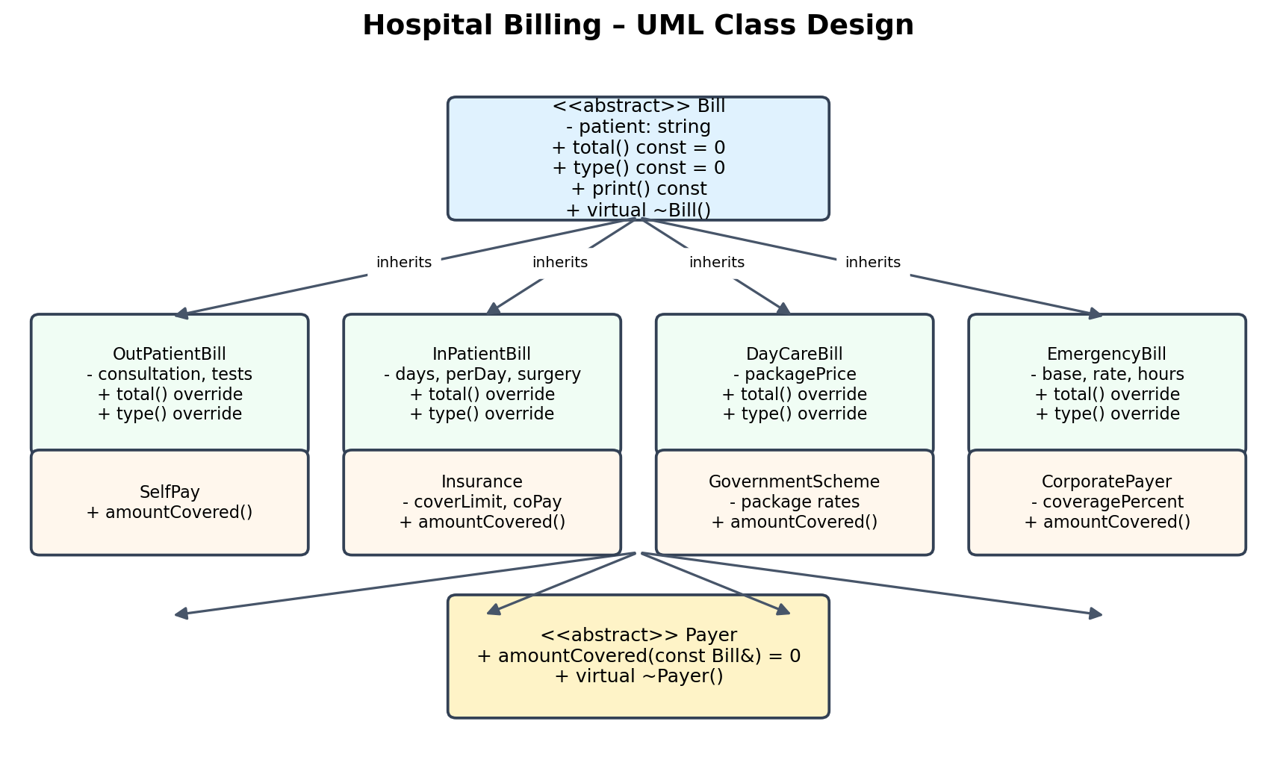
Figure A1: UML-style class diagram for Bill and Payer hierarchies.
class Bill {
protected:
std::string patient;
public:
virtual ~Bill() = default;
virtual double total() const = 0; // pure virtual
virtual std::string type() const = 0; // pure virtual
void print() const; // concrete function
};

A1.3 – Process All Bills Together
An array or vector of Bill pointers can contain addresses of different derived objects. Calling total() on each pointer invokes the override belonging to the actual object.
ALGORITHM CalculateDayTotal
INPUT: bills[0 ... n-1], an array of Bill pointers
totalDay ← 0
FOR i ← 0 TO n-1
IF bills[i] = NULL THEN
CONTINUE
END IF
totalDay ← totalDay + bills[i].total()
bills[i].print()
END FOR
OUTPUT totalDay
END ALGORITHM

Alternative concept and complexity analysis
A tagged structure could store a type field and all possible charge fields. Its total() operation would use switch(type) to choose the formula. Both designs take O(n) time to total n bills because each bill is processed once. The tagged structure stores the union of possible fields (or all fields) in each record; the polymorphic design stores the selected derived data plus an implementation-level vptr. The switch design requires editing the central switch whenever a new bill type is added. The polymorphic design permits a new derived class to implement the interface without editing the existing Bill class or the loop.
Criterion | Virtual hierarchy | One struct + switch
Total n bills | O(n) | O(n)
Per-bill dispatch | Virtual call | Type test and switch
New bill type | Add derived class | Edit struct and central switch
Extensibility | Open for extension | Central decision logic grows
Storage | Base state + derived fields + typical vptr | Common record containing type and required fields

TASK A2 – UNDERSTAND RUNTIME BINDING (5 Marks)

A2.1 – Early and Late Binding
Early binding selects a function using the static type known at compile time. A non-virtual call through a Bill pointer is resolved using Bill. Late binding applies to virtual functions: the call is dispatched using the dynamic type of the object at run time. Therefore, Bill* b = new OutPatientBill(...); followed by b->total() calls OutPatientBill::total().

A2.2 – The Virtual Table
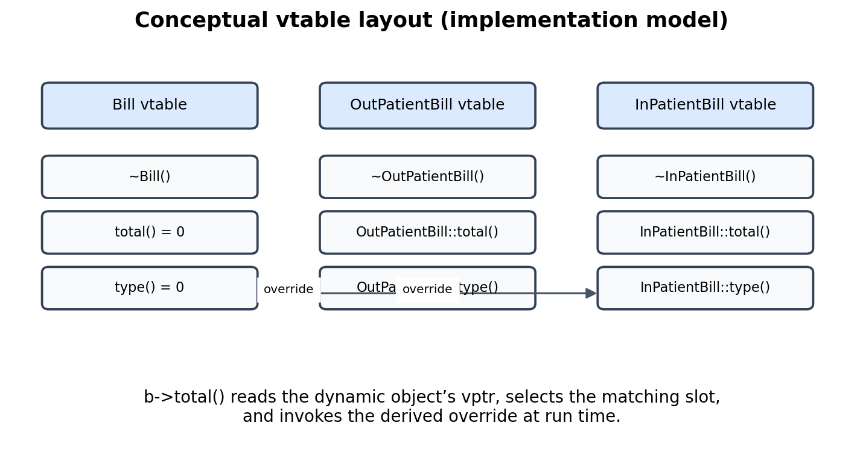
Figure A2: Conceptual vtable slots. Exact layout is compiler ABI-specific.
A vtable is a common implementation technique, not a layout mandated by the C++ language. Conceptually, each polymorphic class has entries for its virtual functions. A polymorphic object usually stores a hidden pointer (vptr) to the appropriate table. The call b->total() uses the object’s dynamic type to select the correct override.

A2.3 – Virtual Destructors
Bill must have a virtual destructor because derived objects are deleted through Bill*. With a virtual destructor, destruction begins at the most-derived type and then proceeds through base classes. Without it, deleting a derived object through a base pointer has undefined behaviour; derived cleanup may not run and resources may be leaked.

Predict the Output
Prediction before execution:
500 ~OPBill ~Bill
The output is 500 followed by the derived destructor message and then the base destructor message. show() is non-virtual, but it calls total(), which is virtual. The call to show() is statically bound to Bill::show(); the nested call to total() is dynamically dispatched to OPBill::total().
If virtual is removed from ~Bill, deleting the OPBill through Bill* has undefined behaviour. A common observed manifestation is that only the base destructor runs or the runtime reports a new/delete type mismatch. The exact manifestation is not guaranteed. AddressSanitizer is intended to help diagnose the invalid deletion, but its runtime could not initialise in this execution environment (shadow-memory reservation failure); no sanitizer result is claimed.

Alternative concept and complexity analysis
Without virtual total(), the program could use dynamic_cast to test for each supported derived type and call its calculation. With k bill types, the worst case may require up to k casts per bill, so processing n bills can take O(nk) type checks in the worst case. A virtual design performs one dispatch per bill, O(n) total. A typical polymorphic object uses one vptr-sized field in addition to its data; exact object sizes are implementation-dependent. A cast-based design may not require virtual dispatch for total(), but dynamic_cast itself requires suitable RTTI support and can still be costly.

TASK A3 – DESIGN WITH ABSTRACT CLASSES (5 Marks)

A3.1 – Payer Interface
Payer is an abstract class with amountCovered(const Bill&) as a pure virtual function. Each payer implements its own policy while the billing workflow remains independent of the payer type.
Class | Policy data | amountCovered() rule
SelfPay | None | Returns the full bill total.
Insurance | coverLimit, coPaymentPercent | Returns the lesser of policy cover limit and the amount remaining after co-payment.
GovernmentScheme | Fixed rates by bill type | Returns the applicable fixed package amount, capped at the bill total.
CorporatePayer (extension) | coveragePercent | Returns the configured percentage of the bill total.

class Payer {
public:
virtual ~Payer() = default;
virtual double amountCovered(const Bill& bill) const = 0;
};
For the implementation in this report, insurance coverage is calculated as min(coverLimit, bill.total() × (1 − coPay/100)). This is an explicit policy assumption for demonstration; actual policy contracts may define deductibles, exclusions and per-claim limits differently.

A3.2 – Extension
A corporate tie-up is added by defining CorporatePayer : public Payer and overriding amountCovered(). Existing Bill classes, payer classes and code that accepts a Payer reference do not need modification. This demonstrates programming to an interface.

Alternative concept and complexity analysis
A function pointer or std::function can hold a policy callable selected at run time. Each callable receives a Bill and returns the covered amount. A captured lambda can store the cover limit and co-payment percentage. Both interface dispatch and function invocation are O(1) per bill, so n evaluations are O(n). A derived payer object stores its policy data as named fields; a std::function may also carry a callable target and type-erasure storage, possibly allocating for large captures. The class hierarchy is clearer when payer policies have meaningful state and behaviour; std::function is convenient when policies are small configurable callables.

TASK A4 – DESIGN THE EXCEPTION STRATEGY (4 Marks)

A4.1 – Identify the Errors
Error condition | Exception / handling
Negative consultation, room, package or emergency charge | std::invalid_argument or BillingError
Claim exceeds insurance cover | ClaimError derived from BillingError
Unknown government package code | BillingError with an explicit package message
Missing patient record | BillingError / PatientRecordError
Text supplied where numeric input is expected | std::invalid_argument from std::stod
Numeric input outside supported range | std::out_of_range
Allocation failure | std::bad_alloc

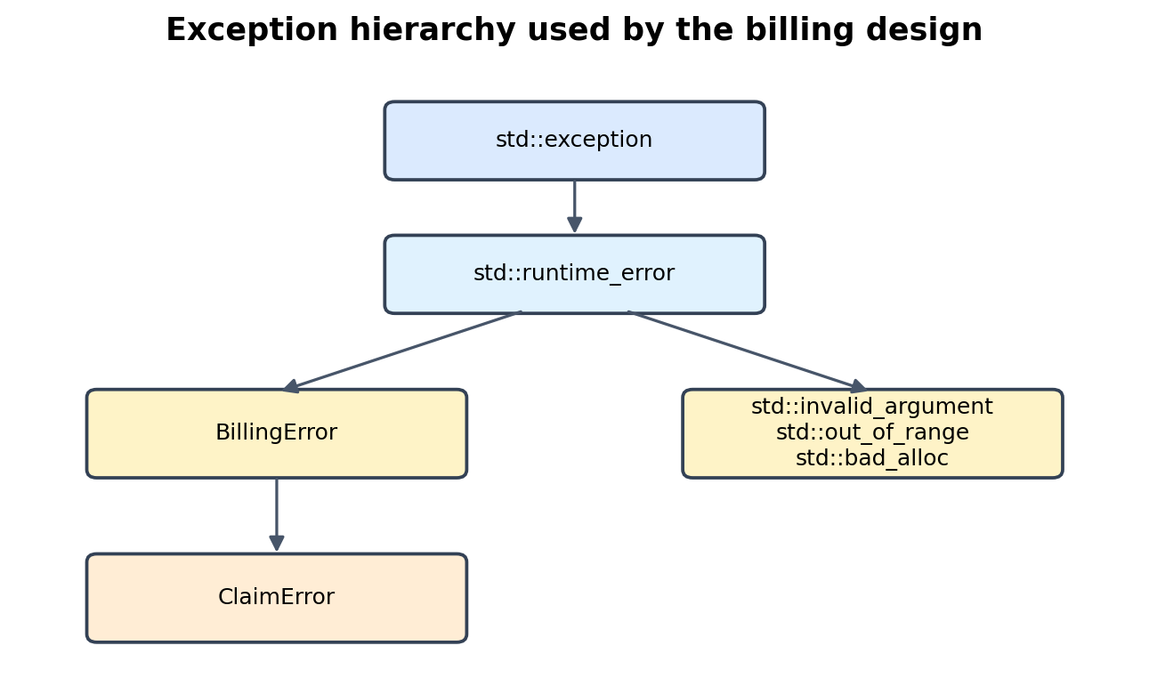
Figure A4: Exception inheritance used in the solution.

A4.2 – Specify Exceptions
Constructors and validation functions may throw when their preconditions are violated. total() may be specified noexcept only if all calculations are guaranteed not to throw and do not perform throwing operations; this implementation does not impose noexcept on total(). Payer calculation may similarly throw for invalid configuration. Logging may throw if it allocates or writes to a failing stream, so it should not be casually marked noexcept.
Destructors should not throw. During stack unwinding, a second exception escaping a destructor can call std::terminate. Destructors should release resources and report cleanup failures through non-throwing mechanisms.
Function / operation | Exception specification | Reason
Bill and Payer destructors | noexcept (implicit/default) | Cleanup must not interrupt unwinding.
validateCharge() | May throw | Invalid domain values must be reported.
approve() / settle() | May throw | Claim validation and audit rethrow.
total() | Not declared noexcept here | Future charge validation may throw.
RAII cleanup destructor | noexcept | Resource release must remain safe.

Alternative concept and complexity analysis
A return-code design could return Status plus an output parameter and error message. Normal-path work remains O(1), and an error path performs a status check and message construction. It avoids stack unwinding but forces every caller to check and propagate the status. Extra storage is needed for the status and possibly a message object. Exceptions keep normal-path code uncluttered but are expensive when frequently thrown; return codes or expected-like results are preferable for routine, expected validation failures.

TASK A5 – DESIGN RECOVERY AND RETHROWING (4 Marks)

A5.1 – Where to Catch
The lowest layer detects an error and throws a typed exception. A service boundary may catch a specific exception to add audit context, write a log entry and rethrow using throw; so the original exception object is preserved. The application boundary catches the exception, translates it into a user-facing message and decides whether to continue with the next bill. A catch(...) at the outermost boundary is a final safety net for unexpected non-standard exceptions; it should not replace specific handlers.
try {
return approve(billed, cover);
} catch (const ClaimError& e) {
auditLog(e.what());
throw; // rethrow the same exception
}
// At the application boundary:
try {
settle(billed, cover);
} catch (const std::exception& e) {
reportToUser(e.what());
} catch (...) {
reportToUser("Unexpected billing failure");
}

A5.2 – No Leaks on Errors
When an exception leaves a scope, C++ performs stack unwinding: automatic objects created in that scope are destroyed in reverse construction order. RAII types such as std::string, std::vector, std::unique_ptr and file streams release their owned resources in destructors. A unique_ptr deletes its object automatically even when an exception bypasses the normal return path. Manual delete statements in every catch block are fragile because each new error path creates another opportunity to forget cleanup.

Predict the Output
Prediction before execution:
~f ~main caught 42
Guard g in f is destroyed first because f is the innermost active scope. Then Guard m in main is destroyed as the exception continues unwinding. The catch(int) handler prints caught 42. The statement printing not printed is skipped because control leaves f by throwing before reaching it.

Alternative concept and complexity analysis
Manual cleanup in each catch block has the same asymptotic time for releasing a fixed number of resources, but code size and maintenance burden increase with the number of resources and error paths. If r resources and e independent error exits exist, manual cleanup can require up to O(r × e) cleanup placements. RAII centralises cleanup in resource-owning objects and requires O(r) ownership declarations, independent of the number of exits.

TASK B1 – IMPLEMENT AND VALIDATE THE POLYMORPHIC BILLING (7 Marks)

B1.1 – Validate the Implementation
The implementation contains four bill types: OutPatient, InPatient, DayCare and Emergency. Each overrides total() and type(). The payer implementations are SelfPay, Insurance, GovernmentScheme and CorporatePayer. unique_ptr<Bill> stores heterogeneous derived objects safely.

Completed TODO program – required core
class Bill {
protected:
std::string patient;
public:
explicit Bill(const std::string& p) : patient(p) {}
virtual ~Bill() = default;
virtual double total() const = 0; // TODO 1
virtual std::string type() const { return "Bill"; }
void print() const {
std::cout << type() << ' ' << patient << ": " << total() << '\\n';
}
};
class OutPatient : public Bill {
double consultation, tests;
public:
OutPatient(const std::string& p, double c, double t)
: Bill(p), consultation(c), tests(t) {}
double total() const override { return consultation + tests; } // TODO 2
std::string type() const override { return "OP"; }
};
class InPatient : public Bill {
int days; double perDay, surgery;
public:
InPatient(const std::string& p, int d, double rate, double s)
: Bill(p), days(d), perDay(rate), surgery(s) {}
double total() const override { return days * perDay + surgery; } // TODO 3
std::string type() const override { return "IP"; }
};
Expected output for the supplied two-object TODO program:
OP Ravi: 1700
IP Meena: 47500
Total 49200
Hand verification: Ravi = 500 + 1,200 = 1,700. Meena = 3 × 2,500 + 40,000 = 47,500. Day total = 1,700 + 47,500 = 49,200.

Payer validation table
Bill | Bill total | SelfPay | Insurance (80%, cap 50,000) | Government package | Corporate (70%)
OP Ravi | 1,700 | 1,700 | 1,360 | 1,500 | 1,190
IP Meena | 47,500 | 47,500 | 38,000 | 30,000 | 33,250
DayCare Arun | 18,000 | 18,000 | 14,400 | 15,000 | 12,600
Emergency Latha | 5,000 | 5,000 | 4,000 | 5,000 | 3,500

The table uses demonstration values: insurance co-payment is 20%; government package caps are OP 1,500, IP 30,000, day-care 15,000 and emergency 5,000; corporate coverage is 70%. These values are test fixtures, not actual hospital policy rates.

B1.2 – Compare with Your Design
The implementation follows the Part A design: Bill is abstract, total() and type() are virtual, print() uses the interface, and Bill has a virtual destructor. unique_ptr replaces raw owning pointers to make deletion exception-safe. DayCare and Emergency are added as additional derived classes without changing the base class.

B1.3 – Prove Runtime Binding
When total() is virtual, Bill pointers call the derived total() implementation. If virtual is removed from the pure virtual declaration, the code no longer has a virtual dispatch contract; a pure virtual function without virtual is not legal syntax for an ordinary pure virtual member, so compilation fails. If instead the base declares a non-virtual total() implementation, calls through Bill* bind to that base implementation and cannot select derived totals polymorphically.

B1.4 – Prove the Virtual Destructor
With virtual ~Bill(), deleting a Bill pointer to a derived object invokes the derived destructor and then the base destructor. Removing virtual makes deletion through Bill* undefined behaviour. The sanitizer executable compiled, but this environment failed to reserve AddressSanitizer shadow memory; therefore a clean or diagnostic ASan run cannot be reported.

B1.5 – Alternative: Templates
A template function can process each bill type at compile time, for example template<class Range> double totalRange(const Range& r). This avoids virtual dispatch and allows inlining, but separate containers are generally needed for each type. If all bill types must be stored in one heterogeneous list, templates alone do not provide that single common runtime collection; std::variant or a type-erased wrapper would be needed.
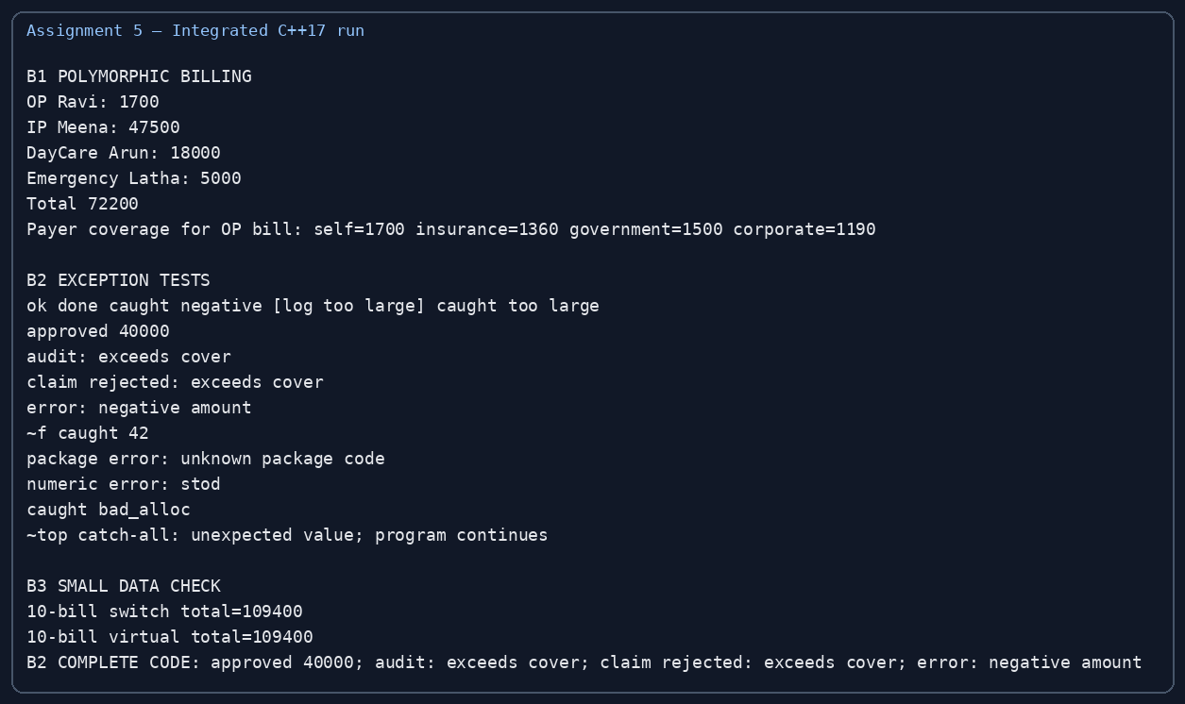
Figure B1: Terminal-style capture of the compiled integrated C++17 program.

TASK B2 – ENGINEER ERROR CONDITIONS (5 Marks)

Deliberate error conditions
Test | Input / action | Expected behaviour | What it demonstrates
Negative charge | Charge = -5 | invalid_argument / BillingError | Validation rejects invalid domain values.
Claim above cover | Billed 60,000; cover 50,000 | ClaimError("exceeds cover") | Specific business exception is logged and rethrown.
Unknown package | Unrecognised package code | BillingError with package detail | Unknown configuration is not silently accepted.
Text for number | std::stod("abc") | std::invalid_argument | Library conversion reports malformed numeric input.
Huge allocation | Request impossible array size | std::bad_alloc or length_error depending request | Allocation failure is handled at the application boundary.
Top-level catch(...) | Unexpected thrown value | Final handler reports failure | The application boundary prevents an uncaught exception from terminating normal control flow.

Predict the Output
Prediction before execution for the supplied program:
ok done caught negative [log too large] caught too large
The first amount (100) passes validate(), so process() returns and main prints done. The negative amount throws invalid_argument; process() does not catch that type, so main catches it and prints caught negative. The large amount throws out_of_range; process() catches that type, logs it once, and rethrows with throw;. Main then catches the same exception and prints caught too large. Only out_of_range is logged because process() has a handler only for that type.

Completed TODO 1 and TODO 2
double approve(double billed, double cover) {
if (billed < 0 || cover < 0)
throw std::invalid_argument("negative amount");
if (billed > cover)
throw ClaimError("exceeds cover");
return billed;
}
double settle(double billed, double cover) {
try {
return approve(billed, cover);
} catch (const ClaimError& e) {
std::cout << "audit: " << e.what() << '\\n';
throw; // rethrow the same exception
}
}
Verified expected output:
approved 40000
audit: exceeds cover
claim rejected: exceeds cover
error: negative amount

throw; versus throw e;
throw; rethrows the currently handled exception object, preserving its dynamic type and exception identity. throw e; throws a new exception object whose static type is the declared type of e. In this specific handler, e is const ClaimError&, so throw e; creates a new ClaimError object and does not slice it to std::exception. If the handler instead caught a base-class reference to a derived exception, throw e; could slice the derived part. Therefore throw; is the safest rethrow form.
Additional executed error probes: the program rejects an unknown package code, catches std::invalid_argument from std::stod("not-a-number"), triggers std::bad_alloc using an array bound equal to the maximum size_t value, and uses catch(...) as a final safety net. A Guard object is created before the unexpected throw; its destructor prints ~top during stack unwinding, showing that local resources are released before the catch-all handler continues.
package error: unknown package code\nnumeric error: stod\ncaught bad_alloc\n~top catch-all: unexpected value; program continues

Alternative: std::optional<double>
approveOptional() could return std::optional<double>; a value means approved and std::nullopt means rejected. This makes rejection an ordinary return path and avoids exception construction/unwinding. For one million claims, both approaches are O(n) in the normal workload. With 0% invalid claims, exception-based validation does not throw and can be competitive. At 1% and especially 50% invalid claims, throwing for routine rejection is much more expensive. optional stores a value plus an engagement state, usually a small fixed overhead per result; exceptions use runtime-managed exception storage only on the error path.
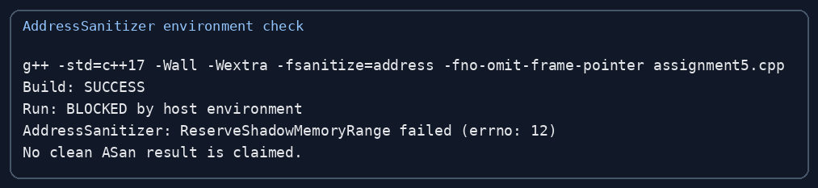
Figure B2: Sanitizer build succeeded; runtime execution was blocked by host shadow-memory reservation.

TASK B3 – VIRTUAL FUNCTIONS vs switch vs EXCEPTIONS: THE COST (8 Marks)

B3.1 – Correctness on Small Data
A 10-record dataset was evaluated using a tagged struct and switch. The sum was 109,400. The same formulas are used by the polymorphic implementation; both approaches must return identical totals for the same inputs. The small-data test checks correctness before interpreting performance.

B3.2 – Increase the Data Size
The benchmark was compiled with g++ -std=c++17 -O2 -Wall -Wextra. Each dataset contains a 50/50 mixture of outpatient and inpatient bills with deterministic values. Times below are one observed run in milliseconds; they are not universal performance guarantees.
Number of bills | Virtual functions (ms) | switch (ms)
1,000 | 0.0189 | 0.0199
1,000,000 | 36.0763 | 18.6718
10,000,000 | 107.2780 | 85.0424

The measured switch version was faster in this run. At small sizes, timing is dominated by measurement overhead and noise. At large sizes, virtual dispatch and pointer indirection can reduce optimisation opportunities; however, data layout, allocation strategy, CPU cache, compiler and workload can change the result.

B3.3 – Cost of Exceptions
Invalid claims | Return-code validation (ms) | Exception validation (ms)
0% | 5.6557 | 3.7541
1% | 5.0313 | 117.7830
50% | 5.2996 | 5,581.8100

The no-error exception case does not actually throw and was close to the return-code baseline in this run. As invalid claims increase, exception construction and stack unwinding dominate. Return codes are therefore preferable when rejection is frequent and expected; exceptions are appropriate for exceptional failures that should not be part of routine control flow.

B3.4 – Engineering Trade-off
Virtual functions offer clean extension and heterogeneous storage at a small dispatch cost. switch can be faster and compact for a closed, stable set of types, but adding a new type requires updating central logic. Exceptions improve separation of error handling from normal logic, but frequent exceptions are expensive. For the hospital scenario, maintainability and extension are important, while routine business validation can use explicit result types if invalid claims are common.

Alternative: std::variant and std::visit
std::variant<OutPatientBill, InPatientBill, ...> stores one of the alternatives in each element and a discriminator tag. std::visit dispatches to the matching overload. It avoids heap allocation per bill when stored directly in a vector and can be cache-friendly, but each element reserves enough storage for its largest alternative plus alignment and a tag. In this run, variant_visit took 103.363 ms for 10,000,000 bills; it was slower than both virtual and switch in this particular build. This is an observed result, not a general ranking.
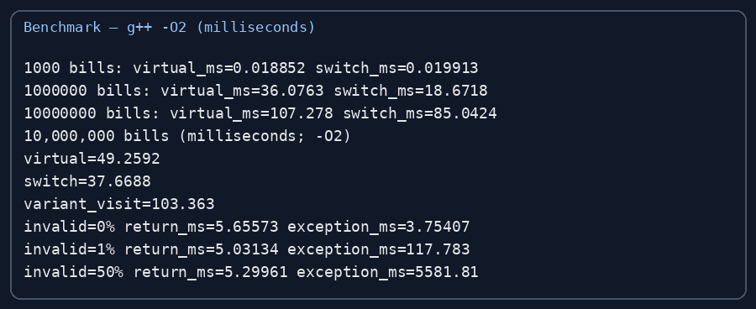

TASK B4 – FINAL ENGINEERING DECISION (5 Marks)

B4.1 – Implement a Practical Extension
DayCareBill and EmergencyBill are the new bill types. They derive from Bill and override total() and type(); no existing Bill interface or processing loop is modified. CorporatePayer is the new payer and implements Payer::amountCovered(). Earlier OP and IP calculations remain unchanged. The integrated output shows all four bill categories being processed through the same collection.

B4.2 – Check Resource Safety
The code uses std::unique_ptr for bill ownership and standard-library strings/vectors for automatic cleanup. Exception tests throw and catch standard and custom exceptions. The AddressSanitizer build completed successfully, but execution failed before main() because the host could not reserve the ASan shadow-memory range. Therefore, this report cannot claim a clean sanitizer report. Re-run the provided source on the student’s own Linux/WSL system with ASan enabled and attach the clean terminal output before submission.

B4.3 – Production Decision
The polymorphic Bill and Payer interfaces are suitable as the core production architecture because new bill and payer types can be added independently and processed through stable interfaces. RAII and typed exceptions provide reliable resource cleanup and clear failure categories. For frequent expected claim rejections, use a result/optional/status return rather than exceptions; reserve exceptions for unexpected failures, configuration errors and infrastructure faults. Production deployment also requires validated rates, currency-safe integer arithmetic (paise/cents), audit persistence, concurrency controls, security review and comprehensive tests.

Alternative: Configuration / Plug-in Rules
A configuration-driven system could load bill formulas and payer rates as validated rules. Each bill would be evaluated by an interpreter or rule engine rather than a compiled virtual call. Rule interpretation may take more than O(1) depending on the number of rule operations, while a direct virtual call is O(1) dispatch plus the calculation. Rule storage is proportional to the number and size of configured rules. Configuration enables rate changes without recompilation but increases parsing, validation, versioning and security risks. A hybrid is recommended: keep stable domain interfaces in C++ and load carefully validated rates and package limits from versioned configuration.

Decision factor | Finding
Extensibility | Strong: derived bill and payer classes can be added without changing the interfaces.
Performance | Measured switch faster in this one benchmark; profile production workload before optimising.
Reliability | RAII and typed exceptions provide safe cleanup and clear error categories.
Frequent invalid claims | Prefer optional/status results for expected business rejections.
Production recommendation | Adopt polymorphic interfaces with validated configuration, smart pointers, integer money and audit logging.

EXPERIMENTAL METHOD, LIMITATIONS AND SUBMISSION CHECKLIST

Compiler and commands
g++ --version
g++ -std=c++17 -Wall -Wextra assignment5.cpp -o assignment5
./assignment5
g++ -std=c++17 -O2 -Wall -Wextra bench.cpp -o bench
./bench
g++ -std=c++17 -Wall -Wextra -fsanitize=address \
-fno-omit-frame-pointer assignment5.cpp -o assignment5_asan
./assignment5_asan
Compiler used for the recorded runs: g++ 14.2.0 on Linux. The benchmark uses -O2. The sanitizer command compiled, but the host runtime failed to reserve shadow memory; a clean sanitizer execution remains to be completed on another supported environment.

Repository structure to create
DSA01-192565064-Assignment5/
README.md
Task01_Design/
uml.png
vtable.png
exceptions.png
Task02_RuntimeBinding/
predict_output.cpp
Task03_Payer/
payer_design.cpp
Task04_Exceptions/
complete_claim.cpp
Task05_Recovery/
stack_unwinding.cpp
TaskB1_PolymorphicBilling/
assignment5.cpp
output.png
TaskB2_ErrorTests/
error_tests.cpp
output.png
TaskB3_Benchmarks/
bench.cpp
benchmark_output.png
TaskB4_Extension/
extended_billing.cpp
sanitizer_report.txt

README.md content to include
# DSA01-192565064-Assignment5
Name: SWETHAMBIGAI.S
Register Number: 192565064
Compiler: g++ 14.2.0
Standard: C++17
Compile: g++ -std=c++17 -Wall -Wextra assignment5.cpp -o assignment5
Run: ./assignment5
Benchmark: g++ -std=c++17 -O2 -Wall -Wextra bench.cpp -o bench
Result: Four bill types and four payer policies are implemented.
Exception tests cover invalid values, claim rejection and stack unwinding.
Note: Re-run AddressSanitizer on a supported local environment and add its output.

Final submission checklist
- Create repository named DSA01-192565064-Assignment5.
- Create a folder for each task and include source files, test inputs and output screenshots.
- Add the actual GitHub repository link to the cover page and README.
- Commit progressively, with at least one commit per task.
- Run each program on the student’s own computer and replace/add personal terminal screenshots.
- Re-run the AddressSanitizer tests on a supported environment and attach the actual report.
- Check all source files compile with the stated C++17 command before submission.
Important: This report includes reproducible program output and benchmark evidence generated in the preparation environment. The GitHub link and a clean student-side AddressSanitizer run are intentionally left for completion rather than being fabricated.

APPENDIX A – INTEGRATED C++17 IMPLEMENTATION
The following source file was compiled with g++ 14.2.0 and executed to produce the billing and exception output in Figure B1. It includes the bill hierarchy, payer hierarchy, custom exceptions, rethrowing and stack-unwinding demonstration.

APPENDIX B – BENCHMARK SOURCE
The benchmark source compares virtual dispatch, a tagged switch, std::variant/std::visit and return-code versus exception-based validation. Compile with -O2.
#include <iostream>
#include <vector>
#include <memory>
#include <chrono>
#include <variant>
#include <stdexcept>
#include <cstdint>
struct VBill { virtual ~VBill()=default; virtual double total()const=0; };
struct VOP:VBill{double a,b; VOP(double x,double y):a(x),b(y){} double total()const override{return a+b;}};
struct VIP:VBill{double a,b; int d; VIP(double x,double y,int z):a(x),b(y),d(z){} double total()const override{return a*d+b;}};
struct SBill{int type; double a,b; int d;};
struct OP{double a,b; double total()const{return a+b;}};
struct IP{double a,b;int d;double total()const{return a*d+b;}};
using Var=std::variant<OP,IP>;
template<class F> double measure(F f){auto a=std::chrono::steady_clock::now(); volatile double x=f(); auto b=std::chrono::steady_clock::now(); if(x<0)std::cerr<<x; return std::chrono::duration<double,std::milli>(b-a).count();}
int main(){
const int N=10000000;
std::vector<std::unique_ptr<VBill>> v; v.reserve(N);
std::vector<SBill> s; s.reserve(N);
std::vector<Var> z; z.reserve(N);
for(int i=0;i<N;i++){double a=(i%100)+100,b=(i%20)+20;int d=i%5+1;if(i%2){v.emplace_back(new VOP(a,b));s.push_back({0,a,b,0});z.emplace_back(OP{a,b});}else{v.emplace_back(new VIP(a,b,d));s.push_back({1,a,b,d});z.emplace_back(IP{a,b,d});}}
volatile double sink=0;
for(int n:{1000,1000000,N}){
double vtime=measure([&]{double q=0;for(int i=0;i<n;i++)q+=v[i]->total();sink=q;return q;});
double stime=measure([&]{double q=0;for(int i=0;i<n;i++){auto x=s[i];q+=(x.type==0?x.a+x.b:x.a*x.d+x.b);}sink=q;return q;});
std::cout<<n<<" bills: virtual_ms="<<vtime<<" switch_ms="<<stime<<"\n";
}
double tv=measure([&]{double q=0;for(auto&x:v)q+=x->total();sink=q;return q;});
double ts=measure([&]{double q=0;for(auto x:s)q+=(x.type==0?x.a+x.b:x.a*x.d+x.b);sink=q;return q;});
double tz=measure([&]{double q=0;for(auto&x:z)q+=std::visit([](auto const& y){return y.total();},x);sink=q;return q;});
std::cout<<"10,000,000 bills (milliseconds; -O2)\nvirtual="<<tv<<"\nswitch="<<ts<<"\nvariant_visit="<<tz<<"\n";
for(int rate:{0,1,50}){int count=N*rate/100;
auto tr=measure([&]{long long ok=0;for(int i=0;i<N;i++){bool bad=i<count;if(bad){}else ++ok;}sink=ok;return (double)ok;});
auto te=measure([&]{long long ok=0;for(int i=0;i<N;i++){try{if(i<count)throw std::runtime_error("invalid");++ok;}catch(const std::exception&){} }sink=ok;return (double)ok;});
std::cout<<"invalid="<<rate<<"% return_ms="<<tr<<" exception_ms="<<te<<"\n";
}
}

