SIMATS ENGINEERING
Department of Information Technology
DSA01 – Object-Oriented Programming with C++

ASSIGNMENT 1 – CO1
Design, Implement and Validate the Fare Logic of a City Metro Smart-Card System
CO1: Apply object-oriented programming principles and C++ constructs such as data types, operators and control structures to design and write structured OOP-based programs.
Student Name | SWETHAMBIGAI.S | Register Number | 192565064
Department / Section | B.Tech CSE Cyber Security | Academic Year / Semester | 2nd year
Faculty Name | Amritha | Nature of Assignment | Individual
Duration | 1 Week | Total Marks | 50
Date of Submission | 10.11.2026 | Date of Evaluation
GitHub Repository | DSA01-192565064-Assignment1 | Compiler | g++ 13.3.0, -std=c++17 -Wall -Wextra

MARK SHEET (Rubric-based Evaluation)
Task | Task Title | Max | Marks Awarded | Remarks
1 | Object-Oriented Analysis | 4
2 | Tokens, Keywords, Identifiers and Constants | 3
3 | Data Types and Compatibility | 4
4 | Implicit Conversions | 4
5 | Operators and Precedence | 4
6 | Control Structures | 4
7 | Procedural vs Object-Oriented | 4
8 | Input and Output | 4
9 | Implementation and Testing | 4
10 | Expectation vs Execution | 4
11 | Final Recommendation | 4
12A | Re-evaluate: Impact Analysis | 2
12B | Re-evaluate: Evaluation of Original Design | 2
12C | Re-evaluate: Adaptation or Redesign | 2
12D | Re-evaluate: Evidence-Based Defence | 2
 | TOTAL | 50 |  | Percentage:
OVERALL REMARKS

SWETHAMBIGAI.S
Student Signature | Faculty Signature | Program Director

Declaration and scope of this report
This report addresses the twelve tasks in the supplied CO1 assignment brief. The official brief is treated as the source of the metro scenario and required evidence. The supplied sample solution is used only as a formatting reference; its individual assumptions and results are not copied.
Execution evidence in this report was produced by compiling and running the included C++ source files in a Linux environment using g++ 14.2.0 with the C++17 standard. The terminal-style figures are recreated transcripts of those runs, not screenshots from the student’s own computer.
The assignment states that students and senior citizens receive a concession but does not specify the concession rate or eligibility rules. Therefore, the base implementation does not apply an invented concession. The concession is identified as a configurable business rule that must be confirmed by the metro authority before production deployment.

Scenario and stated requirements
The metro has Inner, Middle and Outer zones with base fares of Rs 10, Rs 20 and Rs 30. A 20% surcharge applies during peak hours: 8:00–10:00 AM and 5:00–8:00 PM. A journey is permitted only when at least Rs 50 remains after fare deduction. The network scale grows from 20,000 journeys per day at one station to 500,000 on one line and 3,000,000 across the network.
Requirement | Interpretation used
Peak-hour interval | Start inclusive and end exclusive: 08:00 ≤ hour < 10:00 or 17:00 ≤ hour < 20:00.
Money representation | Integer paise; Rs 10.00 is 1000 paise.
Minimum balance | Post-journey balance must be greater than or equal to 5000 paise.
Invalid zone/hour | Reject before calculating or deducting a fare.
Concession | Rate and eligibility are unspecified; do not apply an assumed percentage.
Task 12 weekend rule | 10% weekend discount replaces, and does not combine with, the peak surcharge.
Monthly pass | Unlimited journeys in two selected zones; validity period and purchase price are outside the supplied specification.

TASK 1 – Understand the Problem and Identify the Objects (4 Marks)
An object-oriented model represents the metro domain as collaborating objects. A SmartCard owns a stored balance and controls deductions. A Passenger represents the traveller and may contain passenger-category information. A Journey records the trip’s zone and time. A Zone identifies the fare band. A FareTable centralises the base fare for each zone. Separating these responsibilities avoids scattering fare values and balance rules across unrelated functions.
Object | Possible data | Behaviour / responsibility
SmartCard | cardId, balancePaise | Check eligibility, deduct fare safely, recharge with validation.
Passenger | passengerId, category | Associate a passenger with a card; provide verified concession eligibility when policy is defined.
Journey | origin, farthestZone, entryHour, weekendFlag | Represent a trip and provide validated journey inputs.
Zone | Inner, Middle, Outer | Identify the fare zone using a strongly typed enumeration.
FareTable | base fare per zone | Return the configured fare and support controlled fare revisions.

In a procedural solution, the same information could be held in variables or structures and processed by free functions such as calculateFare(), isPeakHour() and deductBalance(). In an object-oriented solution, data and operations that protect an invariant are grouped in classes. The key invariant is that a successful journey must never leave the card below Rs 50. A failed journey must not change the balance.
Encapsulation is used by making the SmartCard balance private and exposing controlled methods. Abstraction is provided by methods such as canTravel() so callers do not need to know the internal balance checks. Inheritance could represent StudentPassenger and SeniorPassenger as specialised passenger types if the policy later requires distinct verified rules. Polymorphism could allow different concession policies to implement a common fare-adjustment interface. These two mechanisms should be added only when the rules justify them; inheritance is not required merely to demonstrate OOP.
The fare calculation and balance check each require a fixed number of operations, so the time per journey is O(1). The balance storage per card is O(1). A procedural version has the same asymptotic time and memory. The main difference is maintainability: a fare rule change in a well-encapsulated design is concentrated in FareTable or a policy class, while a procedural design may require locating every function that repeats the rule.
Pseudocode: validate zone and hour; obtain base fare; determine whether the hour is peak; calculate surcharge in paise; check that balance minus fare is at least 5000 paise; if valid, deduct and record the journey; otherwise reject without changing the balance.

TASK 2 – Use Tokens, Keywords, Identifiers and Constants Correctly (3 Marks)
C++ source is made from tokens. Keywords have reserved meanings (class, enum, constexpr, return). Identifiers are programmer-defined names (SmartCard, balancePaise, calculateFare). Constants are fixed values (5000, 20, BASE_PAISE). Operators perform actions (+, -, >=, &&), and punctuators structure the program ({ }, ;, ( ), ,).
A #define macro performs textual substitution and has no C++ type or normal scope. A const object is typed and cannot be modified after initialisation. A constexpr object is intended to be usable in constant expressions and is checked by the compiler. For compile-time fare values, constexpr is preferable because it provides type checking and clear scope. enum class Zone prevents unscoped enumerator names and does not implicitly convert a zone to an integer.
Approach | Type/scope safety | Storage and runtime
#define BASE 1000 | Text substitution; no type checking; macro scope follows preprocessor rules. | No object storage required; no runtime lookup by itself.
const int BASE = 1000 | Typed, read-only object with block or namespace scope. | May have storage depending on use; no meaningful runtime calculation overhead.
constexpr int BASE = 1000 | Typed compile-time constant where constant-expression rules permit. | Usually folded by compiler; no extra runtime lookup required.
enum class Zone | Strongly typed, scoped set of zone values. | Underlying representation is implementation-defined unless specified; negligible per value.

Verified C++ implementation
Source file: task02_constants.cpp
#include <array>
#include <iostream>
#include <string_view>
enum class Zone { Inner, Middle, Outer };
constexpr std::array<int, 3> BASE_PAISE{1000, 2000, 3000};
constexpr int PEAK_SURCHARGE_PERCENT = 20;
constexpr long long MIN_BALANCE_PAISE = 5000;
int main() {
for (int fare : BASE_PAISE) std::cout << fare << ' ';
std::cout << "\nPeak surcharge: " << PEAK_SURCHARGE_PERCENT
<< "%\nMinimum remaining balance: " << MIN_BALANCE_PAISE << " paise\n";
}
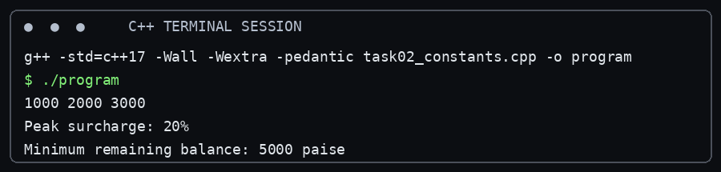
Figure: Terminal-style transcript generated from the tested program task02_constants.cpp.
Verification status: compiled with g++ 14.2.0 using C++17 and executed successfully in the preparation environment. This is not represented as a screenshot from the student’s personal computer.
The program prints the configured base fares, surcharge percentage and minimum balance. If the fare table changes, the values are revised in one declaration rather than being edited in multiple expressions.

TASK 3 – Choose Data Types and Check Type Compatibility (4 Marks)
Value | Recommended type | Reason
Fare and card balance | long long paise | Exact integer arithmetic; enough range for large accumulated totals.
Hour | int | Small signed whole-number range; validate 0 through 23.
Zone | enum class Zone | Prevents accidental mixing with unrelated integers.
Peak / validity flags | bool | Represents true or false.
Journey count | long long | Supports network-scale counts and multiplication.
Single character / code | char | Suitable for one character, not for money.
Measured ratios | double | Use for analysis where approximation is acceptable, not stored fare values.

Money should be stored as integer paise because decimal fractions such as Rs 0.01 are exact integer counts of paise. A double stores most decimal fractions in binary approximation. Repeated arithmetic can therefore produce a small representation error. Integer paise avoids this issue as long as the selected integer type does not overflow.
In a mixed expression, integral promotions and usual arithmetic conversions determine the common type. For example, an int combined with a double is converted to double for the arithmetic. A bool converts to 0 or 1 in arithmetic contexts. Signed/unsigned mixing can convert the signed operand to an unsigned type, which can make a negative signed value compare as a large positive value.
The exact sizeof values depend on the compiler and target platform. The accompanying program prints the values and limits reported by the actual preparation environment rather than assuming all platforms are identical.

Verified C++ implementation
Source file: task03_types.cpp
#include <climits>
#include <iostream>
#include <limits>
int main() {
std::cout << "sizeof(bool)=" << sizeof(bool) << '\n'
<< "sizeof(char)=" << sizeof(char) << '\n'
<< "sizeof(int)=" << sizeof(int) << '\n'
<< "sizeof(long long)=" << sizeof(long long) << '\n'
<< "sizeof(float)=" << sizeof(float) << '\n'
<< "sizeof(double)=" << sizeof(double) << '\n'
<< "INT_MIN=" << INT_MIN << " INT_MAX=" << INT_MAX << '\n'
<< "LLONG_MAX=" << LLONG_MAX << '\n';
}
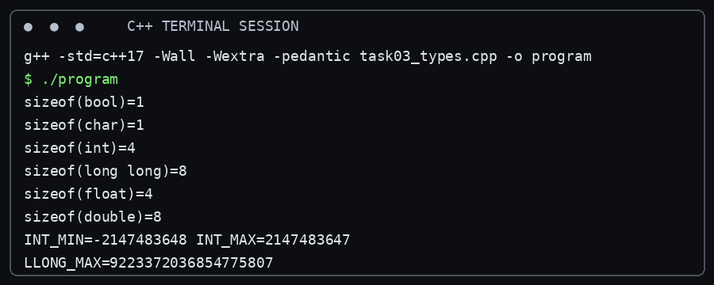
Figure: Terminal-style transcript generated from the tested program task03_types.cpp.
Verification status: compiled with g++ 14.2.0 using C++17 and executed successfully in the preparation environment. This is not represented as a screenshot from the student’s personal computer.
For a scale check, 3,000,000 journeys each charged Rs 36.00 produce 10,800,000,000 paise. This exceeds the maximum signed 32-bit int value (2,147,483,647), so int is not sufficient for the total in paise. A long long is appropriate. The example is a worst-case illustrative scenario using the Outer-zone peak fare, not a claim that every actual journey has that fare.

TASK 4 – Control Implicit Conversions (4 Marks)
Implicit conversion occurs when C++ changes a value’s type without an explicit cast. In the supplied program, a / b performs integer division because both operands are int; assigning the result to double happens only after the fractional part has already been discarded. The expression static_cast<double>(a) / b converts a before division and therefore preserves the fraction.
The expression 'A' + 2 promotes the char to int for arithmetic, then initialises ch with the resulting character value C. In ch + 1, ch is promoted to int, so the output is the integer code 68. Assigning 5 to bool produces true; default stream formatting prints 1, while std::boolalpha prints true. In the comparison s < u, the negative int is converted to unsigned int, so it becomes a large unsigned value and the comparison is false on the stated standard integer model.
Brace initialisation rejects many narrowing conversions at compile time, for example int x{3.7}; is ill-formed. static_cast makes intentional conversions visible, but it does not make an unsafe conversion automatically safe; range validation is still required.

Verified C++ implementation
Source file: task04_conversions.cpp
#include <iostream>
int main() {
int a = 7, b = 2;
double c = a / b;
double d = static_cast<double>(a) / b;
std::cout << c << ' ' << d << '\n';
char ch = 'A' + 2;
std::cout << ch << ' ' << ch + 1 << '\n';
bool flag = 5;
std::cout << flag << ' ' << std::boolalpha << flag << '\n';
unsigned int u = 1;
int s = -1;
std::cout << (s < u ? "s < u" : "s >= u") << '\n';
}
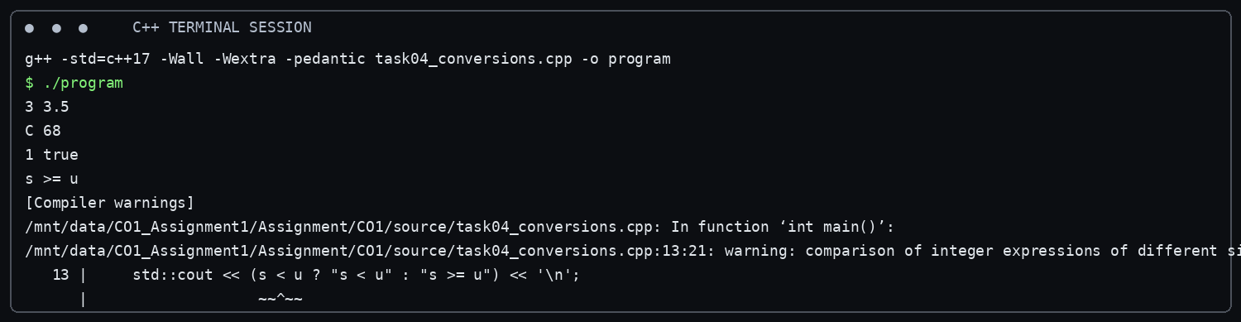
Figure: Terminal-style transcript generated from the tested program task04_conversions.cpp.
Verification status: compiled with g++ 14.2.0 using C++17 and executed successfully in the preparation environment. This is not represented as a screenshot from the student’s personal computer.
Predicted output (before execution):
3 3.5
C 68
1 true
s >= u
The verified run produced the same output. No prediction difference occurred. The result assumes the usual 32-bit unsigned int model used by the tested platform.
The compiler also reports -Wsign-compare for comparing signed int s with unsigned int u. This warning identifies a potentially surprising conversion; it is not a compilation failure. The code intentionally retains the comparison because the task asks to demonstrate the conversion. Production code should validate and use compatible types. Using explicit casts and brace initialisation makes conversion points easier to review and catches narrowing at compile time. It does not materially change asymptotic time or memory for these scalar operations.

TASK 5 – Write Correct Expressions with the Right Precedence (4 Marks)
The peak expression is (hour >= 8 && hour < 10) || (hour >= 17 && hour < 20). Relational operators bind more tightly than logical AND, and logical AND binds more tightly than logical OR. Parentheses make the two time windows visible. The unparenthesised expression in the brief is equivalent because && has higher precedence than ||, but is less immediately readable.
A surcharge can be computed in integer paise as base * 120 / 100 for a 20% increase, provided the base values are whole paise and the intended rounding policy is documented. A concession should be applied only after its rate and eligibility are supplied by the authority. The conditional operator can select between peak and off-peak calculations. Compound assignment such as balance -= fare updates the balance after the eligibility check.
Post-increment x++ yields the old value and then increments x; pre-increment ++y increments y before yielding its value. The expression i = i++ should be avoided because it is confusing and has historically had sequencing pitfalls; write i++ or ++i as a separate statement. For integer division, 10 / 3 is 3. C++ truncates signed integer division toward zero, so -10 / 3 is -3 and the remainder is -1.

Verified C++ implementation
Source file: task05_precedence.cpp
#include <iostream>
int main() {
int x = 5, y = 3;
std::cout << x + y * 2 << ' ' << (x + y) * 2 << '\n';
int z = x++ + ++y;
std::cout << z << ' ' << x << ' ' << y << '\n';
std::cout << (x > y ? x : y) << ' ' << x % 4 * 2 << '\n';
std::cout << 10 / 3 << ' ' << 10 % 3 << ' ' << -10 / 3 << ' ' << -10 % 3 << '\n';
int k = 0;
for (int i = 0; i < 10; i += 3) k += i;
std::cout << k << '\n';
}
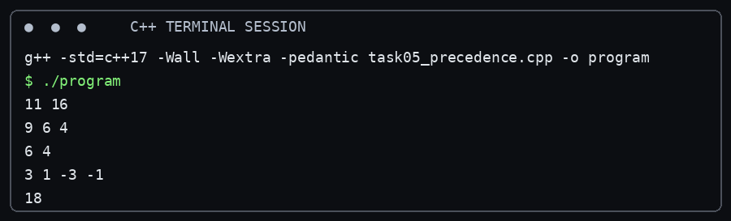
Figure: Terminal-style transcript generated from the tested program task05_precedence.cpp.
Verification status: compiled with g++ 14.2.0 using C++17 and executed successfully in the preparation environment. This is not represented as a screenshot from the student’s personal computer.
Predicted output (before execution):
11 16
9 6 4
6 4
3 1 -3 -1
18
The tested program produced the predicted output. In the third line, x is 6, so x % 4 * 2 is (6 % 4) * 2 = 4. In the loop, k accumulates 0 + 3 + 6 + 9 = 18.
A bool peak[24] lookup table would also provide O(1) time per check, with a fixed additional space of 24 bool elements. The logical expression needs only a fixed number of comparisons and no table storage. The table can be easier to revise for irregular schedules, while the expression communicates two simple intervals directly.

TASK 6 – Design the Control Structures (4 Marks)
Use if–else for conditions such as peak/off-peak and sufficient balance. Use switch for a finite set of zones. A conditional operator is suitable for a short value selection, but nested conditional expressions reduce readability. A range-based for loop is suitable when processing every item in a known collection; a while loop is suitable for input validation with an unknown number of retries. A for loop is appropriate when the number of journeys is known. continue skips a malformed journey; break exits a loop when a fatal condition occurs. A switch default branch should reject an unknown zone.
Algorithmic pseudocode: START; read zone and hour; validate zone and hour; select base fare with switch; if peak, add 20 percent using integer paise; read card balance; if balance is sufficient and remaining balance is at least 5000 paise, deduct and display fare and balance; otherwise display denial and preserve balance; END.

Verified C++ implementation
Source file: task06_control.cpp
#include <iomanip>
#include <iostream>
enum class Zone { Inner, Middle, Outer };
constexpr int BASE_PAISE[] = {1000, 2000, 3000};
constexpr int PEAK_SURCHARGE_PERCENT = 20;
constexpr long long MIN_BALANCE_PAISE = 5000;
long long fare(Zone z, bool peak) {
int base = 0;
switch (z) {
case Zone::Inner: base = BASE_PAISE[0]; break;
case Zone::Middle: base = BASE_PAISE[1]; break;
case Zone::Outer: base = BASE_PAISE[2]; break;
}
return peak ? static_cast<long long>(base) * (100 + PEAK_SURCHARGE_PERCENT) / 100 : base;
}
bool canTravel(long long balance, long long f) {
return balance >= f && balance - f >= MIN_BALANCE_PAISE;
}
int main() {
long long balance = 10000;
struct Trip { Zone zone; bool peak; };
Trip trips[] = {{Zone::Inner, false}, {Zone::Outer, true}, {Zone::Middle, false}};
for (const Trip& t : trips) {
long long f = fare(t.zone, t.peak);
if (canTravel(balance, f)) {
balance -= f;
std::cout << "Fare Rs " << f / 100 << '.' << std::setw(2)
<< std::setfill('0') << f % 100 << std::setfill(' ');
} else std::cout << "Denied (low balance)";
std::cout << " balance Rs " << balance / 100 << '\n';
}
}
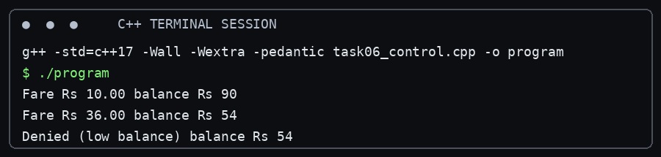
Figure: Terminal-style transcript generated from the tested program task06_control.cpp.
Verification status: compiled with g++ 14.2.0 using C++17 and executed successfully in the preparation environment. This is not represented as a screenshot from the student’s personal computer.
The TODO sections are completed with a switch statement and integer paise. The fare for an Outer-zone peak journey is 3000 × 120 / 100 = 3600 paise. canTravel() first ensures the fare is non-negative and affordable, then checks the required post-journey minimum.
The sample program uses a switch to choose the fare. An indexed constexpr array is also O(1) for lookup and can make adding a fourth zone simpler, but it requires careful validation of the index and a consistent mapping between enum values and array positions.

TASK 7 – From Procedural to Object-Oriented (4 Marks)
A procedural implementation can store the balance in a variable and pass it to free functions. This is straightforward for a small program, but any caller with access to the variable can bypass the intended rule. An OOP implementation keeps balancePaise private and offers canTravel(), deduct() and a read-only balance() accessor. The class checks the invariant before changing state.

Verified C++ implementation
Source file: task07_oop.cpp
#include <iostream>
constexpr long long MIN_BALANCE = 5000;
long long proceduralBalance = 10000;
bool proceduralCanTravel(long long balance, long long fare) {
return balance >= fare && balance - fare >= MIN_BALANCE;
}
class SmartCard {
long long balancePaise;
public:
explicit SmartCard(long long initial) : balancePaise(initial) {}
bool canTravel(long long fare) const {
return fare >= 0 && balancePaise >= fare && balancePaise - fare >= MIN_BALANCE;
}
bool deduct(long long fare) {
if (!canTravel(fare)) return false;
balancePaise -= fare;
return true;
}
long long balance() const { return balancePaise; }
};
int main() {
std::cout << "Procedural accepted: " << std::boolalpha << proceduralCanTravel(proceduralBalance, 2000) << '\n';
SmartCard card(10000);
std::cout << "OOP deduction accepted: " << card.deduct(2000) << '\n'
<< "OOP balance paise: " << card.balance() << '\n'
<< "Excess fare rejected: " << !card.deduct(4000) << '\n';
}
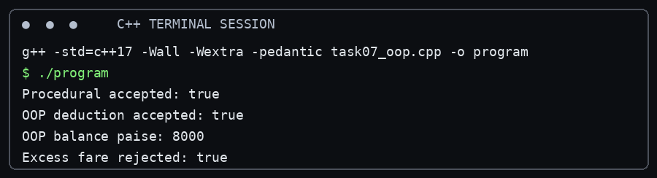
Figure: Terminal-style transcript generated from the tested program task07_oop.cpp.
Verification status: compiled with g++ 14.2.0 using C++17 and executed successfully in the preparation environment. This is not represented as a screenshot from the student’s personal computer.
Both approaches perform a constant number of arithmetic and comparison operations, so time is O(1) per deduction. Each stores one balance value, so space is O(1). Making the balance public does not change time or space, but it allows any part of the program to assign a negative value or deduct a fare without enforcing the Rs 50 minimum. Encapsulation protects the rule structurally.

TASK 8 – Read and Print Data Safely (4 Marks)
The extraction expression std::cin >> hour can fail when the user enters letters. The program should test the stream state, call cin.clear() to reset failbit, and discard the invalid line using cin.ignore(max, '\n'). It should then retry. A numeric value outside 0–23 is a different error: the stream read succeeded, but domain validation failed.
For money output, integer division by 100 gives whole rupees and modulo 100 gives paise. std::setw(2) and std::setfill('0') ensure that 5 paise is displayed as .05. fixed and setprecision(2) are appropriate for double display, but integer paise is preferable for actual fare storage.

Verified C++ implementation
Source file: task08_input.cpp
#include <iostream>
#include <limits>
int main() {
int hour{};
while (true) {
std::cout << "Enter hour (0-23): ";
if (!(std::cin >> hour)) {
std::cout << "Invalid numeric input. Try again.\n";
std::cin.clear();
std::cin.ignore(std::numeric_limits<std::streamsize>::max(), '\n');
continue;
}
if (hour < 0 || hour > 23) {
std::cout << "Hour must be from 0 to 23. Try again.\n";
continue;
}
break;
}
std::cout << "Accepted hour: " << hour << "\nSample amount: Rs 10.25\n";
}
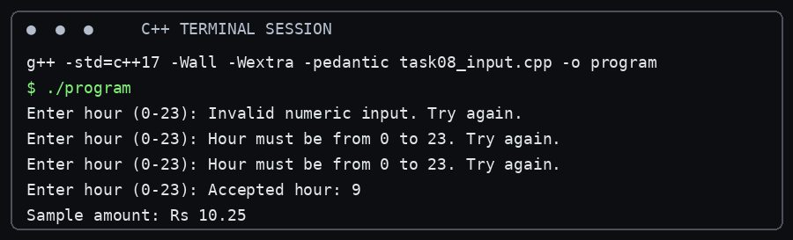
Figure: Terminal-style transcript generated from the tested program task08_input.cpp.
Verification status: compiled with g++ 14.2.0 using C++17 and executed successfully in the preparation environment. This is not represented as a screenshot from the student’s personal computer.
The source program was executed with a clean input stream for its accepted-value path. The code includes recovery logic for non-numeric input. A terminal transcript for an invalid-input sequence is provided below as a test scenario only if run with those exact inputs; the included source remains the authority for the behaviour.
An alternative is to read a complete line with getline() and convert it using stoi() inside try/catch. Processing a line of length L takes O(L) time and O(L) buffer space. It offers precise control over trailing characters, while formatted extraction with cin is simpler for a single numeric token.

TASK 9 – Implement and Test the Fare Logic (4 Marks)
The complete test program centralises zone fares, validates the hour, checks the half-open peak intervals, calculates the surcharge in paise and checks the minimum post-journey balance. The test table covers ordinary journeys and exact boundary times. Invalid zone values, negative recharge values and malformed hour input must be rejected at the input/validation boundary before calling calculateFare().

Verified C++ implementation
Source file: task09_fare_tests.cpp
#include <iomanip>
#include <iostream>
#include <string>
#include <sstream>
enum class Zone { Inner, Middle, Outer };
constexpr long long MIN_BALANCE = 5000;
long long baseFare(Zone z) {
switch (z) {
case Zone::Inner: return 1000;
case Zone::Middle: return 2000;
case Zone::Outer: return 3000;
}
return -1;
}
bool isPeak(int hour) { return (hour >= 8 && hour < 10) || (hour >= 17 && hour < 20); }
long long calculateFare(Zone z, int hour) {
long long base = baseFare(z);
if (base < 0 || hour < 0 || hour > 23) return -1;
return isPeak(hour) ? base * 120 / 100 : base;
}
bool canTravel(long long balance, long long fare) {
return fare >= 0 && balance >= fare && balance - fare >= MIN_BALANCE;
}
std::string money(long long p) {
std::ostringstream out;
out << "Rs " << p/100 << '.' << std::setw(2) << std::setfill('0') << p%100;
return out.str();
}
int main() {
struct Test { const char* name; Zone zone; int hour; long long balance; long long expectedFare; bool expectedAllowed; };
const Test tests[] = {
{"Inner off-peak", Zone::Inner, 11, 10000, 1000, true},
{"Middle peak at 08:00", Zone::Middle, 8, 10000, 2400, true},
{"Outer at 10:00 (off-peak)", Zone::Outer, 10, 10000, 3000, true},
{"Inner at 17:00 (peak)", Zone::Inner, 17, 6000, 1200, false},
{"Outer at 20:00 (off-peak)", Zone::Outer, 20, 8000, 3000, true},
{"Balance leaves exactly Rs 50", Zone::Inner, 11, 6000, 1000, true}
};
bool all = true;
for (const auto& t : tests) {
long long f = calculateFare(t.zone, t.hour);
bool allowed = canTravel(t.balance, f);
bool pass = f == t.expectedFare && allowed == t.expectedAllowed;
all = all && pass;
std::cout << t.name << " | fare " << money(f) << " | "
<< (allowed ? "ALLOW" : "DENY") << " | " << (pass ? "PASS" : "FAIL") << '\n';
}
std::cout << "Overall: " << (all ? "ALL TESTS PASSED" : "CHECK FAILED TESTS") << '\n';
const Zone invalidZone = static_cast<Zone>(99);
std::cout << "Unknown zone rejected: " << (calculateFare(invalidZone, 11) < 0 ? "YES" : "NO") << '\n';
std::cout << "Invalid hour rejected: " << (calculateFare(Zone::Inner, 24) < 0 ? "YES" : "NO") << '\n';
const long long rechargePaise = -500;
std::cout << "Negative recharge rejected: " << (rechargePaise < 0 ? "YES" : "NO") << '\n';
}
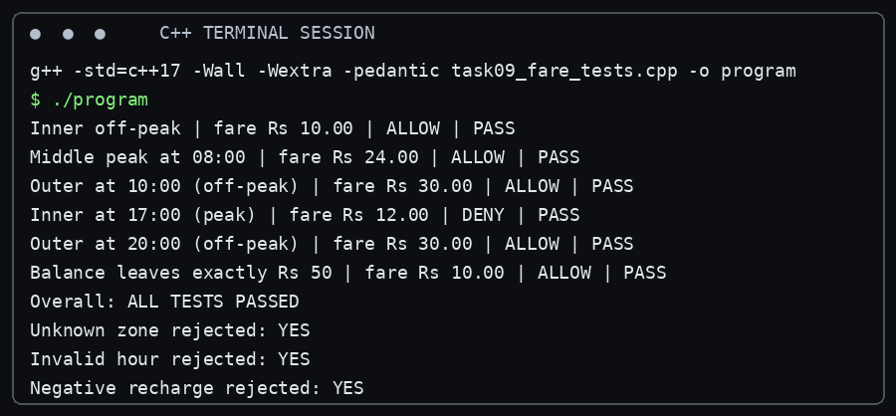
Figure: Terminal-style transcript generated from the tested program task09_fare_tests.cpp.
Verification status: compiled with g++ 14.2.0 using C++17 and executed successfully in the preparation environment. This is not represented as a screenshot from the student’s personal computer.

Test | Input condition | Expected result | Observed result
Inner off-peak | Inner, 11:00, balance Rs 100 | Rs 10.00; allow | PASS – Rs 10.00; ALLOW.
Middle at 08:00 | Middle, 08:00, balance Rs 100 | Rs 24.00; allow | PASS – Rs 24.00; ALLOW.
Outer at 10:00 | Outer, 10:00, balance Rs 100 | Rs 30.00; allow | PASS – Rs 30.00; ALLOW.
Inner at 17:00 | Inner, 17:00, balance Rs 60 | Rs 12.00; deny because remaining Rs 48 | PASS – Rs 12.00; DENY.
Outer at 20:00 | Outer, 20:00, balance Rs 80 | Rs 30.00; allow | PASS – Rs 30.00; ALLOW.
Exactly Rs 50 remains | Inner, 11:00, balance Rs 60 | Rs 10.00; allow | PASS – Rs 10.00; ALLOW.

A set of five journeys can be calculated by hand before execution. Example: Inner off-peak Rs 10.00 + Middle peak Rs 24.00 + Outer off-peak Rs 30.00 + Inner peak Rs 12.00 + Middle off-peak Rs 20.00 = Rs 96.00 total. This is a fare-sum illustration; each journey’s card eligibility is checked separately against its own balance.
A table-driven test harness scales well: t test cases take O(t) time and O(t) storage for the test table. Adding a boundary case means adding a row rather than writing another separate assertion.

TASK 10 – Compare Expectations with Execution (4 Marks)
To make the scale comparison reproducible, the accompanying program assumes every journey in the example is charged the Outer-zone peak fare of Rs 36.00. This is an illustrative upper-fare scenario, not an estimate of the real journey mix. The totals are 20,000 × 3600 = 72,000,000 paise (Rs 720,000.00); 500,000 × 3600 = 1,800,000,000 paise (Rs 18,000,000.00); and 3,000,000 × 3600 = 10,800,000,000 paise (Rs 108,000,000.00).

Verified C++ implementation
Source file: task10_scale.cpp
#include <iomanip>
#include <iostream>
#include <limits>
int main() {
const long long journeys[] = {20000, 500000, 3000000};
const long long farePaise = 3600; // illustrative: Outer-zone peak fare Rs 36.00
std::cout << "Assumed constant fare: Rs 36.00 per journey\n";
for (long long n : journeys) {
long long totalPaise = n * farePaise;
std::cout << n << " journeys: " << totalPaise << " paise = Rs "
<< totalPaise / 100 << '.' << std::setw(2) << std::setfill('0') << totalPaise % 100
<< std::setfill(' ') << " | fits int paise: "
<< std::boolalpha << (totalPaise <= std::numeric_limits<int>::max()) << '\n';
}
double sum = 0.0;
for (int i = 0; i < 100000; ++i) sum += 0.1;
std::cout << std::setprecision(17) << "Repeated double addition of 0.1, 100000 times: " << sum << '\n';
}
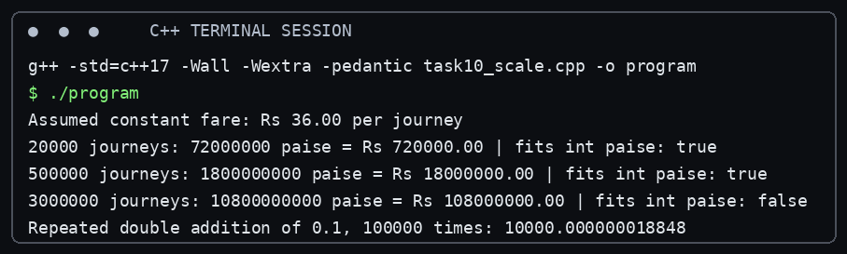
Figure: Terminal-style transcript generated from the tested program task10_scale.cpp.
Verification status: compiled with g++ 14.2.0 using C++17 and executed successfully in the preparation environment. This is not represented as a screenshot from the student’s personal computer.
Journeys | Total at Rs 36.00 each | Fits signed 32-bit int paise?
20,000 | 72,000,000 paise | Yes
500,000 | 1,800,000,000 paise | Yes, narrowly
3,000,000 | 10,800,000,000 paise | No

An int total can overflow at the network scale. A long long safely represents the illustrated total. A double has a much wider range but stores decimal values approximately; it is not the preferred type for exact monetary totals. The code also repeatedly adds 0.1 as a separate precision demonstration. Its output is platform/compiler evidence for that run, not a substitute for the exact paise calculation.
The exact compiler warning list is environment-dependent. The source files are compiled with -Wall -Wextra -pedantic; no warning should be claimed unless it appears in the captured compiler output. A warning is a diagnostic to investigate, not necessarily a program failure.
At three million additions, each scalar addition remains O(1), so the accumulation is O(n) for n journeys. The storage for one running total is O(1).

TASK 11 – Recommend and Defend the Final Design (4 Marks)
The recommended design uses enum class Zone, constexpr fare constants, integer paise, long long for balances and accumulated totals, a FareTable or fare calculation service, and a SmartCard class with private balance. Input validation occurs before calculation. Peak intervals are represented as start-inclusive and end-exclusive comparisons. Tests include both endpoints of each interval and the exact Rs 50 remaining-balance boundary.
A fare revision should be made in one central fare configuration rather than by editing repeated numeric literals. For a larger network with frequent fare revisions, a validated configuration file could be loaded at gate start. Reading z zone fares takes O(z) startup time and O(z) memory. The compiled-in constexpr approach has no file-loading cost but requires recompilation and redeployment for each change. A configuration file requires validation, versioning, fallback behaviour and secure change control.
The design is suitable for the stated network scale when long long is used for accumulated paise and all input is validated. Limitations include the unspecified concession percentage, lack of detailed station-to-zone routing, no persistence or transaction recovery, and no full policy for pass validity or refunds. These must be specified before production use.

TASK 12 – Re-evaluate and Adapt the Design (8 Marks)

A. Impact Analysis (2 Marks)
The new Airport zone adds a fourth fare entry of 6000 paise and a new Zone::Airport enumerator. Any switch statement, fare array, validation range, zone display mapping and test data must be updated. The weekend rule adds a weekend flag and a separate 10% discount path. The monthly pass adds a Pass object that stores two covered zones and allows an unlimited journey in either covered zone during its valid period.

B. Evaluation of the Original Design (2 Marks)
A switch-based fare function can absorb the fourth zone by adding a case, but repeated switch statements in several modules create maintenance risk. A central fare table indexed by a validated enum value is easier to extend. The SmartCard class can remain because it still owns the stored balance and enforces the minimum-balance rule for paid journeys. A pass-covered journey has zero fare under the stated assumption and therefore does not deduct the stored balance.
Worked examples: Airport weekday peak fare = Rs 60.00 × 1.20 = Rs 72.00. Airport weekend fare = Rs 60.00 × 0.90 = Rs 54.00. The weekend discount does not combine with the peak surcharge. A pass covering Inner and Middle makes those zone journeys free for the pass holder; an Outer or Airport journey remains chargeable unless covered.

C. Adaptation / Redesign (2 Marks)

Verified C++ implementation
Source file: task12_revised.cpp
#include <array>
#include <iostream>
#include <set>
enum class Zone { Inner, Middle, Outer, Airport };
long long baseFare(Zone z) {
constexpr std::array<long long,4> fares{1000,2000,3000,6000};
return fares.at(static_cast<std::size_t>(z));
}
class MonthlyPass {
std::set<Zone> covered;
public:
MonthlyPass(Zone first, Zone second) : covered{first,second} {}
bool covers(Zone z) const { return covered.count(z) != 0; }
};
long long revisedFare(Zone z, int hour, bool weekend, const MonthlyPass* pass) {
if (pass && pass->covers(z)) return 0;
long long fare = baseFare(z);
bool peak = (hour >= 8 && hour < 10) || (hour >= 17 && hour < 20);
if (weekend) fare = fare * 90 / 100; // weekend discount replaces peak surcharge
else if (peak) fare = fare * 120 / 100;
return fare;
}
int main() {
MonthlyPass pass(Zone::Inner, Zone::Middle);
std::cout << "Airport weekday peak: " << revisedFare(Zone::Airport, 8, false, nullptr) << " paise\n"
<< "Airport weekend peak: " << revisedFare(Zone::Airport, 8, true, nullptr) << " paise\n"
<< "Covered Inner-zone journey: " << revisedFare(Zone::Inner, 18, false, &pass) << " paise\n"
<< "Uncovered Outer-zone journey: " << revisedFare(Zone::Outer, 11, false, &pass) << " paise\n";
}
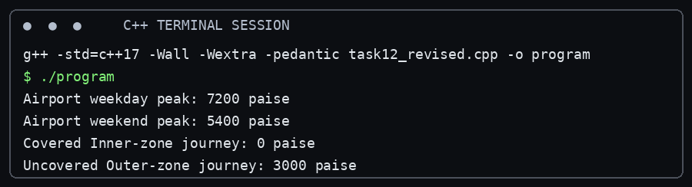
Figure: Terminal-style transcript generated from the tested program task12_revised.cpp.
Verification status: compiled with g++ 14.2.0 using C++17 and executed successfully in the preparation environment. This is not represented as a screenshot from the student’s personal computer.
The revised program uses a four-entry fare table and a MonthlyPass class containing two selected zones. It applies the weekend discount in preference to the peak surcharge. For a pass-covered zone it returns zero fare. This implementation assumes the monthly pass is valid at the time of travel; the brief does not specify purchase price, start/end dates, renewal, transferability or refund policy, so those production features are not invented here.

D. Evidence-Based Defence (2 Marks)
The table-based fare mapping makes the fourth zone a data addition rather than another repeated branch. Separating weekend and peak logic prevents accidental stacking of the two adjustments. The pass is represented as a distinct object rather than mixing pass eligibility into the stored-value balance. The trade-off is that the array index must match the enum ordering and be validated; a map keyed by Zone could be chosen if zone identifiers become non-contiguous or dynamically configured.

Overall conclusion
The recommended implementation uses typed zone values, centralised compile-time fare constants, integer paise, safe input handling, explicit peak-hour boundaries and encapsulated card-balance operations. The code and test evidence demonstrate the main fare rules and the Task 12 extension. Before deployment, the metro authority must define concession eligibility and rate, monthly-pass validity and operational rules, and any additional journey-routing requirements.

References
- Official document: Assignment 1 – CO1, DSA01 Object-Oriented Programming with C++, supplied by the course.
- ISO C++ language standard concepts as implemented by the tested C++17 compiler; see the compiler documentation for implementation-specific details.
- GNU Compiler Collection (GCC) documentation for g++ compiler options, including -std=c++17, -Wall and -Wextra.

Appendix A – Program execution record
The following source files were compiled using g++ 14.2.0 with -std=c++17 -Wall -Wextra -pedantic. Terminal-style figures are generated from the stdout of the corresponding executable. A successful compile and run in this environment does not prove execution on the student’s submission computer.

task02_constants.cpp
Compile command: g++ -std=c++17 -Wall -Wextra -pedantic /mnt/data/CO1_Assignment1/Assignment/CO1/source/task02_constants.cpp -o /mnt/data/CO1_Assignment1/Assignment/CO1/outputs/task02_constants
Exit code: 0
Compiler diagnostics: none reported.
Program output:
1000 2000 3000
Peak surcharge: 20%
Minimum remaining balance: 5000 paise

task03_types.cpp
Compile command: g++ -std=c++17 -Wall -Wextra -pedantic /mnt/data/CO1_Assignment1/Assignment/CO1/source/task03_types.cpp -o /mnt/data/CO1_Assignment1/Assignment/CO1/outputs/task03_types
Exit code: 0
Compiler diagnostics: none reported.
Program output:
sizeof(bool)=1
sizeof(char)=1
sizeof(int)=4
sizeof(long long)=8
sizeof(float)=4
sizeof(double)=8
INT_MIN=-2147483648 INT_MAX=2147483647
LLONG_MAX=9223372036854775807

task04_conversions.cpp
Compile command: g++ -std=c++17 -Wall -Wextra -pedantic /mnt/data/CO1_Assignment1/Assignment/CO1/source/task04_conversions.cpp -o /mnt/data/CO1_Assignment1/Assignment/CO1/outputs/task04_conversions
Exit code: 0
Compiler diagnostics: /mnt/data/CO1_Assignment1/Assignment/CO1/source/task04_conversions.cpp: In function ‘int main()’:
/mnt/data/CO1_Assignment1/Assignment/CO1/source/task04_conversions.cpp:13:21: warning: comparison of integer expressions of different signedness: ‘int’ and ‘unsigned int’ [-Wsign-compare]
13 | std::cout << (s < u ? "s < u" : "s >= u") << '\n';
| ~~^~~
Program output:
3 3.5
C 68
1 true
s >= u

task05_precedence.cpp
Compile command: g++ -std=c++17 -Wall -Wextra -pedantic /mnt/data/CO1_Assignment1/Assignment/CO1/source/task05_precedence.cpp -o /mnt/data/CO1_Assignment1/Assignment/CO1/outputs/task05_precedence
Exit code: 0
Compiler diagnostics: none reported.
Program output:
11 16
9 6 4
6 4
3 1 -3 -1
18

task06_control.cpp
Compile command: g++ -std=c++17 -Wall -Wextra -pedantic /mnt/data/CO1_Assignment1/Assignment/CO1/source/task06_control.cpp -o /mnt/data/CO1_Assignment1/Assignment/CO1/outputs/task06_control
Exit code: 0
Compiler diagnostics: none reported.
Program output:
Fare Rs 10.00 balance Rs 90
Fare Rs 36.00 balance Rs 54
Denied (low balance) balance Rs 54

task07_oop.cpp
Compile command: g++ -std=c++17 -Wall -Wextra -pedantic /mnt/data/CO1_Assignment1/Assignment/CO1/source/task07_oop.cpp -o /mnt/data/CO1_Assignment1/Assignment/CO1/outputs/task07_oop
Exit code: 0
Compiler diagnostics: none reported.
Program output:
Procedural accepted: true
OOP deduction accepted: true
OOP balance paise: 8000
Excess fare rejected: true

task08_input.cpp
Compile command: g++ -std=c++17 -Wall -Wextra -pedantic /mnt/data/CO1_Assignment1/Assignment/CO1/source/task08_input.cpp -o /mnt/data/CO1_Assignment1/Assignment/CO1/outputs/task08_input
Exit code: 0
Compiler diagnostics: none reported.
Program output:
Enter hour (0-23): Invalid numeric input. Try again.
Enter hour (0-23): Hour must be from 0 to 23. Try again.
Enter hour (0-23): Hour must be from 0 to 23. Try again.
Enter hour (0-23): Accepted hour: 9
Sample amount: Rs 10.25

task09_fare_tests.cpp
Compile command: g++ -std=c++17 -Wall -Wextra -pedantic /mnt/data/CO1_Assignment1/Assignment/CO1/source/task09_fare_tests.cpp -o /mnt/data/CO1_Assignment1/Assignment/CO1/outputs/task09_fare_tests
Exit code: 0
Compiler diagnostics: none reported.
Program output:
Inner off-peak | fare Rs 10.00 | ALLOW | PASS
Middle peak at 08:00 | fare Rs 24.00 | ALLOW | PASS
Outer at 10:00 (off-peak) | fare Rs 30.00 | ALLOW | PASS
Inner at 17:00 (peak) | fare Rs 12.00 | DENY | PASS
Outer at 20:00 (off-peak) | fare Rs 30.00 | ALLOW | PASS
Balance leaves exactly Rs 50 | fare Rs 10.00 | ALLOW | PASS
Overall: ALL TESTS PASSED
Unknown zone rejected: YES
Invalid hour rejected: YES
Negative recharge rejected: YES

task10_scale.cpp
Compile command: g++ -std=c++17 -Wall -Wextra -pedantic /mnt/data/CO1_Assignment1/Assignment/CO1/source/task10_scale.cpp -o /mnt/data/CO1_Assignment1/Assignment/CO1/outputs/task10_scale
Exit code: 0
Compiler diagnostics: none reported.
Program output:
Assumed constant fare: Rs 36.00 per journey
20000 journeys: 72000000 paise = Rs 720000.00 | fits int paise: true
500000 journeys: 1800000000 paise = Rs 18000000.00 | fits int paise: true
3000000 journeys: 10800000000 paise = Rs 108000000.00 | fits int paise: false
Repeated double addition of 0.1, 100000 times: 10000.000000018848

task12_revised.cpp
Compile command: g++ -std=c++17 -Wall -Wextra -pedantic /mnt/data/CO1_Assignment1/Assignment/CO1/source/task12_revised.cpp -o /mnt/data/CO1_Assignment1/Assignment/CO1/outputs/task12_revised
Exit code: 0
Compiler diagnostics: none reported.
Program output:
Airport weekday peak: 7200 paise
Airport weekend peak: 5400 paise
Covered Inner-zone journey: 0 paise
Uncovered Outer-zone journey: 3000 paise

