Machine Learning Notes
Linear Regression | Cost Function | Visualization

1. Linear Regression Model
Linear Regression is the simplest and most widely used supervised learning algorithm. It predicts a continuous output value by learning a linear relationship between the input features and the target variable.

1.1 What is Linear Regression?
Linear Regression fits a straight line through the data that best represents the relationship between:
- Input (X): The feature/independent variable (e.g., house size)
- Output (Y): The target/dependent variable (e.g., house price)

1.2 The Model Equation
The linear regression model is represented as:

f(x) = wx + b

Where:
x = input feature
w = weight (slope) → controls the steepness of the line
b = bias (intercept) → where the line crosses the y-axis
f(x) = predicted output (y-hat)

1.3 How the Model Learns
- Start with random values of w and b
- Make predictions using f(x) = wx + b
- Compare predictions with actual values
- Adjust w and b to reduce the error
- Repeat until the best line is found

1.4 Example
Predicting house price based on size:

House Size (sq ft) | Actual Price (Lakhs) | Predicted Price (Lakhs)
1000 | 40 | 42
1500 | 60 | 61
2000 | 80 | 79
2500 | 100 | 98

2. Cost Function Formula
The Cost Function measures how wrong the model's predictions are. It tells us how far the predicted values are from the actual values. The goal of training is to minimize this cost.

2.1 Mean Squared Error (MSE)
The most commonly used cost function for Linear Regression is Mean Squared Error:

J(w, b) = (1 / 2m) * sum[ (f(x[i]) - y[i])^2 ]

Where:
m = number of training examples
f(x[i]) = predicted value for i-th example (= wx[i] + b)
y[i] = actual value for i-th example
(f - y)^2 = squared error for each example
1/2m = average over all examples (1/2 simplifies derivative)

2.2 Why Squared Error?
- Squaring removes negative signs (errors cancel out otherwise)
- Penalizes larger errors more heavily than smaller ones
- Makes the math easier — the function is smooth and differentiable
- Results in a convex (bowl-shaped) curve — easy to minimize

2.3 Step-by-Step Calculation
Example with 3 training samples:

i | x (input) | y (actual) | f(x) = 2x+1 | Error (f-y) | (f-y)^2
1 | 1 | 3 | 3 | 0 | 0
2 | 2 | 5 | 5 | 0 | 0
3 | 3 | 8 | 7 | -1 | 1

J(w,b) = (1 / 2*3) * (0 + 0 + 1)
= (1/6) * 1
= 0.167

Lower J = Better model fit

3. Cost Function Intuition
Understanding what the cost function means and how minimizing it helps find the best model parameters.

3.1 Core Idea
Think of the cost function as a "badness score":
- High J(w,b) → Model predictions are far from actual values → Bad model
- Low J(w,b) → Model predictions are close to actual values → Good model
- J(w,b) = 0 → Perfect predictions (rarely happens in real data)

3.2 What Happens When We Change w?
For a simplified model f(x) = wx (ignoring b):

Value of w | Line slope | Cost J(w) | Fit Quality
0 | Flat line | High | Very poor
0.5 | Gentle slope | Medium | Moderate
1 (optimal) | Best fit slope | Lowest | Best fit
2 | Steep slope | High | Very poor

As w increases from 0, J decreases → reaches a minimum → then increases again. This creates a U-shaped (parabola) curve.

3.3 The Goal of Training

Goal: minimize J(w, b)

Find values of w and b such that:
J(w, b) is as small as possible

This is achieved using: Gradient Descent

3.4 Gradient Descent (Brief)
Gradient Descent is the algorithm used to minimize J(w,b):
- Start at any random w, b
- Calculate the slope (gradient) of J at that point
- Move in the opposite direction of the slope (downhill)
- Repeat until reaching the minimum

Update rule:
w = w - alpha * (dJ/dw)
b = b - alpha * (dJ/db)

alpha = learning rate (how big each step is)

4. Visualizing the Cost Function
Visualization helps understand how the cost function behaves as we change w and b.

4.1 Single Parameter — 2D Plot (w only)
When we only vary w (keeping b=0), the cost function forms a parabola (U-shape):

J(w)
| * *
| * *
| * *
| * *
| * (minimum) *
| *_______________|_____________*
+-------------------------------------------> w
w_optimal

* The bottom of the curve = optimal w
* Gradient Descent rolls down to reach this point

4.2 Two Parameters — 3D Surface Plot (w and b)
When we vary both w and b, the cost function forms a 3D bowl shape:

J(w,b)
/\
/ \ High cost
/ \ _ _
| (*) | <- Minimum (optimal w and b)
\_ _ _ /
|
Low cost

* Any point on the bowl = a pair of (w, b) values
* Height of the bowl = cost J at that point
* The very bottom = best w and b values

4.3 Contour Plot (Top-Down View)
A contour plot shows the 3D bowl from above as concentric ellipses:

b
| ( outer ring = high cost )
| ( ( middle ring ) )
| ( ( ( * center ) ) )
| ( ( inner ring ) )
| ( inner = low cost )
+--------------------------------> w

* Each ellipse = same cost value
* Center dot (*) = minimum cost point
* Gradient Descent moves from outer to center

4.4 Key Observations from Visualization

Observation | Meaning
Bowl shape (convex) | Only one minimum — guaranteed to converge
Steep slopes | Large gradients — big steps in gradient descent
Flat regions | Small gradients — slow convergence
Center of contour | Optimal w and b values
Learning rate too big | Overshoots the minimum — cost oscillates
Learning rate too small | Very slow convergence

5. Quick Summary

Concept | Formula / Key Point
Linear Regression Model | f(x) = wx + b
Cost Function (MSE) | J(w,b) = (1/2m) * sum[(f(x)-y)^2]
Goal | Minimize J(w,b)
Method | Gradient Descent
2D Plot shape | Parabola (U-shape)
3D Plot shape | Bowl (convex surface)
Contour Plot | Concentric ellipses — center = optimal

OPTIONAL LAB IMAGES :
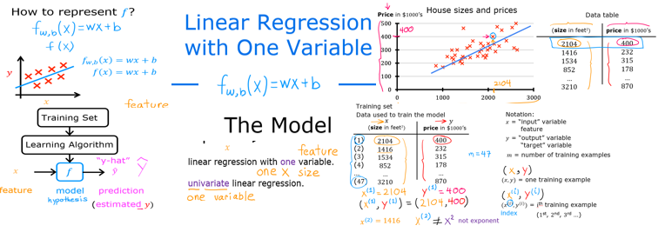

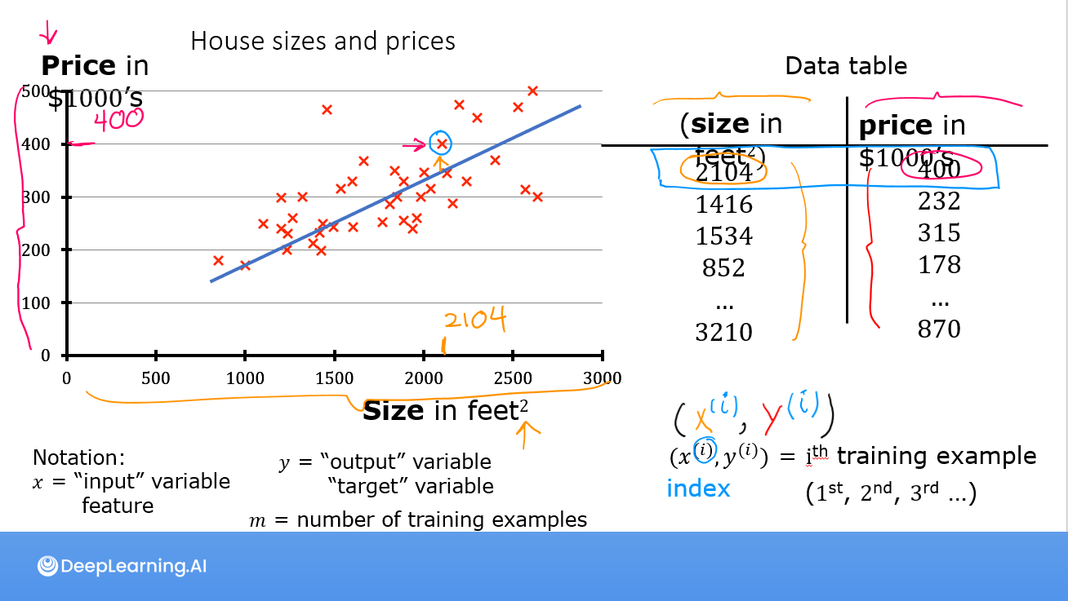
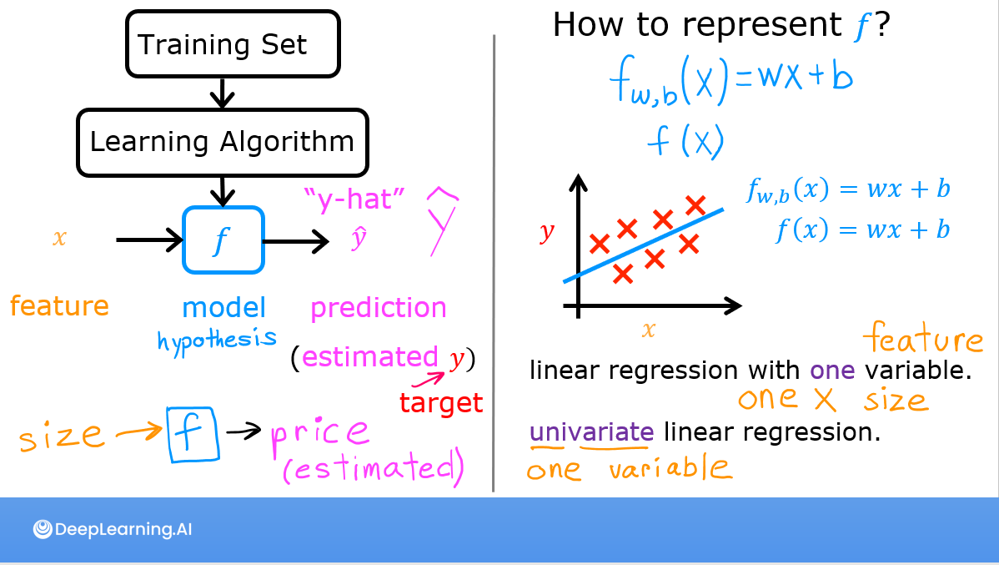

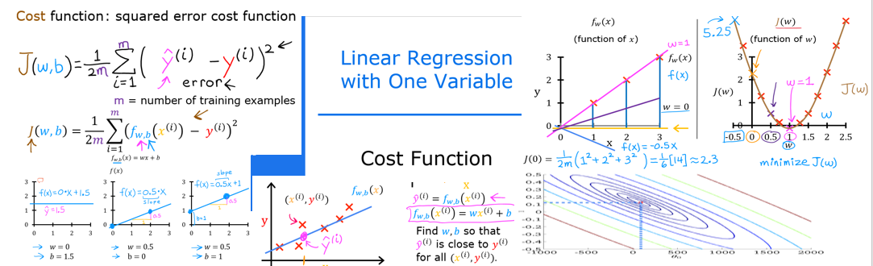

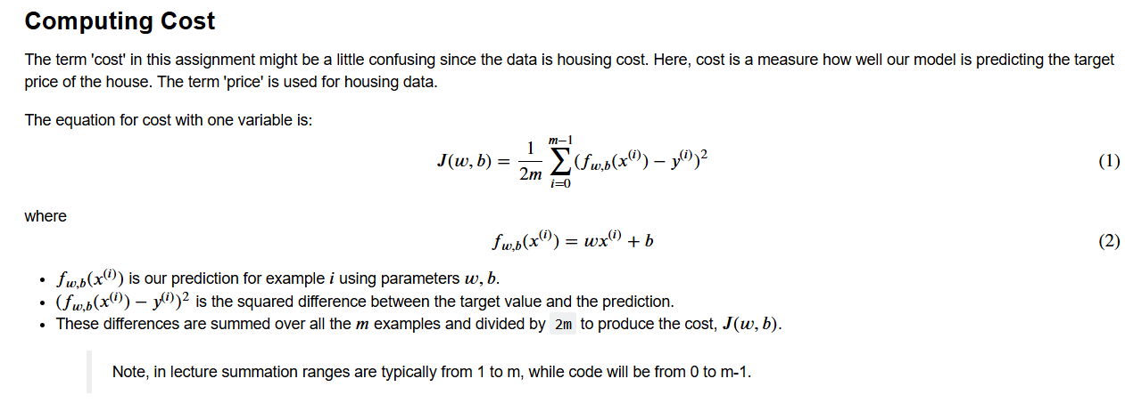

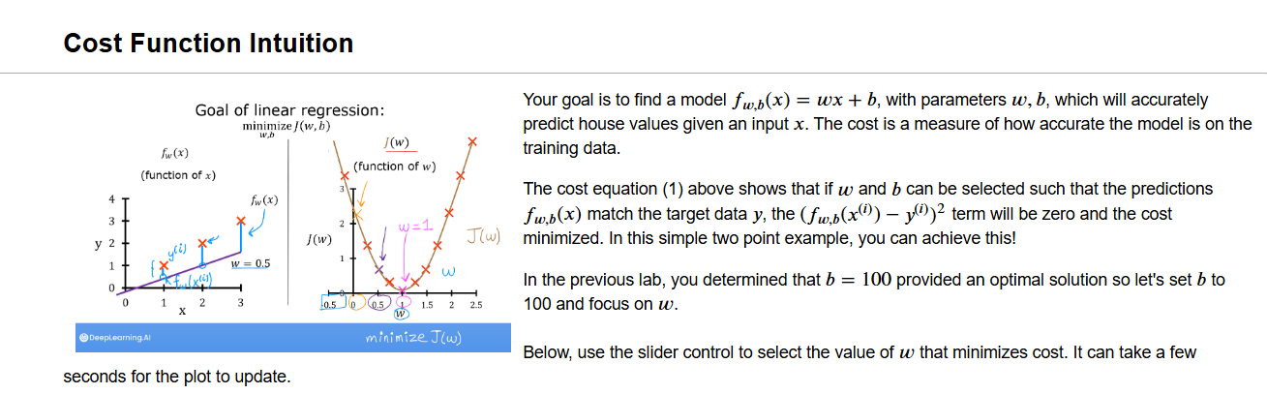
— End of Notes —

