VR Interview Simulation: A Resume-Grounded, Sequential Multi-Persona Conversational AI Framework for Immersive Interview Practice
N. Swetha  Department of Computer Science and Design  Rajalakshmi Engineering College  Chennai, Tamil Nadu, India  nslswetha2007@gmail.com | VA. Mukesh  Department of Computer Science and Design  Rajalakshmi Engineering College  Chennai, Tamil Nadu, India  mukeshva95@gmail.com
Under the guidance of Dr. P. Revathy
Abstract—Mock-interview practice is constrained by the limited availability of experienced interviewers, generic questioning detached from a candidate's background, flat screen-based interfaces and little objective feedback on non-verbal conduct. This paper presents VR Interview Simulation, an immersive mock-interview platform that integrates a Unity virtual boardroom (OpenXR with a desktop fallback), resume-grounded conversational AI, a sequential three-interviewer panel, head-pose-based behavioural telemetry and automated post-interview feedback. Candidate PDF resumes are parsed locally by a Python bridge (pypdf with heuristic pattern matching) into a structured profile, which is injected as runtime context into cloud-hosted Convai characters. A finite-state orchestrator moves the candidate through human-resources, behavioural and hiring-manager stages and forwards earlier transcripts to later interviewers. Headset orientation is used to estimate gaze alignment with the active interviewer, together with posture stability and response latency, and a ten-competency evaluation model converts transcripts and telemetry into an on-screen summary and a PDF report. The paper describes the architecture, algorithms and implementation, and reports implementation-level verification. It does not report experimental results: no human-subject study has been conducted, the scoring model is an engineering heuristic that has not been validated against recruiter judgement, and gaze alignment is estimated from head pose and not from eye tracking.
Keywords—virtual reality, mock interview, conversational AI, resume grounding, multi-agent orchestration, head-pose gaze estimation, automated feedback, Unity, Convai

I. INTRODUCTION
The employment interview remains a central step in candidate selection, and the design of structured interviews has attracted a substantial body of empirical research [1]. For candidates, the interview is also a performance: they must present their background coherently, answer behavioural questions under evaluative pressure, and manage visible conduct such as eye contact and pacing. Practising this performance with experienced interviewers is resource-intensive, and computer-based practice tools have therefore been explored for some time [2], [3].
Existing computer-based tools address parts of the problem. Interview simulators with a virtual interviewer provide repeated practice and automated feedback [2], [3], and a separate line of work analyses recorded interviews to support recruiters [4], [5]. What remains less common in the works reviewed here is a single practice environment that places the candidate in a three-dimensional interview setting, grounds the questioning in the candidate's own resume, presents a multi-person panel, observes non-verbal conduct from headset tracking, and returns structured feedback after the session. This paper describes VR Interview Simulation, a system that integrates these elements, and reports its design and implementation.

A. Problem Statement
The project addresses the following limitations of conventional mock-interview practice, which are drawn from the project's design rationale and are not quantified in this paper: (i) limited access to experienced human evaluators; (ii) generic questioning that is detached from the candidate's qualifications; (iii) flat, screen-based interfaces that do not reproduce the spatial presence of an in-person panel; (iv) the absence of multi-interviewer dynamics in which each interviewer examines different competencies and builds on earlier discussion; and (v) little objective feedback on non-verbal conduct. The talent-analytics survey of Qin et al. also notes that research combining conversational interviewing techniques with comprehensive interview-question resources remains limited [5].

B. Overview of the System
VR Interview Simulation is implemented as a Unity 6 application with an OpenXR-based virtual-reality mode and a desktop fallback. A candidate uploads a PDF resume, which a local Python script converts into a structured profile. The profile is held in a session manager and supplied as runtime context to three cloud-hosted conversational characters from the Convai platform. A finite-state orchestrator moves the candidate through a human-resources (HR) stage, a behavioural stage and a hiring-manager stage, forwarding earlier transcripts to later interviewers. During the session the application derives gaze alignment, posture stability and response latency from head-mounted-display (HMD) pose, and afterwards a ten-competency evaluation model produces an on-screen summary and a PDF report.

C. Contributions and Organisation
The engineering contributions, each supported by the project inspection summarised in Section XIII, are:
- an integrated architecture combining an immersive interview environment, cloud conversational AI and local resume processing (Sections V, VIII);
- resume-driven candidate-context extraction and injection into conversational characters (Section VI);
- a sequential three-interviewer orchestration with cross-stage transcript forwarding (Section VII);
- HMD-based behavioural telemetry that estimates gaze alignment from head pose without additional sensors (Section IX); and
- an automated competency-based feedback pipeline that ends in a PDF placement report (Section X).
Section II reviews related work, Section III states the research gap, and Section IV states the objectives. Sections V to X describe the architecture and subsystems, Section XI the implementation, and Sections XII and XIII the testing and verification. Sections XIV to XVI cover limitations, future work and conclusions. No human-subject evaluation has been conducted; claims are therefore limited to what the system implements.

II. RELATED WORK

A. Interview Training Systems
Virtual Reality Job Interview Training (VR-JIT) provides repeated interviewing trials with a virtual human-resources representative together with online didactic material; a study of 70 participants reported preliminary support that participation was associated with enhanced vocational outcomes, including job offers in the following six months [2]. MACH (My Automated Conversation coacH) uses an animated character that asks interview questions, mimics some of the user's behaviour, shows non-verbal behaviour of its own and gives visual feedback after the interaction; in a week-long trial with 90 undergraduates, human experts rated the MACH group as improved in overall interview performance relative to control groups [3]. Both are evidence that simulated interviewers can support practice. Neither description in the cited abstracts mentions a head-mounted immersive environment, resume-derived questioning or a multi-person panel.

B. Automated Interview Analysis
HireNet predicts recruiter-assessed hirability from asynchronous video interviews, using a corpus of more than 7,000 candidates and modelling verbal, audio and video content [4]. The system is recruiter-facing and non-interactive. The survey of Qin et al. situates such work within talent analytics, covering resume understanding, interview-question recommendation and assessment scoring, and highlights fairness, interpretability and data-privacy concerns [5]. These concerns apply equally to the scoring component described in Section X.

C. Resume Understanding
Resume understanding converts resume files into structured fields. According to the survey in [5], early approaches used keyword search and rule-based matching, later ones used statistical sequence models, and recent ones treat the task as named-entity recognition with pretrained language models and layout-aware models. The parser in this work belongs to the first category (Section VI) and is acknowledged as the least capable of these.

D. Presence, Realism and VR in Affective Settings
Slater distinguishes Place Illusion (the sensation of being in the depicted place) from Plausibility Illusion (the credibility of the depicted events) and argues that, when both occur, participants tend to respond realistically to immersive virtual environments [6]. A meta-analysis of 13 studies reported a large effect of virtual reality exposure therapy relative to control conditions for anxiety disorders [7]. This evidence concerns clinical exposure therapy and is cited only as background on VR as a medium for eliciting realistic affective responses; it is not evidence about interview training.

E. Head Orientation as a Gaze Cue
Stiefelhagen and Zhu examined head orientation and eye orientation as contributors to gaze direction in four-person meetings and reported that head orientation contributed on average 68.9% to the overall gaze direction and supported focus-of-attention estimation with 88.7% average accuracy [8]. Their setting differs from a candidate facing a panel, but the result motivates head pose as a proxy for attention while making clear that it is a proxy and not a measurement of eye direction.
TABLE I
QUALITATIVE CAPABILITY COMPARISON
Approach | HMD VR | Conv. agent | Resume ground. | Multi-intvw. | Non-verbal | Feedback
VR-JIT [2] | NR | Yes | NR | No | NR | NR
MACH [3] | NR | Yes | NR | NR | Yes | Yes
HireNet [4] | No | No | No | No | Yes | No
This work | Yes | Yes | Yes* | Yes† | Yes‡ | Yes§
NR: not reported in the cited abstract. Entries for prior work reflect only what the cited sources state and are not exhaustive descriptions of those systems. For this work, "Yes" denotes implementation, not validated effectiveness. *Heuristic parser. †Sequential, not simultaneous. ‡Head-pose estimate, not eye tracking. §Heuristic scoring, unvalidated.

III. RESEARCH GAP AND MOTIVATION
The works above treat interview practice, interview analysis and resume parsing largely as separate problems. The gap addressed here is one of integration: the proposed system combines (1) an immersive virtual interview setting, (2) conversational AI interviewers, (3) candidate resume grounding, (4) a sequential multi-persona panel with context propagation, (5) non-verbal observation from HMD tracking, and (6) automated post-interview feedback in one end-to-end pipeline. The claim made is that this combination is implemented and inspectable; it is not claimed that the system is the first of its kind, nor that the combination improves interview outcomes. Testing that proposition requires user studies that are outside the scope of this paper (Section XV).

IV. SYSTEM OBJECTIVES AND CONTRIBUTIONS
The project's engineering objectives, taken from the implemented code, are to (1) provide a spatial interview environment, (2) extract candidate information from a PDF resume and inject it into conversational agents, (3) orchestrate three sequential interview stages, (4) propagate earlier-stage transcripts to later interviewers, (5) measure head orientation, gaze alignment, posture stability and response latency, and (6) synthesise transcripts and telemetry into a competency-based report. The questions the implementation answers are design questions:
- DQ1. Can resume-derived context be supplied to cloud conversational characters at runtime?
- DQ2. Can a three-persona panel be orchestrated sequentially with transcript forwarding?
- DQ3. Can gaze-alignment, posture and latency metrics be derived from HMD pose alone?
- DQ4. Can transcripts and telemetry be converted into a structured, exportable report automatically?
Four evaluation questions follow from the design but are not answered here: whether an immersive panel elicits stronger presence and realistic anxiety than a 2D conversational agent (EQ1); whether resume grounding improves perceived question relevance (EQ2); whether a specialised sequential panel gives more comprehensive preparation than a single general agent (EQ3); and how closely HMD-derived metrics agree with expert recruiter assessments (EQ4).

V. SYSTEM ARCHITECTURE
The system has three execution tiers (Fig. 1). The Unity client renders the environment, manages scenes and the interview state machine, captures telemetry and runs the feedback engine. A local Python subsystem, invoked as a child process, extracts resume text and renders the final PDF. The Convai cloud performs speech recognition, language-model dialogue, speech synthesis and lip-sync generation; the Unity client communicates with it through the Convai Unity SDK. All session state is held locally in memory; there is no remote database.
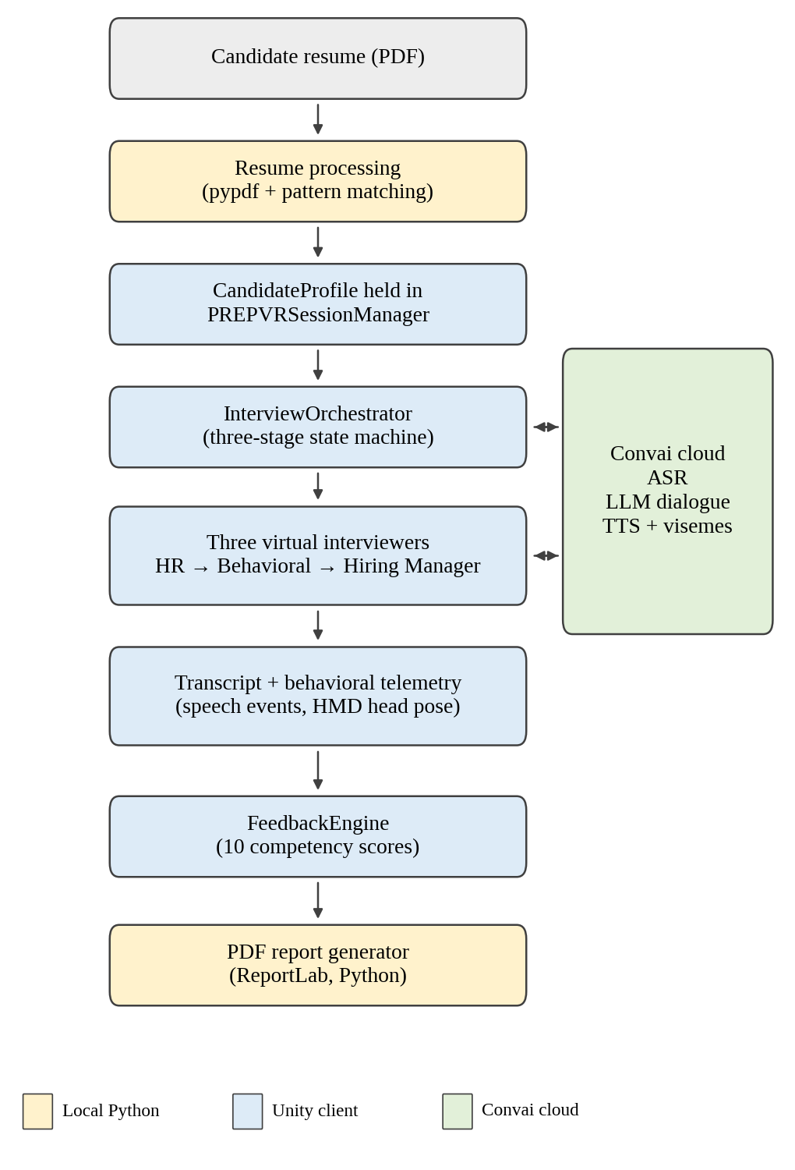
Fig. 1. Overall architecture. Shading indicates the execution tier: local Python, Unity client, Convai cloud.
TABLE II
TECHNOLOGY STACK (FROM PROJECT MANIFESTS)
Component | Technology (version) | Role
Engine | Unity 6 (6000.3.21f1); URP 17.3.0 | Rendering, scenes, game logic
XR | XR Interaction Toolkit 3.6.1; XR Plugin Management 4.7.0; OpenXR | HMD tracking, controllers
Input | Input System 1.20.0 | Keyboard, mouse, XR input
Conversation | Convai Unity SDK 4.6.0 | Characters, audio streaming, dynamic context
Language | C# (.NET Standard 2.1); Python 3.10+ | Client logic; local scripts
Python libs | pypdf; reportlab | Resume text extraction; PDF rendering
UI | uGUI; TextMeshPro 3.2.0 | Screens and runtime HUD
OpenXR is the Khronos open standard for cross-platform access to VR and AR devices [9].
The application is organised as seven scenes: Welcome, Home, Interview Type, Resume Upload, Resume Review, Interview Room and Interview Over. A persistent session manager (PREPVRSessionManager, a DontDestroyOnLoad singleton) carries the candidate profile, transcript, visual observations, feedback and an IsVRMode flag across scene transitions, and SceneLoader selects desktop or VR mode before entering the interview. The interview-type screen offers the HR and behavioural panel track; the technical coding track is displayed as "Coming Soon" and is not implemented.

VI. RESUME INTELLIGENCE AND PERSONALISATION
The resume pipeline (Fig. 2) begins when the candidate selects a PDF through a native Windows file dialog (the Unity Editor file panel is used in the editor). ResumeUploadController calls PythonBackendBridge, which launches unity_bridge.py parse <file.pdf> as a headless process and reads its standard output. The script extracts raw text with pypdf and applies deterministic pattern matching: regular expressions for e-mail addresses and telephone numbers, a lexicon of more than 45 technical keywords (for example Python, Java, C#, Machine Learning, Unity, React and Cloud) for skills, and keyword scans for education (University, College, Institute, B.Tech, M.S. and similar) and experience (Intern, Engineer, Developer, Lead and similar). The output is a JSON object with the fields candidate_name, email, phone, skills, education, experience, projects and summary, which Unity deserialises into a CandidateProfile.
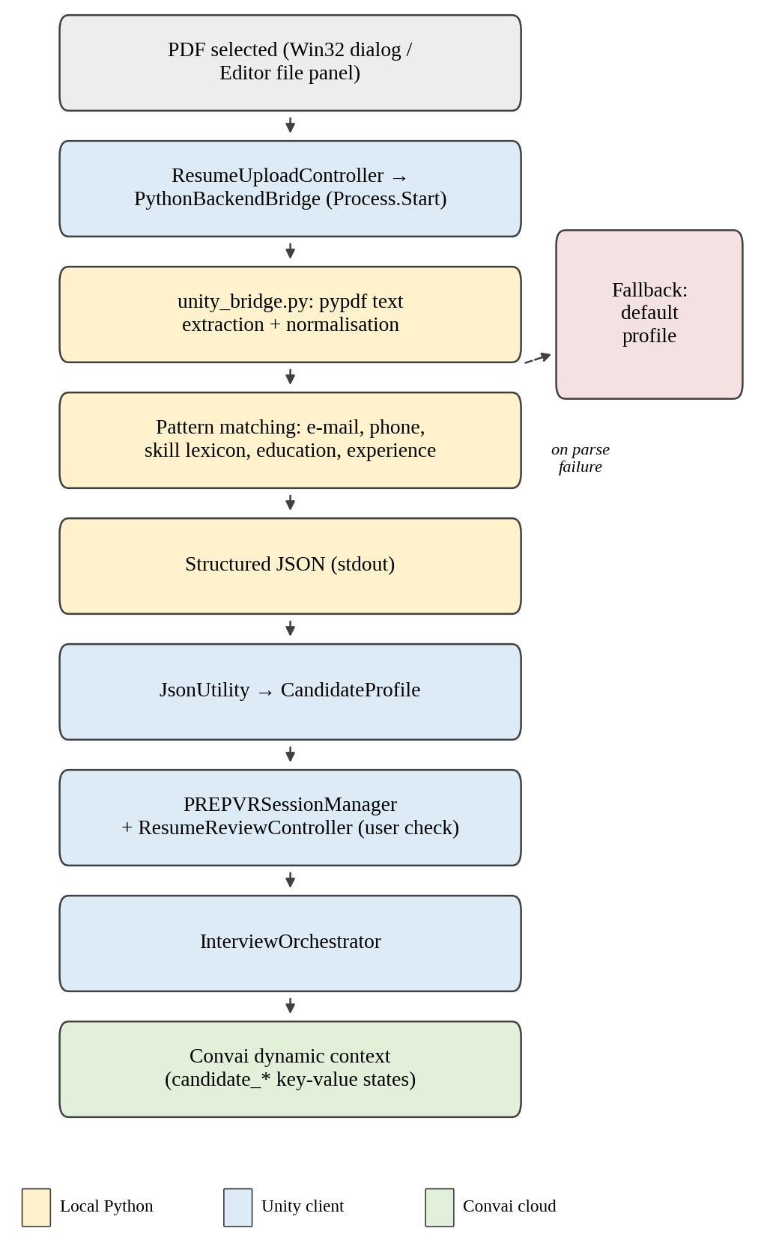
Fig. 2. Resume intelligence pipeline from PDF to Convai dynamic context.
The candidate reviews the parsed profile on the Resume Review screen before entering the room. If parsing fails because the PDF is corrupted or the Python environment is missing, the controller reports the failure and continues with a default profile so that the session does not fail.
At room initialisation the orchestrator supplies profile fields as key-value states to each character's dynamic context (candidate_name, candidate_skills, candidate_education, candidate_projects) and builds opening prompts that reference them, for example an instruction to ask about the candidate's first listed project. Convai documents dynamic context as session-specific information pushed to a character at runtime that exists only for the current session and takes effect asynchronously, visible in the character's next reply [10]. The effect of grounding on question relevance has not been measured (EQ2).
The parser is heuristic. It uses keyword and pattern matching and not a trained named-entity-recognition or layout-aware model of the kind surveyed in [5]; unconventional or multi-column layouts may yield incomplete extraction.

VII. CONVERSATIONAL AI AND MULTI-INTERVIEWER ORCHESTRATION

A. Division of Responsibilities
Table III separates what runs locally from what runs in the cloud. Python does not call any external large-language-model service; resume parsing and the fallback evaluator in the Python script are deterministic. All generative dialogue is performed within Convai's hosted backend. The specific language models used by that backend are not exposed to the client and are not known to the authors.
TABLE III
EXECUTION RESPONSIBILITIES
Tier | Responsibilities
Unity (local) | Scenes, XR rig, orchestration, microphone capture and streaming via SDK, audio playback, lip-sync rendering, telemetry, feedback scoring
Python (local) | PDF text extraction and pattern-based parsing; PDF report rendering; a heuristic fallback evaluator
Convai (cloud) | Speech recognition, dialogue generation from persona prompt, narrative configuration and injected context, speech synthesis, viseme generation

B. Three-Stage Sequential Panel
The orchestrator, InterviewOrchestrator, is a deterministic finite-state machine over the stages Uninitialized, Ready, Stage1_HR, Stage2_Behavioral, Stage3_HiringManager and Complete (Fig. 3). Each stage targets about 180 s; a stage hands over when its timer exceeds the target or an exchange quota is met. A separate 600 s interview timer runs in parallel, and either panel completion or timer expiry leads to the Interview Over scene. Table IV summarises the roles. The three interviewers are separate Convai characters; the HR interviewer uses a Convai sample avatar and the other two use a seated formal avatar.
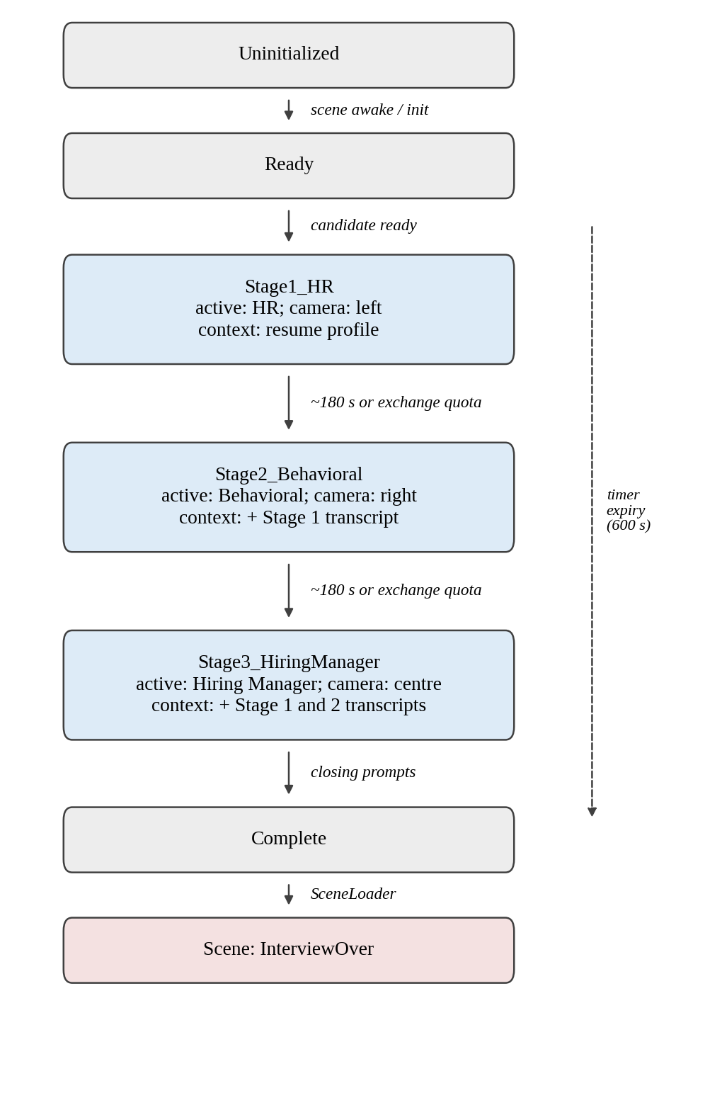
Fig. 3. Three-stage interview state machine with active target, camera focus and forwarded context per stage.
TABLE IV
INTERVIEW STAGES
Stage | Role (object name) | Focus | Context received
1 | HR (HR Interviewer) | Background, resume, career trajectory, communication, motivation | Resume profile
2 | Behavioural (Behaviour Analyst) | Teamwork, adaptability, problem solving; STAR-oriented questions | Profile + Stage 1 transcript
3 | Hiring Manager (Technical Interviewer) | Project execution, ownership, leadership, workplace readiness, candidate questions | Profile + Stage 1 and 2 transcripts
Object names are those used in the Unity scene; the paper uses role names.

C. Conversational Interaction Loop
The verbal loop is shown in Fig. 4. The candidate's speech is captured by the microphone (HMD or desktop) and streamed by the SDK over a LiveKit-based channel to Convai, where it is transcribed and passed to the dialogue engine together with the character's persona and dynamic context. The response is returned as synthesised audio and viseme data, which the ConvaiCharacter component plays through a spatial AudioSource and maps to facial blend shapes. The orchestrator can also send text prompts to the active character, which allows the interviewer to speak first at the start of each stage.
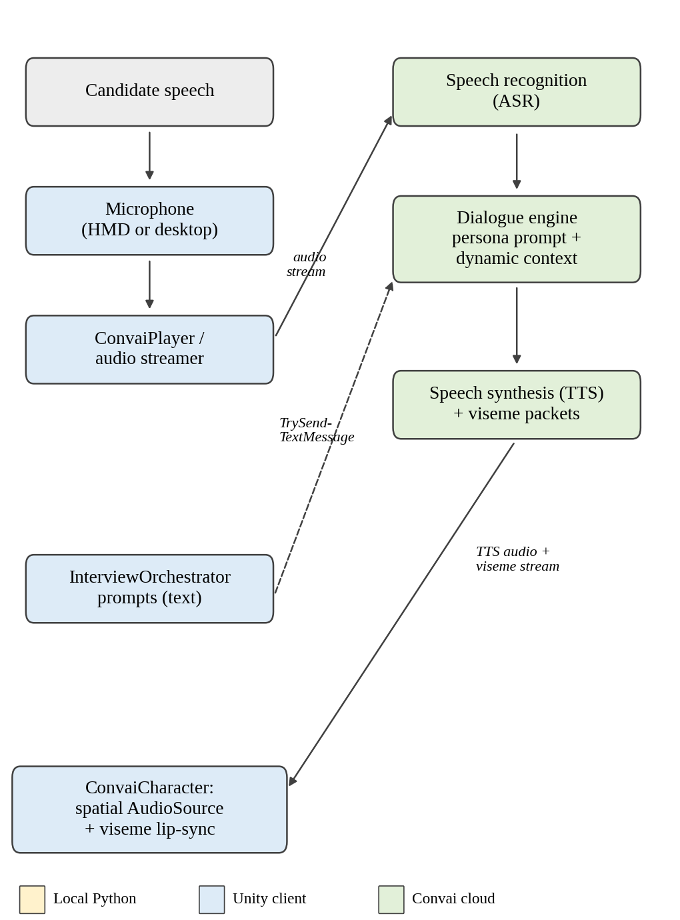
Fig. 4. Candidate conversational interaction loop. Dashed arrow: orchestrator prompts.

D. Active-Speaker Management and Context Propagation
In a room with three avatars, the system must determine which character receives the candidate's speech. The orchestrator implements the SDK's conversation-target interface, sets the player's targeting mode to manual, and updates the active character at each stage change; ConversationTargetEnforcer keeps the target on the active interviewer. At each handover the outgoing interviewer speaks a short hand-over line, InterviewCameraController turns the view toward the next interviewer, and the orchestrator injects the accumulated transcript lines into the incoming character's dynamic context (a previous-stage summary for Stage 2 and the concatenated transcripts of Stages 1 and 2 for Stage 3) before prompting it to begin.
This is a sequential multi-agent architecture: one interviewer is active at a time, and transitions are coordinated by the orchestrator. Interviewers do not converse with one another, and natural interruptions or overlapping speech are not supported. The panel therefore approximates the handover structure of a multi-stakeholder interview but not its conversational dynamics.

VIII. VR/XR INTERVIEW ENVIRONMENT
The environment is a three-dimensional boardroom built in Unity 6 with the Universal Render Pipeline. VR support uses the XR Interaction Toolkit over OpenXR [9]. The rig consists of an XR Origin placed at (0, 0, −1.5), a camera offset, a main camera driven by a tracked-pose driver that follows the HMD, and left and right controllers with ray interactors for interface interaction. The table is positioned at (0, 1.2, 0), and the three interviewers are seated at z = 2.0 with x = −1.5 (HR), 0 (Hiring Manager) and +1.5 (Behavioural), rotated 180° about the vertical axis to face the candidate (Fig. 7). Each interviewer is therefore a spatially distinct source of speech, because the character audio is played through a three-dimensional audio source.
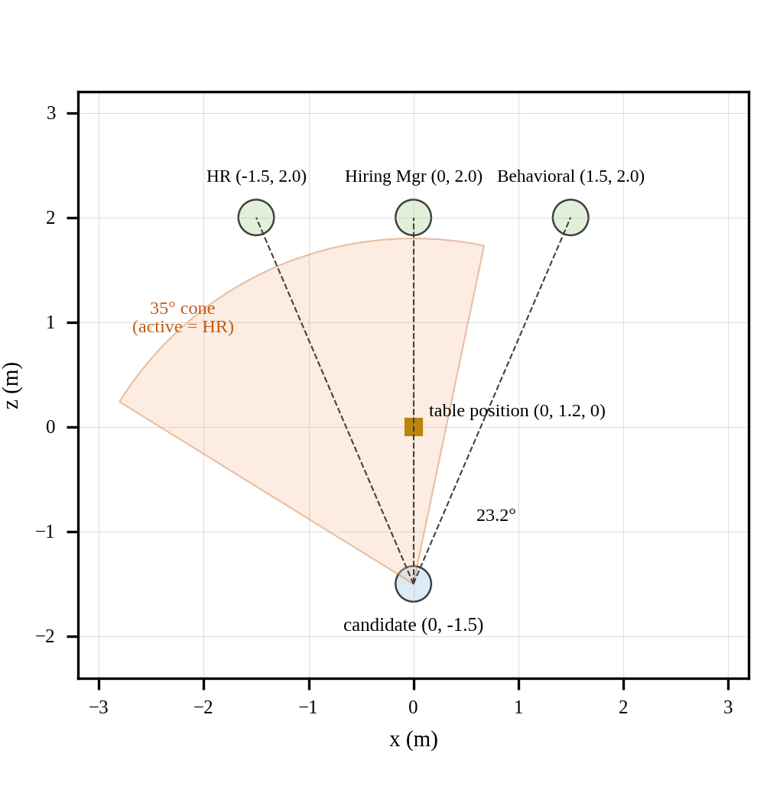
Fig. 7. Top-down layout from the scene coordinates, with the 35° gaze-alignment cone drawn about the direction to the HR interviewer. The marker is the table position; its extent is not recorded.
A runtime HUD shows the current stage, a countdown and the active speaker's name. In VR mode it is a world-space canvas at (0, 1.8, 1.8) in front of the candidate; in desktop mode it is a screen-space overlay. Desktop mode is selected from the home screen and provides a fallback when no headset is used.
The spatial design is motivated by the presence argument in [6]: an interview panel is a social situation in which place and plausibility may contribute to realistic responses. This is a design objective. Whether the environment produces stronger presence or more realistic interview anxiety than a conventional interface is untested (EQ1), and [7] concerns clinical exposure therapy and does not establish it.

IX. NON-VERBAL BEHAVIOURAL ANALYSIS
InterviewVisualEvaluator computes three metrics each frame from the main camera. For gaze alignment, let P_c be the camera position, F its forward unit vector and P_i the position of the active interviewer. The direction to the interviewer and the angular deviation are
D = (P_i − P_c) / ‖P_i − P_c‖ (1)
θ = arccos(F · D) (2)
computed in Unity as Vector3.Angle between the camera's forward vector and the direction to the interviewer. A frame with θ ≤ 35° is classified as eye contact, and a frame with θ > 35° as gaze aversion. The tracking-loss case is handled by clamping angular deltas so that no undefined values propagate.
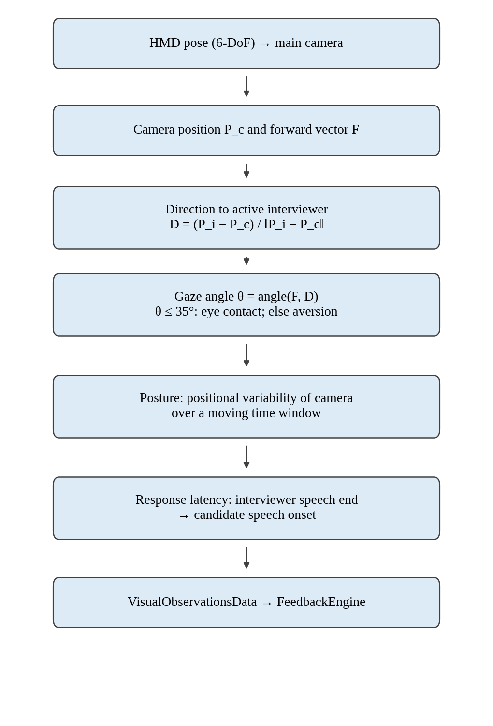
Fig. 5. Non-verbal telemetry pipeline from HMD pose to evaluation.
Posture stability is derived from the variability of the camera's translational position over a moving time window, so that larger drift or sway lowers the score. Response latency is the elapsed time between the completion of an interviewer's speech clip and the onset of the candidate's speech. The evaluation model treats latency of 1.5 to 3.0 s as optimal, less than 0.5 s as interruption and more than 6.0 s as hesitation (Section X).
Head pose is not eye tracking. Eq. (2) uses the orientation of the headset, not the direction of the eyes. It estimates whether the candidate's head is turned toward the active interviewer, and a candidate could look elsewhere with their eyes while keeping the head still, or the reverse. Head orientation has been reported to carry much of the gaze signal in meetings [8], but that result concerned a different setting and does not validate Eq. (2) here. Hardware-based eye tracking was not used.
Consequence of the threshold in this room. Using the scene coordinates and a horizontal-plane approximation that ignores vertical offsets, the direction from the candidate at (0, −1.5) to either side interviewer deviates from the central direction by arctan(1.5/3.5) ≈ 23.2°, and the two side interviewers are about 46.4° apart. With a 35° threshold, a candidate facing the central interviewer is classified as engaged with whichever side interviewer is active (23.2° < 35°), whereas a candidate facing one side interviewer is classified as averted when the other side is active (46.4° > 35°). This follows from the stated coordinates and threshold and is not an empirical finding. The basis for the 35° value is not documented, so it is treated as a design parameter that requires calibration.

X. EVALUATION AND FEEDBACK SYSTEM
After the interview, FeedbackEngine combines transcripts and non-verbal observations into ten competency scores on a 1.0 to 10.0 scale (Table V and Fig. 6). Nine dimensions are computed individually, and Overall Readiness is a weighted sum of the nine. The scoring is rule-based: transcript-derived dimensions use keyword, structure and word-count heuristics, and telemetry-derived dimensions use the thresholds described in Section IX.
TABLE V
PLACEMENT COMPETENCY MODEL
Competency | Source | Evaluation logic
Resume & Profile Alignment | Profile, transcript | Keyword overlap between resume skills and responses
Communication Clarity | Transcript | Word count, grammatical-structure heuristic, filler-word density
Technical Competence | Stage 3 transcript | Depth and relevance of technical terminology
Problem Solving | Stage 2 transcript | Presence of STAR structure in answers
Culture Fit & Values | Stages 1–2 | Sentiment and collaboration keywords
Confidence & Presence | Gaze telemetry | Gaze-engagement (θ ≤ 35°) ratio relative to speaking duration
Listening Skills | Latency | 1.5–3.0 s optimal; < 0.5 s interrupting; > 6.0 s hesitation
Body Language & Eye Contact | Head pose, posture | Stability score penalising drift and sway
Adaptability & Initiative | Stages 2–3 | Indications of recovery from obstacles or self-directed learning
Overall Readiness | Composite | Weighted sum of the nine scores above
Dimensions scoring at least 8.0 are listed as strengths and dimensions below 6.5 as improvement areas; the engine also produces a list of action items. InterviewOverController shows the readiness score, strengths and improvements on screen. On export, FeedbackPdfGenerator serialises the feedback data as JSON and invokes generate_feedback_pdf.py, which renders a multi-page PDF with ReportLab, including score tables, colour-coded badges, action lists and "Page X of Y" numbering. If ReportLab is unavailable, an error is logged and the on-screen results remain. The Python script also contains a fixed-value fallback evaluator, and the code base retains a legacy 13-field evaluation model.
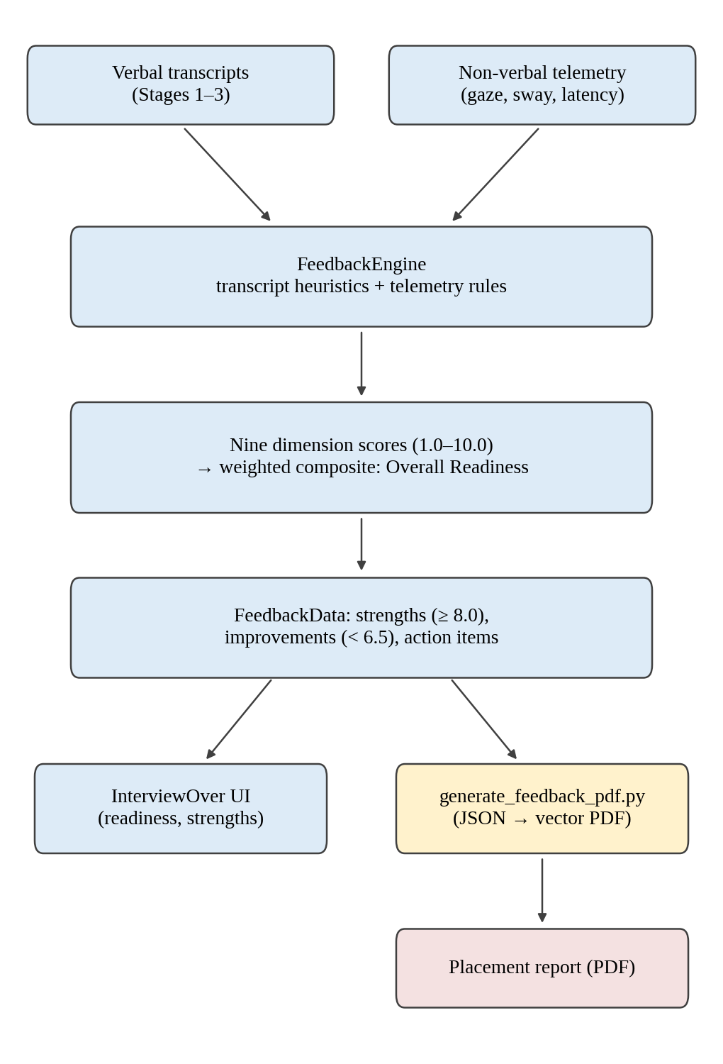
Fig. 6. Feedback generation architecture.
This scoring model is an engineering design and has not been validated against recruiter judgement or against hiring outcomes. Its thresholds, bands and composite weights are design parameters, and keyword-based indicators may reward vocabulary rather than answer quality. Fairness and interpretability concerns identified for automated interview scoring in general [5] therefore apply, and the output should be read as formative practice feedback and not as a selection decision.

XI. IMPLEMENTATION
The application is written in C# with two Python scripts. Only the classes that explain the architecture are described here.
Session and scene control. PREPVRSessionManager is the persistent singleton holding the profile, transcript, observations, feedback and mode flag, with convenience methods for recording answers and observations. SceneLoader wraps scene transitions and sets desktop or VR mode.
Resume path. ResumeUploadController opens the file dialog (Win32 comdlg32.dll in standalone builds) and coordinates parsing. PythonBackendBridge starts Python through System.Diagnostics.Process, passes arguments on the command line and reads JSON from standard output; unity_bridge.py performs extraction. ResumeReviewController presents the parsed profile before the room is entered. Temporary JSON files for the bridges are written to the application's persistent data path and overwritten per session.
Interview runtime. InterviewOrchestrator (about 1,500 lines of C#) holds the stage state machine, initialises the Convai player and the three characters, injects context, dispatches prompts and records transcript lines from speech-completed events. ConversationTargetEnforcer keeps the active target consistent, InterviewCameraController pans the view between interviewers, InterviewTimerManager runs the 600 s interview timer and the stage timers, InterviewRuntimeHUD renders the dual-mode HUD, and InterviewVisualEvaluator produces the telemetry. A debug overlay, InterviewTestMonitor, shows transcripts and states at runtime.
Feedback. FeedbackEngine computes the scores, InterviewOverController presents them, and FeedbackPdfGenerator calls generate_feedback_pdf.py.
Resilience. The Convai manager provides retry callbacks for lost connections, and the orchestrator logs a warning and keeps its state if a character does not respond within a timeout. Resume-parsing failure falls back to a default profile, and PDF-generation failure leaves the on-screen evaluation intact. Convai credentials are held in a Unity settings asset and are not reproduced here.

XII. TESTING AND SYSTEM VERIFICATION
The project includes an automated test harness, InterviewAutomatedTester, attached to the Interview Room scene. It listens to the microphone and cancels automatic injection if the human candidate speaks. If silence exceeds 4.5 s after an interviewer finishes, it injects a synthetic candidate response as a text message to the active character, drawn from a small pre-programmed corpus of three sample answers. This allows the full stage sequence to be exercised repeatedly without a human speaker in a headset. For the resume path, sample PDFs are kept in a test-resume folder and the parser can be run directly from the command line, which allows the extraction step to be checked outside Unity.
These mechanisms provide system verification: they exercise the pipeline and make runs repeatable. They are not scientific validation. Because answers are injected as text, the harness bypasses the microphone and speech-recognition path; its three fixed answers do not represent candidate diversity; and no pass or fail criteria, accuracy measures or run statistics are reported. Nothing in this section supports a claim about parsing accuracy, conversational quality, scoring validity or user benefit.

XIII. IMPLEMENTATION OBSERVATIONS
No quantitative experimental results are reported, because none exist: the project has no user study, no latency measurements, no parsing-accuracy evaluation and no comparison with human raters. This section instead records the implementation status found when the project folder was inspected (Table VI). Status labels follow the project's own classification.
TABLE VI
IMPLEMENTATION VERIFICATION MATRIX
Capability | Evidence (source) | Status
3D boardroom, three seated interviewers | Interview Room scene | Implemented
OpenXR rig; desktop fallback | Package manifest, scene, SceneLoader, HUD | Implemented
PDF upload and local parsing | ResumeUploadController, unity_bridge.py | Implemented
Parsed-profile review screen | ResumeReviewController | Implemented
Sequential three-stage orchestration with manual targeting | InterviewOrchestrator, ConversationTargetEnforcer | Implemented
Cross-stage transcript forwarding | InterviewOrchestrator | Implemented
Convai integration | Convai settings asset, ConvaiCharacter | Configured and verified
Gaze, sway, latency telemetry | InterviewVisualEvaluator | Implemented
Ten-competency model | FeedbackEngine | Implemented
Vector PDF report | generate_feedback_pdf.py | Implemented
Automated test harness | InterviewAutomatedTester | Implemented
Technical coding track | InterviewTypeController | Proposed
Interviewer-to-interviewer dialogue | InterviewOrchestrator | Proposed
Python-side LLM API calls; multi-user cloud database | Repository search | Not implemented
The inspection shows that an end-to-end path exists from resume upload through a three-stage voice interview to an exported report. It also shows that session state persists across seven scenes through a single manager, and that evaluation operates on recorded transcripts and observations independently of real-time audio playback. These are observations about the code and its configuration; they were not obtained from instrumented runs and do not characterise runtime performance.

XIV. LIMITATIONS

A. Technical
- Cloud dependence. Recognition, dialogue and synthesis occur in Convai's cloud, so turn-around latency depends on network conditions and remote queueing. It has not been measured.
- Heuristic resume parsing. Extraction relies on patterns and keyword lexicons and may be incomplete for unconventional or multi-column layouts.
- Sequential dialogue. One interviewer is active at a time; interruptions, overlapping speech and interviewer-to-interviewer exchange are not supported.
- Platform dependence. The standalone file dialog uses the Windows Win32 API, and parsing and report generation require a local Python environment with the needed libraries. Other platforms are unverified.
- Head-pose gaze estimate. Eye contact is estimated from headset orientation, not from eye tracking, using an undocumented 35° threshold.
- Undisclosed models. The language models behind Convai and the configuration of its cloud-side dialogue graphs are not visible from the repository.

B. Validation and Threats to Validity
- No human-subject evaluation. No user study, recruiter validation or comparison with other tools exists, so claims about realism, relevance, comprehensiveness or learning benefit cannot be made.
- Unvalidated scoring. Thresholds, bands and weights are design parameters, and the scoring has not been checked for bias or reliability.
- Hardware and session records. The project configures OpenXR but the material used for this paper does not record the headset model or the duration of VR sessions, so no hardware-specific claim is made.
- Telemetry interpretation. The automatic camera panning toward the active interviewer may interact with HMD-driven head pose, and the interpretation of the metrics in desktop mode is not characterised. The speech-onset detection and the sway window are implementation details that should be documented for reproducibility.
- Limited test scope. The harness uses three fixed text responses and bypasses speech recognition (Section XII). The system has not been deployed at scale.

C. Privacy and Data Handling
The application keeps profile, transcript and observation data in memory and does not upload them to its own database. However, the architecture sends microphone audio to the Convai cloud and injects resume-derived fields and earlier-stage transcript lines into character context, so personal information does reach a third-party service. Use with real candidate data would require informed consent and review of the provider's data-handling terms, and the fairness and privacy concerns noted for AI-based assessment [5] apply.

XV. FUTURE WORK
Planned in the project. A technical coding-interview track (currently displayed as "Coming Soon") and more natural multi-interviewer interaction in place of sequential hand-over.
Proposed by the authors. (i) User studies addressing EQ1 to EQ4 with validated instruments and appropriate controls; (ii) recruiter validation of the competency model and calibration of the thresholds and weights; (iii) richer adaptive questioning based on the candidate's answers; (iv) transformer- or LLM-based resume extraction in place of the heuristic parser, with extraction accuracy evaluated on annotated resumes [5]; (v) hardware eye tracking to replace or validate the head-pose estimate; (vi) characterisation of camera panning against HMD pose; (vii) cloud persistence and multi-user support; (viii) cross-platform file handling; and (ix) privacy-preserving options such as redacting identifying fields before they are sent as context.

XVI. CONCLUSION
This paper described VR Interview Simulation, an immersive mock-interview platform that integrates a Unity and OpenXR environment, resume-grounded cloud conversational AI, a sequential three-interviewer panel with transcript forwarding, head-pose-based behavioural telemetry and an automated ten-competency feedback pipeline that ends in a PDF report. The implementation status was verified through inspection of the project and is reported without performance figures, because no experimental evaluation has been carried out. The principal open questions are empirical: whether the immersive, resume-grounded panel improves presence and perceived relevance, and whether the heuristic, head-pose-based scores agree with expert judgement. Answering them requires the user studies and validation described in Section XV.

ACKNOWLEDGMENT
The authors thank Dr. P. Revathy for her guidance and support throughout this project. The authors also acknowledge the Department of Computer Science and Design, Rajalakshmi Engineering College, Chennai, Tamil Nadu, India, for providing the necessary academic support and resources.

REFERENCES
[1] J. Levashina, C. J. Hartwell, F. P. Morgeson, and M. A. Campion, "The structured employment interview: Narrative and quantitative review of the research literature," Personnel Psychol., vol. 67, no. 1, pp. 241–293, 2014.
[2] M. J. Smith et al., "Job offers to individuals with severe mental illness after participation in virtual reality job interview training," Psychiatr. Serv., vol. 66, no. 11, pp. 1173–1179, 2015, doi: 10.1176/appi.ps.201400504.
[3] M. E. Hoque, M. Courgeon, J.-C. Martin, B. Mutlu, and R. W. Picard, "MACH: My automated conversation coach," in Proc. ACM Int. Joint Conf. Pervasive Ubiquitous Comput. (UbiComp), Zurich, Switzerland, Sep. 2013.
[4] L. Hemamou, G. Felhi, V. Vandenbussche, J.-C. Martin, and C. Clavel, "HireNet: A hierarchical attention model for the automatic analysis of asynchronous video job interviews," in Proc. AAAI Conf. Artif. Intell., vol. 33, 2019, pp. 573–581, doi: 10.1609/aaai.v33i01.3301573.
[5] C. Qin et al., "A comprehensive survey of artificial intelligence techniques for talent analytics," arXiv:2307.03195 [cs.CY], v3, May 2025. [Online]. Available: https://arxiv.org/abs/2307.03195
[6] M. Slater, "Place illusion and plausibility can lead to realistic behaviour in immersive virtual environments," Phil. Trans. R. Soc. B, vol. 364, no. 1535, pp. 3549–3557, 2009, doi: 10.1098/rstb.2009.0138.
[7] M. B. Powers and P. M. G. Emmelkamp, "Virtual reality exposure therapy for anxiety disorders: A meta-analysis," J. Anxiety Disord., vol. 22, no. 3, pp. 561–569, 2008, doi: 10.1016/j.janxdis.2007.04.006.
[8] R. Stiefelhagen and J. Zhu, "Head orientation and gaze direction in meetings," in CHI '02 Extended Abstracts on Human Factors in Computing Systems, Minneapolis, MN, USA, Apr. 2002, pp. 858–859.
[9] Khronos Group, "Khronos releases OpenXR 1.0 specification establishing a foundation for the AR and VR ecosystem," press release, Jul. 29, 2019. [Online]. Available: https://www.khronos.org/news/press/khronos-releases-openxr-1.0-specification-establishing-a-foundation-for-the-ar-and-vr-ecosystem
[10] Convai, "Dynamic context," Convai Unity SDK documentation. [Online]. Available: https://docs.convai.com/api-docs/plugins-and-integrations/convai-unity-sdk/features/dynamic-context (accessed Oct. 4, 2026).

Preparation notes for the authors
This page is not part of the paper. Delete it before submission.
1. Reference provenance
None of the ten references came from the original project materials. All were researched during preparation and checked against publisher, repository or institutional records. Please re-check the following before submission: the UbiComp 2013 paper [3] is cited without page numbers because they were not confirmed; [9] and [10] are web resources and [10] carries an access date of 4 Oct 2026; the sources for [2] and [4] were confirmed through abstracts and indexing records, so statements about those systems are limited to what the abstracts say (Table I marks everything else "NR").
2. Points in the project dossier that were handled conservatively
- Stage 1 context. The dossier lists different context fields for the opening stage in different sections (skills and projects; name, skills and projects; and one section that also includes education). The paper states the general key set (name, skills, education, projects). Please confirm in the code.
- Posture sway. The dossier describes it both as a positional delta over a moving window and as the standard deviation of camera translation. The paper says "variability of translational position over a moving time window".
- Undocumented details. The method for detecting the onset of candidate speech, the length of the sway window, the composite weights of Overall Readiness and the basis for the 35° threshold are not in the dossier. The paper does not state them and lists the threshold and weights as design parameters. If you can supply the weights, they would make a useful table.
- Camera panning and HMD. The dossier says the camera "rotates smoothly" toward the active interviewer. How this interacts with HMD-driven head pose, and how the metrics behave in desktop mode, is not described. It is listed as a limitation. Please confirm what actually happens in VR mode.
- Hardware. No headset model or VR session record is given, so the paper makes no hardware-specific claim. Add the headset model if it was used.
- Privacy. The dossier states that data are local-only, but the architecture sends audio and resume-derived context to Convai. The paper states both facts (Section XIV-C).
- Wording not carried over. Phrases such as "genuine contributions", "publication-grade", "computer vision" (for HMD tracking) and "encrypted WebRTC/WSS" were not used; the first two are evaluative claims, and the last two are not supported by the source description.
- Derived geometry. The 23.2° and 46.4° values in Section IX are computed from the dossier's coordinates in a horizontal-plane approximation, and are labelled as such. The table size is not recorded, so Fig. 7 shows only its position.
- E-mail address. The first address was entered with "#" in place of "@" and has been set to nslswetha2007@gmail.com. Please confirm.
3. Material that would strengthen the paper
- Screenshots of the six views recommended in the dossier (resume upload, profile review, first-person room view, active interviewer, evaluation dashboard, exported report page).
- A sample exported PDF report and any run logs from the automated harness, which would allow Section XIII to describe observed runs.
- Any pilot feedback from users, even informal, reported strictly as informal feedback and not as results.

