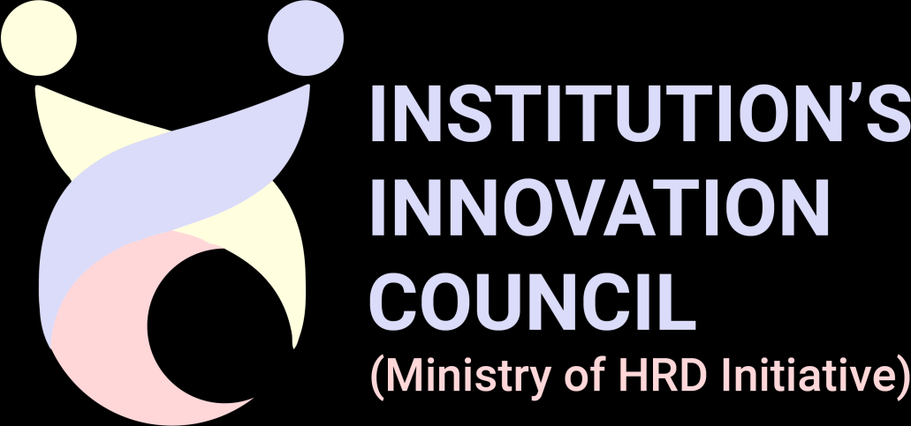
Institution’s Innovation Council
MHRD’s Innovation Cell, AICTE

Innovation / Prototype (Product/Service/Process)

Team Details | Team Lead:
  S.No | Name | Email | Contact no.
  1 | Dr. P. Revathy, Professor, Dept. of CSD | revathy.p.2024.csd@rajalakshmi.edu.in | 9444491760
  Name | Email | Contact no.
  Mukesh VA (241701034) | mukesh.va.2024.csd@rajalakshmi.edu.in | 9445091865
Team Members Details:
Sr. No. | Name | Email | Contact no.
1 | Swetha N | Swetha.n.2024.csd@rajalakshmi.edu.in | 9790936409

Mentor (if any)

Institute Name and Address:
Rajalakshmi Engineering College, Thandalam, Chennai – 602105, Tamil Nadu, India
Department of Computer Science and Design
Title (20 Words Max) |  | VR Simulated Mock Interview Platform with Resume-Based AI Interviewer
*Developed as part of |  | Selected: Academic Research Assignment  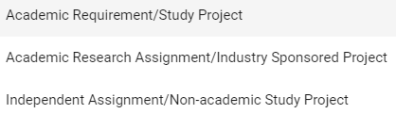
*Choose the Financial Year, during the Idea-PoC/Innovation Developed |  | 2026–2027
*Sector / Domain |  | ICT, Cyber-Physical Systems, AI & ML (Theme 10) – Virtual Reality and Conversational AI for EdTech / Career Readiness
Innovation Type  Selected: Product |  | 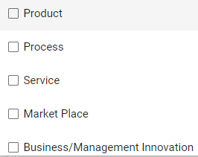
*Development Stage - Technology Maturity of the Solution/Innovation in terms of Technology Readiness Level TRL (if applicable (Refer TRL Stages) | TRL 4 – Small-scale prototype built and tested in a laboratory environment.  The integrated prototype (Unity 6 + OpenXR VR application with desktop fallback, Python resume parser, Convai-based AI interviewer, behavioural monitoring, PDF reporting and placement-dashboard API) has undergone module-level and integration testing. Formal user studies and validation in the intended environment are pending.
Development Stage - Manufacturing Maturity of the Solution/Innovation in terms of Manufacturing Readiness Level (MRL) Refer MRL Stages | Not Applicable – the solution is a software-based product with no physical manufacturing component. It runs on commercially available VR headsets (via OpenXR) and standard computers.
Development Stage: Investment Readiness Level of the Solution/Innovation (IRL). Refer IRL Stages | IRL 1 – Early stage. A working prototype has been developed, but no market validation, pilot with customers, business model testing or external investment has been undertaken so far.
*Define the problem and its relevance to today's market / society / industry need  (Max: 100 Words) | Placement success depends heavily on interview performance, yet students seldom get realistic, repeatable practice. Traditional mock interviews depend on the availability of faculty, trainers or peers and give inconsistent, non-personalised feedback. Online practice platforms lack immersion, and many AI tools do not ground questions in the candidate's own resume or analyse interaction behaviour such as head alignment and response delay. As a result, students enter placement interviews with limited familiarity with real interview settings, and institutions have no organised way to track practice outcomes. An accessible, personalised and scalable interview-practice platform is needed for higher-education institutions.
*Describe the Solution / Proposed / Developed  (Max: 100 Words) | A VR-based mock interview platform developed in Unity 6 with OpenXR, with a desktop fallback for users without a headset. The candidate uploads a PDF resume; a Python module (pypdf, regular expressions, keyword heuristics) builds a structured profile of skills, education and projects. A Convai-powered AI virtual interviewer then conducts a voice-based, resume-grounded interview in an immersive interview room. Head pose (1 Hz), posture stability and response latency are recorded, and a heuristic evaluation across ten competencies generates an on-screen summary and a downloadable PDF report (ReportLab). Results can be synchronised with an institutional placement dashboard through a REST API.
*Explain the uniqueness and distinctive features of the (product / process / service) solution  (Max: 100 Words) | Resume-grounded questioning that is personalised to each candidate's own skills, education and projects. Natural voice conversation with an AI virtual interviewer inside an immersive VR interview room. Behavioural indicators (head alignment using a 35-degree cone, posture stability, response latency) combined with ten-competency heuristic feedback. Automatic PDF report after every session and a placement dashboard for institutional tracking. A desktop fallback widens accessibility, and the modular architecture (resume processing, interview, evaluation, reporting) allows easy extension.
*How your proposed / developed (product / process / service) solution is different from similar kind of product by the competitors if any  (Max: 100 Words) | Traditional mock interviews depend on interviewer availability and give inconsistent feedback. Online interview platforms offer video-based practice without immersion, and generic AI interview tools provide automated feedback but limited resume-based personalisation. Our platform combines resume-grounded questioning, a voice-interactive AI interviewer, VR immersion, behavioural indicators, PDF reports and an institutional placement dashboard in one repeatable, on-demand system that also works in desktop mode when no headset is available.
Is there any IP or Patentable Component associated with the Solution? | No. No patent, copyright or design registration has been filed so far. The software is the team's original work; IP protection may be explored in future.
Has the Solution Received any Innovation Grant/Seed fund Support? | No. The solution has not received any Innovation Grant / Seed Fund support to date (Not Yet Received).
Are there any Recognitions (National/International) Obtained by the Solution? | No. No National / International recognition has been obtained by the solution so far.
Is the Solution Commercialized either through Technology Transfer or Enterprise Development/Startup? | No. The solution has not been commercialised through Technology Transfer or Enterprise Development / Startup. It is currently an academic prototype.
Had the Solution Received any Pre-Incubation/Incubation Support? | No. The solution has not received any Pre-Incubation / Incubation support so far (Not Yet Received).
*Utility: Highlight the utility/value proposition (key benefits) aspects of the solution/innovation*  (Max: 100 Words) | Gives students unlimited, low-pressure, on-demand interview practice that mirrors a real interview room. Resume-grounded questions keep practice relevant to each candidate, voice interaction builds communication fluency, and the PDF report with behavioural indicators highlights areas for improvement (feedback is practice-oriented and heuristic-based). It reduces dependence on faculty or trainer availability, lets placement cells review practice performance through the dashboard, and is accessible without VR hardware through the desktop fallback. It supports SDG 4 (Quality Education), SDG 8 and SDG 9.
*Scalability: Highlight the market potential aspects of the Solution/Innovation (Potential Market Size, segmentation and Target users/customers etc.)  (Max: 100 Words) | Target users: final- and pre-final-year students of engineering, arts, science and management colleges; placement cells; training and coaching centres; and career development programmes. Segments: (1) institutions and placement cells, (2) training institutes, (3) individual job seekers using desktop mode. The modular architecture, cloud-based conversational AI and backend/dashboard services allow deployment across departments and institutions, and new job roles, question sets and domains can be added without redesigning the platform.
*Economic Sustainability: Highlight commercialisation/business application aspects of the solution (how it is going to economic profitable and viable)  (Max: 100 Words) | Proposed as an institutional licence / subscription for colleges, placement cells and training centres, with a lower-cost desktop-mode option for individual learners. Development is largely a one-time effort, with recurring costs limited to conversational AI services and hosting. Use of open-source components (Python, Node.js, Next.js, PostgreSQL) and commercially available VR headsets and PCs keeps costs low, while one platform serves many students without human interviewer time, giving a low marginal cost per user. The revenue model is yet to be validated through pilots.
*Environmental Sustainability: Highlight environmental friendliness aspects and related benefit of the solution/innovation  (Max: 100 Words) | The solution is entirely software-based, with no manufacturing or consumables. Virtual practice and digital PDF reports reduce travel to external training centres and paper use, and existing PCs and VR headsets are reused, avoiding dedicated new hardware. The desktop fallback offers a lower-energy alternative to VR sessions. Energy use of VR hardware and cloud services is acknowledged and can be minimised through efficient scene design and on-demand usage.
Video URL | Not yet available – demonstration video link to be added once uploaded.
Upload Photograph: (JPG, PNG, PDF max 2 MB) | To be attached at submission (JPG / PNG / PDF, max 2 MB) – e.g., screenshot of the Unity interview environment.

(e) Timeline- Develop a timeline against the milestones for taking Idea/PoC to Prototype Development and (or) Commercial level/start-up stage. | Phase 1 – Completed: problem identification, literature survey, requirement analysis.  Phase 2 – Completed: system design; resume-processing module; Unity 6 / OpenXR environment; Convai integration.  Phase 3 – Completed (Oct 2026): behavioural monitoring, heuristic evaluation, PDF reporting, placement-dashboard integration, module and integration testing.  Phase 4 – Planned: user studies and validation of heuristic scoring.  Phase 5 – Planned: pilot in a college placement cell; feedback-driven refinement.  Phase 6 – Planned: enhancements (technical interview track, eye-tracking support, progress tracking) and commercial / start-up stage preparation.
Applicability of Solution 10 Marks
(Max 50 words for each from a-e)
(a) Usability: what is the usability of your innovation. (Level of acceptance of innovation and its Features among target group) | Natural voice interaction with an AI interviewer in a realistic VR room needs only a PDF resume to start. The desktop fallback removes the headset barrier; results are reviewed via an on-screen summary and PDF report. Student acceptance is yet to be established through user studies.
(b) Scalability: how your innovation will be scalable at market level. | The modular architecture (Unity application, Python resume parser, Convai service, Node.js backend, dashboard) supports deployment across departments and institutions. Cloud conversational AI serves many learners, and new job roles, question sets and domains can be added without redesigning the platform.
(c) Economic sustainability: Explain the potential of innovation to become profitable or financially viable. | Can be offered as an institutional licence or subscription to colleges and training centres, replacing repeated human mock-interview sessions. Low marginal cost per additional student and use of open-source components support financial viability. Pricing and revenue model are yet to be validated.
(d) Environment Sustainability: How your innovation is environment friendly or address environmental problems. | Entirely software-based, with no manufacturing or consumables. Virtual practice and digital PDF reports reduce travel and paper use, and existing PCs and VR headsets are reused. The desktop mode offers a lower-energy alternative to VR.
(e) Is there any Intellectual Property (IP) Component associated with innovation? if yes, explain. | No patent or registration has been filed at present. The platform's source code and its resume-grounded VR interview workflow are original work of the team; copyright / IP registration may be pursued in future.
Define the potential market size (in terms of INR) and target customers.  (Max 100 words) | Target customers: engineering, arts, science and management colleges and their placement cells; training and coaching centres; career development programmes; and individual job seekers (desktop mode). Primary users are final- and pre-final-year students preparing for campus placements.  Market size in INR: Not yet quantified – no market study has been conducted. It will be estimated bottom-up (number of institutions and students served × proposed licence / subscription fee) during pilot deployment.
Annexure 1

Themes:
- Healthcare & Biomedical devices.
- Agriculture & Rural Development.
- Smart Vehicles/ Electric vehicle/ Electric vehicle motor and battery technology.
- Food Processing.
- Robotics and Drones.
- Waste management.
- Clean & Potable water.
- Renewable and affordable Energy.
- IoT based technologies (e.g. Security & Surveillance systems etc)
- ICT, cyber physical systems, Block chain, Cognitive computing, Cloud computing, AI & ML.

9 stages of TRL:
TRL 0 : Idea. Unproven concept, no testing has been performed.
TRL 1 : Basic research. Principles postulated observed but no experimental proof available. TRL 2 : Technology formulation. Concept and application have been formulated.
TRL 3 : Applied research. First laboratory tests completed; proof of concept.
TRL 4 : Small scale prototype built in a laboratory environment ("ugly" prototype). TRL 5 : Large scale prototype tested in intended environment.
TRL 6 : Prototype system tested in intended environment close to expected performance. TRL 7 : Demonstration system operating in operational environment at pre-commercial scale. TRL 8 : First of a kind commercial system. Manufacturing issues solved.
TRL 9 : Full commercial application, technology available for consumers.

