Ideation Phase
Empathize & Discover

Date | 29 September 2026
Team ID | Team 13
Team Members | Swetha (Team Leader) – NM ID: 4F75AD648445EA592B04EB92912FC33D  Suvalakshmi (Member) – NM ID: 9C6AFED29391D9C9FA14BF132632A7F9  Subashree (Member) – NM ID: 32184A1A2FC030EB66B4361207DB54BA  Srinkee (Member) – NM ID: C3C0C2408C9F751A1224A0F13700AA8B  Swetha.G (Member) – NM ID: Not provided
Project Name | AI FAQ Assistant
Maximum Marks | 4 Marks

Empathy Map Canvas:
An empathy map is a simple, easy-to-digest visual that captures knowledge about a user’s behaviours and attitudes.

It is a useful tool to helps teams better understand their users.
Creating an effective solution requires understanding the true problem and the person who is experiencing it. The exercise of creating the map helps participants consider things from the user’s perspective along with his or her goals and challenges.
Example:


Reference: https://www.mural.co/templates/empathy-map-canvas

Example: Food Ordering & Delivery Application

AI FAQ Assistant
Team ID: Team 13
Target User
Primary persona: a student or support user who needs a reliable answer to a frequently asked question with minimal search effort. Secondary persona: an administrator/content maintainer.
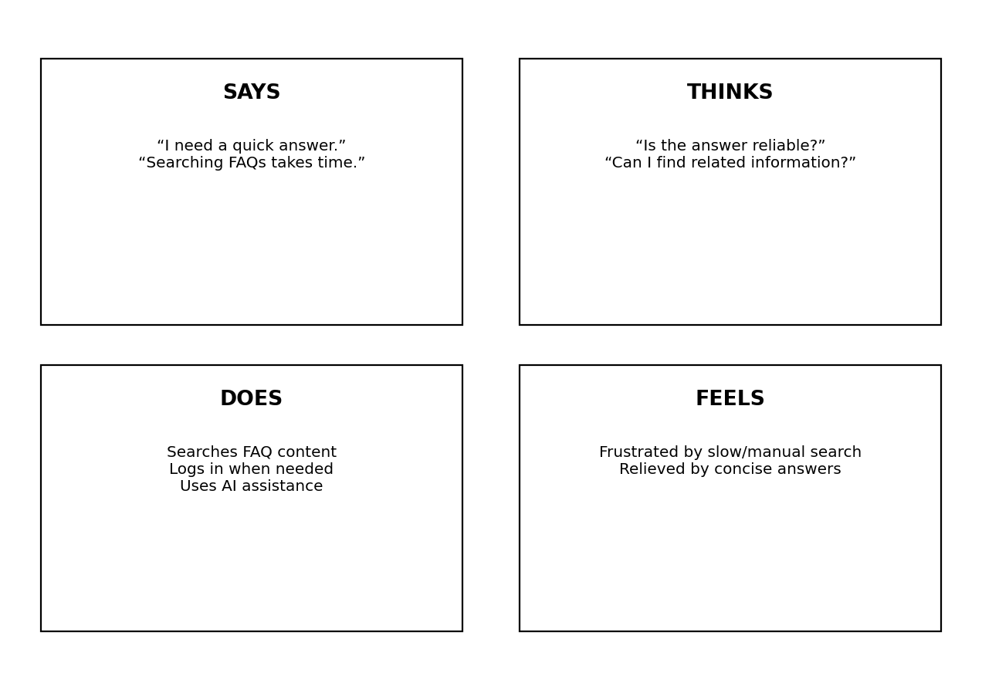
Pains
• Manual searching through many FAQ entries
• Difficulty finding concise answers
• Repeated effort creating similar FAQ content
• Need for secure protected operations
Gains
• Fast keyword search
• Centralized FAQ knowledge base
• AI-assisted FAQ generation
• Authenticated and validated API access

