Project Planning Phase
Project Planning Template (Product Backlog, Sprint Planning, Stories, Story points)

Date | 29 September 2026
Team ID | Team 13
Team Members | Swetha (Team Leader) – NM ID: 4F75AD648445EA592B04EB92912FC33D  Suvalakshmi (Member) – NM ID: 9C6AFED29391D9C9FA14BF132632A7F9  Subashree (Member) – NM ID: 32184A1A2FC030EB66B4361207DB54BA  Srinkee (Member) – NM ID: C3C0C2408C9F751A1224A0F13700AA8B  Swetha.G (Member) – NM ID: Not provided
Project Name | AI FAQ Assistant
Maximum Marks | 5 Marks

Product Backlog, Sprint Schedule, and Estimation (4 Marks)
Use the below template to create product backlog and sprint schedule
Sprint | Functional Requirement (Epic) | User Story Number | User Story / Task | Story Points | Priority | Team Members
Sprint-1 | Authentication | USN-1 | Implement registration with validation and bcrypt hashing. | 3 | High | Team 13 – Swetha (Leader), Suvalakshmi, Subashree, Srinkee, Swetha.G
Sprint-1 | Authentication | USN-2 | Implement login and JWT token generation. | 3 | High | Team 13 – Swetha (Leader), Suvalakshmi, Subashree, Srinkee, Swetha.G
Sprint-2 | FAQ Management | USN-3 | Implement FAQ create/read/update/delete. | 5 | High | Team 13 – Swetha (Leader), Suvalakshmi, Subashree, Srinkee, Swetha.G
Sprint-2 | FAQ Search | USN-4 | Implement keyword search across FAQ fields. | 3 | High | Team 13 – Swetha (Leader), Suvalakshmi, Subashree, Srinkee, Swetha.G
Sprint-3 | AI Assistance | USN-5 | Integrate Gemini API for generated FAQ content. | 5 | High | Team 13 – Swetha (Leader), Suvalakshmi, Subashree, Srinkee, Swetha.G
Sprint-3 | Validation & Errors | USN-6 | Add validation and centralized error handling. | 3 | Medium | Team 13 – Swetha (Leader), Suvalakshmi, Subashree, Srinkee, Swetha.G
Sprint-4 | Testing | USN-7 | Test major API flows and fix integration issues. | 4 | High | Team 13 – Swetha (Leader), Suvalakshmi, Subashree, Srinkee, Swetha.G

Project Tracker, Velocity & Burndown Chart: (4 Marks)
Sprint | Total Story Points | Duration | Sprint Start Date | Sprint End Date (Planned) | Story Points Completed | Sprint Release Date (Actual)
Sprint-1 | 6 | 6 Days | To be recorded | To be recorded | Completed | Completed
Sprint-2 | 8 | 6 Days | To be recorded | To be recorded | Completed | Completed
Sprint-3 | 8 | 6 Days | To be recorded | To be recorded | Completed | Completed
Sprint-4 | 4 | 6 Days | To be recorded | To be recorded | Completed | Completed

Velocity:
Imagine we have a 10-day sprint duration, and the velocity of the team is 20 (points per sprint). Let’s calculate the team’s average velocity (AV) per iteration unit (story points per day)


Burndown Chart:
A burn down chart is a graphical representation of work left to do versus time. It is often used in agile software development methodologies such as Scrum. However, burn down charts can be applied to any project containing measurable progress over time.

https://www.visual-paradigm.com/scrum/scrum-burndown-chart/
https://www.atlassian.com/agile/tutorials/burndown-charts

Reference:
https://www.atlassian.com/agile/project-management
https://www.atlassian.com/agile/tutorials/how-to-do-scrum-with-jira-software
https://www.atlassian.com/agile/tutorials/epics
https://www.atlassian.com/agile/tutorials/sprints
https://www.atlassian.com/agile/project-management/estimation
https://www.atlassian.com/agile/tutorials/burndown-charts

AI FAQ Assistant
Team ID: Team 13
Project Tracker / Velocity
Planned backlog: 26 story points in this document. Core authentication, FAQ, search, AI generation and testing flows are implemented. Exact calendar sprint dates should be filled from the team's actual work log.
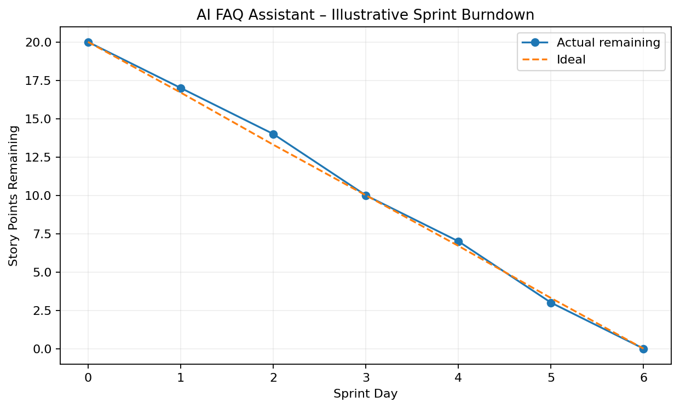
Burndown Note
The chart is illustrative and should not be treated as a measured historical team metric.

