**Programmable Chat API Demo Application for JavaScript**

Referneces: <https://github.com/twilio/twilio-chat-demo-js>

1. Login to Twilio
2. Create all the below :

accountSid : primary Twilio account identifier - find this in the Twilio console.

signingKeySid : The SID for our API Key, used to authenticate - generate in twilio

<https://www.twilio.com/console/runtime/api-keys>

signingKeySecret : The secret for your API Key, used to authenticate, We will get this when we create an API Key.

serviceSid : Like a database for our Chat data

<https://www.twilio.com/console/chat/services>

pushCredentialSid : Credentials are records for push notification channels for APN(Ios) and FCM ( browser).

<https://www.twilio.com/console/chat/credentials>

1. Install Nodejs and visual studio
2. Copy credentials.example.json to credentials.json
3. Set all the above credentials in credentials.json
4. **Install dependencies :**

**$ npm install**

1. Run server

$ npm start

1. Connect:

<http://localhost:8080>

1. Login as guest and chat window appears, create a channel and start chat.

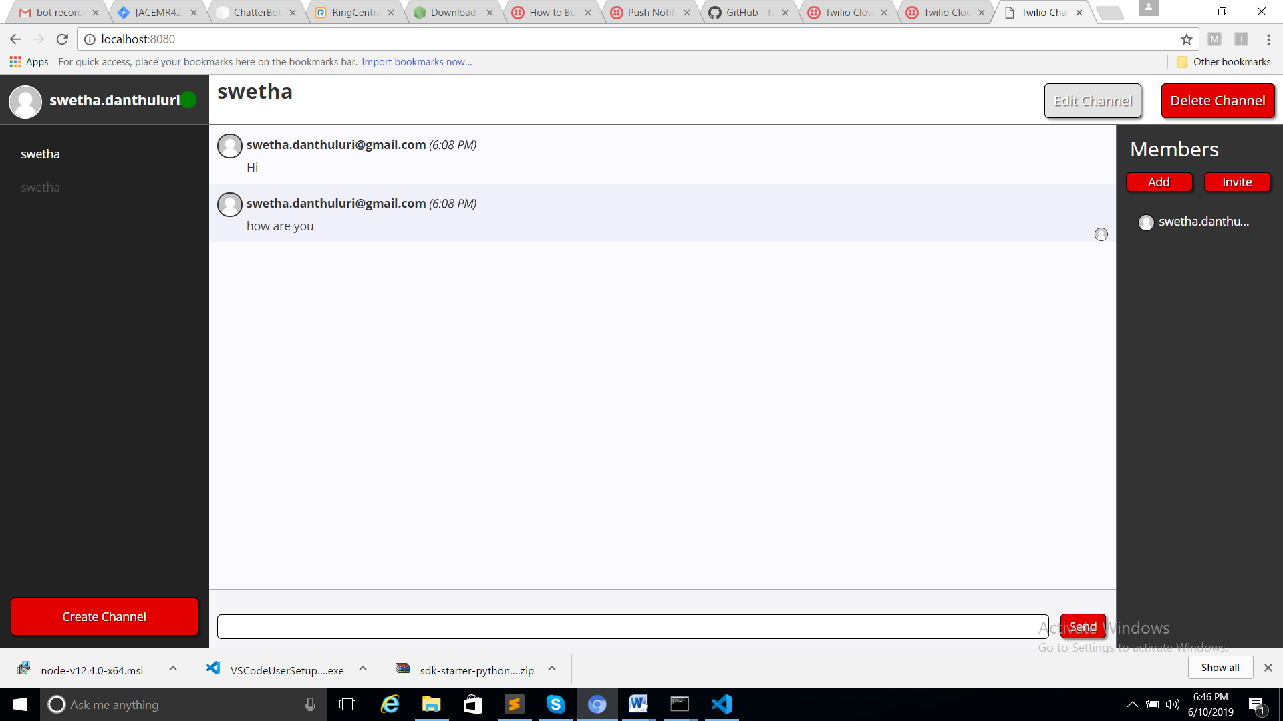

Two Way Communication:

1. Open a browser localhost:8080
2. Create Channel : Give a name to the channel
3. Open incognito window or another browser
4. Open another session localhost:8080
5. Create a channel : Give a name
6. Can communication between users in a channel.

