**Project name:** **DayOut app.**

**Project Description:** DayOut app is an app which helps users in california to find a place that the user can plan on a dayout within his budget. By providing the location and the budget within which the user wants to spend on a day, the app helps user by suggesting all the recreation/tourist attractions around the given location in a span of 200 miles. The app list the top 15 places in the ascending order of the distance to travel so that the user can plan to within this budget. On selecting any of the place, the user can view the current temperature, humidity and wind information. The user can also locate the selected place in map and get to know the distance to be travelled through the Maps app.

**High-level Architecture:**

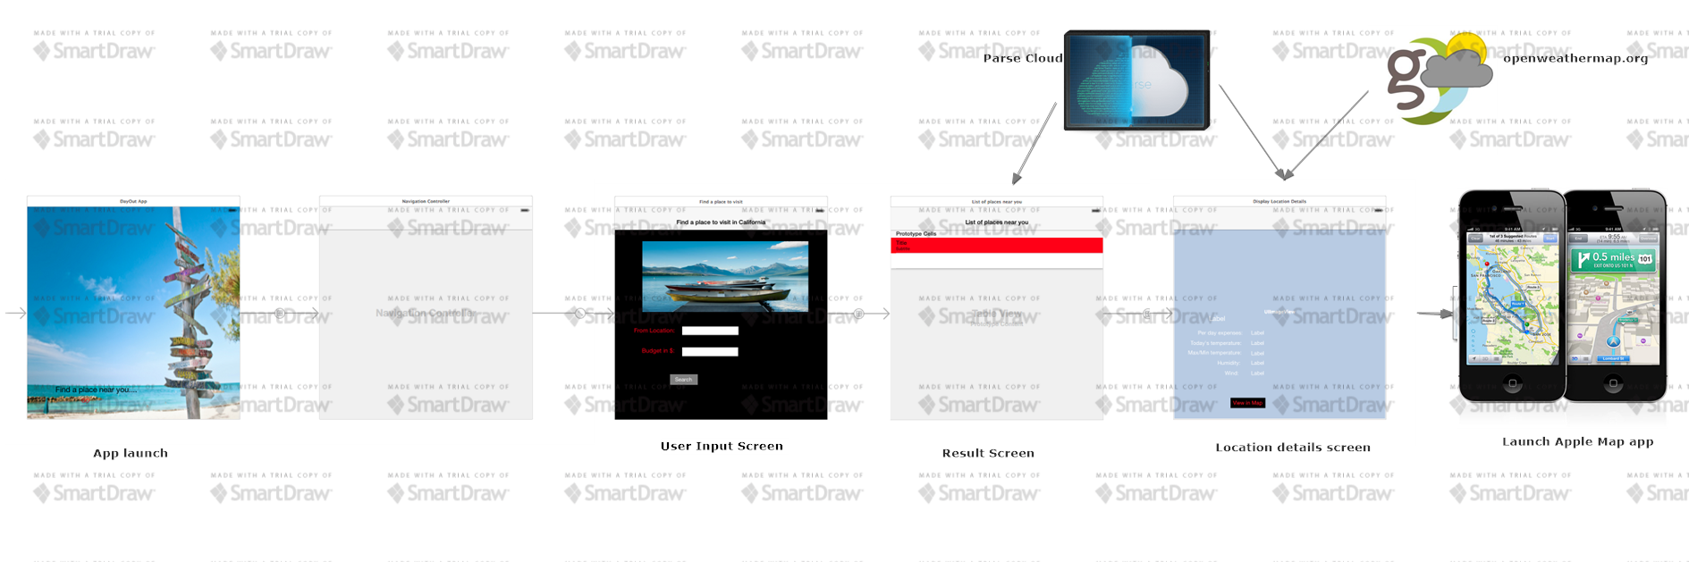

**iOS Techniques:**

* Interacting with Cloud based Parse.
* Maintain database of all the tourist attractions in California.
* PFGeoPoint to maintain the geopoints of all the important places.
* Retrieving and querying Recipe entries using ParseQuery.
* Usage of UIImageView, UITableViewController, UIMapKit. UIAlertView.
* Passing values between different storyboard.
* Usage of weather apis from openweathermap.com in my app.
* MapKit services for locating the selected places and giving the distance to be travelled.
* Info.plist to maintain string values needed for retrieving current location.

**TestCases executed:**

1. Check if the user entered a valid location name.
2. Check if both the fields, from location and budget is entered by the user.
3. Check if the resulted places list is displayed in the ascending order of the distance from the user location.
4. Check if the resulted places list is within the budget of the user.
5. Check if the corresponding background image is displayed for each of the place selected.
6. Check if a valid temperature of the selected place is displayed.
7. Check if the Map app is invoked with the given source and destination locations.
8. Check if the state of the DayOut app is maintained when the user switches back from Map app to DayOut app.

**Future Enhancements:**

This app has location suggested is only within California. I would like to enhance this application by maintain database of the tourist attractions around USA.