**Dunning**

* In SAP FI, Dunning plays a vital role in Accounts receivables. Dunning is **similar to reminder notice** to our business partners for their overdue/open items or outstanding balances.
* Dunning letter summarizes **overdue invoices record and asks for payment to be made**. We configure dunning program for accounts receivable and accounts payable.
* Dunning is a term derived from **German**

**Dunning Program includes following configuration steps:**

* Dunning procedure,
* Dunning level,
* Dunning Areas.

**Dunning procedure** controls the path of dunning to the customer and vendor through the system. We can define our own dunning procedure as per our convenience. **Transaction code: FBMP.**

**Dunning level** defines dunning text; **maximum nine dunning levels** are available. As the dunning level increases, text will also change as consistent to make payment and after 9th Dunning level, Legal proceeding will be happened

**Dunning area** means the **client/company/company code in which we are working on dunning program**. If we don’t want to run dunning program at company code level then we can also run dunning program at **organizational level like, sales organization**.

We generally assign dunning procedures, dunning levels and other configuration steps at **company code level**

**The dunning system covers the following documents.**

* Open A/R invoices, including invoices that are partially credited or partially paid.
* Invoices that include installments.
* A/R credit memos.
* Incoming payments that are not based on invoices.

Usually we create **maximum of 9 dunning levels**, but u create any number of dunning level as per the requirement of client but most of the client go with 4 dunning levels.

**Navigation Path for Creation Dunning Area:**

**Transaction Code: OB61**

SPRO → SAP Reference IMG → Financial Accounting (New) → AR and AP → Business Transactions → Dunning → Basic Setting for Dunning → Define Dunning Areas → Execute.

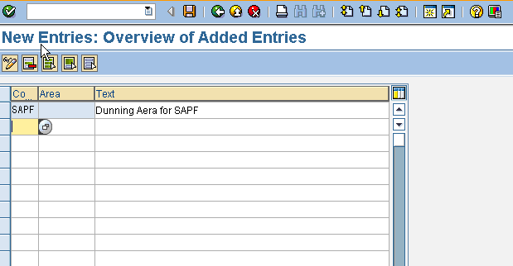

 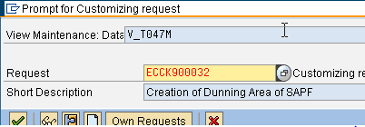

**SAP Dunning Keys**

The next basic setting to configure is **Dunning Keys**. These are **used to limit specific AR** **line items** to a Dunning Level and/or to print them separately on Dunning Notices and with the dunning keys, you can limit the dunning level of an item. If you are already run the dunning program **in two dunning levels, if you want to stop the dunning letter in Third dunning level we will use the dunning key.**

**Navigation Path:**

Transaction SPRO > SAP Reference IMG > Financial Accounting (New) > Accounts Receivable and Accounts Payable > Business Transactions > Dunning > Basic Settings for Dunning > Define Dunning Keys

**Transaction Code: OB17**

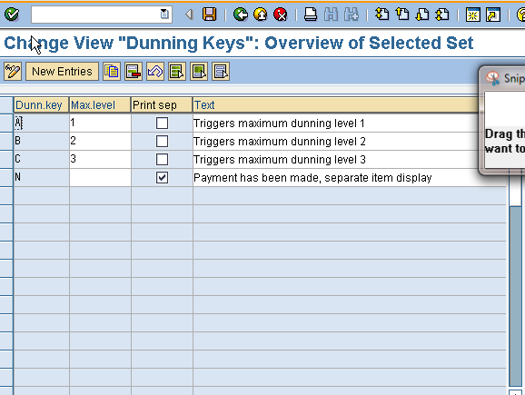

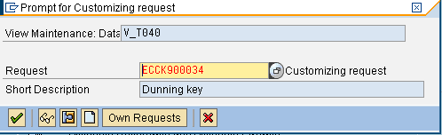

**Dunning Block (optional)**

* In this step, we define the reasons for a dunning block under a key. The key can be entered in an item or in the **account of a Customer master**. Blocked items or accounts are **not considered for the dunning run**.
* Dunning block is usually set for the high profile customer **whose payment record is good** generally we maintain dunning information in customer master data.

**Reasons for not dunning a particular line item or a particular Customer or vendor.**

* Dunning block reason defined at customer master for excluding a particular customer or it can also enter for a line item while entering line item.

**Navigation Path: IMG > Financial Accounting (New) > Account Receivable and Account Payable > Business Transactions > Dunning > Basic Setting for Dunning > Define Dunning Block Reasons**

**Tcode: N/A**

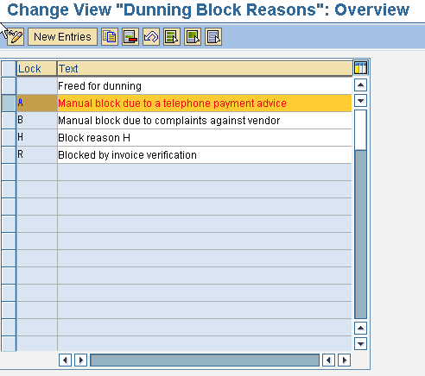

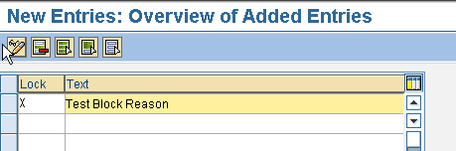

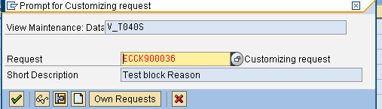

**Dunning procedure and Levels**

**T**he procedure is configured to hold Dunning level interval days, number of levels that apply to a particular procedure, Dunning charges (cost of the reminder to the customer), minimum charges, whether or not interest is charged and if so at what level, etc. The Dunning Procedure is assigned to each customer in the company code correspondence tab in the customer master record (only one Dunning procedure can be applied to a customer at a time). Keep in mind that Dunning Procedures are company code independent.

Navigation Path: Transaction SPRO > SAP Reference IMG > Financial Accounting (New) > Accounts Receivable and Accounts Payable > Business Transactions > Dunning > Dunning Procedure > Define Dunning Procedures

**Transaction Code: FBMP**

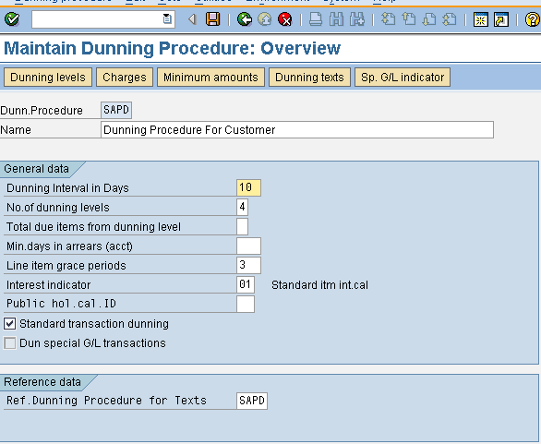

*Pease note that Press Two Times Inter Key and ignore the error message

**Dunning Levels**

Click the dunning levels and input days in Arrears for each dunning levels.

Path: IMG > Financial Accounting (New) > Account Receivable and Account Payable > Business Transactions > Dunning > Dunning Procedure > Define Dunning Procedure

Tcode: FBMP

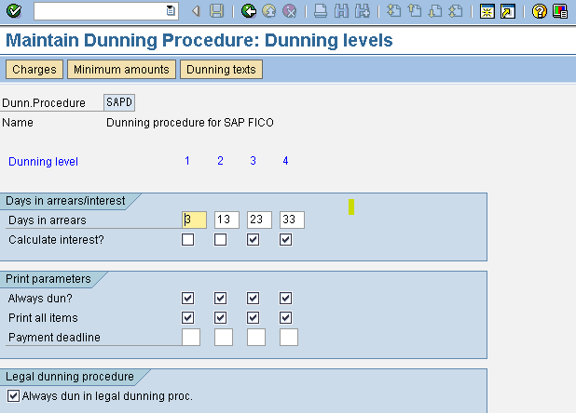

**Define Dunning Charges to Dunning Procedures**

In this step we add the dunning charge as per the dunning level. This is like an administration charge to dun the customer. Currency Euro is assigned during adding the dunning charge

**Navigation Path**: IMG > Financial Accounting (New) > Account Receivable and Account Payable > Business Transactions > Dunning > Dunning Procedure > Define Dunning Procedure

**Tcode**: FBMP

Choose the Dunning procedure, click “Choose” Button, and choose “Charges” button

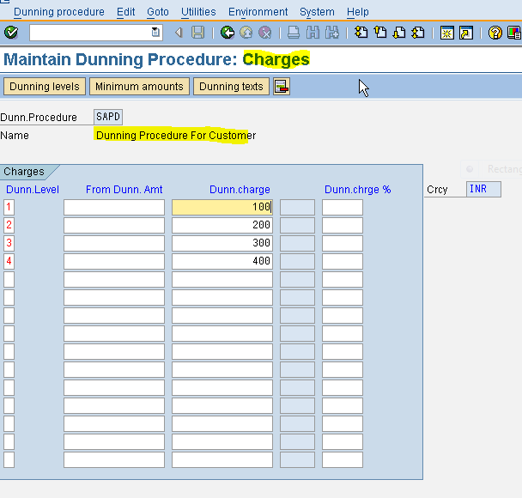

**Minimum Amount**

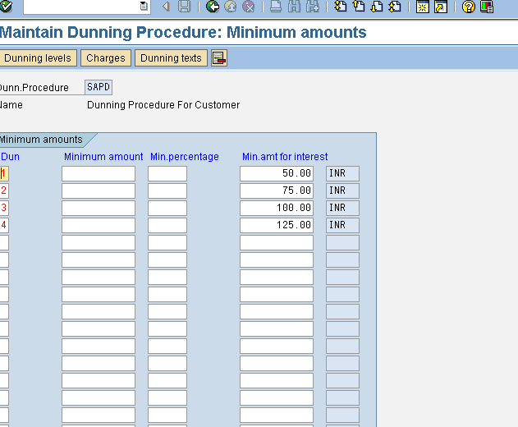

**Dunning Text:**

For inserting dunning forms, click Dunning Texts and assign the required forms for the dunning text with reference to dunning Level. In case the customer has different language and the form contains different language, then please follow the document attached to translate the source language to target language.

**Navigation Path**: IMG > Financial Accounting (New) > Account Receivable and Account Payable > Business Transactions > Dunning > Dunning Procedure > Define Dunning Procedure

**Tcode:** FBMP

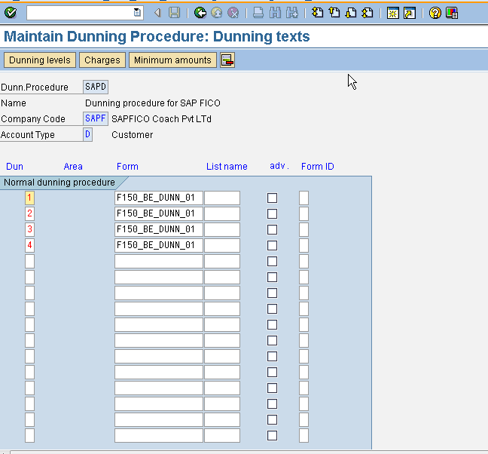

**Assign Special indicator to Dunning Procedures**

In this step, we have assigned Special Indicator Reserve for Bad Debt to dunning Procedure.

Path: IMG > Financial Accounting (New) > Account Receivable and Account Payable > Business Transactions > Dunning > Dunning Procedure > Define Dunning Procedure

Tcode: FBMP

