AI-BASED LOCALIZED FLOOD RISK,
INUNDATION MAPPING AND EARLY WARNING SYSTEM
MACHINE LEARNING LABORATORY-20MSSL12
Swetha S (2403717672622055)
Akshaya T (2403717672622055)

1. Abstract
Floods are complex environmental events whose occurrence and impact depend on several interacting factors. Heavy rainfall can increase surface runoff and river discharge, while elevation, slope, soil moisture and land-surface characteristics influence how water accumulates and moves across an area. The consequences of flooding are also highly dependent on the location of roads, buildings and other infrastructure. Consequently, effective flood assessment requires more than a single rainfall measurement or a simple binary warning.
Conventional flood information systems may rely on meteorological observations, hydrological models, satellite observations or predefined thresholds. These approaches provide valuable information, but each represents only part of the overall flood situation. A rainfall-based forecast can provide advance indication of potential flooding but may not accurately describe the eventual spatial extent. Conversely, a satellite-derived flood map can provide direct spatial evidence but is dependent on satellite availability and does not necessarily provide sufficient advance warning.
Machine learning provides an opportunity to learn relationships between historical environmental conditions and observed flood events. By combining rainfall, river discharge, soil moisture and terrain-related variables, a supervised model can estimate the probability of flooding for a particular location and time. At the same time, deep-learning image segmentation can extract spatial patterns from satellite imagery and identify areas that exhibit flood characteristics.
The research problem addressed by this project is therefore the development of a localized framework that can use these complementary forms of information together. The study investigates whether temporal environmental prediction and spatial satellite-based inundation detection can provide a more informative representation of flood conditions when combined with terrain, uncertainty and exposure information.
The project focuses on five major research objectives: preparing a multi-source flood dataset; developing a machine-learning flood prediction model; developing a deep-learning inundation segmentation model; investigating the fusion of their outputs; and presenting the resulting information through an interpretable decision-support interface. The study also considers model confidence, feature-level explainability and generalization across flood events.
The significance of the project lies in its integrated design. Instead of treating flood prediction, inundation mapping and impact assessment as independent outputs, the proposed framework connects them into a common workflow. This allows the research to examine not only whether the models make accurate predictions, but also whether their outputs can be interpreted together in a localized context.

2. Literature Review
Recent flood research increasingly uses machine learning and deep learning to model the complex relationships between rainfall, discharge, soil conditions and terrain. Systematic reviews show that rainfall, hydrological variables, elevation, soil moisture and remote-sensing observations are commonly used for flood prediction.
Remote sensing research has particularly explored Sentinel-1 SAR imagery for flood mapping. Since radar observations are less dependent on cloud-free conditions than optical imagery, Sentinel-1 is suitable for detecting surface-water changes. Deep-learning segmentation models such as U-Net can learn flood patterns and generate pixel-level inundation maps.
The Sen1Floods11 dataset, introduced by Bonafilia et al. in 2020, provides labelled Sentinel-1 imagery for training and evaluating flood segmentation models and is therefore directly relevant to the proposed U-Net component.
Research on geospatial machine learning also demonstrates the importance of terrain and spatial characteristics. Elevation, slope and environmental conditions can influence how water accumulates and moves. Other recent research has focused on hybrid modelling, uncertainty estimation and decision-support systems.
However, many existing studies concentrate mainly on one aspect, such as flood prediction or satellite-based inundation mapping. This project focuses on combining environmental flood prediction, spatial inundation detection, uncertainty, explainability and infrastructure exposure within one localized framework.
Reference | Relevance to this project
Flood prediction systematic review (2026) | ML/DL approaches, predictors, gaps and generalization issues
Remote sensing + ML systematic review (2026) | Satellite data and multimodal flood modelling
Uncertainty quantification review (2026) | Calibration, uncertainty and extreme-event limitations
Bonafilia et al., Sen1Floods11 (CVPR Workshops, 2020) | Core Sentinel-1 flood-segmentation dataset/reference
Hybrid flood inundation modelling review (2026) | Rationale for combining complementary modelling approaches
Geospatial ML flood prediction review (2026) | Spatial predictors and geospatial ML
Flood modelling and decision-making review (2026) | Decision-support context and flood applications
AI + multi-sensor Earth Observation review (2026) | AI, Earth Observation and operational limitations

3. Methodology
The proposed system follows a two-branch modelling approach that combines environmental flood prediction with satellite-based inundation mapping. The first branch analyses meteorological, hydrological and terrain-related information to estimate the likelihood of flooding, while the second branch uses satellite imagery to identify the actual spatial extent of inundation. The outputs of both branches are later combined to generate localized flood-risk information.
For the environmental prediction branch, XGBoost is used as the primary machine-learning model. Features such as rainfall, river discharge, soil moisture, elevation and slope are used to learn the relationship between environmental conditions and historical flood occurrence. Random Forest is included as a baseline model for comparison. The output of this branch is a flood probability indicating the likelihood of flooding under the given conditions.
For the spatial mapping branch, Sentinel-1 SAR imagery is processed using a U-Net deep-learning model. The model learns from satellite image patches and their corresponding flood masks to distinguish flooded and non-flooded pixels. Its output is a pixel-level inundation probability map, which provides the spatial information that cannot be obtained directly from the tabular prediction model.
The outputs from XGBoost and U-Net are combined through a fusion stage. This allows the system to use both temporal/environmental evidence and spatial satellite evidence when assessing flood conditions. Confidence and uncertainty assessment are incorporated to indicate the reliability of predictions, while SHAP is used to identify important factors influencing the tabular ML predictions.
Finally, terrain and OpenStreetMap information are incorporated to identify potentially exposed roads, buildings and important facilities. In this framework, the predicted flooding represents the hazard, while the combination of hazard and exposed elements provides the basis for localized flood risk. The resulting information can then be presented through the proposed decision-support system.

4. Dataset and Exploratory Data Analysis
The project uses a selected region as a study region. The required data is extracted from larger regional or global datasets according to the geographic boundary and time period of the study. The datasets are divided into tabular environmental data for flood prediction and satellite image data for inundation mapping.
IMD Gridded Rainfall – Rainfall grid cells covering the Coimbatore study region are extracted and used as the main meteorological input, GloFAS – River-discharge information relevant to the Coimbatore region and its associated river/basin system is extracted for hydrological prediction.ERA5-Land – Soil moisture and other environmental variables are extracted for the selected geographic region and time period, SRTM DEM – The elevation data is clipped to the Coimbatore boundary, and terrain features such as slope are derived.Sentinel-1 SAR – Sentinel-1 scenes covering Coimbatore are selected for flood and non-flood conditions and used for spatial inundation detection, Sen1Floods11 – Labelled Sentinel-1 images and flood masks are used to train and evaluate the U-Net model. Since the dataset contains flood events from multiple locations, it provides additional labelled training data beyond the Coimbatore study area.
The tabular data is organized using a common location and time reference, with rainfall, discharge, soil moisture, elevation and slope as input features and historical flood occurrence as the target label. Basic exploratory analysis is performed to examine feature distributions, correlations, missing values and flood-event patterns. The image data is analysed separately by examining image quality, dimensions and the proportion of flooded and non-flooded pixels.
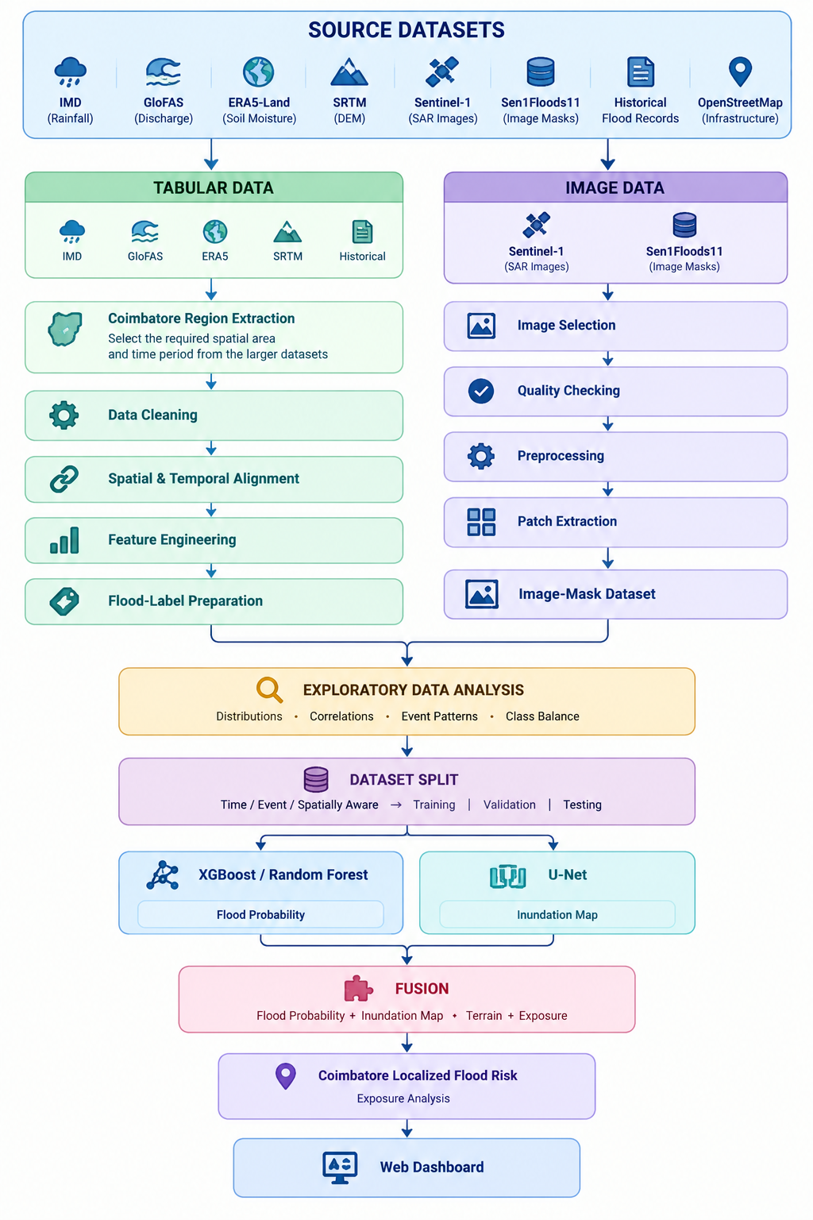

Image EDA examines image dimensions, pixel-value distributions, flood-mask quality and the proportion of flooded and non-flooded pixels. Class imbalance is considered during training and evaluation.

Example dataset:
Date | Lat | Lon | Rain_1d | Rain_3d | Rain_7d | Discharge | Soil_Moisture | Elevation | Slope | Flood
2024-10-15 | 11.02 | 76.95 | 82.4 | 156.7 | 231.5 | 420 | 0.38 | 412 | 3.2 | 1
2024-10-16 | 11.02 | 76.95 | 15.2 | 171.9 | 246.7 | 395 | 0.36 | 412 | 3.2 | 0

5. Implementation
The implementation is organized as a modular system for flood prediction, inundation mapping and risk assessment. Python is used for data processing and machine-learning/deep-learning components. The environmental and hydrological data are cleaned, spatially and temporally aligned, and processed to generate features such as rainfall intensity, accumulated rainfall, river discharge, soil moisture, elevation and slope. XGBoost is used as the primary model for tabular flood prediction, while Random Forest is used as a baseline for comparison.
For image-based flood detection, Sentinel-1 SAR images are selected, checked, pre-processed and divided into suitable patches along with their corresponding flood masks. PyTorch is used to implement the U-Net model, which learns to identify flooded and non-flooded pixels and produces an inundation map. The models are trained and evaluated separately according to their respective data types.
The outputs of both models are then combined through a fusion process. The flood probability from XGBoost provides information about the likelihood of flooding, while the U-Net output provides the spatial location of inundation. Terrain and OpenStreetMap data are added to identify potentially exposed areas and infrastructure. SHAP is used to understand the important factors influencing the ML predictions, while confidence measures help indicate the reliability of the results.
The trained models are connected to a web-based decision-support interface through a backend API. The dashboard can display flood probability, inundation areas, confidence information and exposed locations on a map. The implementation maintains separate stages for data processing, feature generation, model training, prediction, fusion and visualization, making it easier to retrain models and perform experiments such as comparing XGBoost with Random Forest or evaluating the individual and combined model outputs.
Proposed intelligent workflow
Meteorological + Hydrological Inputs
Rainfall • Discharge • Soil Moisture • Terrain
↓
XGBoost
Temporal / Environmental Flood Probability
+
Sentinel-1 SAR → U-Net
Pixel-Level Inundation Probability Mask
↓
Fusion Layer
Temporal Risk + Spatial Inundation Evidence
↓
Confidence + OOD Check + SHAP
↓
Exposure Analysis
Roads • Buildings • Important Facilities
↓
Localized Risk Level + Early-Warning Message
↓
Web Decision-Support Dashboard

6. Model Subtasks
1. Flood Prediction – XGBoost
Uses rainfall, discharge, soil moisture and terrain features to predict the probability of flooding for a given location and time.
2. Baseline Prediction – Random Forest
Uses the same tabular features to provide a baseline for comparing the performance of the primary XGBoost model.
3. Flood Inundation Mapping – U-Net
Processes Sentinel-1 SAR images to classify flooded and non-flooded pixels and generate spatial inundation maps.
4. Model Fusion
Combines the flood probability from XGBoost with the spatial inundation output from U-Net to obtain more complete flood information.
5. Confidence and Explainability
Assesses prediction reliability using confidence/uncertainty measures and uses SHAP to identify the important factors influencing ML predictions.
6. Exposure and Risk Assessment
Combines the flood outputs with terrain and OpenStreetMap features to identify potentially exposed roads, buildings and facilities and derive localized flood-risk information.

7. Results and Discussion
The results will compare the performance of the individual models and the combined system.
For flood prediction, precision, recall, F1-score, ROC-AUC and PR-AUC will be used. Calibration or Brier score can also be used to evaluate the quality of predicted probabilities. Random Forest provides the baseline against which XGBoost is compared.
For flood segmentation, IoU and Dice coefficient, together with precision and recall, will be used to evaluate the U-Net predictions. Visual comparisons between Sentinel-1 imagery, reference flood masks and predicted masks will help identify segmentation errors.
The main experiment will compare:
XGBoost alone → U-Net alone → Fused ML + DL system
Feature-ablation experiments can also determine the contribution of rainfall, discharge, terrain and environmental variables. Event-based and spatial testing will be used where possible to examine whether the models generalize beyond the conditions used for training.
The results will also examine model confidence and SHAP explanations. Limitations such as class imbalance, incomplete historical labels, satellite availability, data gaps and differences between training and real-world conditions will be reported rather than hidden.

8. Conclusion
The proposed AI-based localized flood-risk, inundation-mapping and early-warning system combines complementary data and learning methods to address different aspects of flood assessment. IMD rainfall and GloFAS discharge provide temporal and hydrological information, ERA5-Land contributes supporting environmental context, SRTM describes terrain, Sentinel-1 provides spatial flood evidence, Sen1Floods11 supports supervised segmentation, and OpenStreetMap connects hazard information with exposed infrastructure.
XGBoost provides the primary flood-likelihood model, Random Forest provides a baseline, and U-Net produces a spatial inundation mask. Their outputs are fused with confidence, explainability and exposure information to support a web-based localized view. The system is intended for research and decision support, not as a substitute for official warnings. Its final value will be established through event-based and spatially aware experiments, with transparent reporting of performance and uncertainty.
The following sources are the core research and data basis selected for this project; additional sources may be added during implementation if a specific experiment requires them.

References and Dataset Sources
1. Bonafilia, D., Tellman, B., Anderson, T., & Issenberg, E. (2020). Sen1Floods11: A Georeferenced Dataset to Train and Test Deep Learning Flood Algorithms for Sentinel-1. CVPR Workshops.
2. A systematic review of flood prediction (2018–2025): Flood categories, input features, and Machine Learning, Deep Learning and hybrid approaches. (2026).
3. Integrating remote sensing and machine learning for flood modelling: A systematic literature review. (2026).
4. Open problems in uncertainty quantification for flood modelling: A systematic review. (2026).
5. Hybrid methods in flood inundation modeling: A systematic review. (2026).
6. The application of geospatially-integrated machine learning models for flood prediction: A review. (2026).
7. Flood modelling and flood decision making: a scoping review of the progress of flood technologies and applications. (2026).
8. Artificial intelligence and multi-sensor earth observation for flood forecasting and mapping: a systematic review of operational evidence. (2026).

