

PROJECT REPORT
Estimate of resource usage by Machine Learning and Deep learning algorithms enclosed in REST API.

Swetha sivakumar
Summer Intern 2018
IIT Mandi
v.1.1



Project Introduction :
The ultimate goal of this project is to build a code profiler for the different Machine learning and deep learning models which is provided as service by building a REST api around it . To achieve the final goal few of the major subtasks involved are building the ML/DL models , building REST apis, resource usage data accumulation, building a model to train on collected resource usage data and which can be used to predict resource requirement beforehand for any machine configuration proposed to be used .Therefore by the end of the project we Objective to build a code profiler for profiling and predicting the resource requirements like processor and memory configuraton for any particular service to be used.

Introduction :

API (Application Program Interface):
API is a piece of software that plugs one application directly into data and services of another by granting it permission to certain parts of the server. Basically , an API is a software that helps 2 applications to communicate with each other.

REST API (Representational State Transfer API):
It is an architectural style of building an API. It is light weight and best suited for web services. It mostly uses HTTP protocol but has the capablity to even use SOAP(simple object access protocol). REST api responses can be cached. REST apis are easier to build and scale and use URLs as the api end point . Everytime we post or like a post on Facebook we are actually using a REST api without our knowledge. The facebook graph API is a best example of REST api.
To know more about facebook graph api read the documentation : https://developers.facebook.com/docs/graph-api/overview

Benefits of REST API:
- Best suited for web services.
- Light weight and easy to build.
- Easy to scale
- Uses HTTP protocol
- uses URL as api end point unlike SOAP which uses service interface , thus easier to access and use for the user.
- The user need not know the working of REST api unlike SOAP api where the user must know the entire working of the API before even initiating an interaction.
- Lesser overhead and uses less network bandwidth.
- Supports many data formats like JSON, plaintext, XML, HTML whereas SOAP supports only XML.

Python and Flask Framework :

Python
Python is an interpreted high-level programming language for general-purpose programming. Created by Guido van Rossum and first released in 1991, Python has significant emphasis on code readability.

Benefits of python :
- Easy syntax
- Readability
- High-Level Language
- Open source
- Huge support community
- Numerous third party packages available
- Cross platform
- Numerous machine learning tools available

Flask – Micro framework :
Flask is a web framework written in python , it acts as the WSGI (Web server gateway interface) for REST api .

Benefits of flask :
- Flask is simple and Lightweight
- Numerous standard libraries available
- Easy development
- Provides flexibility
- Library changes are not frequent
- Well documented
- Highly readable code
- Huge support community
- Easy to get a Flask app running from scratch

Postman - API Testing tool :
Sending a post request from browser is difficult so we can use POSTMAN for sending more complex requests and testing if our API works.
POSTMAN is an application to interact with HTTP api’s and it provides a GUI to make various types of requests and receive back the response for the client.It is mostly used for testing and developmental purpose.
Link to install postman for windows/Mac/Linux : https://www.getpostman.com/apps

Building REST api using Flask
To create a Flask application, firstly install flask module using pip command. Secondly, import the module to your application code. Create a flask instance and run the app at a specified port of your wish.

REST api for Mean-Median model :
For the purpose of learning, the very first REST api I built using flask was for a Mean Median model and tested the same with HTTP java client and postman.

REST api(s) to handle various types of datatype :
Later I have built 6 models of REST api for learning to handle various dataypes.
The following are the model details :
- REST api with hardcoded data input within the API
- REST api for handling GET request from java client
- REST api for handling POST request with json as parameter from POSTMAN tool.
- REST api for handling files as request parameter from a java http client
- REST api for handling arrays as request parameter from a java http client
- REST api for handling matrix as request parameter from a java http client

Profiling:
Profiling is a type of dynamic programming analysis that measures the memory and time complexity of a program, the usage of a particular instruction or the frequency and duration of function calls. It helps the developer to understand the behaviour of program and thus help in code and resource optimisation.

Uses of profiling :
A profiler output can help a developer understand the behaviour and resource usage of the software and thus help evaluate the performance of the software in various architectures.
For example , In a cloud based architecture a detailed profiling can help to analyse and predict at what point a new VM must be introduced to manage the load or when an VM must be discarded to avoid shelling out extra money without using them.

Machine Learning:
Layman definition : The field of study which gives computers the ability to learn without being explicitly programmed. (by Arthur Samuel)
Detailed definition : A computer program is said to learn from experience E on a task T and some perfomance P , if its performance on T measured by P improves with experience E.
Examples of machine learning in day to day life :
We mostly find the best google results on top because the google browser had learnt to efficiently index the millions of pages based on the usefullness of the page.
In google news , under a single headline we see a collection of URLs to various newsite articles about same incident. This collection and grouping will take too much work mannualy but instead here the machines have learnt to do the same more efficiently and quickly.

Types of Learning algorithm:

1. Supervised Learning :
In supervised learning initially we give the program a dataset with right answers , so that it can calculate and predict the value , match it with right answer and learn from it. Later the when the program is given a data input without the right answer it predicts the answer by using whatever it learnt during trainning phase.
Types of supervised Learning :
1.Regression
It is used for real/continous value prediction ie. To predict the weather after 10 days or stock prices on some given day.
2.Classification
Here, the prediction will either give a a result within a finite range a rudimentary eg. If given an image it will classify it as either dog or a cat.

2.Unsupervised Learning:
Unsupervised learning is a type of machine learning algorithm used to draw inferences from datasets consisting of input data without labeled responses.
Clustering:
In unsupervised learning, we give the algorithm a dataset and ask it to see if it can find out some pattern in the data.

Objective of project:
The main Objective of the project is to understand the behaviour and estimate the resource usage of REST api for various deep learning and machine learning model in different architectures and varying machine configuration. This can be later used to predict the behaviour of software in real time for any given machine configuration.

USECASE 1

API Version 1
In this architecture, we have a REST api built around a deep learning model. And in this model, if “n” records were considered for prediction, all the “n” records were loaded into memory at one go, then converted to a pandas dataframe and fed to the model’s predict function.

Objective :
To estimate and record the execution time, CPU and Memory utilisation of standalone BLSTM model for varying size of input syslog data records.

Input :
locally generated syslog data = inputfile.csv , number of records to be considered for prediction = n.
The fields in syslog data available to the model as i/p :
USER, PID, %CPU, %MEM, VSZ, RSS, TTY, STAT, START, TIME, COMMAND, Timestamp, OOM_Score, io_read_count, io_write_count, io_read_bytes, io_write_bytes, io_write_chars, num_fds, num_ctx_switches_voluntary, num_ctx_switches_involuntary, mem_rss, mem_vms, mem_shared, mem_text, mem_lib, mem_data, mem_dirty, mem_uss, mem_pss, mem_swap, num_threads, cpu_time_user, cpu_time_system, cpu_time_user, cpu_time_children_system, container_nr_sleeping, container_nr_running, conatiner_nr_stopped, container_nr_uninterruptible, container_nr_iowait, container_under_oom.
(All these fields contain value stored as string data type in the .csv file, but all of them are converted to float datatype in the REST api)
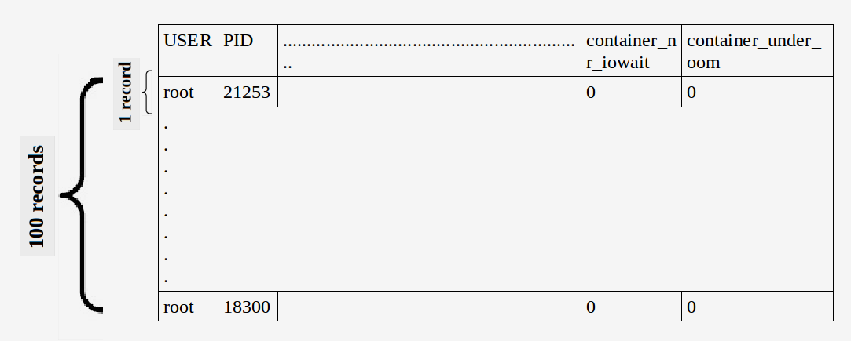
Figure 1: Snapshot of input dataset

Output :
The resource usage like %CPU, %MEM, cores used, response time are all stored for future reference in a logger file and also in .csv file for easy data retrieval.
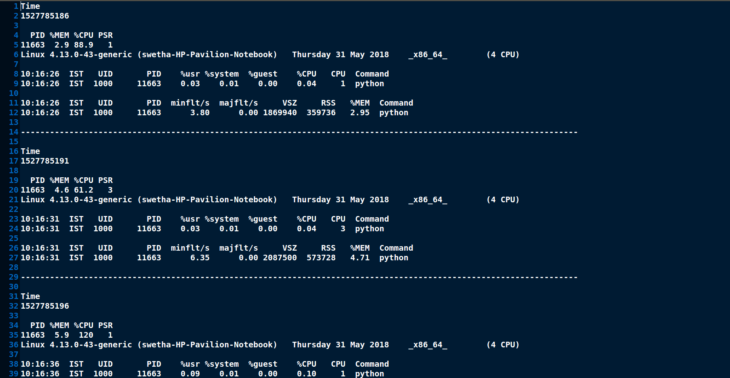
Figure 2 : Snapshot of resource log

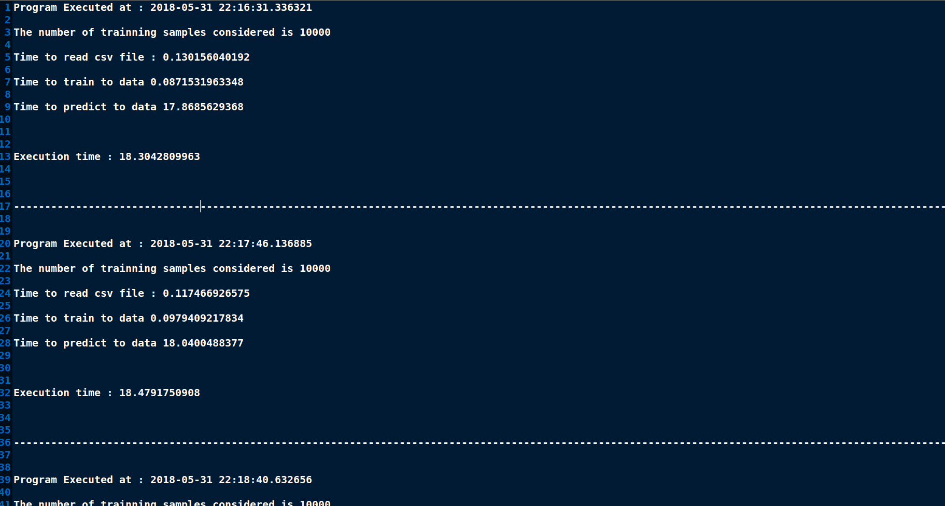
Figure 3 : Snapshot of response time log

Plotting of the Graphs are done a python script using matplotlib package by reading data from a CSV file.

Configuration of machine used :
Features | Machine 1
RAM | 12 GB
Proccessor Model | Intel(R) Core(TM) i7-6500U CPU @ 2.50GHz
CPU(seconds) | 4
Threads per core | 2
Cores per Socket | 2
Socket | 1
CPU MHz | 600 MHz
CPU Min MHz | 400 MHz
CPU Max MHz | 3100 MHz

Machine Learning model used :
Bidirectional Long short term memory (BLSTM)

Block Diagram :
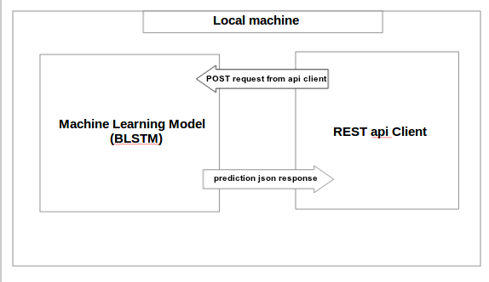

Figure 4 : Block diagram for architecture used for experiment

Procedure :
The REST api client (Any browser client / java or python client capable of sending HTTP request and receive and handle HTTP response from the API) sends a HTTP Post request to the REST api built around the BLSTM model. The POST request sends the following 2 parameters : The number of data records to be considered for prediction by BLSTM model and the name of the csv dataset file to read data from. The API on receiving the request , calls the predict() function which prepares the dataset and loads BLSTM model , predicts the values and returns the json to API client.
Note : the following table contains only the execution time logs , the %cpu and %memory logfiles are available in SVN repository.

Observations :
For all the experiments below in this usecase, the Deep learning model in consideration is Bidirectional long short term memory neural networks (BLSTM neural networks)

No. of Records considered : It is the total number of records considered by the BLSTM model for prediction purpose. And in this model of API, all the “n” records in consideration are loaded to memory at once.
Total Execution time (seconds) : It is the time taken in seconds by the standalone BLSTM model without REST api to predict and output the predictions.
1.1 (Date of experiment : 2018-05-31 )
Number of records considered by model : 1
S.no | No. of Records considered | Total execution time (seconds)
1 | 1 | 0.417
2 | 1 | 0.402
3 | 1 | 0.404
4 | 1 | 0.423
5 | 1 | 0.410
The average time of execution is : 0.415 seconds
TABLE 1

1.2 (Date of experiment : 2018-05-31 )
Number of records considered by model : 100
S.no | No. of Records considered | Total execution time(seconds)
1 | 100 | 0.536
2 | 100 | 0.472
3 | 100 | 0.480
4 | 100 | 0.473
5 | 100 | 0.500
The average time of execution is : 0.492 (seconds)
TABLE 2

1.3 (Date of experiment : 2018-05-31 )
Number of records considered by model : 1000
S.no | No. of Records considered | Total execution time(seconds)
1 | 1000 | 2.114
2 | 1000 | 2.137
3 | 1000 | 2.125
4 | 1000 | 2.129
5 | 1000 | 2.129
The average time of execution is : 2.161(seconds)
TABLE 3

1.4 (Date of experiment : 2018-05-31 )
Number of records considered by model : 5,000
S.no | No. of Records considered | Total execution time(seconds)
1 | 5000 | 9.933
2 | 5000 | 9.537
3 | 5000 | 9.534
4 | 5000 | 9.579
5 | 5000 | 9.574
The average time of execution is : 9.631(seconds)
TABLE 4

1.5 (Date of experiment : 2018-05-31 )
Number of records considered by model : 10,000
S.no | No. of Records considered | Total execution time(seconds)
1 | 10000 | 18.990
2 | 10000 | 18.914
3 | 10000 | 18.9183
4 | 10000 | 18.991
5 | 10000 | 18.881
The average time of execution is : 18.939(seconds)
TABLE 5

1.6 (Date of experiment : 2018-05-31 )
Number of records considered by model : 25,000
S.no | No. of Records considered | Total execution time(seconds)
1 | 25000 | 46.439
2 | 25000 | 50.122
3 | 25000 | 46.240
4 | 25000 | 52.363
5 | 25000 | 47.087
The average time of execution is : 48.450(seconds)
TABLE 6

1.7 (Date of experiment : 2018-05-31 )
Number of records considered by model : 50,000
S.no | No. of Records considered | Total execution time(seconds)
1 | 50000 | 92.095
2 | 50000 | 90.164
3 | 50000 | 90.715
4 | 50000 | 90.078
5 | 50000 | 97.804
The average time of execution is : 92.171 (seconds)
TABLE 7

1.8 (Date of experiment : 2018-05-31 )
Number of records considered by model : 1,00,000
S.no | No. of Records considered | Total execution time(seconds)
1 | 100000 | 154.346
2 | 100000 | 156.875
3 | 100000 | 156.612
4 | 100000 | 156.608
The average time of execution is : 156.110(seconds)
TABLE 8

1.9 (Date of experiment : 2018-05-31 )
Number of records considered by model : 1,25,000
S.no | No. of Records considered | Total execution time(seconds)
1 | 125000 | 200.213
2 | 125000 | 196.112
3 | 125000 | 194.389
4 | 125000 | 195.507
5 | 125000 | 195.708
The average time of execution is : 196.386(seconds)
TABLE 9

1.10 (Date of experiment : 2018-05-31 )
Number of records considered by model : 1,50,000
S.no | No. of Records considered | Total execution time(seconds)
1 | 150000 | 276.642
2 | 150000 | 283.305
3 | 150000 | 310.876
4 | 150000 | 329.291
5 | 150000 | 276.795
The average time of execution is : 295.382(seconds)
TABLE 10

1.11 (Date of experiment : 2018-05-31 )
Number of records considered by model : 2,00,000
S.no | No. of Records considered | Total execution time(seconds)
1 | 200000 | 385.118
2 | 200000 | 372.296
3 | 200000 | 369.441
4 | 200000 | 368.473
The average time of execution is : 373.832(seconds)
TABLE 11

1.12 (Date of experiment : 2018-05-31 )
Number of records considered by model : 225000
S.no | No. of Records considered | Total execution time(seconds)
1 | 225000 | 342.370
TABLE 12

1.13 (Date of experiment : 2018-05-31 )
Number of records considered by model : 250000
S.no | No. of Records considered | Total execution time(seconds)
3 | 250000 | 386.200
TABLE 13

1.14 (Date of experiment : 2018-05-31 )
Number of records considered by model : 325000
S.no | No. of Records considered | Total execution time(seconds)
1 | 325000 | 591.357
TABLE 14

1.15 (Date of experiment : 2018-05-31 )
Number of records considered by model : 350000
S.no | No. of Records considered | Total execution time(seconds)
1 | 350000 | Memory Error
TABLE 15
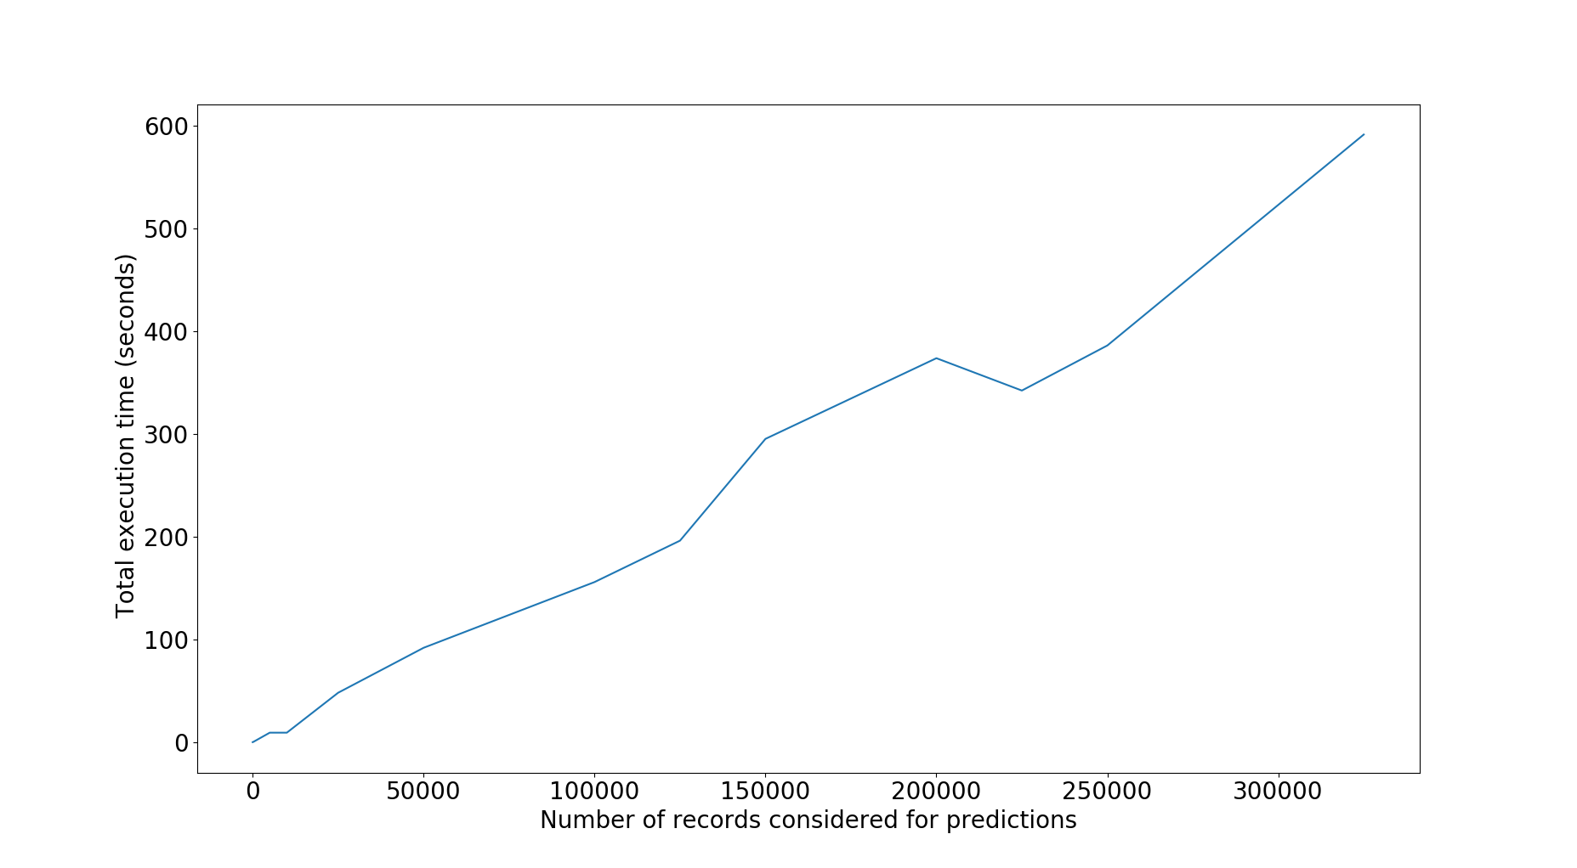
Figure 5 : Graph for Number of clients vs Total execution time in seconds for standalone BLSTM model.
Inference of graph :
From the above graph we can infer that, as the number of records considered for prediction increases the total execution time also increases.
For the obtained results of Number of records vs Total execution time , the mathematical equation of the trendline is as follows :
f(x)=0.0018x – 1.54166 [Mathematical equation of linear trendline]

Result :
Estimated execution time for standalone BLSTM model for varying number of considered data records and created log files for the %cpu , %memory and number of cores used .

Limitations :
In this method , if “ n ” records where considered for prediction , then all the “ n ” records where loaded into memory at once. This leads to heavy usage of RAM despite the constant RAM usage by the actual prediction model.Thus above 3,25,000 records Memory Error was witnessed.

Pseudo Code for API version1 :
FUNCTION loadModel()
LOAD pretrained BLSTM model
FUNCTION prepare_data, accept dataframe as parameter()
DROP Timestamp column
DIVIDE selected columns by a specified number
RETURN dataframe values
CREATE flask instance
CREATE route to predict function
GET system time
WRITE system time to file
CREATE result json , SET "success" to false
INITIALIZE result[“predictions”] with empty array
INPUT number of records to be considered to n
INITIALIZE df with dataframe of n records
FUNCTION CALL prepare_data on df, STORE response in variable dataset
IF shape(dataset) < 60
DUPLICATE and APPEND the same to dataset
CONVERT dataset to array
ELSE IF
CONVERT dataset to array
CREATE arrays and select columns of dataset
CALL deep learning model
GET system time
WRITE system time to file
RETURN json to http client
IF python script is executed directly(without being imported into another program) then
FUNCTION CALL loadModel()
RUN app @ port

USECASE 2

Objective :
To estimate and record the Execution time, CPU and Memory utilisation of REST api around BLSTM model for varying size of input syslog data records.

Input :
Locally generated Syslog data = input.csv file, number of records to be considered for prediction = n .
The fields in syslog data available to the model as input :
USER, PID, %CPU, %MEM, VSZ, RSS, TTY, STAT, START, TIME, COMMAND, Timestamp, OOM_Score, io_read_count, io_write_count, io_read_bytes, io_write_bytes, io_write_chars, num_fds, num_ctx_switches_voluntary, num_ctx_switches_involuntary, mem_rss, mem_vms, mem_shared, mem_text, mem_lib, mem_data, mem_dirty, mem_uss, mem_pss, mem_swap, num_threads, cpu_time_user, cpu_time_system, cpu_time_user, cpu_time_children_system, container_nr_sleeping, container_nr_running, conatiner_nr_stopped, container_nr_uninterruptible, container_nr_iowait, container_under_oom.
(All these fields contain value stored as string data type in the .csv file, but all of them are converted to float datatype in the REST api)
Figure 5 : snapshot of input dataset

Output :
The resource usage like %CPU, %MEM, cores used, response time are all stored for future reference in a logger file and also in .csv file for easy data retrieval.
Here are a sample snapshots of log files for reference,
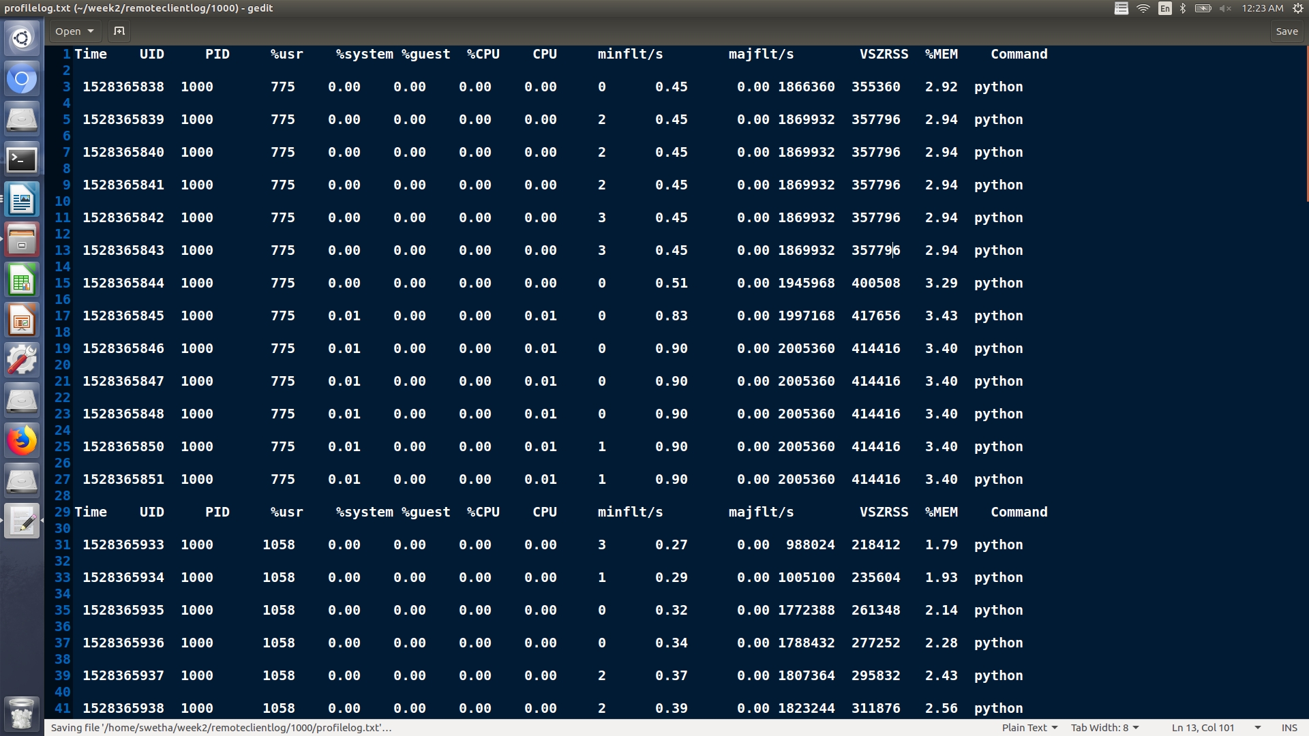

Figure 6 : snapshot of resource log
Plotting of the Graphs are done a python script using matplotlib package by reading data from a CSV file.

Configuration of machine used :
Features | Machine 1
RAM | 12 GB
Proccessor Model | Intel(R) Core(TM) i7-6500U CPU @ 2.50GHz
CPU(seconds) | 4
Threads per core | 2
Cores per Socket | 2
Socket | 1
CPU MHz | 600 MHz
CPU Min MHz | 400 MHz
CPU Max MHz | 3100 MHz

Machine Learning model used :
Bidirectional Long short term memory (BLSTM)

Block diagram :
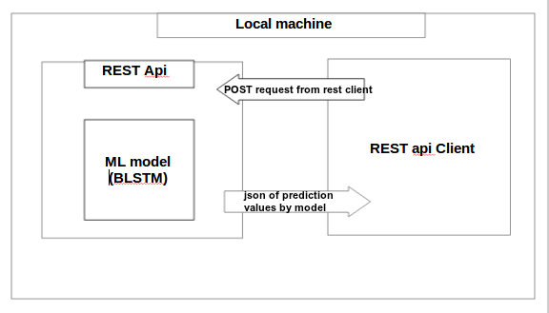
Figure 7 : Block diagram for REST api with Deep learning model

Procedure :
The REST api client (Any browser client / java or python client capable of sending HTTP request and receive and handle HTTP response from the API) sends a HTTP Post request to the REST api built around the BLSTM model. The POST request sends the following 2 parameters : The number of data records to be considered for prediction by BLSTM model and the name of the csv dataset file to read data from. The API on receiving the request , calls the predict() function which prepares the dataset and loads BLSTM model , predicts the values and returns the json to API client.

Observations :
For all the below experiments in this usecase BLSTM model is used.
2.1
No. of records considered : 0 (idle server)
conclusion : Initially on starting the API server , the %CPU utilisation is high and with time when no input is given the usage decays to near 0%.
Initially on starting the API server , there is a sudden increase int the %memory utilisation and then the utilisation most often saturates at 2.9%.
2.2
Number of records considered by model : 1
S.no | No. of Records considered | Total execution time(seconds)
1 | 1 | 3
2 | 1 | 2
3 | 1 | 3
4 | 1 | 2
5 | 1 | 3
The average time of execution is :2.6 seconds
TABLE 16

2.3
Number of records considered by model : 1000
S.no | No. of Records considered | Total execution time(seconds)
1 | 1000 | 4
2 | 1000 | 5
3 | 1000 | 4
4 | 1000 | 3
5 | 1000 | 4
The average time of execution is :4 seconds
TABLE 17

2.4
Number of records considered by model : 10,000
S.no | No. of Records considered | Total execution time(seconds)
1 | 10000 | 20
2 | 10000 | 21
3 | 10000 | 21
4 | 10000 | 21
5 | 10000 | 24
The average time of execution is :21.4 seconds
TABLE 18

2.5
Number of records considered by model : 25,000
S.no | No. of Records considered | Total execution time(seconds)
1 | 25000 | 45
2 | 25000 | 41
3 | 25000 | 41
4 | 25000 | 41
5 | 25000 | 43
The average time of execution is :42.2 seconds
TABLE 19

2.6
Number of records considered by model : 50,000
S.no | No. of Records considered | Total execution time(seconds)
1 | 50000 | 98
2 | 50000 | 95
The average time of execution is :96 seconds
TABLE 20
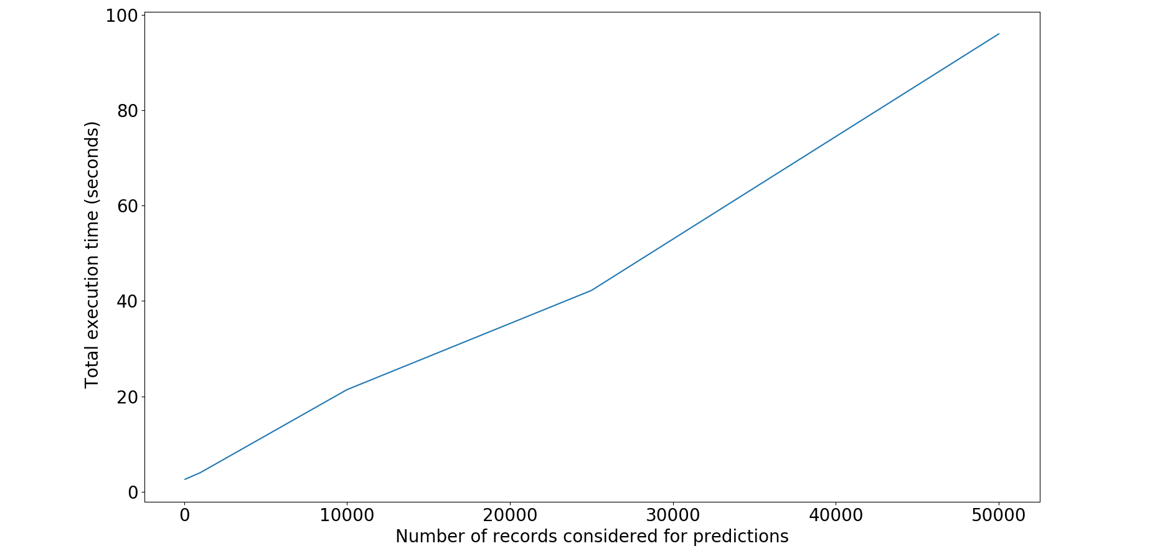
Figure 8: Graph for Number of records vs Total time of execution in seconds for BLSTM model with API

Inference of Graph :
The mathematical equation of the trendline of the Number of records considered vs Total execution time is as follows :
f(x) = 0.00184 + 1.588 [Trend line equation of the dataset]
Visually, from the graph we can infer that, as the Number of records considered from prediction increases, the total time taken for execution also increases almost linearly.

Result :
Estimated the approximate execution time of REST api around the BLST model , but the primary Objective was to plot the %CPU and %MEM usage of the architecture and derive any possible pattern.

Limitations/Error:
In this method , if “ n ” records where considered for prediction , then all the “ n ” records where loaded into memory at once. This leads to heavy usage of RAM despite the constant RAM usage by the actual prediction model.Thus above 3,25,000 records Memory Error was witnessed.

USECASE 3

Proposed Solution for Limitation/Error :
To overcome this memory error , the new method will read and load into the memory the data in small batches . This batches will be repeated until the total number of records in consideration is achieved.

Benefits Of Batch Processing :
By batch processing we are thus avoiding loading the whole “ n ” data records in consideration into the memory at once but instead load the “ n ” records in batches one after the other . Thus the RAM overflow is prevented.

Objective :
To estimate and record the Execution time, CPU and Memory utilisation of REST api around BLSTM model for varying size of input syslog data records using remote client ie. API and client run in different physical machines.

Input :
Locally generated Syslog data = input.csv file , number of records to be considered for prediction = n .
The fields in syslog data available to the model as i/p :
USER, PID, %CPU, %MEM, VSZ, RSS, TTY, STAT, START, TIME, COMMAND, Timestamp, OOM_Score, io_read_count, io_write_count, io_read_bytes, io_write_bytes, io_write_chars, num_fds, num_ctx_switches_voluntary, num_ctx_switches_involuntary, mem_rss, mem_vms, mem_shared, mem_text, mem_lib, mem_data, mem_dirty, mem_uss, mem_pss, mem_swap, num_threads, cpu_time_user, cpu_time_system, cpu_time_user, cpu_time_children_system, container_nr_sleeping, container_nr_running, conatiner_nr_stopped, container_nr_uninterruptible, container_nr_iowait, container_under_oom.
(All these fields contain value stored as string data type in the .csv file, but all of them are converted to float datatype in the REST api)
Figure 9 : snapshot of input dataset

Output :
The resource usage like %CPU, %MEM, cores used, response time are all stored for future reference in a logger file and also in .csv file for easy data retrieval.
Plotting of the Graphs are done a python script using matplotlib package by reading data from a CSV file.
Here are few snapshots of log files for reference,

Figure 10 : snapshot of resource log

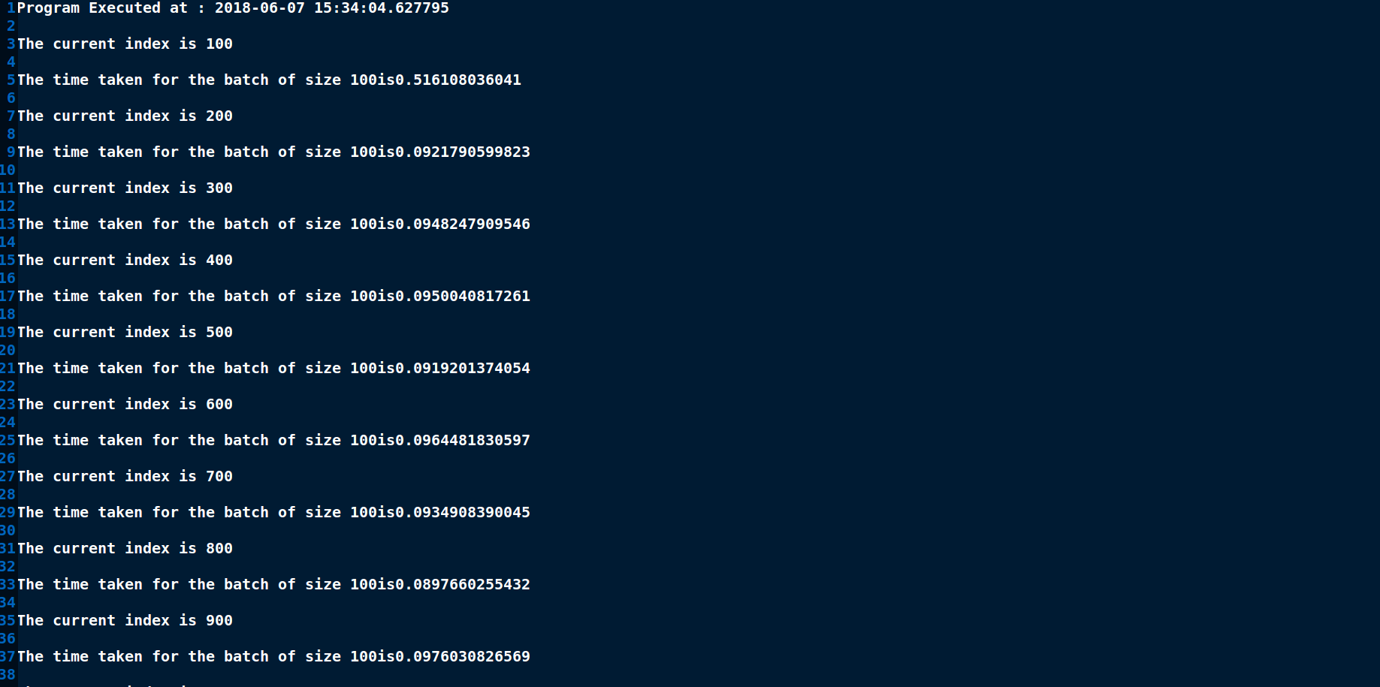
Figure 11 : snapshot of response time log

Configuration of machine used :
Features | Machine 1
RAM | 12 GB
Proccessor Model | Intel(R) Core(TM) i7-6500U CPU @ 2.50GHz
CPU(seconds) | 4
Threads per core | 2
Cores per Socket | 2
Socket | 1
CPU MHz | 600 MHz
CPU Min MHz | 400 MHz
CPU Max MHz | 3100 MHz

Machine Learning model used :
Bidirectional Long short term memory (BLSTM)

Block diagram :

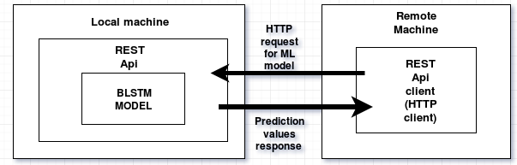
Figure 12 : Block diagram of REST api tested with remote client

Observations :
For each of these experiments the number of iteratives is more than 5, but for averaging only 5 is considered.

Table header explanation :
No. of Records considered : Total number of records considered for prediction
Size of each batch of data : Size of each batch of data loaded into memory at once
Total time of execution (seconds) : Total time of execution in seconds of the BLSTM model on the number of records considered
Total time taken by client (seconds) : Total time taken in seconds by the client to send a http request to the REST api around BLSTM model and to receive response for the same.
3.1
S.no | No. of Records considered | Size of each batch of data | Total time of execution (seconds) | Total time taken by client (seconds)
1 | 60 | 60 | 0.498 | 0.519
2 | 60 | 60 | 0.462 | 0.473
3 | 60 | 60 | 0.465 | 0.466
4 | 60 | 60 | 0.454 | 0.472
5 | 60 | 60 | 0.460 | 0.544
Average time taken inside REST api for 60 records : 0.466 seconds
Average time taken for complete http request/response for the client:0.771 seconds
TABLE 21

3.2
S.no | No. of Records considered | Size of each batch of data | Total time of execution (seconds) | Total time taken by client (seconds)
1 | 1000 | 100 | 1.441 | 2.864
2 | 1000 | 100 | 1.454 | 3.652
3 | 1000 | 100 | 1.522 | 1.671
4 | 1000 | 100 | 1.558 | 1.770
5 | 1000 | 100 | 1.513 | 1.599
Average time taken inside REST api for 60 records : 1.498 seconds
Average time taken for complete http request/response for the client :2.057 seconds
TABLE 22

3.3
S.no | No. of Records considered | Size of each batch of data | Total time of execution (seconds) | Total time taken by client (seconds)
1 | 10000 | 1000 | 18.151 | 25.711
2 | 10000 | 1000 | 17.611 | 26.410
3 | 10000 | 1000 | 17.723 | 18.860
4 | 10000 | 1000 | 17.916 | 19.332
5 | 10000 | 1000 | 17.929 | 22.028
Average time taken inside REST api for 60 records :18.065 seconds
Average time taken for complete http request/response for the client :21.395 seconds
TABLE 23

3.4
S.no | No. of Records considered | Size of each batch of data | Total time of execution (seconds) | Total time taken by client (seconds)
1 | 25000 | 5000 | 46.940 | 55.798
2 | 25000 | 5000 | 47.0277 | 55.861
3 | 25000 | 5000 | 45.368 | 49.607
4 | 25000 | 5000 | 47.175 | 56.722
5 | 25000 | 5000 | 46.578 | 49.444
Average time taken inside REST api for 60 records :46.580 seconds
Average time taken for complete http request/response for the client :54.982 seconds
TABLE 24

3.5
S.no | No. of Records considered | Size of each batch of data | Total time of execution (seconds) | Total time taken by client (seconds)
1 | 50000 | 10000 | 90.283 | 96.188
2 | 50000 | 10000 | 90.509 | 107.061
3 | 50000 | 10000 | 90.776 | 97.721
4 | 50000 | 10000 | 90.653 | 96.578
5 | 50000 | 10000 | 101.118 | 109.475
Average time taken inside REST api for 60 records :92.029 seconds
Average time taken for complete http request/response for the client :102.068 seconds
TABLE 25

3.6
S.no | No. of Records considered | Size of each batch of data | Total time of execution (seconds) | Total time taken by client (seconds)
1 | 100000 | 25000 | 157.073 | 183.816
2 | 100000 | 25000 | 154.255 | 178.046
3 | 100000 | 25000 | 163.110 | 189.665
4 | 100000 | 25000 | 167.089 | 185.103
5 | 100000 | 25000 | 155.606 | 175.156
Average time taken inside REST api for 60 records :159.843 seconds
Average time taken for complete http request/response for the client :180.270 seconds
TABLE 26

3.7
S.no | No. of Records considered | Size of each batch of data | Total time of execution (seconds) | Total time taken by client (seconds)
1 | 250000 | 50000 | 386.692 | 403.399
2 | 250000 | 50000 | 386.587 | 404.678
3 | 250000 | 50000 | 388.387 | 413.680
4 | 250000 | 50000 | 387.127 | 408.153
5 | 250000 | 50000 | 388.937 | 412.087
Average time taken inside REST api for 60 records : 387.546 seconds
Average time taken for complete http request/response for the client : 408.399 seconds
TABLE 27

3.8
S.no | No. of Records considered | Size of each batch of data | Total time of execution (seconds) | Total time taken by client (seconds)
1 | 500000 | 100000 | 801.823 | 867.252
2 | 500000 | 100000 | 777.472 | 859.185
3 | 500000 | 100000 | 773.329 | 884.507
4 | 500000 | 100000 | 794.800 | 873.728
5 | 500000 | 100000 | 784.927 | 871.865
Average time taken inside REST api for 60 records : 784.927 seconds
Average time taken for complete http request/response for the client : 871.307 seconds
TABLE 28

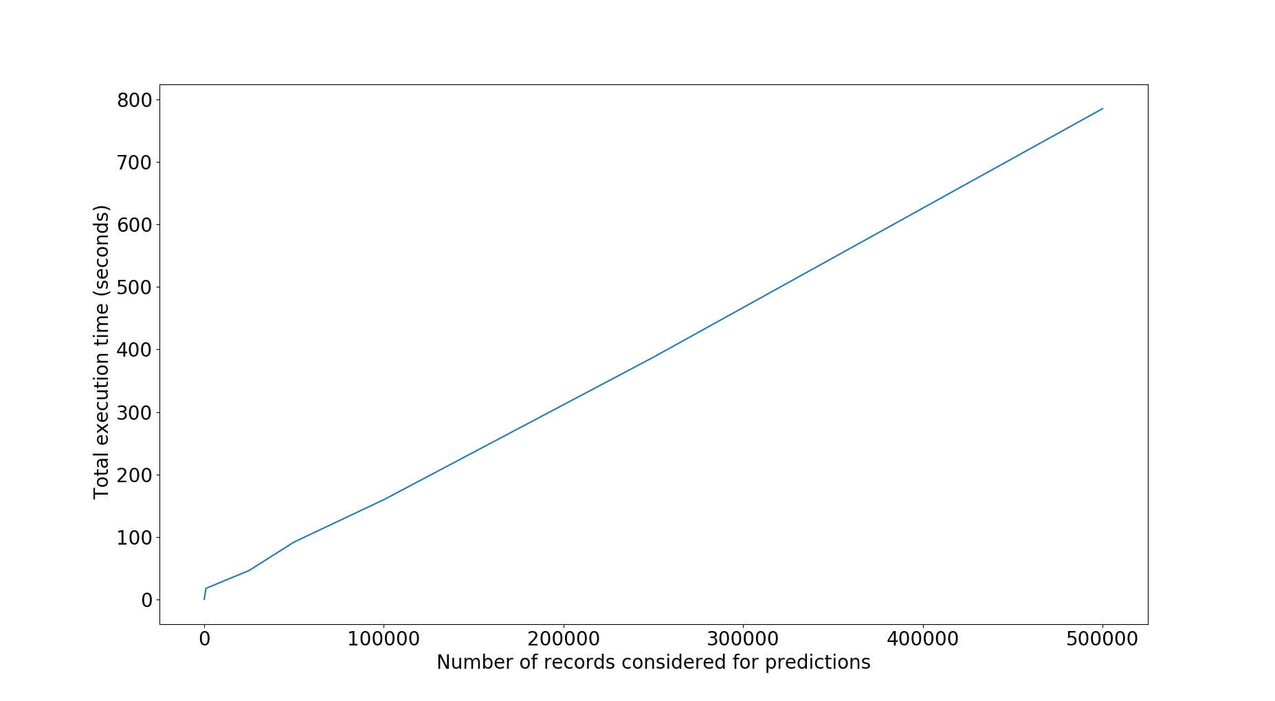
Figure 13 : Graph for Number of records vs Total execution time in seconds for REST api with BLSTM model
Inference from the graph :
From the above graph we can conclude that, the number of records considered for prediction and the total time for execution of the Model inside the api are linearly related.
The mathematical equation of trendline for the above data collected for Number of records vs Total execution time is as follows :
f(x) = 0.00155 x + 4.0769 [Mathematical equation of the trendline]
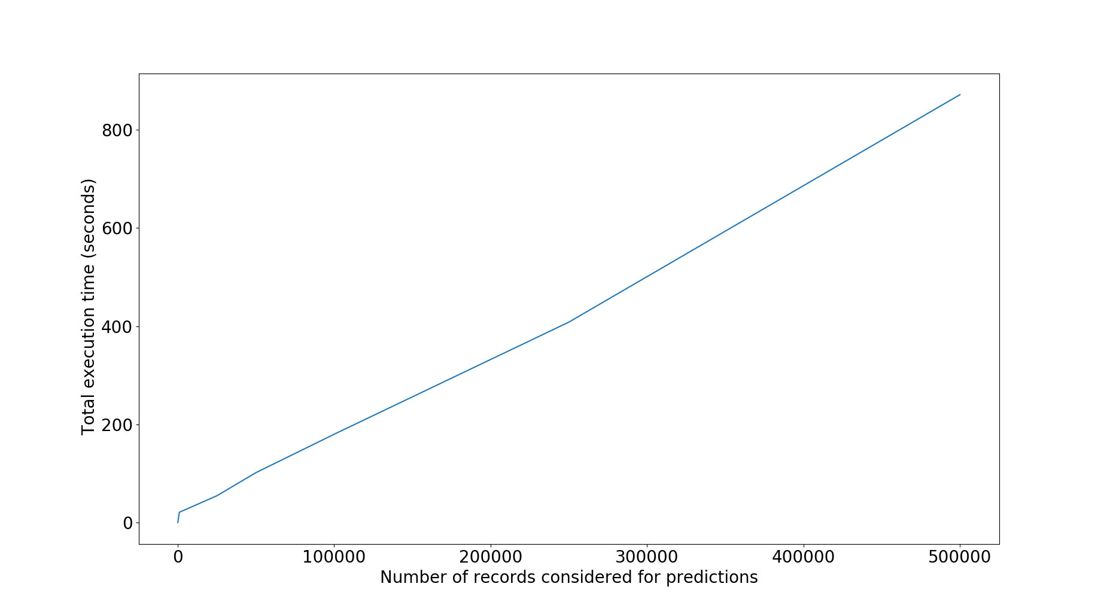
Figure 14 : Graph for Number of records vs Total execution time in seconds for the http client to send request and receive response from REST api with BLSTM model.
Inference from the graph :
From the above graph we can conclude that, the number of records considered for prediction and the total time taken for the complete request and response of a http client are linearly related.
The mathematical equation of trendline for the above data collected for Number of records vs Total execution time is as follows :
f(x) = 0.0017 x + 4.6698 [Mathematical equation of the trendline]

USECASE 4

Shifting the Batching proccess to client side :
In the previous model of API, though batching was introduced and it solved the RAM exhaustion problem, the batching was done in the server side within the REST Api. Thus in this scenario, the client for any number of records considered for prediction, sent only one HTTP request to the REST Api, and inside the API, the data was read in batches and predicted. The benefit of this method was that, the process being an IO intensive process, this method avoided the HTTP overhead.
But in the NMSworks project architecture that has been proposed, w e are using stream-processing applications like Apache Kafka, or Storm. Thus, the architecture of REST api was changed again. The batching process was shifted from server side to client side. The python http client for the REST Api was built to mimic the streaming mechanisms of stream-processing applications.
In the python client, the total number of records to be considered for prediction are read in batches based on the loockback of the machine learning model in consideration. And for every batch, a individual HTTP request is made to the API. And in the Server side, for every HTTP request the Machine learning model is invoked once.
REST API with batched clients were built for the following 4 models :
- Bidirectional long short term memory neural networks (BLSTM)
- Simple linear regression
- Long short term memory neural networks with 3 layers of 32 neurons, 64 neurons and 32 neurons respectively
- Long short term memory neural networks with 3 layers of 32 neurons, 64 neurons and 1 neuron respectively.

Flask API with concuurent batched client requests :
Till this point of time, all the API’s built and tested had received only synchronous( one ater the other ) http requessts from clients and thus handled the requests also in synchronous manner. But most of real life applications follow asynchronous nature ie. Many clients might make request to the REST api simaltaneously (concurrent requests).
Normally, when we write a simple REST api using FLASK and run the same with “Python <filename.py>” command from our terminal, we are in reality serving the API with the inbuilt and default server. This server is suitable only for development environment and cannot be used for production environment. Also, a FLASk Api server with inbuilt server can handle only one request at a time. In case, the development server is provided with concurrent requests, it creates a waiting queue, queues the requests and handles them one after the other.
Thus for production level usage of the FLASK Api, we need to use an application server like Gunicorn and a reverse proxy like Nginx in the front end. And to handle the concurrent request, we need to make the FLASK application multithreaded or we can introduce multiple workers in application server like gunicorn.
Application server :
An apllication server is basically a software framework that provides the user with facilities to create web applications and also run it in a server environment.

Figure 14 : Block diagram of REST api tested with concurrent clients

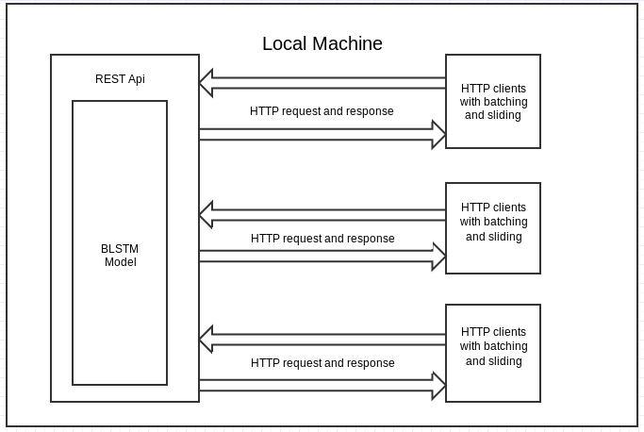

Objective :
To plot and study the %CPU usage, %MEM usage, Response time, Throughput (per second) for the latest REST api model for varying number of concurrent clients.

Input :
Locally generated Syslog data = inputfile.csv , number of concurrent clients = n.
The fields in syslog data available to the model as i/p :
USER, PID, %CPU, %MEM, VSZ, RSS, TTY, STAT, START, TIME, COMMAND, Timestamp, OOM_Score, io_read_count, io_write_count, io_read_bytes, io_write_bytes, io_write_chars, num_fds, num_ctx_switches_voluntary, num_ctx_switches_involuntary, mem_rss, mem_vms, mem_shared, mem_text, mem_lib, mem_data, mem_dirty, mem_uss, mem_pss, mem_swap, num_threads, cpu_time_user, cpu_time_system, cpu_time_user, cpu_time_children_system, container_nr_sleeping, container_nr_running, conatiner_nr_stopped, container_nr_uninterruptible, container_nr_iowait, container_under_oom.
(All these fields contain value stored as string data type in the .csv file, but all of them are converted to float datatype in the REST api)

Figure 15 : snapshot of input dataset

Output :
The resource usage like %CPU, %MEM, cores used, response time are all stored for future reference in a logger file and also in .csv file for easy data retrieval.
Plotting of the Graphs are done a python script using matplotlib package by reading data from a CSV file.

Configuration of Machine used :
Features | Machine 1
RAM | 12 GB
Proccessor Model | Intel(R) Core(TM) i7-6500U CPU @ 2.50GHz
CPU(seconds) | 4
Threads per core | 2
Cores per Socket | 2
Socket | 1
CPU MHz | 600 MHz
CPU Min MHz | 400 MHz
CPU Max MHz | 3100 MHz

Machine Learning model used :
Bidirectional Long short term neural networks (BLSTM)

Procedure :

Observations :
Table headers explanation :
%Memory usage : It measures the percentage of memory used by the BLSTM model.
%CPU usage : It measures the percentage of CPU time used by the BLSTM model.
Overall response time (seconds) : It ia the total time taken in seconds for the API to serve to the requests of all the concurrent clients.
No. of concurrent clients | %Memory usage | %CPU usage | Overall response time (seconds)
1 | 2.96 | 0.01 | 0.577
10 | 4.01 | 0.02 | 1.860
20 | 4.16 | 0.02 | 2.259
30 | 4.07 | 0.02 | 3.569
40 | 3.92 | 0.81 | 2.540
50 | 4.49 | 0.76 | 5.909
60 | 4.14 | 0.65 | 4.120
70 | 4.55 | 0.5 | 4.730
80 | 4.42 | 0.44 | 5.309
90 | 4.12 | 0.41 | 5.860
100 | 4.29 | 0.40 | 7.119
110 | 4.23 | 0.40 | 8.909
120 | 4.39 | 0.41 | 8.269
130 | 4.00 | 0.17 | 12.710
140 | 4.31 | 0.18 | 10.160
150 | 4.58 | 0.18 | 9.050
160 | 4.72 | 0.18 | 10.440
170 | 4.50 | 0.19 | 12.240
180 | 4.87 | 0.19 | 10.589
190 | 4.74 | 0.19 | 12.190
200 | 4.65 | 0.19 | 11.800
210 | 4.69 | 0.20 | 12.009
TABLE 29
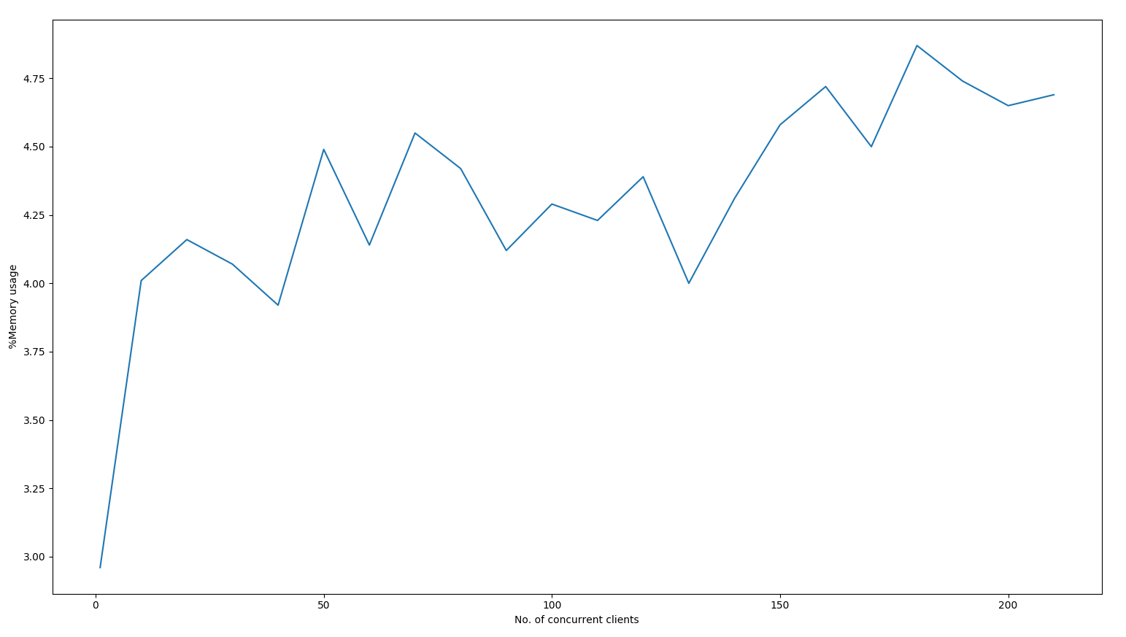


Figure 16 : Graph of Number of concurrent clients vs %Memory used

Figure 17 : Graph of Number of concurrent clients vs Total response time

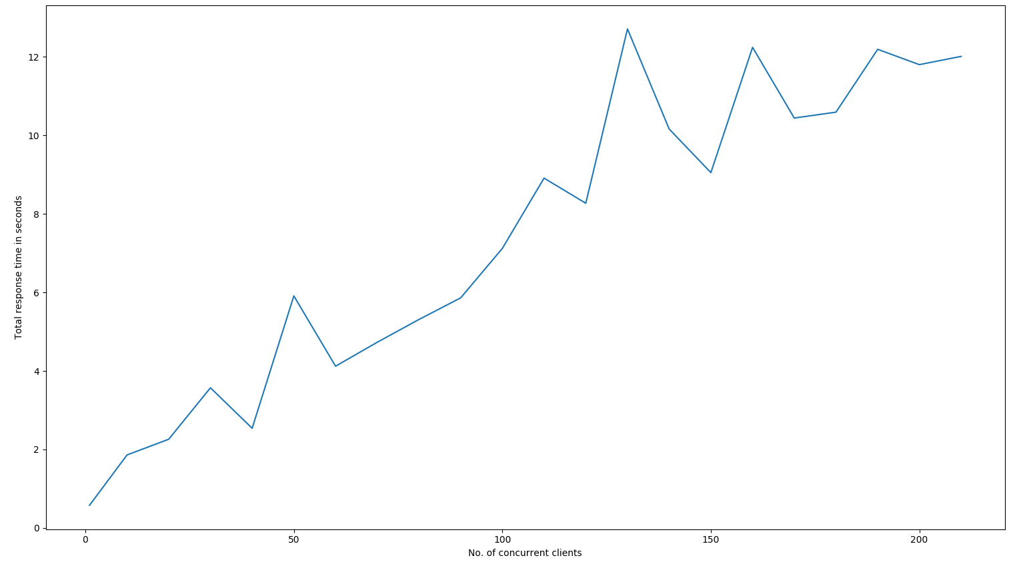
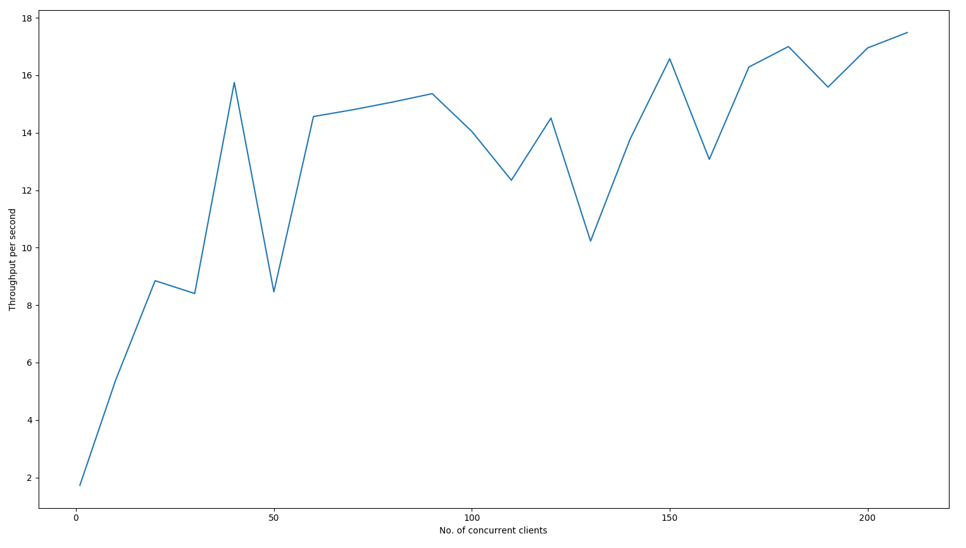

Figure 18 : Graph of Number of concurrent clients vs Throughput

Result :
From the above graphs we can deduce that the best fit line for the collected throuhput, %memory, %cpu data with respect to number of concurrent line is a increasing function.
Thus we can conclude that as the number of concurrent clients increases the response time, %CPU usage, %memory usage, throughput also increases.
Though we expect the throughput to decrease as the number of clients increases, here with the increase in number of concurrent clients we see that the response time increase significantly and although multiple clients are requesting concurrently, the batch request inside every individual client is done synchronously. Thus the throuhput does not decrease that significantly.

USECASE 5

Objective :

Input :
Locally generated Syslog data = inputfile.csv , number of concurrent clients = n.
The fields in syslog data available to the model as i/p :
USER, PID, %CPU, %MEM, VSZ, RSS, TTY, STAT, START, TIME, COMMAND, Timestamp, OOM_Score, io_read_count, io_write_count, io_read_bytes, io_write_bytes, io_write_chars, num_fds, num_ctx_switches_voluntary, num_ctx_switches_involuntary, mem_rss, mem_vms, mem_shared, mem_text, mem_lib, mem_data, mem_dirty, mem_uss, mem_pss, mem_swap, num_threads, cpu_time_user, cpu_time_system, cpu_time_user, cpu_time_children_system, container_nr_sleeping, container_nr_running, conatiner_nr_stopped, container_nr_uninterruptible, container_nr_iowait, container_under_oom.
(All these fields contain value stored as string data type in the .csv file, but all of them are converted to float datatype in the REST api)

Figure 19 : Snapshot of input data

Output :
The resource usage like %CPU, %MEM, cores used, response time are all stored for future reference in a logger file and also in .csv file for easy data retrieval.

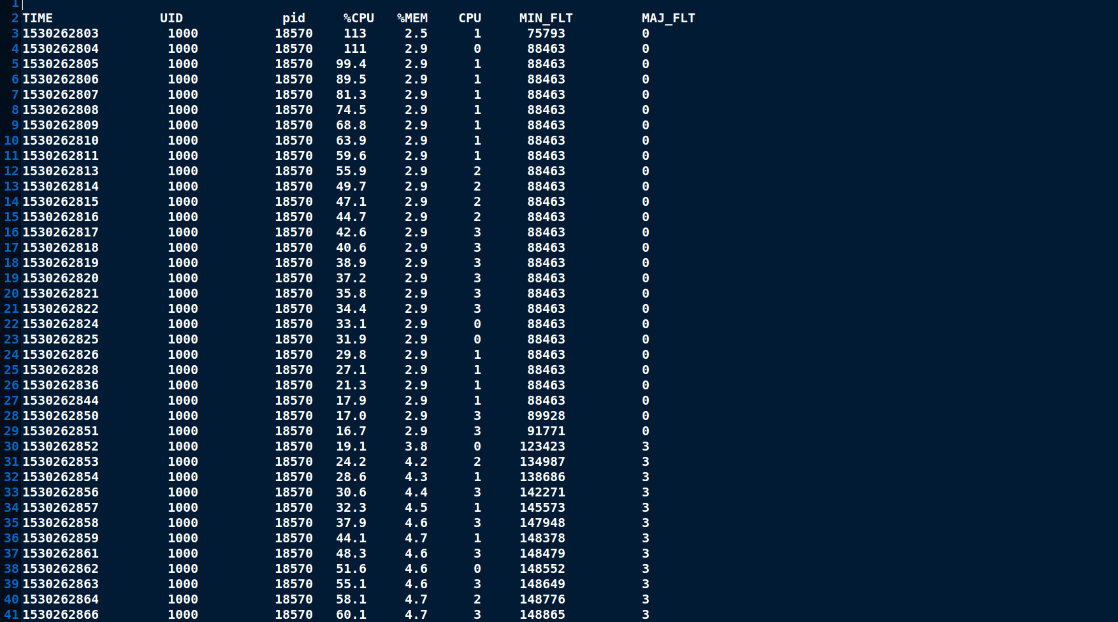

Figure 20 : Snapshot of resource log

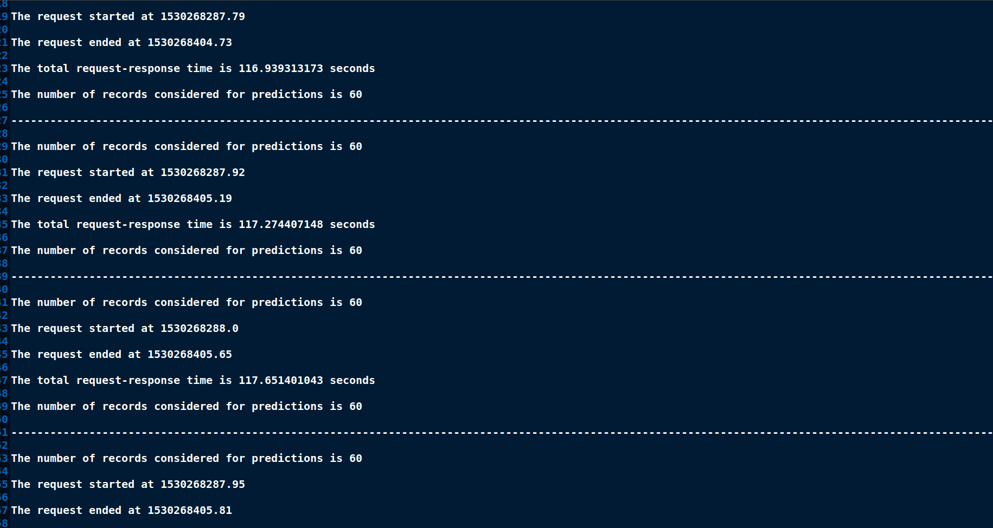
Figure 21 : Snapshot of response time log
Plotting of the Graphs are done a python script using matplotlib package by reading data from a CSV file.

Machine learning model used :
Bidirectional long short term memory neural network (BLSTM)

Machine configurations considered for experiment :
Features | Machine 1 | Machine2
RAM | 12 GB | 8GB
Proccessor Model | Intel(R) Core(TM) i7-6500U CPU @ 2.50GHz | Intel(R) Core(TM) i7-7700 CPU @ 3.60GHz
CPU(seconds) | 4 | 8
Threads per core | 2 | 2
Cores per Socket | 2 | 4
Socket | 1 | 1
CPU MHz | 600 MHz | 800MHz
CPU Min MHz | 400 MHz | 800 MHz
CPU Max MHz | 3100 MHz | 4200 MHz

NOTE :
- For all the below experiments each individual client has 150 synchronous requests happening one after the other.
- For measuring the %CPU, %MEM usage 2 commands are commonly used – top, ps.
Top is an interactive way of monitoring resource usage.
PS command is mostly used for logging the resource usage.
Though the %MEM usage given by both the commands are the same, the %CPU read by both the commands are different, this is due to the difference in the defenition of the %CPU measured by each of these commands.
TOP : The %CPU in top command gives the average %CPU usage since the last sample was taken.
PS : The %CPU in PS gives the average %CPU since the time of start of program till the time at which the reading was taken.

5.1
Experiment done on Machine 1
5.1.1
S. no | No. of concurrent clients | No. of requests per client | Total response time (seconds) | Avg. response time for 1 client (seconds) | Throughput (per second)  (per second)
1 | 100 | 150 | 486.670 | 483.789 | 0.205
1 | 100 | 150 | 486.219 | 482.125 | 0.205
1 | 100 | 150 | 485.927 | 483.272 | 0.205
average total response time (seconds) : 486.272
average response time for one client (seconds) : 483.062
average Throughput (per second): 0.205
TABLE 30
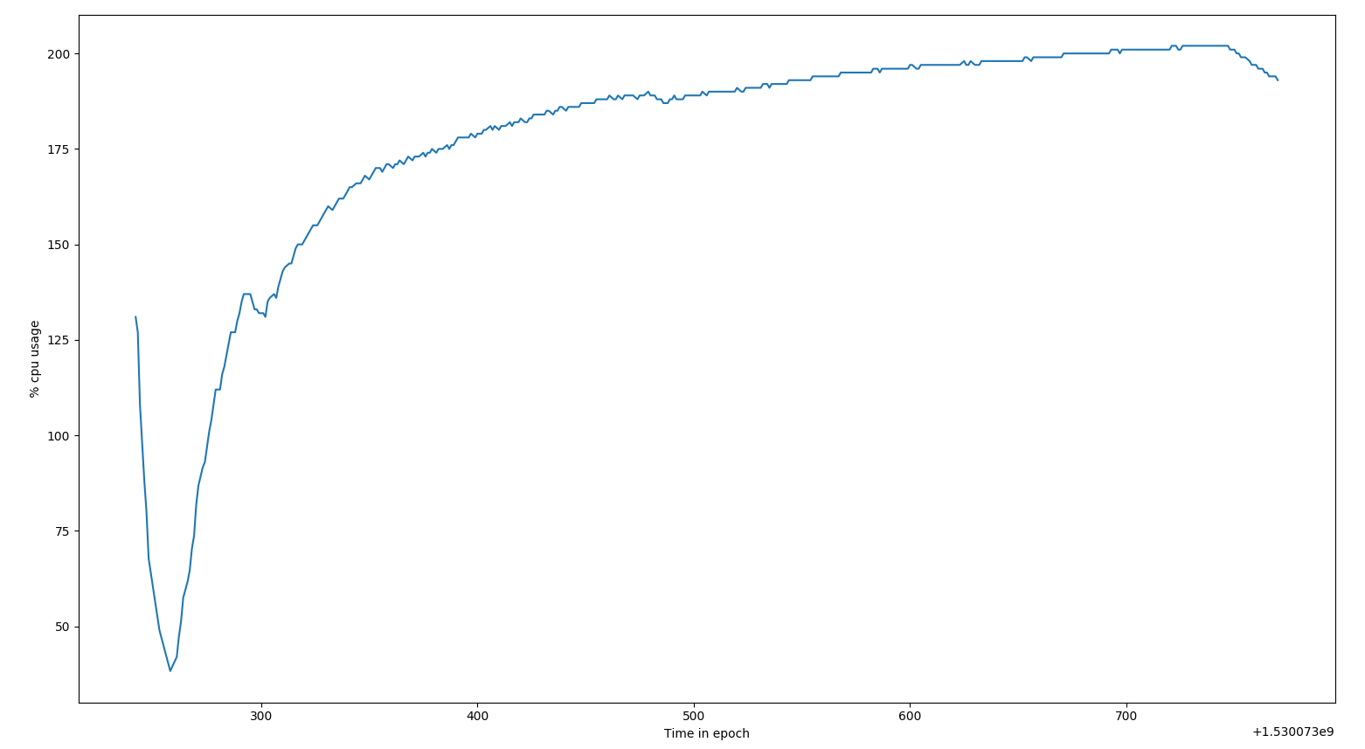

Figure 22 : Graph for Time in epoch vs %CPU usage for BLSTM model in machine 1

x-axis : Time in seconds
y-axis : %CPU usage measured using ps command
Inference of graph :
In the above graph, we can see that for a initial and small period os time the %CPU usage is decreasing exponentially and then after reaching a lowest point it has a logrithmic growth. The decreasing region of the graph depicts the idle REST api to which no requests where made, the API had just been started. The logarithmic growth region depicts the increase in %CPU usage due to concurrent clients.

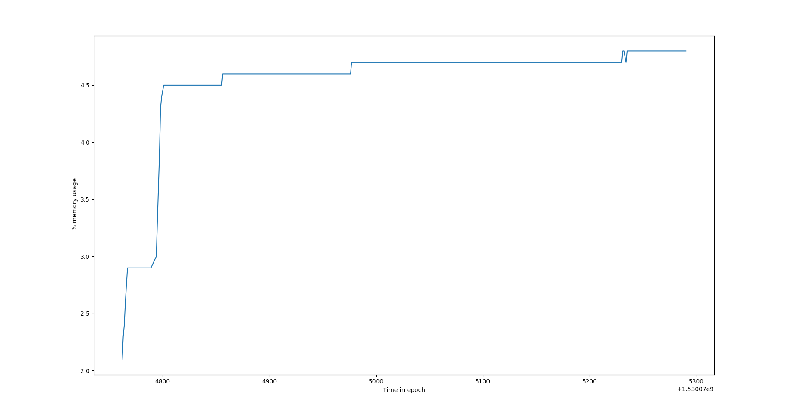
Figure 23 : Graph for Time in epoch vs %MEM usage for BLSTM model in machine 1
x-axis : Time in epoch
y-axis : %MEM usage measured using ps command
Inference of graph :
In the above graph, the starting increasing curve is due to the fact that it is the time of first few http requests reaching the server, thus from an idle server’s 2.96% memory the %memory used suddenly shoots up. After sometime, we can say that at anytime “n” concurrent clients are using the API, thus the memory percentage is constant.

5.1.2

S. no | No. of concurrent clients | No. of requests per client | Total response time (seconds) | Avg. response time for 1 client  (seconds) | Throughput (per second)
1 | 150 | 150 | 867.080 | 857.429 | 0.172
1 | 150 | 150 | 861.150 | 852.087 | 0.174
1 | 150 | 150 | 864.519 | 853.917 | 0.173
average total response time (seconds) : 864.249
average response time for one client (seconds) : 854.477
average Throughput (per second): 0.172
TABLE 31
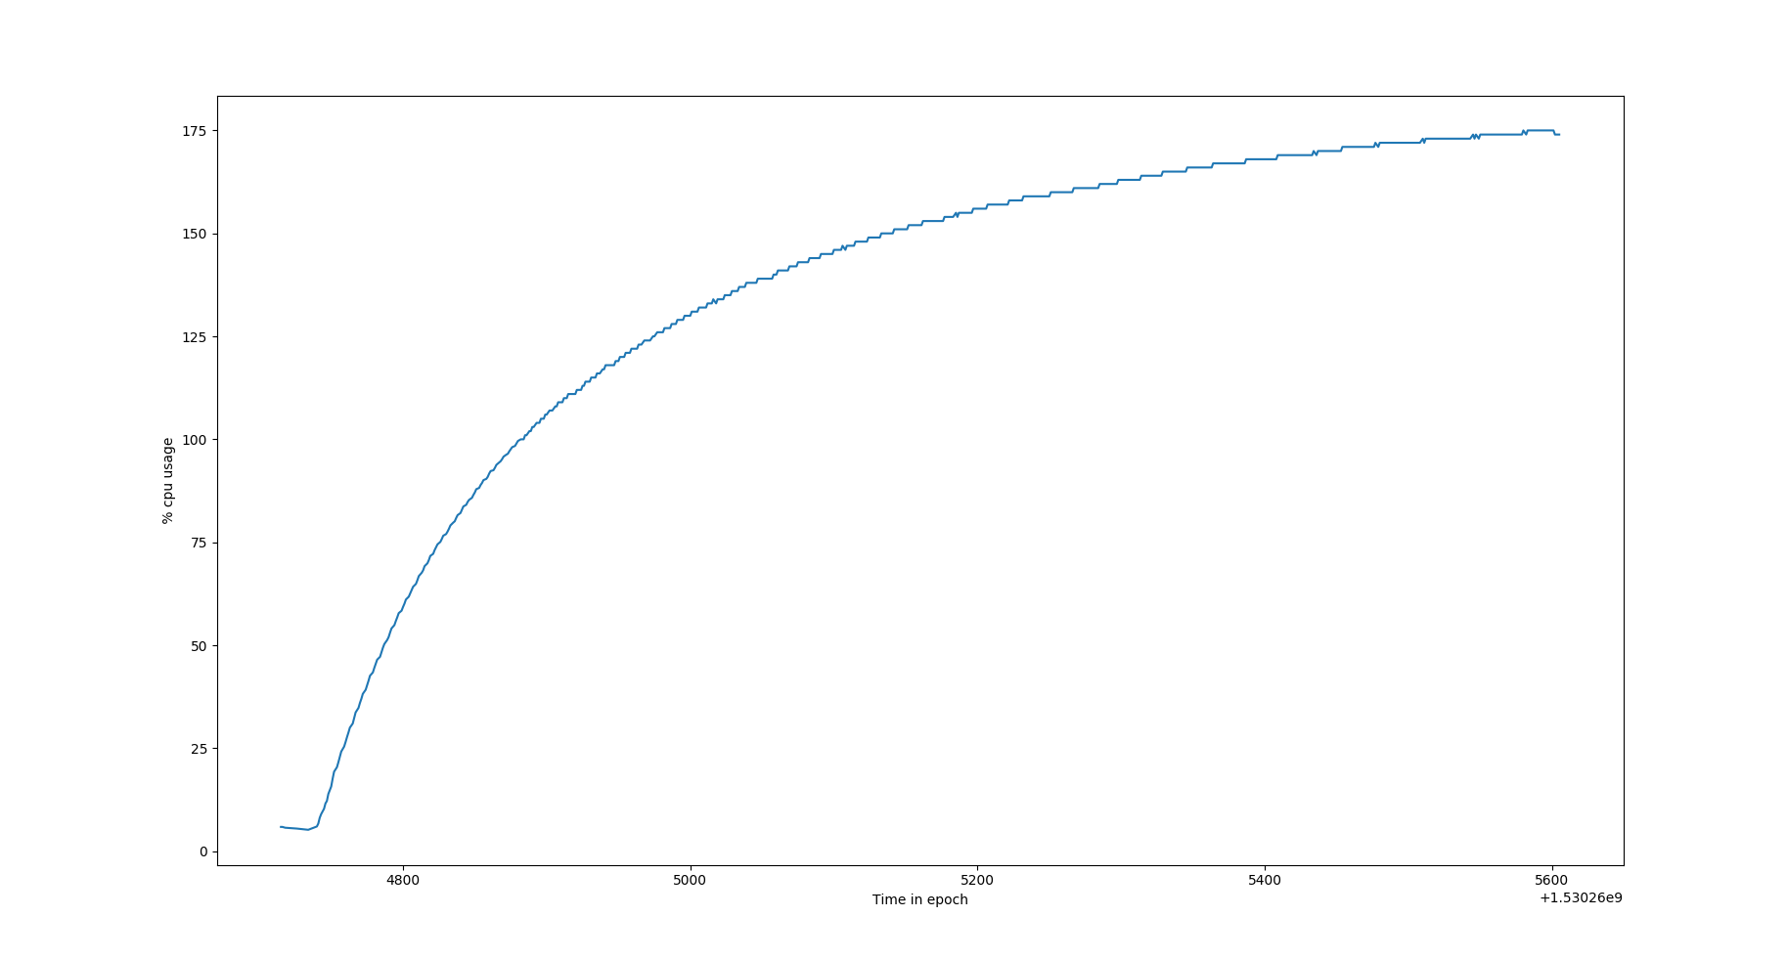

Figure 24 : Graph for Time in epoch vs %CPU usage for BLSTM model in machine 1
x-axis : Time in seconds
y-axis : %CPU usage measured using ps command
Inference of graph :
In the above graph, we can see that for a initial and small period os time the %CPU usage is decreasing exponentially and then after reaching a lowest point it has a logrithmic growth. The decreasing region of the graph depicts the idle REST api to which no requests where made, the API had just been started. The logarithmic growth region depicts the increase in %CPU usage due to concurrent clients.

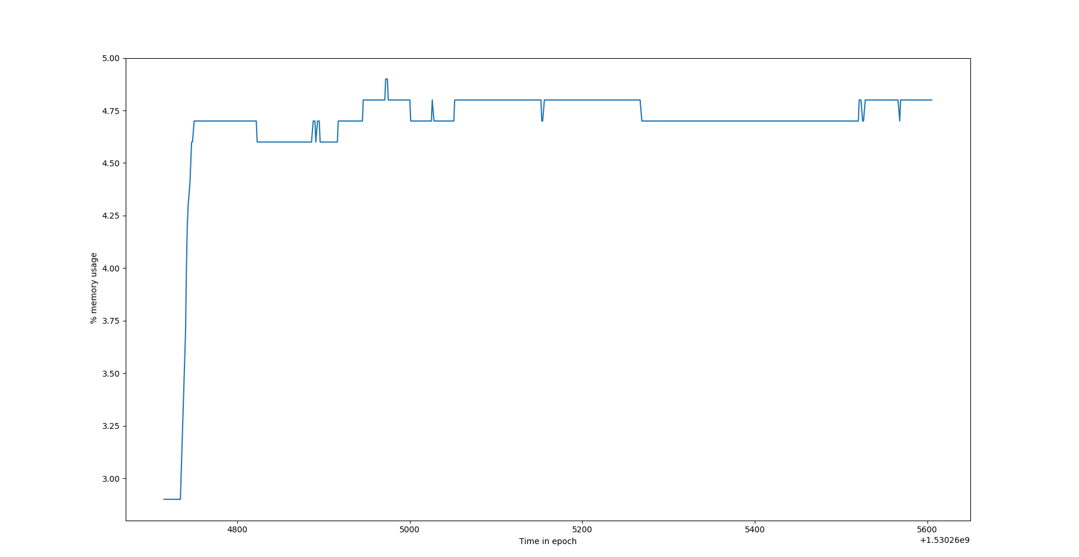
Figure 25 : Graph for Time in epoch vs %MEM usage for BLSTM model in machine 1

x-axis : Time in epoch
y-axis : %MEM usage measured using ps command
Inference of graph :
In the above graph, the starting increasing curve is due to the fact that it is the time of first few http requests reaching the server, thus from an idle server’s 2.96% memory the %memory used suddenly shoots up. After sometime, we can say that at anytime “n” concurrent clients are using the API, thus the memory percentage is constant. But as we can see in few places there is a fluctuating in memory usage, this is due to the fact that as multiple concurrent clients might be requesting the api with same input batch, thus no new memory needs to be used, instead the cached result can be utilised and sometimes the case is otherwise.

5.1.3

S. no | No. of concurrent clients | No. of requests per client | Total response time (seconds) | Avg. response time for 1 client (seconds) | Throughput (per second)
1 | 200 | 150 | 776.190 | 756.164 | 0.257
1 | 200 | 150 | 787.430 | 762.981 | 0.253
1 | 200 | 150 | 782.231 | 760.471 | 0.255
average total response time (seconds) : 781.950
average response time for one client (seconds) : 759.872
average Throughput (per second): 0.255
TABLE 32
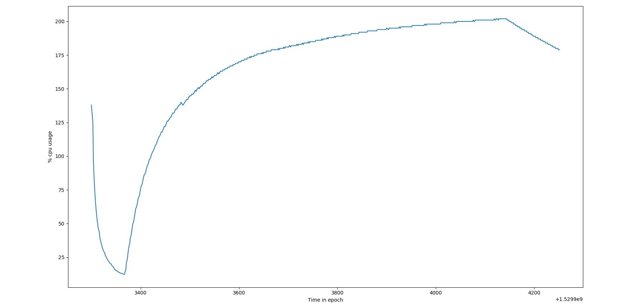

Figure 26 : Graph for Time in epoch vs %CPU usage for BLSTM model in machine 1
x-axis : Time in seconds
y-axis : %CPU usage measured using ps command
Inference of graph :
In the above graph, we can see that for a initial and small period os time the %CPU usage is decreasing exponentially and then after reaching a lowest point it has a logrithmic growth. The decreasing region of the graph depicts the idle REST api to which no requests where made, the API had just been started. The logarithmic growth region depicts the increase in %CPU usage due to concurrent clients.

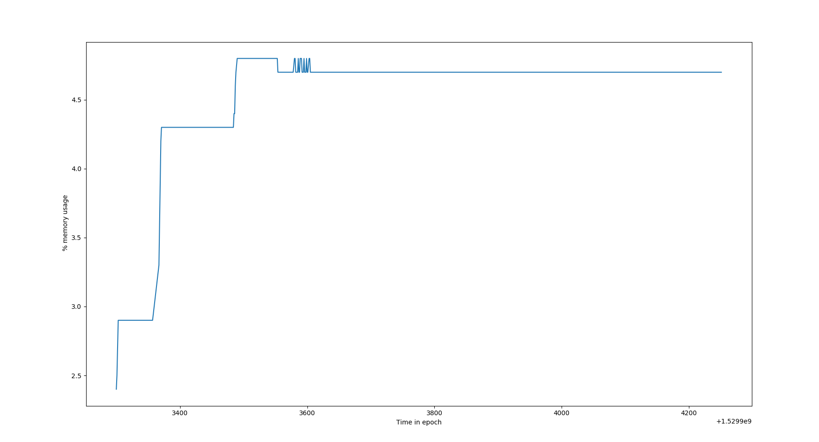

Figure 26 : Graph for Time in epoch vs %MEM usage for BLSTM model in machine 1

x-axis : Time in epoch
y-axis : %MEM usage measured using ps command
Inference of graph :
In the above graph, the starting increasing curve is due to the fact that it is the time of first few http requests reaching the server, thus from an idle server’s 2.96% memory the %memory used suddenly shoots up. After sometime, we can say that at anytime “n” concurrent clients are using the API, thus the memory percentage is constant. But as we can see in few places there is a flucuation in memory usage, this is due to the fact that as multiple concurrent clients might be requesting the api with same input batch, thus no new memory needs to be used, instead the cached result can be utilised and sometimes this is not the case.
5.1.4
S. no | No. of concurrent clients | No. of requests per client | Total response time (seconds) | Avg. response time for 1 client  (seconds) | Throughput (per second)
1 | 250 | 150 | System hanged
1 | 250 | 150 | System hanged
1 | 250 | 150 | System hanged
TABLE 33

5.2
This experiment was carried out with Machine 2
5.2.1
S. no | No. of concurrent clients | No. of requests per client | Total response time (seconds) | Avg. response time for 1 client (seconds) | Throughput (per second)
1 | 50 | 150 | 155.320 | 154.600 | 0.321
1 | 50 | 150 | 141.689 | 140.263 | 0.352
1 | 50 | 150 | 155.836 | 140.329 | 0.320
average total response time (seconds) : 99.291
average response time for one client (seconds) : 145.064
average Throughput (per second):0.331
TABLE 34

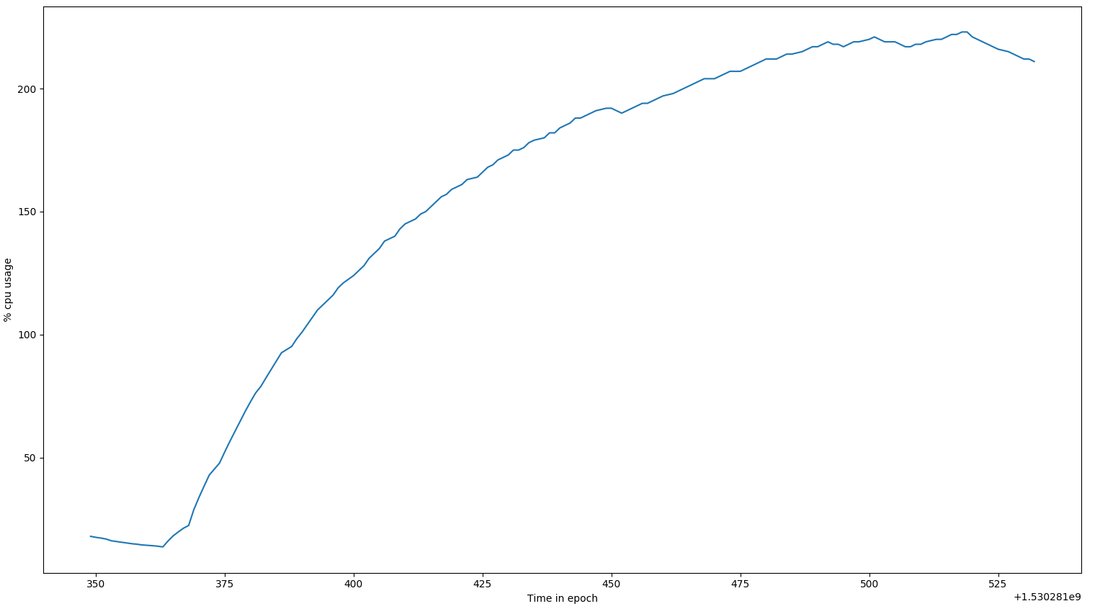

Figure 27 : Graph for Time in epoch vs %CPU usage for BLSTM model in machine 2
x-axis : Time in seconds
y-axis : %CPU usage measured using ps command
Inference of graph :
In the above graph, we can see that for a initial and small period os time the %CPU usage is decreasing exponentially and then after reaching a lowest point it has a logrithmic growth. The decreasing region of the graph depicts the idle REST api to which no requests where made, the API had just been started. The logarithmic growth region depicts the increase in %CPU usage due to concurrent clients.

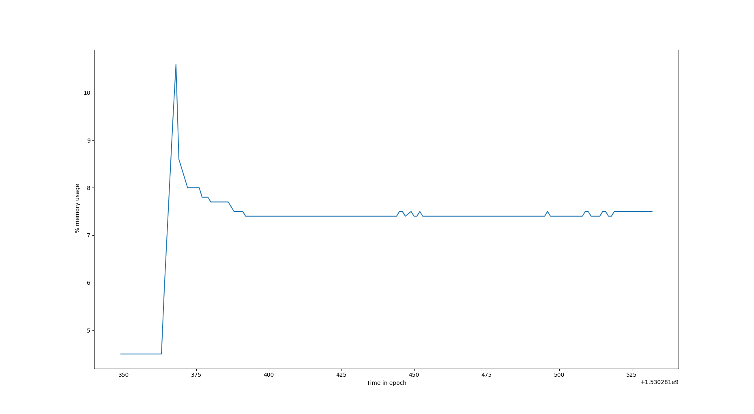
Figure 28 : Graph for Time in epoch vs %MEM usage for BLSTM model in machine 2
x-axis : Time in epoch
y-axis : %MEM usage measured using ps command
Inference of graph :
In the above graph, the starting increasing curve is due to the fact that it is the time of first few http requests reaching the server, thus from an idle server’s 2.96% memory the %memory used suddenly shoots up. After sometime, we can say that at anytime “n” concurrent clients are using the API, thus the memory percentage is constant. But as we can see in few places there is a drop in memory usage, this is due to the fact that as multiple concurrent clients might be requesting the api with same input batch, thus no new memory needs to be used, instead the cached result can be utilised.

S. no | No. of concurrent clients | No. of requests per client | Total response time (seconds) | Avg. response time for 1 client  (seconds) | Throughput (per second)
1 | 100 | 150 | 291.369 | 287.303 | 0.343
1 | 100 | 150 | 280.060 | 278.353 | 0.357
1 | 100 | 150 | 281.839 | 278.861 | 0.354
average total response time (seconds) : 284.422
average response time for one client (seconds) : 281.505
average Throughput (per second): 0.351
TABLE 35

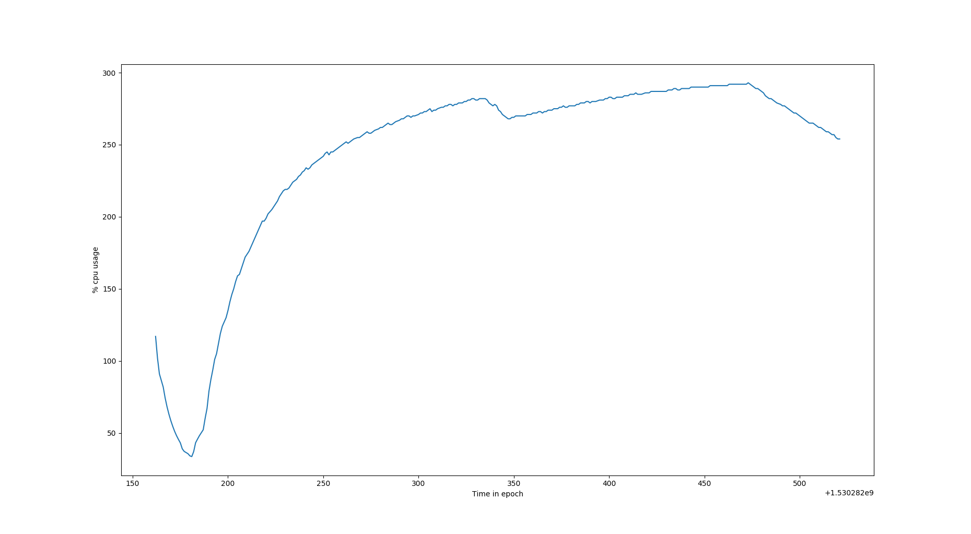
Figure 29 : Graph for Time in epoch vs %CPU usage for BLSTM model in machine 2
x-axis : Time in seconds
y-axis : %CPU usage measured using ps command
Inference of graph :
In the above graph, we can see that for a initial and small period os time the %CPU usage is decreasing exponentially and then after reaching a lowest point it has a logrithmic growth. The decreasing region of the graph depicts the idle REST api to which no requests where made, the API had just been started. The logarithmic growth region depicts the increase in %CPU usage due to concurrent clients.

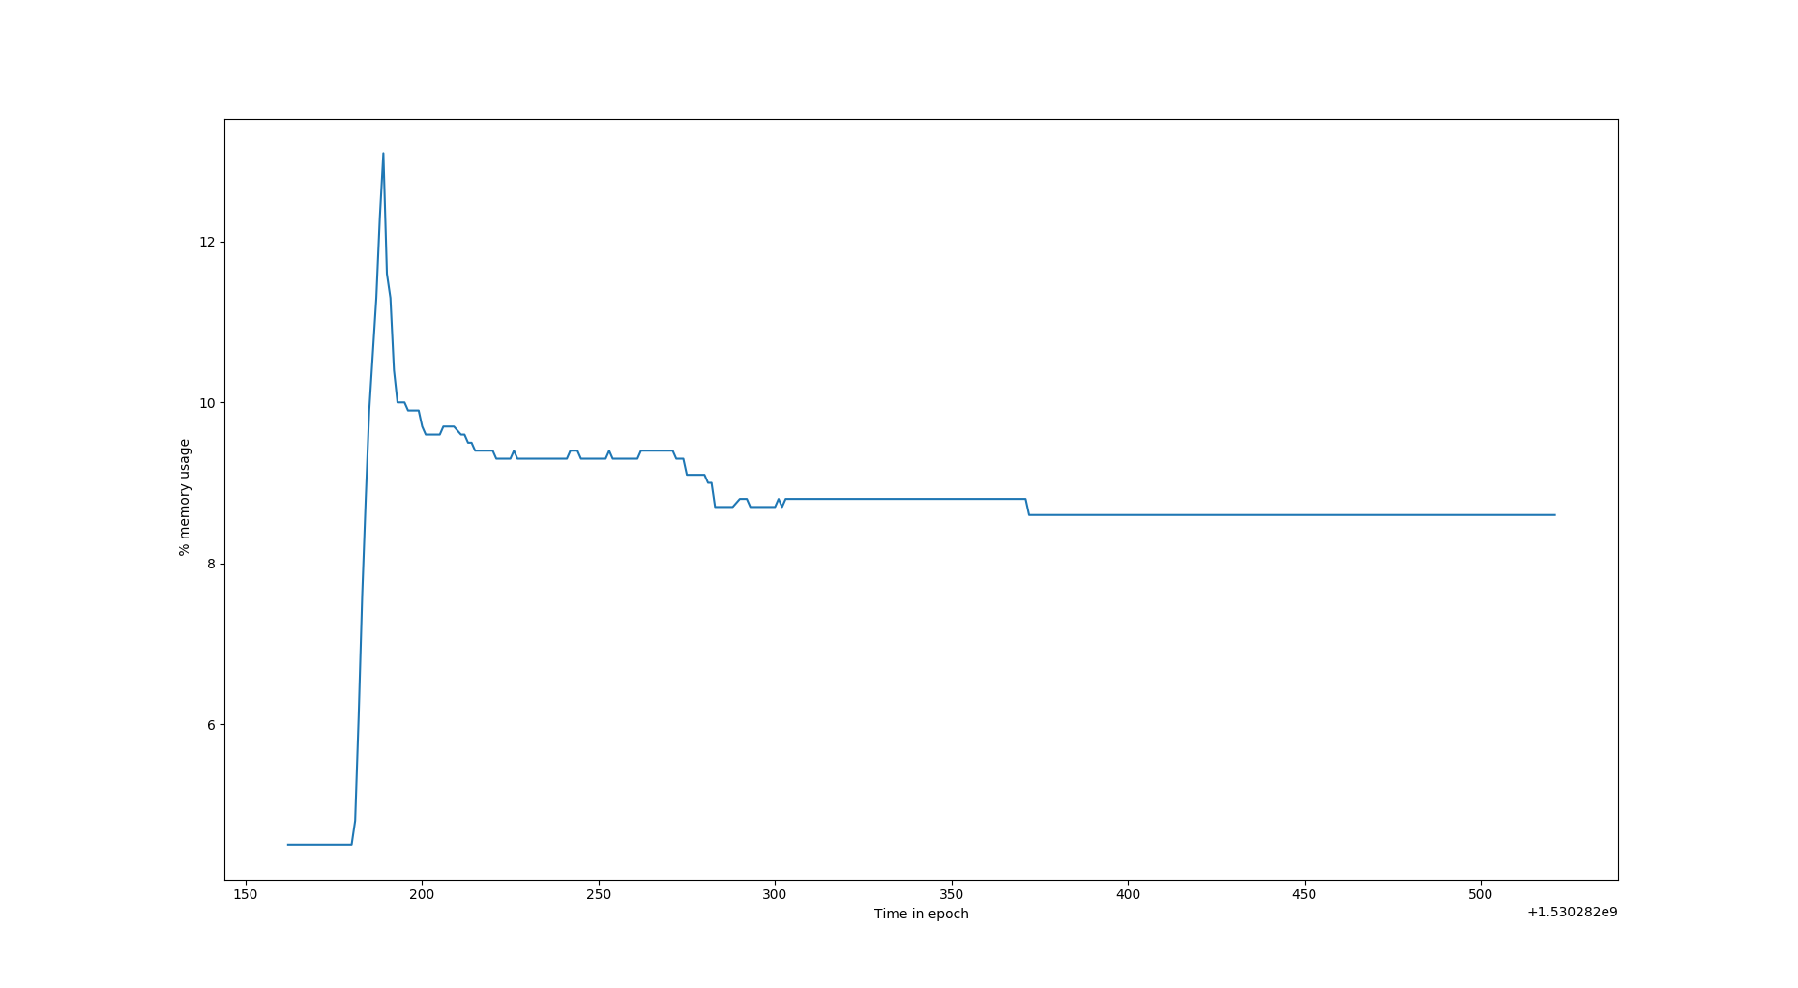
Figure 30 : Graph for Time in epoch vs %CPU usage for BLSTM model in machine 2
x-axis : Time in epoch
y-axis : %MEM usage measured using ps command
Inference of graph :
In the above graph, the starting increasing curve is due to the fact that it is the time of first few http requests reaching the server, thus from an idle server’s 2.96% memory the %memory used suddenly shoots up. After sometime, we can say that at anytime “n” concurrent clients are using the API, thus the memory percentage is constant. But as we can see in few places there is a drop in memory usage, this is due to the fact that as multiple concurrent clients might be requesting the api with same input batch, thus no new memory needs to be used, instead the cached result can be utilised.

S. no | No. of concurrent clients | No. of requests per client | Total response time (seconds) | Avg. response time for 1 client (seconds) | Throughput (per second)
1 | 150 | 150 | System Hanged
1 | 150 | 150 | System Hanged
TABLE 36

Result :
From the above experiments we can see that
[1] As the number of concurrent clients increases the overall response time also increases and most importantly we observe that the average response time for each request also increases in proportion to the total response time. This is due to the fact that, despite the individual clients are concurrent, the 150 requests inside each of the individual client is synchronous in nature. Due to this, when a client’s synchronous requests are disrupted by the requests from other concurrent clients, the disrupted client goes to waiting queue.
[2]We also noticed that, the %Cpu usage grows logrithmically with time and the %Memory usage for the program is usually constant and sometimes fluctuating due to caching of predicted values.
[3]We also observer from the above experiment, at any point of time the %CPU is high but the corresponding memory usage is low and constant. Thus we can infer that this process is I/O intensive process and thus has a larger waiting time which causes high %CPU usage and low %MEM usage.

USECASE 6

Objective :
To plot and study the performance of REST api with LSTM model with 3 layers (32 neurons, 64 neurons, 1 neuron respectively) in two different hardware configuration.

Input :
The fields contained in the .csv input file that is fed to the LSTM 32_64_1 model are as follows :

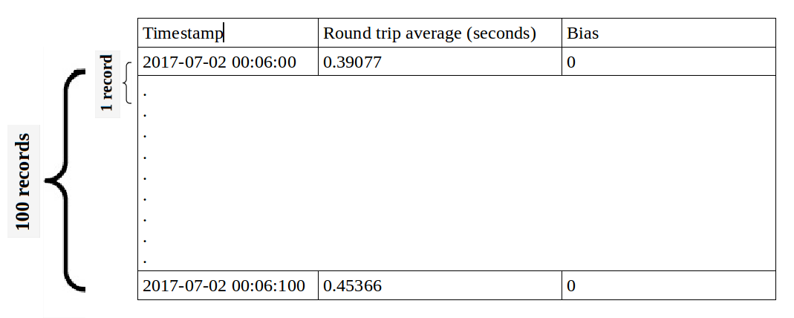
Figure 27 : snapshot of input dataset
Timestamp(string), Round trip average(float), bias(float)

Output :
The resource usage like %CPU, %MEM, cores used, response time are all stored for future reference in a logger file and also in .csv file for easy data retrieval.
Here are sample log files,

Figure 32 : snapshot of resource log

Figure 33 : snapshot of response time log.
Plotting of the Graphs are done a python script using matplotlib package by reading data from a CSV file.

Configurations of machines used for the experiment :
Features | Machine 1 | Machine2
RAM | 12 GB | 8GB
Proccessor Model | Intel(R) Core(TM) i7-6500U CPU @ 2.50GHz | Intel(R) Core(TM) i7-7700 CPU @ 3.60GHz
CPU(seconds) | 4 | 8
Threads per core | 2 | 2
Cores per Socket | 2 | 4
Socket | 1 | 1
CPU MHz | 600 MHz | 800MHz
CPU Min MHz | 400 MHz | 800 MHz
CPU Max MHz | 3100 MHz | 4200 MHz

Machine Learning model used :
LSTM with 3 layers (32 neurons – 64neurons – 1 neuron )
NOTE :
- For all the below experiments each individual client has 150 synchronous requests happening one after the other.
- For measuring the %CPU, %MEM usage 2 commands are commonly used – top, ps.
Top is an interactive way of monitoring resource usage.
PS command is mostly used for logging the resource usage.
Though the %MEM usage given by both the commands are the same, the %CPU read by both the commands are different, this is due to the difference in the defenition of the %CPU measured by each of these commands.
TOP : The %CPU in top command gives the average %CPU usage since the last sample was taken.
PS : The %CPU in PS gives the average %CPU since the time of start of program till the time at which the reading was taken.
6.1
The following experiments were carried out in Machine 1 configuration
6.1.1
S. no | No. of concurrent clients | No. of requests per client | Total response time (seconds) | Avg. response time for 1 client  (seconds) | Throughput (per second)
1 | 50 | 150 | 121.370 | 119.816 | 1.235
1 | 50 | 150 | 120.651 | 119.481 | 1.243
1 | 50 | 150 | 119.740 | 117.056 | 1.252
average total response time (seconds) : 120.587
average response time for one client (seconds) : 118.784
average Throughput (per second): 1.243
TABLE 37
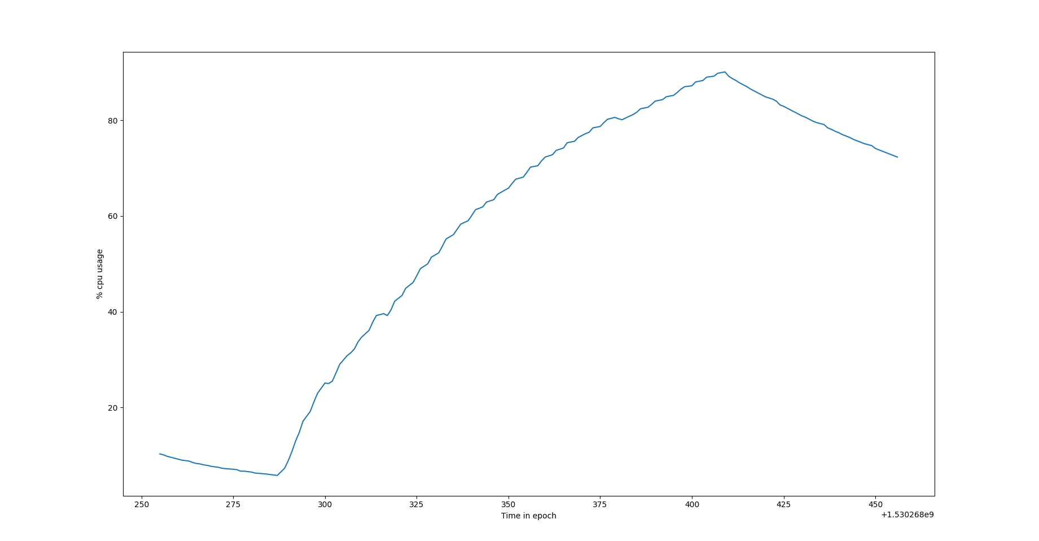

Figure 34 : Graph of time in epoch vs %CPU usage by LSTM 32_64_1 model in machine 1

x-axis : Time in seconds
y-axis : %CPU usage measured using ps command
Inference of graph :
In the above graph, we can see that for a initial and small period os time the %CPU usage is decreasing exponentially and then after reaching a lowest point it has a logrithmic growth. The decreasing region of the graph depicts the idle REST api to which no requests where made, the API had just been started. The logarithmic growth region depicts the increase in %CPU usage due to concurrent clients.
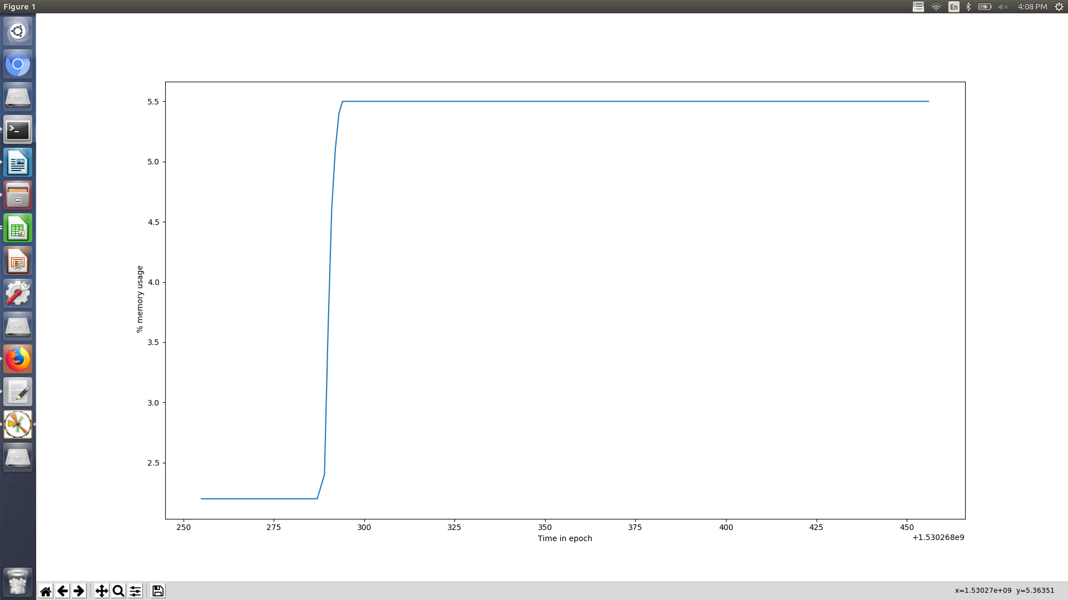

Figure 35 : Graph of time in epoch vs %MEMs usage by LSTM 32_64_1 model in machine 1
x-axis : Time in epoch
y-axis : %MEM usage measured using ps command
Inference of graph :
In the above graph, the starting increasing curve is due to the fact that it is the time of first few http requests reaching the server, thus from an idle server’s 2.96% memory the %memory used suddenly shoots up. After sometime, we can say that at anytime “n” concurrent clients are using the API, thus the memory percentage is constant.
6.1.2
S. no | No. of concurrent clients | No. of requests per client | Total response time (seconds) | Avg. response time for 1 client  (seconds) | Throughput (per second)
1 | 100 | 150 | 161.763 | 154.830 | 0.618
1 | 100 | 150 | 159.361 | 154.733 | 0.627
1 | 100 | 150 | 161.946 | 153.597 | 0.617
average total response time (seconds) : 161.023
average response time for one client (seconds) :154.3866
average Throughput (per second): 0.620

TABLE 38
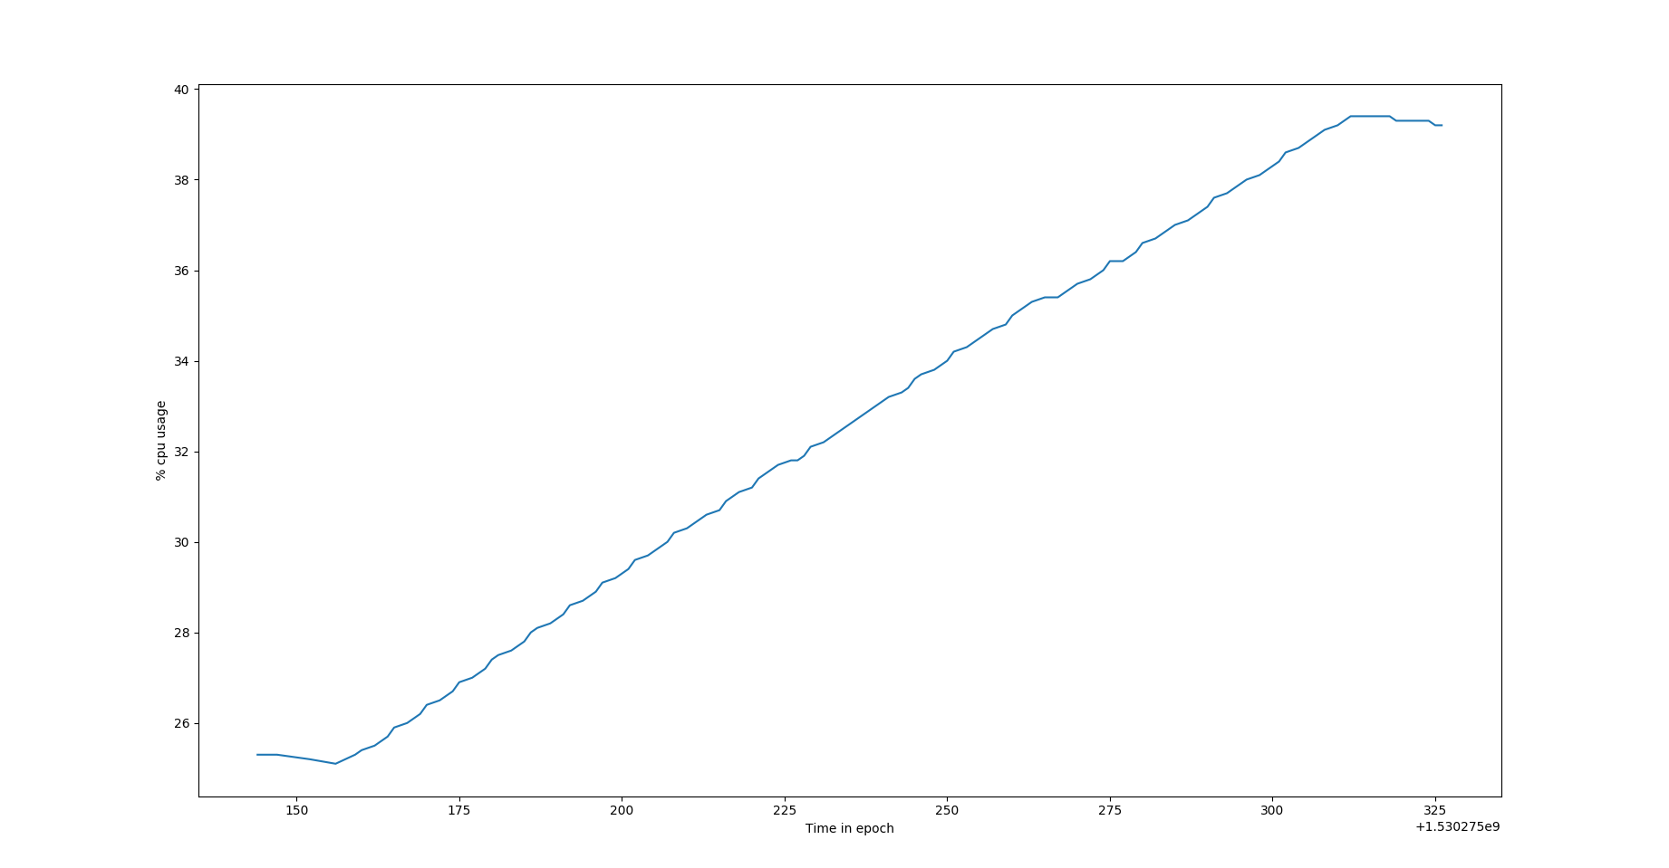

Figure 35 : Graph of time in epoch vs %CPU usage by LSTM 32_64_1 model in machine 1

Figure 36 : Graph of time in epoch vs %MEM usage by LSTM 32_64_1 model in machine 1
x-axis : Time in epoch
y-axis : %MEM usage measured using ps command
Inference of graph :
In the above graph, the starting increasing curve is due to the fact that it is the time of first few http requests reaching the server, thus from an idle server’s 2.96% memory the %memory used suddenly shoots up. After sometime, we can say that at anytime “n” concurrent clients are using the API, thus the memory percentage is constant.
6.1.3
S. no | No. of concurrent clients | No. of requests per client | Total response time (seconds) | Avg. response time for 1 client  (seconds) | Throughput (per second)
1 | 150 | 150 | 243.819 | 238.862 | 0.615
1 | 150 | 150 | 236.380 | 232.286 | 0.634
1 | 150 | 150 | 241.836 | 237.942 | 0.620
average total response time (seconds) : 240.678
average response time for one client (seconds) : 238.555
average Throughput (per second): 0.623
TABLE 39

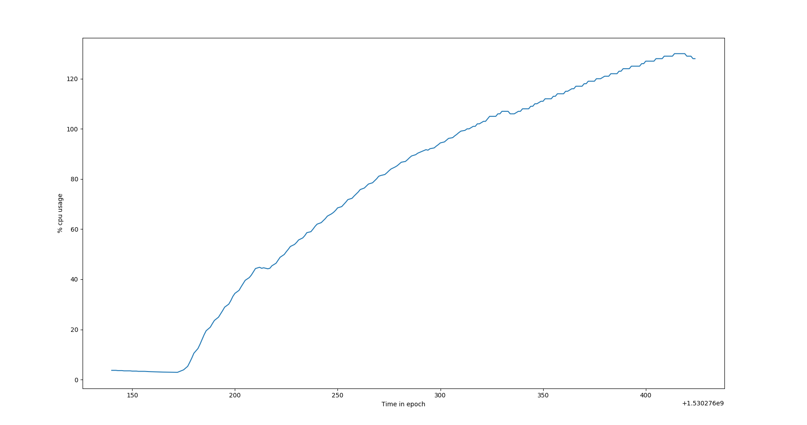

Figure 37 : Graph of time in epoch vs %CPU usage by LSTM 32_64_1 model in machine 1
x-axis : Time in seconds
y-axis : %CPU usage measured using ps command
Inference of graph :
In the above graph, we can see that for a initial and small period os time the %CPU usage is decreasing exponentially and then after reaching a lowest point it has a logrithmic growth. The decreasing region of the graph depicts the idle REST api to which no requests where made, the API had just been started. The logarithmic growth region depicts the increase in %CPU usage due to concurrent clients.

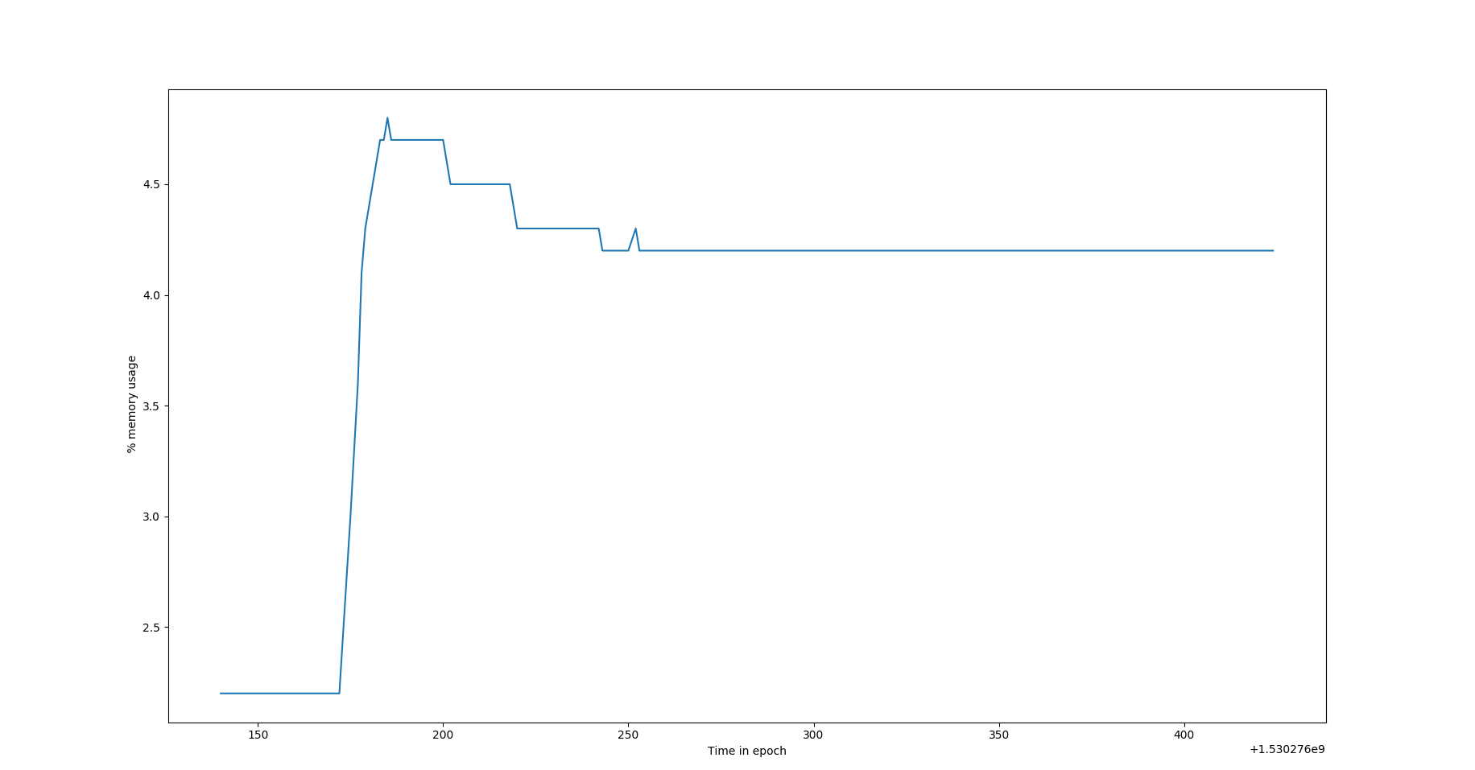

Figure 38 : Graph of time in epoch vs %MEM usage by LSTM 32_64_1 model in machine 1
x-axis : Time in epoch
y-axis : %MEM usage measured using ps command
Inference of graph :
In the above graph, the starting increasing curve is due to the fact that it is the time of first few http requests reaching the server, thus from an idle server’s 2.96% memory the %memory used suddenly shoots up. After sometime, we can say that at anytime “n” concurrent clients are using the API, thus the memory percentage is constant. But as we can see in few places there is a drop in memory usage, this is due to the fact that as multiple concurrent clients might be requesting the api with same input batch, thus no new memory needs to be used, instead the cached result can be utilised.
6.2
The following experiments were carried out in Machine 2 configuration
6.2.1
S. no | No. of concurrent clients | No. of requests per client | Total response time (seconds) | Avg. response time for 1 client  (seconds) | Throughput (per second)
1 | 50 | 150 | 47.799 | 47.433 | 1.046
1 | 50 | 150 | 47.275 | 46.809 | 1.057
1 | 50 | 150 | 49.229 | 48.627 | 1.015
average total response time (seconds) : 48.275
average response time for one client (seconds) :47.623
average Throughput (per second): 1.053
TABLE 40

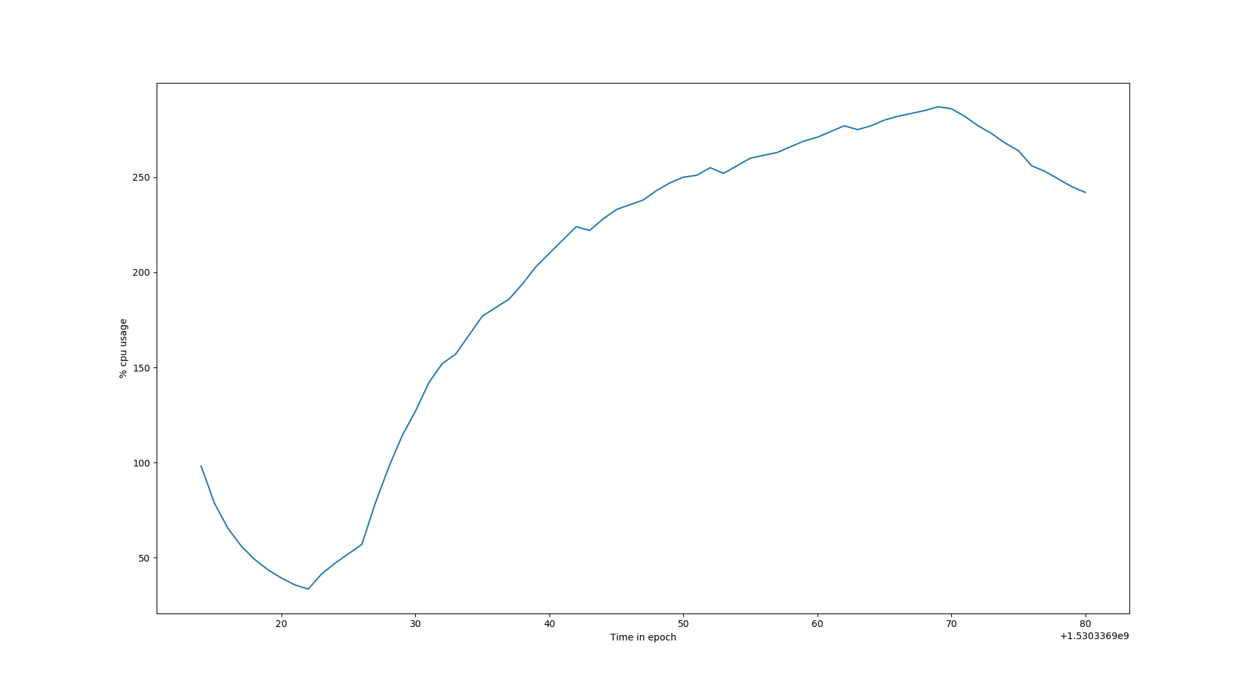
Figure 39 : Graph of time in epoch vs %CPU usage by LSTM 32_64_1 model in machine 2
x-axis : Time in seconds
y-axis : %CPU usage measured using ps command
Inference of graph :
In the above graph, we can see that for a initial and small period os time the %CPU usage is decreasing exponentially and then after reaching a lowest point it has a logrithmic growth. The decreasing region of the graph depicts the idle REST api to which no requests where made, the API had just been started. The logarithmic growth region depicts the increase in %CPU usage due to concurrent clients.

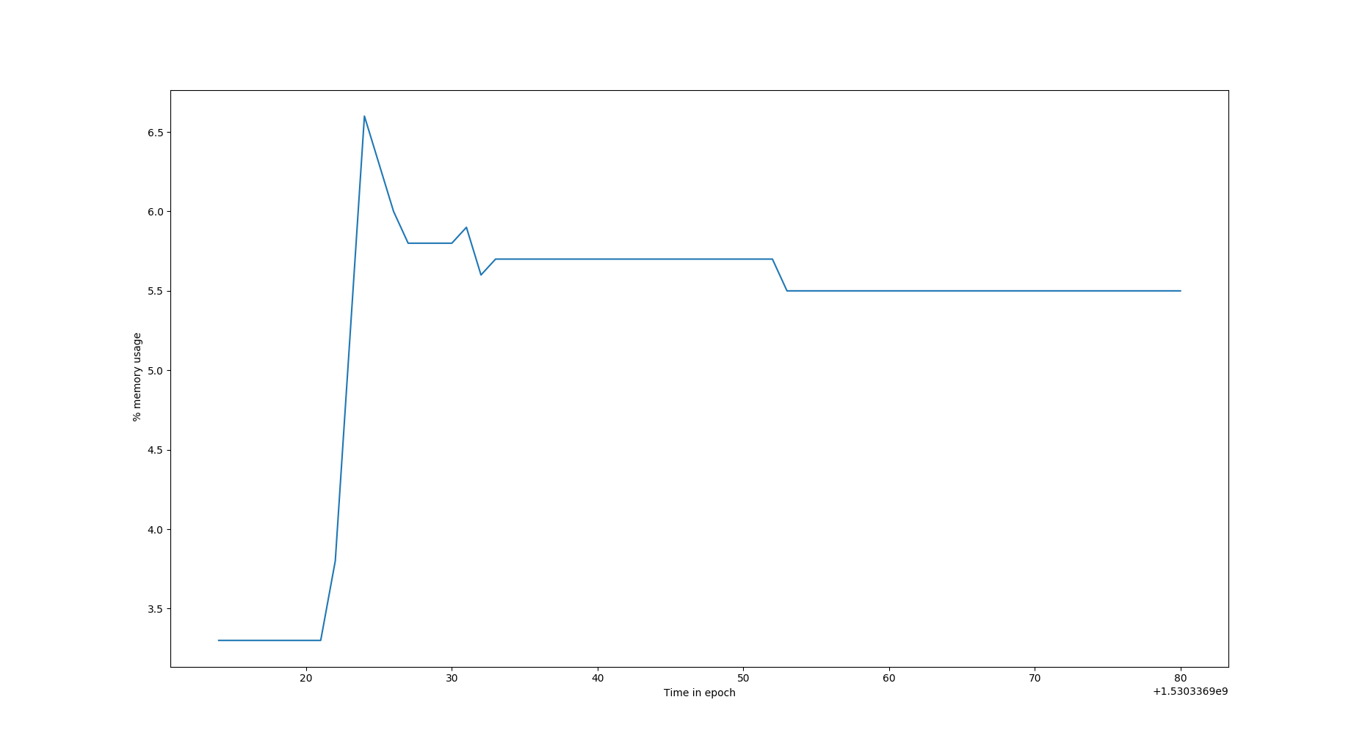
Figure 40 : Graph of time in epoch vs %MEM usage by LSTM 32_64_1 model in machine 2
x-axis : Time in epoch
y-axis : %MEM usage measured using ps command
Inference of graph :
In the above graph, the starting increasing curve is due to the fact that it is the time of first few http requests reaching the server, thus from an idle server’s 2.96% memory the %memory used suddenly shoots up. After sometime, we can say that at anytime “n” concurrent clients are using the API, thus the memory percentage is constant. But as we can see in few places there is a drop in memory usage, this is due to the fact that as multiple concurrent clients might be requesting the api with same input batch, thus no new memory needs to be used, instead the cached result can be utilised.
6.2.2
S. no | No. of concurrent clients | No. of requests per client | Total response time (seconds) | Avg. response time for 1 client  (seconds) | Throughput (per second)
1 | 100 | 150 | 91.670 | 84.629 | 1.090
1 | 100 | 150 | 90.609 | 88.008 | 1.103
1 | 100 | 150 | 91.491 | 87.937 | 1.093
average total response time (seconds) : 91.256
average response time for one client (seconds) : 86.858
average Throughput (per second): 1.095
TABLE 41

Figure 41 : Graph of time in epoch vs %CPU usage by LSTM 32_64_1 model in machine 2
x-axis : Time in seconds
y-axis : %CPU usage measured using ps command
Inference of graph :
In the above graph, we can see that for a initial and small period os time the %CPU usage is decreasing exponentially and then after reaching a lowest point it has a logrithmic growth. The decreasing region of the graph depicts the idle REST api to which no requests where made, the API had just been started. The logarithmic growth region depicts the increase in %CPU usage due to concurrent clients.

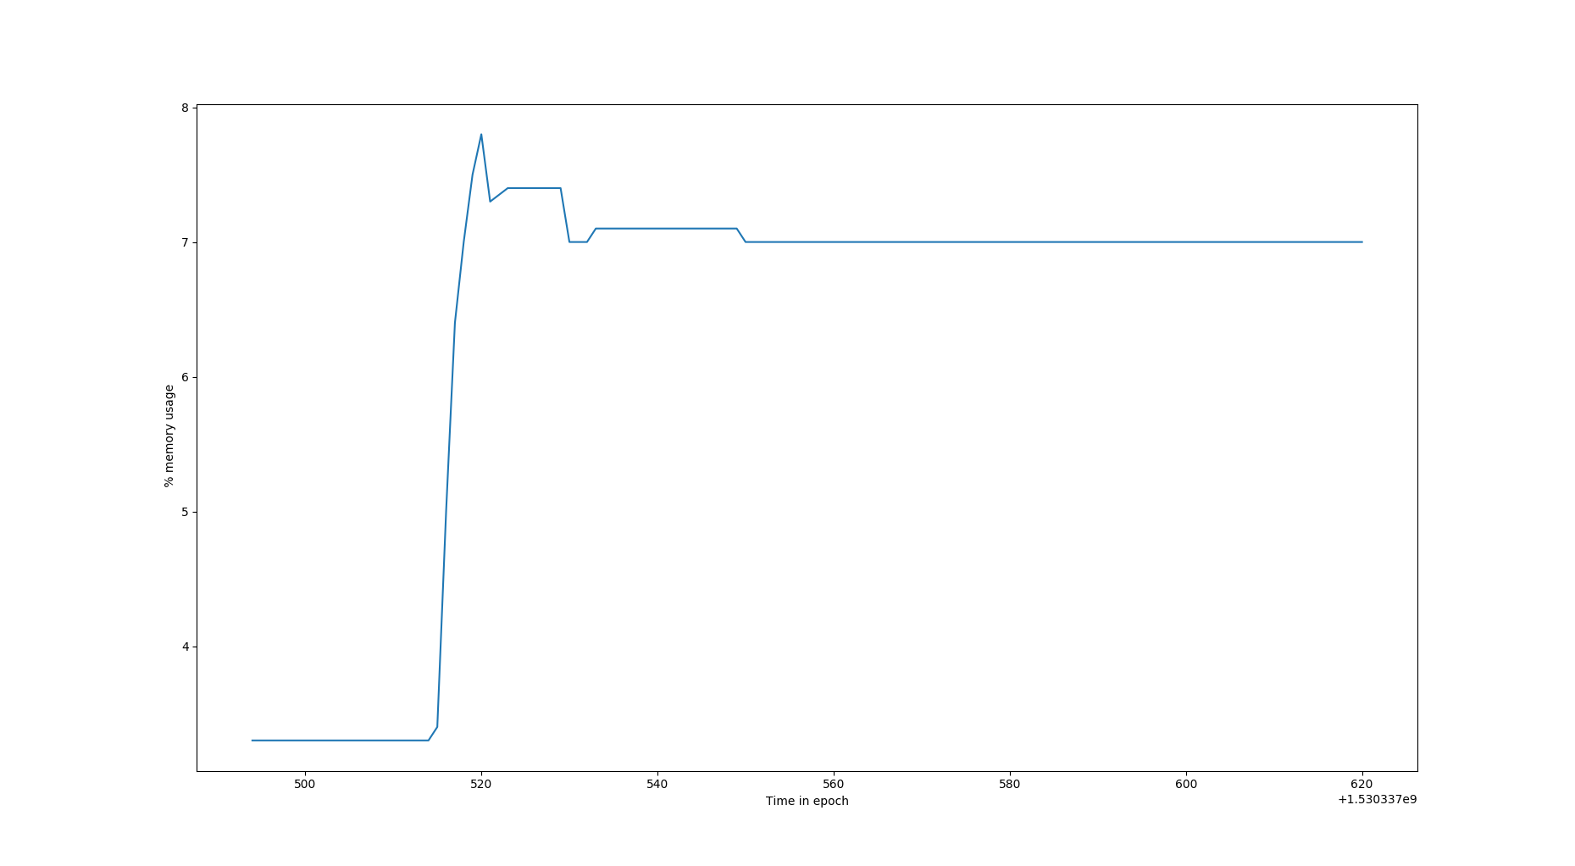
Figure 42 : Graph of time in epoch vs %MEM usage by LSTM 32_64_1 model in machine 2
x-axis : Time in epoch
y-axis : %MEM usage measured using ps command
Inference of graph :
In the above graph, the starting increasing curve is due to the fact that it is the time of first few http requests reaching the server, thus from an idle server’s 2.96% memory the %memory used suddenly shoots up. After sometime, we can say that at anytime “n” concurrent clients are using the API, thus the memory percentage is constant. But as we can see in few places there is a drop in memory usage, this is due to the fact that as multiple concurrent clients might be requesting the api with same input batch, thus no new memory needs to be used, instead the cached result can be utilised.

6.2.3
S. no | No. of concurrent clients | No. of requests per client | Total response time (seconds) | Avg. response time for 1 client  (seconds) | Throughput (per second)
1 | 150 | 150 | 153.369 | 141.892 | 0.978
1 | 150 | 150 | 151.856 | 138.214 | 0.987
1 | 150 | 150 | 139.130 | 135.171 | 1.071
average total response time (seconds) : 148.118
average response time for one client (seconds) : 138.425
average Throughput (per second): 1.011
TABLE 42
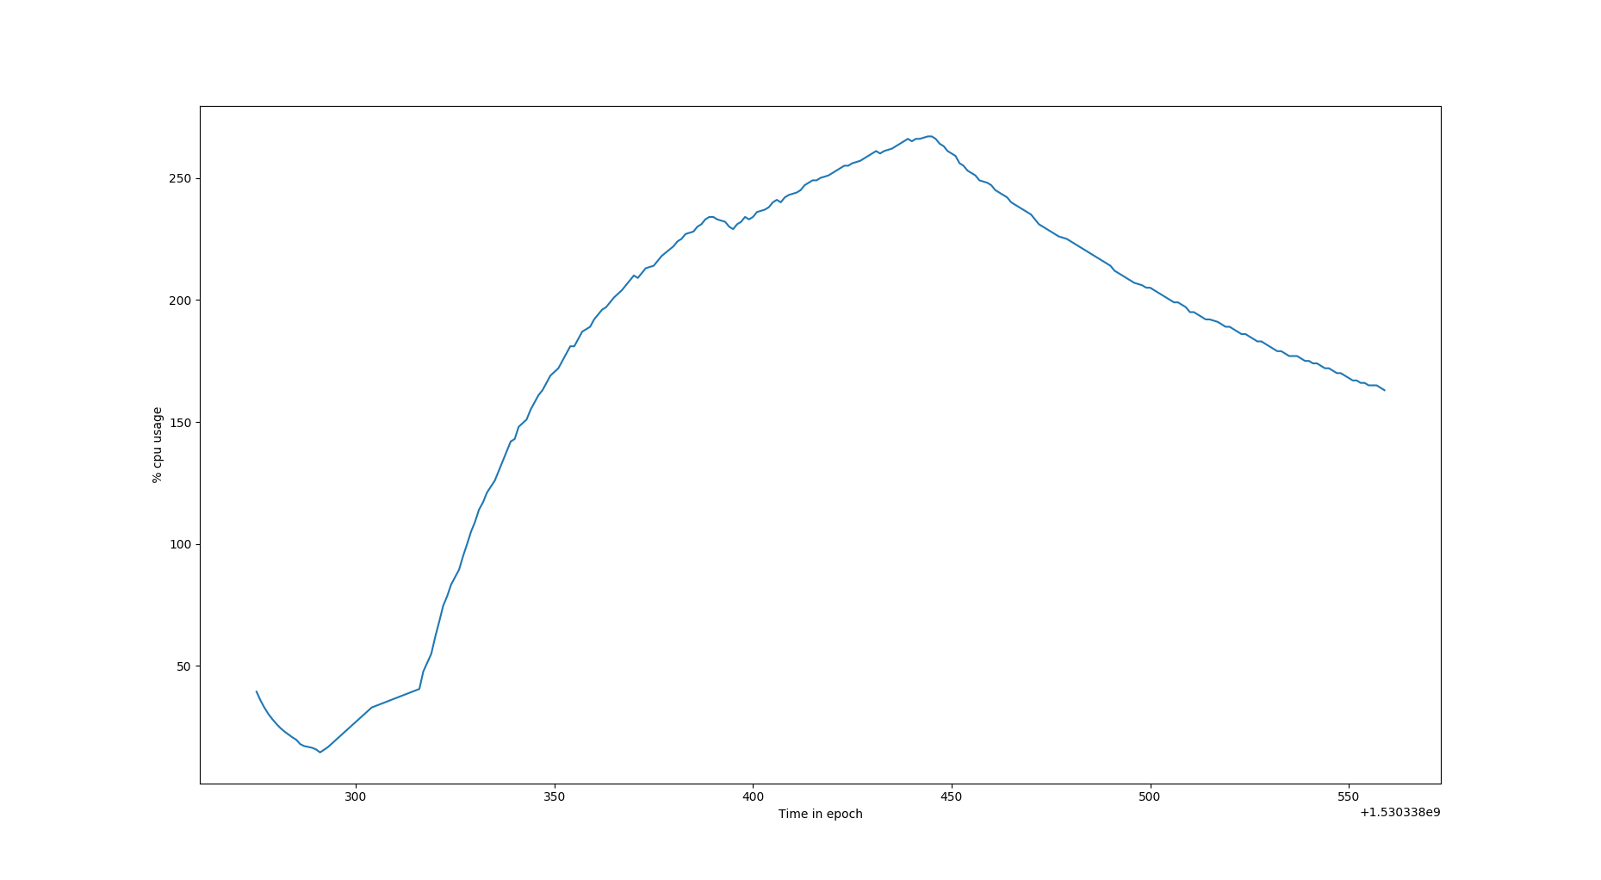

Figure 43 : Graph of time in epoch vs %CPU usage by LSTM 32_64_1 model in machine 2
x-axis : Time in seconds
y-axis : %CPU usage measured using ps command
Inference of graph :
In the above graph, we can see that for a initial and small period os time the %CPU usage is decreasing exponentially and then after reaching a lowest point it has a logrithmic growth. The decreasing region of the graph depicts the idle REST api to which no requests where made, the API had just been started. The logarithmic growth region depicts the increase in %CPU usage due to concurrent clients.

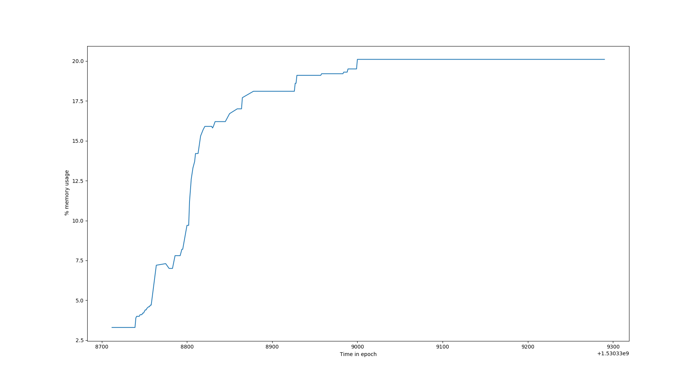
Figure 43 : Graph of time in epoch vs %CPU usage by LSTM 32_64_1 model in machine 2
x-axis : Time in epoch
y-axis : %MEM usage measured using ps command
Inference of graph :
In the above graph, the starting increasing curve is due to the fact that it is the time of first few http requests reaching the server, thus from an idle server’s 2.96% memory the %memory used suddenly shoots up. After sometime, we can say that at anytime “n” concurrent clients are using the API, thus the memory percentage is constant.

6.2.4
S. no | No. of concurrent clients | No. of requests per client | Total response time (seconds) | Avg. response time for 1 client  (seconds) | Throughput (per second)
1 | 200 | 150 | System hanged
1 | 200 | 150
1 | 200 | 150
TABLE 43

Result :
From the above experiments we can see that
[1] As the number of concurrent clients increases the overall response time also increases and most importantly we observe that the average response time for each request also increases in proportion to the total response time. This is due to the fact that, despite the individual clients are concurrent, the 150 requests inside each of the individual client is synchronous in nature. Due to this, when a client’s synchronous requests are disrupted by the requests from other concurrent clients, the disrupted client goes to waiting queue.
[2]We also noticed that, the %Cpu usage grows logrithmically with time and the %Memory usage for the program is usually constant and sometimes fluctuating due to caching of predicted values.
[3]We also observer from the above experiment, at any point of time the %CPU is high but the corresponding memory usage is low and constant. Thus we can infer that this process is I/O intensive process and thus has a larger waiting time which causes high %CPU usage and low %MEM usage.

USECASE 7

Objective :
To plot and study the performance of REST api with LSTM model with 3 layers (32 neurons, 64 neurons, 1 neuron respectively) in two different hardware configuration.

Input :
The fields contained in the .csv input file that is fed to the LSTM 32_64_1 model are as follows :
Timestamp(string), Round trip average(float), bias(float)

Figure 44 : Sanpshot of input dataset

Output :
The resource usage like %CPU, %MEM, cores used, response time are all stored for future reference in a logger file and also in .csv file for easy data retrieval.
Here are sample log files,

Figure 45 : Sanpshot of resource log

Figure 46 : Sanpshot of response time log
Plotting of the Graphs are done a python script using matplotlib package by reading data from a CSV file.

Configurations of machines used for the experiment :
Features | Machine 1 | Machine2
RAM | 12 GB | 8 GB
Proccessor Model | Intel(R) Core(TM) i7-6500U CPU @ 2.50GHz | Intel(R) Core(TM) i7-7700 CPU @ 3.60GHz
CPU(seconds) | 4 | 8
Threads per core | 2 | 2
Cores per Socket | 2 | 4
Socket | 1 | 1
CPU MHz | 600 MHz | 800MHz
CPU Min MHz | 400 MHz | 800 MHz
CPU Max MHz | 3100 MHz | 4200 MHz

Machine Learning model used :
LSTM_32_64 _32 ie. LSTM with 3 layers of 32 neurons, 64 neurons, 32 neurons respectively.
NOTE :
For all the below experiments each individual client has 150 synchronous requests happening one after the other.
For measuring the %CPU, %MEM usage 2 commands are commonly used – top, ps.
Top is an interactive way of monitoring resource usage.
PS command is mostly used for logging the resource usage.
Though the %MEM usage given by both the commands are the same, the %CPU read by both the commands are different, this is due to the difference in the defenition of the %CPU measured by each of these commands.
TOP : The %CPU in top command gives the average %CPU usage since the last sample was taken.
PS : The %CPU in PS gives the average %CPU since the time of start of program till the time at which the reading was taken.
7.1
For the following experiments Machine 1 configuration is used.
7.1.1
S. no | No. of concurrent clients | No. of requests per client | Total response time (seconds) | Avg. response time for 1 client  (seconds) | Throughput (per second)
1 | 50 | 150 | 141.039 | 138.719 | 0.354
1 | 50 | 150 | 95.329 | 93.806 | 0.524
1 | 50 | 150 | 139.086 | 137.958 | 0.359
average total response time (seconds) : 125.151
average response time for one client (seconds) : 123.494
average Throughput (per second): 0.412
TABLE 44

Figure 47 : Graph for Time in epoch vs %MEM for LSTM 32-64-32 model in machine 1
x-axis : Time in epoch
y-axis : %MEM usage measured using ps command
Inference of graph :
In the above graph, the starting increasing curve is due to the fact that it is the time of first few http requests reaching the server, thus from an idle server’s 2.96% memory the %memory used suddenly shoots up. After sometime, we can say that at anytime “n” concurrent clients are using the API, thus the memory percentage is constant.

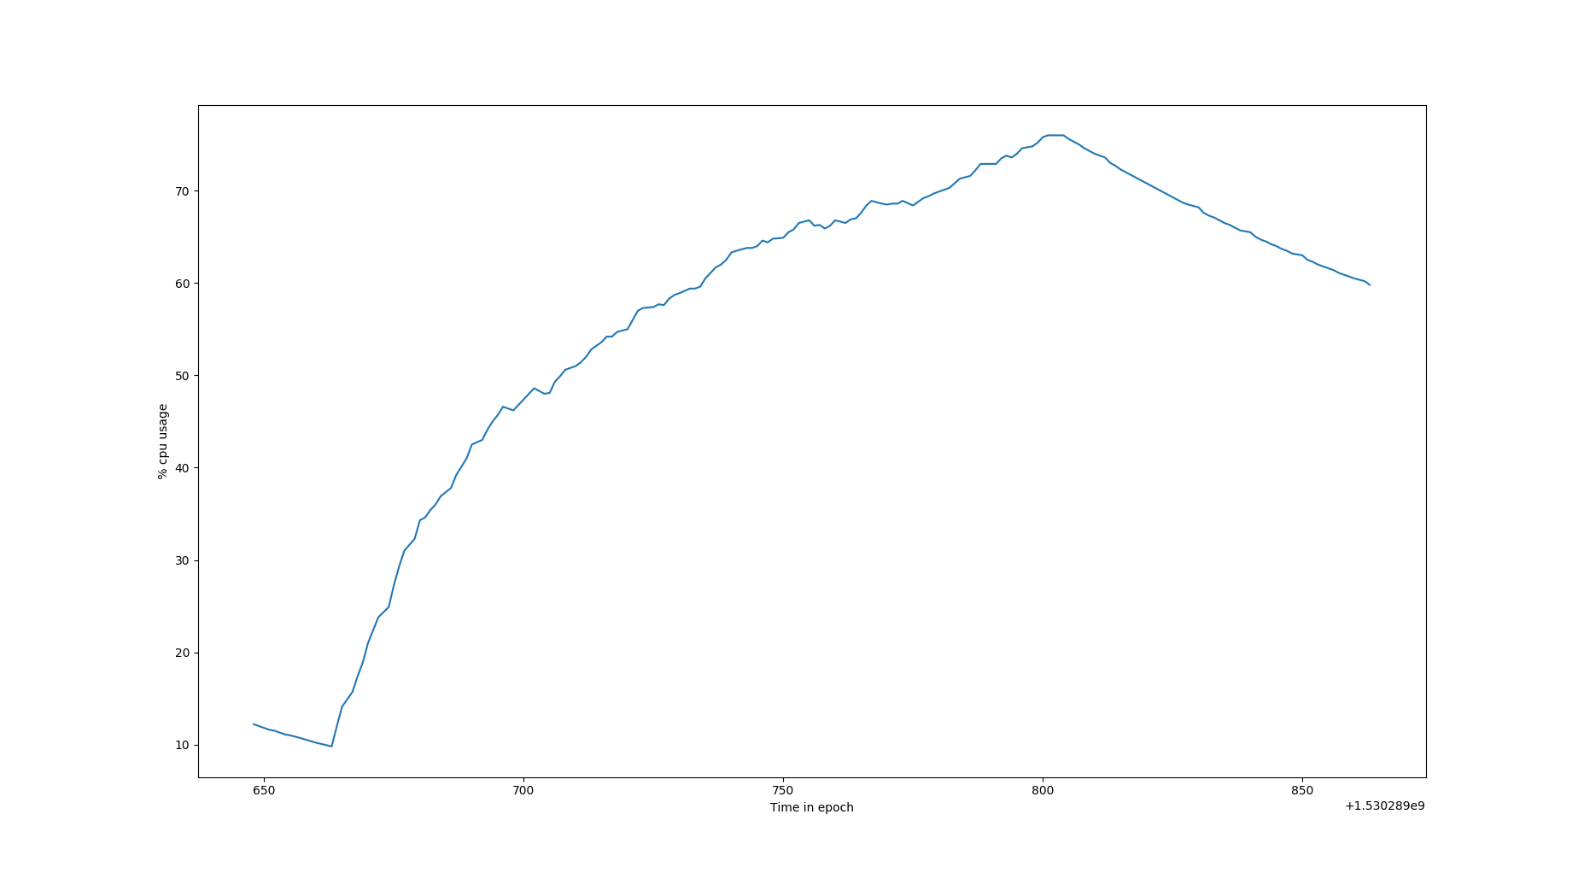
Figure 48 : Graph for Time in epoch vs %CPU for LSTM 32-64-32 model in machine 1
x-axis : Time in seconds
y-axis : %CPU usage measured using ps command
Inference of graph :
In the above graph, we can see that for a initial and small period os time the %CPU usage is decreasing exponentially and then after reaching a lowest point it has a logrithmic growth. The decreasing region of the graph depicts the idle REST api to which no requests where made, the API had just been started. The logarithmic growth region depicts the increase in %CPU usage due to concurrent clients.

7.1.2
S. no | No. of concurrent clients | No. of requests per client | Total response time (seconds) | Avg. response time for 1 client  (seconds) | Throughput (per second)
1 | 100 | 150 | 237.569 | 209.377 | 0.420
1 | 100 | 150 | 250.440 | 224.742 | 0.399
1 | 100 | 150 |  | 210.115 | 0.449
average total response time (seconds) : 236.849
average response time for one client (seconds) : 214.744
average Throughput (per second): 0.422
TABLE 45

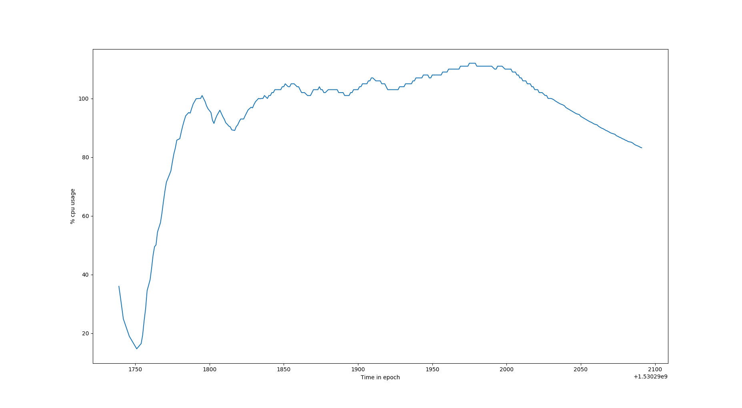
Figure 48 : Graph for Time in epoch vs %CPU for LSTM 32-64-32 model in machine 1
x-axis : Time in seconds
y-axis : %CPU usage measured using ps command
Inference of graph :
In the above graph, we can see that for a initial and small period os time the %CPU usage is decreasing exponentially and then after reaching a lowest point it has a logrithmic growth. The decreasing region of the graph depicts the idle REST api to which no requests where made, the API had just been started. The logarithmic growth region depicts the increase in %CPU usage due to concurrent clients.

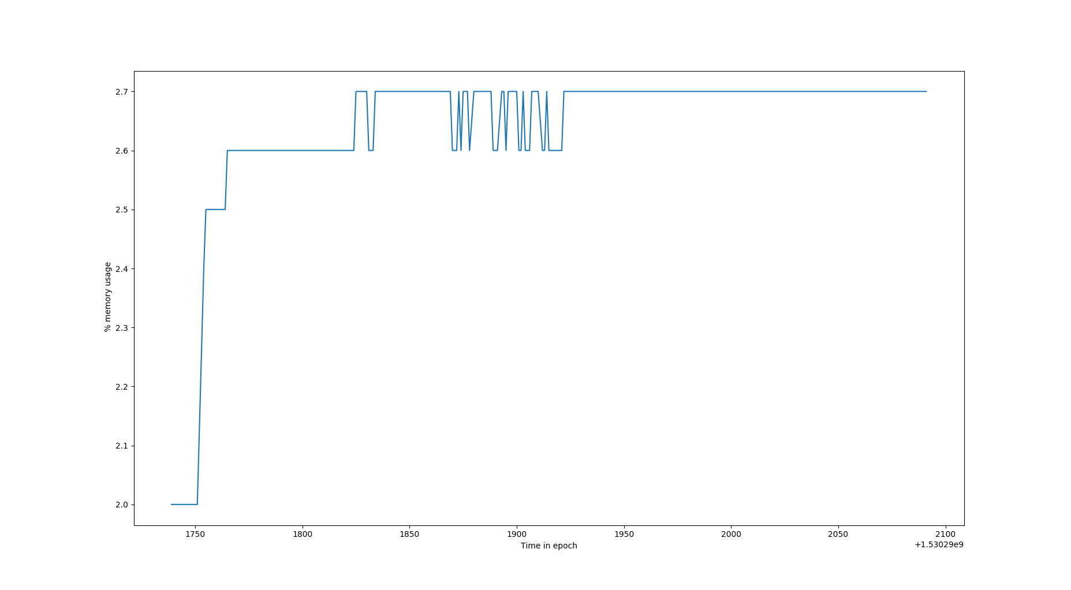
Figure 48 : Graph for Time in epoch vs %MEM for LSTM 32-64-32 model in machine 1
x-axis : Time in epoch
y-axis : %MEM usage measured using ps command
Inference of graph :
In the above graph, the starting increasing curve is due to the fact that it is the time of first few http requests reaching the server, thus from an idle server’s 2.96% memory the %memory used suddenly shoots up. After sometime, we can say that at anytime “n” concurrent clients are using the API, thus the memory percentage is constant. But as we can see in few places there is a fluctuation in memory usage, this is due to the fact that as multiple concurrent clients might be requesting the api with same input batch, thus no new memory needs to be used, instead the cached result can be utilised and sometimes this is not the case.
7.1.3
S. no | No. of concurrent clients | No. of requests per client | Total response time (seconds) | Avg. response time for 1 client (seconds) | Throughput (per second)
1 | 150 | 150 | 276.269 | 266.561 | 0.542
1 | 150 | 150 | 232.220 | 226.339 | 0.645
1 | 150 | 150 | 309.009 | 288.857 | 0.485
average total response time (seconds) : 246.903
average response time for one client (seconds) :260.585
average Throughput (per second): 0.557
TABLE 46

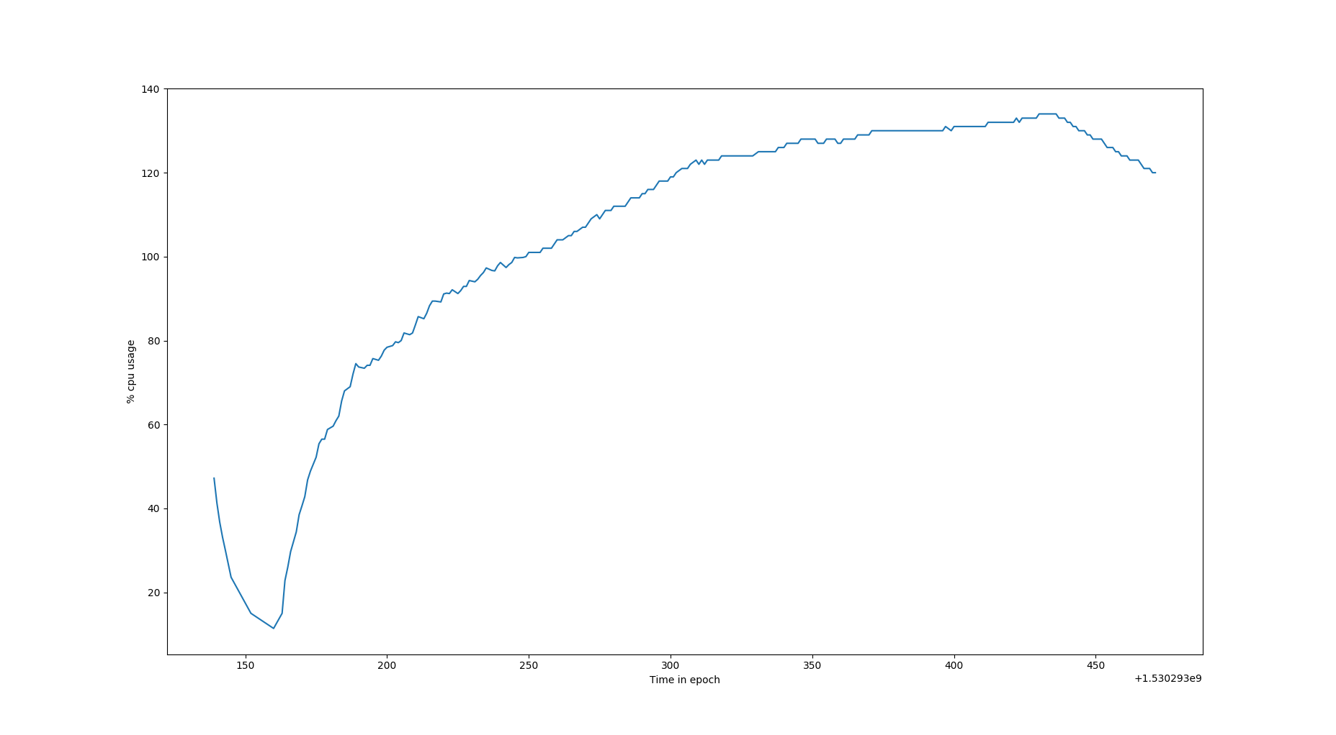
Figure 49 : Graph for Time in epoch vs %CPU for LSTM 32-64-32 model in machine 1
x-axis : Time in seconds
y-axis : %CPU usage measured using ps command
Inference of graph :
In the above graph, we can see that for a initial and small period os time the %CPU usage is decreasing exponentially and then after reaching a lowest point it has a logrithmic growth. The decreasing region of the graph depicts the idle REST api to which no requests where made, the API had just been started. The logarithmic growth region depicts the increase in %CPU usage due to concurrent clients.

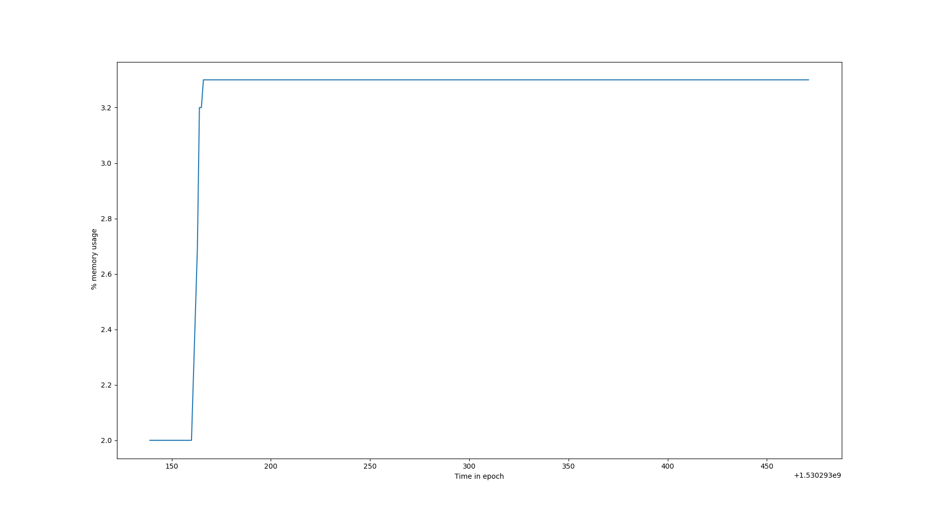
Figure 50: Graph for Time in epoch vs %MEM for LSTM 32-64-32 model in machine 1
x-axis : Time in epoch
y-axis : %MEM usage measured using ps command
Inference of graph :
In the above graph, the starting increasing curve is due to the fact that it is the time of first few http requests reaching the server, thus from an idle server’s 2.96% memory the %memory used suddenly shoots up. After sometime, we can say that at anytime “n” concurrent clients are using the API, thus the memory percentage is constant.

7.2
These experiments were carried out in Machine 2 configuration
7.2.1
S. no | No. of concurrent clients | No. of requests per client | Total response time (seconds) | Avg. response time for 1 client  (seconds) | Throughput (per second)
1 | 50 | 150 | 41.589 | 40.518 | 1.202
1 | 50 | 150 | 47.029 | 46.356 | 1.063
1 | 50 | 150 | 43.928 | 45.937 | 1.065
average total response time (seconds) : 45.181
average response time for one client (seconds) : 44.270
average Throughput (per second): 1.156
TABLE 47

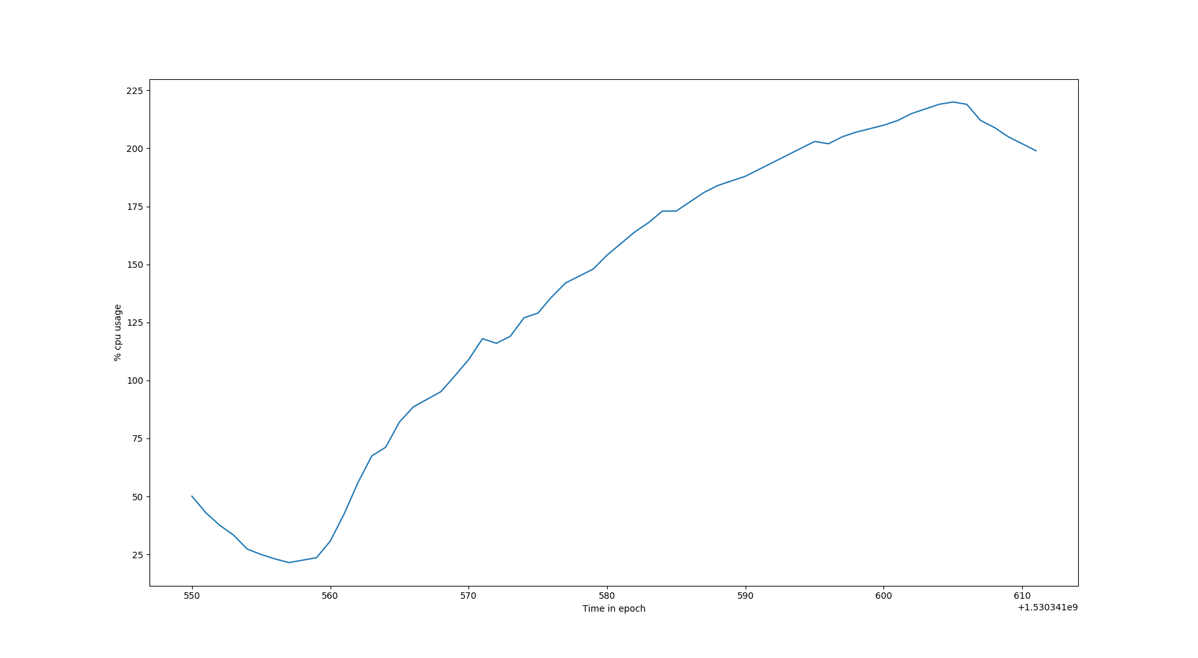
Figure 51 : Graph for Time in epoch vs %CPU for LSTM 32-64-32 model in machine 2
x-axis : Time in seconds
y-axis : %CPU usage measured using ps command
Inference of graph :
In the above graph, we can see that for a initial and small period os time the %CPU usage is decreasing exponentially and then after reaching a lowest point it has a logrithmic growth. The decreasing region of the graph depicts the idle REST api to which no requests where made, the API had just been started. The logarithmic growth region depicts the increase in %CPU usage due to concurrent clients.

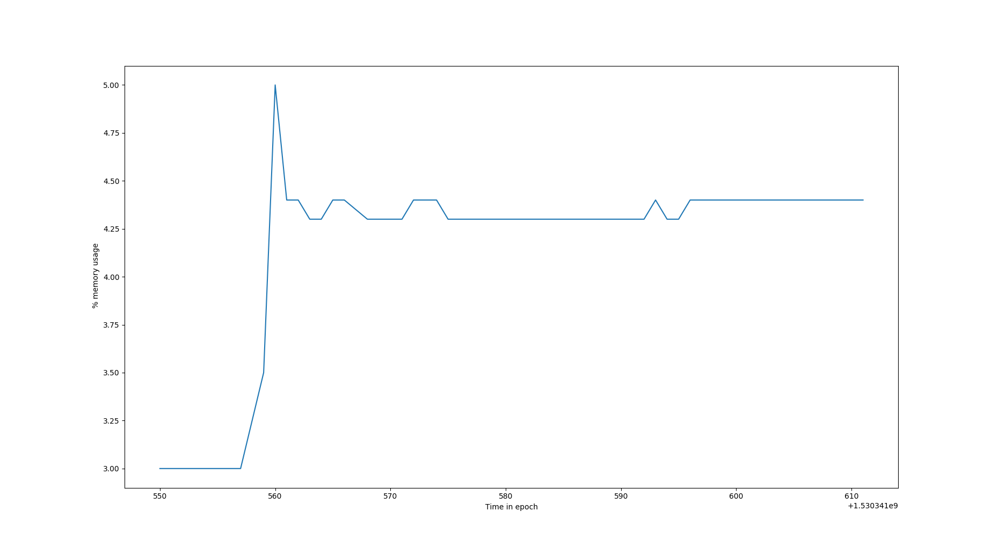
Figure 51 : Graph for Time in epoch vs %MEM for LSTM 32-64-32 model in machine 2
x-axis : Time in epoch
y-axis : %MEM usage measured using ps command
Inference of graph :
In the above graph, the starting increasing curve is due to the fact that it is the time of first few http requests reaching the server, thus from an idle server’s 2.96% memory the %memory used suddenly shoots up. After sometime, we can say that at anytime “n” concurrent clients are using the API, thus the memory percentage is constant. But as we can see in few places there is a drop in memory usage, this is due to the fact that as multiple concurrent clients might be requesting the api with same input batch, thus no new memory needs to be used, instead the cached result can be utilised.
7.2.2
S. no | No. of concurrent clients | No. of requests per client | Total response time  (seconds) | Avg. response time for 1 client  (seconds) | Throughput (per second)
1 | 100 | 150 | 124.849 | 113.063 | 0.800
1 | 100 | 150 | 89.279 | 83.764 | 1.120
1 | 100 | 150 | 121.976 | 115.027 | 0.819
The average total response time (seconds) : 112.034
average response time for one client (seconds) : 66.604
average Throughput (per second) :0.806
TABLE 48

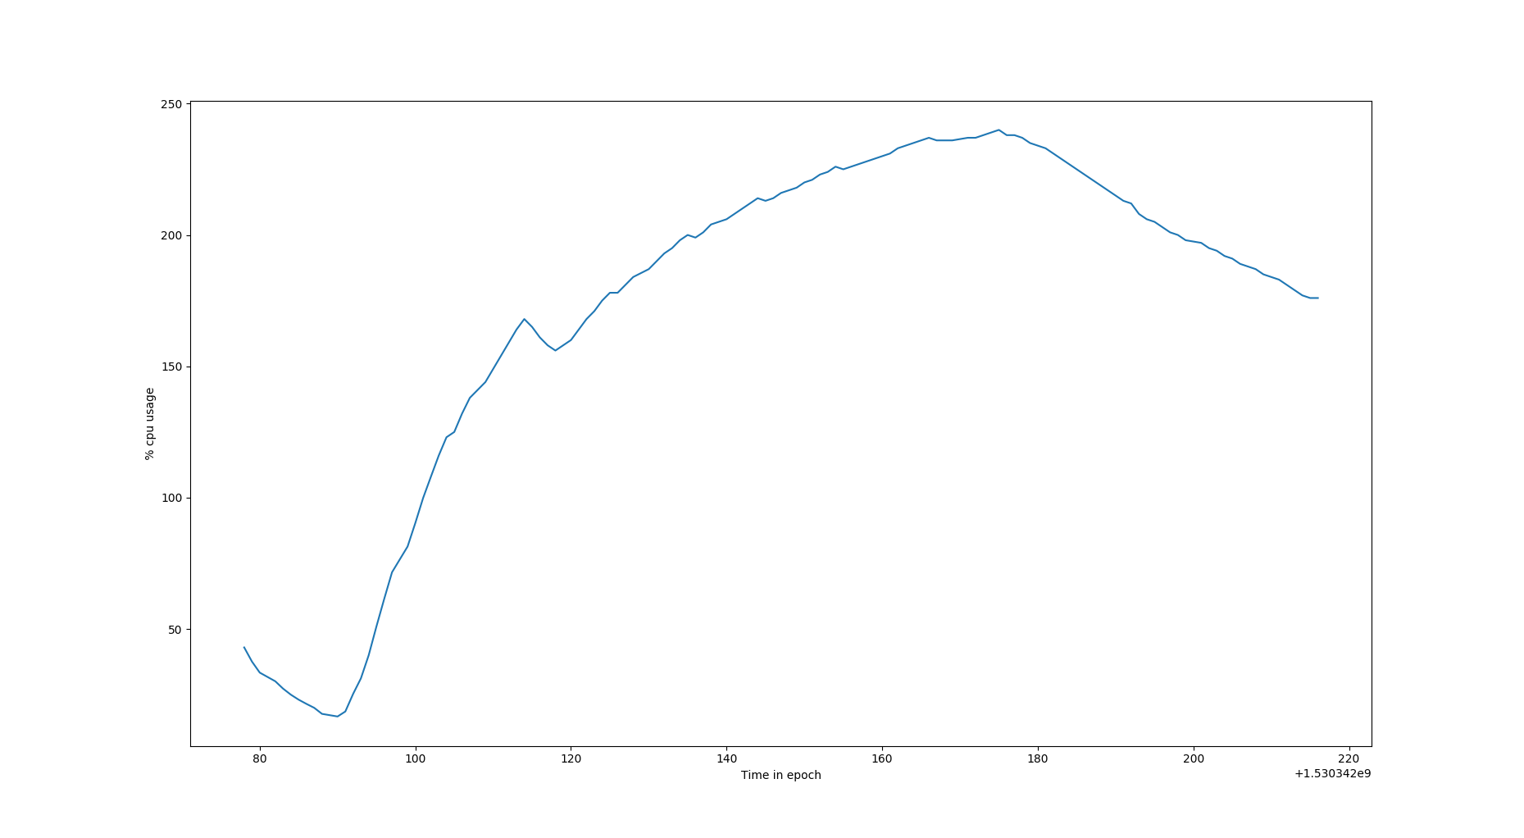
Figure 52 : Graph for Time in epoch vs %CPU for LSTM 32-64-32 model in machine 2
x-axis : Time in seconds
y-axis : %CPU usage measured using ps command
Inference of graph :
In the above graph, we can see that for a initial and small period os time the %CPU usage is decreasing exponentially and then after reaching a lowest point it has a logrithmic growth. The decreasing region of the graph depicts the idle REST api to which no requests where made, the API had just been started. The logarithmic growth region depicts the increase in %CPU usage due to concurrent clients.

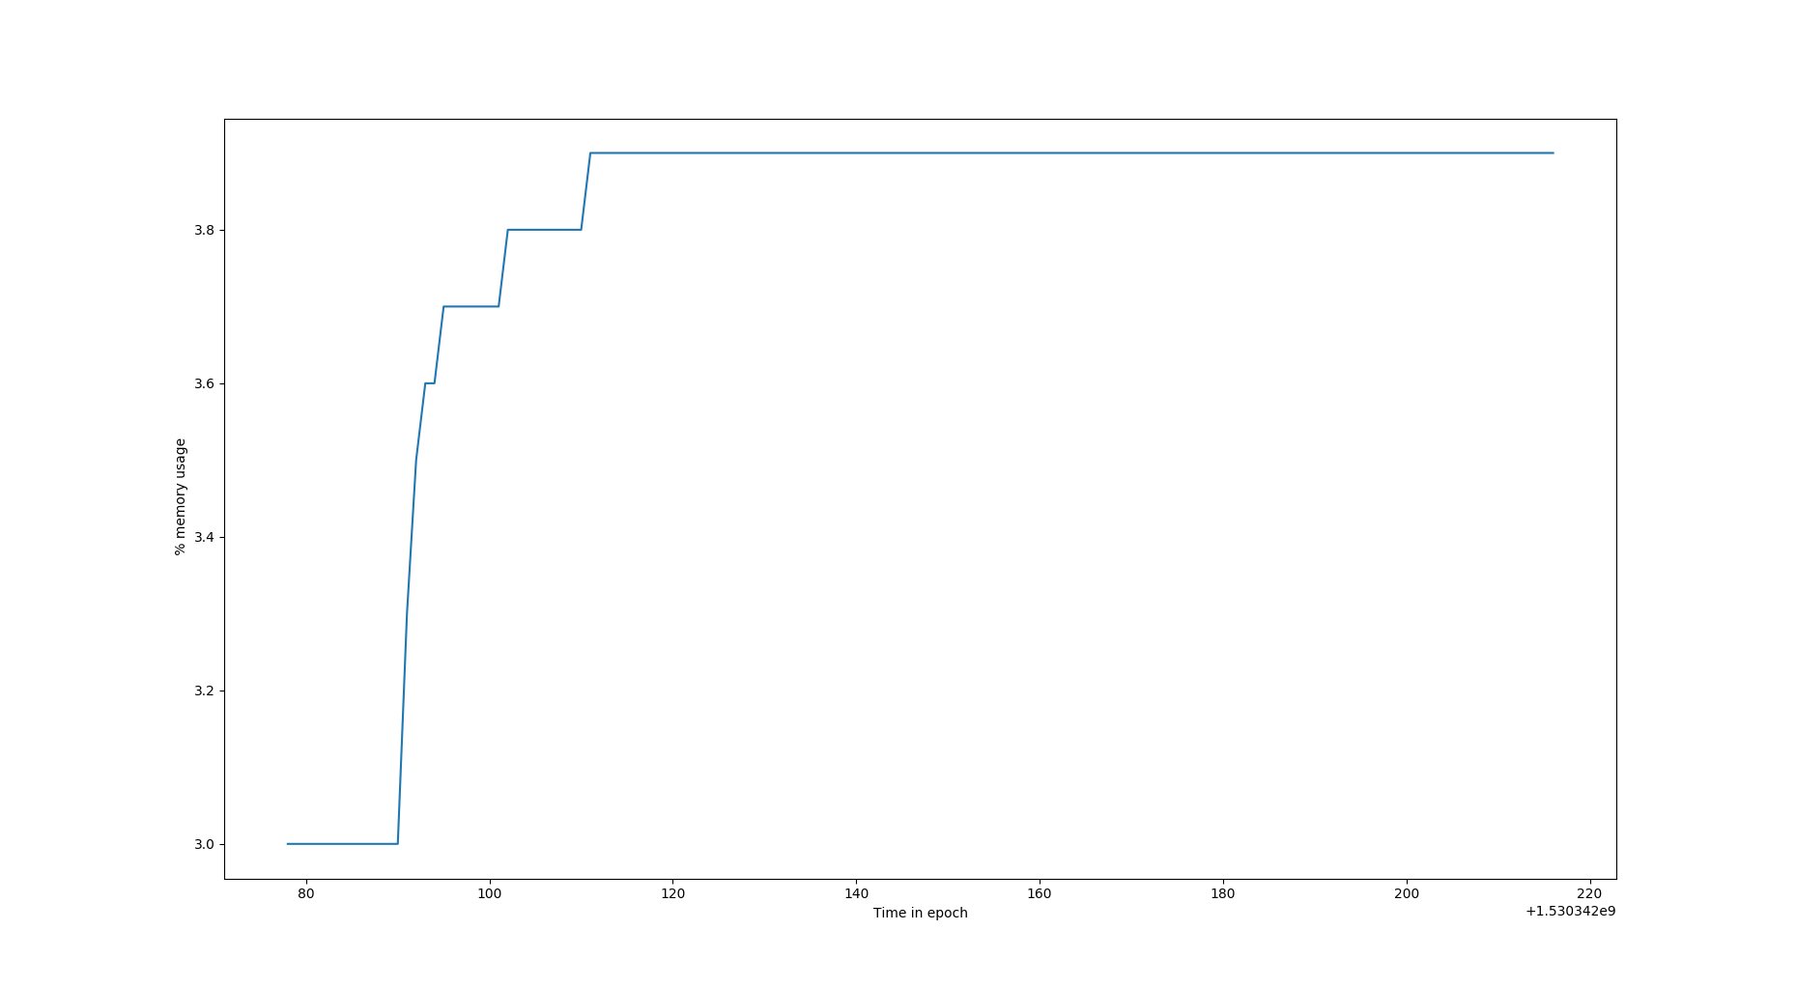
Figure 53 : Graph for Time in epoch vs %CPU for LSTM 32-64-32 model in machine 2
x-axis : Time in epoch
y-axis : %MEM usage measured using ps command
Inference of graph :
In the above graph, the starting increasing curve is due to the fact that it is the time of first few http requests reaching the server, thus from an idle server’s 2.96% memory the %memory used suddenly shoots up. After sometime, we can say that at anytime “n” concurrent clients are using the API, thus the memory percentage is constant. But as we can see in few places there is a drop in memory usage, this is due to the fact that as multiple concurrent clients might be requesting the api with same input batch, thus no new memory needs to be used, instead the cached result can be utilised.
7.2.3
S. no | No. of concurrent clients | No. of requests per client | Total response time (seconds) | Avg. response time for 1 client  (seconds) | Throughput (per second)
1 | 150 | 150 | 146.299 | 137.766 | 1.025
1 | 150 | 150 | 147.285 | 136.024 | 1.018
1 | 150 | 150 | 146.829 | 137.928 | 1.021
average total response time (seconds) : 146.804
average response time for one client (seconds) : 137.239
average Throughput (per second) : 1.021
TABLE 49

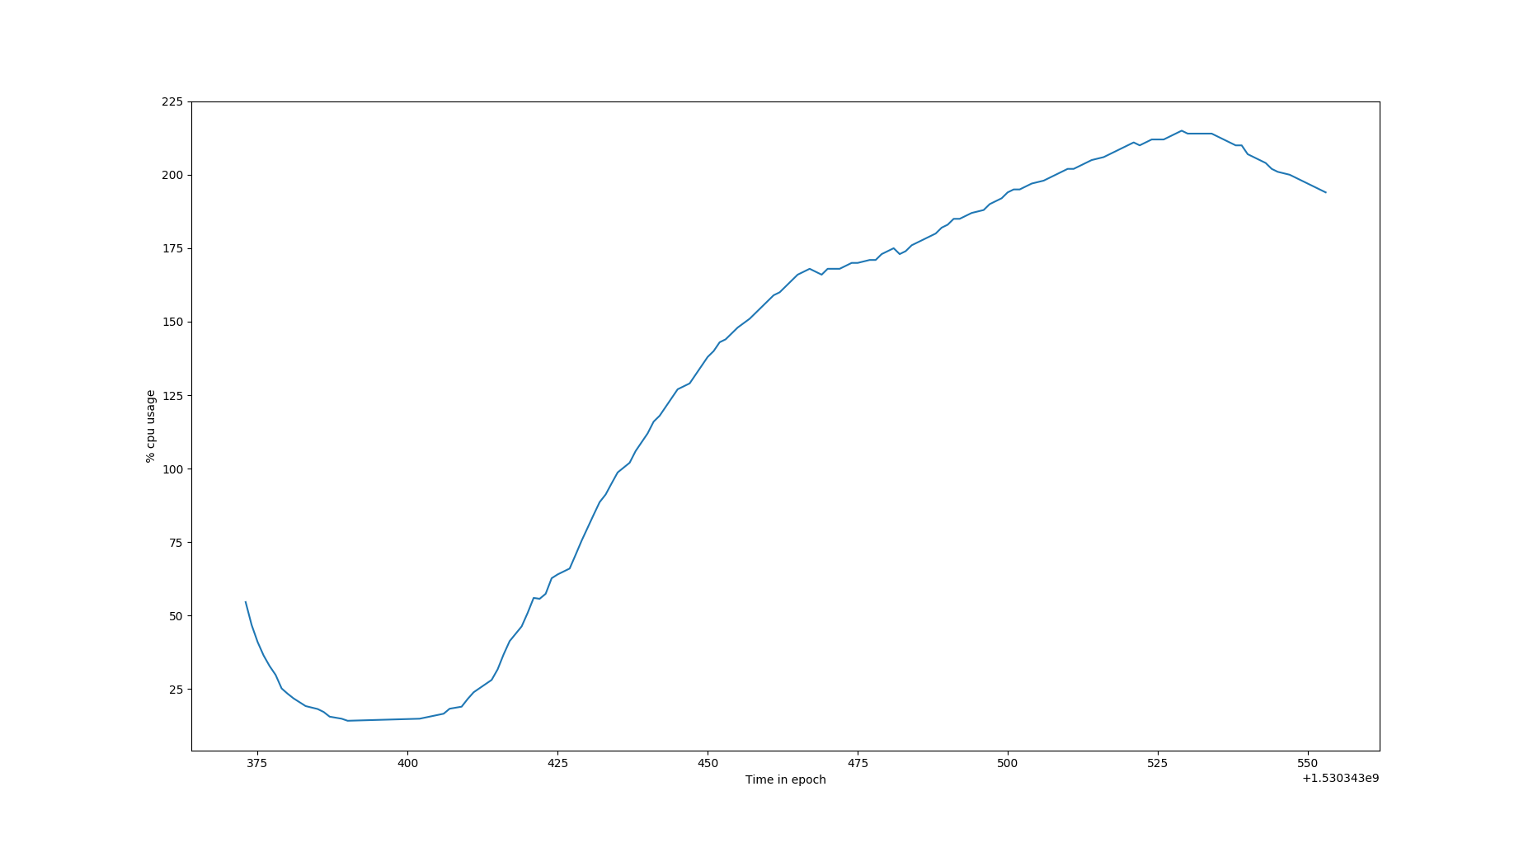
Figure 54 : Graph for Time in epoch vs %CPU for LSTM 32-64-32 model in machine 2
x-axis : Time in seconds
y-axis : %CPU usage measured using ps command
Inference of graph :
In the above graph, we can see that for a initial and small period os time the %CPU usage is decreasing exponentially and then after reaching a lowest point it has a logrithmic growth. The decreasing region of the graph depicts the idle REST api to which no requests where made, the API had just been started. The logarithmic growth region depicts the increase in %CPU usage due to concurrent clients.

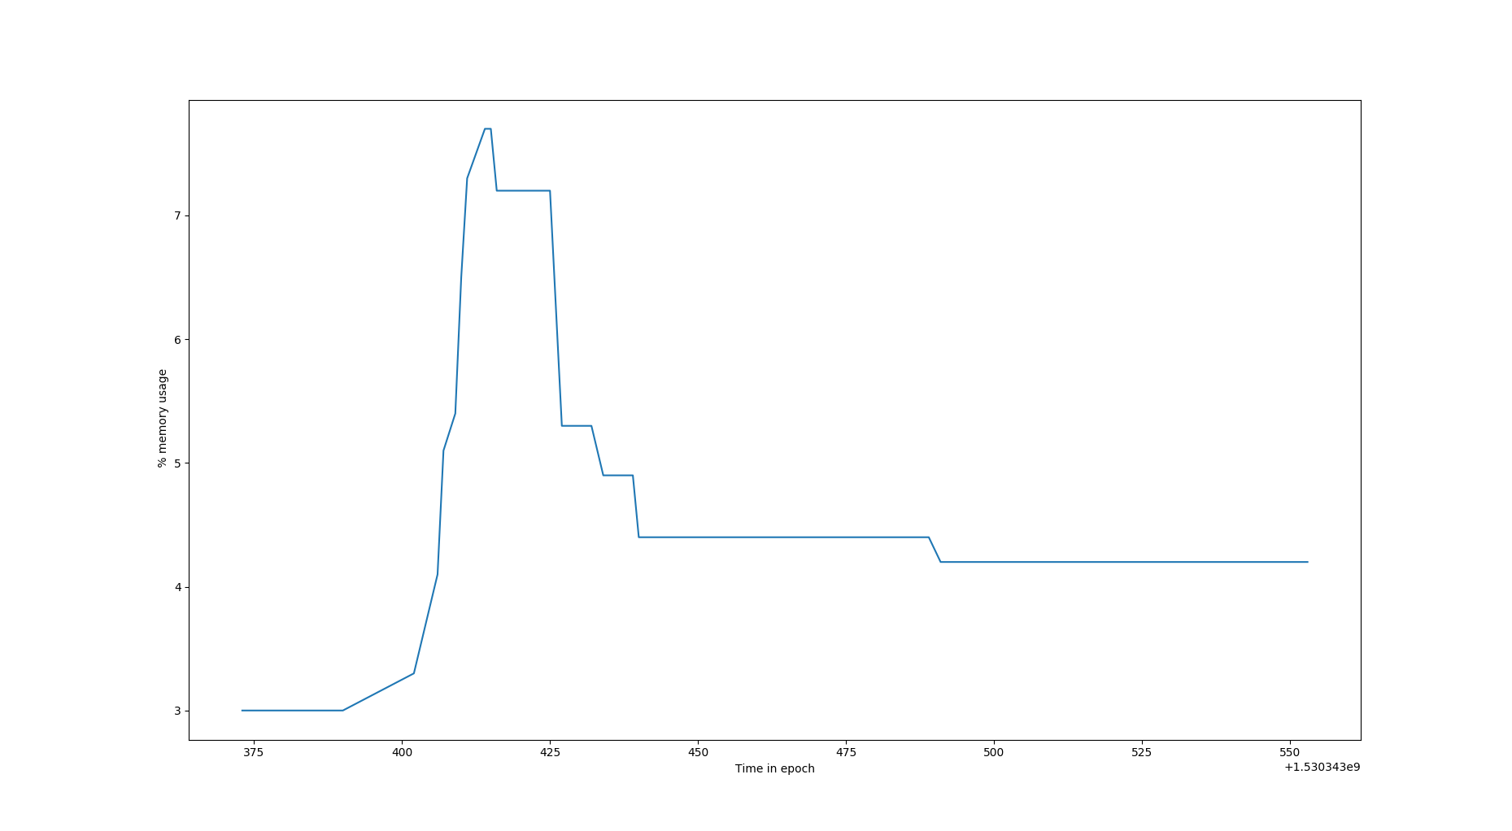
Figure 55 : Graph for Time in epoch vs %MEM for LSTM 32-64-32 model in machine 2
x-axis : Time in epoch
y-axis : %MEM usage measured using ps command
Inference of graph :
In the above graph, the starting increasing curve is due to the fact that it is the time of first few http requests reaching the server, thus from an idle server’s 2.96% memory the %memory used suddenly shoots up. After sometime, we can say that at anytime “n” concurrent clients are using the API, thus the memory percentage is constant. But as we can see in few places there is a drop in memory usage, this is due to the fact that as multiple concurrent clients might be requesting the api with same input batch, thus no new memory needs to be used, instead the cached result can be utilised.

RESULT :
[1] As the number of concurrent clients increases the overall response time also increases and most importantly we observe that the average response time for each request also increases in proportion to the total response time. This is due to the fact that, despite the individual clients are concurrent, the 150 requests inside each of the individual client is synchronous in nature. Due to this, when a client’s synchronous requests are disrupted by the requests from other concurrent clients, the disrupted client goes to waiting queue.
[2]We also noticed that, the %Cpu usage grows logrithmically with time and the %Memory usage for the program is usually constant and sometimes fluctuating due to caching of predicted values.
[3]We also observer from the above experiment, at any point of time the %CPU is high but the corresponding memory usage is low and constant. Thus we can infer that this process is I/O intensive process and thus has a larger waiting time which causes high %CPU usage and low %MEM usage.

Conclusion :
Any application that we build thrives on data , either the application was built to retrieve data for the user or the application needs the data to do some computaion and return result to the user or the client.
Eample :
The weather applications in our mobile phones , When we enter city name as “Delhi” , The application itself does not have all the required data but rather creates a request to a server in the cloud which holds the data , Once the server hosting the data receives the request it replies to the client with the corressponding data in a JSON / XML format.This data is received by the application and then proccessed and displayed for the user.
REST API : It is just a interface which allows two pieces of softwares to communicate and co-ordinate with each other despite their functional or structural differences.
In the project above we have mainly built 3 models of API and API client architecture and studied their behaviour using parameters like response time, execution time, %CPU usage, %Memory usage.
In case of API v1(bulk reading model), we can infer that the response time and the number of records are linearly related. But this method of bulk reading cannot be very useful in real world, example in cases where there is very large amount of data we need to have servers with very high RAM else it will lead to a memory error.
Thus we have moved to API v2 with inbuilt batch processing and this model overcame the RAM exhaustion issue and also we noticed that the response time and

References :
[1]Flask (A python micro framework). [Online]. Available: http://flask.pocoo.org/
[2]Keras.io. [Online]. Available:
[3]Github. [Online]. Available: https://github.com/keras-team/keras/issues/6462
[4]Coderanch. [Online]. Available: https://coderanch.com/t/627014/java/java-net-SocketException-Connection-reset
[5]Github. [Online]. Available: https://github.com/keras-team/keras/issues/2397
[6]Digital Ocean. [Online]. Available: https://www.digitalocean.com/community/tutorials/how-to-serve-flask-applications-with-gunicorn-and-nginx-on-ubuntu-14-04
[7]Matplotlib. [Online]. Available: https://matplotlib.org/
[8]Unix.Stackexchange. [Online]. Available: https://stackoverflow.com/questions/36872136/plotting-csv-file-data-to-line-graph-using-matplotlib
[9]Geeks for geeks. [Online]. Available: https://www.geeksforgeeks.org/graph-plotting-in-python-set-1/
[10]Unix.Stackexchange. [Online]. Available: https://unix.stackexchange.com/questions/58539/top-and-ps-not-showing-the-same-cpu-result
[11]Hackernoon. [Online]. Available: https://hackernoon.com/ina-comprehensive-guide-on-the-web-server-gateway-interface-of-python-7030524b543
[12]Github. [Online]. Available: https://github.com/keras-team/keras/issues/5199
[13]Marinamele. [Online]. Available: http://www.marinamele.com/7-tips-to-time-python-scripts-and-control-memory-and-cpu-usage
[14]Pandas.pydata. [Online]. Available: https://pandas.pydata.org/pandas-docs/stable/generated/pandas.DataFrame.dropna.html
[15]ERSI. [Online]. Available: https://support.esri.com/en/technical-article/000012876
[16]Tutorialspoint. [Online]. Available: https://www.tutorialspoint.com/svn/index.htm
[17]2Daygeek. [Online]. Available: https://www.2daygeek.com/command-check-find-number-of-cpu-cores-linux/
[18]Github. [Online]. Available: https://github.com/fabric/fabric/issues/1467
[19]Thenewboston. [Online]. Available: https://www.youtube.com/watch?v=ZVGwqnjOKjk&list=PL6gx4Cwl9DGDi9F_slcQK7knjtO8TUvUs
[20]Stackoverflow. [Online]. Available: https://stackoverflow.com/questions/276052/how-to-get-current-cpu-and-ram-usage-in-python
[21]Stackoverflow . [Online]. Available: https://stackoverflow.com/questions/3913502/restful-call-in-java
[22]Stackoverflow. [Online]. Available: https://stackoverflow.com/questions/3383865/how-to-log-error-to-file-and-not-fail-on-exception
[23]Linuxquestions. [Online]. Available: https://www.linuxquestions.org/questions/linux-server-73/ps-and-top-commands-are-giving-different-cpu-utilization-for-the-same-job-945082/
[24]Keras. [Online]. Available: https://keras.io/models/model/
[25]Stackoverflow. [Online]. Available: https://stackoverflow.com/questions/16326529/python-get-process-names-cpu-mem-usage-and-peak-mem-usage-in-windows/16331254
[26]TowardsDataScience. [Online]. Available: https://towardsdatascience.com/simple-and-multiple-linear-regression-in-python-c928425168f9

