Multi-Task Cascaded Convolutional Networks based Intelligent Fruit Detection for Designing Automated Robot

In this paper author is designing Multi-Task Cascaded Convolution Neural Network to build fruit detection model as this network is good at face detection so author applying same MTCNN model to build fruit detection model. This model will accept tree images as input and then detect 3 different types of fruit such as Apple, Strawberry and Oranges. The author has used own fruit dataset which he has capture with his digital camera and he has not publish this dataset on internet so to build MTCNN model we have 360 degree fruit dataset from KAGGLE.

Below is the dataset use to build MTCNN model

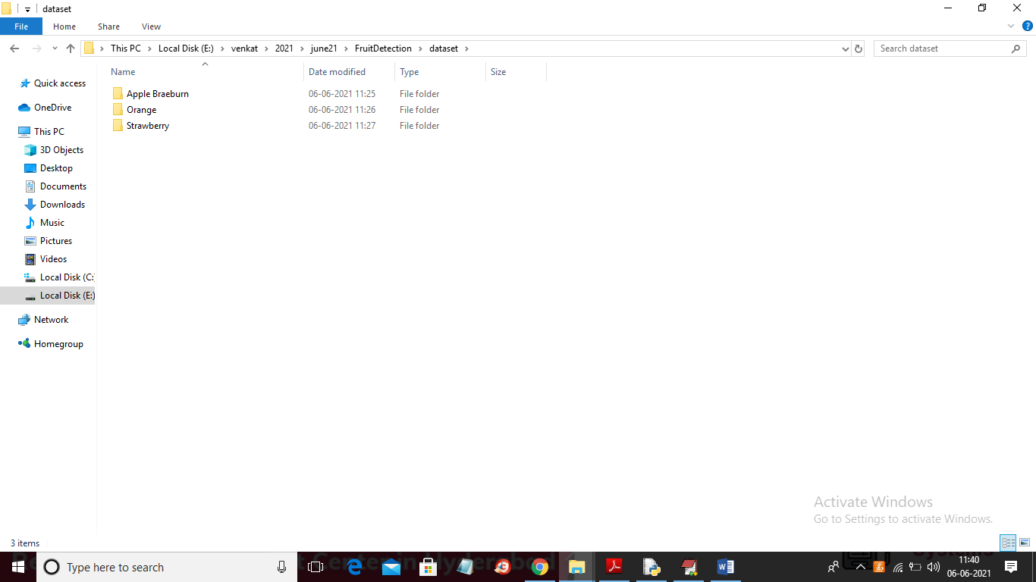

Go inside any fruit folder to see images of that fruit

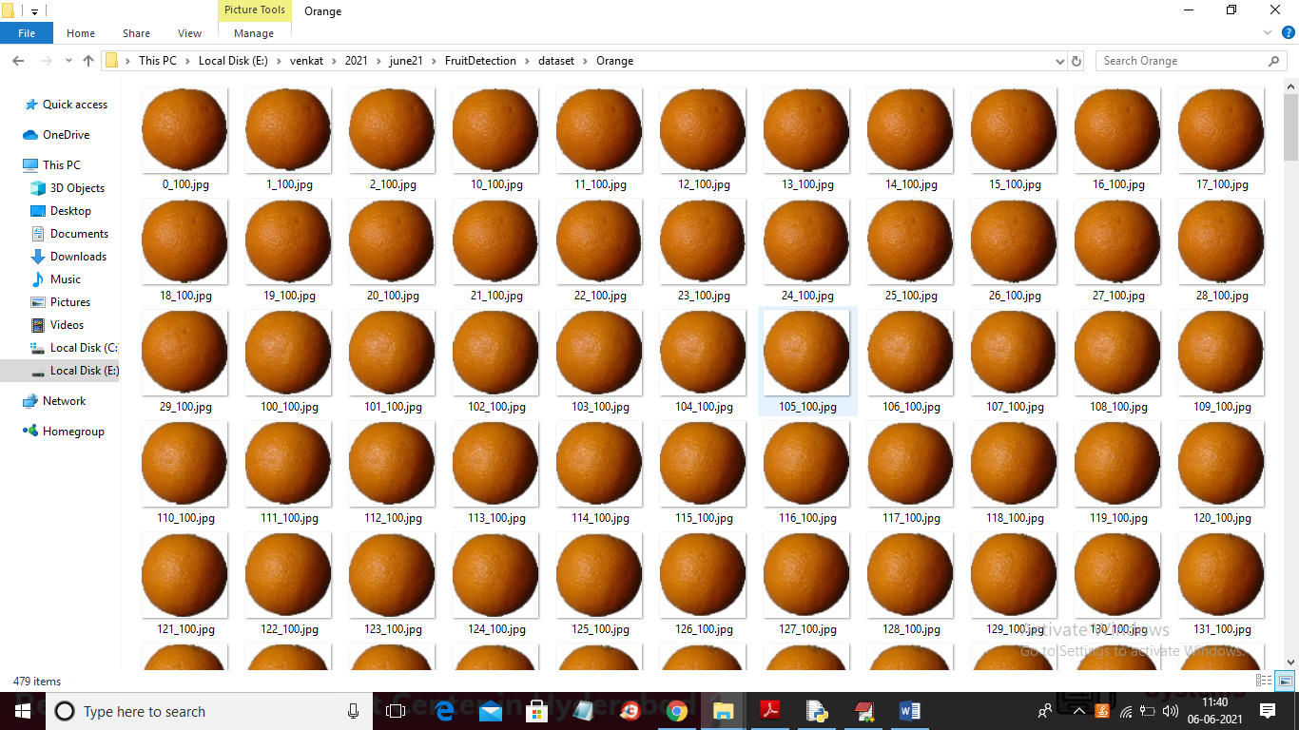

To build MTCNN model we have used image generator and augmentation technique from KERAS.

SCREEN SHOTS

To run project double click on ‘run.bat’ file to get below screen

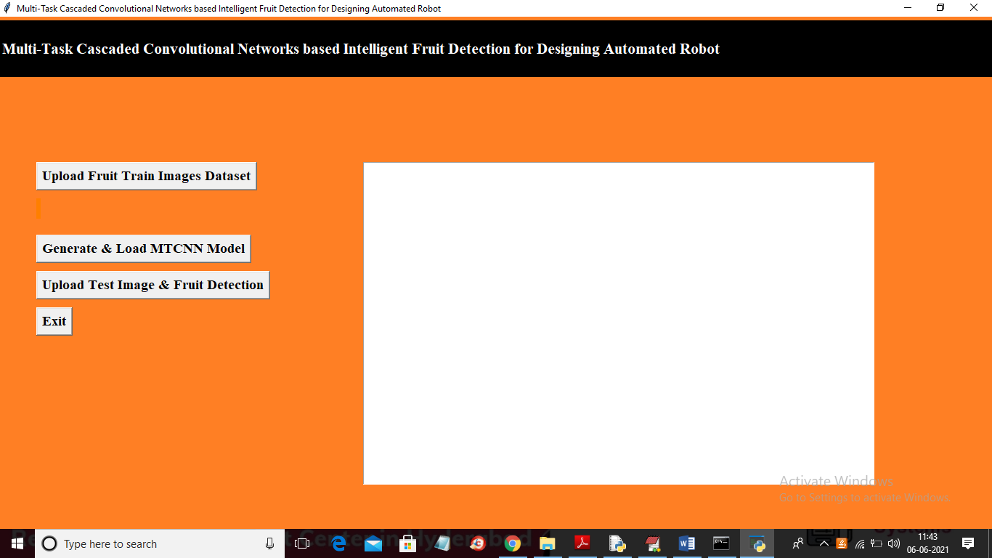

In above screen click on ‘Upload Fruit Train Images Dataset’ button to load dataset

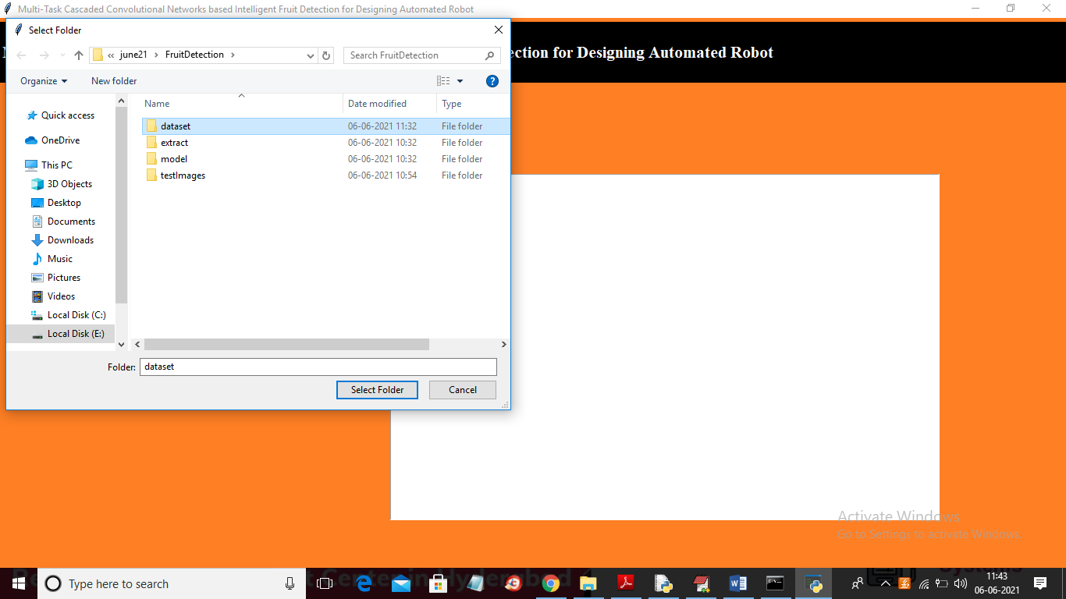

In above screen selecting and uploading ‘dataset’ folder and then click on ‘Select Folder’ to upload dataset images and to get below screen

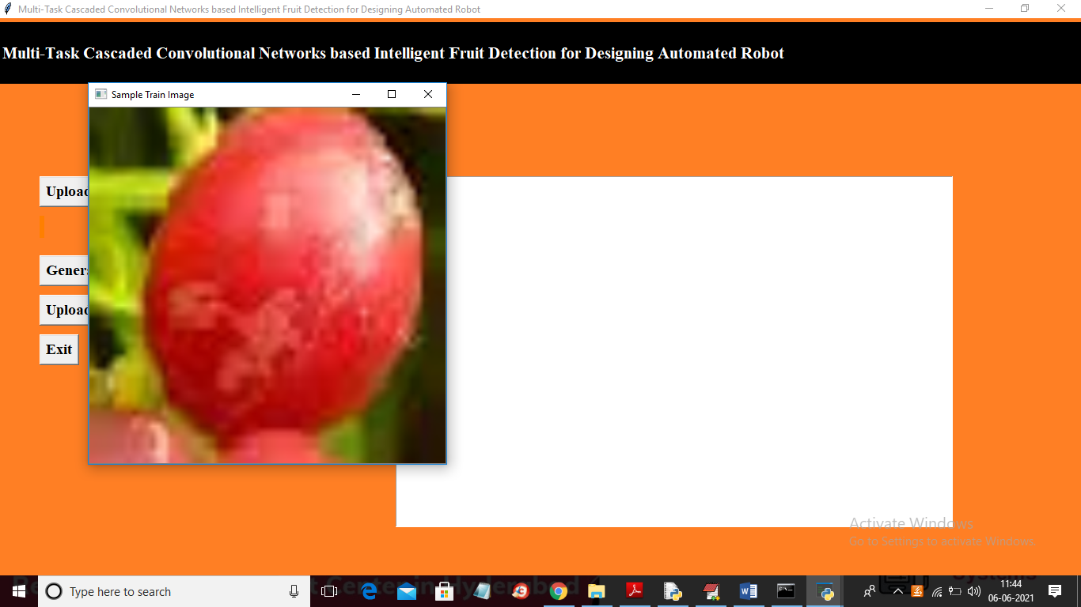

In above screen dataset images loaded and to check image process successfully I am displaying one sample processed image from dataset and now close above image to get below screen

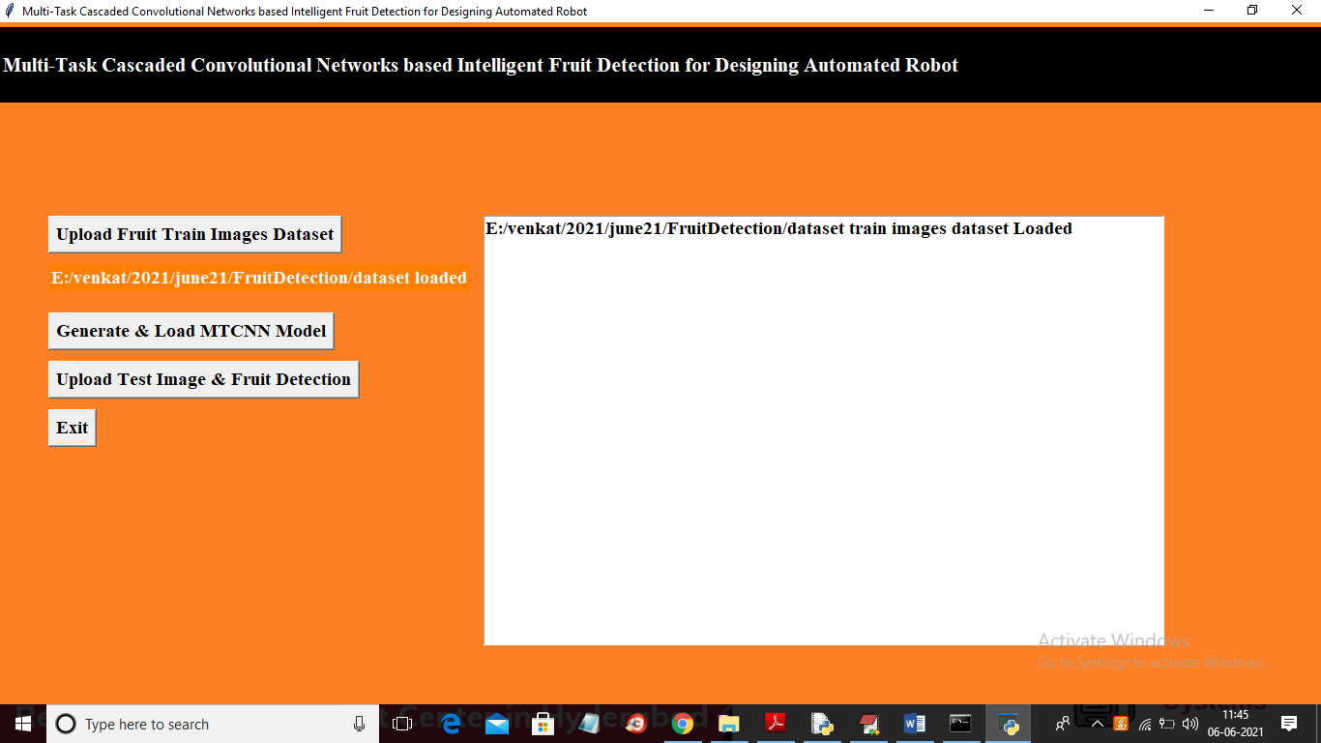

In above screen dataset loaded and now click on ‘Generate & Load MTCNN Model’ button to generate and load model

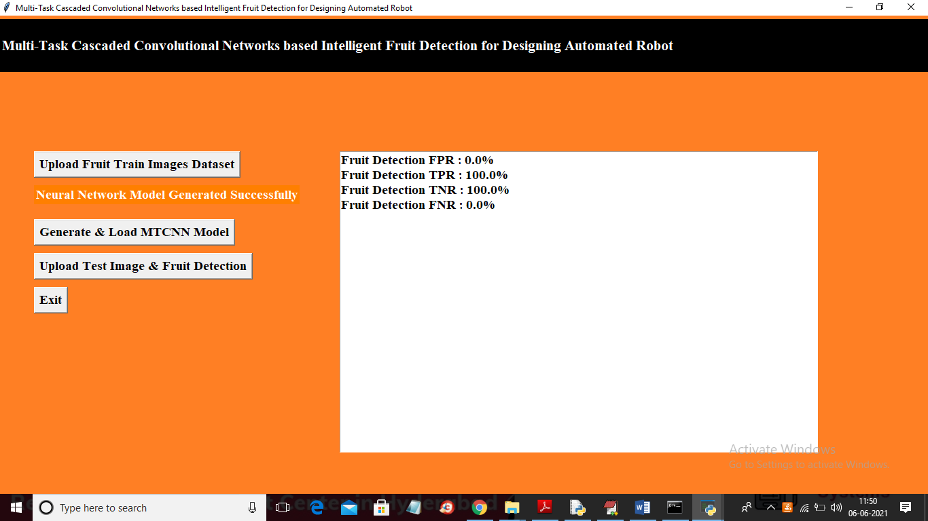

In above screen MTCNN model generated and we got TPR and TNR which means MTCNN prediction on test data is 100% and false prediction rate is 0% and in below graph we can see MTCNN accuracy and loss

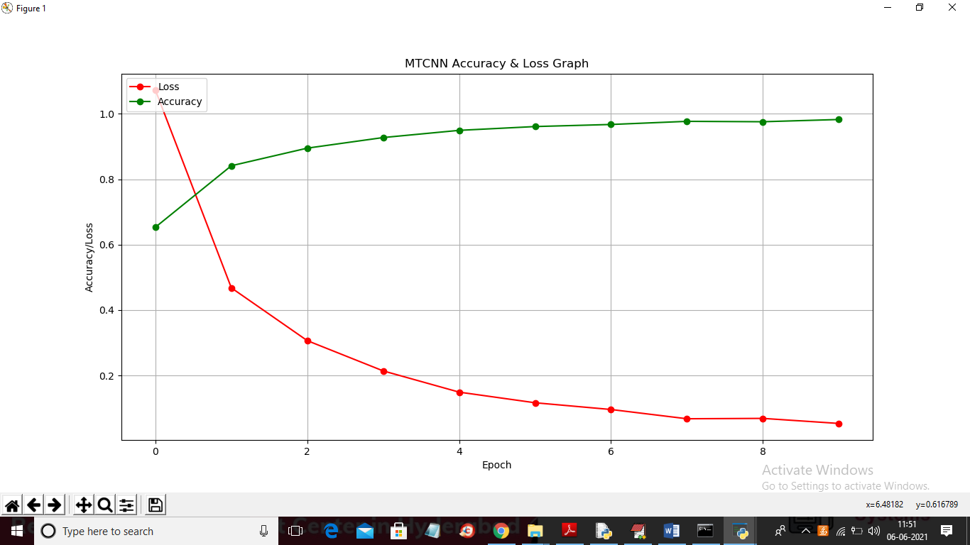

In above graph x-axis represents MTCNN epoch and y-axis represents accuracy and loss value and in above graph red line represents loss and green line represents accuracy and with each increasing epoch we can see loss value decrease and accuracy get increase closer to 100%. Now close above graph and then click on ‘Upload Test Image & Fruit Detection’ button to upload test image and then get fruit detection output

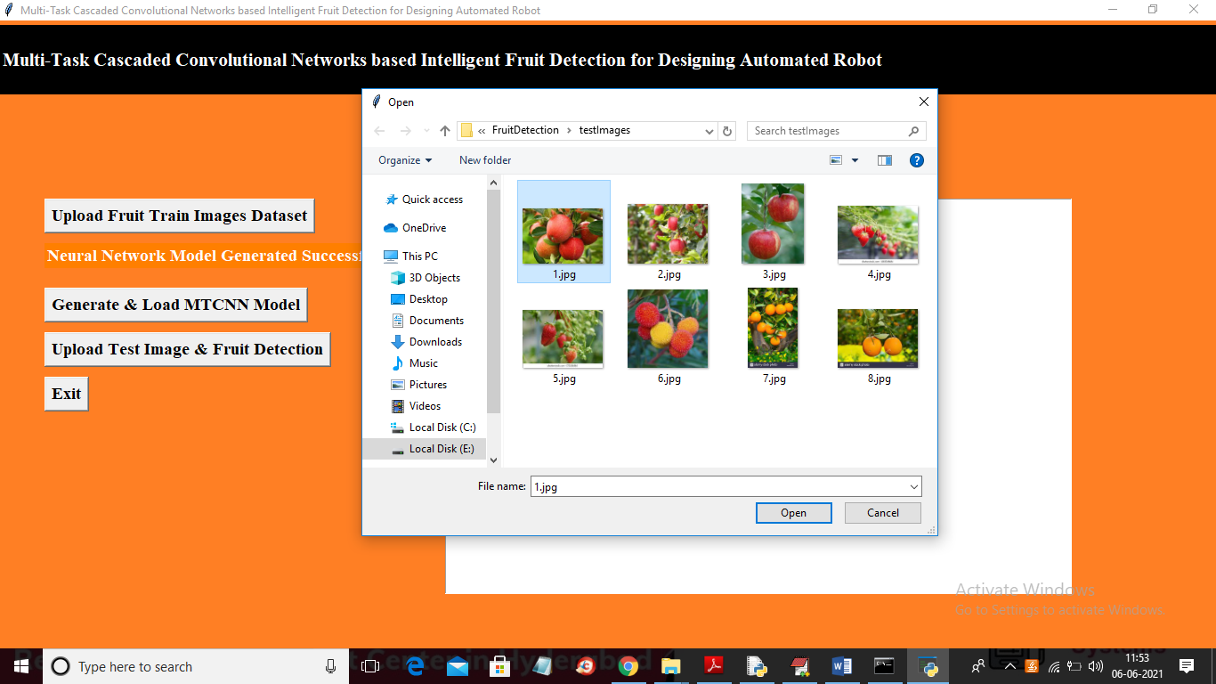

In above screen selecting and uploading ‘1.jpg’ image and then click on ‘Open’ button to get below result

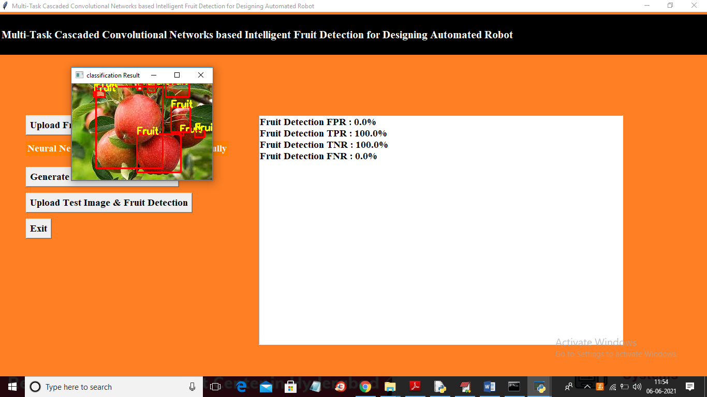

In above screen we can see MTCNN detected fruit and surround them with bounding boxes. Test other image

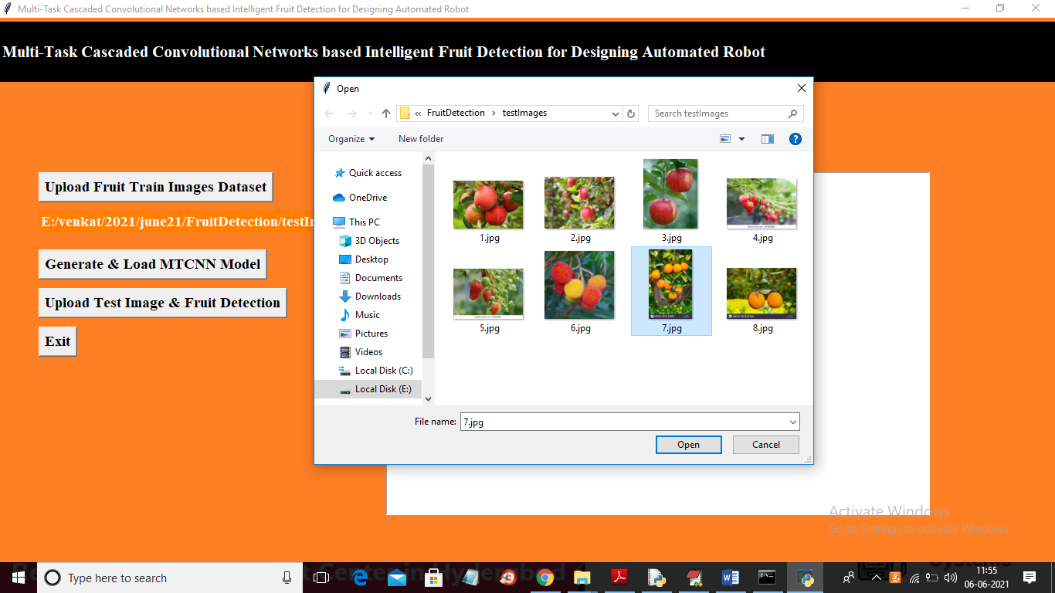

In above screen uploading ‘7.jpg’ below is the result

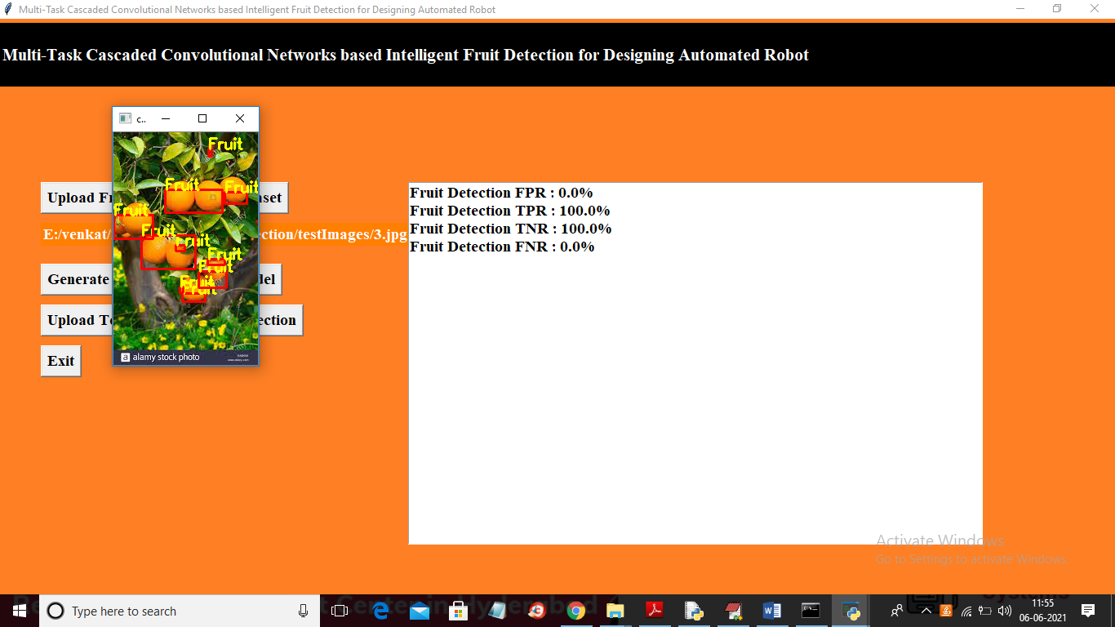

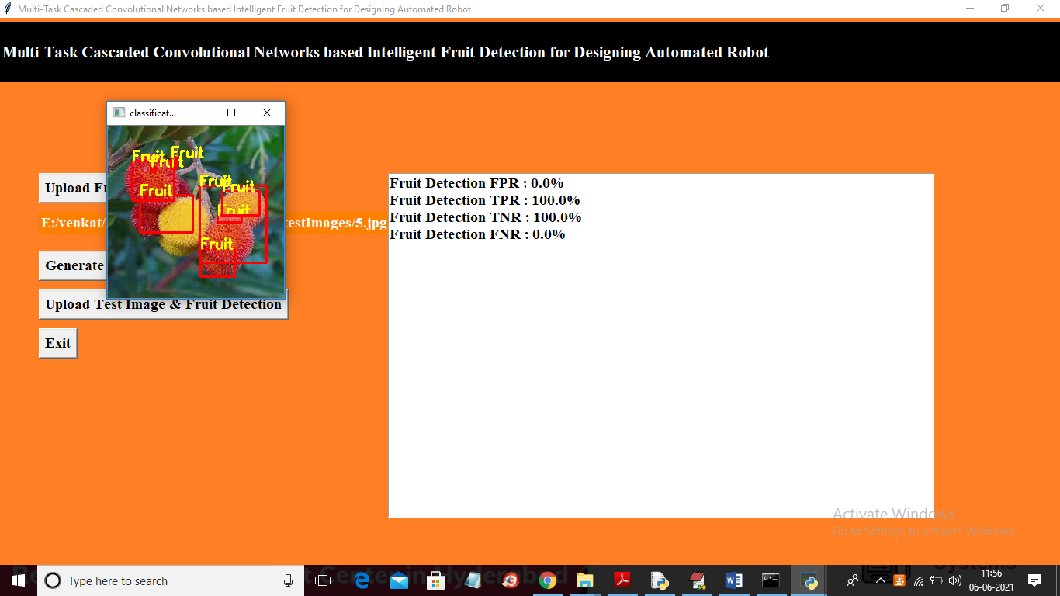

Similarly you can test with other images also