1. Clone GitHub repository
2. Import this project as an existing Maven Project into Eclipse IDE
3. This will import below 5 projects:

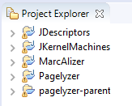

1. Change the Java build path to your systems JDK path
2. Run Maven build in below hierarchy:
3. JDescriptors
4. JKernelMachines
5. pagelyzer
6. MarcAlizer
7. Pagelyzer
8. All the Maven builds should run successfully
9. By default, the project uses Firefox browser for the selenium webdriver to run.
10. We need to change it to Chrome browser
11. The changes should be made in below config file:

Config_content.xml

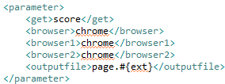

1. We need to run TestWebMonitoring.java file to compare the web pages for the changes.