CRICKET PLAYER PERFORMANCE
PROJECT DOCUMENTATION

A Salesforce-Based Cricket Performance Management System
B.Sc. DATA SCIENCEFinal Year ProjectAcademic Year 2026–2027
1

USER STORY
As a cricket coach or team manager, I want to maintain player profiles and match-wise performance records in one centralized application so that I can easily review player statistics, monitor performance and reduce manual record keeping.
1. INTRODUCTION
1.1 PROJECT OVERVIEW
Cricket Player Performance is a Salesforce-based application designed to store and manage cricket player information and performance data in a structured manner. Cricket teams generate information such as runs, wickets, catches, overs, matches and other statistics. Maintaining these details manually across notebooks or separate spreadsheets can make record management difficult.
The proposed system provides a centralized environment where player records and performance records can be created, connected and reviewed. Salesforce custom objects, fields, relationships, Lightning App components, Roll-Up Summary fields and Flow automation are used to build the application.
The project focuses on practical sports-data management rather than live scoring. It provides a foundation that can later be extended with dashboards, analytics, tournament information and external data integration.
Objectives
Maintain player information digitally.
Record match-wise player performance.
Connect performance records with the correct player.
Calculate selected performance summaries automatically.
Provide simple navigation through a Lightning application.
Reduce repetitive manual data-management tasks using Flow.
1

1.2 PURPOSE
The purpose of the Cricket Player Performance system is to provide an organized digital platform for maintaining cricket player and performance information. The application is intended for coaches, team managers, sports coordinators and other authorized users who need to maintain and review player records.
Major Purposes
Digitize cricket performance records.
Keep player information in a centralized location.
Maintain match-wise performance history.
Reduce manual calculation of selected totals.
Provide connected records through object relationships.
Automate selected activities using Salesforce Flow.
Create a scalable foundation for future sports analytics.
Scope
The initial scope includes player management, performance recording, relationships, summary calculations and basic automation. Features such as live score integration, advanced predictive analytics, mobile applications and external cricket APIs can be considered future enhancements.
Expected Outcome
The final application should allow an authorized user to create player records, enter performance information, view related records and use automatically calculated summaries. The project also demonstrates the use of Salesforce configuration and automation in a real-world sports-management context.
1

2. IDEATION PHASE
The ideation phase identifies the user problem, understands the user's needs and generates possible solutions before implementation. The project idea was developed around the difficulties involved in maintaining cricket player performance records manually.
Ideation Goals
Understand the main customer problem.
Identify users and their expectations.
Explore possible application features.
Select feasible features for the academic project.
Connect user needs with Salesforce capabilities.
Key Users
User | Requirement
Coach | View and maintain player performance.
Team Manager | Maintain player and match records.
Sports Coordinator | Organize player information.
Authorized Staff | Create and update approved records.
The ideation process resulted in a centralized Cricket Player Performance application using Salesforce objects and automation.
1

2.1 PROBLEM STATEMENT (CUSTOMER PROBLEM STATEMENT TEMPLATES)
Cricket teams frequently record player performance across multiple matches. When information is maintained manually, users may need to search through different files or records to understand a player's complete performance history.
Customer Problem Statement
“Cricket coaches and team managers need a simple and centralized way to record, organize and review player performance because manual records and disconnected spreadsheets can make performance tracking time-consuming and difficult to maintain.”
Problems Identified
Problem | Impact
Scattered records | Difficult to obtain a complete player history.
Manual entry | Requires repeated effort.
Manual calculations | Summary statistics may require extra work.
Poor connectivity | Player and performance records may remain separate.
Limited automation | Repeated processes must be performed manually.
Need for a Solution
A centralized application can address these issues by providing structured objects, connected records, calculated summaries and automation within a single platform.
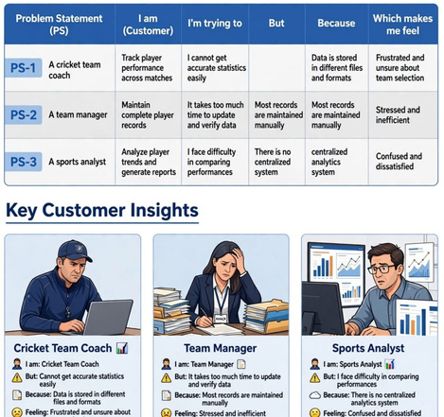

1

2.2 EMPATHY MAP CANVAS
The empathy map helps identify what a typical user says, thinks, does and feels while managing cricket performance records.
SAYS | THINKS
“I need all player records in one place.”“I want to check performance history quickly.”“I do not want to calculate totals repeatedly.” | “Can I update records easily?”“Can I see all performances of a player?”“Can the system automate repeated work?”
DOES | FEELS
Creates player records.Adds match performance.Checks statistics.Updates information. | Manual tracking may feel time-consuming.Wants organized information.Expects simple navigation.
User Needs
Easy record creation.
Clear relationship between player and performance.
Simple navigation.
Automatic summaries where required.
Useful automation.
Organized performance history.
Figure 2.1 – Empathy Map Canvas (Attach screenshot here)
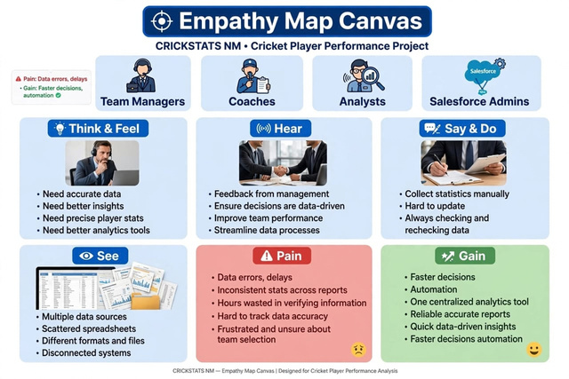

1

2.3 BRAINSTORMING
Brainstorming was used to identify possible features for the Cricket Player Performance application. Ideas were grouped according to data management, performance tracking, automation and future analytics.
Category | Brainstormed Ideas
Player | Profile, role, team, player ID, age group
Performance | Runs, wickets, catches, overs, runs conceded
Match | Date, opponent, venue, match type, result
Automation | Flows, notifications, record updates
Summary | Total runs, total wickets, matches played
Interface | Lightning App, tabs, record pages
Future | Dashboards, charts, trends, analytics
Selected Features
For the initial academic implementation, the project focuses on objects, tabs, Lightning App, fields and relationships, Roll-Up Summary fields and Flow automation.
Figure 2.2 – Brainstorming / Idea Canvas (Attach screenshot here)
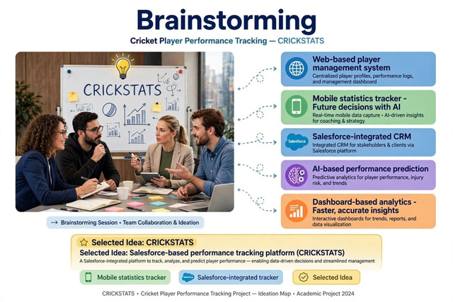

1

3. REQUIREMENT ANALYSIS PHASE
3.1 CUSTOMER JOURNEY MAP
The customer journey describes the steps followed by a user while managing cricket player performance information.
Stage | User Activity | System Support
Access | Open application | Lightning App
Player Setup | Create/select player | Player Object
Performance | Add match statistics | Performance Object
Review | View history | Relationships / Related Lists
Summary | Check totals | Roll-Up Summary
Automation | Trigger defined process | Flow
Update | Modify records | Record pages / fields
Journey Outcome
The journey moves from player creation to performance entry, review, summary and automation. Each stage is supported by a Salesforce feature.
[ SCREENSHOT TO BE ATTACHED HERE ][ SCREENSHOT TO BE ATTACHED HERE ][ SCREENSHOT TO BE ATTACHED HERE ][ SCREENSHOT TO BE ATTACHED HERE ][ SCREENSHOT TO BE ATTACHED HERE ]
Figure 3.1 – Customer Journey Map (Attach screenshot here)
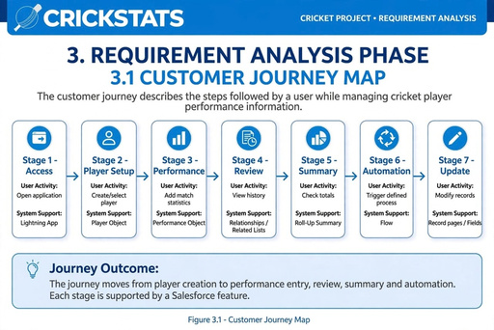

1

3.2 DATA FLOW DIAGRAM
The Data Flow Diagram represents how information moves through the system.
Level 0
User → Cricket Player Performance Application → Player / Performance Data → Reports and Summaries
Level 1
User enters player details.
System stores data in the Player object.
User creates performance details.
Performance is linked to the appropriate Player.
Roll-Up Summary calculates configured totals.
Flow performs configured automation.
User views updated records and summaries.

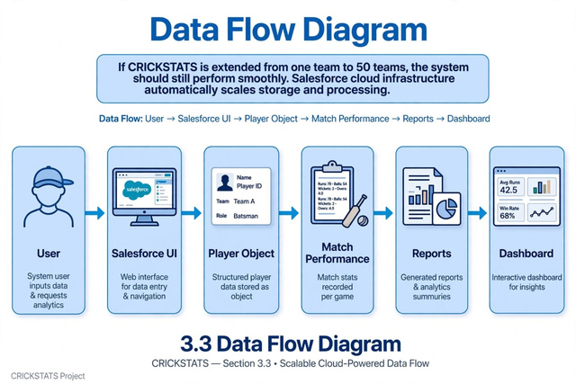

Figure 3.2 – Data Flow Diagram (Attach DFD screenshot here)
1

3.3 TECHNOLOGY STACK
Technology | Purpose
Salesforce Platform | Main cloud platform.
Custom Objects | Store Player and Performance data.
Custom Fields | Store cricket-specific attributes.
Object Relationships | Connect player and performance records.
Lightning App | Main user interface.
Lightning Tabs | Application navigation.
Flow Builder | Process automation.
Roll-Up Summary | Aggregate related-record values.
Web Browser | Access Salesforce environment.
Functional Requirements
Create and manage player records.
Create performance records.
Relate performance records to players.
Display selected calculated summaries.
Provide navigation through tabs.
Execute configured automation.
Non-Functional Requirements
Usability
Consistent data structure
Maintainability
Controlled access
Reliable automation
1

4. PROJECT DESIGN PHASE
4.1 PROBLEM SOLUTION FIT
Problem-solution fit connects the problems identified during ideation with the technical features selected for the project.
Problem | Solution
Scattered player data | Centralized Player object
Separate performance data | Related Performance object
Manual calculations | Roll-Up Summary fields
Difficult navigation | Lightning Tabs and App
Repeated activities | Flow automation
Limited history view | Related Lists
Design Principle
Each major user problem is mapped to a specific Salesforce capability. This creates a direct connection between customer requirements and implementation.
Figure 4.1 – Problem Solution Fit Canvas (Attach screenshot here)
1

4.2 PROPOSED SOLUTION
The proposed system is a Salesforce application that centralizes player profiles and match-wise performance records. It uses custom objects and relationships to create a structured sports-data model.
Main Components
Player Management – stores player profile information.
Performance Management – stores match-wise statistics.
Relationships – connects performance records with players.
Summary Calculation – calculates selected totals.
Lightning App – combines project features into one interface.
Flow Automation – performs configured actions.
Proposed Workflow
The user opens the Lightning application, selects the required tab and creates or selects a player. Performance details are entered and connected to that player. Related records can then be viewed from the player record. Roll-Up Summary fields can calculate configured totals, while Flow can automate selected record-based processes.
Benefits
Centralized data
Organized history
Reduced repetitive calculations
Connected records
Configurable automation
Future expansion
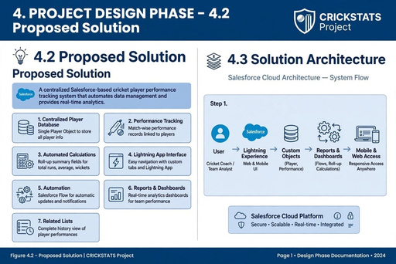

1

4.3 SOLUTION ARCHITECTURE
Layer | Components
User Layer | Coach / Manager / Authorized User
Interface Layer | Lightning App, Tabs, Record Pages
Application Layer | Objects, Fields, Relationships
Automation Layer | Flows and Roll-Up Summary
Data Layer | Player and Performance Records
Platform Layer | Salesforce Cloud Platform
Architecture Flow
User → Lightning App → Tabs / Record Pages → Objects → Relationships → Automation → Updated Records and Summaries
Figure 4.2 – Solution Architecture Diagram (Attach screenshot here)
1

5.1 PROJECT PLANNING
Project planning divides the development into milestones so that each Salesforce configuration step can be completed and tested systematically.
Phase | Activity | Output
Planning | Define requirements | Project scope
Milestone 1 | Create development account | Development environment
Milestone 2 | Create objects | Player / Performance objects
Milestone 3 | Create tabs | Navigation
Milestone 4 | Create Lightning App | Application shell
Milestone 5 | Fields & relationships | Connected data model
Milestone 6 | Roll-Up Summary | Automatic totals
Milestone 7 | Flows | Automation
Testing | Verify functions | Validated application
Planning Guidelines
Create the data model before automation.
Use meaningful field names.
Test relationships using sample records.
Verify summary calculations.
Test each Flow condition.
Capture screenshots after each milestone.
Figure 5.1 – Project Planning / Timeline (Attach screenshot here)
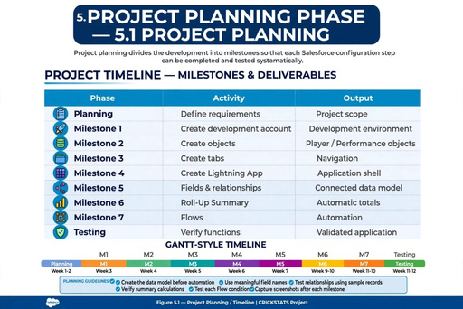

1

6. PROJECT DEVELOPMENT PHASE
PROJECT FLOW
The development phase converts the project design into a working Salesforce application. The milestones are completed sequentially.
Creation of Development Account → Object Creation → Tabs → Lightning App → Fields & Relationships → Roll-Up Summary → Flows → Testing
Development Sequence
Milestone 1 establishes the development environment.
Milestone 2 creates the core objects.
Milestone 3 creates navigation tabs.
Milestone 4 combines the tabs into the Lightning App.
Milestone 5 creates cricket-specific fields and relationships.
Milestone 6 calculates selected aggregate values.
Milestone 7 introduces automation using Flow.
Figure 6.1 – Project Flow Diagram (Attach screenshot here)
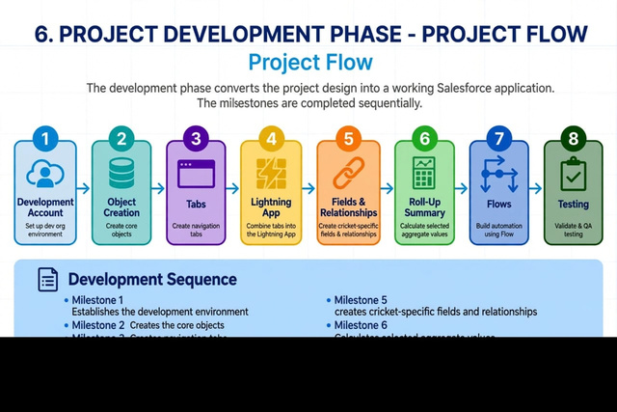

1

MILESTONE 1: CREATION OF DEVELOPMENT ACCOUNT
The first milestone is to create or access a Salesforce development environment. This environment provides the workspace required to configure the objects, fields, Lightning App and automation.
Activities
Open the Salesforce development environment.
Create or access the development account.
Sign in successfully.
Open Setup.
Open Object Manager and verify the configuration environment.
Expected Result
A working Salesforce development environment is available for building the Cricket Player Performance application.
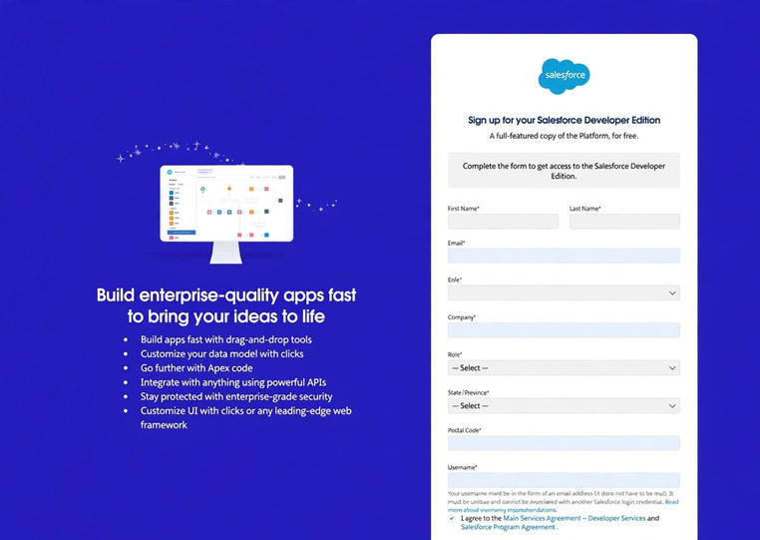

Figure 6.2 – Salesforce Development Account / Setup (Attach screenshot here)
1

MILESTONE 2: OBJECT CREATION
Objects provide the main data structure of the application. The project can use Player and Performance as the core custom objects.
Object | Purpose
Player | Stores player profile and summary information.
Performance | Stores match-wise performance.
Team (Optional) | Stores team information if required.
Match (Optional) | Stores match information for future expansion.
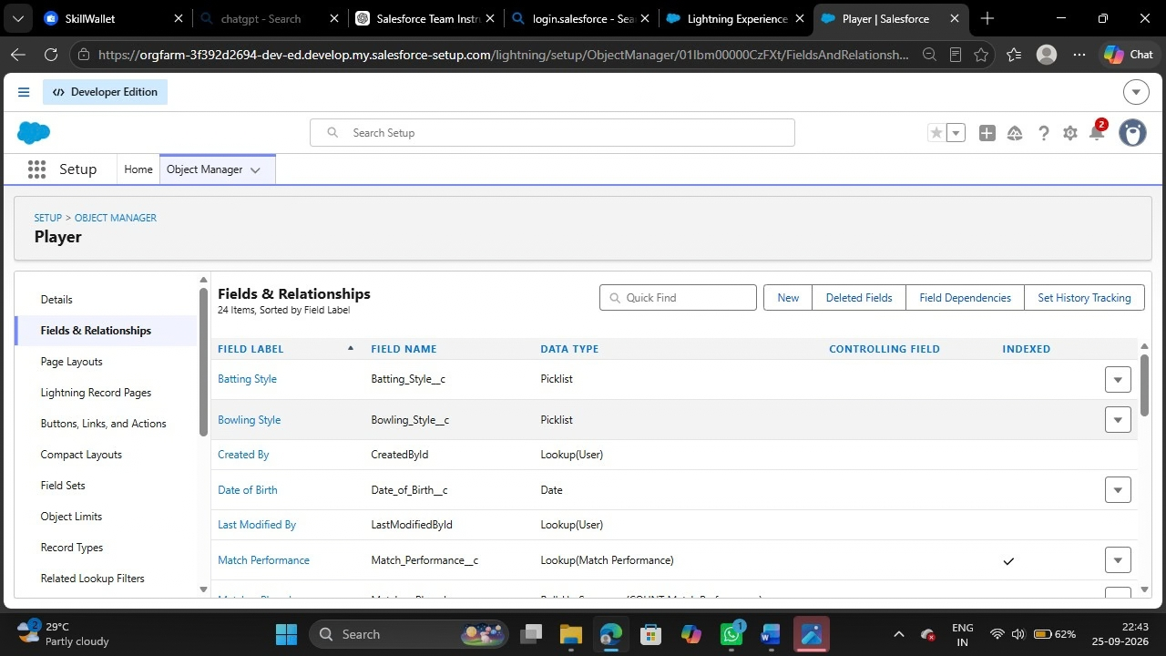

MILESTONE 3: TABS
Tabs provide navigation to the custom objects. Player and Performance tabs allow users to access records without navigating through configuration screens.
Create a Player tab.
Create a Performance tab.
Choose suitable tab labels and icons.
Save and verify the tabs.

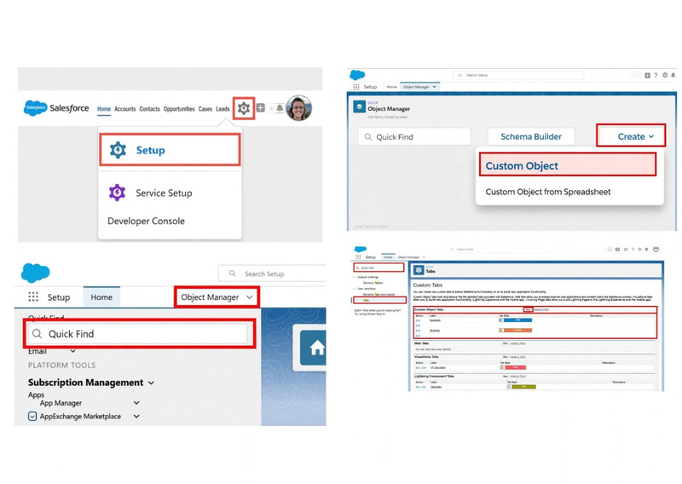
Figure 6.3 – Object Creation and Tabs (Attach screenshots here)
1

MILESTONE 4: THE LIGHTNING APP
The Lightning App combines the project components into a single application interface. It provides a convenient entry point for users to work with player and performance records.
Application Components
App Name: Cricket Player Performance
Player tab
Performance tab
Additional project tabs if required
Navigation and record pages
Configuration Steps
Open App Manager.
Select Create New Lightning App.
Enter the application name.
Choose navigation items.
Add Player and Performance tabs.
Save and launch the application.
Verify navigation and record access.
Expected Result
A working Lightning App provides a single interface for managing cricket player performance information.

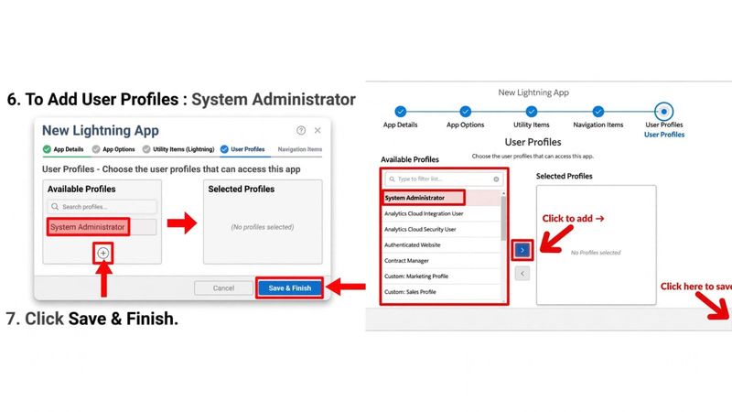
Figure 6.4 – Lightning App Configuration / Final App (Attach screenshot here)
1

MILESTONE 5: FIELD & RELATIONSHIP
Fields define the data stored in each object. Relationships connect records so that the system can display related performance information.
Object | Field | Purpose
Player | Player Name | Player identification
Player | Player Role | Batter / Bowler / All-rounder / Wicketkeeper
Player | Team | Team information
Performance | Match Date | Date of performance
Performance | Runs Scored | Batting performance
Performance | Wickets Taken | Bowling performance
Performance | Overs Bowled | Bowling workload
Performance | Runs Conceded | Bowling statistics
Performance | Player | Relationship to Player

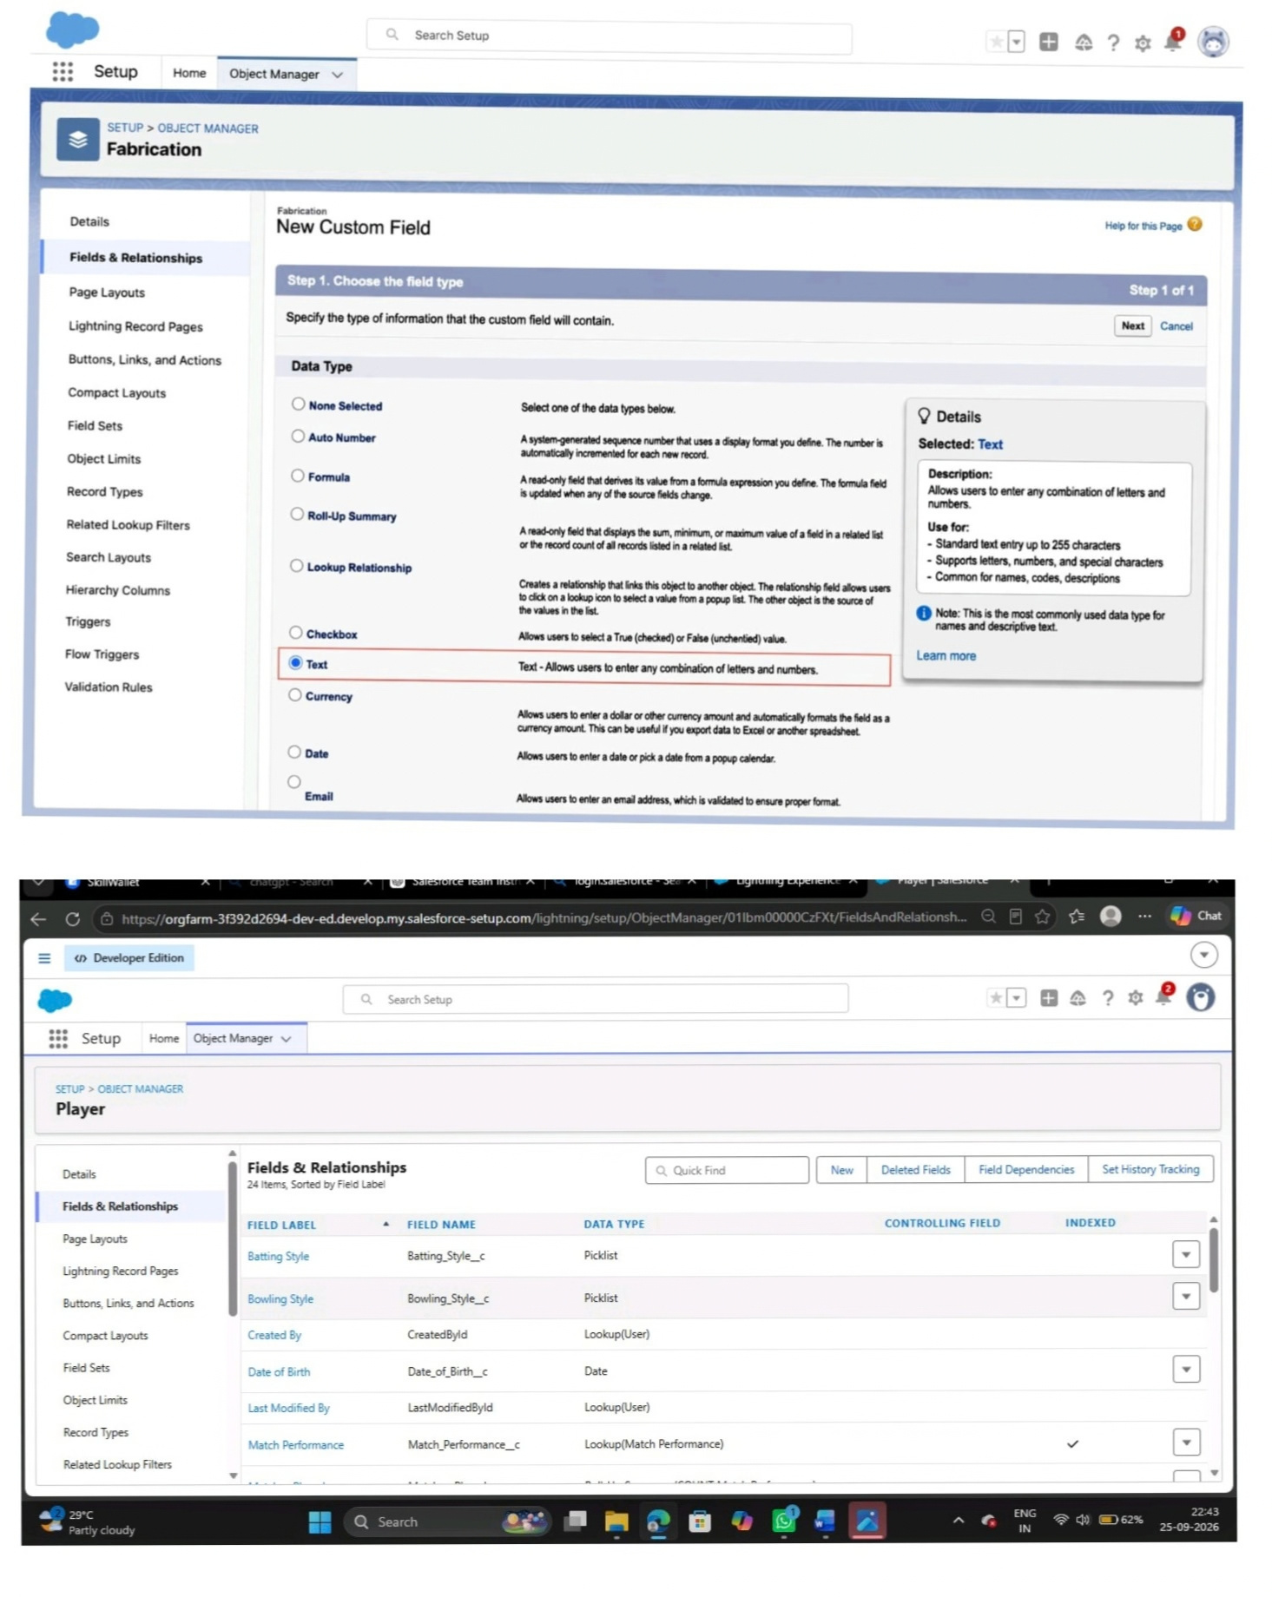
MILESTONE 6: ROLL-UP SUMMARY
Roll-Up Summary fields can calculate aggregate information from related child records when the configured relationship supports the feature.
Total Runs = sum of Runs Scored.
Total Wickets = sum of Wickets Taken.
Matches Played = count of related performance records where configured.
These summary values reduce the need for users to manually add performance figures.
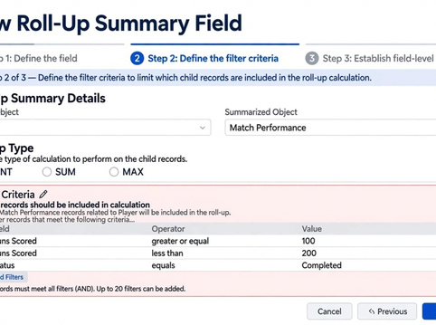

Figure 6.5 – Fields, Relationship and Roll-Up Summary (Attach screenshots here)

MILESTONE 7: FLOWS
Salesforce Flow provides automation for record-based processes. In this project, Flow can be used to reduce repetitive work and maintain consistent actions when Player or Performance records are created or updated.
Possible Flow Scenarios
Trigger when a new player is created.
Trigger when a performance record is created or updated.
Check required conditions before an action.
Update a related record when a defined condition is satisfied.
Create a notification or task for a configured event.

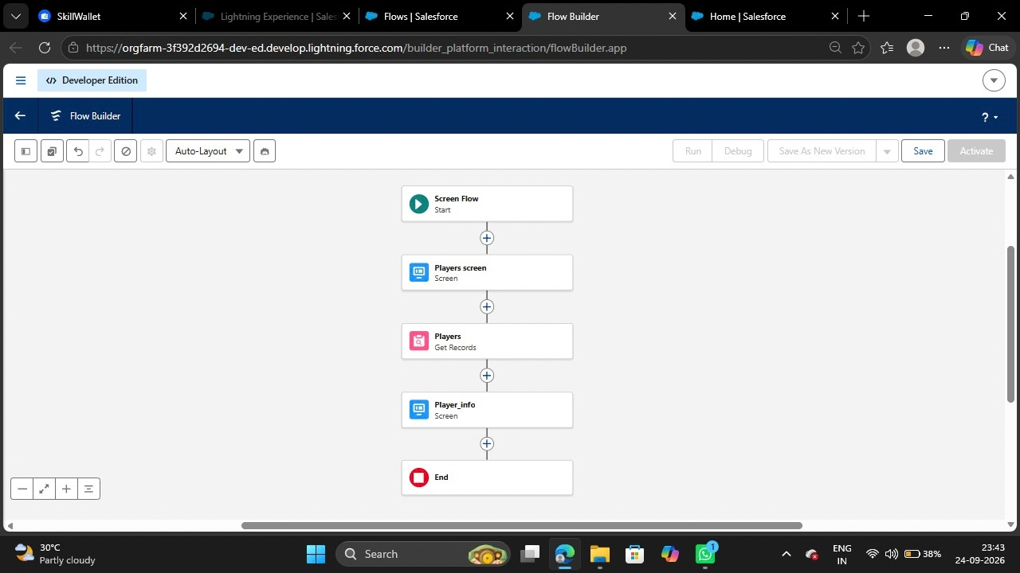
Example Flow
When a Performance record is created, the Flow can check the configured conditions and perform the required action. The exact Flow logic should match the final project implementation and must be tested with sample records.
Final Project Flow
Development Account → Objects → Tabs → Lightning App → Fields & Relationships → Roll-Up Summary → Flows → Testing
CONCLUSION
The Cricket Player Performance project demonstrates how Salesforce objects, relationships, Lightning applications, Roll-Up Summary fields and Flow automation can be combined to manage sports performance information. The system provides a structured approach for maintaining player profiles, recording match-wise performance and viewing calculated summaries. The design can be extended in the future with dashboards, advanced analytics, tournament management and external cricket-data integration.

Figure 6.6 – Final Cricket Player Performance Application (Attach screenshot here)

1

