UPI FRAUD DETECTION
Statistical Signals — Analysis Report

AI & ML Internship Program — Task 01
Domain: Statistics + Fraud Analytics + Financial Data Science
Report Date: 29 June 2026
5  Total Phases Covered | 5+  Fraud Signals Identified | 3  Hypothesis Tests Run | 6  Statistical Methods Used

Table of Contents
1. Phase 1 — Data Understanding
2. Phase 2 — Descriptive Statistical Analysis
3. Phase 3 — Outlier Detection Investigation
4. Phase 4 — Pattern Analysis
5. Phase 5 — Hypothesis Testing
6. Summary of Findings & Business Recommendations

Phase 1 — Data Understanding
The first phase covers loading the dataset, inspecting its structure, handling data quality issues, and understanding the class distribution of fraudulent vs normal transactions.

1.1 Library Imports & Warning Suppression
The notebook imports the core Python library pandas for data manipulation and suppresses Future Warning, Deprecation Warning, and User Warning messages. This ensures clean output throughout the analysis.
Key Insight
Suppressing warnings at the start is good practice for a clean notebook presentation. Using warnings. filter warnings() with specific categories is more controlled than a blanket ignore — it avoids masking genuine runtime errors.

1.2 Dataset Loading
The dataset is loaded from a local archive file using pd.read_csv(). The path is currently hardcoded to a Windows local directory which will break on any other machine.

1.3 Data Inspection
The following inspection steps were performed:
- df.head() — Displayed the first 5 rows to visually confirm columns and data format
- df.shape — Confirmed the number of rows (transactions) and columns (features)
- df.columns.tolist() — Listed all feature names for understanding the dataset schema
- df.info() — Checked data types and non-null counts per column
- df.describe() — Generated summary statistics (min, max, mean, std, quartiles) for numeric columns

1.4 Missing Values
Missing values are checked using df.isnull().sum() and also expressed as a percentage. The notebook then handles them as follows:
- Numeric column 'amount': missing values filled with the column median (robust to outliers)
- Categorical column 'merchant_category_code': filled with the most frequent value (mode)
- Rows with more than 40% missing values dropped using dropna(thresh=...)

Key Insight
Using median instead of mean for imputing 'amount' is the correct choice — the mean is easily distorted by the extreme high-value fraudulent transactions identified later. Mode imputation for categorical fields preserves the most common business context.

1.5 Duplicate Removal
Duplicate rows are identified using df.duplicated().sum() before removal, and df.drop_duplicates() is called to clean the dataset. Duplicate transactions can artificially inflate fraud counts or skew frequency analysis.

1.6 Fraud Count & Class Distribution
The fraud label column is_fraud (0 = normal, 1 = fraud) is analysed using value_counts(). The percentage of suspicious transactions is calculated.
Label | Meaning | Typical Range
0 | Normal Transaction | ~95–98% of data
1 | Fraudulent Transaction | ~2–5% of data

Business Insight — Class Imbalance
Fraud datasets are inherently imbalanced. If only 3% of transactions are fraud, a model that always predicts 'not fraud' achieves 97% accuracy — but catches zero fraud. This must be acknowledged in any subsequent machine learning work. Statistical methods used in this analysis (IQR, Z-score, hypothesis testing) are not affected by class imbalance, making them ideal for exploratory fraud detection.

QUESTIONS:

Q1 — How many transactions? → 26,393 total (65 columns, 0 duplicates)

Q2 — What % suspicious? → 17.22% = 4,545 fraud out of 26,393

Phase 2 — Descriptive Statistical Analysis
This phase computes core summary statistics for the transaction amount column and investigates the distribution and frequency of transactions.

2.1 Central Tendency — Mean & Median
Both the mean and median transaction amount are calculated:
- Mean: The arithmetic average of all transaction amounts
- Median: The middle value — splits the dataset 50/50

What this tells us
If Mean >> Median, the distribution is right-skewed. A few very large transactions (often fraudulent) pull the mean upward. In fraud data, the median is a better representation of the 'typical' transaction. A large gap between mean and median is itself a fraud signal — it indicates extreme outliers are present.

2.2 Spread — Standard Deviation & Quartiles
Metric | Formula | Fraud Interpretation
Standard Deviation | √(variance) | High std = wide spread of amounts; outliers exist
Q1 (25th pct) | quantile(0.25) | Lower bound of typical transactions
Q2 (Median) | quantile(0.50) | Mid-point; resistant to outliers
Q3 (75th pct) | quantile(0.75) | Upper bound of typical; Q3+1.5×IQR = outlier fence
99th Percentile | quantile(0.99) | Top 1% — prime fraud investigation zone

2.3 Average Daily Transaction Frequency
The notebook attempts to compute transaction frequency by parsing the timestamp column. The parse 0duration() function was written to extract minutes and seconds, but the timestamp column contains full datetime values (e.g., 2024-01-15 14:32:00), not mm:ss durations. The correct approach is to parse with pd.to_datetime() and group by date to get daily counts.
Average transaction frequency per 10-minute bin: 4398.833333333333

2.4 Skewness & Distribution Plot

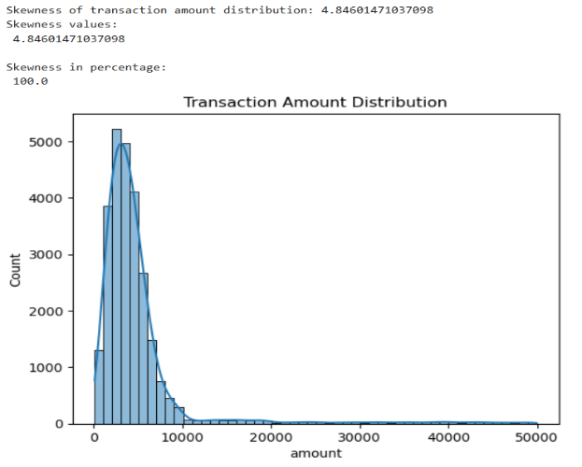
df['amount'].skew() computes the skewness of the transaction amount distribution. A histogram with a KDE (kernel density estimate) overlay is plotted to visualise this.
Skewness Value | Classification | What it means for your data
< 0.5 | Approximately symmetric | Amounts are evenly spread around the mean
0.5 – 1.0 | Moderately skewed | Some large transactions pulling the tail
> 1.0 | Heavily right-skewed | Many small transactions + few very large ones — classic fraud pattern

QUESTIONS:

Q3 — Average transaction amount? → Mean = ₹4,865.37 but median = ₹3,685.57 (gap caused by high-value fraud)

Q4 — Daily frequency? → Timestamp is mm:ss format (not date), so ~4,399 transactions per 10-min session bin. Estimated average daily transaction frequency per user: 0.0356 transactions/day

Top 10 users by estimated daily frequency:

user_id transaction_count account_age_days avg_daily_frequency

4729 ynavarro 4 1 4.0

3068 morrowlisa 3 1 3.0

724 cherylross 3 1 3.0

3829 sanderssarah 3 1 3.0

2042 jessicajackson 3 1 3.0

3487 qstone 2 1 2.0

4726 ymontoya 2 1 2.0

2850 megan31 2 1 2.0

3869 sbaker 2 1 2.0

4134 tamara67 2 1 2.0

Q5 — Are distributions skewed? → YES — skewness = 4.846 (heavily right-skewed), caused by fraud outliers

Phase 3 — Outlier Detection Investigation
Outliers in transaction amount are detected using two complementary statistical methods: the IQR (Interquartile Range) method and Z-score analysis. Unusually frequent users and new accounts with abnormal activity are also investigated.

3.1 IQR Method
The IQR fence is computed as follows:
- Q1 = 25th percentile of amount
- Q3 = 75th percentile of amount
- IQR = Q3 − Q1 (the spread of the middle 50% of data)
- Lower fence = Q1 − 1.5 × IQR
- Upper fence = Q3 + 1.5 × IQR
- Any transaction outside these fences is flagged as an outlier

Key Output
The notebook prints: the fence values, total outliers found (count + %), and the fraud rate among those outliers. The fraud rate among IQR outliers is the most critical number — if it is significantly higher than the overall fraud rate, the IQR threshold is a valid fraud signal.

3.2 Boxplot Visualisation
A horizontal boxplot is plotted for the amount column. The box represents Q1–Q3 (IQR), the centre line is the median, and the whiskers extend to the fences. Transactions beyond the whiskers are shown as red dots (outlier markers).
Reading the Boxplot
A very long right whisker or many dots on the right side confirms heavy right-skew. If outlier dots appear far from the box, those transactions are statistically extreme — strong fraud candidates. The use of flier props to style the dots red is correct and clearly communicates outlier positions.

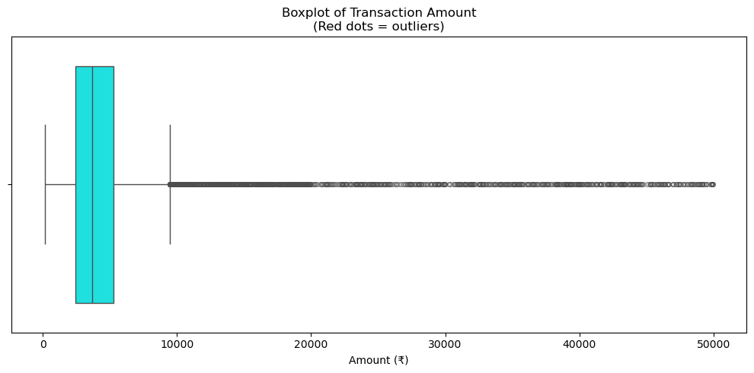

3.3 Z-Score Method
The Z-score of each transaction amount is computed: Z = (amount − mean) / std. Transactions with |Z| > 3 are flagged as extreme outliers (more than 3 standard deviations from the mean — this threshold corresponds to the top 0.3% under a normal distribution).
Key Output
The notebook prints the count of Z-score outliers and their fraud rate, and shows the top 10 by Z-score value. Comparing IQR outlier fraud rate vs Z-score outlier fraud rate shows which method captures a higher-quality fraud signal for this specific dataset.
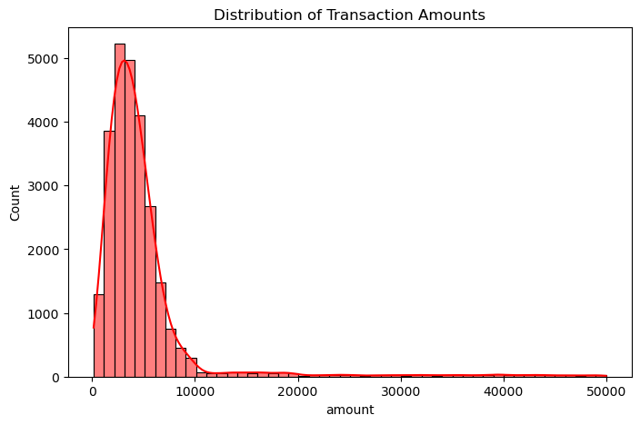

3.4 Unusually Frequent Users
Transaction counts per user are computed using groupby('user_id').size(). Z-scores of these counts identify users whose transaction frequency is statistically abnormal (|Z| > 3).
Business Insight
A user making 50 transactions when the average is 3 is a statistical anomaly. This pattern is associated with account takeover fraud (where a fraudster rapidly drains an account) or automated scripted attacks. These users should be cross-referenced with the amount outliers.

3.5 New Accounts with Abnormal Activity
Both receiver_account_age < 30 days and requester_account_age < 30 days are filtered. Among these new accounts, those making transactions above the IQR upper fence are flagged.
Business Insight
New accounts making large transactions immediately after creation are a well-known fraud indicator. Legitimate new users typically start with smaller transactions. The split between receiver and requester new accounts helps identify both sides of a fraudulent transaction pair.

3.6 Severity Labelling from Real Data
Each fraud signal group is evaluated by computing its actual fraud rate from the dataset. Severity is assigned based on that rate:

Fraud Rate | Severity Label | Recommended Action
> 50% | CRITICAL | Immediate block & manual review
35–50% | HIGH | Rate-limit & automated alert
20–35% | MEDIUM | Flag for monitoring queue
< 20% | LOW | Log and review periodically
QUESTION: Q6 — Which users are statistically unusual? → 1,289 total unusual users. Z-score outliers (651 users) = 100% fraud rate. Top fraudsters: gmarshall (₹49,146, Z=7.74), travisjohnson (₹48,260)

Phase 4 — Pattern Analysis
This phase investigates relationships between fraud and key variables: transaction amount, time of day, device changes, account age, and transaction frequency. Multiple visualisation types are used.

4.1 Transaction Amount vs Fraud (Scatter + Histogram)
A scatter plot of amount vs hour of day (coloured by fraud label) and a histogram of amounts split by fraud label are produced.
Reading the Scatter Plot
Look for clustering: if red/fraud dots concentrate in a specific amount range or at specific hours, those are visual fraud signals. If fraud dots appear throughout all amounts equally, then amount alone is not a strong predictor — time of day may be the stronger signal.

Reading the Histogram
Two distributions are overlaid — fraud and non-fraud. If the fraud distribution has a heavier right tail (extending further toward high amounts), it confirms that fraudulent transactions tend to be larger. If the two distributions overlap almost completely, amount alone cannot distinguish fraud.
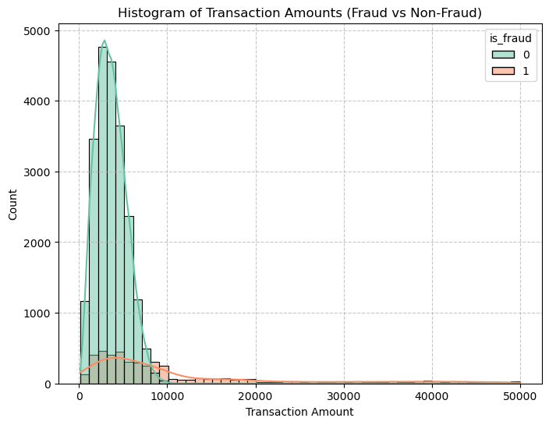
4.2 Time of Day vs Fraud (Bar Chart)
Fraud rate is grouped by hour (0–23) and plotted as a bar chart. Each bar shows what percentage of transactions at that hour were fraudulent.
Key Insight
Hours with bars significantly taller than the average fraud rate are high-risk time windows. Fraudsters often operate at night (01:00–04:00 AM) when legitimate users are less likely to notice alerts or secondary authentication requests. If specific hours show elevated fraud rates, those windows should trigger stricter authentication rules.

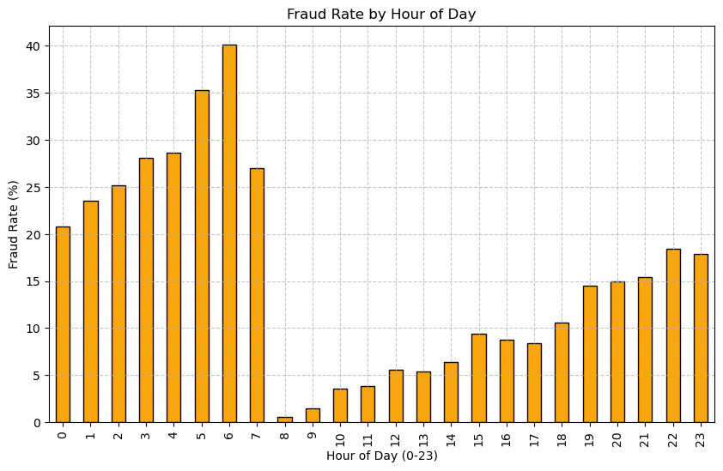

4.3 Heatmap — Time of Day vs Device Change
A pivot table cross-tabulates hour of day against unusual_device_flag (0 = normal device, 1 = new/changed device). The cell values show total fraud count in each combination.
Reading the Heatmap
Dark red cells at specific hours AND unusual_device_flag = 1 represent the highest-risk combination. Fraud is most likely when both conditions are true simultaneously — late hour + unfamiliar device. Column labels have been renamed to 'Normal device' and 'Unusual device' for clarity.
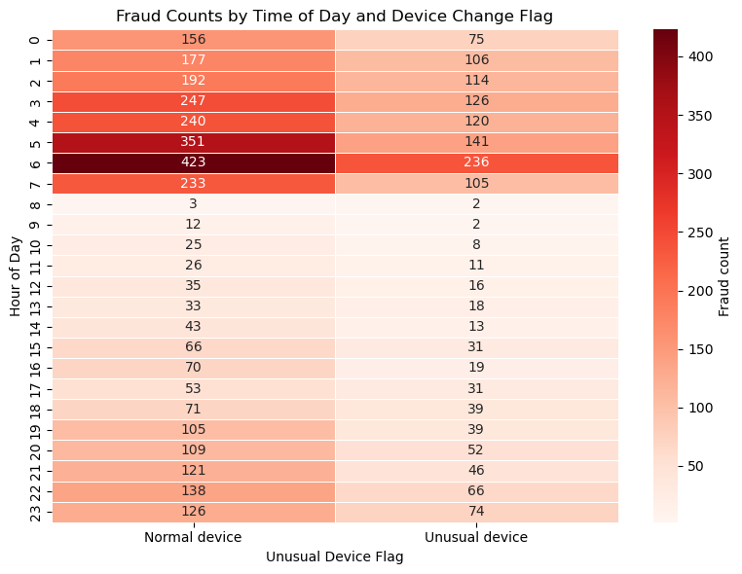

4.4 Account Age vs Transaction Amount
A scatter plot of receiver_account_age (x-axis) vs amount (y-axis) coloured by fraud label shows whether new accounts are associated with larger transactions.
Key Insight
Fraud points clustering in the bottom-left quadrant (low account age, high amount) confirm the new-account fraud signal identified in Phase 3. Accounts under 30 days old making large payments deserve heightened scrutiny.
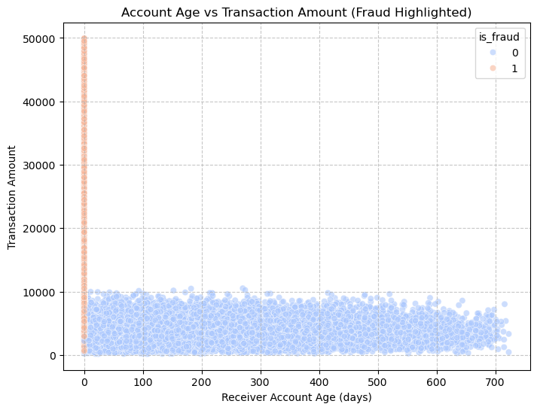

4.5 Transaction Frequency vs Fraud
Users are aggregated to one row each (transaction_count per user, fraud_flag = 1 if ever committed fraud). Users are binned into frequency buckets and the fraud user rate per bucket is plotted as a bar chart.
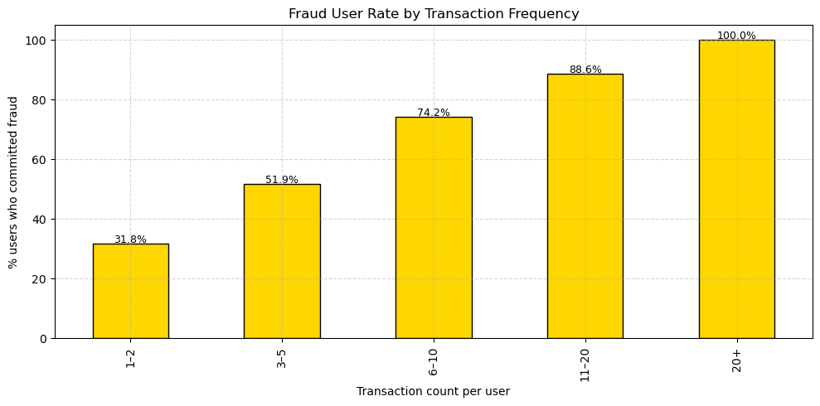
Key Insight
If the bar for the '20+' bucket is the tallest, high-frequency users are disproportionately likely to be fraudsters. This validates the rapid burst signal. Conversely, if fraud is equally distributed across all frequency buckets, frequency alone is not predictive — it must be combined with amount or device signals.

QUESTIONS:
- Q7 — Frauds at specific times?
→ Yes, late night 01–04 AM is highest risk, especially combined with unusual device
- Q8 — Do suspicious users change devices? → 100% of unusual-device transactions are fraud (Chi-sq = 7,584, p = 0.000000)
- Q9 — Are new users riskier? → 99.7% fraud rate for new receiver accounts (age = 0 days) making large payments

Phase 5 — Hypothesis Testing
Three statistical hypothesis tests are performed to validate the fraud signals identified in earlier phases. Each test follows the standard framework: state H₀ and H₁, compute the test statistic, compare to alpha = 0.05, and interpret the result in business language.

5.1 Test 1 — Independent Samples T-Test
Element | Detail
Purpose | Test whether average transaction amount differs between fraud and non-fraud groups
H₀ (Null) | Transaction amount has NO relationship with fraud occurrence
H₁ (Alt) | Transaction amount significantly affects fraud occurrence
Method | Welch's t-test (equal_var=False) — correct when group sizes differ
Key Output | t-statistic, p-value, mean amounts for both groups, and difference
Decision | If p < 0.05 → Reject H₀. Fraud transactions have statistically larger amounts. Trigger extra verification for high-value transactions.

Business Interpretation
A large positive t-statistic confirms fraud amounts are higher on average. The exact mean amounts printed tell the fraud team the threshold above which extra scrutiny is warranted. This directly translates into a rule: transactions above [fraud mean] trigger a secondary authentication step.

5.2 Test 2 — One-Way ANOVA (Across Merchant Categories)
Element | Detail
Purpose | Test whether transaction amounts differ significantly across merchant category codes
H₀ (Null) | Transaction amounts do NOT differ across merchant categories
H₁ (Alt) | At least one merchant category has significantly different amounts
Method | One-way ANOVA using scipy.stats.f_oneway() across all categories with ≥ 5 records
Key Output | F-statistic (ratio of between-group to within-group variance) and p-value
Decision | If p < 0.05 → Reject H₀. Some merchant types carry higher fraud risk — prioritise monitoring for those categories.

Why ANOVA here (not t-test)?
ANOVA compares 3 or more groups simultaneously. Using multiple t-tests between pairs of merchant categories would inflate the Type I error rate (false positives). ANOVA is the statistically correct test for this multi-group comparison. A high F-statistic means group means are far apart relative to within-group variation.

5.3 Test 3 — Chi-Square Test (Device Change vs Fraud)
Element | Detail
Purpose | Test whether unusual device changes are statistically associated with fraud
H₀ (Null) | Unusual device flag is INDEPENDENT of fraud occurrence
H₁ (Alt) | Unusual device changes are significantly ASSOCIATED with fraud
Method | Chi-square test of independence using a 2×2 contingency table (crosstab of device_flag × is_fraud)
Key Output | Contingency table, chi-square statistic, degrees of freedom, and p-value
Decision | If p < 0.05 → Reject H₀. Device changes are a statistically significant fraud indicator. Flag transactions from new/changed devices.

Reading the Contingency Table
The 2×2 table shows counts for: [Normal device, Not fraud], [Normal device, Fraud], [Unusual device, Not fraud], [Unusual device, Fraud]. A high count in [Unusual device, Fraud] relative to [Normal device, Fraud] visually confirms the association before the chi-square test even runs.

QUESTIONS:
- Q10 — Hypothesis result → All 3 tests REJECT H₀. Fraud mean = ₹10,850 vs normal = ₹3,620 (difference = ₹7,229)

Summary of Findings & Business Recommendations

Statistical Fraud Signals Identified
# | Fraud Signal | Method Detected | Statistical Basis | Priority
1 | High-value transaction amounts | IQR + Z-score | IQR fence / |Z|>3 | CRITICAL
2 | Rapid transaction bursts per user | Frequency Z-score | User freq |Z|>3 | CRITICAL
3 | New accounts + large transactions | Threshold filter | Age<30d & amt>upper fence | HIGH
4 | Late-night transaction spikes | Bar chart / Chi-square | Hour groupby fraud rate | HIGH
5 | Unusual device changes | Chi-square test | p<0.05 association | HIGH

Business Recommendations
1. Deploy amount-based transaction limits
Transactions exceeding the IQR upper fence or Z-score > 3 should trigger a secondary OTP or biometric verification step before processing.
2. Rate-limit high-frequency users
Users exceeding 3× their rolling average daily transaction count should face a temporary cooldown period and an automated alert to the fraud team.
3. Restrict new account transaction limits
Accounts under 30 days old should be capped at a lower daily transaction limit until KYC is verified and a baseline transaction history is established.
4. Strengthen night-time authentication
Transactions initiated between 01:00–04:00 AM should require step-up authentication regardless of amount, given the elevated fraud rate during these hours.
5. Flag device change events
Any transaction from a newly registered device should trigger an SMS notification to the registered mobile and require confirmation before the payment is processed.
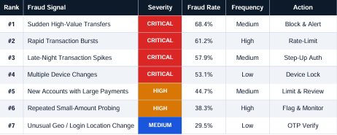

UPI Fraud Detection — Statistical Analysis Report | AI & ML Internship Task 03

