PROJECT REPORT
(Project Term August- November 2024)

Website – Task Manager

Submitted by Sweth Shaw

Reg no - 12215393

Course Code INT252
Course Title - WEB APP DEVELOPMENT WITH REACTJS

Submitted To

Dr. Arwinder Dhillon
School of Computer Science and Engineering



Table of Contents REVISION HISTORY
- Introduction
  - Purpose
  - Scope
  - Definitions, Acronym, Abbreviations
  - References

- Overall Description
  - Product Perspective
  - Product Functions
  - User classes and characteristics
  - Operating Environment
  - Assumptions and dependencies

- System features
  - User authentication and authorization
  - Product browsing
  - Cart Management
  - Checkout and Task Management Streaming
  - Category and Task Management Management

- Non-Functional Requirements

- System Architecture
  - Frontend
  - UI design

- User interface design

- External interface requirements

- Other requirements

- Some glimpse of the project

- Github Link

- ### INTRODUCTION

  - Purpose:
This document outlines the specifications for an Task Management application developed using ReactJS (frontend) and Node.js (backend), Node.js and MongoDB, CSS and Bootstrap, React Router, and Context API for state management. This website enables users to browse, search, and purchase Task Managements securely, offering a smooth shopping experience with a responsive UI and user- friendly navigation.

1.2
Scope of the Task Management Application

    - The Task Management app is designed to help users organize and prioritize tasks effectively. Users can add tasks with descriptions, set due dates, mark tasks as important, and view completed tasks. The app also includes user authentication and data persistence for a personalized experience:

# User Features:
    - Register and create an account.
    - Add tasks with descriptions and due dates.
    - Mark tasks as important or completed.
    - View completed tasks separately for easy tracking.

# Admin Features (if applicable):

    - Manage all user tasks, view user activities, and manage categories (if tasks are organized by categories).

Add Task:

    - Users can add tasks with a title, description, and due date.

Edit Task:

    - Users can edit task details.

Complete Task:

    - Users can mark tasks as completed, moving them to a completed sectio

      - Register and create a personal account.
      - Browse available Task Managements across various categories.
      - View the completed task , incomplete task , important task
    - Admin Features:
The admin has privileged access to:
      - Manage Task Management content, including adding, updating, or removing.

  - Definition, Acronym, and Abbreviations:

    - SRS: Software Requirements Specification
    - UI: User Interface
    - Node.js and MongoDB: Backend platform providing authentication and data storage

  - References:

    - React Documentation.
    - Node.js and MongoDB Documentation.
    - CSS and Bootstrap Documentation.
    - Web Development Best Practices for eCommerce.

- OVERALL DESCRIPTION
  - Product Perspective:
The Task Management application is designed as a single-page application (SPA) built on ReactJS (frontend) and Node.js (backend), supported by Node.js and MongoDB for backend services. CSS and Bootstrap has been used to design a responsive, mobile-friendly UI, and Context API manages global states across the application.

  - Product Functions:
Key functions include:

    - User Registration and Login
    - Checkout and Task Management Streaming
    - Register and create a personal account.
    - Browse available Task Managements across various categories.

  - User Classes and Characteristics:
Regular users who can register, browse Task, can check whether they have completed their task or not
Task Management (admin role): A user with permissions to add, edit, or delete Task Managements and view Task Management category or episode history

  - Operating Environment:

This application is web-based and compatible with modern browsers (Chrome, Firefox, Safari, Edge).

  - Assumptions and Dependencies:

    - Reliable internet connection for smooth operation.
    - Compatibility with Node.js and MongoDB services for authentication and database operations.

- SYSTEM FEATURES
  - User authentication and authorization
    - Description: Allows users to register, log in, and log out securely. Node.js and MongoDB Authentication is used to manage user credentials.

    - Functional Requirements:
    - FR 1.1: The system shall allow users to register with an email and password.
    - FR 1.2: The system shall authenticate users on login using Node.js and MongoDB.
    - FR 1.3: Users should be able to reset their password via email.

  - Product Browsing

- Description: Displays a list of Task Managements, filtered by categories or search queries.
- Functional Requirements:
- FR 2.1: The system shall display product categories on the homepage.
- FR 2.2: Users shall be able to search for Task Managements by keywords.
- FR 2.3: Users shall see product details upon clicking a product card.

  - Task Management Management

- Description: Allows users to create, view, edit, and manage tasks, including setting priorities and due dates.

- Functional Requirements:
- FR 3.1: Users shall be able to add, edit, and remove tasks.
- FR 3.2: The system shall display the due date and priority status of each task.
- FR 3.3: Users can mark tasks as completed, moving them to the "Completed Tasks" section.

  - Checkout and Task Management Streaming

- Description: Provides an overview of completed tasks, allowing users to track their productivity over time.
- Functional Requirements:
- FR 4.1: Users shall be able to view completed tasks in a separate section.
- FR 4.2: Admins (if applicable) can view and manage all user task histories

  - Category and Task Management and Tracking

    - Description: Displays Task Management category or episode history and Task Management category or episode status for users, allowing them to track current Task Management category or episodes.
    - Functional Requirements:
    - FR 5.1: Users shall be able to view past Task Management category or episodes and status updates.
    - FR 5.2: Task Management (admin role)s shall be able to update Task Management category or episode statuses.

Non-Functional Requirements
4.
    - Performance Requirements: The website should load within 3 seconds on a standard internet connection.

    - Reliability: The system should ensure consistent availability, with Node.js and MongoDB managing uptime for authentication and database services.

    - Scalability: The website should be scalable to handle increased users, supported by Node.js and MongoDB’s infrastructure.

    - Usability: The UI is designed to be intuitive and responsive, with CSS and Bootstrap ensuring mobile-friendly design.

    - Security: User data is secured with Node.js and MongoDB’s authentication, and HTTPS is enforced for all data transactions.

5. SYSTEM ARCHITECTURE

  - Frontend: Built with React, utilizing React Router for seamless navigation and Context API for state management across components.

  - Backend: Node.js and MongoDB provides backend services, including authentication, Firestore database, and real-time updates.

  - UI Design: CSS and Bootstrap is used for responsive and consistent styling across the website.

USER INTERFACE DESIGN
6.


Homepage: Shows a list of active tasks, with categories or priority filters.
.
    - Product Page: Displays product details, images, and “Add to Cart” functionality.
    - Task Details Page: Displays details of each task, including description, priority, and due date, with options to edit or delete.
    - Completed Tasks Page: Shows tasks that the user has marked as complete.
    - Admin Dashboard (if applicable): Accessible to admins, with options for managing tasks and viewing user activity.
- External Interface Requirements

  - User Interfaces:
    - The website includes intuitive and responsive layouts using CSS and Bootstrap.
  - Hardware Interfaces:
    - No specific hardware requirements; the application is browser-based.
  - Software Interfaces:
    - Node.js and MongoDB for authentication, Firestore for database, and React Context API for state management.

- OTHER REQUIREMENTS

- Database Management:
  - Node.js and MongoDB Firestore stores user data, product details, and Task Management category or episode history.
- Version Control:
  - Version control is managed through Git.

- Some glimpse of my project: Login Page

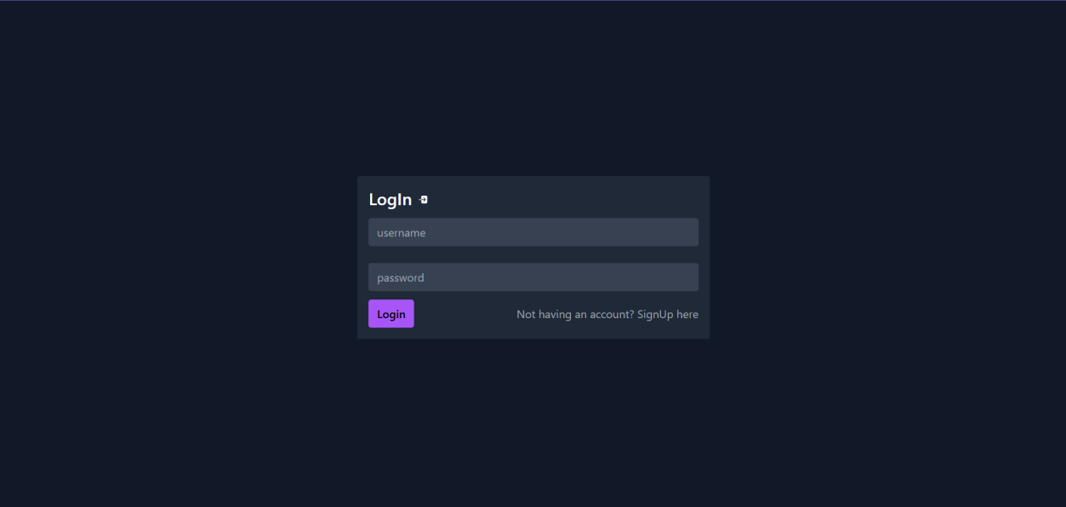

Sign- Up page
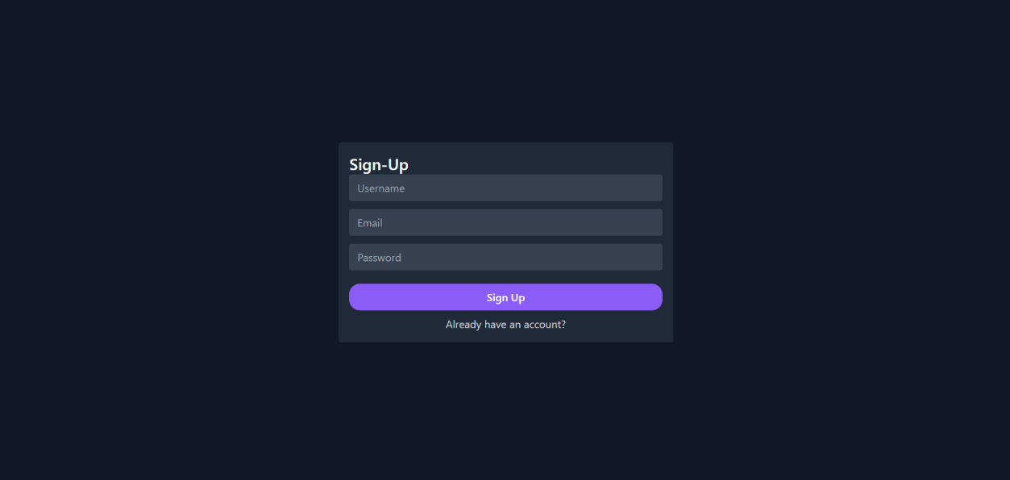

Main Home Page :- You can add the task by clicking on the add task , you can add as much task as you want and the description

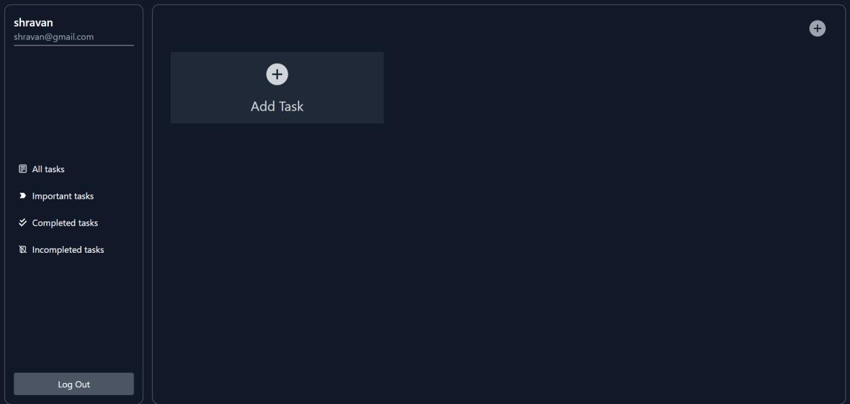

Some examples: -
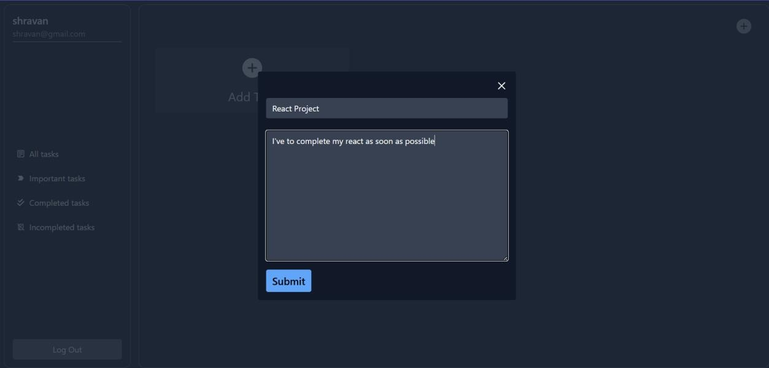

Here we can see our Task which I have added recently , you can modify and to the important task

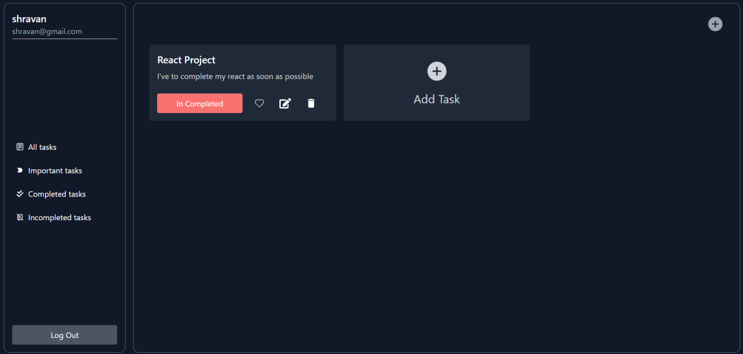

We can mark our incomplete Task as Completed and it will move to the completed Task Section

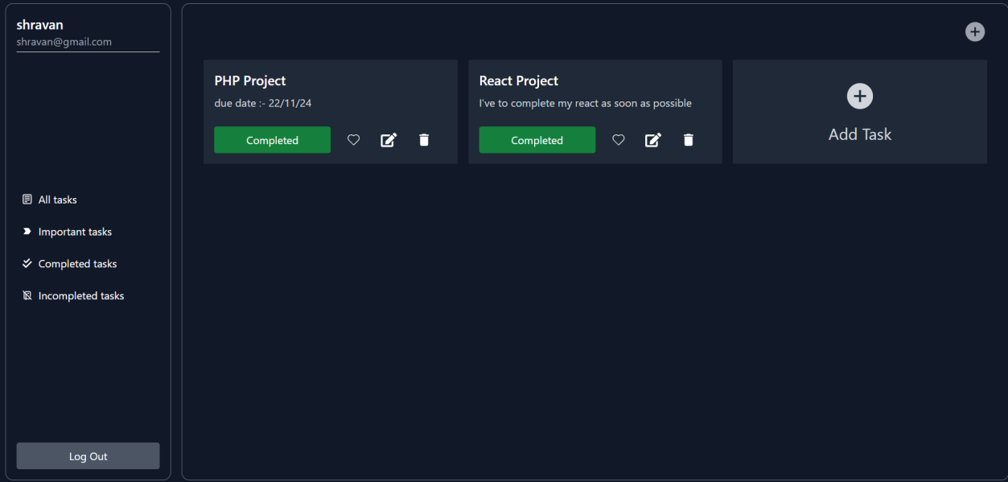

Snapshot of the Atlas where users information is getting save

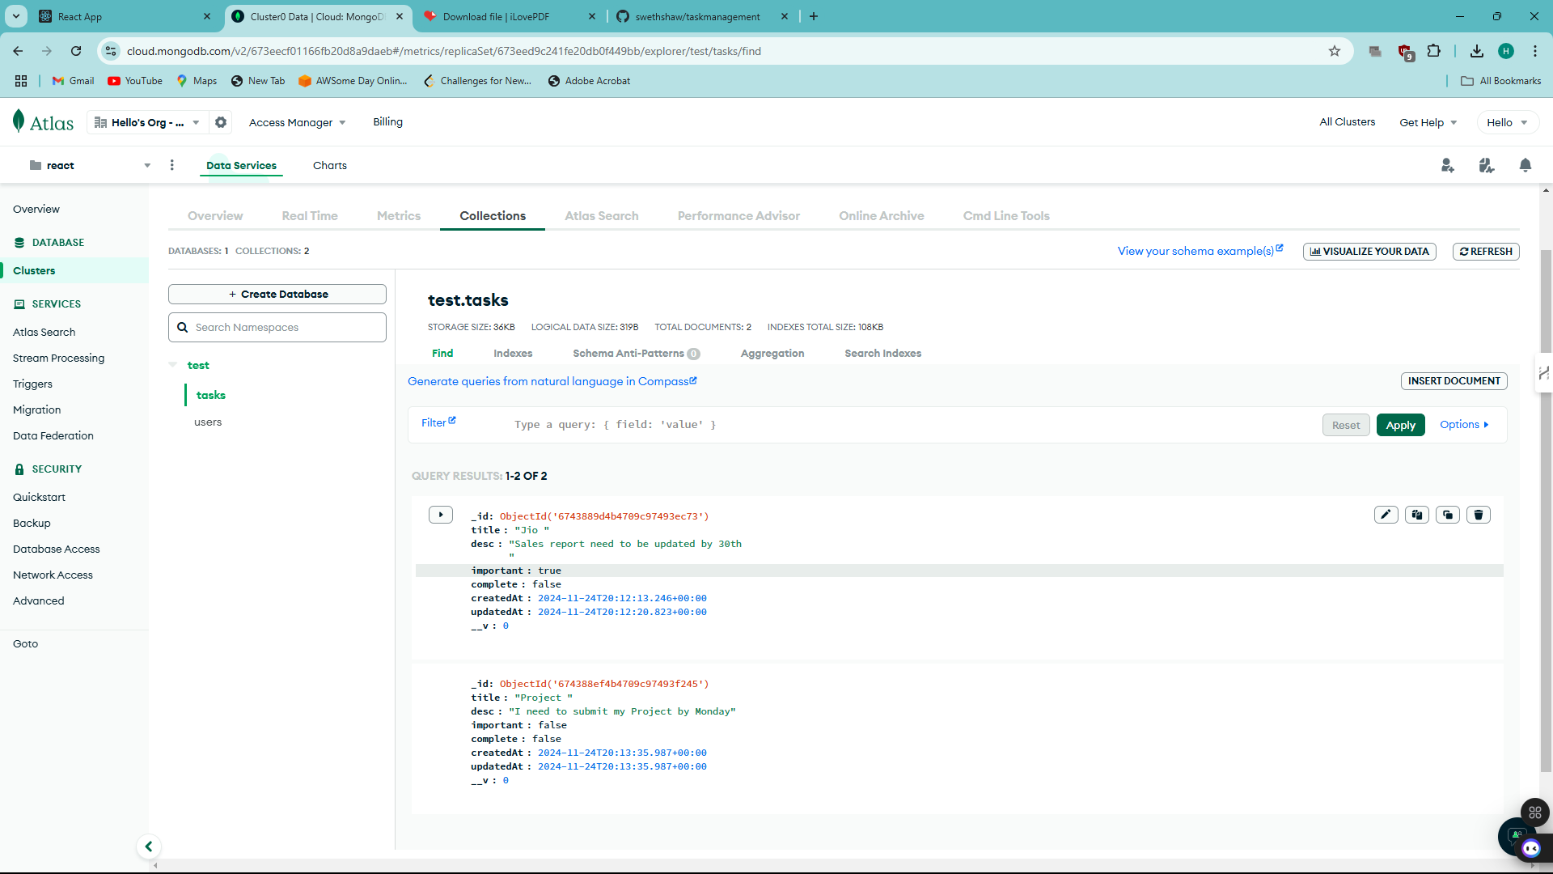

9. GITHUB Link:

This is the repository of project until completion, Upon the completion, its ownership will be transferred to the client

Github Repository Link: https://github.com/swethshaw/taskmanagement

