**Capabilities Built:**

1. Total typing time and random sentences parametrized in constants.js file.
2. Copy pasting into input area restricted.
3. Current character to type is highlighted with blue font colour and grey background, with slightly bigger font size.
4. Wrongly typed character highlighted in red font colour.
5. Wrongly typed space is highlighted with orange background.
6. Number of errors & Accuracy % updated as when typed.
7. Number of errors & Accuracy % re-set as when typing is corrected.
8. Timer updated periodically in seconds.
9. Timer colour changed to red when reached last 40% remaining time.
10. Words Per Minute (WPM) & Characters Per Minute displayed after time-out.
11. Input screen restricted for copy pasting text into it.
12. Input screen frozen when time is up.
13. Content to be typed from content-display area is auto populated with the next random sentence when current sentence is completed typing.
14. Restart button displayed once current testing is time up.
15. Test is restarted when restart button is clicked.

**Click on ‘Start Typing Here’ to start the test**

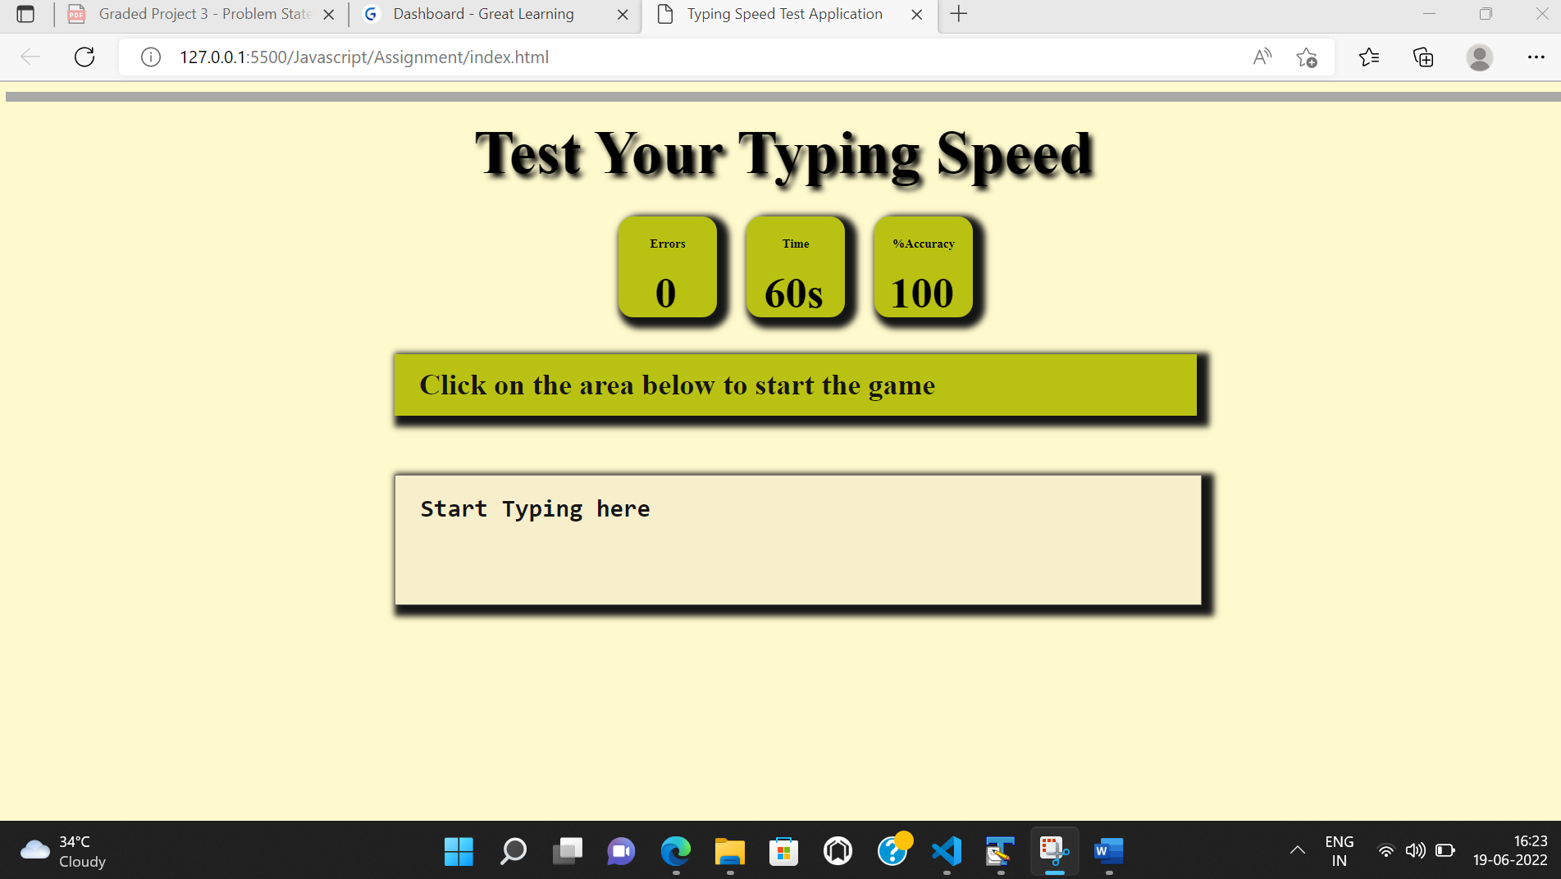

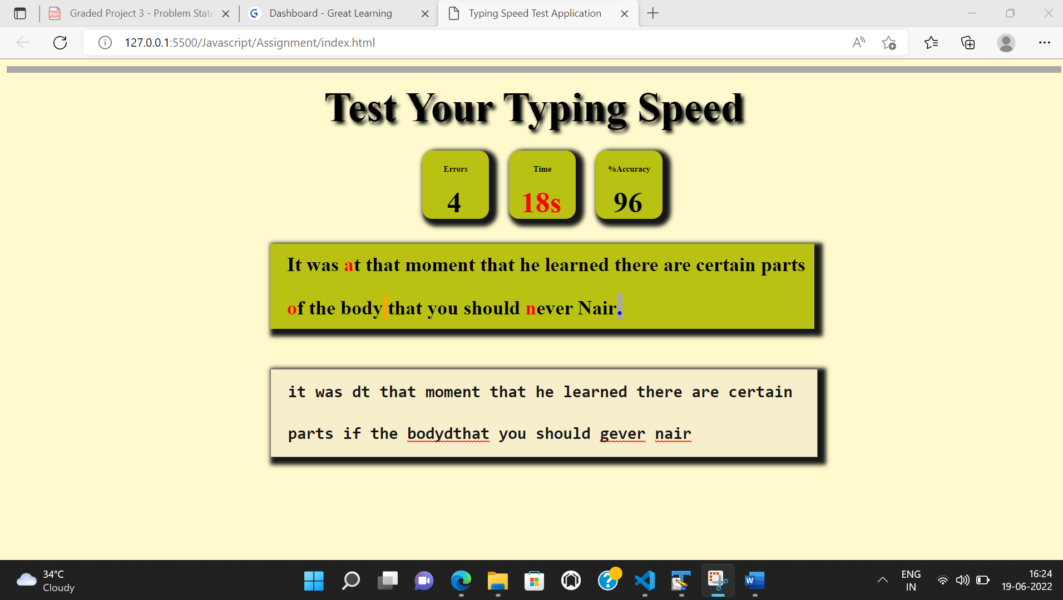

**Input Screen frozen when time is up**

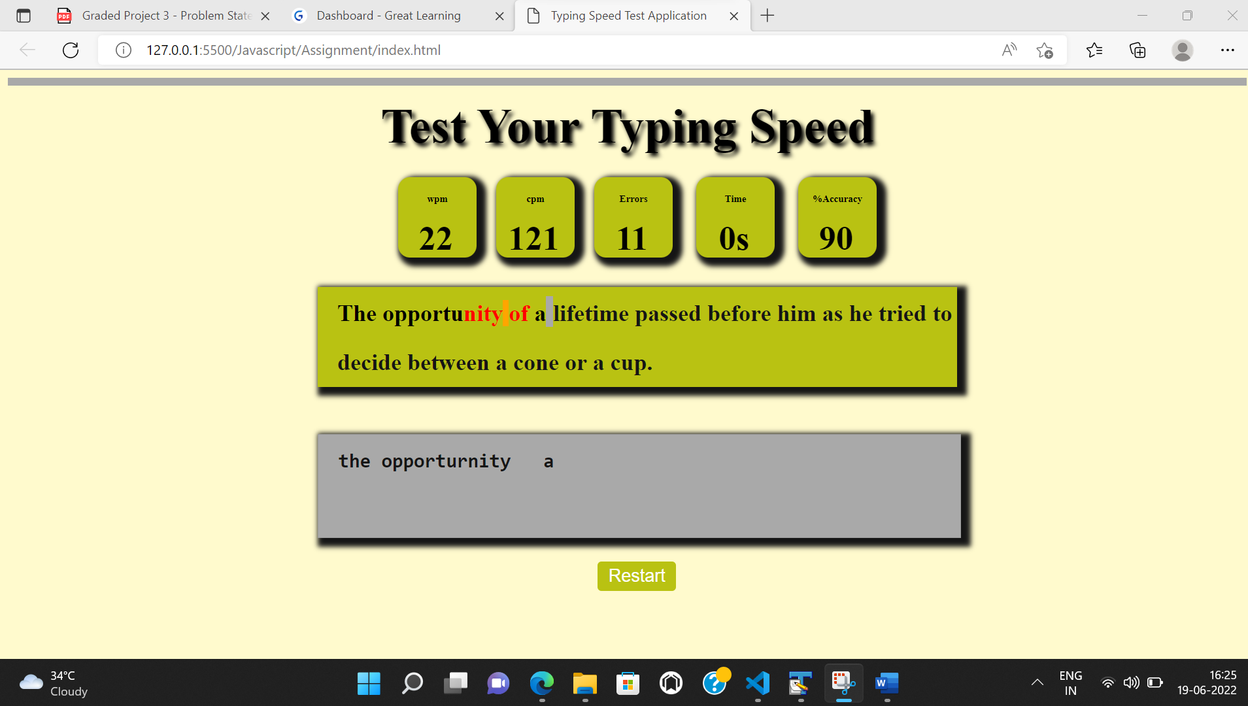

**Restart Button enabled and highlighted when hoverd**

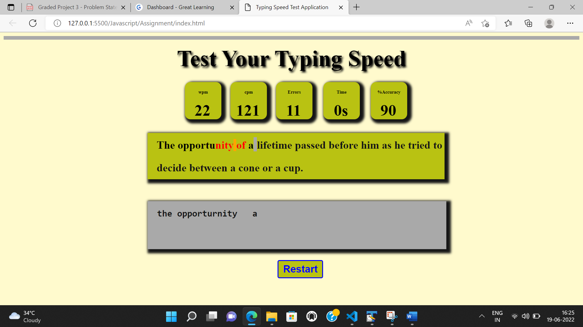

**Restart test**

