|  |
| --- |
| CGI |
| LAB REPORT |
| LAB-CI/CD |
|  |
| **SWET SHEERSH** |
| **8/12/2023** |

|  |
| --- |
| This report contains CI/CD codes and their output snapshots. |

[**ci-assignment-ii**](https://gitlab-cgi.stackroute.in/cgi-sdet-assignments-fy2324/ci-assignment-ii)

**.gitlab-ci.yml  file:**

image: docker:19.03.1

before_script:

- apk add --update openjdk11 maven

stages:

- Clean

- Compile

- Test

- Package

Clean:

stage: Clean

script:

- echo "Cleaning workspace..."

- rm -rf target

Compile:

stage: Compile

script:

- echo "Compiling..."

- mvn compile

Test:

stage: Test

script:

- echo "Running tests..."

- mvn test

Package:

stage: Package

script:

- echo "Packaging..."

- mvn package

after_script:

- echo "Pipeline completed."

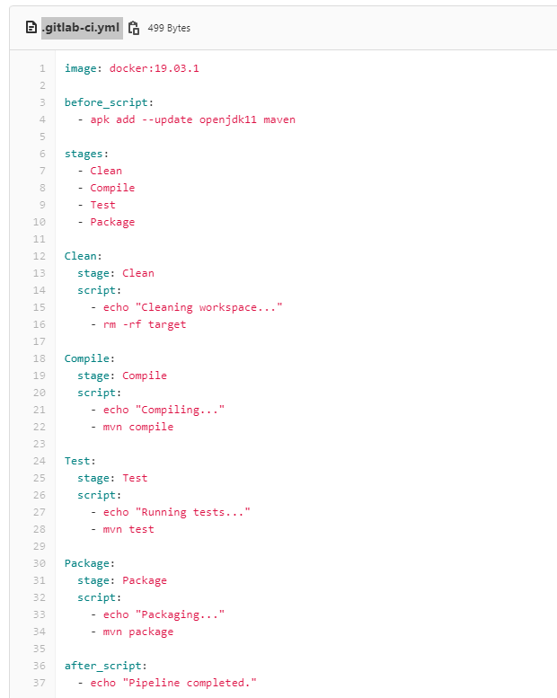

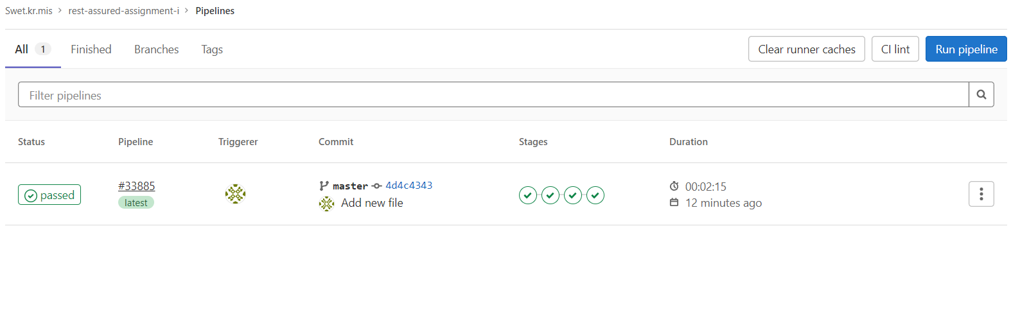

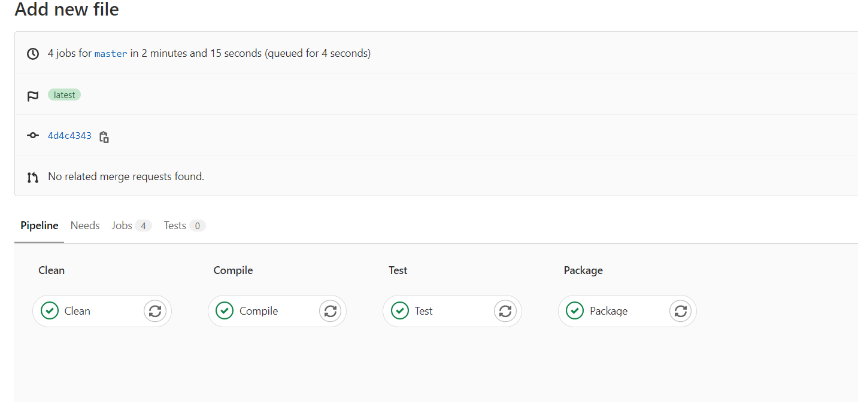

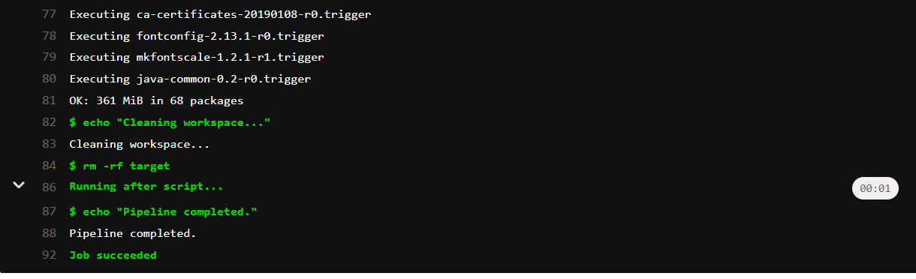

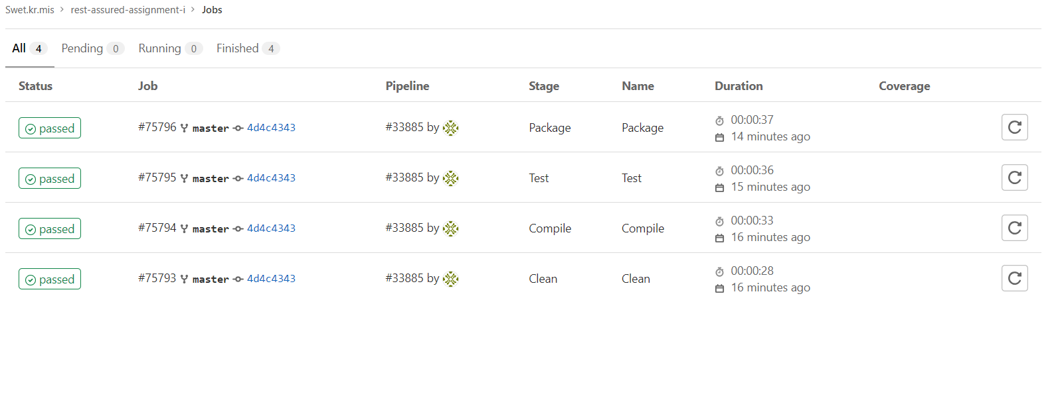

**Jenkins:**

pipeline {

agent any

stages {

stage('Clean') {

steps {

dir("C:\\Users\\HARSH\\Desktop\\CGITranning\\RestAssuredAssign\\rest-assured-assignment-i") {

echo 'Cleaning workspace...'

// Add any clean-up steps you need here

bat 'rd /s /q target'

}

}

}

stage('Compile') {

steps {

dir("C:\\Users\\HARSH\\Desktop\\CGITranning\\RestAssuredAssign\\rest-assured-assignment-i") {

echo 'Compiling...'

bat 'mvn compile' // Use "bat" for Windows batch commands

}

}

}

stage('Test') {

steps {

dir("C:\\Users\\HARSH\\Desktop\\CGITranning\\RestAssuredAssign\\rest-assured-assignment-i") {

echo 'Running tests...'

bat 'mvn test' // Use "bat" for Windows batch commands

}

}

}

stage('Package') {

steps {

dir("C:\\Users\\HARSH\\Desktop\\CGITranning\\RestAssuredAssign\\rest-assured-assignment-i") {

echo 'Packaging...'

bat 'mvn package' // Use "bat" for Windows batch commands

}

}

}

}

post {

always {

echo 'Pipeline completed.'

}

}

}

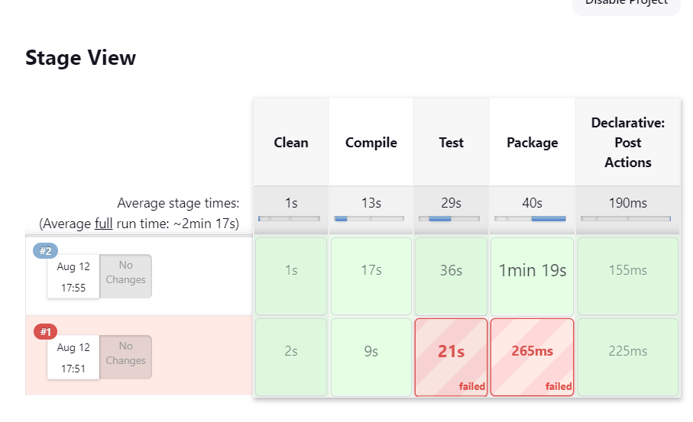

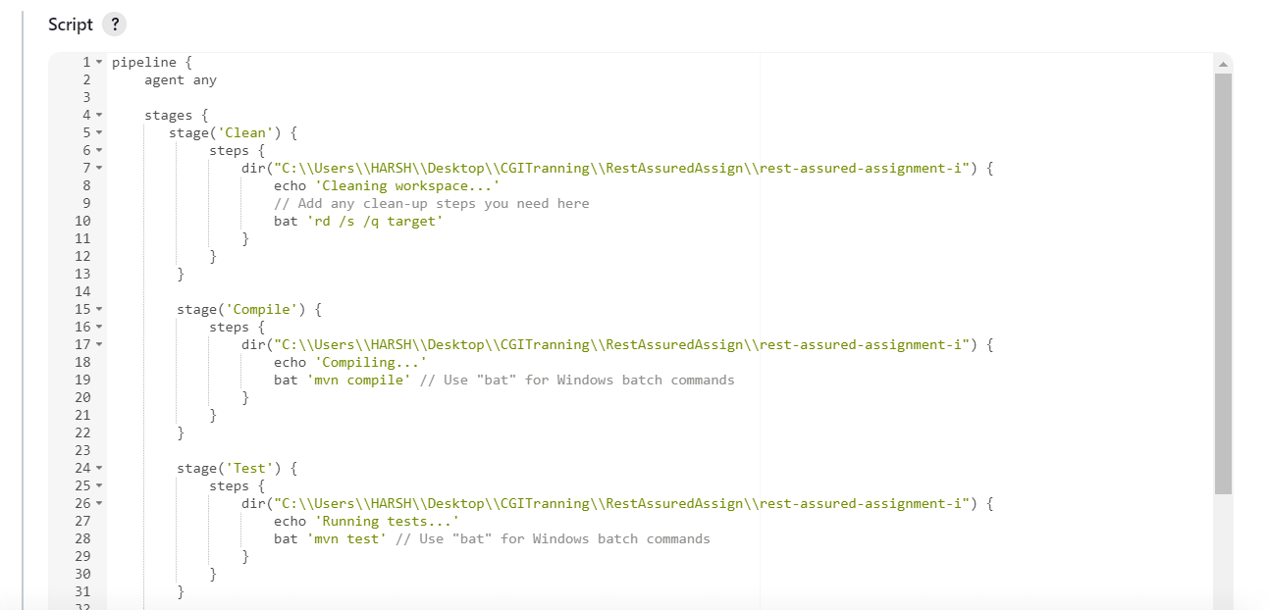

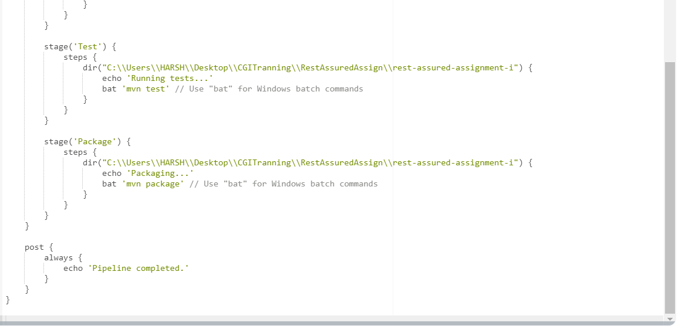

Thank You…