[1]

Design and Implementation of Efficient Battery Management System (Cell Balancing Module)

1 Ei Mon Soe, 2 Myint Myint Than, 3 Pyone Ei Ei Shwe

1,2,3 Department of Electronic Engineering Yangon Technological University, Yangon

[*1soemoneimgy@gmail.com*](mailto:1soemoneimgy@gmail.com)

[*2myintmyintthan.ec@gmail.com*](mailto:2myintmyintthan.ec@gmail.com)

[3 *libra.shwe*@gmail.com](mailto:3%20libra.shwe@gmail.com)

*Abstract*—This paper presents design and implementation of efficient battery management system (BMS). Battery Management System is the useful and popular system nowadays. Most of electronic devices are used this system for safety. The Battery management system which monitors and controls the voltage, current and temperature. In this paper, using cell voltage balance block to protect over charging and discharging and to know the voltage for each battery while charging. This block is comprised by PC817, IRF 540N MOSFET and voltage divider network. This cell balancing method is passive cell balancing. Moreover, LM35 temperature sensor is used to measure the battery temperature. PIC 16F887 is using to control the battery’s voltage, current and temperature, prevent from unsafe conditions such as overheating, over charging or discharging and then display on LCD. MikroC language is used for program. Design and implementation will be done by using PC 817, IRF 540, PIC 16F887, ACS 712 current sensor, LM35 and LCD display.

***Keywords*** *—Battery Management System (BMS), MikroC language, PIC 16F887, IRF540N MOSFET, PC 817.*

# INTRODUCTION

Batteries are used in transportation, aerospace, military, and portable devices such as mobile phone and laptops. Battery is the device that convert chemical energy to electrical energy [1-3]. There are two types of battery. They are primary battery which is known as non-rechargeable and secondary called rechargeable battery. There are several types of rechargeable batteries such as Lead acid, Ni-Cd, lithium ion and etc. Some applications using lithium ion battery that consist of battery management system for safety [4-6]. Nowadays, a lot of batteries are connected in series or parallel depends on the applications. In this saturations, batteries can explosive, shortening lifetime and damage. Then, if the same battery type is using, the performance of cells are different from one another due to the usage time [7]. For these reasons, Battery Management System is needed. This system is used to protect the batteries from explosion and unsafe condition, extent the battery lifetime. There are a lot of functions in battery management system depend on applications [8, 9]. The basic functions are to measure the batteries’ voltage, current and temperature, monitoring the battery’s state, control charging and discharging and cell balancing.

The purpose of this system is to maintain the battery’s voltage in the specific range for each battery and prevent overcharging and discharging. It is also measured the temperature to avoid explosion and to protect the batteries from abuse and damage. And then, it must monitor the batteries’ state and to extend the battery life. Lithium ion battery is very popular today. But, it is easy to explosive. In this paper, 12V 7Ah lead acid battery are used. Lead acid battery type is easy to use and safe more than lithium ion battery. Four batteries are connected in series and controlled the batteries’ voltage and temperature. Fig.1 shows the block diagram of battery management system for this paper.



Fig.1 Block diagram of Battery Management System

# Review of Battery Management system

The battery management system is useful embedded system. Battery management system are used in many battery operated industrial and commercial system to make battery operation more efficient and the estimation of battery state [10-11]. Most of electronic devices and electric vehicle can abuse or explosive due to high energy density and high efficient. Battery management system can monitor current and detect input current.

One of the functions for battery management system is cell balancing module. There are two ways for BMS. They are passive and active cell balancing. In passive cell balancing, the threshold value is selected and if different between two cells exceed that threshold then excess energy is wasted through bypass resistors. Passive cell balancing is implemented while charging only [12]. Active cell balancing is a charge redistributed method that is exceeded energy from high charge to low charge cell. It is using inductor or capacitor.

# Technology

The technology of designed Battery Management System comprises PC 817, IRF 540N, PIC 16 F887, LM 35 and LCD display. If the one of the batteries is exceeded the threshold voltage, it is needed to discharge. In this paper PC817 is used as a switch driver and IRF540N is using as a switch. We need to know the temperature. LM35 is using to sense the temperature.

## A. PC817

In PC817 has a transistor which is controlled based on light. When the LED is powered the light from it falls on the transistor and it conducts.PC817 is used to provide electrical isolation between two circuits, one part of the circuit is connected to the IR LED and the other to photo transistor. It is 4 pin DIP 1channel type. The applications are electrical isolation circuits, microcontroller switching circuit, signal isolation, noise coupling circuits, isolation digital from analog circuits and AC/DC power control.

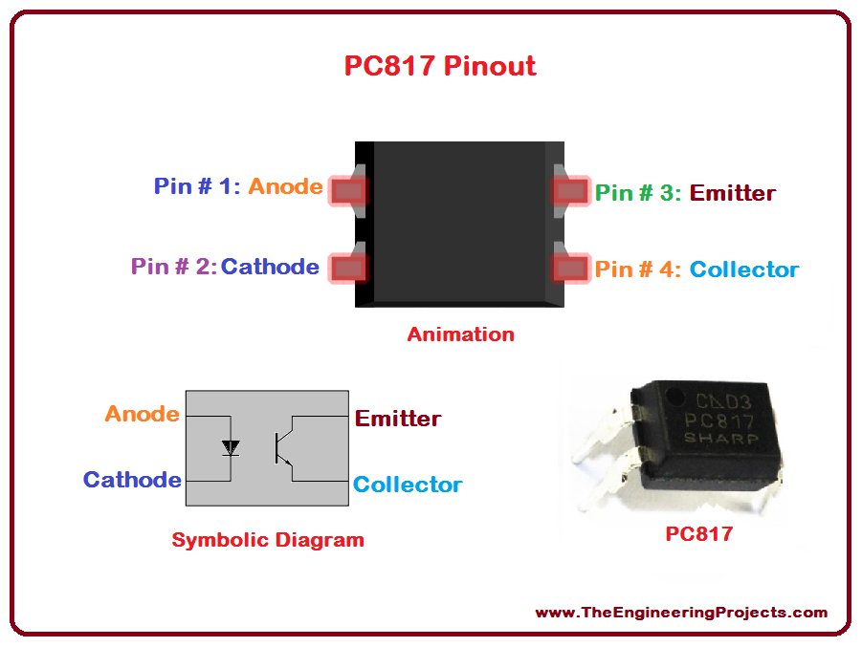

Fig. 2 Pin diagram of PC817

## B. IRF540N

IRF540N is an N channel MOSFET. This MOSFET can drive load upto 23A and threshold voltage is 4V. It has good switching characteristics. The applications are switching high power devices, control speed motors, high speed switching applications and converter or inverter circuits. In this paper, it is used in cell balancing block as a switch.

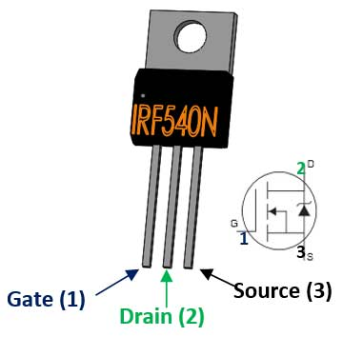

Fig. 3 Pin diagram of IRF 540N

## C. LM35

LM35 is temperature sensor that is used in several applications. It reads the temperature and the output is voltage. Its output is 100mV/1°C. It is used to measure temperature of particular environment, providing for thermal shutdown circuit and checking battery temperature.

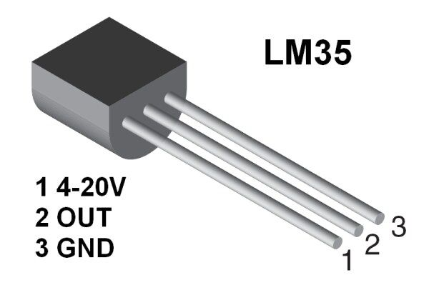

Fig. 4 Pin diagram of LM35

# DESIGN CALCULATION OF THE BATTERY MANAGEMENT SYSTEM

There are four batteries that connected in series in this paper. We need to get 12V in each batteries. 14.5 V is fully charging for each battery. So we determined the threshold voltage is 14.5V. If one of the batteries is more than 14.5, it is overcharging. So, we need to discharge for this battery. Moreover, battery depend on temperature. When the temperature is very high, battery can explosive. So, we need to know the temperature. If the temperature is high, battery will cutoff the power switch.

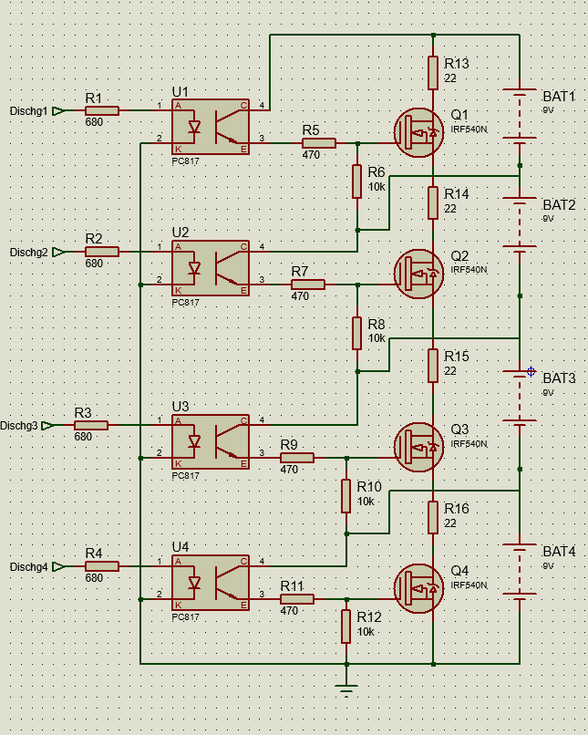

Fig. 5 Cell Balancing Circuit Diagram

Firstly, the cell balancing was designed. PC 817 and IRF 540N are used. In this device PC817 is used as a switch driver and the input is the output of PIC16F887. Therefore, the value of resistors was designed by the following equation;

CTR = current transfer ratio

CTR =120% (from datasheet)

$$I_{C}=6 mA, I_{F}=5 mA, V_{in}=5V,$$

$$CTR=\frac{I_{C}}{I_{F}}×100\%$$

$$CTR=\frac{6m}{5m}×100\%=1.2V$$

$$V_{in}-1.2=3.8V$$

$R=\frac{3.8}{5m}$ =760Ω

R1, R2, R3, R4=680Ω (standard value)

$V_{CC}$ =12V

$V_{CE}$ =5V

$I_{C}$ =15mA (selected from datasheet)

R= $\frac{V_{CC}-V_{CE}}{I_{C}}$

R= $\frac{12-5}{15m}$

R=467Ω

R5, R7, R9, R11=470Ω (selected value)

If the battery is more than 14.5V, it can call overcharging. Using the 7Ah battery, we choose discharge current is 0.68A. We designed the resistor values

$V=IR,$ Let V=14.5V (threshold voltage)

$$14.5=0.68×R$$

$$R=\frac{14.5}{0.68}$$

R=21.3Ω

R13, R14, R15, R16 = 22Ω (selected)

Power dissipation, $P=I^{2}×R$

P= ${0.68}^{2}×$ 22=10W

We choose 22 Ω (10W) resistors to use.

PIC16F887 input is 5V but the output of battery is the input of PIC. So, we used voltage divider circuit. Fig. 6 shows the voltage divider circuit diagram.

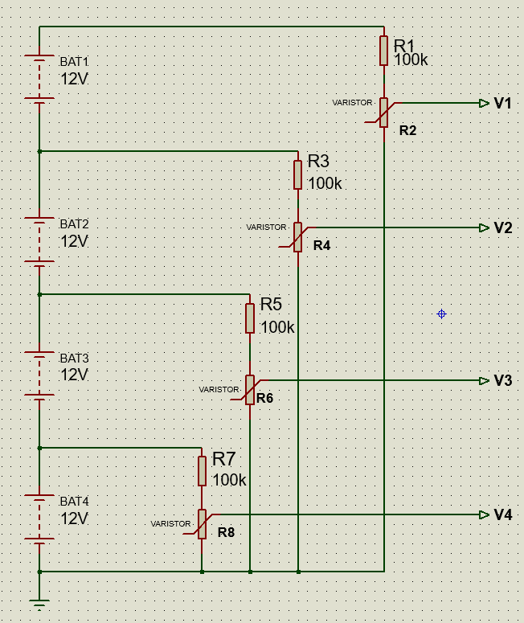

Fig. 6 Voltage divider network

Secondly the voltage divider network is used because of the PIC16F887 input. The output of the batteries is very high but the input of PIC is about 5V. So, we used the voltage division equation to get the input voltage of the PIC16F887.

The threshold voltage is 100V,

5V is the desired voltage,

The following equation is voltage division,

$$V1=5×\frac{Bat volt}{100}$$

There are 4 batteries that is connected in series,

Bat1 volt=48V, Bat2 volt=36V, Bat3 volt=24V and Bat4 volt=12V,

By the voltage division equation,

V1=2.4V, V2=1.8V, V3=1.2V, V4=0.6V

The value of resistors was designed by the divider equations:

$$V=Bat volt×\frac{R}{R+100k}$$

From this equation, we get R2, R4, R6, R8 values.

R2, R4, R6, R8 =5.3kΩ

We choose the resistors’ value are 10kΩ

# simulation and result

The simulation result is using Proteus 7.7 and the software is MikroC programming language. Fig. 7 shows the circuit diagram.

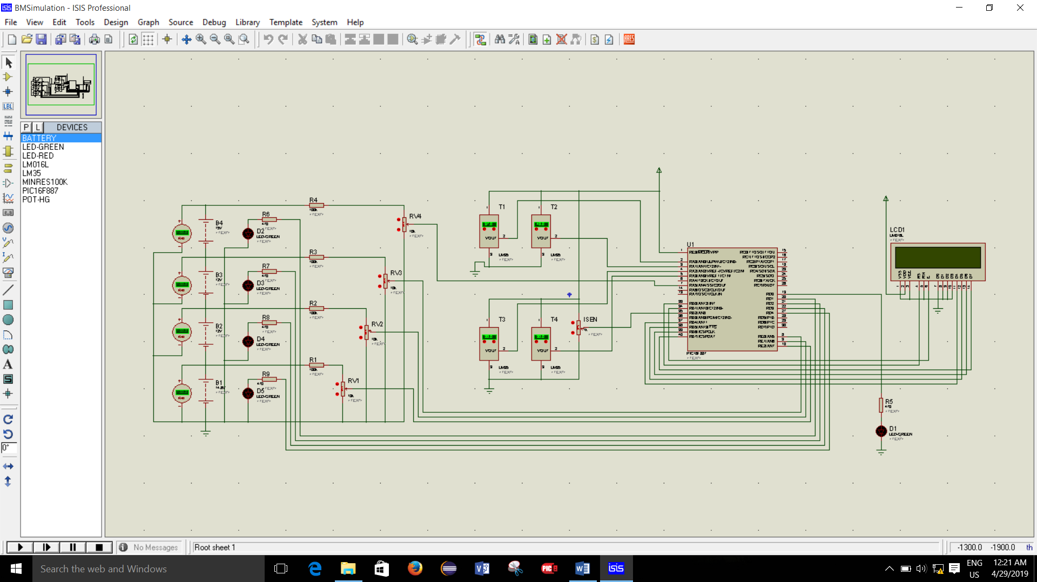

Fig. 7 Circuit diagram of Battery Management System

In the figure. 7, the voltmeter are used to measure the battery’s voltage and LEDs are used to display which battery is needed to discharge. The LCD is used to display the battery’s voltage and temperature. The threshold temperature is 45 degree/C. If one of the battery’s temperature is more than the threshold the LED is off and cut off the power switch.

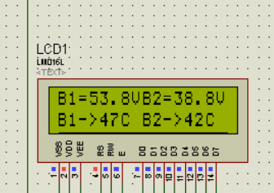

Fig. 8 (a) Result of voltage and temperature of battery 1 and 2

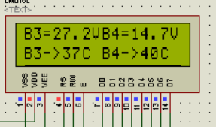

Fig. 8 (b) Result of voltage and temperature of battery 3 and 4

From the fig.8 (a), B1 is the voltage of all batteries. B2 is the voltage of 3 batteries. We want to know the voltage of each battery. We can calculate the voltage of Bat4;

B1=53.8V, B2=38.8V

Bat4=53.8V-38.8V=15V> 14.5V (LED D2 is ON)

From the fig.8 (b), B3 is the voltage of 2 batteries. B4 is the voltage of the one battery. We can calculate Bat3 and Bat2 ;

B3=27.2V

Bat3=38.8V-27.2V=11.6V<14.5V (LED D3 is OFF)

B4=14.7V

Bat2=27.2V-14.7V=12.5V<14.5V (LED D4 is OFF)

B4=Bat1=14.7>14.5V (LED D5 is ON)

Fig. 9 shows the result of cell balancing circuit with LED.

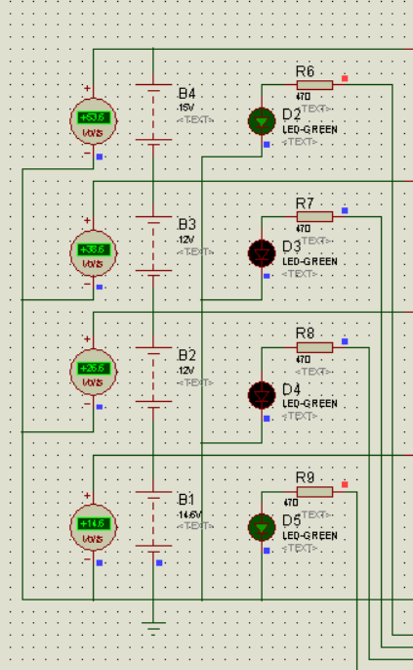

Fig. 9 Simulation Result of cell balancing circuit

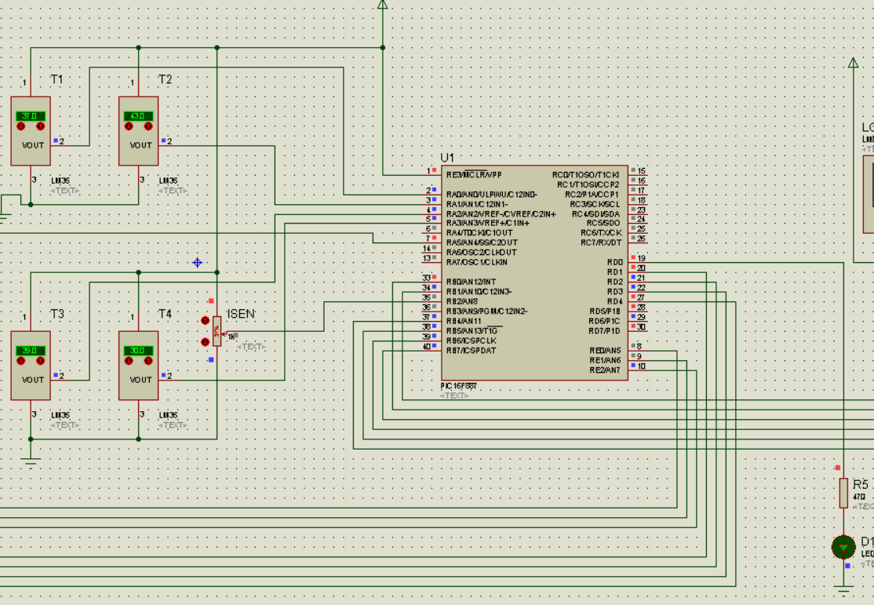

Fig.10 Simulation Result of temperature sensor

The threshold temperature is 45 degree/C. If one of the battery’s temperature is more than the threshold the LED is off and cut off the power switch. In fig.10 B1 temperature is 47 degree. It is greater than threshold temperature. LED D1 is off.

# Conclusion

This paper intends to control the batteries’ voltage, current and temperature by using PIC16F887. The mikroC program is used to protect the overcharging and deep discharging. LM35 is used to sense temperature. If the batteries are reach at high temperature or over threshold current, batteries will stop in charging or loading. Moreover, the voltage and temperature for each battery are displaying on LCD display. When one of the batteries is overcharging, the battery will discharging and LED is on.

The future enhancement of this work is to balance the batteries’ voltage by using active cell balancing and can use more than four batteries other types of battery.

References

1. John Chatxakis,Kostas Kalaizakis, Nicholas C. Voulgaris, “Designing a New Generalized Battery Management System”,IEEE vol.50.no5 October 2003
2. G. Krishna Teja and S.R.S Prabhaharan “Smart Battery Management System with Active Cell Balancing , Indian Journal of Science and Technology,Vol8(19),August 2015
3. C. Chen, K.L. Man, T.O. Ting, Chi-Un Lei, T. Krilavičius,T.T. Jeong, J.K. Seon, Sheng-Uei Guan and Prudence W.H. Wong, “Design and Realization of a Smart Battery Management System”, Proceeding of the International MultiConference of Engineers and Computer Scientists 2012 Volume 2. March 2012.
4. Crompton, T. R. (2000-03-20). Battery Reference Book (third ed.). Newnes. p. Glossary 3. ISBN 0080499953. Retrieved 2016-03-18.
5. David Linden, Thomas B. Reddy (ed). Handbook Of Batteries 3rd Edition. McGraw-Hill, New York, 2002 ISBN 0-07-135978-8 chapter 22.
6. Ryan Roderick, “ A Look Inside Battery-Management Systems”, http://electronicdesign.com/print/power/look-inside-battery-management.
7. Markus Lelie 1,2,*,†, Thomas Braun 1,2,†, Marcus Knips 1,2,†, Hannes Nordmann 1,2,†,Florian Ringbeck 1,2,†, Hendrik Zappen 1,2,† and Dirk Uwe Sauer 1,2,3 “Battery Management System Hardware Concepts:An Overview”,
8. Christopher M. Melvile , “Design and experimental testing of a battery management system for lead acid batteries “ , Master Thesis 2013 , the Pennsylvania State University.
9. Rui Hu , “Battery management system for electric vehicle applications” , scholarship at Windsor University 2011.
10. Joonas Sainio, “Battery management system design and implementation in electric raceabout” , bachelor thesis 2013.
11. Battery management system. 2011 Nov 30. Available from: http:// Wikipedia.org.
12. Ashwin Srinivas Badrinath , “Protection circuitry and passive balancing for battery management system” ,ICPPEIC 2017.

1.