T

his tutorial will introduce you to the Basket feature of

the EuPathDB databases.

All EuPathDB

databases are built with the same

architectural design so they look similar to e

ach other

and features such as

“

My Basket

”

are the same across

all of the databases. This tutorial uses PlasmoDB to

illustrate the basket feature.

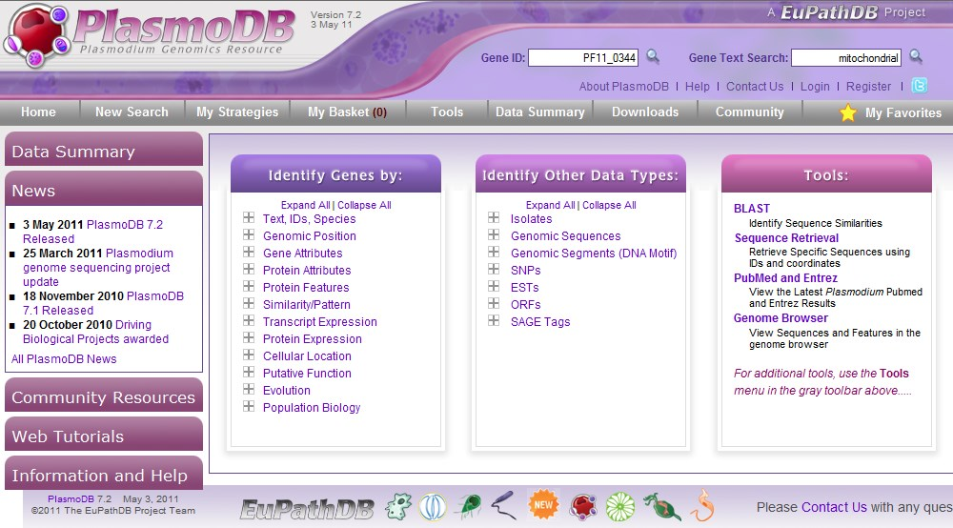

Your basket is a location where you can assemble a list of genes. The list of genes in your basket can be accessed while you are building a search strategy. In this way, the basket differs from the “My Favorites” feature which only provides a quick link to the gene pages of your favorite genes.



For a tutorial on the “My Favorites” feature, click the link below. [http://eupathdb.org/tutorials/Favorites/favorites_viewl et_swf.html](http://eupathdb.org/tutorials/Favorites/favorites_viewlet_swf.html)

**Save**

**genes to the basket when you intend to perform**

**additional queries using the list of genes in your**

**basket.**

Let's perform a text s

earch and add some genes to

the

basket.

Using the text search,

l

et's look in all the

plasmodium species for genes whose products have the

word k

inase associated with the

m

.

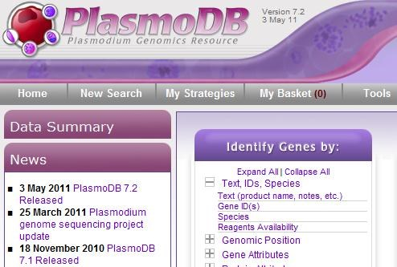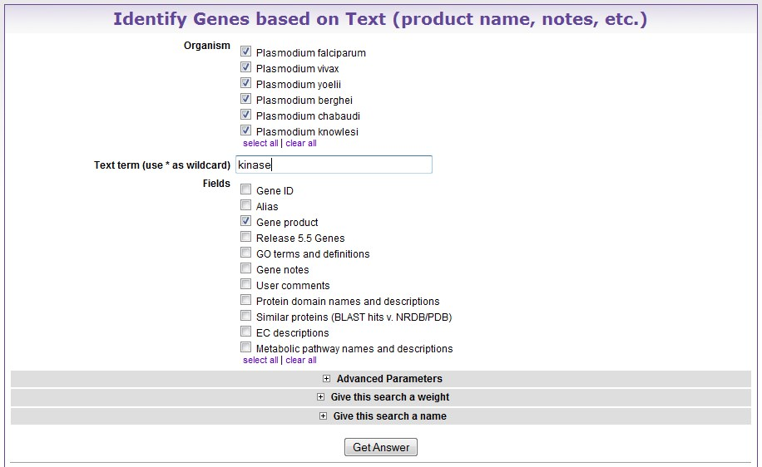

The query result list from our '

kinase' text search

contains 6

73

genes.

Yo

u have the option to add all 6

73

genes at once to the

basket

by clicking on the

“

Add 673 genes to Basket

.

”

O

r

genes can

b

e added

t

o the basket

one at a time

.

To add

genes one at a time, c

lick on the basket icon located to

the left of the Gene ID

.

You need to log in to your account to access the basket.

Once you are logged in, you can click on the basket icon.

The icon turns green once the gene has been added to

the basket.

You

can also add genes to the basket from a gene

record

.

Click on the Gene ID

in the results table to open

the gene

r

ecord

page.

To add a gene to the basket from a gene

record

page,

click the basket icon underneath the gene name.

Getting

back to

our text search

results…

To open the

basket, click on the

“

Basket

”

tab in the

“

My

Strategies

”

menu.

The basket now contains a table

of information

concerning the 6

genes that you just added. The column

headings are interactive just as in any other

results

page.

To remove a gene from the basket, click on the green

basket icon next to the gene id and then click refresh.

You can remove all genes fr

om your basket by cli

cking

the

“

Empty Basket

”

button. You can also save your

basket to use later.

**When yo**

**u save your basket, it**

**becomes a list that can be queried in search strategies.**

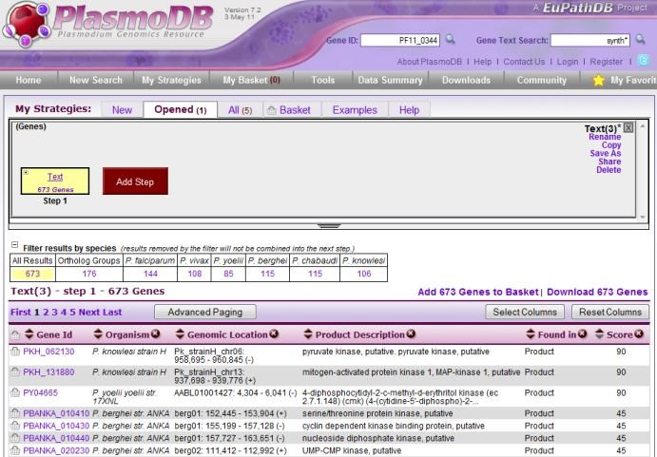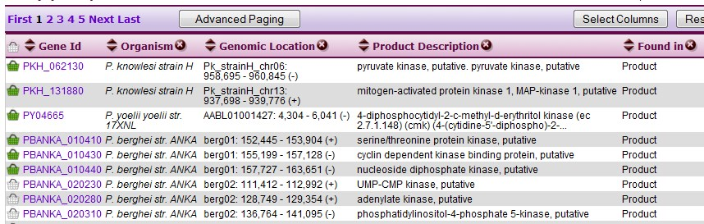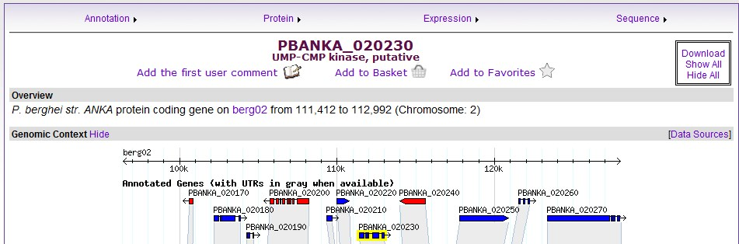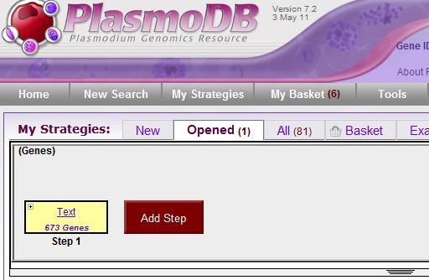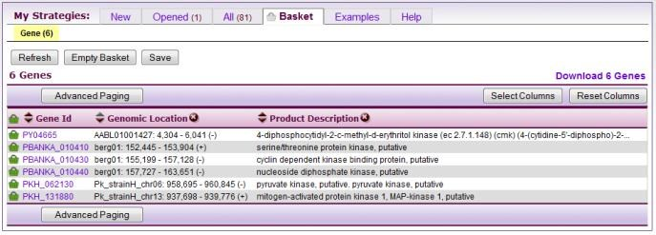

The power of the basket lies in the user’s ability to compose a list of hand-picked IDs that can then be used while they are building a search strategy. For the following example we will create a list of kinase genes that have an even number of transmemebrane domains.

Make sure the basket is empty. Choose “Empty Basket” and then click “Refresh.”.

First we will add a column of transmembrane domain information to the results table and sort the table based on transmembrane domain number.

Click the 'Select Columns' button above the results table.

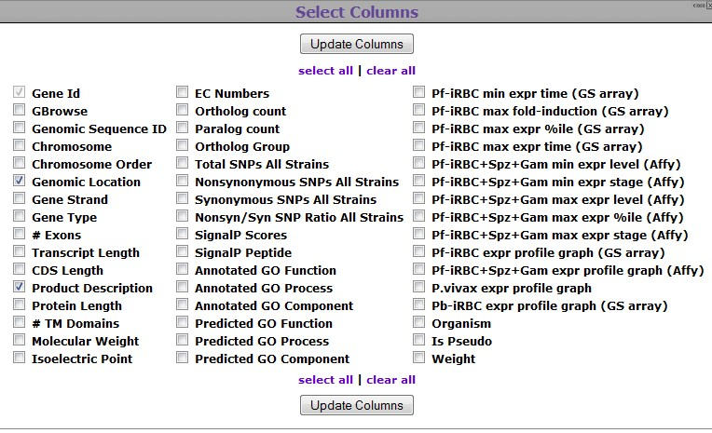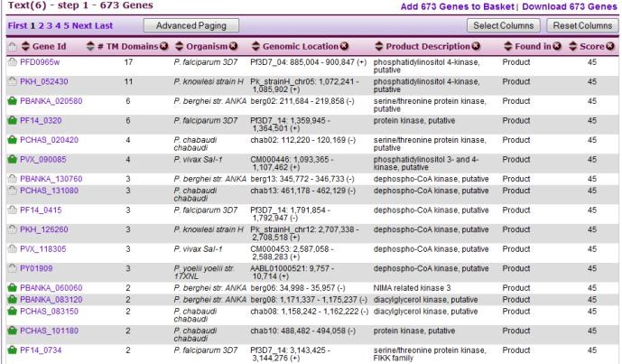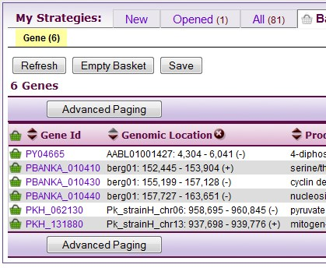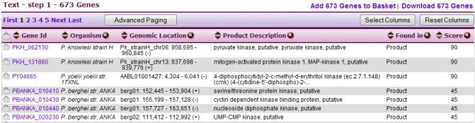

From the “Select Columns” popup window, choose “#

TM Domains” and click “Update Columns.”

A column labeled 'TM Domains' is added to the results table. To sort the results table, click the arrows next to the column name. The order of columns can be changed by dragging and dropping the column heading.

Let's add to the basket genes that have 2, 4, or 6 transmembrane domains. Add genes to the basket by clicking the basket icon next to the Gene ID.

To view the basket

,

click on the

“

Basket

”

t

ab in the

“

My

Strategies

”

menu.

The

basket now contains 1

5

genes

that have an even

number of

transmembrane domains.

Once you click

“

Save

,

”

the list can be used during

queries.

Let's a

dd a step to the strategy

and

find out how

many genes in the basket have

a

predicted signal

peptide

.

From the 'Add Step' popup window,

choose

what type

of search you will run for the second step of your

strategy.

To look for predicted signal peptide, choose

“

Genes

,

”

“

Protein Features

”

and

“

Predicted Signal

Peptide

.

”

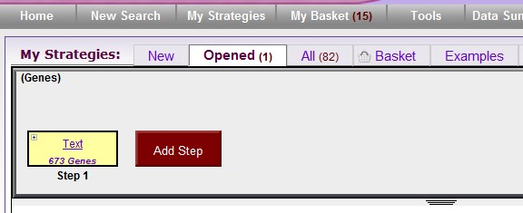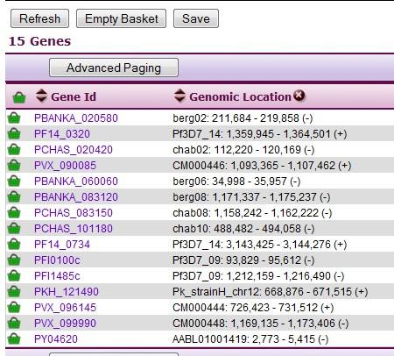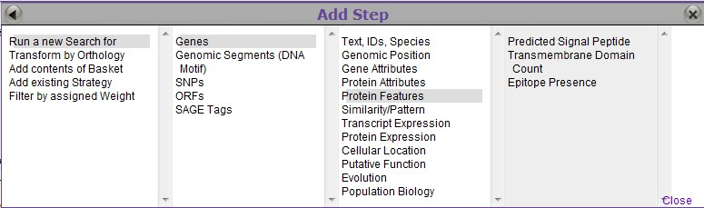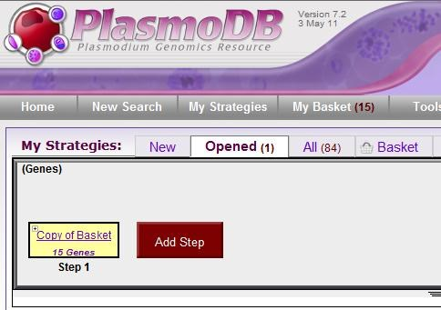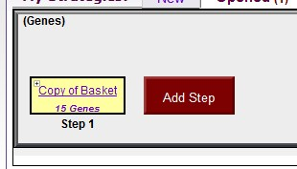

To find genes that meet the conditions of both step 1

and step 2 of your strategy, choose

“

1

intersect

2

.

”

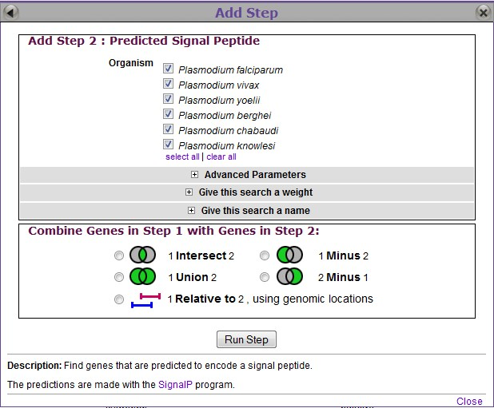

This query returned two genes, although your basket still contains the entire list of 15 genes. According to our search strategy, each of these Plasmodium genes encodes a kinase gene product, has an even number of transmembrane domains, and contains a predicted signal peptide.

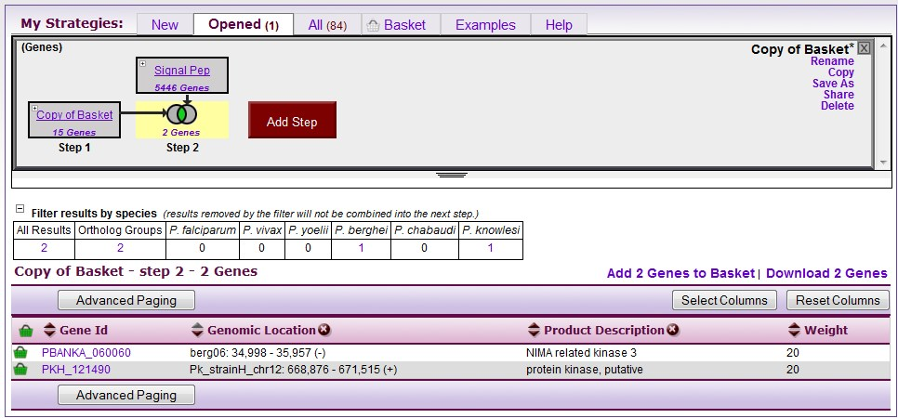

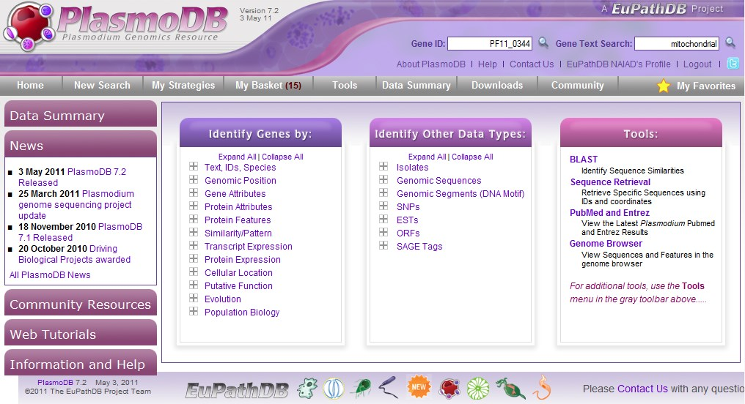

Thank you for using this EuPathDB tutorial.

Please contact us with any questions or suggestions.