Assignment 6 – Users
Lab exercise Journal
Vigneshwar Padmanaban

Objective:
1. We have a list of users along with their UID, GECOS, SHELL and Home dir information. We have to write a program to read the newusers.txt file and add these users in the machine. We should disable the password authentication of these users, and use RSA Authentication.
2. In addition to this list of users, we will add a new test user(sample1) along with the list, then generate a public key/private key pair to do SSH into the user.

Steps performed:
1. Adding a new user in the list:
Downloaded the newusers.txt and pubkeys directory and placed them in my desired location. I added the user “sample1” to newusers.txt file. (snapshot below)
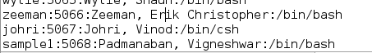

2. Generating the RSA keys:
I logged in as root and generated Public key(id_rsa.pub)/Private key(id_rsa) pair.
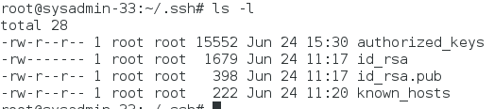

I copied this public key into directory /pubkeys for the newly added user 'sample1'.
3. C program
To add users:
I wrote a C program to read the “newusers.txt” file and get the information for each user like User name, UID, GECOS and SHELL. For every user successfully read from file, I added them into system with adduser command
Creating
To create Scratch directory:
Similarly, we created directories /scratch/username for each user.
Changing File permissions and File ownership:
We changed the ownerships to their corresponding user names (using chown) and also file permissions of .ssh and authorized_keys are set to 700 and 600 respectively (using chmod), for establishing successful ssh connection.
Copying the public keys:
We used cat command to copy the contents of .pub public key into /.ssh/authorized_keys for each user profile.
4. Preparing for ssh connection:
Installed openssh-server.
Made sure that the /etc/ssh/sshd_config file has permissions for RSAAuthentication “yes”
PubkeyAuthentication “yes”
We did an ssh into sample1
$ ssh sample1@sysadmin-33
The output of ssh is shown below figure.

Clean program: clr.c
This program was created based out on the main program(assi6.c), to delete all the newly added users, groups, their scratch folders, cleaning the authorized keys file, for the testing purpose.

SSH command Output: (Successfully ssh into ‘sample1’ user)
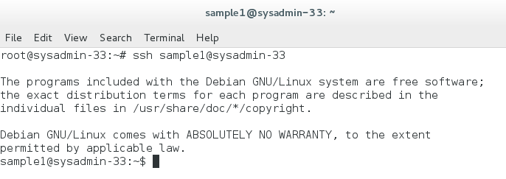
Output of C program(assi6.c):
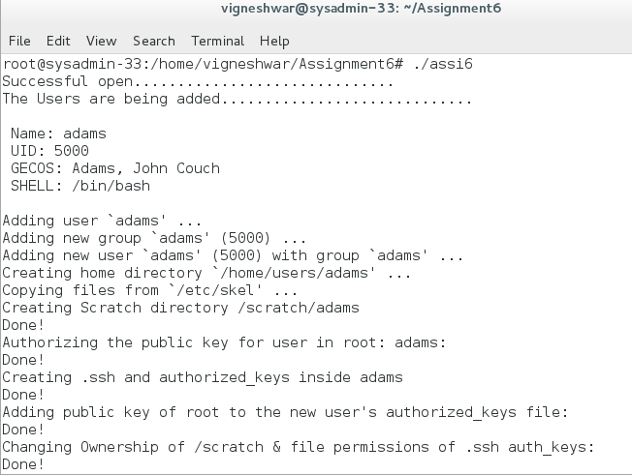

C program output explained below:
Starting from the first line, The File status is displayed
The user information is displayed before added into system
adduser command output
Scratch dir being added..
Adding the public key of new user into root's authorized_keys list
Creating and configuring the .ssh and authorized_keys for every users
Appending the public key of root into new user's authorized_keys file.
Changing ownership of .ssh and authorized_keys for establishing ssh connection.

C Code: (Main code)
assi6.c (C program to add the Users/Create directories/Change file permission/ownerships)
/* This script does the following:

1. It reads the newusers.txt file and display the formatted output in
screen.Then it adds those users in the system, with the Name/HOME
DIR/UID/SHELL/GECOS information as mentioned in the newusers.txt.

2. It creates new dir /scratch/USERNAME for every user.

3. It adds the public key information in /pubkeys dir, to the
authorized_keys file in ~/.ssh/authorized_keys
*/
#include<stdio.h>
#include<string.h>
#include <sys/mman.h>
#include <sys/types.h>
#include <sys/stat.h>
#include <fcntl.h>
#include <unistd.h>
#include <stdlib.h>

/****** Variable declaration: ******/
FILE *f;
char name[40],uid[40],gecos[40],shell[40],t1,str[100];
int i,j,part,cnt,k=0;
int l,m,n,o=0;
char buf1[200],buf2[200],buf3[200],buf4[200],buf5[200],buf6[200],buf7[200];
int size1,size2=0;

void count_size()
{
size2 = 0;
for(k=0;shell[k]!='\0';k++)
{
if(shell[k]!=' ')
{
size2 = size2 + 1;
}
}
shell[size2-1]='\0';
}

void print_var()
{
printf("\n Name: ");
for(j=0;name[j]!='\0';j++)
printf("%c",name[j]);

printf("\n UID: ");
for(j=0;uid[j]!='\0';j++)
printf("%c",uid[j]);

printf("\n GECOS: ");
for(j=0;gecos[j]!='\0';j++)
printf("%c",gecos[j]);

printf("\n SHELL: ");
for(j=0;shell[j]!='\0';j++)
printf("%c",shell[j]);
count_size();
printf("\n");
}
/******* Executing Linux Commands ********/
void exec_command()
{
snprintf(buf1,200,"adduser --home /home/users/%s --gecos '%s' --uid %s --shell '%s' --disabled-login --disabled-password %s",name,gecos,uid,shell,name);
system(buf1);

printf("Creating Scratch directory /scratch/%s \n",name);
snprintf(buf2,200,"mkdir /home/scratch/%s -p",name);
system(buf2);
printf("Done!\n");

printf("Authorizing the public key for user in root: %s:\n",name);
snprintf(buf3,200,"cat /home/vigneshwar/Assignment6/pubkeys/%s.pub >> ~/.ssh/authorized_keys",name);
system(buf3);
printf("Done!\n");

printf("Creating .ssh and authorized_keys inside %s \n",name);
snprintf(buf4,200,"mkdir /home/users/%s/.ssh",name);
system(buf4);
printf("Done!\n");

printf("Adding public key of root to the new user's authorized_keys file: \n");
snprintf(buf5,200,"cat /root/.ssh/id_rsa.pub >> /home/users/%s/.ssh/authorized_keys",name);
system(buf5);
printf("Done!\n");

printf("Changing Ownership of /scratch & file permissions of .ssh auth_keys: \n");
snprintf(buf6,200,"chown %s /home/scratch/%s",name,name);
system(buf6);

snprintf(buf7,200,"chmod 700 /home/users/%s/.ssh && chmod 600 /home/users/%s/.ssh/authorized_keys",name,name);
system(buf7);

printf("Done!\n");

}

int main()
{
/******* Opening File:*******/
f = fopen("/home/vigneshwar/Assignment6/newusers.txt","r");

if (f == NULL)
{
printf("Unsuccessful open............................ \n");
}
else
{
printf("Successful open.............................. \n");
printf("The Users are being added.............................\n");
}

/*Reading File */

while(fgets(str,100,f) != NULL)
{
part = 0;
l=m=n=o=0;

for(i=0;str[i]!='\0';i++)
{
switch(part)
{
case 0:
{
name[l] = str[i];
if(str[i] == ':')
{
name[l]='\0';
part=1;
}
l = l+1;
break;
}
case 1:
{
uid[m] = str[i];
if(str[i] == ':')
{
uid[m]='\0';
part=2;
}
m = m+1;
break;
}
case 2:
{
gecos[n] = str[i];
if(str[i] == ':')
{
gecos[n]='\0';
part=3;
}
n= n+1;
break;
}
case 3:
{
if(str[i] != ' ' || str[i] != '\0')
{
shell[o] = str[i];
o = o + 1;
}
else
shell[o]='\0';
break;
}
default:
{
break;
}
}
}
//Executing the display function and Linux commands:
print_var();
exec_command();
}
fclose(f);
return 0;
}

