Assignment 8 – Improving SSHD Security
Vigneshwar Padmanaban

Objective:
1. We need to change the port number of SSH from default port 22 to any port number above 20000
2. Need to setup iptables rules in such a way that it allows port 80 and 443, pinging and rejects all other ports
3. Need to install port knocking mechanism in our machine an configure it in such a way that, whenever the correct sequence is knocked, we will open the door for that particular SSH port, for a short amount of time.

Steps:
Changing port number:
1. I changed the port number from 22 to 20001 in sshd_config file in /etc/ssh and ran service sshd restart

Configuring iptables:
1. Ran iptables -L and verified that there was no rule setup already and no firewal installed.
2. Installed iptables-persistent to configure iptables rules.
3. Created a new rule file called iptables.test.rules and defined rules to block all ports except the port 80, 443 and also allowed the icmp ping.
4. Ran the iptables-restore < /etc/iptables.test.rules
Now the new rules are visible in iptables -L
5. iptables-save > /etc/iptables.up.rules Saved this to master file.
6. To make sure this stays even after restart, we did
nano /etc/network/if-pre-up.d/iptables
included these lines
#!/bin/sh
/sbin/iptables-restore < /etc/iptables.up.rules
Also made this file as executable.

7. After setting up the rules I made sure that the SSH is not working in the new port 20001, able to access internet and pinging is allowed.
Now the next step is to allow port knocking for SSH.

Port Knocking:
1. Installed knockd
2. Analyzed the various modes of knocks_config in knockd man page.
3. As instructed I chose the example2 format of allowing ssh for a short duration.
4. After choosing a custom sequence number 2022 3022 4022, with command timeout as 60 seconds(used a long duration for testing purpose).
5. restarted the daemon knockd
Attempt1: connection refused.
When knocked, the start_command in knockd config ran successfully, but still refusing ssh:
/sbin/iptables/ -A INPUT -s 192.168.26.29 -p tcp –dport 20001 -j ACCEPT
verified that this line is included in the iptables rules by running iptables -L
While researching, at some places -I is used instaed of -A in the above command,. So, modified the config again and restarted daemon.
Attempt2:
Knocked from another computer (*26..29) with sequence 2022 3022 4022
In host computer I verified that the knock was listened in /var/log/knockd.log and start_command executed
iptables -L -n contains the rule to accept ssh from *26.29
then in 26.29 I ran ssh to host at port -p 20001, connection established.

(ssh from sysadmin-46 to sysadmin-33)
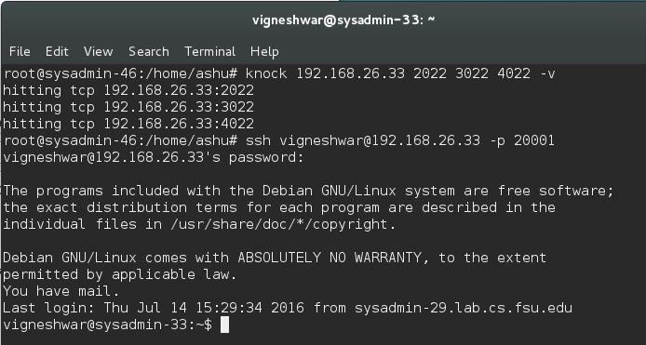

After 60 seconds, connection window closed.
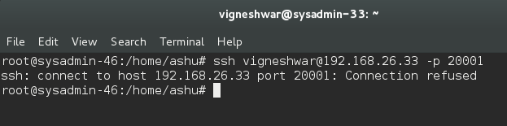
Iptables reflection:
After knocking: as you can see the sysadmin-29 is granted access. (The other IP with *.1.102 is my personal laptop IP, which is permanently allowed to access).
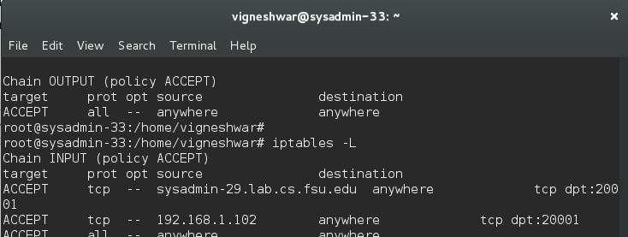

After command time out: sysadmin-29 denied access
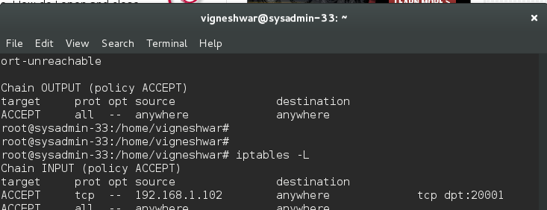
/var/log/knockd.log: (knocking – start_command - end_command)
