请求页面：

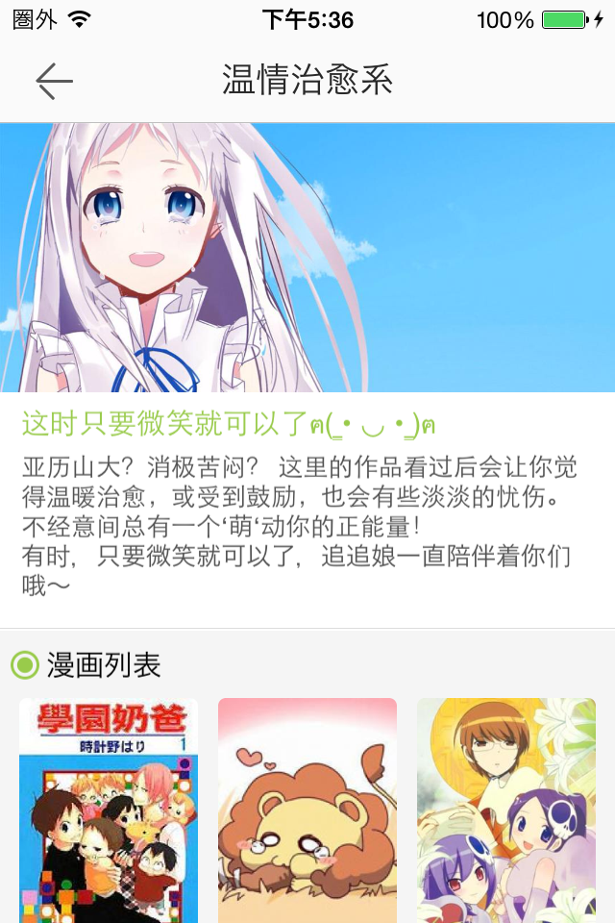

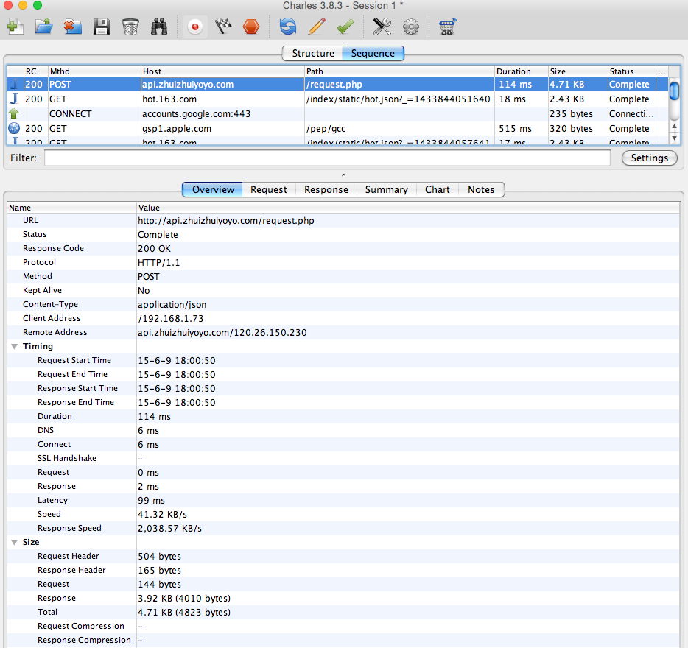

请求参数：

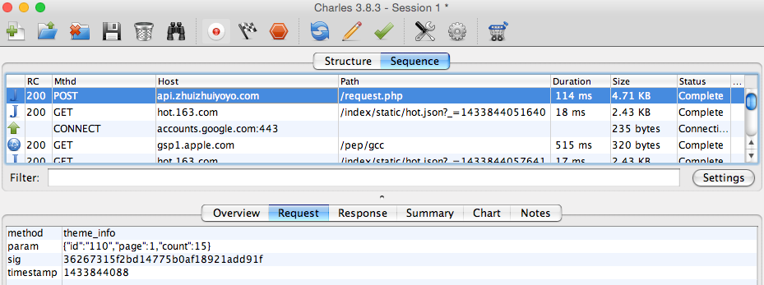

返回的第1页数据：

{

"errorCode": 0,

"theme": {

"id": 110,

"cover": "http:\/\/image-cdn.zhuizhuiimg.com\/\/image\/32817_1429516722.jpg",

"name": "温情治愈系",

"url": "zzComic:\/\/G.CL.com\/110\/S",

"title": "这时只要微笑就可以了ฅ( ̳• ◡ • ̳)ฅ",

"comment_count": 0,

"up_count": 0,

"inner_cover": {

"u": "http:\/\/image-cdn.zhuizhuiimg.com\/\/image\/35356_1429518783.jpg",

"w": 1080,

"h": 472

},

"description": "亚历山大？消极苦闷？ 这里的作品看过后会让你觉得温暖治愈，或受到鼓励，也会有些淡淡的忧伤。不经意间总有一个‘萌‘动你的正能量！\r\n有时，只要微笑就可以了，追追娘一直陪伴着你们哦～\r\n"

},

"total": "18",

"comics": [{

"id": 8247,

"name": "学园奶爸",

"cover_img": "http:\/\/image-cdn.zhuizhuiimg.com\/\/image\/6573_1429511193.jpg",

"finished": 0,

"last_volume": "65话",

"topic_count": 402

}, {

"id": 24135,

"name": "百兽之王鬃毛喵喵",

"cover_img": "http:\/\/image-cdn.zhuizhuiimg.com\/\/image\/19702_1429512078.jpg",

"finished": 0,

"last_volume": "25话",

"topic_count": 418

}, {

"id": 5968,

"name": "只有神知道的世界",

"cover_img": "http:\/\/image-cdn.zhuizhuiimg.com\/\/image\/4660_1429511066.jpg",

"finished": 1,

"last_volume": "268话 (已完结)",

"topic_count": 391

}, {

"id": 7101,

"name": "夏目友人帐",

"cover_img": "http:\/\/image-cdn.zhuizhuiimg.com\/\/image\/5595_1429511127.jpg",

"finished": 0,

"last_volume": "85话",

"topic_count": 893

}, {

"id": 2858,

"name": "一周的朋友",

"cover_img": "http:\/\/image-cdn.zhuizhuiimg.com\/\/image\/2005_1429505386.jpg",

"finished": 0,

"last_volume": "39话",

"topic_count": 246

}, {

"id": 10663,

"name": "我们大家的河合庄",

"cover_img": "http:\/\/image-cdn.zhuizhuiimg.com\/\/image\/8643_1429511338.jpg",

"finished": 0,

"last_volume": "59话",

"topic_count": 248

}, {

"id": 7947,

"name": "好想告诉你",

"cover_img": "http:\/\/image-cdn.zhuizhuiimg.com\/\/image\/6316_1429511176.jpg",

"finished": 0,

"last_volume": "100话",

"topic_count": 1035

}, {

"id": 14408,

"name": "深夜食堂",

"cover_img": "http:\/\/image-cdn.zhuizhuiimg.com\/\/image\/11718_1429511544.jpg",

"finished": 0,

"last_volume": "第12卷",

"topic_count": 373

}, {

"id": 10684,

"name": "我们的存在",

"cover_img": "http:\/\/image-cdn.zhuizhuiimg.com\/\/image\/8661_1429511339.jpg",

"finished": 1,

"last_volume": "16卷 (已完结)",

"topic_count": 125

}, {

"id": 15538,

"name": "狼之子雨和雪",

"cover_img": "http:\/\/image-cdn.zhuizhuiimg.com\/\/image\/12678_1429511609.jpg",

"finished": 1,

"last_volume": "第16话",

"topic_count": 361

}, {

"id": 18909,

"name": "蜂蜜与四叶草",

"cover_img": "http:\/\/image-cdn.zhuizhuiimg.com\/\/image\/15483_1429511793.jpg",

"finished": 1,

"last_volume": "10卷 (已完结)",

"topic_count": 76

}, {

"id": 2461,

"name": "TARI TARI",

"cover_img": "http:\/\/image-cdn.zhuizhuiimg.com\/\/image\/1717_1429505241.jpg",

"finished": 0,

"last_volume": "7话",

"topic_count": 19

}, {

"id": 4544,

"name": "元气少女缘结神",

"cover_img": "http:\/\/image-cdn.zhuizhuiimg.com\/\/image\/3453_1429506163.jpg",

"finished": 0,

"last_volume": "131话",

"topic_count": 3539

}, {

"id": 19436,

"name": "请问您今天要来点兔子吗？",

"cover_img": "http:\/\/image-cdn.zhuizhuiimg.com\/\/image\/15915_1429511821.jpg",

"finished": 0,

"last_volume": "55话",

"topic_count": 176

}, {

"id": 6402,

"name": "哈啰！大根君",

"cover_img": "http:\/\/image-cdn.zhuizhuiimg.com\/\/image\/5012_1429511087.jpg",

"finished": 0,

"last_volume": "3卷",

"topic_count": 73

}]

}

第2页数据返回了：

{

"errorCode": 0,

"theme": {

"id": 110,

"cover": "http:\/\/image-cdn.zhuizhuiimg.com\/\/image\/32817_1429516722.jpg",

"name": "温情治愈系",

"url": "zzComic:\/\/G.CL.com\/110\/S",

"title": "这时只要微笑就可以了ฅ( ̳• ◡ • ̳)ฅ",

"comment_count": 0,

"up_count": 0,

"inner_cover": {

"u": "http:\/\/image-cdn.zhuizhuiimg.com\/\/image\/35356_1429518783.jpg",

"w": 1080,

"h": 472

},

"description": "亚历山大？消极苦闷？ 这里的作品看过后会让你觉得温暖治愈，或受到鼓励，也会有些淡淡的忧伤。不经意间总有一个‘萌‘动你的正能量！\r\n有时，只要微笑就可以了，追追娘一直陪伴着你们哦～\r\n"

},

"total": "18",

"comics": [{

"id": 17004,

"name": "贫乏神来了",

"cover_img": "http:\/\/image-cdn.zhuizhuiimg.com\/\/image\/13905_1429511689.jpg",

"finished": 1,

"last_volume": "第11卷",

"topic_count": 61

}, {

"id": 16101,

"name": "白兔糖",

"cover_img": "http:\/\/image-cdn.zhuizhuiimg.com\/\/image\/13171_1429511639.jpg",

"finished": 1,

"last_volume": "第09卷",

"topic_count": 169

}, {

"id": 12913,

"name": "未闻花名",

"cover_img": "http:\/\/image-cdn.zhuizhuiimg.com\/\/image\/10517_1429511467.jpg",

"finished": 1,

"last_volume": "13话",

"topic_count": 582

}]

}

未闻花名主页

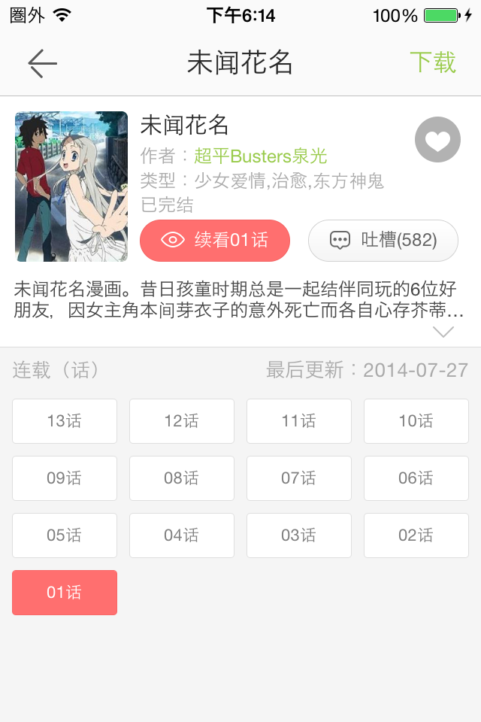

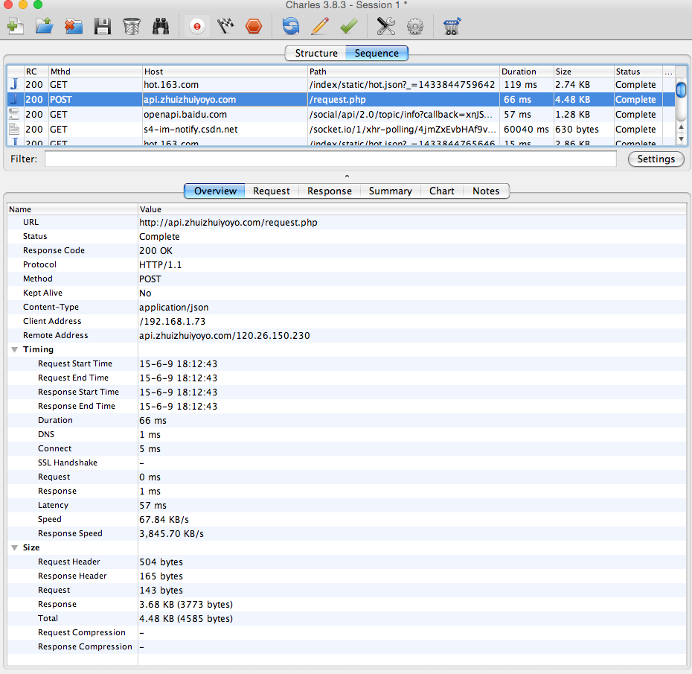

请求参数：

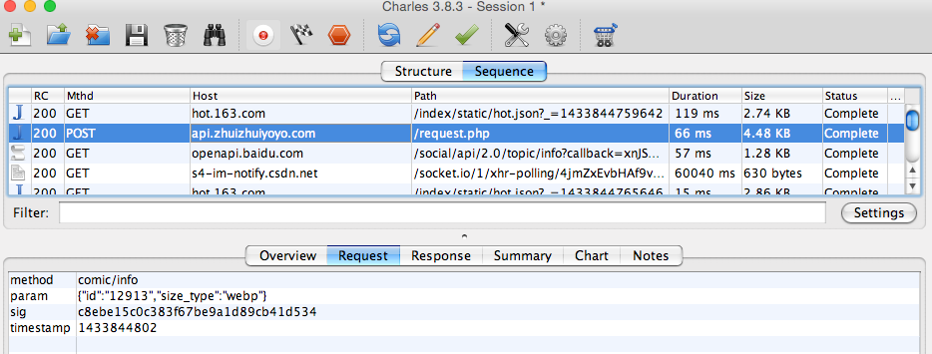

返回结果：

{

"errorCode": 0,

"comic": {

"id": 12913,

"name": "未闻花名",

"author": "超平Busters泉光",

"introduction": "未闻花名漫画。昔日孩童时期总是一起结伴同玩的6位好朋友，因女主角本间芽衣子的意外死亡而各自心存芥蒂导致关系疏离。但某一天，虽然各种事物都在变化，但唯独她不变的芽衣子却突然出现在已像隐蔽青年般的主人公宿海仁太面前，并要仁太帮助她完成心愿从而成佛。在这个过程中昔日的好友，散发着辣妹气息的安城鸣子、进入了以大学为目标的学校的松雪集和鹤见知利子、以及在高中便放弃升学现正四处游历的久川铁道慢慢加入到帮助芽间完成心愿的队伍中来。而在大家努力帮助她完成心愿的同时，十年前发生的种种往事以及彼此心中的秘密也渐渐浮现在大家面",

"cover_img": "http:\/\/image-cdn.zhuizhuiimg.com\/\/image\/10517_1429511467.jpg",

"finished": 1,

"last_volume": "13话",

"last_volume_updated_at": 1406390400,

"category_name": "少女爱情,治愈,东方神鬼",

"read_times": 174628,

"favorite_count": 23762,

"hand": 1,

"topic_count": 582

},

"sections": [{

"id": 229483,

"name": "13话",

"comic_id": 12913,

"sequence": 2000001300,

"sub_status": 1,

"type": 3,

"definitions": [{

"type": 1,

"size": 7144738

}]

}, {

"id": 229472,

"name": "12话",

"comic_id": 12913,

"sequence": 2000001200,

"sub_status": 1,

"type": 3,

"definitions": [{

"type": 1,

"size": 8139046

}]

}, {

"id": 229467,

"name": "11话",

"comic_id": 12913,

"sequence": 2000001100,

"sub_status": 1,

"type": 3,

"definitions": [{

"type": 1,

"size": 9092142

}]

}, {

"id": 229463,

"name": "10话",

"comic_id": 12913,

"sequence": 2000001000,

"sub_status": 1,

"type": 3,

"definitions": [{

"type": 1,

"size": 9121834

}]

}, {

"id": 229456,

"name": "09话",

"comic_id": 12913,

"sequence": 2000000900,

"sub_status": 1,

"type": 3,

"definitions": [{

"type": 1,

"size": 6466734

}]

}, {

"id": 229453,

"name": "08话",

"comic_id": 12913,

"sequence": 2000000800,

"sub_status": 1,

"type": 3,

"definitions": [{

"type": 1,

"size": 9558072

}]

}, {

"id": 229448,

"name": "07话",

"comic_id": 12913,

"sequence": 2000000700,

"sub_status": 1,

"type": 3,

"definitions": [{

"type": 1,

"size": 7035222

}]

}, {

"id": 229445,

"name": "06话",

"comic_id": 12913,

"sequence": 2000000600,

"sub_status": 1,

"type": 3,

"definitions": [{

"type": 1,

"size": 5942412

}]

}, {

"id": 229440,

"name": "05话",

"comic_id": 12913,

"sequence": 2000000500,

"sub_status": 1,

"type": 3,

"definitions": [{

"type": 1,

"size": 4601272

}]

}, {

"id": 229436,

"name": "04话",

"comic_id": 12913,

"sequence": 2000000400,

"sub_status": 1,

"type": 3,

"definitions": [{

"type": 1,

"size": 7206596

}]

}, {

"id": 229432,

"name": "03话",

"comic_id": 12913,

"sequence": 2000000300,

"sub_status": 1,

"type": 3,

"definitions": [{

"type": 1,

"size": 7956572

}]

}, {

"id": 229427,

"name": "02话",

"comic_id": 12913,

"sequence": 2000000200,

"sub_status": 1,

"type": 3,

"definitions": [{

"type": 1,

"size": 8176298

}]

}, {

"id": 229421,

"name": "01话",

"comic_id": 12913,

"sequence": 2000000100,

"sub_status": 1,

"type": 3,

"definitions": [{

"type": 1,

"size": 13005632

}]

}]

}

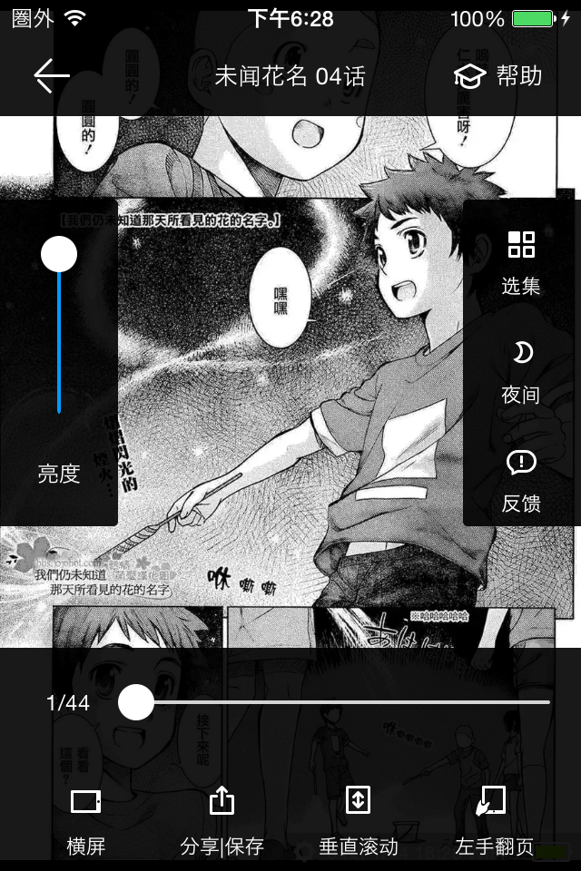

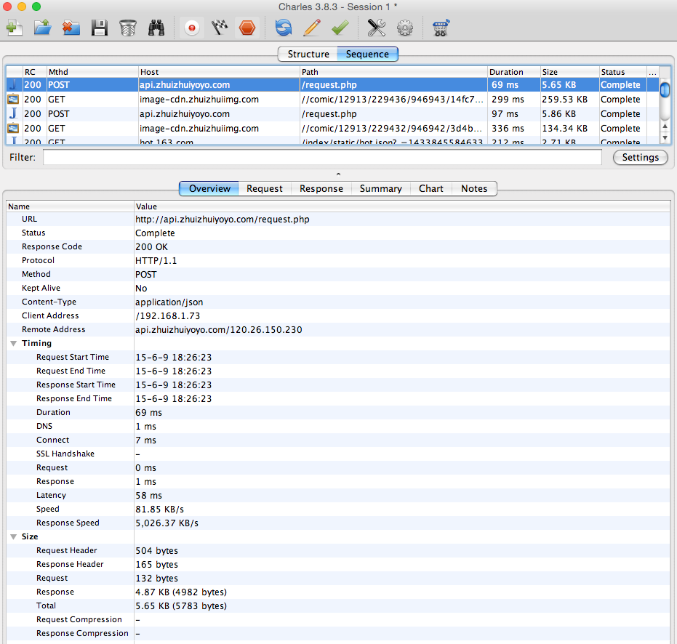

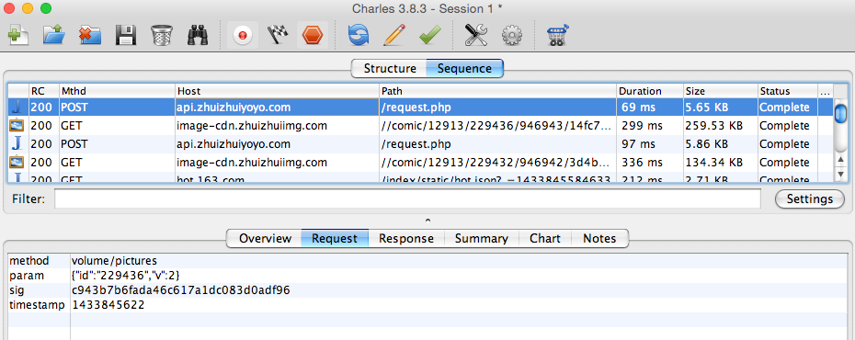

返回结果：

{

"errorCode": 0,

"host": "http:\/\/image-cdn.zhuizhuiimg.com\/",

"pictures": [{

"id": "11044342",

"url": "\/comic\/12913\/229436\/946943\/14fc76842324f7dd1b8090709353d2d9_1423583856.jpg.webp"

}, {

"id": "11044347",

"url": "\/comic\/12913\/229436\/946943\/f94e466e309e68ccde3996ee785ab770_1423583857.jpg.webp"

}, {

"id": "11044351",

"url": "\/comic\/12913\/229436\/946943\/c923d46e33ca3cfa08975309f1010b81_1423583857.jpg.webp"

}, {

"id": "11044356",

"url": "\/comic\/12913\/229436\/946943\/c19dd2ff8a0a59bd13f845fa25a3ee0c_1423583858.jpg.webp"

}, {

"id": "11044360",

"url": "\/comic\/12913\/229436\/946943\/2a84c9fe2013e0e7242b1225866a9a80_1423583858.jpg.webp"

}, {

"id": "11044371",

"url": "\/comic\/12913\/229436\/946943\/0e7eb42d7ea2358f15181c231e03cdba_1423583859.jpg.webp"

}, {

"id": "11044376",

"url": "\/comic\/12913\/229436\/946943\/23b13c12eefacd8c33b445ed34a3e78b_1423583860.jpg.webp"

}, {

"id": "11044380",

"url": "\/comic\/12913\/229436\/946943\/0603f2af2a9915e5f201cd314e35650a_1423583861.jpg.webp"

}, {

"id": "11044383",

"url": "\/comic\/12913\/229436\/946943\/97073bf595ce2229448605edb847a259_1423583861.jpg.webp"

}, {

"id": "11044388",

"url": "\/comic\/12913\/229436\/946943\/beeea3fb407fe124970be72ab4832a1f_1423583862.jpg.webp"

}, {

"id": "11044393",

"url": "\/comic\/12913\/229436\/946943\/b780c3be0526149bc6347f5d9d0faf93_1423583862.jpg.webp"

}, {

"id": "11044396",

"url": "\/comic\/12913\/229436\/946943\/6cefc8cf1babf03dddb60b9b8ab76f4a_1423583863.jpg.webp"

}, {

"id": "11044400",

"url": "\/comic\/12913\/229436\/946943\/304cdc08a50a9ad2f69545bba955da01_1423583863.jpg.webp"

}, {

"id": "11044405",

"url": "\/comic\/12913\/229436\/946943\/4799301e40dbaf526c6046b5864da056_1423583864.jpg.webp"

}, {

"id": "11044409",

"url": "\/comic\/12913\/229436\/946943\/44371ab3bd381c5f07c4370a440f5771_1423583864.jpg.webp"

}, {

"id": "11044417",

"url": "\/comic\/12913\/229436\/946943\/6eb5f96ee467a68ed4041eb7a1c61d91_1423583865.jpg.webp"

}, {

"id": "11044421",

"url": "\/comic\/12913\/229436\/946943\/dc13f5a23180404abc2fddc9b25a81cd_1423583866.jpg.webp"

}, {

"id": "11044426",

"url": "\/comic\/12913\/229436\/946943\/b32c6ed13024397c52aa1dbf7f8a22c6_1423583867.jpg.webp"

}, {

"id": "11044431",

"url": "\/comic\/12913\/229436\/946943\/a0e52c2256bb264caccfb178ad7caae6_1423583868.jpg.webp"

}, {

"id": "11044435",

"url": "\/comic\/12913\/229436\/946943\/3edd88e81419b371bdd0ef173627e3c1_1423583868.jpg.webp"

}, {

"id": "11044442",

"url": "\/comic\/12913\/229436\/946943\/c5edbd8a5b81de16636a2eebcf4ee43d_1423583869.jpg.webp"

}, {

"id": "11044446",

"url": "\/comic\/12913\/229436\/946943\/8a4a12c95a7eb7d9f208ca08db76d8e3_1423583870.jpg.webp"

}, {

"id": "11044451",

"url": "\/comic\/12913\/229436\/946943\/7861181d9c081e4dd5bf83780c6c451c_1423583870.jpg.webp"

}, {

"id": "11044459",

"url": "\/comic\/12913\/229436\/946943\/b9032522dbe6e15f2fea4590cd47bb95_1423583871.jpg.webp"

}, {

"id": "11044462",

"url": "\/comic\/12913\/229436\/946943\/23bffbaeda0e984da351a11520aae05f_1423583872.jpg.webp"

}, {

"id": "11044468",

"url": "\/comic\/12913\/229436\/946943\/7661a882344eea7215b3ed31fa8099bb_1423583873.jpg.webp"

}, {

"id": "11044473",

"url": "\/comic\/12913\/229436\/946943\/8ebd25e5f5d3f84345dfaacaa3a1c1d0_1423583873.jpg.webp"

}, {

"id": "11044478",

"url": "\/comic\/12913\/229436\/946943\/1372de1783f38aa176e48247d5c85ac0_1423583874.jpg.webp"

}, {

"id": "11044485",

"url": "\/comic\/12913\/229436\/946943\/ef4b8ad3658457c4d5e2aed3f72fa01e_1423583875.jpg.webp"

}, {

"id": "11044491",

"url": "\/comic\/12913\/229436\/946943\/8ecf8cbb7a6b2bf65a8c636d0674d789_1423583876.jpg.webp"

}, {

"id": "11044496",

"url": "\/comic\/12913\/229436\/946943\/9ad1b61876da459ae7ee9675e70c1327_1423583877.jpg.webp"

}, {

"id": "11044500",

"url": "\/comic\/12913\/229436\/946943\/f81c2dbedba93f900f2c20f7913d5bb4_1423583878.jpg.webp"

}, {

"id": "11044504",

"url": "\/comic\/12913\/229436\/946943\/d26577003055a97b037020580c036de3_1423583879.jpg.webp"

}, {

"id": "11044510",

"url": "\/comic\/12913\/229436\/946943\/8ec1dea61bd50350215af35ba444f853_1423583879.jpg.webp"

}, {

"id": "11044515",

"url": "\/comic\/12913\/229436\/946943\/cb2cb2cd57f58cb004dc4208897a7e5d_1423583880.jpg.webp"

}, {

"id": "11044519",

"url": "\/comic\/12913\/229436\/946943\/a7195da45f6268bc5661bc543eb41304_1423583881.jpg.webp"

}, {

"id": "11044524",

"url": "\/comic\/12913\/229436\/946943\/60e93a037b0a6c1d9db77dc087a98526_1423583882.jpg.webp"

}, {

"id": "11044529",

"url": "\/comic\/12913\/229436\/946943\/e45501acb4a6150abaa01c701dfd8ef5_1423583883.jpg.webp"

}, {

"id": "11044534",

"url": "\/comic\/12913\/229436\/946943\/ca40a8596b84123f74862d021e04a6ad_1423583884.jpg.webp"

}, {

"id": "11044539",

"url": "\/comic\/12913\/229436\/946943\/5a418a1cd14ec09a7dc92c1558917eca_1423583884.jpg.webp"

}, {

"id": "11044545",

"url": "\/comic\/12913\/229436\/946943\/489776955a1a8d0cce8aa482073dbfe6_1423583885.jpg.webp"

}, {

"id": "11044547",

"url": "\/comic\/12913\/229436\/946943\/d067e44cf9e752d1bf5f31ccf2ed841c_1423583886.jpg.webp"

}, {

"id": "11044552",

"url": "\/comic\/12913\/229436\/946943\/c1e5998742c8c136d890abde2506439f_1423583886.jpg.webp"

}, {

"id": "11044560",

"url": "\/comic\/12913\/229436\/946943\/2a28051dfd29480e5b5a8e88a0eaf15e_1423583887.jpg.webp"

}]

}

合并图片：

http://image-cdn.zhuizhuiimg.com////comic//12913//229436//946943//23b13c12eefacd8c33b445ed34a3e78b_1423583860.jpg.webp