利用rpmbuild制作rpm包

# 1 安装制作rpm包需要的软件

yum install rpmbuild

yum install rpmdevtools

# 2 开始制作rpm包

## 2.1 生成目录树

cd ${HOME}

rpmdev-setuptree

tree rpmbuild

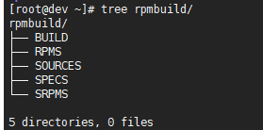

## 2.2 拷贝源码文件的压缩包到SOURCE目录下

cp -f /home/rpmuser/rpmbuild/SOURCES/hellorpm-0.0.1-1.x86_64.tar.gz ${HOME}/rpmbuild/SOURCES/

## 2.3 生成hellorpm.spec文件

cd ${HOME}/rpmbuild/SPECS

rpmdev-newspec -o hellorpm.spec

**C:\Users\chaofei\AppData\Local\Temp\enhtmlclip\Image(1).png**

## 2.4 修改hellorpm.spec文件

vim hellorpm.spec

如下图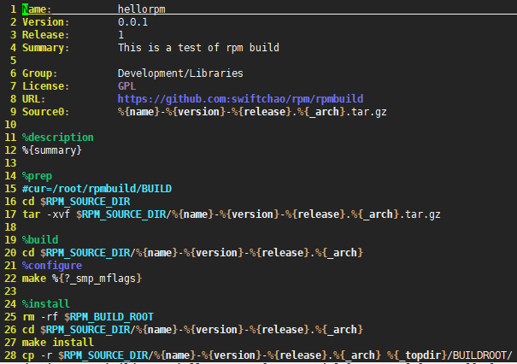

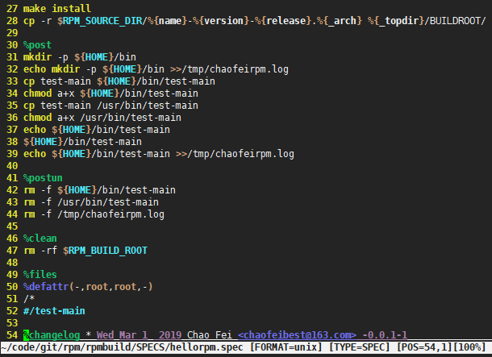

## 2.5 生成rpm包文件

cd ${HOME}/rpmbuild

rpmbuild -ba SPECS/hellorpm.spec

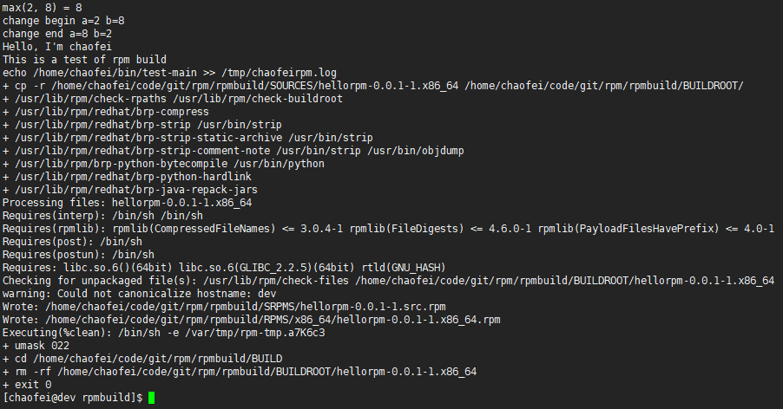

## 2.6 查看生成rpm包之后的目录结构树

cd ${HOME}

tree rpmbuild

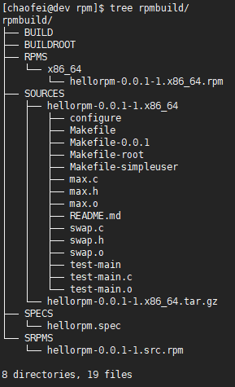

## 2.7 查看rpm包的信息

cd /home/chaofei/code/git/rpm/rpmbuild/RPMS/x86_64

rpm -qpi hellorpm-0.0.1-1.x86_64.rpm

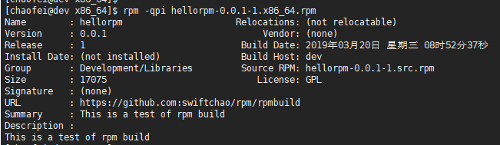

## 2.8 解压rpm包，查看是否制作正确

rpm2cpio hellorpm-0.0.1-1.x86_64.rpm | cpio -idmv

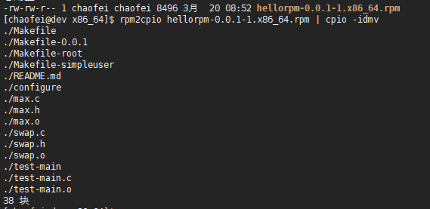

# 3 安装rpm包

cd /home/chaofei/code/git/rpm/rpmbuild/RPMS/x86_64

rpm -qa | grep hello

sudo rpm -ivh hellorpm-0.0.1-1.x86_64.rpm

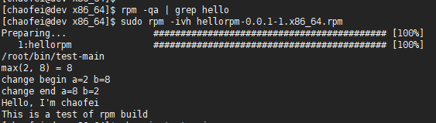

## 3.1 测试是否安装成功

whereis test-main

test-main

rpm -qa | grep hello

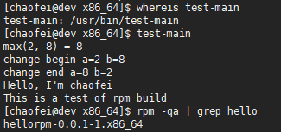

# 4 卸载rpm包

rpm -qa | grep hello

test-main

su root -c "rpm -qa | grep hello | xargs rpm -e"

