National Headquarters, Suleja-Bwari Road, Bwari, P. M. B. 189, Garki Abuja, Nigeria.

**Tel.:** 08166335513, 08123658955

**Website**: [www.jamb.gov.ng](http://www.jamb.gov.ng/) **Email**: [registrar@jamb.gov.ng](mailto:registrar@jamb.gov.ng) support.jamb.gov.ng

# (OFFICE OF THE REGISTRAR)

*Date Printed: Feb-03-2020*

Dear ,

REGISTRATION NUMBER: EXAMINATION NUMBER :

## PROVISIONAL LETTER OF ADMISSION TO UNIVERSITY OF PORT-HARCOURT, FOR 2015/2016 SESSION



*I am delighted to inform you that you have been offered provisional admission to UNIVERSITY OF*

*PORT-HARCOURT, to study a FIRST DEGREE programme in BIOCHEMISTRY with the following details:*

*Faculty: SCIENCES*

*Department: BIOCHEMISTRY*

*Degree: Bachelor of Science (B.SC.)*

*Duration of Programme: 4 YEARS*

Output Best with Colour Printer

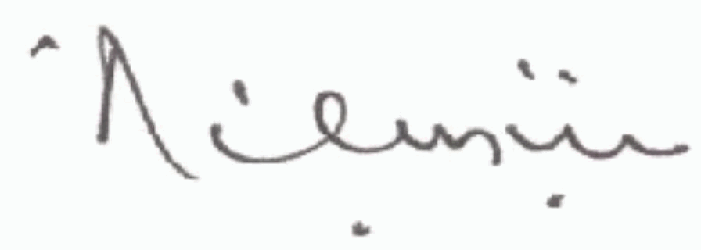***'Dibu Ojerinde***

*Registrar*

I am delighted to inform you that you have been offered provisional admission to UNIVERSITY OF



*PORT-HARCOURT, to study a FIRST DEGREE programme in GEOGRAPHY AND ENVIRONMENTAL MANAGEMENT with the following details:*

*Faculty: SOCIAL SCIENCE*  *Degree: Bachelor of Education (B.SC.)*

*Department: GEOGRAPHY AND ENVIRONMENTAL MANAGEMENT*  *Duration of Programme: 4 YEARS*

The confirmation of this provisional admission is subject to your possession of the minimum entry requirements for the programme to which you have been offered this admission with the following conditions:

1. *At the point of registration in the Institution, you will be required to present the original(s) of the certificate(s) or any other acceptable evidence of the qualifications on which this offer of admission has been based. The Board reserves the right to withdraw this admission even after registration if it is discovered that you have been involved in any form of examination/admission irregularities.*

Output Best with Colour Printer

1. *If it is discovered at any time that you do not possess any of the qualifications which you claim to have obtained, you will be required to withdraw from the Institution.*
2. *Information relating to date of registration, schedule of charges, accomodation facilities, medical examination and any other institutional conditions should be obtained directly from the institution to which you have been admitted.*
3. *In the absence of any response from you within a reasonable time, the institution to which you have been admitted will assume that you are not interested in the offer and may proceed to replace you.*
4. *You are required to present to the institution at the time of registration a letter of reference from a person of*

I am delighted to inform you that you have been offered provisional admission to UNIVERSITY OF



*PORT-HARCOURT, to study a FIRST DEGREE programme in GEOGRAPHY AND ENVIRONMENTAL MANAGEMENT with the following details:*

*Faculty: SOCIAL SCIENCE* *Degree: Bachelor of Education (B.SC.)*

*Department: GEOGRAPHY AND ENVIRONMENTAL MANAGEMENT* *Duration of Programme: 4 YEARS*

The confirmation of this provisional admission is subject to your possession of the minimum entry requirements for the programme to which you have been offered this admission with the following conditions:

1. *At the point of registration in the Institution, you will be required to present the original(s) of the certificate(s) or any other acceptable evidence of the qualifications on which this offer of admission has been based. The Board reserves the right to withdraw this admission even after registration if it is discovered that you have been involved in any form of examination/admission irregularities.*

Output Best with Colour Printer

1. *If it is discovered at any time that you do not possess any of the qualifications which you claim to have obtained, you will be required to withdraw from the Institution.*
2. *Information relating to date of registration, schedule of charges, accomodation facilities, medical examination and any other institutional conditions should be obtained directly from the institution to which you have been admitted.*
3. *In the absence of any response from you within a reasonable time, the institution to which you have been admitted will assume that you are not interested in the offer and may proceed to replace you.*