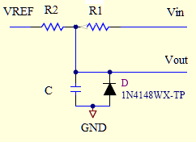
Monitoring Voltage:
2

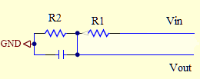
1

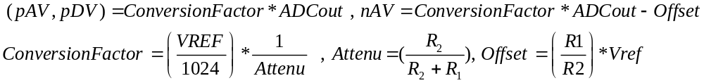

Table of values:
 | R1,precision | R2,precision | Attenu | # of bits | VREF, Vref | 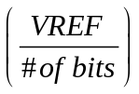 | 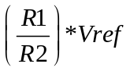
+AN_6 , +DIG_6V | 18 kΩ,1% | 6.04 kΩ,1% | 0.2512479 | 10 bits (1024) | 2.43V | 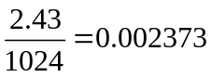 | N/A
-AN_6V | 15 kΩ,1% | 2 kΩ,1% | 0.1176471 | 10 bits  (1024) | 2.43V  2.5V |  | 18.75V

Monitoring Current:

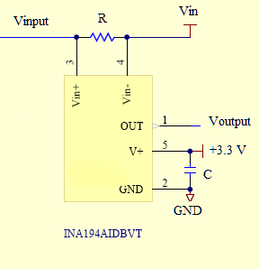
1

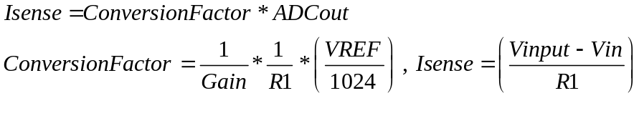
 | R1 | 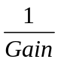 | # of bits | VREF
+AN_6 | 0.1 R | 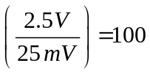 | 10 bits (1024) | 2.43V
-AN_6V | 0.1R |  | 10 bits  (1024) | 2.43V
+DIG_6V | 0.05 R |  | 10 bits  (1024) | 2.43 V

Example: Voltage Measurements:

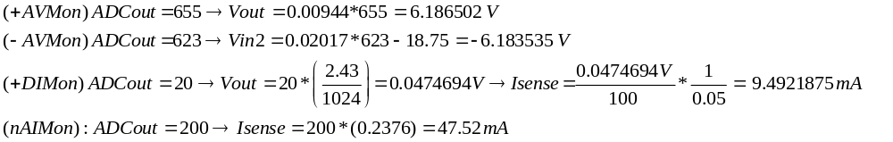

Monitoring the Qpump:

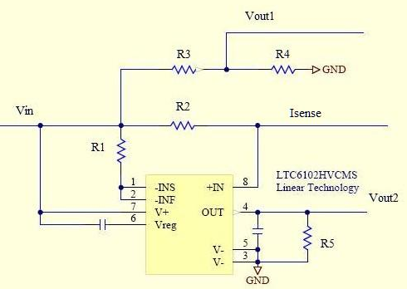

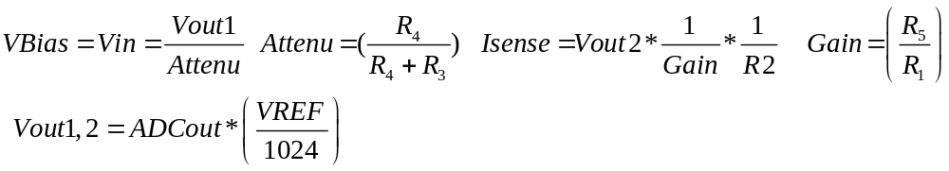

R1,% | R2,% | R3,% | R4,% | R5,% | # of bits | VREF | VREF/1024 | Attenu | 1/Gain
4.99k,01% | 20,0.1% | 976k,0.1% | 24.9k,0.1% | 10k,0.1% | 10bits(1024) | 2.43V | 0.002373 | 0.0248776 | 0.05

Example:
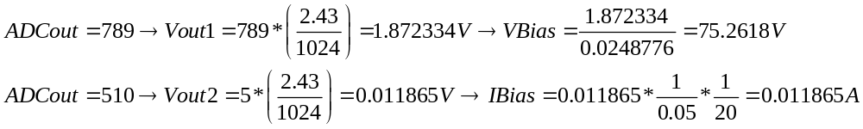
Monitoring the channels voltage and currents:

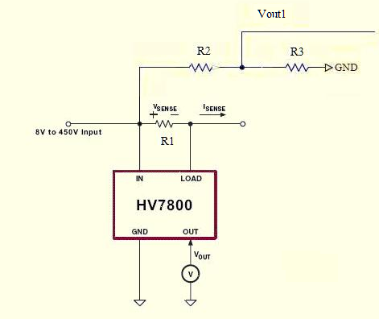

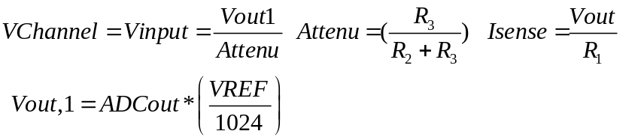

R1,% | R2,% | R3,% | # of bits | VREF | VREF/1024 | Attenu
100k,0.1% | 976k,0.1% | 24.9k,0.1% | 10bits(1024) | 2.43V | 0.002373 | 0.0248776

