Swift ProSys
Asset Register
Setup Guide
This guide walks through installing and configuring the Asset Register application from a fresh machine to a working local instance, and outlines what to change before deploying it in production.

1. What You're Setting Up
Asset Register is a Django application for tracking company IT assets — workstations, monitors, keyboards, mice, UPS units, hard disks, software licenses, air conditioners, biometric devices, networking gear, employees, vendors, projects and incidents. It provides a branded login, a dashboard, bulk import from spreadsheets, exports, and an automatic audit history for every change made to an asset.

2. Prerequisites
Install the following before you begin:
Requirement | Notes
Python 3.11+ | Used to run Django and manage the virtual environment
pip | Comes bundled with Python
Git | To clone the repository
MySQL Server | Production database (SQLite works for local dev without it)
MySQL client libraries | Required to build the mysqlclient Python package

3. Getting the Code
- Clone the repository:
git clone <repository-url>
cd Assets
- Create and activate a virtual environment:
python -m venv venv
# Windows
venv\Scripts\activate
# macOS / Linux
source venv/bin/activate
- Install dependencies:
pip install -r requirements.txt
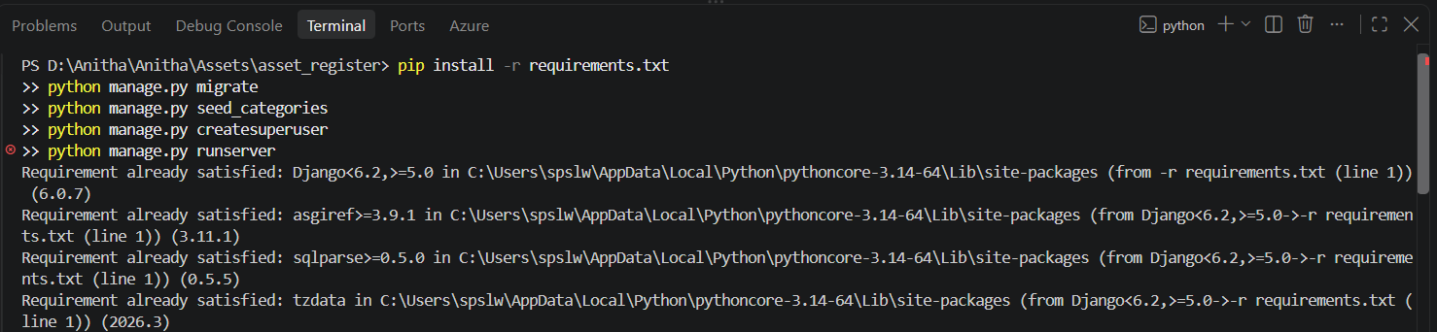
Figure 1 — Dependencies already satisfied after a successful pip install.

4. Configuring the Environment
The application reads its configuration from a .env file in the project root, loaded via python-dotenv. This file is intentionally excluded from version control (see .gitignore) — create your own copy locally.
- Create a file named .env in the project root (next to manage.py).
- Add the following variables, adjusting values for your environment:
DJANGO_SECRET_KEY="<a long random string>"
DJANGO_DEBUG=True
DJANGO_ALLOWED_HOSTS=127.0.0.1,localhost
DB_NAME="asset_register"
DB_USER="<your-db-user>"
DB_PASSWORD="<your-db-password>"
DB_HOST="<your-db-host>"
DB_PORT=3306
ALLOW_CLEAR_ALL=True
Note: For a quick local trial without MySQL, set DB_ENGINE=sqlite instead of the DB_* variables above and the app will use a local SQLite file.
To generate a real secret key rather than typing one by hand, run:
python -c "from django.core.management.utils import get_random_secret_key; print(get_random_secret_key())"
Important: Never commit the real .env file. Keep DJANGO_DEBUG=False, a real DJANGO_ALLOWED_HOSTS, and ALLOW_CLEAR_ALL=False in any production environment.

5. Database Setup
- Apply migrations to create the schema:
python manage.py migrate
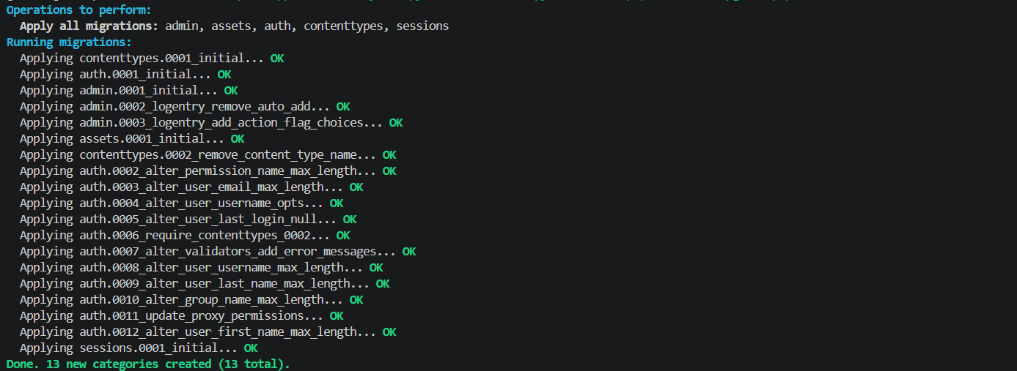
Figure 2 — All migrations applying cleanly on a fresh database.
- Load the starter categories (Workstation, Monitor, Keyboard, Mouse, UPS, Hard Disk, Software/OS, and more):
python manage.py seed_categories
- Create an admin account:
python manage.py createsuperuser
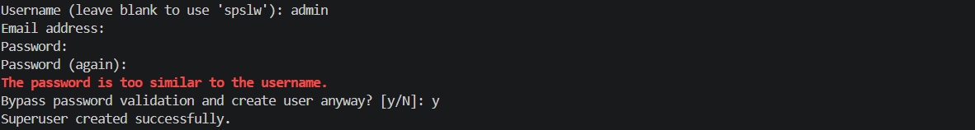
Figure 3 — Creating the first admin login. Django will warn if the password is too similar to the username; type "y" to bypass only for local/dev use, and use a stronger password in production.

6. Running the Application
python manage.py runserver
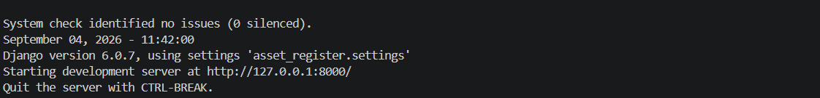
Figure 4 — The development server starting successfully on http://127.0.0.1:8000/.
URL | Purpose
http://127.0.0.1:8000/ | Login page, then the dashboard
http://127.0.0.1:8000/admin/ | Full Django admin panel
http://127.0.0.1:8000/import/ | Bulk import from spreadsheet
http://127.0.0.1:8000/history/ | Full audit trail

Note: Only staff/superuser accounts can log in. Regular non-staff users cannot currently reach the dashboard — create additional staff accounts from the admin panel as needed.

7. Bringing In Existing Spreadsheet Data
There are two separate paths for importing spreadsheet data, depending on the source file:
- Web UI (/import/) — for clean, single-sheet files already close to the app's own column format. Best for ongoing day-to-day imports, supports .csv, .txt and .xlsx, and previews rows before committing.
- import_legacy_assets management command — a one-time command for an old messy multi-sheet tracking workbook, where each tab (Keyboard, Monitor, Mouse, UPS, Hard Disk, Bluetooth, Software/OS, Others, Workstation List) has its own column layout.
python manage.py import_legacy_assets /path/to/Assets.xlsx --dry-run
Important: Always run import_legacy_assets with --dry-run first and read the report before committing the real import.
Two related cleanup commands are available after a legacy import:
- reroute_other_assets [--apply] — moves rows that landed in the "Other Asset" catch-all into their correct category.
- scrub_legacy_secrets [--apply] — finds and removes plain-text secrets (passwords, license keys) that were imported before the sensitive-field filter existed. Take a database backup before using --apply.

8. Before Going to Production
Complete this checklist before the application is exposed beyond your own machine:
Item | Action
Secret key | Generate a real DJANGO_SECRET_KEY (see Section 4) and keep it out of source control
Debug mode | Set DJANGO_DEBUG=False
Allowed hosts | Set DJANGO_ALLOWED_HOSTS to your real domain(s)/IP(s)
Clear-all safeguard | Set ALLOW_CLEAR_ALL=False so the destructive bulk-delete feature is disabled
Database password | Use a strong, unique MySQL password; never reuse example/placeholder values
Legacy secrets | Run scrub_legacy_secrets after any bulk import of old spreadsheets
Static files | Run python manage.py collectstatic and serve via your web server

9. Everyday Maintenance
- Adding a new asset category: use the Django admin panel — no code changes or migrations needed.
- Category-specific fields (e.g. DPI for a mouse, panel type for a monitor) are configured in assets/category_fields.py and stored in each asset's extra_details field.
- Every change to an asset's status, assigned user, location, brand, model, or serial number is automatically logged to the audit history — no manual step required.
- Fields flagged as sensitive (passwords, license/product keys) are filtered out of the import and UI by default.

10. Getting Help
For anything not covered here, see the project's README.md for a full feature list and data-model explanation, or check the Django admin panel for direct data inspection.

