Guideline: Data Modeling
Data Modeling in the Context of Data Design
Data design is an integral part of the application development process. For most applications, data is a key element in the ability to deliver business function.
The approach by which data design is achieved is through the use of models. Data models pictorially show the data components comprising and supporting a given application and its processes along with the key interactions/interdependencies that exist between those data components. Since modeling is at the core of data design, data modeling has become the generic name used to reference data design activities.
This guideline presents the fundamental concepts in developing a Data Model. While the intent of data design is to ultimately manifest a data model in the form of physical data constructs occupying disk space in the form of a database or sets of data files, considerations as to the target physical implementation are not factored in when developing a Data Model. This is important to keep in mind as it means the principles presented apply generically to the design of data regardless of how it ultimately is physically implemented. Independence from physical implementation considerations in Data Models enables them to be flexible yet stable in support of business processes and open to any target form of physical data store – flat files, hierarchical databases, relational databases, networked databases, etc.
It is important to stress that while data may be at the core of data design activities, achieving good data design requires strong and on-going teaming with application process/logic designers throughout the development cycle. Data design and application process/logic design are intrinsically and unalterably dependent on one another and affect one another. Additionally, both parties – data designers and application process/logic designers – must engage the application’s business users throughout the development cycle to assure, validate, and verify that they jointly deliver end products supporting the business.
Throughout the development cycle, data models serve as key communication vehicles between and across both business and technical users:
- in understanding the business nuances of data
- to verify the comprehensiveness and completeness of the data defined to support an application
- as one of the fundamental tools by which knowledge and insight to an application’s processes and underpinnings can be gained
While this paper may present data design principles primarily from the context of developing a new, from-scratch application, elements of the discussion equally apply to other types of projects in which data design efforts may be a part. Examples of other projects in which these concepts may apply include but are not limited to data conversion/migration projects and application enhancements/modifications. The extent to which they apply to any given project will vary per each project’s scope definition and the degree to which data is relevant to the activities to be accomplished within that scope.
Data Models and Object-Oriented Design
In a traditional OOAD approach, a set of classes are identified in the design model that will need to persist data in the database. Although different from developing a Data Model, this approach meets many of the same needs. The persistent classes in the design model function in the same manner as the traditional entities in the Data Model. These design classes accurately reflect the data that must be persisted, including attributes and key relationships.
Creating a separate Data Model is an option in situations when an idealized design of the database that is independent from the application design is required. However, in the best case it would end up capturing the same information in a different form. In the worst case it would not, and thus in the end might not meet the business needs of the application. For projects using this approach, close collaboration between application designers and database designers is absolutely critical to the successful development of the database design.
Data Modeling Languages
Many data modeling languages exist and all are not universally supported by the various software modeling tools available in the marketplace. No convergence of these languages has occurred to define a governing set of concepts (e.g., a standard of language element concepts) to which data modeling languages must adhere. Nor is there hard-set standard terminology for data modeling concepts, though most of the core concepts do have universally accepted names.
Consequently, some of the topics discussed in this paper can be known or referred to via terms/names other than those used in this paper. Accordingly, it also means all concepts discussed in this paper are not explicitly expressed as language elements in all data modeling languages. Likewise, when explicitly expressed in a language, the syntax and semantics (graphical notations/symbols) used to present them vary from having elements of commonality to being quite distinct.
While such is the state of data modeling terminology and the languages supporting it, the concepts discussed in this paper universally apply to data design whether explicitly or implicitly supported by the language being used in the software tool to graphically depict the data model.
The concepts presented in this paper are primarily illustrated using Information Engineering (IE) data modeling notations. Some examples illustrate concepts using other language conventions, particularly when IE does not offer an explicit, distinct language element for the concept.
Data Model Development
Data design is accomplished using a combination of top-down and bottom-up data analysis. As with top-down application design, top-down development of data models progresses from a high-level of abstraction to a lower-level of detail through each phase of the development cycle. Bottom-up data analysis is needed when the basis of understanding stems from existing data constructs in the form of inputs, outputs, processing documents and/or pre-existing data designs and implementations. It starts from a detailed level of understanding and extrapolates toward an abstract, business level of understanding data. The degree to which either approach is used will vary per given application development effort based upon the knowledge and materials from which the data required by an application is derived and identified.
The Building Blocks of Data Models
There are three fundamental data model building blocks used in Data Models:
- Entities
- Attributes
- Relationships
Entities
Entities are identified via top-down and bottom-up data analysis. They represent something – a person, place, item, event, etc. - of significant interest to the business or organization requiring identification via name or description. They can be conceptual or physical; digitized or not digitized; tangible or intangible; or associated with automatic or manual processes.
Entities are given noun names and usually represent static objects rather than dynamic processes or activities. These should be singular nouns chosen to describe the basic business notion. Examples of entity names include: EMPLOYEE, SHIPMENT, RESERVATION, INVOICE, PART, and CUSTOMER. Modifiers may be used to further classify or clarify the business notion an entity represents. Examples include: PURCHASE ORDER, SHOP ORDER, HOTEL RESERVATION, UNION EMPLOYEE, and AIR SHIPMENT.
Top-down analysis begins with business knowledge usually obtained through process definition or business rule development. Development of business rules involves the following:
- Acquisition of rule information from interviews, JAD sessions, and business documents
- Analysis of information forming concise business rules
- Validation of the rules with the source of the rule and other effected functional area representatives
Business rules are then translated into data model constructs. Entities are identified from nouns in the rule sentence structure.
When identifying entities using top-down analysis, care should be taken to address only objects that clearly meet the definition of an entity. Things such as listings, computer reports, paper forms, or other output-related objects are usually not entities (for example, a schedule may be identified as an entity when in fact it is a listing containing attributes from a number of entities such as flights, work orders, or tasks, each of which has schedule dates as attributes). Therefore, in these types of cases, SCHEDULE is not an entity.
In bottom-up analysis, individual data (identified from existing documentation of reports, screens/windows, databases, etc) are aggregated into groups and organized to form entities based on common characteristics and usage. The results are then refined using a set of rules known as normalization. Normalization is discussed in another section of this guideline.
Using IE notations, an entity is depicted as a rectangular box having the entity’s name placed immediately over the box as is shown in the following figure.
Figure 1 – A Data Model Entity
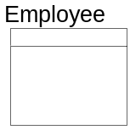
Before continuing the discussion it is important to introduce the notions of type and occurrence as relates to objects depicted in a data model.
Type refers to the classification of data - independent of value.
Occurrence refers to a specific value of a classification of data. The term instance is sometimes used instead of occurrence, and to aid in understanding this notion, from a physical implementation perspective, correlates to the notion of a record in a file or a row in a table.
For example, PURCHASE ORDER is an entity type of data classification, while "purchase order number 15327" is a specific occurrence of PURCHASE ORDER.
Generally, items depicted in data models refer to classifications of data (types),not their specific values (occurrences).
Figure 2 – Data Model Notions of Type and Occurrence
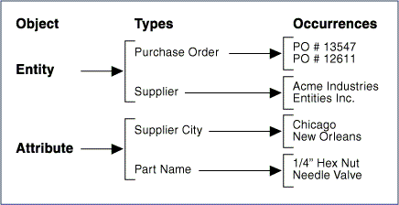
The number of occurrences an entity may have should be estimated and may also be shown on the data model, as well as entered into the data dictionary. This information is useful later in the design process for estimating the size of the database. Specifically how this information is captured and depicted in a data model varies across the data modeling tools available in the marketplace.
An entity ID number is required in some automated data dictionaries so that the name of the entity can be modified without affecting other connections between that entity and other dictionary objects such as attributes and relationships. This number can be used to show ownership of the entity by particular projects or corporate data administration (for example, entity IDs beginning with 5XXX might belong to a particular project).
Figure 3 – Sample Depiction of an Entity with Occurrence and Identification Numbers
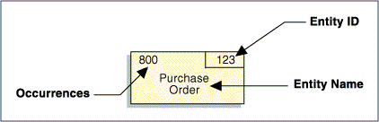
Entities must have definitions and these should be retained in the data dictionary. Their definitions should be as precise as possible and include information regarding different classifications of the entity (for example, different types of customer orders). Where possible, the entity should be described on its own and not in terms of relationships with other entities. Characteristics that make an entity distinct from other entities should be described, as well as, the criteria for identifying the entity. How and when the entity is created should also be described.
Clear entity definitions can often be difficult to achieve. However, these are very important to the success of the data design. It is not unusual for definitions to be continuously modified as the data design evolves.
When producing a data model for multiple business processes, an individual should be designated are the controller of the definitions for the entities. Typically, this person is the Data Administrator (DA) for the organization. Repository-based tools designed for multi-user access can often assist the DA in maintaining the integrity of the data model.
Types of Entities
There are two classifications of entities:
- Kernel or Independent: An entity representing a business object that stands alone and is not dependent on any other entity. CUSTOMER, SUPPLIER, and PART are typical examples of this type of entity.
- Dependent: An entity that depends on the existence of one or more other entities for its identification. These entities are further classified as
- Associative: An entity that represents the multiple association or intersection between two or more other entities. PART-SUPPLIER, representing the association between a PART and a SUPPLIER, is a typical associative entity.
- Characteristic: An entity that describes some characteristic of a kernel entity. A purchase order line item is a typical characteristic entity.
Kernel entities should be identified early in the development of the Data Model. Associative and characteristic entities are generally depicted and identified as part of detailing the Data Model.
Attributes
Each entity in a data model will eventually contain attributes. An attribute represents a single unit of data describing the entity (for example, the attributes of EMPLOYEE would include NAME, ADDRESS, BIRTH DATE, and JOB TITLE). The attributes defined for an entity and the details provided for them evolve as the data model progresses through the development cycle.
Following IE notation, attributes are listed in the bottom portion of the rectangular box depicting an entity as is shown in the following figure.
Figure 4 – Attributes Specified in a Data Model
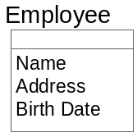
As the primary intent of an early LDM is to establish scope and the framework for the development effort, its focus is entity identification and definition. Attributes provided for entities in an early LDM tend to be those of most interest to the business. They consequently are initial, but incomplete, attributes listings. Fuller attribute lists will be associated with the entities as a greater depth of the business and the application processes along with the data needed to support them is gained throughout development.
Attribute Naming Guidance
An attribute name should
- Be logical; it should describe what the element is rather than how or when it is used.
- Not include physical mechanics such as file codes or storage IDs.
- Always be singular.
- Be composed of the following:
- A noun word describing the category (for example, ID, NUMBER, NAME, DATE, TIME, CODE, DESCRIPTION, AMOUNT).
- A key descriptor word. This noun word serves as a modifier to the category word and is similar or the same as entity noun names (for example, PURCHASE ORDER, INVOICE, PART, SUPPLIER, EMPLOYEE, ACCOUNT, WORK ORDER, and RESERVATION).
- Modifier words as necessary, to fully qualify the attribute (for example, START, END, MONTHLY, YEAR-TO-DATE, MINIMUM, and MAXIMUM). It is important that these modifiers are used consistently.
Keys
Initially, no significance is placed on the attributes listed for an entity. As the model progresses from an abstract to a more detailed representation of the data design, it becomes important to designate the attribute(s) that uniquely distinguish one occurrence of an entity from another. Such distinction may be via one, or a concatenation of many, attributes. It is also possible that multiple means exist by which occurrences of an entity may be distinguished from one another.
An attribute or concatenation of attributes that can provide the ability to distinguish entity occurrences are generically referred to as Keys. A key defined via the concatenation of multiple attributes is called a Composite Key.
The different keys available to distinguish occurrences for an entity are called Candidate Keys.
Primary Keys
The candidate key by which an occurrence for an entity will be identified is called the entity’s Primary Key. Each entity ultimately must have a primary key to uniquely identify an occurrence of the entity.
Sometimes more than one possible primary key exists among the candidate keys. Each possible primary key must be evaluated to determine which should be the actual primary key (for example, VENDOR NUMBER and VENDOR NAME might both suffice as a primary key to the vendor entity). To select the best primary key, the following questions should be considered:
- Do all candidate keys uniquely identify the entity?
- Is it possible that different entities are being considered?
- Which of the candidate keys is the most stable and will maintain its uniqueness in the future?
NAME is rarely used as a primary key as it likely will not provide uniqueness across the possible values it represents. Even where such values are found to be unique, it is rare such uniqueness can be maintained over time without the data design impinging on the values used. That would represent poor data design.
Sometimes composite keys can become overly long in length or in the number of attributes comprising them posing complexities in data access.
Where uniqueness is not strongly inherent in the attributes the business has selected as a key or where its composition poses access complication, an attribute solely defined for the purpose of assuring uniqueness or to reduce access complication is created. Such a key is called a Surrogate Key. Examples of such surrogate keys include EMPLOYEE NUMBER for EMPLOYEE and ORDER ID for PURCHASE ORDER.
A surrogate key may be designated as the primary key for an entity. This does not countermand the role the attributes comprising the “natural” primary key play in enforcing occurrence uniqueness for an entity. In many cases, the users perform their processes using the “natural” key and its corresponding surrogate key is generated and only known “behind the scenes”. Consequently, it is important to understand the correlation between a surrogate key and its underlying “natural” key as they each relate to supporting the rules governing data for the application’s business functions and processes.
Following IE data modeling notation, an attribute or concatenation of attributes comprising an entity’s primary key are segregated from the other attributes describing an entity and listed in the top box the entity.
Figure 5 – Sample Specification of an Entity’s Primary Key
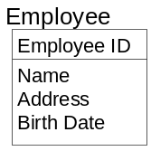
Foreign Keys
Data comprising the primary key of one entity can exist as attribute(s) in another entity whether as part of that other entity’s primary key or not. Such data is referred to as being a Foreign Key in an entity. An entity may contain multiple foreign keys. If the foreign key is part of a concatenated primary key, it is called a primary foreign key.
Using IE diagramming syntax, foreign keys are designated via a “(FKn)” notation following each attribute comprising the foreign key. The “n” in (“FKn)” represents a number distinguishing one foreign key from another – the first foreign key being “(FK1)”, the next “FK2)”, etc.
Figure 6 – Sample Specification of a Foreign Key in an Entity
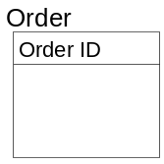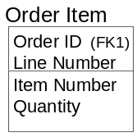
Entities having foreign keys generally have a data dependency on the entity from which the data represented by the foreign key is a primary key. Such entities are referred to as dependent entities. These dependencies tend to be intrinsically hierarchical in nature. The entity for which the data is a primary key is referred to as the parent entity and the entity for which the data is a foreign key is referred to as the child entity. The association between two such entities is hence referred to as a parent-child relationship. The business rules governing how these entities interact per their data dependencies are encompassed in the concept of Referential Integrity.
Relationships
A relationship is a two-way connection between two entities expressing a link between them that is of importance to the business. Typically, relationships can be described in terms of verbs. Since entities are nouns, a short sentence can be constructed using one entity noun as the subject and the other as the object with the verb in the middle (for example, a PURCHASE ORDER is placed with a SUPPLIER. PURCHASE ORDER and SUPPLIER are the entities and "placed with" is the relationship).
In an IE-based data model a relationship is depicted as a solid line connecting two entities with symbols/notations at either end conveying information about the relationship from each entity’s perspective. The types of information conveyed on relationship lines include Cardinality and Optionality.
Cardinality
The cardinality marking on a relationship identifies whether one or many occurrences of an entity may exist for each occurrence of the related entity. Following IE notations, a "crow's foot" at one end of a relationship means that many occurrences of that entity can relate to a single occurrence of the entity at the other end of the relationship. A straight line at the one end of a relationship means that a maximum of one entity occurrence may exist for a single occurrence of the related entity. This means that a relationship may be one of three types and depicted in a data models as follows:
- One-to-one
- One-to-many
- Many-to-many
One-to-one relationships are relatively uncommon. An example of this type would be that a DRIVER holds a DRIVER'S LICENSE.
The most common type of relationship is one-to-many (for example, PURCHASE ORDERs are placed with a SUPPLIER). In the context of one-to-many relationships, the terms parent and child are often used to refer to the entities at the one-end and many-end of the relationship, respectively.
Many-to-many relationships often appear to be relatively common in the early stages of data modeling. However, they will be transformed into two or more one-to-many relationships as the data model is refined via normalization. Many-to-many relationships are sometimes referred to as complex relationships. An example of this type of relationship exists between PART and SUPPLIER: a PART can have many SUPPLIERs and a SUPPLIER can supply many PARTs.
The notion of cardinality is also found in the Unified Modeling Language (UML) used in OO development. This notion is called multiplicity in UML and refers to the range of values that an attribute can assume.
Optionality
Optionality identifies whether a relationship must exist (mandatory) or may exist (optional) at the instance when an occurrence of an entity is created. For example, if a PURCHASE ORDER must relate to a SUPPLIER when it is created, then the relationship is mandatory and is marked with a bar. If a PURCHASE ORDER can be created without referencing a SUPPLIER, the relationship is optional and is marked with an O.
The optionality symbol is placed at the end of the relationship opposite from the entity being created. Two separate optionality symbols are required - one at each end of the relationship line so that optionality is explained for both members of the relationship.
The specification of both cardinality and optionality for relationships in a data model are dictated by the business rules governing the data being modeled.
The following table summarizes the IE-based notations used to represent the relationships that appear in data models.
Figure 7 – Relationship Notations and Their Interpretations

Notation | RELATIONSHIP interpretation (From Left to Right)
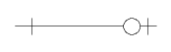 | Represents a “one to zero-or-one (minimum of zero and a maximum of one)” relationship between two entities
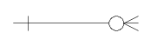 | Represents a “one to zero-or-many (minimum of zero and a maximum of many)” relationship between two entities
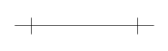 | Represents a “one to one (minimum of one and a maximum of one)” relationship between two entities
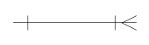 | Represents a “one to one-or-many (minimum of one and a maximum of many)” relationship between two entities

The following figure shows a sample relationship as would be depicted in an IE-based data model highlighting the cardinality and optionality specified at either end of the relationship.
Figure 8 – Sample Relationship as Depicted in Data Models
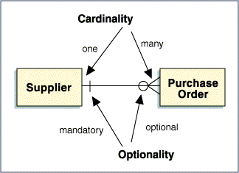
The “Substance” of Relationships
As has been stated, relationships show the connections between entities – data connections. As this implies, the “substance” of a relationship is bound by data that exists in common between the entities forming the relationship. Consequently, data dependency between entities is the basis from which relationships are identified and defined.
Following good data modeling practices, this would imply having attribute names in common between entities in a relationship. However, as this may not always hold true, it is best to understand the concept from the perspective of the data an attribute represents rather than merely from its name. For example, SOCIAL SECURITY NUMBER and TAX IDENTIFICATION NUMBER both represent the same data for an individual – their social security number – though TAX IDENTIFICATION NUMBER has a broader context as it, unlike SOCIAL SECURITY NUMBER, applies to more than just individuals. Consequently, entities containing one of these attribute names could have data connections to an entity containing the other attribute name.
This can also occur when a business notion is known by different names across the enterprise, each name stemming from the understanding and perspective each group has concerning that data. Unlike SOCIAL SECURITY NUMBER and TAX IDENTIFICATION NUMBER, such attribute names represent the identical scope and range of data. They are synonyms for the business notion. An example of such attributes would be FAMILY NAME, LAST NAME and SIR NAME. Synonyms for an attribute should be noted in the data dictionary.
A relationship minimally has as the basis of its data connection the primary key of one of the entities in the relationship. This is important to keep in mind when determining if a relationship exists or not between entities.
A Non-Identifying Relationship is one in which the primary key of one entity is a foreign key in another entity and does not contribute to the composition of the other entity’s primary key.
An Identifying Relationship is one in which the primary key of one entity is a foreign key in another and does contribute to the composition of the other entity’s primary key.
Identifying relationships most commonly appear between parent-child entities.
Relationship Labels
Sometimes it is not clear what the role of the relationship is and it is worthwhile to place a text label on the relationship line to clarify its meaning within the model (for example, a relationship between EMPLOYEE and CAR could mean many things: employee drives car, employee insures car, or employee rents car). Usually, only one of these will be correct for this business instance.
The standard convention for interpreting relationship labels is to read the label from left-to-right or top-down. If the label is intended to be read right-to-left or bottom-up, then it should be placed in parentheses as a means to highlight it should be read as such. Some data modeling tools require a relationship to be labeled in both directions while others do not provide for labeling of relationships. Consequently, the ability to label relationships, the robustness of such capabilities, and the rules governing the entries made regarding relationship labeling are governed by the data modeling tool used.
Figure 9 – Labeling Relationships
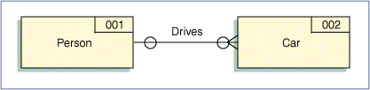
The diagram in Figure 9 shows another convention by which entities can be depicted. The numeric number shown in the upper right corner of the entity is an entity identification number. It serves as a unique identifier for the entity as an object in a data dictionary. This is not as prevalently used a notation as that used from IE- based or derived languages.

Degree
The degree of a relationship is the number of entity occurrences related to a single entity at the other end of the relationship. As this number usually varies, the minimum, maximum, and modal average is captured (for example, if suppliers are sometimes inactive, the minimum is zero; if the most frequently used supplier has no more than 50 purchase orders active at any one time, the maximum is 50; if most suppliers have 10 purchase orders active at a given time, the modal average of the relationship is 10).
The ability to specify degree for a relationship as part of a data model is dictated by the data modeling language(s) supported by the modeling tool used. It is valuable information regarding a relationship and should be captured, even if not explicitly shown in the data model. Ideally, it should be among the properties captured about a relationship in a data dictionary.
Figure 10 – Specifying the Degree of a Relationship
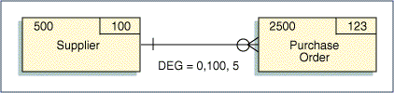
Note: The maximum is a typical maximum, not an absolute maximum.
The numeric number provided in the left-most corner of each entity in this diagram represents the maximum number of occurrences the entity is estimated to have. This is also valuable information that should be captured for use in subsequent design and implementation activities.
Recursive (Multiple) Relationships
On occasions, two entities may have more than one relationship with each other. This occurs when the primary key of one entity is represented in another entity via multiple sets of attributes – each attribute set being a foreign key. Such relationships are referred to as recursive relationships.
For example, in a foreign exchange system, the entity CURRENCY has two relationships with EXCHANGE RATE - once as the base currency and once as the risk currency. In the exchange rate from Australian dollars (AUD) to US dollars (USD), AUD is the risk currency and USD is the base currency. EXCHANGE RATE would contain the attributes RISK CURRENCY ID, BASE CURRENCY ID, and RATE OF EXCHANGE.
Figure 11 – Sample of a Recursive Relationships
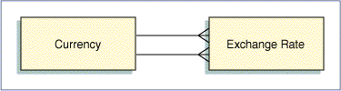
Self-Recursive Relationships
An entity may have a relationship to itself. These are called self-recursive relationships. For example, EMPLOYEE supervises EMPLOYEE is a one-to-many hierarchical relationship between EMPLOYEE and EMPLOYEE. PART contains PART is an example of a many-to-many recursive relationship which will be resolved into two one-to-many bill-of-materials relationships, described later in this document. These relationships are treated with the same rules as those between two different entities.
Typically, self-recursive relationships represent hierarchies, such as an organization chart within a company. As this generally is the case, both ends of the relationship will have optional existence conditions. That’s because there will always be an occurrence representing the top of the hierarchy without a parent and an occurrences at the bottom of the hierarchy with no children. For example, in the EMPLOYEE supervises EMPLOYEE situation, there is always one EMPLOYEE who is at the top and does not have a supervisor. Likewise, there are EMPLOYEEs at the bottom who do not supervise anyone.
Figure 12 – Examples of Self-Recursive Relationships
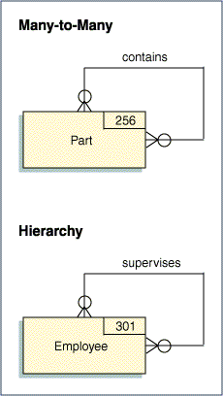
Connection Traps
It is often possible to show relationships in more than one way. As a result, unnecessary relationships may be present in a data model. Consequently, a model should be examined for redundant relationships and, if found, they should be removed.
A triangular relationship between three entities should always be questioned. One of the three relationships is usually redundant. For example, a DIVISION has many DEPARTMENTs; a DEPARTMENT has many EMPLOYEEs. This implies that a DIVISION has many EMPLOYEEs. Explicit depiction of this relationship conveys no additional or unknown information about the interaction between DIVISION and EMPLOYEE that is not understood in the context of DIVISION to DEPARTMENT and DEPARTMENT to EMPLOYEE. Such a relationship, therefore, is redundant.
Sometimes the relationships that are shown are not optimal and it is possible to create "connection traps" as shown in the diagram below.
In a fan trap, the relationships are not optimal because a grandparent-parent-child is shown as grandparent- parent and grandparent-child. This fails to show the parent-child relationship.
In a chasm trap, the relationships are not optimal because a grandparent-parent-child relationship is shown as parent-child and grandparent-child. This fails to show the grandparent-parent relationship.
Figure 13 – Examples of Connection Traps and Resolution
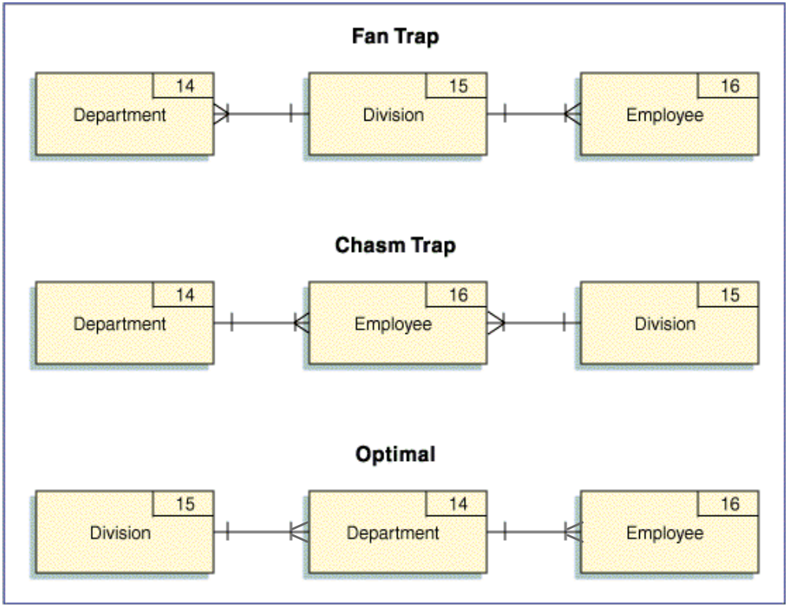
Subject Areas
A subject area is a natural subdivision of a data model centered on a major resource or activity of the enterprise. It consists of a highly cohesive grouping of entities and their relationships used by common business activities.
Subject area modeling is a means for providing high-level views of a data model by suppressing its lower level detail thus enabling a decomposition mechanism for data models as can be done in process analysis. The concept is used as a means of organizing and partitioning the contents of data models into superset aggregates. Subject area boundaries are derived by understanding what data is valuable to a business and how it is used, so that logical groupings of data entities can be identified. As this aligns data with its business context, such diagramming of data is also sometimes referred to as a Data Context Model.
The effect of adding subject areas to a data model is that a hierarchy is established for the data contained in the model. Some of the advantages of creating a subject area hierarchy are as follows:
- It makes the data model easier to understand by allowing the reviewer to focus on specific sections of the data model, without being overwhelmed by the total diagram.
- If the rules of parallel decomposition have been followed, the subject area hierarchy on the data model should map to the process model hierarchy represented by functional decomposition of the application. Since both models should have initially been developed independently, the two hierarchies can be used to cross-validate each other.
- It provides a mechanism to allow the application developer to consider the implications of system "builds". Since the subject areas are derived from an understanding of the business, any decisions to implement an application in a phased implementation approach (such as decisions that are based on a desire to implement one functional area of the business first) can be validated against the data model by reviewing the subject area containing all of the data entities needed to support the area of the business under consideration.
Identifying Subject Areas
Subject areas can be defined early in the application development cycle since each kernel entity is potentially a subject area.
In the figure below, a section of a data model is shown that contains three levels of a subject area hierarchy. The top level service area – Service Delivery in the sample diagram - contains all data entities in the subject area (in this case, all the entities shown in the sample diagram) and represents (for illustrative purposes) all of the data required to support this major business activity.
Figure 14 – Sample Subject Area Hierarchy
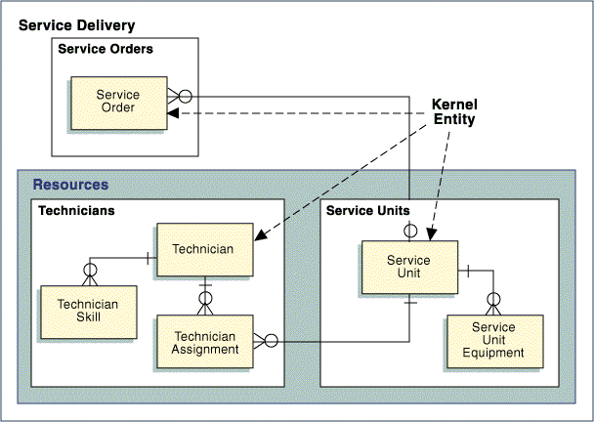
Within this subject area are two lower level subject areas - Service Orders and Resources. The Resources subject area being further decomposed into two lowest level subject areas relating to Technicians and Service Units. At each of the lowest level subject areas (Service Orders, Service Units, and Technicians), the focal point is a single kernel entity plus any related associative or characteristic entities contained within the subject area boundary.
The name of the lowest level subject area should be the plural name of the kernel entity (for example, in the diagram provided, the subject area focused on the kernel entity TECHNICIAN is named TECHNICIANS). The counterpart to this subject area on a process model would potentially be a part of the business based around maintaining technicians.
Subject Areas and Prototyping
Using subject area hierarchies provide a valuable starting point for developing a superstructure for a prototype menu hierarchy. Each of the levels of the hierarchy can be considered as a level in a window hierarchy that needs to be traversed to get to the object of interest. At that point, the business events related to the kernel entity form the actions to be performed against the entity.
Data Dictionary
Each entity, attribute, and relationship should be fully described in a data dictionary or glossary. Depending on project standards, entries in the data dictionary should document the following:
Entities
- The entity name and aliases
- The description of the entity
- Additional information which, while not part of a conceptual schema, may need to be documented on particular projects:
- The purpose of the entity
- What an occurrence of the entity represents
- Special considerations for the entity relative to this project effort
- Current volume - Current number of occurrences
- Expected growth - Number of new occurrences per year
- Growth percentage - Annual rate at which new occurrences are expected to increase/decrease
- Where entity is used - Organizational unit
- Availability - High, medium, or low
- Security - Level of authority needed to protect an occurrence of the entity when originated or changed
- Confidentiality - Level of authority needed for reading an occurrence of the entity
- Approximate size - Approximate size of data for an average occurrence of the entity
Attributes
- The purpose of the attribute
- The definition of the attribute
- The attribute’s domain
Relationships
- The participating entities
- The business rule or fact that necessitates the relationship
- The cardinality associated with the entities’ participation in the relationship

Evolution of the Data Model
Development of the Data Model typically involves a succession of refinements.
An early, outlined Data Model identifies the population of entities and key attribute content, and describes how the entities are tied together by relationships. It presents a high-level view of the significant information of interest to the business and establishes the foundation from which data design will progress.
Detailing a Data Model primarily involves resolving the many-to-many relationships present in the outlined data model, and normalizing the data.
The transformation of many-to-many relationships involves the introduction of “intermediary” entities to obtain one-to-many relationships. These are categorized as Associative Entities and Characteristic Entities.
Associative Entities
An associative entity is the association or intersection of two or more entities. This new entity has attributes of its own and is a legitimate business concept and should be named using a noun representative that concept. If a single noun name is difficult to determine, then the name is built from the names of the entities being associated.
For example, a many-to-many relationship between PART and SUPPLIER may be modeled with a new entity in the middle – PART SUPPLIER. This associative entity represents a specific PART from a specific SUPPLIER. It has two one-to-many relationships back to each of the original entities - PART and SUPPLIER - and has attributes such as cost, lead time, and quantity on order.
An associative entity can be thought of as a matrix between occurrences of the entities that originally had the many-to-many relationship. Using this analogy, the maximum number of occurrences an associative entity can have is the Cartesian Product of the occurrences each entity in the many-to-many relationship from which the associative entity was “derived”. For example, if 100 PARTs are possible and 200 SUPPLIERs are possible, the maximum number of PART.SUPPLIERs is 100 x 200 or 20,000 occurrences.
Figure 15 – Sample of Resolving Many-to-Many Relationship via an Associative Entity
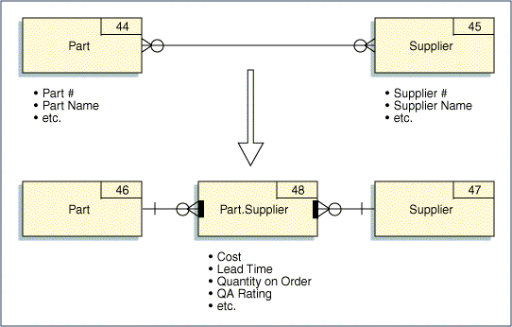
It is possible for an associative entity to be an association of more than two entities. For example, a WINE VINTAGE can be shown to be an association among WINE TYPE, VINEYARD, and YEAR. Thus, it is actually a three-way association.
Figure 16 – Example of a Three-way Association of Entities
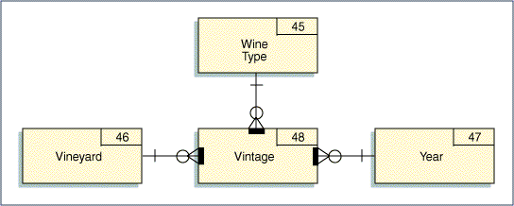
Primary Key Rules for Associative Entities
An associative entity’s primary key should be comprised of the concatenation of the primary keys for each entity involved in the association (the participating entities). For example, the primary key of PART SUPPLIER is PART NUMBER plus SUPPLIER NUMBER. These are primary foreign keys.
If the primary key of an associative entity is not the concatenation of the participating entity's keys, an evaluation should be completed to determine whether the association is defined correctly.
Associative Entities and Existence Dependency
An occurrence of an associative entity cannot exist unless there first exists occurrences of the participating entities. For example, a specific PART SUPPLIER cannot exist unless the specific PART and the specific SUPPLIER exist first. Furthermore, deletion of a PART requires deletion of all PART SUPPLIERs involving that particular PART. Therefore, it can be said that PART SUPPLIER is existence-dependent on its participating entities. Associative entities are always existence dependent on their participating entities.
The following diagram is provided here as a sample of how existence dependency may be depicted in a data model. In this diagram the associative entity’s existence dependencies are shown as bold marks inside the associative entity – one for each relationship back to each of its participating entities.
Figure 17 – Example of Explicit Depiction of Existence Dependency in a Data Model
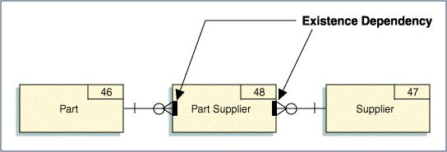
An existence dependency is different from a mandatory relationship because a mandatory relationship can be disconnected from one entity occurrence and connected to another occurrence (e.g., an EMPLOYEE related to a WORK CENTRE can be disconnected from one WORK CENTRE and connected to another). With existence dependency, relationships can not be sustained between the associative entity and its participating entities in this manner because the associative entity’s occurrence can not be re-connected to another occurrence in the participating entity.
Obviously, an occurrence of PART SUPPLIER can not exist without first having its corresponding value for its foreign keys from each of its participating entities – PART and SUPPLIER. However, the relationship between an occurrence in PART SUPPLIER is strongly connected to each of its parent entity’s occurrence – and specifically to those occurrences. The associative entity occurrence can not be connected to any other occurrence in the participating entities. For example, a PART.SUPPLIER occurrence involving, say, PART number 123 cannot be connected to any other PART occurrence – only to PART number 123.
Existence dependency is inherently part of the relationships between an associative entity and the participating entities forming the association. Consequently, many data modeling notations do not provide a means to explicitly indicate existence dependency between such entities. This also means such explicit depiction of existence dependency is not widely available across the data modeling tools in the marketplace.
Where existence dependency can be depicted in a data model, it clearly identifies the relationships and entities participating and defining the association. The ability to call-out this relationship property can be particularly valuable if the associative entity has relationships that are not involved in the association.
Note that explicit demarcation of existence dependence is not provided in all data modeling languages/notations and would only be available in data modeling tools supporting it.
Characteristic Entities
A characteristic entity helps describe a kernel entity in some way. A characteristic entity exists with a kernel entity in a parent-child relationship. The kernel entity is the parent and the characteristic entity is the child. Usually, characteristic entities have a one-to-many relationship with the parent entity (one parent has many characteristic children). However, it is possible for a one-to-one relationship to exist.
Characteristic entity names should be nouns and they often include their parent names as a modifier. Examples of characteristic entities are PURCHASE ORDER LINE ITEM, DOCUMENT REVISION, and EMPLOYEE VACATION PROFILE.
Figure 18 – Example of Characteristic Entities Depiction in a Data Model
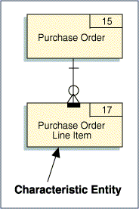
Primary Key Rules for Characteristic Entities
Usually, the primary key of a characteristic entity inherits the primary key of the parent entity but also includes some other attribute to make the key unique. For example, PURCHASE ORDER LINE ITEM typically has the key PURCHASE ORDER NUMBER plus LINE ITEM NUMBER. Likewise, DOCUMENT REVISION has the key DOCUMENT ID plus REVISION NUMBER.
If the key of the characteristic entity does not include the parent entity's key as a primary foreign key, an evaluation should be completed to determine whether the characteristic has been properly defined.
Characteristic Entities and Existence Dependency
A characteristic entity is, by definition, existence-dependent on the parent entity (an occurrence of a characteristic entity cannot exist unless the parent entity occurrence exists first). Likewise, if a parent entity occurrence is deleted, all the related characteristic entity occurrences are also deleted.
An example of explicitly denoting existence dependency between the parent-child entities is shown above in Figure 18 via the bold bar in the characteristic entity, PURCHASE ORDER LINE ITEM.
Generalization-Specialization: Supertype-Subtype Characteristic Entities
In most cases, describing a business notion as an entity is driven by the attributes that collectively characterize that business notion - an employee can be characterized or described by an employee number, a name, a job title, a skill set, etc. Generalization-Specialization is a technique by which entities are characterized via both their similarities and their differences and is represented in data models via supertype-subtype entities.
Though generalization and specialization result in the same graphical depiction of data in a data model, as their names imply, they do so from opposite perspectives. However, the distinction as to which led to further abstract understanding of the data can often not be purely delineated as it tends to be a combination of both.
Generalization establishes supertype-subtype entities through the identification of common business notions or attributes across a set of entities. The supertype is formed to represent the commonality across a set of entities and its subtypes to represent their distinctions. Discovery is driven from bottom-up, conical data analysis. It enables further abstraction in how data is represented across in the data model.
For example, consider an electric utility data model that has entities for construction work done on POLEs and in TRENCHes. The entities POLE and TRENCH could be made subtypes of a newly created supertype entity WORK LOCATION.
Specialization establishes supertype-subtype entities by breaking an entity down into logical subtypes. Discovery of such entities is via successive top-down, specialized decomposition of an entity.
An airline may offer both domestic and international flights. Each is similar in that they both generically are AIRLINE FLIGHTs, so a common set of attributes exists for each. Yet, a set of attributes distinct to each also exists. AIRLINE FLIGHT is the supertype entity and DOMESTIC FLIGHT and INTERNATIONAL FLIGHT are its subtype entities. Furthermore, there are a common set of attributes to describe a DOMESTIC FLIGHT and a distinct set unique to each PASSENGER FLIGHT and CARGO FLIGHT. DOMESTIC FLIGHT, therefore, though a subtype entity to AIRLINE FLIGHT can, in turn, be a supertype entity. In this case, PASSENGER FLIGHT and CARGO FLIGHT are its subtype entities.
As this shows, subtypes may themselves be further classified into subtypes, thus becoming a supertype forming what are called generalization-specialization hierarchies or simply generalization hierarchies since a greater level of data abstraction is achieved regardless of which analysis is applied. No matter how the hierarchy was identified, once defined, traversal down the hierarchy represents increasing degrees of specialization and traversal up the hierarchy represents increasing degrees of generalization.
There is no limit to the number of levels a generalization hierarchy can have nor to the number of subtypes a supertype may have. The following diagram illustrates a generalization hierarchy for the airline examples discussed above.
Figure 19 – Sample of a Generalization Hierarchy
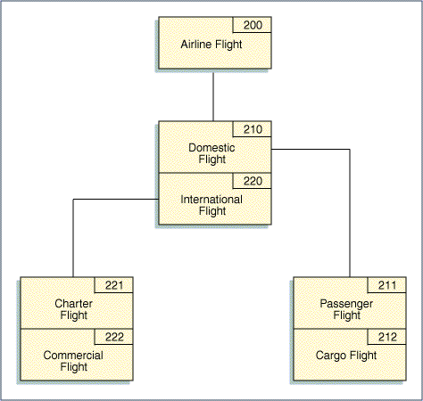
Generalization and specialization improves the overall stability and flexibility of a data model. They minimize the impact of change by reducing the overall number of entities and relationships in a data model. By so doing, change is contained to the entities and/or relationships having significance to the change.
Supertype-Subtype Constraints
Subtypes may be mutually exclusive or inclusive.
In the airline flight example illustrated and discussed above, CHARTER FLIGHT and COMMERCIAL FLIGHT are mutually exclusive subtypes of INTERNATIONAL FLIGHT. This means a flight can be one or the other but not both. Such subtypes are also referred to as disjointed subtypes and the hierarchy they form as a disjointed hierarchy.
Contrast this to a say a supertype entity that represents a PERSON having subtypes that represent the different types of roles a PERSON may have. In this case, it is possible that a PERSON can function in more than one role – the role subtype entities are mutually inclusive. For example, in a movie production, an individual - an occurrence of PERSON - may have the roles of DIRECTOR, of PRODUCER, of ACTOR, as well as other roles. In this case, a PERSON can be any number of the subtypes – one, some, or all. Such subtypes are also referred to as overlapping subtypes and the hierarchy they form as overlapping hierarchies.
In some cases, it is required that an occurrence of a supertype entity must be a member of at least one of its subtype entities. In other cases, it may exist onto itself without being a member of any of its subtypes. These are referred to as total completion and partial completeness, respectively. Generalization tends to be total completion since the supertype entity was derived from its subtype entities.
Subtype Entity Properties
In a supertype-subtype structure, a subtype entity automatically inherits all the attributes of the more generalized supertype (i.e., the dependent entity <subtype> inherits all characteristics of the entity on which it is dependent <supertype>). Each subtype entity may have individual characteristics and these are not shared with the other subtype entities comprising a characterizing supertype-subtype set. It is not possible for a supertype to inherit characteristics from a subtype. Each subtype has attributes of its own that are different from the other subtypes, but all subtypes share the common attributes of the supertype.
These same rules apply to relationships. The subtypes inherit all relationships of its supertype.
ust as a subtype can have attributes distinct onto itself from both its supertype and sibling subtypes, it can also have distinct relationships to other entities that its supertype and sibling subtypes do not have.
When documenting subtype hierarchies, a subtype entity should be treated as any other entity and receive a name, definition, ID, etc. Since, by definition, the supertype's attributes are inherited by the subtype, it is not necessary to duplicate the supertype's attributes for as being part of each subtype. Only the unique attributes each subtype has need to be identified.
Subtype Discriminator Attribute (Supertype Class Code)
Often an attribute is created as part of the supertype entity for the purpose of linking one of its occurrences to its correspondent subtype occurrence. Such an attribute is generally referred to as the subtype discriminator or as the supertype class code. Typically, such an attribute is short in length, usually 1 to 3 characters and might require a separate edit and description/reference/look-up table in the database in its support. .Such attributes are important factors taken into consideration on how a given generalized hierarchy will ultimately be physically implemented.
Figure 20 – Example of a Subtype Discriminator
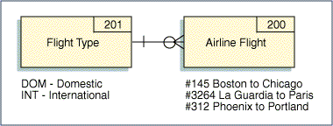
Orthogonality: Parallel Subtypes for a Supertype
A supertype entity can have multiple subtype sets. These multiple subtype sets are said to be orthogonal (or parallel) and enable specializing a supertype entity in multiple ways. For example, expanding on the movie production example cited earlier in this section of the document, beyond a PERSON having a role in the production company as a DIRECTOR, a PRODUCER, an ACTOR, etc., a PERSON may be an employee of the movie production company or could be an external RESOURCE. There is no limitation as to the number of subtype sets an entity may have.
Figure 21 – Example of a Supertype Having Multiple Subtypes
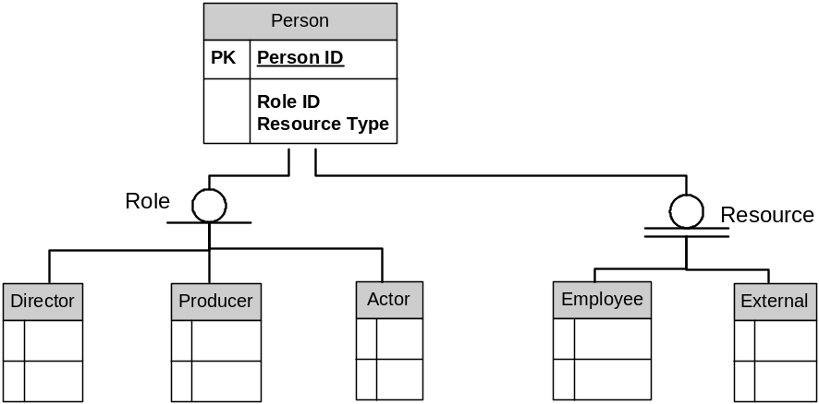
In the example illustrated in the above figure, the Role subtype is partially complete meaning a PERSON occurrence can exist without having a Role subtype occurrence. The Resource subtype is totally complete meaning a PERSON occurrence must be an occurrence of one of the Resource subtypes. Note how this is distinguished in the software product’s graphical syntax as a single line under the subtype category for partial completeness; as a double line for total completeness.
The graphical depiction is based upon Integrated Definition for Data Modeling (IDEF1X) syntax which extends IE to include explicit syntax for supertype-subtypes. The software modeling tool used to draw this diagram had explicit syntax to indicate subtype completeness but did not have explicit syntax for subtype exclusivity.
For reference, languages that also use this type of graphic symbol for supertype-subtypes and do include explicit syntax for subtype exclusivity often use the convention of an open circle, as is shown in the above diagram, to convey the subtypes are mutually inclusive (overlapping subtypes) and a closed circle (a solid black circle) to convey they are mutually exclusive (disjoint subtypes). In our example, this can not be determined from the diagram. Here, it is likely that the Role subtypes are mutually inclusive as a PERSON occurrence – that is, an individual – could fulfill multiple roles and that the Resource subtypes are mutually exclusive since an individual could be an EMPLOYEE or an EXTERNAL Resource but not both.
When to Consider Generalization-Specialization
- A large number of entities seem to cover the same or nearly the same abstract business notion.
- The attributes and/or relationships of different occurrences of an entity are substantially different.
- Different processes apply to specific classes of the entity.
- The business meaning is substantially enhanced by showing subtypes.
- Several entities on the model have similar relationships and/or attributes.
- The model exhibits a relatively high degree of sensitivity to change and greater abstraction may offer greater stability and flexibility to the model reducing that vulnerability.
Generalization-specialization can be overdone creating needless detail in a data model thus obscuring the important business notions. Therefore, it should be applied rationally.
Model Syntax for Supertype-Supertype Entities
The graphical means by which supertype-subtype entities are depicted are among the most varied of the concepts discussed in this paper.
Figure 19 shown previously in this section, illustrates one of these graphical depictions. All the subtype entities for a supertype entity are contiguously abutted to one another in a vertical column. A line is drawn having no markings at either end between a supertype entity and the top entity in the column of grouped subtype entities. This line is referred to as a subtype connection. The syntax shown in the diagram does not explicitly connote completeness (total or partial) via markings on the subtype connection line requiring such information to be retained via descriptive mechanisms or notation in the data model, a data dictionary, etc.
In this syntax and many others, a subtype connection is not a relationship. A relationship connects entities representing discrete notions. Subtype connections link entities representing common notions.
Traversal down the hierarchy tends to be interpreted as “a supertype is a subtype”, as in a PERSON is a DIRECTOR, an ARLINE FLIGHT is a DOMESTIC FLIGHT. Often “is a” is concatenated and written as “isa”. For this reason, generalization hierarchies are also sometimes called "is a" or definition hierarchies.
The following table shows how a supertype-subtype connection would be interpreted for each combination of subtype constraints. The extent to which these can be explicitly indicated on subtype connections varies across the data modeling languages available, so too their correspondent graphical depiction. A fairly common graphical portrayal of generalization hierarchies is a tree-like structure with specialized markings at each tree-branch-fan point explicitly connoting the subtype constraints that apply to that level in the tree structure.
Figure 22 – Interpretation of Subtype Connections AcrossSubtype Constraint Combinations
Subtype Constraint |  | Interpretation  “An occurrence of the supertype…”
Exclusivity | Completeness | Interpretation  “An occurrence of the supertype…”
Mutually Exclusive | Total | Must be an occurrence of one and only one of its subtypes
Mutually Exclusive | Partial | May be an occurrence of one and only one of its subtypes
Mutually Inclusive | Total | Must be an occurrence of one, some or all of its subtypes
Mutually Inclusive | Partial | May be an occurrence of zero, some, or all of its subtypes

If explicit syntax for generalization hierarchies is not in the data model language, the concept can be graphically shown using relationships as is shown in the following diagram. However, note how there is no quick means by which to recognize a generalization hierarchy, the members of its tree, and the subtype constraints governing each level in the tree in this syntax. Much valuable understanding of the data is lost without having an explicit means by which to connote generalization hierarchies in a data modeling syntax.
Figure 23 – Sample Depiction of a Generalization Hierarchy Using IE Notation
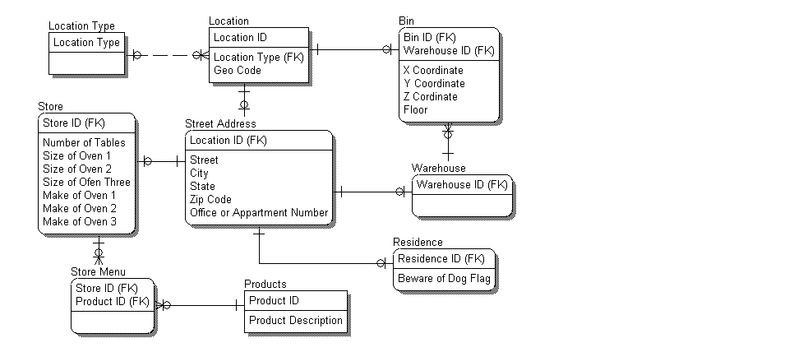
Unlike subtype connections, relationships require identification of primary keys for each participating entity. So an entity that is a subtype has the same primary key as its supertype entity. Note that the supertype entity must have a non-key attribute serving as the subtype discriminator across the sibling subtype entities.
Figure 23 above shows the business notion of location in a generalization hierarchy. The Location entity is an independent entity and, in this example, will be the supertype entity. Geo Code is common to all Location occurrences and is thus defined as an attribute of Location. By virtue of being members of a generalized hierarchy, all subtypes of Location implicitly inherit Geo Code. Consequently, Geo Code is not defined in any subtypes of Location. The non-key attribute, Location Type, is used to distinguish between the Street Address and Bin subtype entities and serves as this generalization hierarchy level’s subtype discriminator. Both Street Address and Bin entities have Location ID as their primary key by virtue of being a child entity in a parent-child relationship – Location as their supertype being their parent. The Bin ID attribute in Bin is a synonym of Location Id as they both represent the same business notion. Each also has a set of attributes distinct onto themselves. When portrayed as relationships, supertype-subtypes are always one-to-(zero or one) relationships as the supertype is mandatory and the subtype is optional. Street Address has subtypes: Residence, Warehouse and Store. Note that these are also modeled as one-to-(zero or one) relationships since a street address can be a either a residence or a store or a warehouse.

Normalization
Where data analysis techniques previously discussed in this guideline broadly focused on the items comprising a data model – identification of entities and the interactions between them, normalization’s focus is narrow as it is applied individually to each entity in the model.
Data normalization is a technique for decomposing data per prescribed dependency rules between an entity’s primary key and its attributes resulting in stable data constructs in the data design. Its principles have mathematical set theory underpinnings and deal with optimizing data constructs for effective update operations (insertion, deletion, modification) against the data they represent. It emerged as a data design method with the advent of relational databases. While its origins may be tightly linked with relational databases, its principles are not bound to them and have equal applicability to other types of databases.
Normalization of data should eliminate redundancies and ensure that data inconsistencies can not arise from application processes. A normalized data model has the advantage of showing the inherent relationships among the data based on the business rules of the enterprise. As applications are implemented, the physical design of the database will often vary from this model for performance reasons. However, without the logical model as a starting point, the physical database designer can make false assumptions about the data that can lead to inflexible application designs.
Normalization views an entity as a set (as in a mathematical set) of data represented in tabular form. An entity occurrence is a tuple in that mathematical set comprised of the values it has for the attributes defined for the entity - a tuple being discrete pieces of information jointly considered as a single unit such as an occurrence of an entity would naturally be perceived. Occurrences are viewed as rows, so it then follows that the values for each attribute in each occurrence of an entity are viewed as the columns in the tabular representation of this mathematical set.
Theoretically, normalization proceeds from an unnormalized set of data (an entity) to increasingly normalized sets of that data (entities) via successive decomposition of that data. Each successive step further restricts the relations between an entity’s primary key and its attributes strengthening the entity’s structural design and removing its vulnerability to application update (insertion, deletion, modification) anomalies.
The intent of normalization is to have data in the model in normal form (NF) – normal form being defined as having satisfied data normalization rules. Data not in normal form is in unnormal form – 0NF or UNF for shortened reference.
There are five normalization rules and they have a prescribed sequence in which they should be applied to each entity – from least to most restrictive. Each rule is individually referred to per the sequence in which it is applied – first normal form, second normal form, etc. The shortened reference used for each being, respectively, 1NF, 2NF, 3NF, etc. They are all applied to an entity - data found to satisfy a less restrictive rule does not infer it also satisfies more restrictive rules.
The degree of normalization a given entity may have is defined by the highest NF its data satisfies – an entity in 2NF has data satisfying both 1NF and 2NF rules. The degree of normalization a given data model may have is defined by the lowest NF achieved by all its entities – a data model in 3NF has entities that all have data in 3NF but may also satisfy higher NFs. Most data design strives to achieve 3NF because the subsequent, higher levels of NF rarely offer any additional change to the design as the dependencies they uncover are not commonly encountered and 3NF has proven to generally offer the best performance for physical implementation.
Data design driven by bottom-up data analysis would, by nature, need to repetitively apply normalization as a means to rationalize the data into well-defined data design structures. Data design driven from top-down data analysis has less need to apply normalization repetitively as rationalization of data is a natural consequence of starting from a high-level understanding of the data. In this case, assuring the entities in a model adhere to third normal form typically results in a fine-tuning of the data assigned to the entities. In contrast, bottom-up data analysis uses normalization as a means to discover entities and the attributes that should be assigned to them. Optimal data design is achieved with a balance of both top-down and bottom-up data analysis. Some data modeling software tools provide utility programs and/or product aids to assist in the normalization process.
Often times a modeler will arrive at the correct normalization intuitively without going through each of the NFs in a rigorous, step-wise fashion. From this perspective, normalization can be viewed as a series of questions that the modeler can use to check his or her intuition.
Unnormalized Data - 0NF
Unnormalized data is characterized by groups of data elements that are repeated for each occurrence of other data elements. Unnormalized data is difficult to portray as a table or flat file because, while many groups of data are repeated, each column and row intersection does not necessarily contain a value.
The following diagram shows three entities with their assigned attributes. The notation for attributes is as follows:
- The entity name is followed by the attribute names in parentheses.
- The primary keys of the entity are underlined.
- Any attributes that repeat within the entity are placed in square brackets.
Figure 24 – Example of 0NF
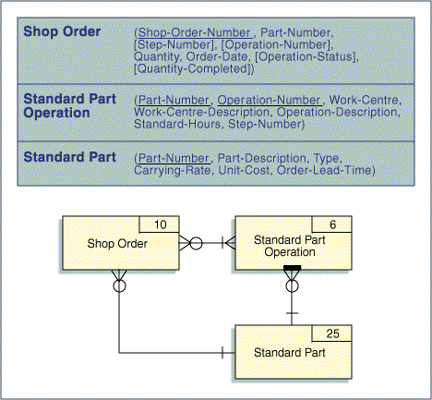
First Normal Form - 1NF
An entity is considered to be 1NF when it has no repeating groups of attributes within it. If an entity has repeating groups of attributes, these must be removed into separate entities to place them into 1NF.
In the 0NF example, the entity SHOP ORDER has a repeating group of attributes consisting of STEP-NUMBER, OPERATION-NUMBER, OPERATION-STATUS, and QUANTITY-COMPLETE. These attributes are removed to create a new entity SHOP ORDER OPERATION. This new entity is an associative entity and carries with it the primary keys of SHOP ORDER and STANDARD PART OPERATION (SHOP-ORDER-NUMBER and STEP-NUMBER).
Figure 25 – Example of 1NF
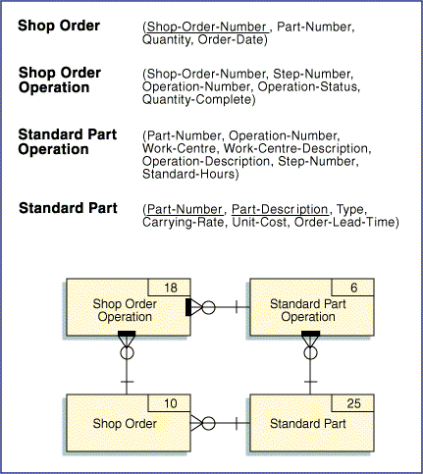
Functional Dependency – 2NF
An attribute is functionally dependent on another if it can be determined from the attribute (i.e., the first attribute is a determinant or key for the second attribute). For example, a person's name can be determined from a social security number. It can be said that NAME is functionally dependent on SOCIAL SECURITY NUMBER.
To check for second normal form, the identifier for each attribute within the group must be determined. Attributes that are dependent on only part of the key of an entity are considered partially dependent on the key (note that when an entity has a single data element key there can be no partial dependency). These partially dependent attributes must be separated into a new group or table to achieve second normal form.
A group of attributes is in 2NF when it is in 1NF and all partial dependencies have been removed (i.e., an entity is in 2NF when each attribute is dependent on the whole primary key).
In the 1NF example, the entity STANDARD PART OPERATION has several attributes that are partially dependent on the primary key. WORK-CENTRE, WORK-CENTRE-DESCRIPTION, and OPERATION-DESCRIPTION are dependent on OPERATION-NUMBER alone. These attributes are separated out into a new entity, STANDARD OPERATION.
Figure 26 – Example of 2NF
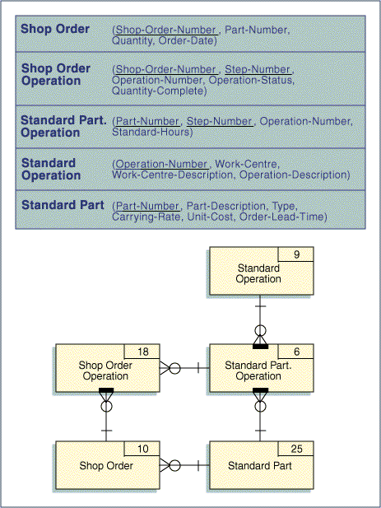
Transitive Dependency – 3NF
It is possible for an attribute to be dependent on not only the primary key of the record but also on another attribute. This situation is called transitive dependency. This condition creates redundancies in a database that can be avoided by placing the data into third normal form.
If an attribute is transitively dependent, it must be removed into a separate entity. An entity is in third normal form if it is in second normal form and each attribute is non-transitively dependent on the primary key, that is, each attribute is dependent on the whole primary key and nothing but the whole primary key.
In the example, the entity STANDARD OPERATION has WORK-CENTRE-DESCRIPTION transitively dependent on WORK-CENTRE. This attribute is removed and added to a new entity, WORK CENTRE.
Figure 27 – Example of 3NF
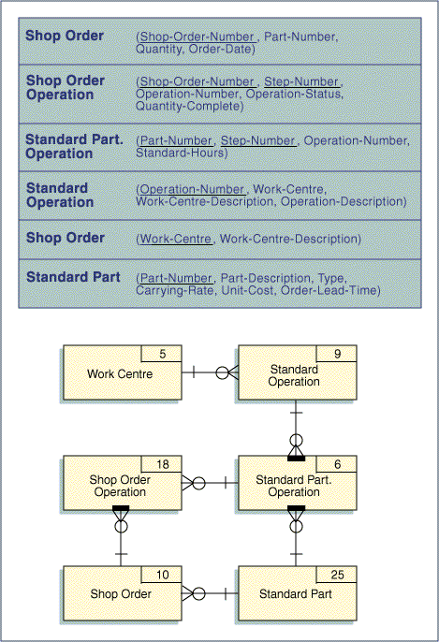
Normalizing Entities – 1NF to 5NF
The following is a brief procedure for checking the normal form for the entities in a data model:
- Does any entity contain repeating groups? If so, remove them to another entity. The primary key of the new entity will be the primary key of the original entity and the primary key of the repeating group. The original entity will have a one-to-many relationship to the new entity. When an all attributes are at an atomic level and all repeating groups are removed, the entity is 1NF.
- Does any entity contain attributes that are only partially dependent on the entity’s primary key? If so, remove these attributes to an entity where they are fully dependent on the entity’s primary key. Create a foreign key reference from the first entity to the second entity. When all partial key dependencies have been removed an entity is 2NF.
- Does any entity contain attributes that are dependent on other attributes in the entity other than that entity’s primary key? These are referred to as transitive dependencies. If so, move these attributes to a new entity. There will be a foreign key reference from the original entity to the primary key of the new entity. When all the values of an entity’s non-key attributes are determined by the primary key and only by the primary key, the entity is 3NF,
And so to have touched upon all normal forms, a brief example of 4NF and 5NF are given here.
Note: 4NF and 5NF only apply to associative entities that relate three or more other entities.
- In an associative entity that relates three or more entities (a.k.a. a multi-valued dependency) are there any two components of the primary key that can vary without reference to the third component of the primary key? If so, the three part associative entity should be split into separate associative entities. When a three-part associative entity is split into two two-part associative entities it is known as fourth normal form (4NF).
Because a pizza restaurant has an extensive menu, including many local cuisines depending on the locale, an employee can be trained in multiple cooking skills based on the type of food product. In the following figure, Employees Skills and Product shows which employees have the skills to prepare each product. But what about a new product that has a skill but for which no employees have been trained? To accommodate this situation, the three-way association was split into two two-way associative entities, Employee Skills and Product Skills.
Figure 28 – Example of 4NF
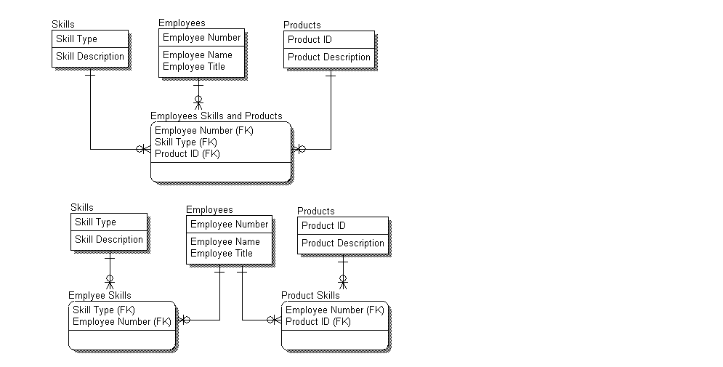
- If a three-way associative entity is decomposed into two two-way associative entities, will a join of the two-way entities result in any rows not found in the original three way entity? If so, the three-way entity should not be decomposed. This is the reverse of the fourth normal form and is known as fifth normal form (5NF).
Because of regional variations in taste, the same product can be made using more than one recipe. For each city in which stores are located, a store has its own set of product / recipes variations.
The first set of entities in the following figure shows a three-way association of Products, Recipes and Store Cities. A sample set of values for this table is shown in Table 1. The second set of table shows three two-way associations: Products to Recipes; Recipes to Store Cities and Products to Store Cities. Sample sets of values for each of these is shown in Table 2, 3 and 4, respectively.
When the three two-way tables are joined the result is a join projection. This is done in two steps. First, Products to Recipes and Recipes to Store Cities are joined on Recipe. This intermediate result set is the first three columns shown in Table 5. Then Recipes to Store Cities and Products to Store Cities are joined to the intermediate result set using Product and Store City. The rows resulting from this join projection are indicated with a “Y” in the fourth column. The fifth column indicates the row number in the original three-way associative table illustrated in Table 1. Notice, the row in the join projection for “Marinara Sauce / Sweet / Houston” is not present in the Products to Recipes to Store Cities three-way associative entity. Therefore, the original three-way association is not decomposable into three two-way associations.
Figure 29 – Example of 5NF
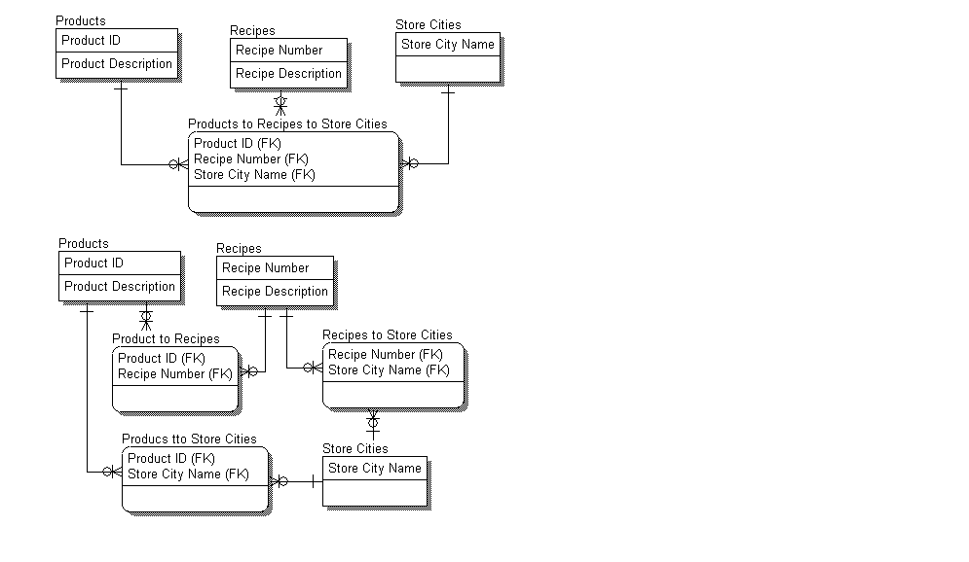
Table 1 – Products to Recipes to Store Cities - A Three-Way Associative Entity
Product | Recipe | Store City
Meat Sauce | Spicy | Waco
Meat Sauce | Sweet | Houston
Marinara Sauce | Spicy | Houston
Meat Sauce | Spicy | Houston
Marinara Sauce | Sweet | Dallas
Table 2 - Products to Recipes
Product | Recipe
Meat Sauce | Spicy
Meat Sauce | Sweet
Marinara Sauce | Spicy
Marinara Sauce | Sweet
Table 3 – Recipes to Store Cities
Recipe | Store City
Spicy | Waco
Sweet | Houston
Spicy | Houston
Sweet | Dallas
Table 4 - Products to Store Cities
Product | Store City
Meat Sauce | Waco
Meat Sauce | Houston
Marinara Sauce | Houston
Marinara Sauce | Dallas
Table 5 – Join of Products to Recipes and Recipes to Store Cities on Recipe
Product | Recipe | Store City | Join Projection | Original Row Number in the 3-Way Associative Table (Table 1)
Meat Sauce | Spicy | Waco | Y | 1
Meat Sauce | Spicy | Houston | Y | 4
Meat Sauce | Sweet | Houston | Y | 2
Meat Sauce | Sweet | Dallas
Marinara Sauce | Spicy | Waco
Marinara Sauce | Spicy | Houston | Y | 3
Marinara Sauce | Sweet | Houston | Y
Marinara Sauce | Sweet | Dallas | Y | 5

Creating Entities and Relationships via Normalization
The process of normalization creates new entities and relationships. Each new entity created should have a relationship with the entity from which it was separated. A one-to-many relationship exists between the old entity and the new entity.
Note: Entities split out via normalization often have primary keys that are subsets of one another. In this case, the “many” (in IE syntax, the “crow's foot”) of a relationship always belongs at the entity that includes the other entity's primary key as a foreign key.

