ITMS 428/528 Group Project

**Project Management Plan**



Department of Information Technology and Management

**November 2021**

**Group Project Members:**

Kemelbek Tashkulov

Anthea Gonzalez

Piotr Rajchel

Naveed Zahid

Magdalena Boufal

Yuping Jiang

Sai Teja

**Version 1.0**

**Revision History**

Note: The revision history cycle begins once changes or enhancements are requested after the document has been baselined.

| **Date** | **Version** | **Description** | **Author** |
| --- | --- | --- | --- |
| 11/08/2021 | 1.0 | Initial Version | Anthea Gonzalez |

**Artifact Rationale**

The Project Management Plan (PMP), according to the Guide to the Project Management Body of Knowledge (PMBOK®), is a formal, approved document used to guide both project execution and project control. The primary uses of the PMP are to document planning assumptions and decisions, facilitate communication among stakeholders, and document approved scope, cost, and schedule baselines. By showing the major products, milestones, activities and resources required on the project, it is also a statement of how and when a project's objectives are to be achieved.

The project manager creates the PMP following input from the project team and key stakeholders. The plan should be agreed on and approved by at least the project team and its key stakeholders.

The PMP is mandatory for all projects. While it is a project-level document, it should be updated as necessary, including for each increment

**Table of Contents**

**1.** **Introduction 1**

**1.1.** **Project Overview 1**

**1.2.** **Scope Statements 1**

**1.3.** **Goals and Objectives 1**

**1.4.** **Stakeholders and Key Personnel 1**

**2.** **Project Organization 1**

**3.** **Acquisition Process 1**

**4.** **Monitoring and Control Mechanisms 1**

**5.** **Systems Security Plans and Requirements 1**

**6.** **Work Breakdown Structure (WBS) and Schedule 2**

**7.** **Project Success Criteria 2**

**8.** **Communication Management Plan 2**

**9.** **Risk Management Plan 2**

**10.** **Software Configuration Management (SCM) Plan 2**

**11.** **Training Plan 2**

**12.** **Quality Assurance Plan 2**

**13.** **Project Measurement Plan 2**

**13.1.** **Description 3**

**13.2.** **Performance Measurements 3**

**14.** **Reference Materials 5**

**Approval Signatures 6**

**15.** **Project Plan Approval 6**

**16. Appendix 7**

# Introduction

This PMP describes the project management processes that ITMS 428/528 will follow during execution of the ITMS 428/528 Group project. The project’s processes will align with plans and processes of the Project Management Accountability System (PMAS) Guide New processes will be defined for any management areas not covered by the PMAS Guide. This PMP will govern the management practices across the life of the project. As those practices evolve, this document will be updated to reflect the changes.

## Project Overview

This project will deliver a database with implementation of different controls using the NIST Risk Management Framework into said database. The database will have at least 7 tables with 1000+ entries and at least 5 users. Creation of the database will be done through MySQL and MySQL Workbench as well as the implementation of the controls.

## Scope Statements

See Appendix A, “Project Charter”.

## Goals and Objectives

See Appendix A, “Project Charter”.

## Stakeholders and Key Personnel

See Appendix A, “Project Charter”.

# Project Organization

See Appendix A, “Project Charter”.

# Acquisition Process

There is no acquisition process in place for this project as there are no external contractors nor companies involved or required for the completion of this project. All tools and software used for this project are open-source and/or free to use without needing the use of external contractors.

# Monitoring and Control Mechanisms

This project follows standard monitoring and control processes as defined in ProPath for risk management, requirements traceability, and operational readiness.

The team's progress was monitored through various communication methods, including virtual meetings and discussion through WhatsApp. The Project Manager was responsible for updating the progress on various tasks on the Project Schedule and WhatsApp Group Chat, ensuring that the schedule displayed the time required for each project component. Any requirement updates or deadline changes were communicated through the WhatsApp platform. Group meetings were also scheduled and held to ensure that the group members were on the same page and on track to complete the project deliverables.

# Systems Security Plans and Requirements

System security plans and requirements will be developed as part of the project’s planning phase.

| **Resource** | **Security Plan** | **Status** |
| --- | --- | --- |
| [GitHub Repo](https://github.com/swiftzircon/ITMS-528-DB-Project) | Only team members are allowed to access the source code for editing and modifications | Applied |
| File Storage | All project files are stored in a Team Google Drive, only team members will have access to the Team Google Drive. | Applied |
| WhatsApp | The WhatsApp group chat was used for primary communications. The WhatsApp group chat requires a direct invitation to join, this was sent to all team members. | Applied |

# Work Breakdown Structure (WBS) and Schedule

See Appendix B, “Work Breakdown Structure and Schedule”.

# Project Success Criteria

| **Category** | **Goal** | **Success Criteria** |
| --- | --- | --- |
|  | Forming the group | No more than 7 team members |
|  | Assessing tasks to group members | The project manager assigned tasks and controls to the group members based on their experience and preference. |
|  | Establish and enforce a Project Schedule | The project manager shall create and update the Project schedule as needed. |
| **Project Planning and**  **Management** | Complete the Risk Management Log | Project risks are identified, documented and monitored in the Risk Management Log. |
|  | Complete the EVM Workbook | The EMV Workbook is completed with the correct calculations and cost estimates for group members. |
|  | Complete the Project Management Plan | The Project Management Plan is completed as accurately as possible. |
|  | Monitor risks and conflicts in project schedule | Conflicts within the group members are addressed in the WhatsApp group chat. |
|  | Select project storage | The selection and use of a GitHub Repository to store the project files. |
| **Database Creation** | Select database tables to import and use | The selection of what database sets to use for the project. |
|  | Create user accounts | The creation and maintenance of user accounts for the databases. |
|  | Control(s) implementation | The implementation of the required project controls on the databases selected prior. |
| **Control Implementation** | Testing and debugging | After the controls were implemented, the controls were tested and debugged as needed. |
|  | Final checkthrough | A final walkthrough shall be conducted to ensure that all of the project requirements are met. |

# Communication Management Plan

The primary communication method for this project is WhatsApp. In-class meetings and out-of-class virtual meetings will also be used.

* 1. **WhatsApp**

All communication among the team and team members took place in the WhatsApp group chat. Communications via the WhatsApp group chat include, but are not limited to, written messages, images and files.

* 1. **Team Meetings**

In addition to meeting during the class time, the team also had NUM additional meetings take place virtually.

| **Meeting Date** | **Location** |
| --- | --- |
| November 5, 2021 | Google Meet |
| November 12, 2021 | Google Meet |
| November 26, 2021 | Google Meet |

# Risk Management Plan

Risks for this project will be identified, documented and tracked using a Risk Management Log. A response strategy will be created for every risk identified, with the Project Manager leading the efforts to prevent the risk and/or mitigate its effects.

[**The Risk Management Log can be found here.**](https://docs.google.com/spreadsheets/d/12TWKG-Wp2By39tA4w-vNIzlziFf3dvW7/edit?usp=sharing&ouid=112722400852532387591&rtpof=true&sd=true)

# Software Configuration Management (SCM) Plan

| **Category** | **Software/Modules** | **Version** |
| --- | --- | --- |
| **Project Planning and**  **Management** | ProjectLibre | 1.9.3 |
|  | GitHub | 3.2.4 |
|  | MySQL | 8.0.27 |
| **Database Creation and** | MySQL Workbench | 8.0.22 |
| **Control Implementation** | VirtualBox | 6.1.30 |
|  | Ubuntu | 18.04.2 |

# Training Plan

Training for all group members will be decided on by the Project Manager. All group members should be familiar with the following requirements:

* MySQL
  + MySQL Workbench
* Virtualbox
  + Ubuntu
* GitHub

If needed, training can be outsourced to other outside organizations and programs that might be available. There is no major training expected since group members were assigned tasks based on their current skill set.

# Quality Assurance Plan

* 1. **Introduction**

The project management team is in charge of the oversight and management over the project and the project’s group members. The Quality Assurance Plan itself will be used as a sort of guide for what the project management team will be controlling. The Quality Assurance Plan will outline the different roles, qualifications and training needed, the objectives that the group is trying to meet and the standards the group are to meet, and the verification and validation

of the project.

* 1. **Defining Roles**
* Project Manager: The project manager is in charge of the management of the team and the organization of communication among the group members documenting the project
* Database Administrator: Admin is someone who will have access to everything related to database and server side.
* Database Manager: Will be given full access but won’t be as same as the admin.
* Database Designer: Designer will be given the role to create, edit and make users if needed. They are the one who will design the database.
  1. **Role Qualifications**

Qualifications of each role were based on previous experience and preference. Each group member was given instructions relating to the project that outlined what is expected of them and their assigned role.

* 1. **Objectives and Standards**

The ITMS 428/528 group will create and develop the database based off of the instructions that they were given.

The ITMS 428/528 group will also follow standards set by the group members prior to starting on the project itself.

* 1. **Verification**

In order to ensure that all of the group members have completed their assigned tasks correctly, all group work shall be reviewed before final submission. The Project manager shall do a final walkthrough and double check that all of the necessary documentation and tasks are completed. In addition, all group work shall be tested and debugged by the group members prior to final submission and walkthrough.

# Project Measurement Plan

## Description

The Project Measurement Plan contains the measurement objectives created from the project requirements and objectives. For the metrics in the database creation, we measured the successful creation of at least 7 tables with 1000 entries. For the metrics in the control implementation, we measured the successful implementation and testing of the required controls. These metrics were measured with the testing of functionality and the ability to produce the correct results.

## Performance Measurements

**ITMS 428/528 Group Project Performance Measurements**

| **No.** | **Measurement Name** | **Measurement Objective** | **Metric** |
| --- | --- | --- | --- |
| 1. | Implementing controls | The required controls are implemented and function as intended. | Project Success Criteria |
| 2. | Testing controls | The required controls are implemented successfully and meet the project requirements. | Project Success Criteria |
| 3. | Testing database | The database tables are created successfully and meet the project requirements | Project Success Criteria |
| 4. | Data Collection | The audit reports are generated and filled with the required information. | Project Success Criteria |
| 5. | Documentation | All necessary resources and materials for the project are recorded and organized in the project documents. | Project Success Criteria |

# Reference Materials

Group Communication/Organization

* [ProjectLibre](https://sourceforge.net/projects/projectlibre/)
* [WhatsApp](https://www.whatsapp.com/)
* [GitHub](https://github.com/)

Database Creation / Control Implementation

* [MySQL](https://www.mysql.com/)
* [MySQL Workbench](https://www.mysql.com/products/workbench/)
* [VirtualBox](https://www.virtualbox.org/)
* [Ubuntu](https://ubuntu.com/)

**Approval Signatures**

PAO has additional approver language:

# Project Plan Approval

The signatures below indicate that the undersigned:

* Have reviewed the Project Plan.
* Have formally voiced applicable concerns to the PM.
* Concur that the Project Plan accurately represents their expectations and conditions required for the project.
* Are committed to providing the required resources.
* Are unaware of undocumented conditions that prevent the success of this project.

REVIEW DATE: 11/26/2021

SCRIBE: Anthea Gonzalez

Signed: Piotr Rajchel

Project Manager

Date 11/26/2021

Signed: Maurice Dawson

Business Sponsor

Date 11/26/2021

**Template Revision History**

| **Date** | **Version** | **Description** | **Author** |
| --- | --- | --- | --- |
| 11/08/2021 | 1.0 | Initial Version | Anthea Gonzalez |

# 

# Appendix

1. **Project Charter**

|  | Project Information |
| --- | --- |
| Project Name | ITMS 428/528 Database Security Project |
| Project Number | 1 |
| Project Manager | Piotr Rajchel |

| Project Overview |
| --- |
| This project will deliver a database with implementation of different controls using the NIST Risk Management Framework into said database. The database will have at least 7 tables with 1000+ entries and at least 5 users. Creation of the database will be done through MySQL and MySQL Workbench as well as the implementation of the controls. |
| Project Deliverables |
| * Select at least 7 tables with 1000+ entries * Create at least 5 users * Implement the required controls onto the databases * Complete all Project Management Documents * Create a presentation with our project processes, finding, and final deliverables |
| Project Goals and Objectives |
| 1. Creation of at least 7 tables with at least 1000 entries each 2. Implementation of the required controls 3. Testing and debugging of the implemented controls 4. Presentation of project outcomes |
| Scope Statement |
| The final project deliverable will have at least 7 tables with 1000 entries in the database. The tables will have the required implenations on them and will be created through MySQL and MySQL Workbench |

|  | Project Schedule |  |
| --- | --- | --- |

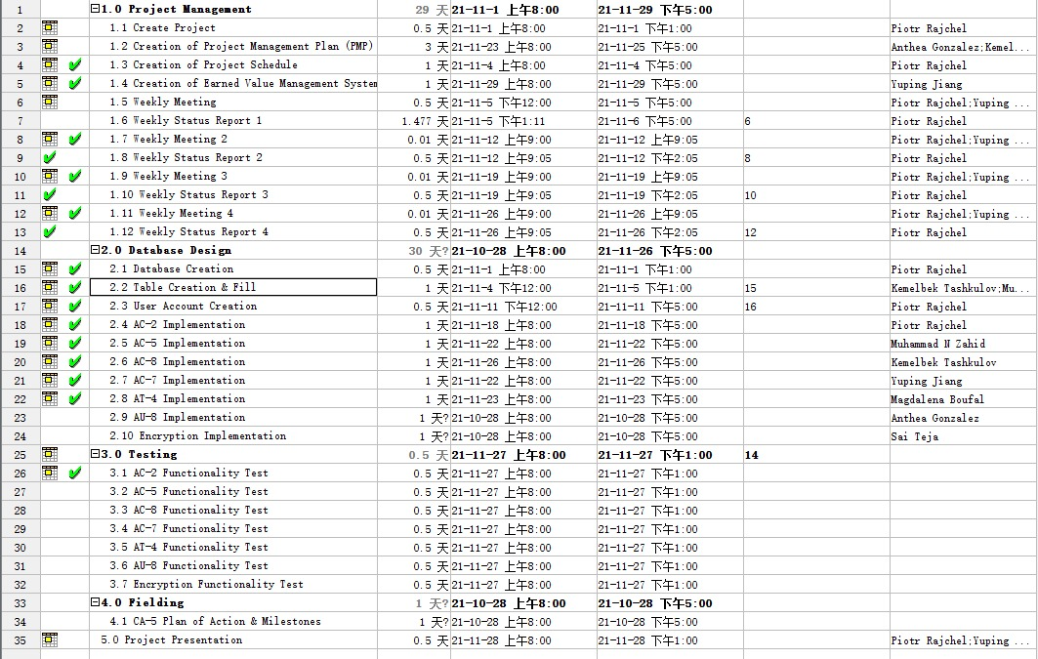

| Risks |
| --- |
| *Assumptions* |
| 1. The group has the necessary amount of group members to complete the project. 2. Each group member has all of the necessary knowledge and skills to help complete the project. 3. Personal schedules of each group member will make virtual communication extremely important |
| *Constraints* |
| 1. The time given to complete the project might not be enough since group members will have to split theory time and efforts with other assignments. 2. Some deadlines and meetings land on holiday breaks, which might make it difficult for some team members to complete their tasks. |

|  | Dependencies |
| --- | --- |
| *Task* | *Depends On* |
| Database Creation | The selection of at least 7 tables with 1000 entries |
| Controls Implementation | The implementation of the required controls on to the database tables |
| Testing and debugging | Requires completed database creation and control implementation |
| PM Document Completion | Requires completed PMP, EVM Workbook, and Risk Management Log |

|  | Stakeholders and Key Personnel |
| --- | --- |
| *Stakeholders/Key Personnel* | *Responsibilities* |
| Project Manager | Responsible for day-to-day management of the project and must be competent in managing the scope, schedule, finance, risk, quality and resources. |
| Database Designer | Communicate with the Project Manager while designing and building the databases required for the project |
| Database Manager | Communicate with the Project Manager while managing what users get what types of access |
| Database Admin | Communicate with the Project Manager while completing the administrative tasks |

|  | Project Organization |  |
| --- | --- | --- |
| *Team Member* | *Title* | *Department* |
| Piotr Rajchel | Project Manager | Management |
| Kemelbek Tashkulov | Database Designer | Design |
| Anthea Gonzalez | Database Manager | Management |
| Naveed Zahid | Database Designer | Design |
| Magdalena Boufal | Database Designer | Design |
| Yuping Jiang | Database Admin | Admin |
| Sai Teja | Database Manager | Management |

| Budget (Estimate) |  |
| --- | --- |

1. **Work Breakdown Structure and Schedule**

