1. Store blood group of 50 different patients (O+,A+,B+,AB+,O-,A-,B-,AB-). Graphically show how mnay patients have O- blood group.

Ans:

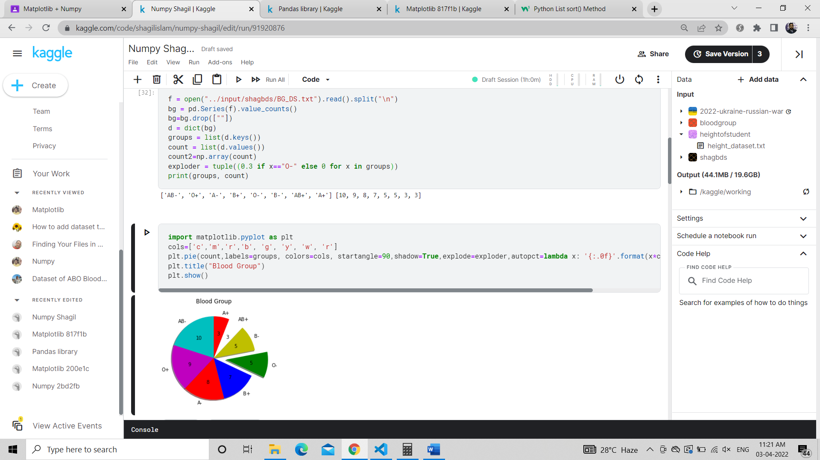

1. For a certain student Store data of marks obtained by the student in English, Bengali, Hindi, Maths, History and Geography. Graphically represent the data in a pie chart and bring out the slice having least marks. ( No subject should have same marks).

Ans:

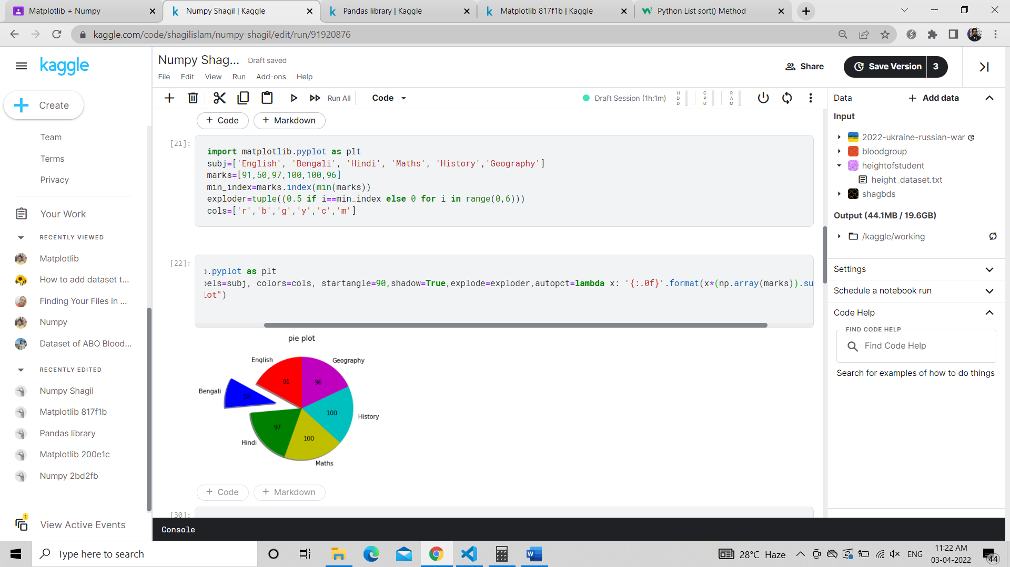

1. Store height of 50 students in inches. Now while the data was beign recorded manually there has been some typing mistake and therefore height of 2 students have been recorded as 172 inch and 2 students have been recorded as 12 inch. Graphically plot and show how you can seggregate correct data from abnormal data.

Ans:

