**Sarah Wigodsky**

**DATA 698 Analytics Masters Research Project**

**City University of New York**

**Advisor: Arthur O’Connor**

**May 20, 2019**

**Exploring the Relationship Between**

**Exonerations, Fatal Police Shootings and Crime in the United States**

**Introduction:**

Is there a relationship between the number of people exonerated for crimes and the number of fatal police shootings? Is crime rate correlated with the number of exonerations or the number of fatal police shootings?

Inspired by the work done by the Innocence Project to exonerate those who have been wrongfully convicted, this study will explore factors that can be used to predict the likelihood of an individual being wrongfully convicted in the United States. The study aims to determine if there is a correlation between counties with higher crime rates and counties with higher numbers of exonerated individuals. In addition, this study aims to determine if there is a correlation between counties with higher rates of police shootings and higher numbers of exonerated individuals.

The impetus for this line of research is the notion that high rates of violent crimes put pressure on police and others involved in the process of law enforcement. This strain may cause police to be more likely to fatally shoot an individual and may create a situation where there is more pressure to convict an individual, causing there to be a higher rate of wrongful convictions.

If the factors that contribute to situations in which an individual is wrongfully convicted of a crime can be predicted, steps can be taken to minimize the likelihood of such an event occurring. Likewise, if the pressures that contribute to fatal shootings by police officers can be predicted, steps can be taken to minimize its likelihood.

**Literature Review:**

The National Registry of Exonerations houses data on individuals who were exonerated for crimes and conducts research to identify trends and factors relating to wrongful imprisonment. Research conducted by the National Registry of Exonerations has identified racial disparities amongst people who were wrongfully convicted of crimes. Forty seven percent of wrongfully convicted individuals are black; this is three times higher than the proportion of black people in the United States. Black people who are innocent are seven times more likely to be convicted of murder than white people who are innocent. (Gross, 2017) A study entitled “The Race Effect on Wrongful Convictions” notes the unreliability of eyewitness testimony, particularly when based off cross-racial identifications. Seventy four percent of wrongful convictions that were overturned using DNA evidence came from cases that relied upon eyewitness testimony. (Rizer, 2003) There is an association between wrongdoing at the hands of police and race. A black person exonerated for murder is more likely to have encountered police misconduct. Black people are more likely than white people to be freed in group exonerations; groups of people who are exonerated together are often the result of the planting of drugs by police. (Gross, 2017)

Police shootings have received a considerable amount of media coverage recently. Much of the focus regarding violence at the hands of police officers has centered around racial disparities. The percentage of black people shot by police in the United States is more than twice the proportion of black people present in those regions. (Fryer, 2018) Lopez suggests that the police in the United States shoot and kill many more people than police in other developed nations because of the prevalence of gun violence in the United States. Since the United States has more gun violence than other developed nations, the police use guns more often due to the heightened danger they face. The number of police shootings can be linked not only to the rate of gun use by civilians, but the rate of gun ownership in the United States. The "American Journal of Public Health found that every 10 percent increase in firearm ownership correlated with 10 additional officers killed at the state level over a 15-year period." (Lopez, 2018) In the Northwestern Journal of Criminal Law and Criminology, Sherman identified a positive correlation between police killings and gun density, violent index crime rate, homicide rate, and arrests per 100,000 people. (Sherman, 1979) Hemenway also identified a correlation between police killings and violent crime rate. (Hemenway, 2019)

While the National Registry of Exonerations collects data on individuals who were exonerated for crimes they did not commit, there is no way to compile a complete list of individuals who were falsely incarcerated, as many of those individuals’ cases have not been overturned. Collecting complete data on police shootings poses a different challenge. States were not consistent in the ways in which they collected data, making the data collected before 2010 to be unreliable. (Banks, 2016) Sherman notes that police killings are under-reported. Data about the same location from different sources are not consistent. Despite inconsistencies in numbers, researchers have reached the same conclusions regarding correlations utilizing different sources of data. (Sherman, 1979)

**Theory and Hypotheses:**

The first hypothesis theorizes that there is a positive correlation between the number of exonerated individuals and the rate of violent crime in counties across the United States.

The second hypothesis theorizes that there is a positive correlation between the number of fatal police shootings and the rate of violent crime in counties across the United States.

The third hypothesis theorizes that there is a positive correlation between the number of exonerated individuals and the number of fatal police shootings in counties across the United States.

A correlation between the number of fatal police shootings and the number of exonerated individuals will demonstrate that factors affecting these variables are shared. It will also bring to light that these two catastrophic outcomes should not be considered in isolation of each other.

**Data Research Model:**

Data of exonerated individuals is collected by the National Registry of Exonerations, which is a project of the University of California Irvine Newkirk Center for Science & Society, University of Michigan Law School and Michigan State University College of Law. The data includes the name, age, race, gender, age, county, worst crime displayed, additional crimes, year the crime occurred, year of conviction, year of exoneration, sentence and whether there was DNA testing for those who were exonerated for crimes in the United States. There are 2,365 exonerations listed, occurring between 1989 and 2019 for crimes stemming from convictions that occurred between 1956 and 2017. Cities in the database of exonerated individuals are mapped to counties using the SimpleMaps database. For federal crimes, the city listed in the database is the district in the state where the prosecution took place. The county where the trial took place will be used for the county in such cases. Zero will be imputed for the number of exonerated individuals for years and counties not listed in the database. The ratio of the number of exonerations to the population in the county was taken per year for the year the crime occurred.

Data of violent crime rates in United States’ cities is taken from the Federal Bureau of Investigation’s Uniform Crime Report, which is published each year. The data set includes the state, city, population, number of murders, rapes, robberies, aggravated assaults, property crimes, burglaries, larcenies, motor vehicle thefts, and arsons. Data on violent crime is available between 1999 and 2017. Cities in the database of violent crime are mapped to counties using the SimpleMaps database. The violent crime rate was calculated to be the ratio of the number of violent crimes in the county for each year.

Data of police shootings will come from multiple sources. The Washington Post retains a database of police shootings from 2015 through 2019. The data set includes the name, date, manner of death, whether the victim was armed, age, gender, race, city, state, if the victim showed signs of mental illness, threat level, if the victim was fleeing and if the police officer was wearing a body camera. As of May 12, 2019, the database contains 4,258 entries. Vice News has a data set of police shootings from 2010 through 2016. This data set includes the date, name, whether the shot was fatal, if the subject was armed, race, gender, age, number of shots fired, number of officers present, officer’s race, officer’s gender, department, notes, city, and date. The data from Vice News will be used between 2010 and 2014, as the dataset from the Washington Post is more complete and lists 1,023 deaths at the hands of police in that time frame. Zero will be imputed for the number of individuals shot and killed by police for years and counties not listed in the database. The ratio of the number of individuals shot and killed by police to the population in the county was taken per year.

An additional database of killings at the hands of police compiled by journalist D. Brian Burghart called fatalencounters will be used. Fatal encounters relies on paid researchers, public record requests and the public to provide information on incidents with police that result in deaths. Information provided by the public is fact checked prior to being entered into the database. The data contains information on the subject’s name, age, race, link to a URL image of the deceased, date of injury that resulted in death, location of injury that resulted in death, latitude, longitude, description of circumstances, official disposition of death (justified or not), link to news article, video, awareness by police of mental illness before interaction, agencies involved in death, and cause of death. This database includes deaths that were the result of suicides when police were present, car chases with police, gunshots, tasers, falling from a height, and beatings. There are 25,902 entries beginning in the year 2000 through the present. There are 17,296 deaths in the fatal encounters database that are the result of gunshots, beatings and tasers, and these will be used to draw conclusions. Zero will be imputed for the number of individuals killed by police for years and counties not listed in the database. The ratio of the number of individuals killed by police to the population in the county was taken per year.

Data of incarcerations by county from 1970 through 2016 was taken from the Vera Institute of Justice, which collected data from the United States Bureau of Justice Statistics and from state departments of corrections. The data set includes year, county, region, urban/rural, population, population by race, the number of individuals incarcerated, and the breakdown of incarcerations by race. Counties are designated as located in one of the following regions: East North Central, East South Central, Middle Atlantic, Mountain, New England, Pacific, South Atlantic, West North Central and West South Central. The regions are converted into dummy variables and East North Central is removed to build a regression model. Counties are classified as being rural, small/mid, suburban or urban. This characterization of counties is converted into dummy variables and rural is removed to build a regression model. The population data is for individuals between the ages of 15 and 64. The fraction of the population that is Asian, black, Latino, native and white is calculated. The fraction of the individuals sent to prison by race is also calculated. Finally, the ratio of the percentage of individuals sent to prison by race to the percentage of individuals in the population by race was taken. A ratio of 1 would mean that the percentage of that race in the population is equal to the percentage of that race that is incarcerated.

Data of unemployment rates for counties in the United States from 2007 through 2017 is taken from the United States Department of Agriculture Economic Research Service.

**Results:**

The percentage of individuals exonerated in a county in a given year (shown below as num_convicted_percent) and the number of

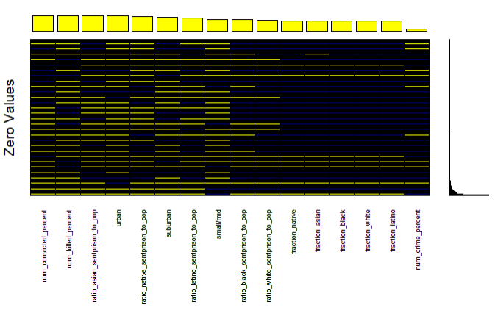

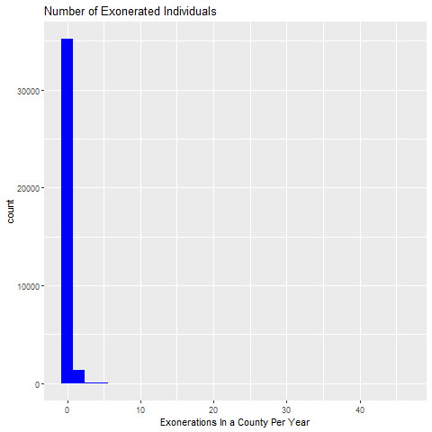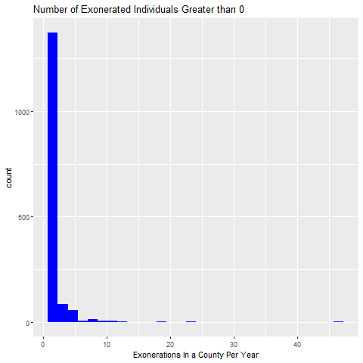

The year the exonerated individual was arrested will be used to identify the crime rate and number of police shootings. A multiple regression model will be built to predict the number of exonerated individuals in a county based on the number of fatal police shootings and the crime rate. The beta coefficients and R2 value will be assessed to determine the extent to which fatal police shootings and crime rate impact the number of exonerated individuals. If the model does not account for a high percentage of the variability in the number of exonerated individuals, the relationship will be explored by region in the United States, by size of city, unemployment rate, and by race.

**References:**

Banks, Duren, et al. “Arrest-Related Deaths Program Redesign Study, 2015-16: Preliminary Findings.” *Bureau of Justice Statistics (BJS)*, 15 Dec. 2016, [www.bjs.gov/index.cfm?ty=pbdetail&iid=5864](http://www.bjs.gov/index.cfm?ty=pbdetail&iid=5864).

Federal Bureau of Investigation. (2018). *Crime in the U.S.* [database]. Retrieved from https://ucr.fbi.gov/crime-in-the-u.s.

Fryer, Roland G. *Reconciling Results on Racial Diﬀerences in Police Shootings*. May 2018, scholar.harvard.edu/files/fryer/files/fryer_police_aer.pdf.

Gross, Samuel R., et al. *Race and Wrongful Convictions*. National Registry of Exonerations, 7 Mar. 2017, www.law.umich.edu/special/exoneration/Documents/Race_and_Wrongful_Convictions.pdf.

Hemenway, D., Azrael, D., Conner, A. et al. J Urban Health (2019) 96: 63. https://doi-org.remote.baruch.cuny.edu/10.1007/s11524-018-0313-z

Lopez, German. “American Police Shoot and Kill Far More People than Their Peers in Other Countries.” *Https://www.vox.com/Identities/2016/8/13/17938170/Us-Police-Shootings-Gun-Violence-Homicides*, Vox Media, 14 Nov. 2018.

National Registry of Exonerations. (2019). *National Registry of Exonerations* [database]. Retrieved from https://www.law.umich.edu/special/exoneration/Pages/informationandresearch.aspx.

Rizer, Arthur L. III (2003) "The Race Effect on Wrongful Convictions, "William Mitchell Law Review: Vol. 29: Iss. 3, Article 5. Available at:http://open.mitchellhamline.edu/wmlr/vol29/iss3/5

Sherman, Lawrence W., Langworthy, Robert H. Measuring Homicide by Police Officers, 70 J. Crim. L. & Criminology 546, 1979.

SimpleMaps. (2018). *United States Cities Database* [database]. Retrieved from <https://simplemaps.com/data/us-cities>.

Vice News. (2017). *Vice News Full OIS Data* [database]. Retrieved from https://news.vice.com/en_us/article/a3jjpa/nonfatal-police-shootings-data.

Washington Post. (2019). *Fatal Police Shootings Data* [database]. Retrieved from https://raw.githubusercontent.com/washingtonpost/data-police-shootings/master/fatal-police-shootings-data.csv.