Game Design Document

Fill up the following document

1. **Write the title of your project.**

Answer- Legendary Chronicles

1. **What is the goal of the game?**

Answer- Goal of the Game is to build our creative and focusing skills.

1. Write a brief story of your game.

Answer-

Once, there were two king who were fighting for the same empire for extending there kingdom. One of them is Ratan Singh and another was Alauddin Khailji. So other rulers decided to ask them a question that “**What are the four most important pillar to rule a empire?”** and the one who will answer the first will be the emporer of the empire, but if both of them will lose then the queen Padmavati will win.

1. **Which are the playing characters of this game?**

* **Playing characters are the ones who respond to the user based on the input from the user.**
* **Cars, monkeys, dinos, wizards, etc., are the playing characters in the game.**

|  |  |  |
| --- | --- | --- |
| Number | Character Name | What can this character do? |
| 1 | **Raja Ratan Singh**  Playing Character | This character is the first player of the game and the first ruler and this player answer the question. |
| 2 | **Alauddin Khilji**  Playing Character | This is the second character of the game which wants the throne in his hand. |
| 3 | **Rani Padmavati**  Non-Playing Character | This character is wife of Raja Ratan Singh and will win the emperor. |
| 4 | **Other Emperors**  Non-Playing Character | These characters will ask the question to Raja Ratan Singh and Alauddin Khilji. |
| 5 | **Mehrunssia**  Non-Playing Character | This character is wife of Alauddin Khilji and will win the emperor. |
| 6 | **Soldiers**  Non- Playing Character | This character will do nothing exept protecting the queen and the king. |
| 7 | **Courtyards**  Non-Playing Character | These characters will listen the question and try to answer it. |
| 8 |  |  |

**Draw your imagination of this game. What does this game look like?**

* **Draw the game either on your computer or on paper.**
* **Add images of the game scenes to show each of the playing and non-playing characters at least once.**

Images that I’ll use are:

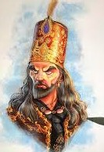 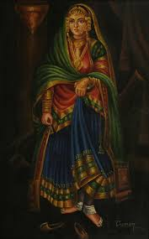

Alauddin Khilji Mehrunssia

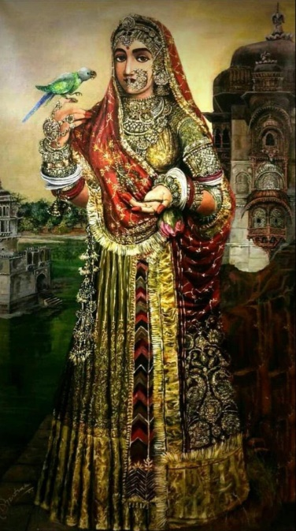 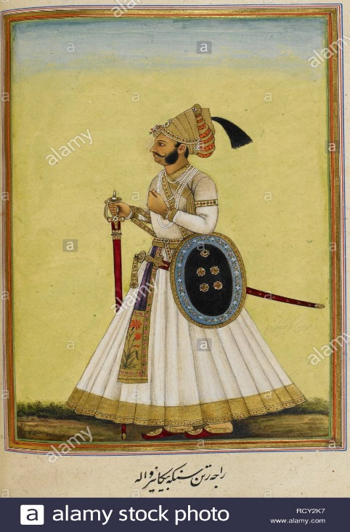

Padmavati Soldiers

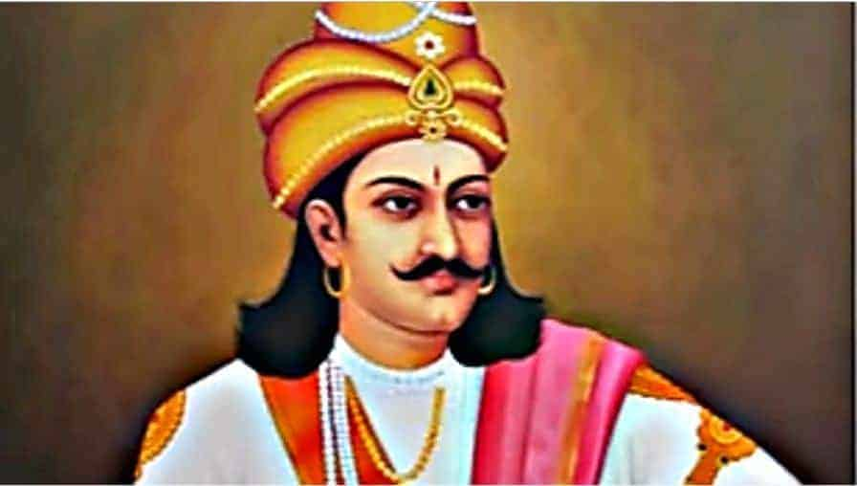 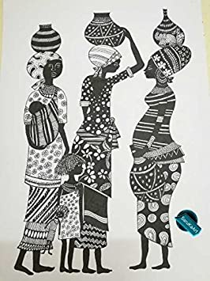

Raja Ratan Singh Courtyards

**How do you plan to make your game engaging?**

Answer- To make my game engaging I’ll make the question difficult and interesting by which my players will be wanting to play this game only. And for that I’ll give my characters and background 3d looks. I’ll try my best to make many more levels of this game so that my player enjoys it.