P2-I13: Video Face, Speech & Voice Learning
  - Pipeline revalidation, evidence-backed playback, learning lifecycle, and bounded-corpus release control
Document | Value
Identifier | MBPRD-P2-I13
Status | Draft for founder review; approved screen direction
Date | 4 September 2026
Increment | P2-I13
Primary implementer | Codex
Source of truth | Git repository after PRD and approved screen assets are committed

Increment decision I13 is the Video Face/Speech/Voice Learning & Pipeline Revalidation increment. It replaces pseudo-video fragment playback with one immutable source video positioned at evidence-backed moments.

1. Executive outcome
MemoryBox will preserve each source video as one immutable object while producing many derived, time-addressed observations and moments. Face, voice, transcript, confidence, correction, and provenance records must point back to that source. The workflow must be proven on the existing bounded test-video corpus before archive-wide processing can be enabled.
- Repair the approximately 155,000-recognition-event explosion and 1–2 second fragment artifacts.
- Open the source video at a requested playhead position and continue normal playback.
- Synchronize transcript navigation and playback in both directions.
- Support owner-confirmed face and voice learning, independently or as corroborating evidence.
- Provide reversible correction/retirement and lightweight owner-facing job visibility.
- Prevent Archive-Wide Recognition Unlock until bounded-corpus acceptance is explicitly recorded.

2. Mandatory code-first assessment
First implementation action Inspect the repository, migrations, data model, workers, tests, and current UI. Classify every requirement as Complete, Partial, Defective, Missing, or Unknown. Do not rebuild working behavior merely because it appears in this PRD. Preserve valid behavior and make the smallest coherent change.

I13 deliberately steps back into previously implemented areas. Codex must revalidate Gallery video cards, timeline expansion and increasing temporal precision, modal navigation, Person filtering, source-video retrieval, transcript display, jump-to-moment behavior, job plumbing, and face learning.
State | Required evidence
Complete | Code location plus automated test or reproducible proof.
Partial | Working portion, missing portion, and extension risk.
Defective | Reproduction, root cause, affected data, and safe remediation.
Missing | Proposed implementation and dependency impact.
Unknown | Investigation required; never silently treated as missing.

3. Scope and implementation order
# | Workstream | Required result
1 | Repair defects | Diagnose cause; quarantine/supersede invalid derived data; prevent recurrence; prove idempotency.
2 | Source playback | One source object; seek to evidence start; no artificial stop.
3 | Transcript sync | Viewport follows playhead; transcript selection seeks video; manual scrolling remains usable.
4 | Face tracking | Revalidate exemplars, continuity, gaps, joins, and sustained-person grouping.
5 | Face Learn | Pause, box face, assign Person, confirm, persist evidence, queue bounded recognition.
6 | Voice Learn | Select/refine interval, edit correction overlay, assign Person, confirm quality.
7 | Recognition | Run voice recognition and face/voice corroboration without requiring face presence.
8 | Lifecycle | Correct Person, retire evidence, invalidate dependent outputs, reprocess affected bounded scope.
9 | Administration | Add owner-only Admin navigation and implement Archive Health, Processing Jobs, Learned Evidence, and Historian Campaigns destinations.
10 | Bounded run | Use only a manifest-controlled test corpus.
11 | Acceptance | Pass functional, integrity, regression, performance, and safety gates.
12 | Recognition unlock | Manual Archive-Wide Recognition Unlock only after founder acceptance; unlocking does not start processing.

4. Architecture and evidence model
Architectural invariant One immutable source video → many derived observations/moments → many possible People → face/voice/transcript evidence → all linked to the same source. Derived records are not new videos.

Concept | Requirement
Source Video | Immutable provider-backed object with stable ID, duration, source date, provenance, and playable locator.
Observation | Time-ranged face box, tracked appearance, speech interval, or transcript-token range.
Moment | Retrieval/presentation grouping over one source video; start time and optional relevance interval, never copied media.
Learned Evidence | Owner-confirmed exemplar tied to Person, source, interval/frame, method, quality, status, and provenance.
Suggestion | Machine-derived Person association reviewable according to confidence and policy.
Correction | Additive adjudication superseding an association while retaining history.
Retirement | Stops future exemplar use; preserves source/history; may trigger reprocessing.
Processing Job | Bounded work unit with scope, state, progress, counts, timestamps, and error summary.

4.1 Integrity rules
- No writes back to Immich; provider data may remain as provenance hints.
- Source video, original audio, and original machine transcript remain preserved. Owner text edits are correction overlays.
- Derived writes are idempotent for the same pipeline version, source, model, and parameters.
- Uniqueness prevents repeated runs from multiplying equivalent observations.
- A Person may appear without speaking or speak off-camera; neither modality requires the other.
- Face co-occurrence alone does not establish the speaker. Face may corroborate independent voice evidence.
- Every Gallery result resolves to the source video and a valid playhead time.

5. Functional requirements
ID | Area | Requirement
I13-FR-001 | Inventory | Enumerate current recognition tables, queues, derivatives, and API/UI consumers before schema changes.
I13-FR-002 | Root cause | Reproduce and document the causal chain behind approximately 155,000 events.
I13-FR-003 | Remediation | Back up, then quarantine/supersede invalid derived records; publish reconciled counts.
I13-FR-004 | Idempotency | Identical bounded reruns cannot create equivalent duplicate observations or moments.
I13-FR-005 | Playback | Load the source, seek to evidence start, and continue beyond the relevance interval.
I13-FR-006 | Navigation | Previous/Next and Gallery return preserve query, filters, timeline range, sort, and scroll.
I13-FR-007 | Transcript follow | Playback highlights/scrolls the active utterance without fighting deliberate scrolling.
I13-FR-008 | Transcript seek | Selecting an utterance or timestamp seeks the source video.
I13-FR-009 | Voice sample | Select/refine interval, edit overlay, see quality guidance, assign Person, confirm.
I13-FR-010 | Face sample | Pause, box/select face, assign Person, inspect quality/state, confirm.
I13-FR-011 | Combined Learn | One action may create face, voice, or both; each remains independent evidence.
I13-FR-012 | Background work | Confirmed evidence queues work restricted to bounded scope and records model/config.
I13-FR-013 | Review | Suggestion exposes source, time, modality, confidence inputs, and adjudication actions.
I13-FR-014 | Correction | Changing Person creates an auditable supersession and schedules re-evaluation.
I13-FR-015 | Retirement | Exclude from future use; preserve source/history; mark dependent suggestions stale.
I13-FR-016 | Jobs | Show scope, progress, counts, error state, and safe Pause/Retry/View actions.
I13-FR-017 | Release lock | API/worker rejects archive-wide recognition until accepted gate exists.
I13-FR-018 | Timeline | Revalidate range resize, playhead, and year→month→day precision with video moments.
I13-FR-019 | Retrieval | Support exact phrase, Person speaking, semantic subject, and appearance queries.
I13-FR-020 | Legacy fragments | Map pseudo-video records to source moments or retire them; never present as separate media.
I13-FR-021 | Fragment inventory | Determine whether 1–2 second artifacts are database records, physical derivative files, or both; inventory each before remediation.
I13-FR-022 | Fragment migration | Map valid fragment references to source-video observations/moments, deduplicate overlaps, update consumers, and quarantine obsolete records.
I13-FR-023 | Derivative files | Delete generated fragment files only after source linkage, reference migration, backup/recovery proof, and verification that no original media is affected.
I13-FR-024 | Admin shell | Add owner-only Admin to the shared primary navigation on every owner screen.
I13-FR-025 | Admin destinations | Admin provides Archive Health, Processing Jobs, Learned Evidence, Historian Campaigns, Providers & Ingestion, People & Identity, and General Settings.
I13-FR-026 | Unlock separation | Unlocking archive-wide recognition and starting archive processing are distinct, deliberate actions.

6. Approved user experience
These screens are the approved I13 direction. They are behavioral references, not permission to discard the existing design system or working components. Reuse current MemoryBox components and preserve the dark theme.

Video Detail / Learn
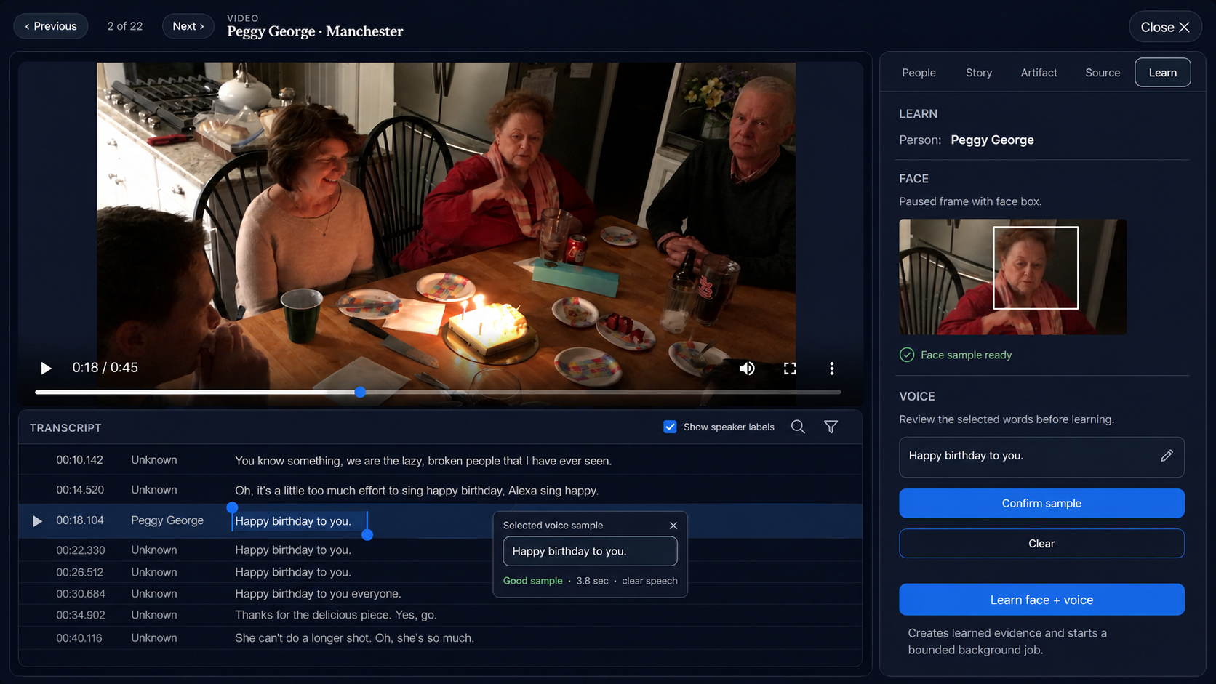
Synchronized transcript selection, face sample, voice confirmation, and combined learning.

Video Detail / People
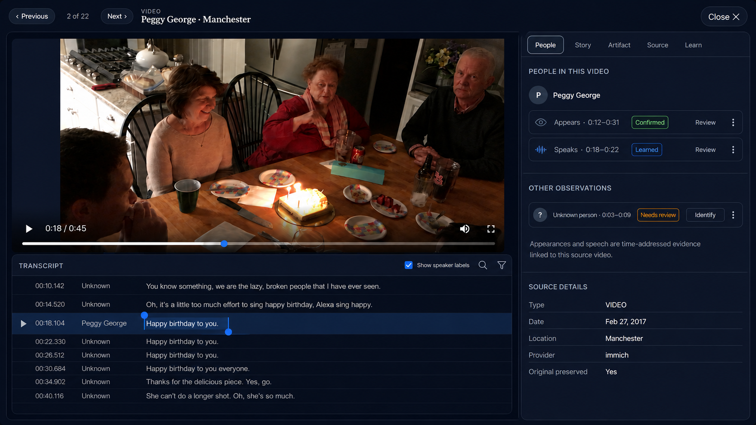
Independent appearance and speech evidence, including review of unknown observations.

Admin landing
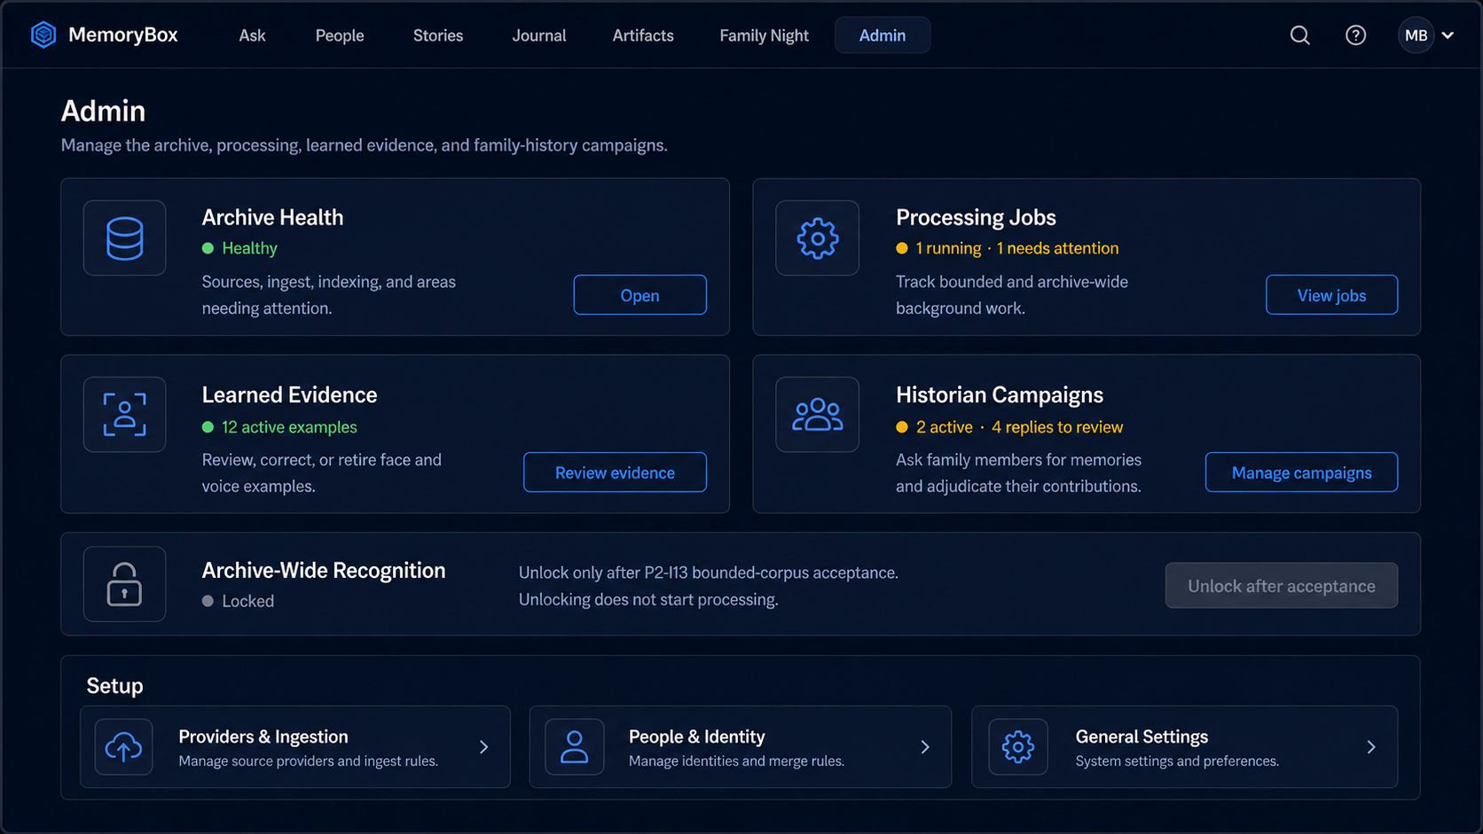
Owner-only home for Archive Health, Processing Jobs, Learned Evidence, Historian Campaigns, and setup.

Admin / Processing Jobs
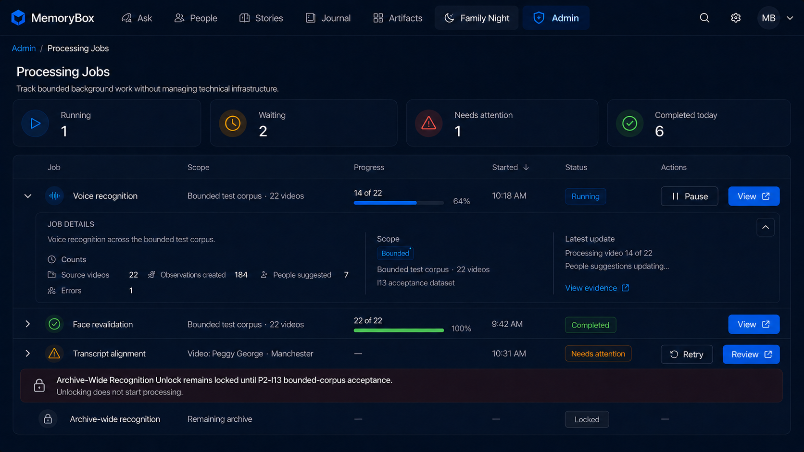
Bounded processing status with an enforceable Archive-Wide Recognition Unlock.

Admin / Learned Evidence
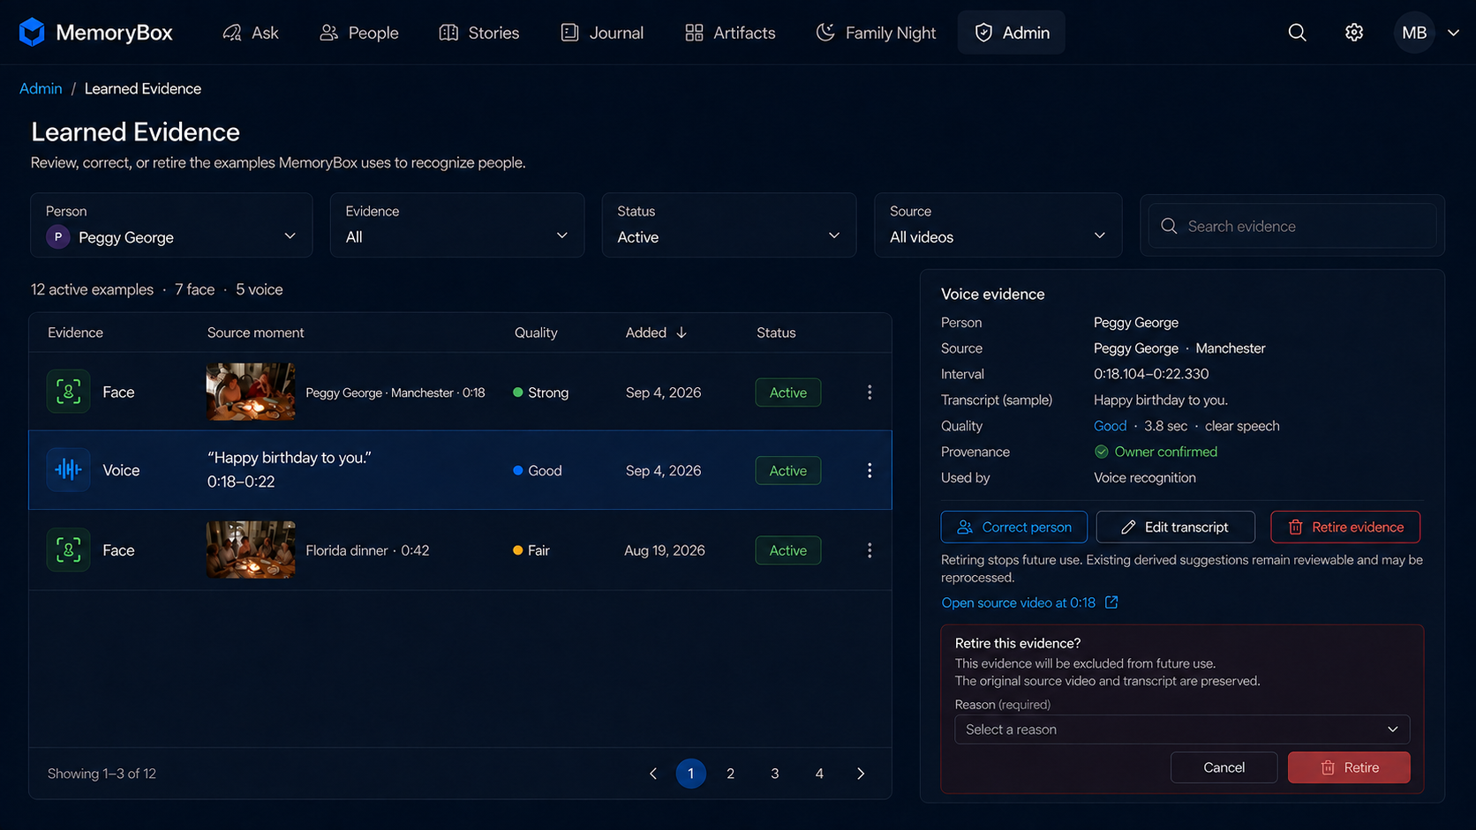
Evidence provenance, correction, transcript editing, and reversible retirement.

6.1 Required refinements
- Before voice confirmation, use “Assigned for learning: [Person]”; do not imply recognition already proved identity.
- Enforce Archive-Wide Recognition Unlock in the service/API, not only through a disabled button.
- Reconcile every Jobs count with persisted work.
- Retirement requires a reason and states that original video/audio/transcript are preserved.
- Admin is owner-only and appears in the shared top navigation; Processing Jobs, Learned Evidence, Archive Health, and Historian Campaigns are Admin destinations.

7. Bounded corpus and Archive-Wide Recognition Unlock
Before any new recognition run, locate or create a versioned bounded-corpus manifest. It must not be inferred from whatever files happen to be reachable.
Manifest field | Requirement
ID/version | Stable name/version committed with evidence.
Sources | Exact stable video identifiers and expected count; no archive wildcard.
Coverage | Face-only, off-camera voice, simultaneous modalities, multiple people, poor audio, occlusion, short/long appearance, and no-match cases.
Expected truths | Owner-confirmed identities and approximate intervals sufficient to score results.
Authorization | Worker and API require a bounded-scope flag.
Unlock | Archive mode requires an accepted-gate record. Unlocking does not start processing; starting remains a separate intentional action.

8. Acceptance criteria
Gate | Pass condition
Integrity | Repeated bounded runs do not increase equivalent observations; every derived record resolves to one source; no pseudo-videos.
Playback | Sampled results open correct source/time within tolerance and continue past the evidence interval.
Transcript | Follow, seek, user scrolling, selection, and correction overlay all work while original remains preserved.
Face | Sustained appearances group sensibly; evidence can be learned, reviewed, corrected, and retired.
Voice | Clean confirmed samples drive suggestions including off-camera speech; face is not required.
Corroboration | Independent evidence remains visible; confidence may combine without collapsing modalities.
Jobs | Scope, progress, counts, failures, Pause/Retry, and evidence drill-through work.
Regression | Gallery, query context, modal navigation, Person filter, timeline expansion, and increasing precision remain operational.
Safety | Pre-acceptance archive starts are rejected; source/provider media is never mutated.
Proof | Implementation report includes before/after counts, tests, screenshots, timing, failures, and residual risks.

Archive-Wide Recognition Unlock Passing tests does not unlock or start archive processing. Founder acceptance is required to unlock it, followed by a separate explicit action to start processing.

9. Non-functional requirements
- Auditability: retain source, model/config, timestamps, actor, confidence inputs, and lifecycle lineage.
- Recoverability: back up or establish rollback before material derived-data remediation.
- Performance: transcript follow/seeking feels immediate; recognition stays asynchronous and observable.
- Resource control: concurrency and GPU/CPU usage are bounded/configurable on FlightSim.
- Privacy: face/voice learning remains owner-controlled and is not disclosed to contributors.
- Accessibility: keyboard operation, visible focus, accessible labels, and non-color state indicators.
- Observability: job counts reconcile with writes; errors identify source/phase without raw infrastructure in owner UI.

10. Delivery and proof
- First commit: repository assessment, classification matrix, bounded manifest, causal analysis, and plan.
- Subsequent commits: small coherent vertical changes in approved order; migrations separate from processing runs.
- No development/test job may target the remaining archive.
- Each milestone reports files, migrations, tests, observed counts, UI proof, and open risks.
- Final package includes completeness matrix, bounded-run report, acceptance checklist, rollback notes, and founder request for Archive-Wide Recognition Unlock.

11. Out of scope
- Replacing Immich or writing corrections to Immich.
- General family multi-user administration.
- I14 communications aggregation and Save as Story.
- Later setting/activity/artifact learning.
- Automatic Archive-Wide Recognition Unlock or automatic processing after a passing run.
- A full developer operations console or raw logs in the owner UI.

12. Misses, gaps, contentions, and recommended dispositions
Issue | Gap | Recommended disposition | Timing
Corpus manifest | Exact membership/truth set is not in current planning material. | Locate existing; otherwise create/review before recognition run. | Blocks processing.
Thresholds | Face, voice, and corroborated confidence thresholds are unspecified. | Make configurable/versioned; measure corpus results before approval. | Blocks acceptance policy.
Transcript edits | Whether edits replace STT is unspecified. | Preserve original; store owner correction overlay for display/search/learning. | Recommended default.
Retirement cascade | Prior suggestion handling is unspecified. | Stop future use; mark dependent suggestions stale; reprocess affected bounded scope. | Confirm before lifecycle build.
155K cleanup | Invalid share is not yet quantified. | Back up; quarantine/supersede; reconcile counts; never blind-delete. | Root cause first.
Track grouping | Gap/merge tolerances are unspecified. | Version configurable tolerances; show sampled errors and count effects. | Can start configurable.
Learning reach | A learned exemplar might trigger full-archive work. | All I13 learning jobs inherit bounded scope; archive-wide recognition remains locked. | Firm rule.
Attribution risk | Visible face could be mistaken for speaker. | Require voice evidence or owner confirmation; face only corroborates. | Firm rule.
Performance targets | No numeric latency/runtime limits exist. | Capture baseline; propose thresholds from measured hardware. | Does not block build.

13. Founder decisions/questions
- Approve immutable machine transcript plus owner correction overlay?
- Approve retirement: stop future use, mark dependent suggestions stale, then reprocess affected bounded scope?
- Does a versioned 22-video manifest already exist; if not, may Codex create it as the first I13 artifact?
- Confirm Archive-Wide Recognition Unlock remains an explicit founder action for I13, with processing started separately?
- Admin placement is approved: owner-only top navigation with Archive Health, Processing Jobs, Learned Evidence, Historian Campaigns, and setup destinations.

Appendix A — Code completeness matrix
Requirement | State | Evidence / location | Change needed | Test
I13-FR-001
I13-FR-002
I13-FR-003
I13-FR-004
I13-FR-005
I13-FR-006
I13-FR-007
I13-FR-008
I13-FR-009
I13-FR-010
I13-FR-011
I13-FR-012
I13-FR-013
I13-FR-014
I13-FR-015
I13-FR-016
I13-FR-017
I13-FR-018
I13-FR-019
I13-FR-020
I13-FR-021
I13-FR-022
I13-FR-023
I13-FR-024
I13-FR-025
I13-FR-026

Appendix B — Source references
- Founder-approved I13 order and architectural rule, 3–4 September 2026.
- Approved I13 screen set: Video Learn, Video People, Processing Jobs, Learned Evidence.
- MBUX-001 MemoryBox UX Foundation and Design Principles v0.3.
- MBPS-001 Memory Box Product Specification v0.1 and current P2 planning decisions.
- MBCAP-001 MemoryBox Capability Catalog — P2 Initial Draft.
- MBEVS-001 EVS Catalog v1.0 completed.
- MBRM-001 MemoryBox Roadmap and P2 Backlog Notes v0.1.

