Report on Gun Murders

S William Chan

6/7/2020

## Introduction

This is a report on 2010 gun murder rates obtained from FBI reports. The original data was obtained from this Wikipedia page. We are going to use the following library:

library(tidyverse)

## -- Attaching packages ------------------ tidyverse 1.3.0 --

## v ggplot2 3.3.0 v purrr 0.3.4  
## v tibble 3.0.0 v dplyr 0.8.5  
## v tidyr 1.0.2 v stringr 1.4.0  
## v readr 1.3.1 v forcats 0.5.0

## -- Conflicts --------------------- tidyverse_conflicts() --  
## x dplyr::filter() masks stats::filter()  
## x dplyr::lag() masks stats::lag()

and load the data we already wrangled:

load("rda/murders.rda")

## Murder rate by state

We note the large state to state variability by generating a barplot showing the murder rate by state:

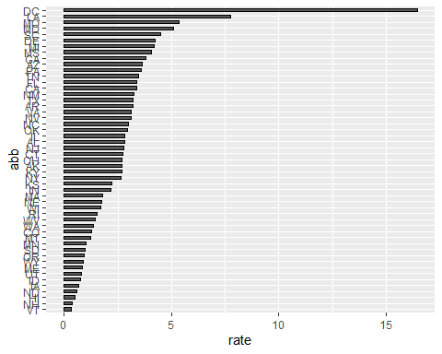

Note that the echo = FALSE parameter was added to the code chunk to prevent printing of the R code that generated the plot.